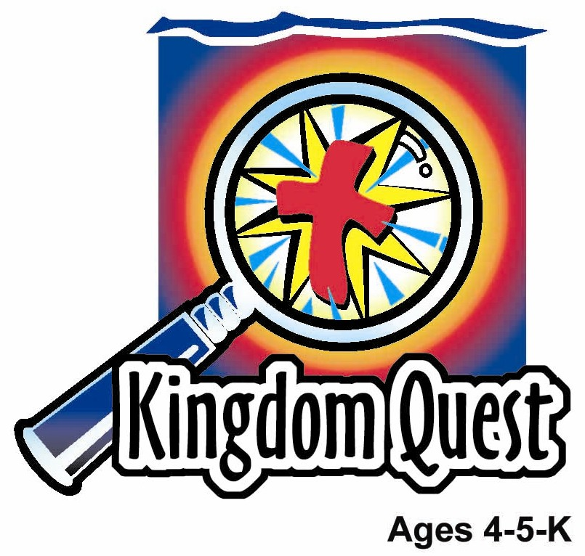
Date: _____________________
Series: God Made Everything (Jun-Aug)
Year 1, Lesson 1

God Made Me

Take Home Point: *GOD MADE ME—God cares for me.
*Repeat this phrase throughout the lesson. The leader will say the first part of the phrase (CAPS). The children respond with the second part of the phrase (italics).

Bible Event: Isaiah 43:1b
Jesus Link: We belong to God who brought us into His family by sending Jesus as our Savior.

We will help children know:
- God made them, and they belong to Him.
- God cares for them so much that He sent them Jesus.
- When they trust Jesus, they belong to God’s family.

We will help the children feel:
- Special just for belonging to God.
- Awed that God calls them by name.
- Thankful that they are part of God’s family.

We will help the children do:
- Understand the significance of the “You Are Special” shadow play.
- Draw a picture of themselves to recognize how special they are.
- Play the game “God Made You” to remember that they belong to God.
THIS LESSON’S ROADMAP

DESTINATION | PAGE # | DISCOVERIES ON YOUR JOURNEY | SUPPLIES NEEDED
Large Group Opening   | 3  3 | Puppet Presentation  Bible Event | - Xiao Hung puppet  - OHP  - figures of the characters for shadow play  - dull colored dot stickers  - brightly colored star stickers  - snack bags of finger biscuits  - Option 2:“You Are Special: video or DVD – by Max Lucado. ISBN 1-58134-166-0 May be purchased off the web.
Small Group Application   | 5  6  6  7 | Activity 1: “I am Special” Craft  Activity 2: “Bamboo Puppet” Snack  Activity 3: ”God Made You” Game  Activity 4: “Mook Can Say the Verse”  Prayer Time | Activity 1:  - one copy of template per child  - colour pencils  Activity 2:  - one salted biscuits for e  each child  - five finger biscuits for  each child  - serviettes  Activity 3:  - star stickers  Activity 4:  - 30cm bamboo stick with face attached  - round stickers
Large Group Wrap-Up   | 8  8 | Singing (Optional)  Lesson Review with Puppet Skit | - optional music for the lesson  - Xiao Er Puppet

Pre-Session Singing: (10 minutes)
Purpose: When all children are in one group singing, it is easy for new children to join the group and immediately get involved. When the music can be correlated, it introduces the theme for the day. Choose two to three songs and list them here.

Large Group Opening: (15 minutes)
Purpose: The puppet demonstrates the need that will be met in today’s lesson. The scripts are not written verbatim, but give a story line in which the group leader can interact with the puppet. The children are introduced to the take home point and then interact with God’s word as they experience the Bible event.

Supplies needed: Xiao Hung puppet; OHP; figures of the characters for shadow play; dull colored dot stickers; brightly colored star stickers; snack bags of finger biscuits;

Puppet Presentation:

Xiao Hung comes onstage with his shoulders slumped. The presenter asks him how his week was. Xiao Hung explains that he is a little upset because at school last week, Ting Ting got a star sticker and Xiao Hung didn’t. Xiao Hung feels sad because the star means that Ting Ting is special and he isn’t.

The presenter asks the children if they think that Xiao Hung is special even if he doesn’t have a star. (Yes.) The presenter explains that, of course, Xiao Hung is special, star sticker or not. Xiao Hung doesn’t know why he would be special to anyone. The presenter explains that today we’re going to find out that one of the main reasons that we are special has nothing to do with what we do or how many stars we have. We are special because of who we belong to. Xiao Hung chimes in that he belongs to his mom and dad. The presenter assures Xiao Hung that we do belong to our families, but there is someone even more important that we belong to – someone who made us. That’s God.

Xiao Hung wants to know if God thinks he’s special, even without a star. Absolutely. The presenter offers Xiao Hung a star sticker just for being himself and belonging to God.

Xiao Hung learns the take home point: GOD MADE ME – God cares for me. The presenter says the first part and Xiao Hung responds with the second part. After the presenter practices it with Xiao Hung several times, he teaches it to the kids.

Bible Event:

Introduce the shadow play by reading the Bible verse Isaiah 43:1b.

This is what the Lord says: “Don’t be afraid, because I have saved you. I have called you by name, and you are mine.” This means that we each belong to God. Today’s shadow play story is going to talk about dots and stars.

Pull out some plain colored dot stickers and brightly colored star stickers to place on yourself as you explain.

The dots are going to remind us what it’s like when we sometimes feel bad about ourselves. Stars are the world’s way to make us feel important. But the shadow play will show us that dots and stars really aren’t important. Instead, we want to remember whom we belong to and why we’re really special. Let’s listen and see if we can figure it out.

Distribute finger biscuits or Rocky for the children to eat during the shadow play.

Storyline for Shadow Play:
In a far away bamboo land lived a tribe called Malaboo. They appreciate the bamboos very much and much of what they do or have is from the bamboo. The Malaboo uses the bamboo to bring in water to their homes from the mountain springs. Their cups were made from bamboo. Well, not forgetting their chopsticks, spoons, soup bowls, pillows, shower, stove, tables, chairs, beds, curtains, bags, shoes, etc. etc.

Anyway, there in this tribe, there was a very skillful craftsman named Toh. Toh was very skillful in crafting things out of bamboo. He also loved walking among the bamboos. And one day when he was taking his usual walk among the bamboos, he saw a very special shoot of bamboo all covered with dots. Looking at the shoot, he saw that it was perfect for crafting although he didn’t really know what to craft it into. He just knew it would be special. Therefore, he cut the shoot and brought it home.

Placing the bamboo in his workshop, Toh sat intently staring at the shoot thinking of what it can be made into and for two days.

That night he started crafting the bamboo and he laboured hard in his workshop. All night his bamboo lamp burned. Knocking, sawing and carving was heard from his little shack all night long till at last it was complete, the masterpiece was complete. He crafted the bamboo shoot into a live size puppet about the height of a child. And to Toh’s surprise, the puppet creaked on its own, the joints in its arms creaking to life. It was God’s blessing to a man who had no child. Now he has a child to love, to care, and to teach.

“Good Morning!” said the little puppet. “Who are you?”

“I… I… I… I’m Toh” stammered the kind old man who is much too shock to believe that his “child” can talk.

“You must be my father!” the wooden puppet said.

“Yes… I believe I am”, said Toh. Then Toh realized, that his child must have a name, and he decided to call him Mook, the native for wood.

Mook was a cheerful child, and energetic as all young children are, and Toh taught him many things, and always told Mook that he was special. After a while Mook wanted to see what the world was like outside of the house as he heard many sounds outside the walls of the courtyard. He often heard the crows of roosters with the clunking of chickens. The busy chatter of women and slow rumbling of bullock carts rolling by. But what he really longed for was to meet with the group of little laughters. It sounded like they were playing, running around but there were also some fighting and crying. Yet daily they would always come together again.

One day, he asked his father if he can go out beyond the walls of the courtyard. Toh was a bit hesitant but knowing that children should always play with each other, he said yes. Mook was really excited and ran out of the house too meet the children who were playing next to their house. It was a bright sunny day for laughter and play.

Shyly he crept over and asked if he could join them. Quickly the children ran away from him when they saw how different Mook looks – and full of dots. The villagers there turned to look and were shocked. With eyes popping out, they asked Mook what he was. But Mook did not understand why they gave such question, nor did he understand why the children ran away from him.

Just then, Toh came out and explained to the villagers how he was blessed by God with Mook as his child. Because Toh was well respected in the village, the Malaboos did not make further fuss but excuse themselves from that vicinity.

So Mook did not have a good time after that day. Although he was allowed to go out of the courtyard of the house, the villagers treated him with indifference. Some children were nasty - tripping him in mud puddles, giving him funny names, shouting nasty things about him, making fun of his dots. He could not understand why they were rude towards him or why they did not like his dots. So one day he ran home crying to his father.

“Why do they treat me so nasty?” “And why is it that the children do not want to play with me?” sobbed Mook as he hugged his father.

After Mook had calmed down, Toh held the little child’s face in his hands, looked lovingly into his eyes and said, “It doesn’t matter what they think, I believe that you are special and wonderfully made. Look at your hands, your arms and your legs, they are covered with beautiful God made dots. Do you see any other bamboo having these dots?”

“No” sobbed Mook.

“Exactly! You are special. I know you are special, with a big loving heart. That is all that should matter” assured Toh.

Mook understood that he was special and that is all that mattered. He has a father who treats him special all the time. One day, people will learn to love us but as for now, we must never let them change our thinking that we are not special because we look different from them. God made us and gave each of us special features and Mook was his dots.

Conclude with the following:

In the drama, Mook didn’t think he was very important because the other Malaboos didn’t like him and he was covered in dots. But in the end, he learned that Toh, the one who made him, thought he was very special. The one who made us thinks that we’re pretty special, too. Who is that? (God.) That’s right. God made us and gave us his own Son Jesus so that we would belong to His family forever. Because we belong to God, we are all very special, no matter what anyone else thinks. Remember: GOD MADE ME – God cares for me.

Option 2: Video
Test your sound and video system beforehand. Cue the video to its precise beginning. For larger groups of children (15 or more), use a large screen TV or imager. Dim the lights before starting the video. To introduce a video, you might read from a Bible storybook and leave off the ending, inviting children to see what happens by watching the video. You could also introduce the video by inviting children to keep an eye out for special actions or words they will see during it.

Su[[plies needed: “You Are Special: video or DVD – by Max Lucado. ISBN 1-58134-166-0 May be purchased off the web; video system; screen

Show the entire video You Are Special by Max Lucado produced by Impact Entertainment & Crossway Books, 2000, ISBN 1-58134-166-0. Begin the video just after the opening credits list “and Crossway Books present” and stop it as the ending credits begin. The length of the video is 22 minutes, 40 seconds.

Use the same conclusion as option 1 but replacing the names appropriately.
Small Group Application: (30 minutes)
Purpose: Smaller groups enable children to develop closer relationships with adults and peers in the church. As you reinforce the take home point with a fun hands-on activity, discuss the Bible event. Be sure to repeat the take home point several times. Say the first part and have the children respond with the second phrase. Application questions help kids apply the take home point to their daily lives. Close this session by gathering your small group for prayer. Let the kids pray!

During the small group application time, discuss the following questions and points:

In our story today, what did Mook have all over him? (Dots.)

How did the dots make him feel? (Sad, no one liked him, the children did not want to play with him, etc.)

Who do we belong to? (God.)

How do we know we are special? (God made us. God loves us. God cares for us and sent Jesus for us. We belong to him, etc.)

Activity 1: “I am Special” Craft
Supplies needed: one copy of template per child; colour pencils

To make:
- Reproduce template – one per child.
- Read the Bible verse on the template to the children, so they know what the project is about.
- Have the children write their name in the box provided.
- Have the children draw a picture of themselves on the template using colour pencils.

To discuss:
- Explain that each of us is special and belongs to God. God calls us by name! By drawing pictures of ourselves and writing our names, we are showing that we know we are special to God.
- Review the take home point: *GOD MADE ME – God cares for me.

Activity 2: “Bamboo Puppet” Snack
Supplies needed: one salted biscuits for each child, five finger biscuits for each child, serviettes

Have each child open up a serviette in front of him/her. Hand to each child one salted biscuit and this will be the head of the bamboo puppet. Then give each child five finger biscuits and they are to arrange the body, two hands and two feet. Let the children admire what they have made for a moment then emphasize:-

The finger biscuits we ate during the shadow play remind us of Mook – he was a puppet made out of bamboo. We have made a little bamboo puppet ourselves from biscuits. Mook was carved out of bamboo by his maker, Toh. Who were we made by? God made each one of us special. Did he use bamboo? No, he made us as people.

Let the children enjoy eating their “bamboo puppet.”

Activity 3: “God Made You” Game
Supplies needed: star stickers

To play:
Play a version of the game “London Bridges.” Choose two children to stand facing each other, arms extended, palms touching to form a “bridge” that the rest of the children will pass under. To the normal tune of London Bridges, sing the following lyrics:

You are special,
God made you,
God made you,
God made you.

You are special,
God made you,
You belong to Him.

When the song ends, the “bridge” collapses and the children forming the “bridge” drop their hands down to catch another child. Each captured child gets a star sticker and told that they are special to God. Repeat, making sure each child gets captured, and each child gets a turn forming the bridge.

Activity 4: “Mook Can Say the Verse”
Purpose: Help kids to memorize and keep scriptures at heart. Using creative ways to help kids enjoy learning the key verse and in small group setting.

Supplies needed: 30cm bamboo stick with face attached; round stickers

Memory Verse: Isaiah 43:1b - The Lord says: “I have called you by name, and you are mine.”

Memory Verse Learning:
Hold out the broomstick that has a face attached as the head. Say that this “puppet” reminds us of Mook but help the children notice what is missing in this puppet. The dots are missing. Ask the children to contribute one of their dots so as to make this puppet like Mook. After the children has attached their dots on the broomstick say that Mook is going to teach us a memory verse. Flip the flashcard at the head to help the children memorize today’s verse. The shepherd can have volunteers help flip the flashcard. After everyone has learnt, reward the children with a dot.

Prayer Time:

Pray for people to realize how special they are to God and understand that they belong to Him.

Large Group Wrap-Up: (10 minutes)

Supplies needed: optional music for the lesson; Xiao Er Puppet

Singing: (Optional)

Lesson Review with Puppet Skit:
Purpose: The crazy bird puppet, Xiao Er, struggles with learning the take home point. The leader shows an example of each small group application activity from this lesson and says the first phrase of the take home point. The kids respond with their phrase. They try to teach the puppet the take home point, but each time, he confuses words or concepts. After three attempts, he finally gets it right and sings the correct take home point in a silly opera-like voice.

Xiao Er’s confused phrases:

Activity 1: “I love to draw!”
Activity 2: “God loves Mop…Ook…finger biscuits!”
Activity 3: “God cares for birds.”

Welcome guests and thank them for attending.
Supplies:

Quantity ()

Large Group Opening:
- Xiao Hung puppet
- OHP
- Figures of the characters for shadow play
- dull-colored dot stickers
- brightly colored star stickers
- snack bags of finger biscuits
- Option 2: “You Are Special: video or DVD – by Max Lucado. ISBN 1-58134-166-0. May be purchased off the web.

Small Group Application
Activity 1:
- one copy of template per child
- colour pencils
Activity 2
- one salted biscuits for each child
- five finger biscuits for each child
- serviettes
Activity 3:
- star stickers

Large Group Wrap-Up
- Xiao Er puppet
- optional music

Memory Verse Learning
- a 30cm length bamboo stick
- 3 pieces of hard card that is A4 size. Fold them together into half (like a booklet). Draw and cut a circle of 14cm diameter but the edge with the fold remains attached. (See diagram) Write the Bible verse on the hard card:-

(1) [Face] (4) “I have called

(2) Isaiah 43:1b (5) you by name

(3) The Lord says: (6) and you are mine.”

- Round stickers

God calls me by name:

God made me special.
Isaiah 43:1b



Silhouettes for Shadow Play:-
- Cut out the cluster of bamboos for forest.
- After cutting the one stick of bamboo, poke holes to represent the dots of the story.
- Fold a strip of paper so as to cut a chain of figures; to represent Malaboos.
- Do the same for the small figure; to represent children.
- Cut out one single small figure; poke holes so as to represent Mook.
- Lay figures on OHP for various scene as you tell the story.

