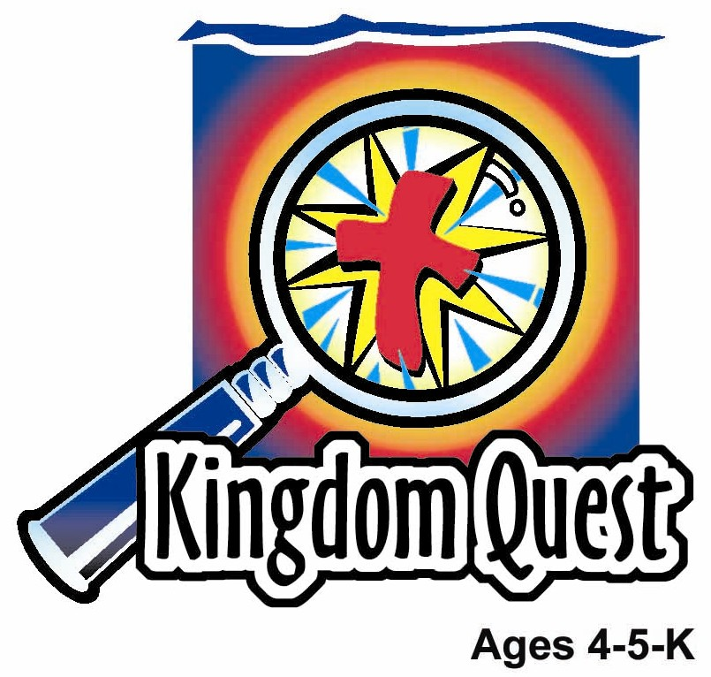
Date: _____________________
Series: God Made Everything (Jun-Aug)
Year 1, Lesson 2

God Made Everything

Take Home Point: *GOD MADE EVERYTHING —Praise God!
*Repeat this phrase throughout the lesson. The leader will say the first part of the phrase (CAPS). The children respond with the second part of the phrase (italics).

Bible Event: Genesis 1:1-25
Jesus Link: God made the world because He loved us and His love sent Jesus into the world to save us.

We will help children know:
- The Bible event of how God, with only a spoken word, made the world.
- God demonstrated creativity and power when He made everything.
- God loves us and made a perfect world for us.

We will help the children feel:
- Amazed by God’s power to make the world and everything in it.
- Loved by God that He wanted to create the world.
- Thankful and full of praise that God made a wonderful gift of the world and everything in it.

We will help the children do:
- Observe the magnificent Bible event of God’s power and love when He made the world and everything around us.
- Examine the colors, shapes and flavors of some of God’s juiciest creations.
- Play a game called “Animalympics” and be amazed at God’s creativity.
THIS LESSON’S ROADMAP

DESTINATION | PAGE # | DISCOVERIES ON YOUR JOURNEY | SUPPLIES NEEDED
Large Group Opening  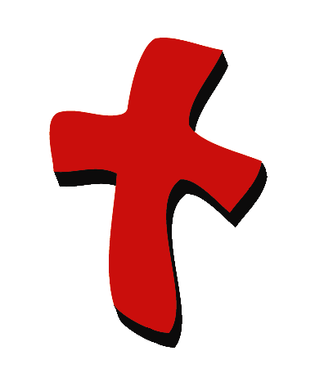 | 4  5 | Puppet Presentation  Bible Event | - Xiao Hung  - name tag necklace  - Bible  - white sheet(s)  - rope or string  - room dividers (optional)  - clothespins or clips  - lamp, spot light, or flash light  - clouds, sun, moon, stars  - waves  - land  - plants and flowers  - fish and birds  - stuffed animals
Small Group Application   | 7  7  8  8-9 | Activity 1: “Creature Creation” Craft  Activity 2: “Fantastic Fruit” Snack  Activity 3: ”Animalympics” Game  Activity 4: “Alphabet Call”  Prayer Time | Activity 1:  - white 8 1/2x11 inch manila card  - glue  - one sun, waves, land and clouds per child  - one per child of bird, fish, animal and plant  - colored pencils  - scissors  Activity 2:  - bowl to hold fruit  - washed, whole fruit (apples, bananas, oranges, grapes or any local fruits available.)  - cups  - serviettes  - water or juice  - knife  Activity 3:  - masking tape  - chair (optional)  - one hard card for each child; marker; mahjong paper with Bible verse written  Acitivity 4:  - one hard card for each child  - marker  - mahjong paper with Bible verse written
Large Group Wrap-Up   | 9  9 | Singing (Optional)  Lesson Review with Puppet Skit | - optional music for the lesson  - Xiao Er Puppet

Pre-Session Singing: (10 minutes)
Purpose: When all children are in one group singing, it is easy for new children to join the group and immediately get involved. When the music can be correlated, it introduces the theme for the day. Choose two to three songs and list them here.

Large Group Opening: (15 minutes)
Purpose: The puppet demonstrates the need that will be met in today’s lesson. The scripts are not written verbatim, but give a story line in which the group leader can interact with the puppet. The children are introduced to the take home point and then interact with God’s word, as they experience the Bible event.

Supplies needed: Xiao Hung; name tag necklace; Bible; white sheet(s); rope or string;
room dividers (optional); clothespins or clips; lamp, spot light, or flash light; clouds, sun, moon, stars; waves; land; plants and flowers; fish and birds; stuffed animals

Puppet Presentation:

The large group presenter made a nametag necklace with Xiao Hung’s name on it. He put it away so Xiao Hung wouldn’t find it and now he can’t remember where he put it. He wants to give it to Xiao Hung today. Xiao Hung comes onstage all excited because he has found an awesome nametag necklace and he knows it’s for him because the nametag necklace has his name on it. The presenter indicates to the audience without Xiao Hung knowing it that that is the nametag necklace he was looking for. The presenter asks Xiao Hung why he wants to know who made it for him. Xiao Hung feels funny keeping the nametag necklace without knowing whom he should thank. When someone takes the time and effort to make something for you it is proper to give them thanks.

The presenter agrees with Xiao Hung. How much time and effort do you think it took God to make the world and everything in it? In today’s Bible event, we are going to learn about God demonstrating his majesty and power with just a spoken word(s) when he made the world and everything around us.

The presenter says, “Xiao Hung, you can thank me for making the nametag necklace.” Xiao Hung is thoughtful for a moment and tells the large group presenter “thank you” for thinking of him and making him this cool gift. And, let’s give thanks and praise to God for making the whole world!

The large group presenter teaches Xiao Hung the take home point. *GOD MADE EVERYTHING —Praise God! The presenter says the first line; Xiao Hung replies with the second line. After practicing it with Xiao Hung several times, the presenter teaches it to the children.

Bible Event: Simple Storytelling
Reading a Bible story or telling the Bible event can be done effectively with expressive voice and dramatic gestures.

Hang a white sheet on a line between two room dividers or hang sheet on line connected to ceiling or other apparatus that works best for your area.

Today’s Bible event explains how God made the whole world. Boys and girls, you will help me tell the Bible event. We are going to say the take home point throughout the story. Remember, *GOD MADE EVERYTHING — Praise God!

Long, long ago, there was no world at all. There was darkness all around just like night. (Turn lights down.) The world had no shape. But, God, who can do anything through His power, wanted to make a wonderful world just right for people to live in.

The first thing God did was take care of the darkness all around. So He said, “Let there be light,” and there was light everywhere. (Turn on lamp, flashlight or spotlight to shine from behind the sheet.) He called the light “day” and the darkness “night.” God said, “It is good” and was pleased. This was day one (hold up one finger) or the beginning of time. Remember, *GOD MADE EVERYTHING — Praise God!

Now there was day and night, but there was water all around. God said, “Let there be something to divide the water into two.” So above, God made the sky and clouds. We see water in the clouds. God named the sky “heaven.” (Attach clouds to the line to hang in front of sheet.) Below, we see the water in the oceans. (Slide in the waves in front of the sheet.) This was day two (hold up two fingers). Remember, *GOD MADE EVERYTHING —Praise God!

God had created day and night and separated the water, but there was no dry land. God knew when he created people, they would want to live and play on land. So, on the third day of creation (hold up three fingers), God said, “Let the water under the sky be gathered together so the dry land will appear.” God called the land “earth” and the water “seas.” (Add land by placing it in front of or behind waves.) God said, “It is good.” However, the land was empty so God made trees and plants. (Add trees and flowers.) Remember, *GOD MADE EVERYTHING — Praise God!

God had more plans. He made lights to separate the day from the night. He made the sun to shine during the day and the moon and stars to shine at night. (Add sun, moon and stars by hanging from line.) God said, “It is good.” He was pleased. This all happened on day four. (Hold up four fingers.) Remember, *GOD MADE EVERYTHING — Praise God!

Next, God began to make living creatures. God said, “Let the water be filled with living things. And let birds fly in the air above the earth.” He made all kinds of birds to fly and every kind of fish to swim. (Add fish and birds with tape or sticky tack.) God was pleased and said, “It is good.” God still wasn’t finished. He had to make the animals. So God said, “Let the earth be filled with animals.” (Add stuffed animals.) He made all kinds of animals. This all happened on day five. (Hold up five fingers.) Not one of these animals has a name yet. I wonder who named all the animals. We will find this out next week.

God knew something was still missing in His wonderful world. Next week, we will learn what God made when He took some dust from the earth, formed a body, and breathed into it.

Remember, *GOD MADE EVERYTHING —Praise God!

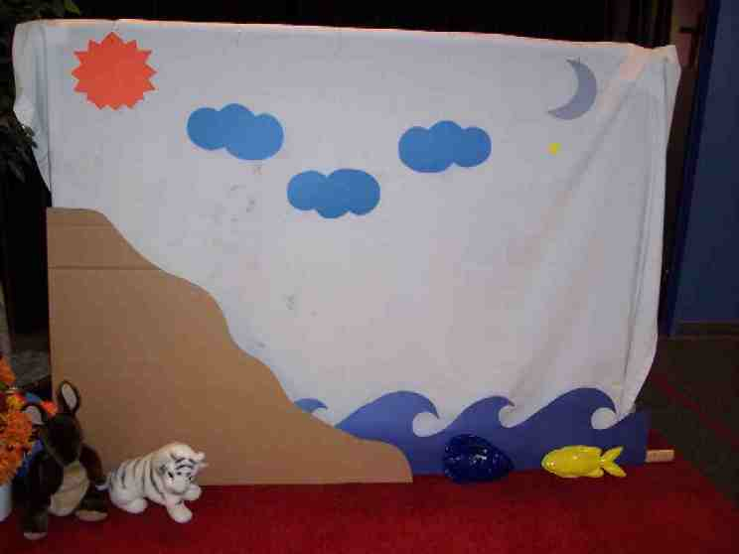

Prayer:
Dear Heavenly Father, we are so thankful that you made everything... the sun, the moon, the trees, the birds, the animals, and the fish. Your creation is beautiful and so awesome. Help us to appreciate it every day. Thank you for giving us life and being a part of our life. Amen.

Small Group Application: (30 minutes)
Purpose: Smaller groups enable children to develop closer relationships with adults and peers in the church. As you reinforce the take home point with a fun hands-on activity, discuss the Bible event. Be sure to repeat the take home point several times. Say the first part and have the children respond with the second phrase. Application questions help kids apply the take home point to their daily lives. Close this session by gathering your small group for prayer. Let the kids pray!

Activity 1: “Creature Creation” Craft
Supplies needed: white 8 1/2x11 inch manila card; glue; one sun, waves, land and clouds per child; one per child of bird, fish, animal and plant; colored pencils; scissors

To make:
Give each child a sheet of 8 ½ x 11 inch, white paper plus the cut outs to paste on the paper. The cut outs include: waves, land, cloud, and sun. The children will glue the waves, land, clouds, and sun to the paper to create the world as God did. Next, the children will decorate/create their animals and plant in any way they want.

Discuss while making craft:

God has a wonderful imagination and made many beautiful and fascinating creatures and plants. God used many shapes and colors. Use your imagination and make your creatures and plant any way you would like. God made the world and everything in it.

If time allows, they can glue their creatures and plant on the paper.

Practice the take home point. *GOD MADE EVERYTHING —Praise God!

Activity 2: “Fantastic Fruit” Snack
Supplies needed: bowl to hold fruit; washed, whole fruit (apples, bananas, oranges, grapes or any local fruits available.); cups; serviettes; water or juice; knife

Provide a bowl with fruit in it like oranges, grapes, bananas, apples or any local fruits available. Remind the children that on day three, God made the plants and flowers. Explain that trees and vines are just a few of many plants God made.

All these fruits come from trees or vines. All of these fruits are a different color and shape. Can you name the colors? God made a beautiful world with wonderful colors and food for us to eat. Now let’s sample this fruit and taste the wonderful flavors God created. (Peel and/or cut fruit.)

Allow children to sample all of the fruit or just the ones they are comfortable eating.

Practice the take home point. *GOD MADE EVERYTHING —Praise God!

Activity 3: “Animalympics Relay”
Supplies needed: masking tape; chair (optional)

To set up:
- Mark a beginning and a return line. These marks can be made by using masking tape for both ends or by using masking tape and a chair.
- Divide the children into equal sized groups and have both groups stand behind the start line of masking tape.
- Have the list of animals handy so you can remind them which animal they are to imitate when it is their turn. For example, you may run the relay in this order: walk like a bear, hop like a rabbit, gallop like a horse, walk like a crab, waddle like a duck, swim like a fish, run like a deer, fly like a bird, jump like a kangaroo and leap like a frog.

To play:
- Each group will have the first child move like an animal from the starting line, turn around at the return line, and come back to the starting position.
- The next child to go will move like a different animal. For example, the first child in each group would move like a bear then the second child in each group would move like a rabbit.
- The group to finish moving like the animals first wins.

Be sensitive to the different motor skills of each child. For example, some children will not be able to gallop yet so let them move to the best of their individual abilities.

Practice the take home point. *GOD MADE EVERYTHING —Praise God!

Activity 4: “Alphabet Call”
Purpose: Help kids to memorize and keep scriptures at heart. Using creative ways to help kids enjoy learning the key verse and in small group setting.

Supplies needed: one hard card for each child; marker; mahjong paper with Bible verse written

Memory Verse: Isaiah 43:1b - The Lord says: “I have called you by name, and you are mine.”

Memory Verse Learning:
Memorize together with the children today’s Bible verse by displaying the mahjong paper on the wall or easel board. After learning, write the first letter of the child’s name on the hard card with marker, example - Chan Mei Ling = C. (For Chinese speaking classes, letter should be used instead of Chinese character because younger children may not be able to recognize the Chinese strokes.) Every child will be represented with one card. Face alphabet down and scatter the hard card randomly. Then choose volunteer to pick a card and say out the letter. The person whose name starts with the letter must say the memory verse. If two or more has the same starting letter for their name, they are to say aloud the verse together. Have volunteers pick on cards until everyone has the chance to recite the memory verse.

Prayer Time:

Have the children give thanks and praise to God for making the world and their favorite part of the world. Thank Jesus for coming to our world.

Large Group Wrap-Up: (10 minutes)

Singing: (Optional)

Lesson Review with Puppet Skit:
Purpose: The crazy bird puppet, Xiao Er, struggles with learning the take home point. The leader shows an example of each small group application activity from this lesson and says the first phrase of the take home point. The kids respond with their phrase. They try to teach the puppet the take home point, but each time he confuses words or concepts. After three attempts, he finally gets it right and sings the correct take home point in a silly opera-like voice.

Xiao Er’s crazy responses:

Activity 1: “Thank you for Kentucky.”
Activity 2: “Thank you for Maggi men.”
Activity 3: “Thank you for Maggi pizza.”

Welcome guests and thank them for attending.
Supplies:

Quantity ()

Large Group Opening:
- Xiao Hung
- name tag necklace
- Bible
- white sheet(s)
- rope or string
- room dividers (optional)
- clothespins or clips
- lamp, spot light, or flash light
- clouds, sun, moon, stars
- waves
- land
- plants and flowers
- fish and birds
- stuffed animals

Small Group Application
Activity 1:
- white 8 1/2x11 inch manila card
- glue
- one sun, waves, land and clouds per child
- one per child of bird, fish, animal and plant
- colored pencils
- scissors
Activity 2:
- bowl to hold fruit
- washed, whole fruit (apples, bananas, oranges, grapes) or any local fruits available.
- cups
- serviettes
- water or juice
- knife
Activity 3:
- masking tape
- chair (optional)
Activity 4:
- one hard card for each child
- marker
- mahjong paper with Bible verse written

Large Group Wrap-Up
- Xiao Er puppet
- optional music
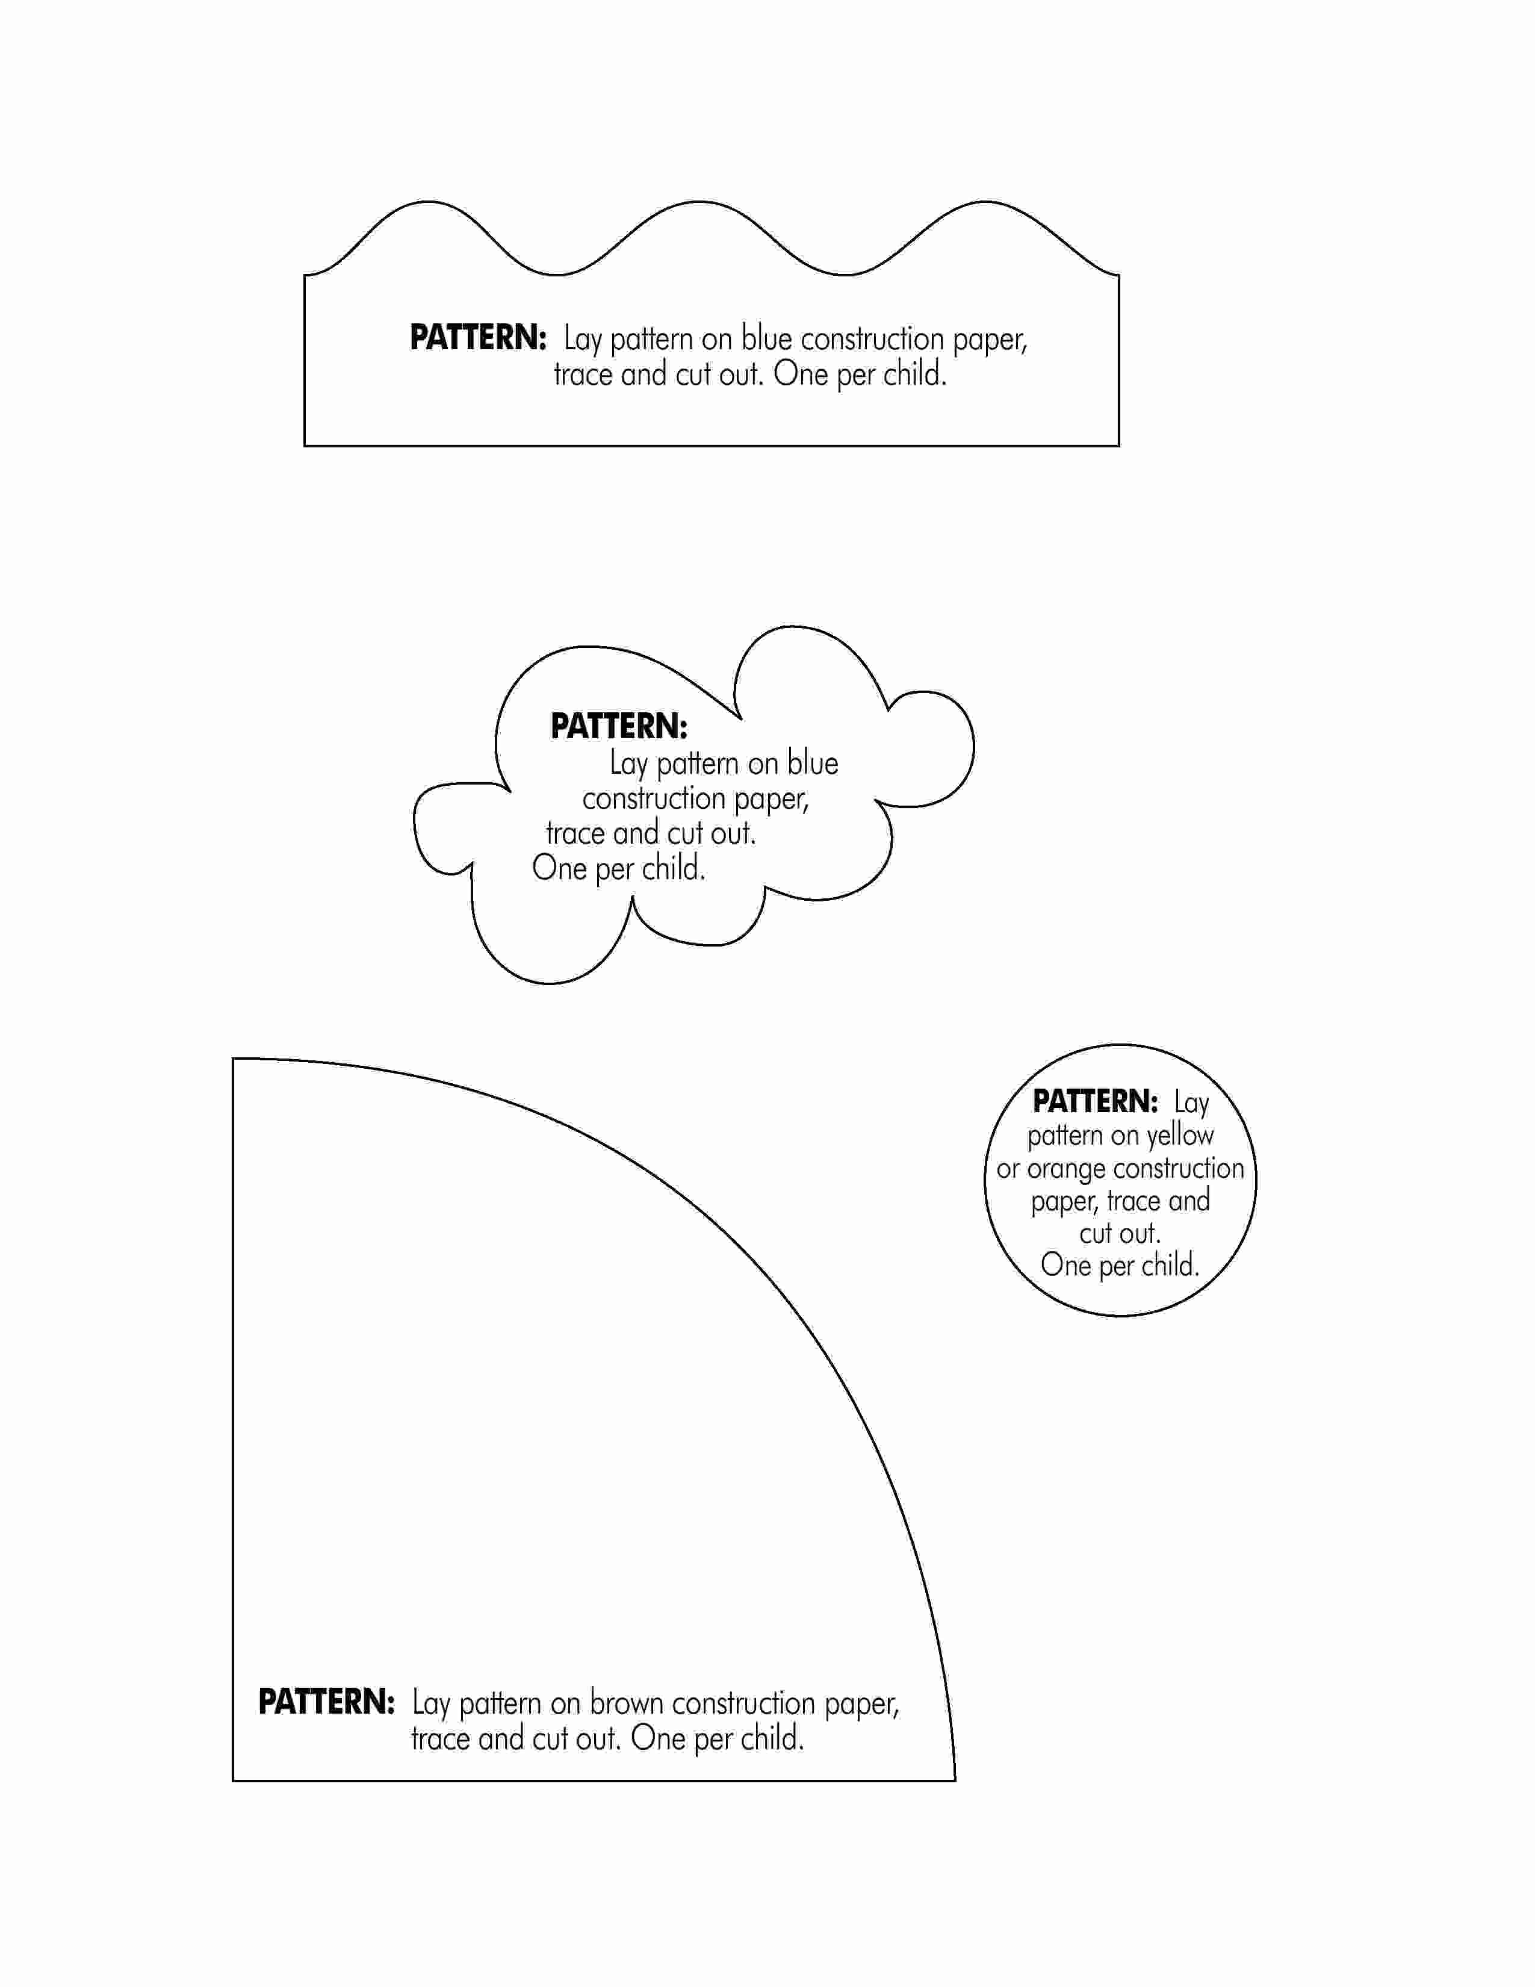
Activity 1-Templates (2 pages)
