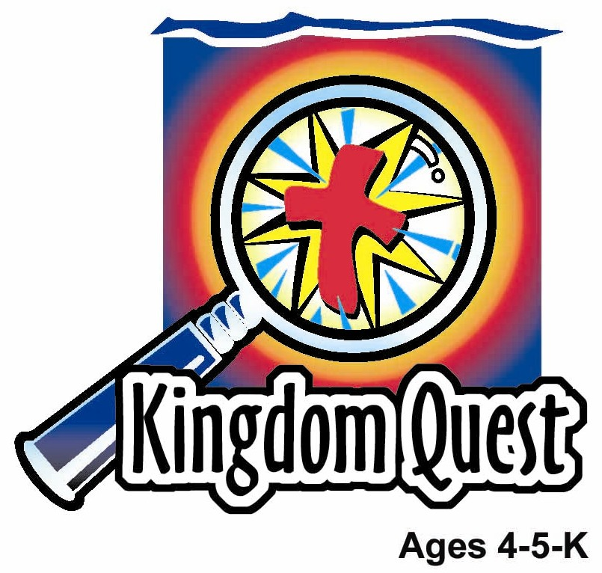
Date: __________________
Series: God Made Everything (Jun-Aug)
Year 1, Lesson 3

God Made People

Take Home Point: *GOD MADE ME SPECIAL—Thank you, God.
*Repeat this phrase throughout the lesson. The leader will say the first part of the phrase (CAPS). The children respond with the second part of the phrase (italics).

Bible Event: Genesis 1:26-27; 2:7, 21-22
Jesus Link: Through Jesus all things were made, including me.

We will help children know:
- The Bible event of how God created the first man and woman different from the rest of creation.
- When God created people, He made them in His image, which means perfect, knowing right from wrong and able to love just as God loves them.
- Ways in which God made them special and unique.

We will help the children feel:
- Awed by the knowledge that in all of creation, God made people in a unique way to demonstrate the special place people hold in God’s creation.
- Confident in knowing that God made them each the way He wants them to be and that the way they are made is precious to God.
- Treasured by the God who created them.

We will help the children do:
- Help act out through an imagination station the Bible event of God creating man and woman.
- Make a “Build-a-Friend” snack and rejoice in the way God has created them.
- Play a game, “Speed Ball,” and discover ways in which God has made them different.
THIS LESSON’S ROADMAP

DESTINATION | PAGE # | DISCOVERIES ON YOUR JOURNEY | SUPPLIES NEEDED
Large Group Opening  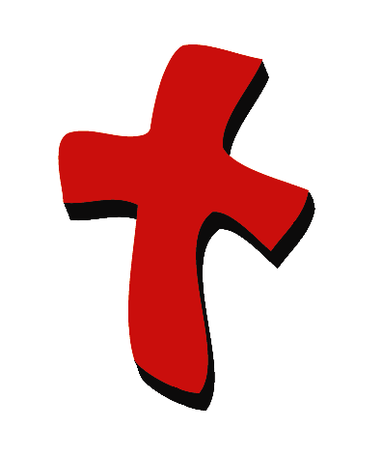 | 4  5 | Puppet Presentation  Bible Event | - Ting Ting puppet  - puppet-sized mirror  - Bible  - white sheet(s)  - rope or string  - room dividers (optional)  - clothespins or clips  - lamp, spotlight, or flashlight  - paper sun, moon, stars, waves, land, plants, flowers, fish, birds  - stuffed animals  - tape or sticky tack  - newsprint large enough to make an outline of a child  - black and red markers
Small Group Application   | 8  9  10  10  11 | Activity 1: “God Made Me Special Book” Craft  Activity 2: “Build-a-Friend” Snack  Activity 3: ”Speed Ball” Game  Activity 4: “Sandy Verse”  Prayer Time | Activity 1:  - two copies of the appendix per child  - scalloped craft scissors  - stapler  - markers  - pencils  Activity 2:  - two quarter size sweet bun or two ball shaped doughnuts per child  - five finger biscuits per child  - two chocolate chips per child  - one sliced cherry per child  - butter or icing  - one spoon per group  - serviettes  - paper cups  - water or juice  Activity 3:  - playground ball  Activity 4:  - Mahjong paper with Bible  verse written and  sandpaper letterings  - 10X30cm poster board with  sandpaper letterings
Large Group Wrap-Up   | 11  11 | Singing (Optional)  Lesson Review with Puppet Skit | - optional music for the lesson  - Xiao Er Puppet

Pre-Session Singing: (10 minutes)
Purpose: When all children are in one group singing, it is easy for new children to join the group and immediately get involved. When the music can be correlated, it introduces the theme for the day. Choose two to three songs and list them here.

Large Group Opening: (15 minutes)
Purpose: The puppet demonstrates the need that will be met in today’s lesson. The scripts are not written verbatim, but give a story line in which the group leader can interact with the puppet. The children are introduced to the take home point and then interact with God’s word, as they experience the Bible event.

Supplies needed: Ting Ting puppet; puppet-sized mirror; Bible; white sheet(s); rope or string; room dividers (optional); clothespins or clips; lamp, spotlight, or flashlight; paper sun, moon, stars, waves, land, plants, flowers, fish, birds; stuffed animals; tape or sticky tack; newsprint large enough to make an outline of a child; black and red markers

Puppet Presentation:
As Ting Ting comes out, she is looking into a handheld mirror and is frowning. The large group presenter asks her why she’s frowning. Ting Ting says she doesn’t like how she looks. She isn’t pretty enough; her hair is too yarny; her face is too blue; or… (name some other characteristic of your ministry’s puppet.)

The presenter expresses dismay that Ting Ting feels that way. He names one or two characteristics of Ting Ting that he admires. Then he tells Ting Ting that, more importantly, someone else thinks Ting Ting is gorgeous. With surprise, Ting Ting asks, “Who?” The presenter says that God thinks she is gorgeous.

The presenter goes on to explain that God made Ting Ting just the way He wants her. He made her to have (name several characteristics of your program’s puppet). God thinks Ting Ting is beautiful because God doesn’t make junk.

The presenter shares that, in today’s Bible event, the children are going to learn that God made people so different from all the rest of creation because God wanted to show how special people are to Him and that He created us to be loved by Him.

Now, when Ting Ting looks in the mirror, instead of seeing hair that is too yarny or a face that is too blue, she can see a child that God created to be special, a child that God loves and that is good.

The presenter teaches Ting Ting the take home point: *GOD MADE ME SPECIAL—Thank you God! The presenter says the first line; Ting Ting responds with the second line. After practicing it with Ting Ting a few times, the presenter practices it with the children.

Bible Event: Imagination Theater
Imagination Theater is an audience participation drama, in which the Bible event is told in creative fashion, using children as actors. The Imagination Box contains the Bible and other special props used for the drama. Begin by removing the Bible and explain that this is God’s word, which tells us of the wonderful deeds God has done. Then, remove an imaginary hat from the box and place it on your head. This is your Imagination Hat. Invite the children to put on their imagination hats, as well. They will use their imaginations to picture the events the Bible tells us about. Some will even use their imaginations to help act out these events. Distribute props to volunteer actors, as they are called forward at the beginning of the presentation.

Set up the stage to resemble the finished product of lesson #2’s large group event. It should look as follows:
- A sheet is hung between two room dividers or on a line or other apparatus that works for your program.
- Lights are turned down and a light is shining behind the sheet.
- Attached to the front of the sheet are land, waves, clouds, sun, moon, stars, trees, flowers, fish, and birds.
- Place several stuffed animals on the floor in front of the scene.

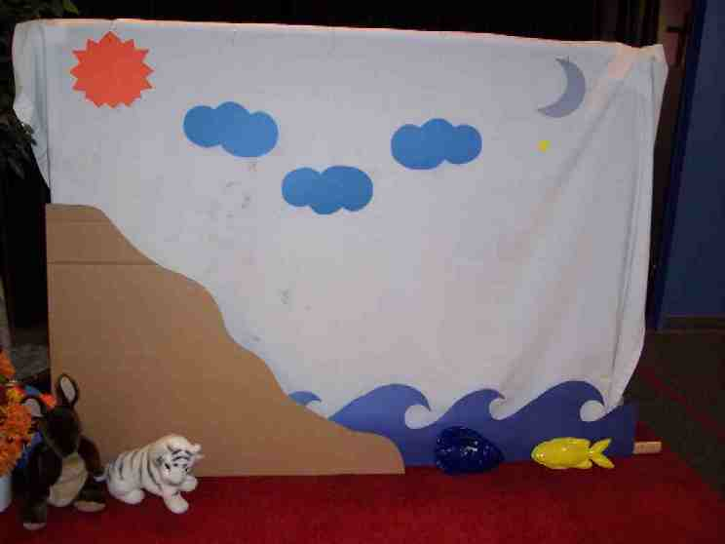

Before the large group presentation, perhaps during the singing, ask a boy to lie down on the newsprint. Outline the child and dismiss him back to large group with a notice that he will be called to help with the imagination station large group presentation later.

Quickly review last week’s lesson, saying:

Last week, we learned that God made everything—praise God. He made everything with only his words. He said, “Let there be light,” and there was light. God said, “Let there be water (point to the water). Let there be clouds (point to clouds). Let there be land (point to land).” And there was water, clouds, and land. God said, “Let there be flowers (point to flowers), trees (point to trees) and all kinds of living plants.” And there were flowers, trees, and all kinds of living plants. “God said, “Let there be fish (point to fish), birds (point to birds) and all kinds of animals” (point to stuffed animals). And it was so. By only His words, God created everything, everything except man. For there were still no people on the earth.

God looked at everything He had created and He said, “It is good.”

Now, it was time for God to create man and woman. He wanted people to be the best thing He made. He wanted to make them not just by speaking the words and making it happen, but in a very special way.

(Hold up the outline of the child.) God had a wonderful idea. He said, “I think I will make people and the people will be like me. The people won’t look like me on the outside, but on the inside they will. They will have a soul. (Draw a heart on the outline and begin to fill it in with red.) This means that in their heart, the deepest part of them, they will be able to have thoughts of me. They will be able to have a friendship with Me. They will be able to talk to me. And, above all else, they’ll be able to love Me and I will be able to love them. They will be perfect, just like I am.”

So God decided He would make man different than all the other animals. He would give him a soul. He would be made in the image of God.

Bring up the volunteer from earlier and lay him on the floor. Place the newsprint over him. Press the paper around the child as you describe how God created man:

God did not just say, “Let there be man.” He knelt down and took dust from the ground and began to shape it in His own hands. It’s just like shaping clay. God shaped it into the form of a man. He shaped arms and legs for the man, a head and a body, fingers, toes, and a face. He gave the man two eyes, two ears, one mouth and a head full of hair. Instead of just using words to form the man, He touched the man and shaped him.

After God shaped him, the man was ready to become alive. God did something else very special to make him come alive. He got right close to him and then blew right into the man’s lungs his own breath and this is what happened.

Remove the paper from the child and beckon him to stand up and take a bow. God made the first man named Adam. But then God also wanted to make the first woman. He wanted her also to have a soul, a heart that would love Him, to talk to Him and be friends with Him. She was perfect, just like God.

Do you think God made the woman just by saying a word? No! He caused Adam to fall into a very deep sleep. Then He reached into Adam and took out a rib. From that rib, God formed the woman, Eve. Just as God made Adam in a special way, He made Eve in a special way.

God made us special. He formed us in our mother’s bodies and created us to have souls, as well. We, too, can think about God, pray to God, and be friends with God. We, too, can love God and be loved by God.

Practice the take home point. You say the first part; the children respond with the second part. *GOD MADE ME SPECIAL—Thank you, God!

End with the following prayer:
Dear God,
Thank You for the best gifts.
Thank You for sending Jesus.
He’s our Savior and Your Son.
You made me special.
Thank You! Thank You! Thank You!
Amen.

Small Group Application: (30 minutes)
Purpose: Smaller groups enable children to develop closer relationships with adults and peers in the church. As you reinforce the take home point with a fun hands-on activity, discuss the Bible event. Be sure to repeat the take home point several times. Say the first part and have the children respond with the second phrase. Application questions help kids apply the take home point to their daily lives. Close this session by gathering your small group for prayer. Let the kids pray!

During small group application time, discuss the following questions and points:

How did God make all of His creation except people? (By only His words.)

How did God create the first man? The first woman? (He formed the man from clay and breathed into him the breath of life. He formed the first woman from the rib of the man.)

What does it mean to be created in God’s image? (We know right from wrong, we can think about God, talk to God and be friends with God. We can love God and be loved by God.)

I wonder how each of us is special… (Let the children name ways in which they are special, for example, their looks, their likes, their skills, their experiences, etc.)

Activity 1: “God Made Me Special Book” Craft
Supplies needed: two copies of the appendix per child; scalloped craft scissors; stapler;
markers; pencils

To make:
- Cut copies of the appendix along dotted lines using scalloped craft scissors.
- Staple together so the pages of the book are in the following order:

  - Front cover: “God Made Me Special Book”
  - Page 1: words—“There is only one of me.”
  - Page 2: oval picture frame.
  - Page 3: words—“There is no one else exactly like me.”
  - Page 4: blank
  - Page 5: words—“I was made to be special to God forever.”
  - Page 6: cross on a hill
  - Back page: blank line with words “My Name” underneath the line.

- On page 2, draw a picture of yourself inside the oval frame
- Color your fingers with markers and make fingerprints on page 4.
- Color the cross and the hill on page six.
- Write your name on the line on the back of the book.
- Use extra time to decorate the book with markers.

To discuss:

Read the book to the children and touch on the following points:

- God made no other child to be you. You are special.
- Even your fingerprints are different than everybody else’s fingerprints.
- Because God made us to live forever, He sent Jesus to die on the cross so we can live forever in heaven.

Practice the take home point. You say the first part; the children respond with the second part. *GOD MADE ME SPECIAL—Thank you, God!

Activity 2: “Build-a-Friend” Snack
Supplies needed: two quarter size sweet bun or two ball shaped doughnuts per child; five finger biscuits per child; two chocolate chips per child; one sliced cherry per child; butter or icing; one spoon per group; serviettes; paper cups; water or juice

To make:
- Put the butter container or a small bowl of icing in the middle.
- Poke one of the finger biscuit through the two quarter size sweet bun to make a head and a body.
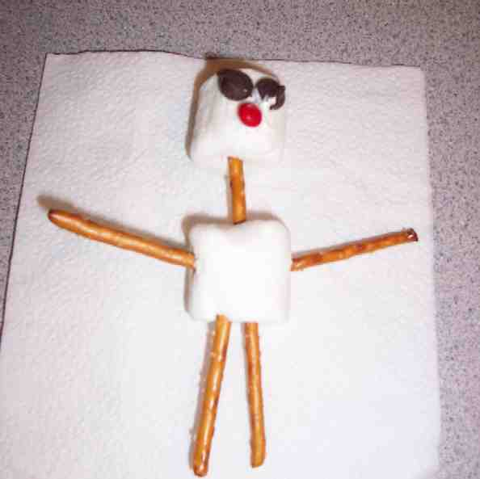
- Dip the bottoms of the chocolate chips and a sliced cherry into the butter and attach to the top bun to make eyes and a mouth.
- Stick the remaining finger biscuits into the bottom bun to make arms and legs for your build-a-friend.
- Eat!

To discuss:
You created your build-a-friend in a special way: by using buns and finger biscuits to form the body and chocolate chips and cherry to form the face.

God created Adam and Eve in a special way. He formed Adam from the clay and blew into him the breath of life. He created Eve from Adam’s rib. God made Adam and Eve perfect. He made them both in His image, to know right from wrong, to talk to God, be friends with God and to love and be loved by God.

God created us in a special way. He formed us inside our mothers’ bodies. After we were born, He continued to help us grow and develop. He made us in His image. While we are not perfect like Adam and Eve were when God first created them, because we sin and choose to do things that are wrong, God sent Jesus to die for our sins so that we can be forgiven. When we trust in the forgiveness Jesus gives us, God looks at us and says, “You are good. You are very, very good.”

Think of one or two ways in which God made you special.

Practice the take home point. You say the first part; the children respond with the second part. *GOD MADE ME SPECIAL—Thank You, God!

Activity 3: “Speed Ball” Game
Supplies needed: playground ball

To play:
- Brainstorm ways in which God made people different. For example: some people are tall, some are short. Some people have blond hair; others have black, brown or red hair. Some people have brown eyes, some blue, green, gold, or hazel. Some people like to eat ice cream; others like to eat pizza, apples, hot dogs, or popcorn. Some people are good at sports; others are good at drawing, singing, or inventing new things.
- Have the children stand in a circle.
- Give one child a ball. That child must name, by the count of five (use your fingers rather than voice to keep count), one thing that describes him (hair color, favorite television show, best friend, etc.)
- After naming a personal trait, the child passes the ball to another child in the circle, bouncing it on the ground in the process.
- The second child repeats the process; avoiding naming the trait that has already been named.
- Subsequent children keep playing in the same manner. If a child repeats a character trait, he or she has five more seconds to think of something new. A child who cannot think of a different trait by the second try must sit down.
- The last child standing wins.
To discuss:
God made each of us different and each of us is special. No two people are the same. Remember what Judy learned: God doesn’t make junk.

Practice the take home point. You say the first part; the children respond with the second part. *GOD MADE ME SPECIAL—Thank You, God!

Activity 4: “Sandy Verse”
Purpose: Help kids to memorize and keep scriptures at heart. Using creative ways to help kids enjoy learning the key verse and in small group setting.

Supplies needed: Mahjong paper with Bible verse written and sandpaper letterings; 10X30cm poster board with sandpaper letterings.

Memory Verse: Isaiah 43:1b - The Lord says: “I have called you by name, and you are mine.”

Memory Verse Learning:
Paste the pre-prepared mahjong paper on the wall or on an easel board. The letters G, C, H, B, I are cut and paste from sand paper. While memorizing with the children, allow the children to take turn to touch these sandpaper letters. Then have the group sit in circle. Remove the mahjong paper and bring out the poster board that has only the sandpaper letterings arranged in sequence but spaced out. (See diagram.) The children are to take turn touching the sandy letterings and quoting the memory verse. The poster board can be hung in the classroom so that children can touch the letters and review the Bible verse at any time on Sundays for coming two months.

I c n y m

Prayer Time:
Thank God for the ways in which He made you special.

Large Group Wrap-Up: (10 minutes)

Singing: (Optional)

Lesson Review with Puppet Skit:
Purpose: The crazy bird puppet, Xiao Er, struggles with learning the take home point. The leader shows an example of each small group application activity from this lesson and says the first phrase of the take home point. The kids respond with their phrase. They try to teach the puppet the take home point, but each time he confuses words or concepts. After three attempts, he finally gets it right and sings the correct take home point in a silly opera-like voice.

Xiao Er’s crazy responses:

Activity 1: “God made me a book.”
Activity 2: “Don’t eat your friends.”
Activity 3: “Don’t try to eat a rhinoceros.”

Welcome guests and thank them for attending.
Supplies:

Quantity ()

Large Group Opening:
- Ting Ting puppet
- puppet-sized mirror
- Bible
- white sheet(s)
- rope or string
- room dividers (optional)
- clothespins or clips
- lamp, spotlight, or flashlight
- paper sun, moon, stars, waves, land, plants, flowers, fish, birds
- stuffed animals
- tape or sticky tack
- newsprint large enough to make an outline of a child
- black and red markers
Small Group Application
Activity 1:
- two copies of the appendix per child
- scalloped craft scissors
- stapler
- markers
- pencils
Activity 2:
- two quarter size sweet bun or two ball shaped doughnuts per child
- five finger biscuits per child
- two chocolate chips per child
- one sliced cherry per child
- butter or icing
- one spoon
per group
- serviettes
- paper cups
- water or juice
Activity 3:
- playground ball
Activity 4:
- Sand paper; cut out letterings G, c, h, b, i
- Mahjong paper with Bible verse written and paste sandpaper letterings over the appropriate letters of the words.
- 10X30cm poster board with sandpaper letterings pasted like diagram above.
Large Group Wrap-Up
- Xiao Er puppet
- optional music

