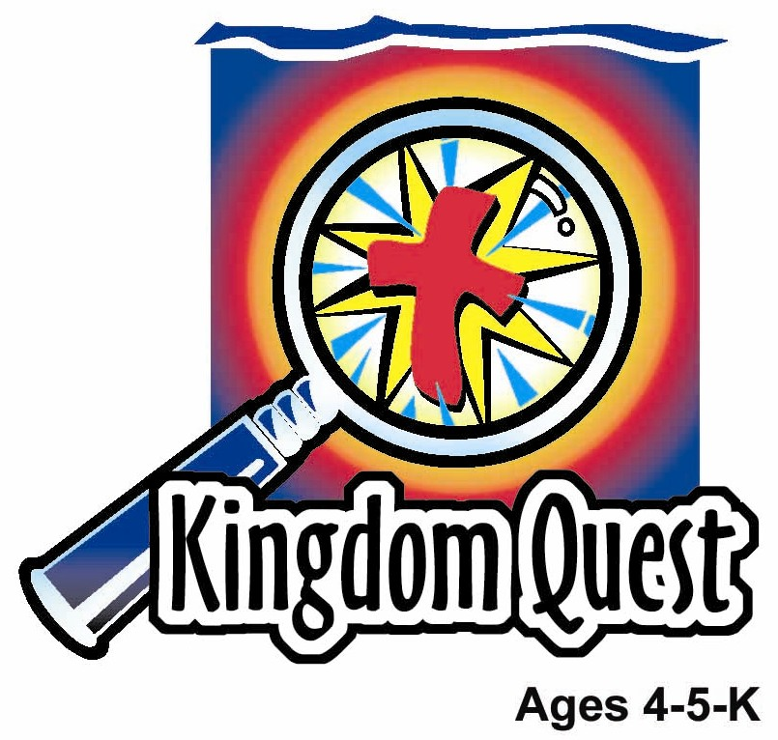
Date: ________________________
Series: Father’s Day Special (Jun-Aug)
Year 1, Lesson 4

God Made the First Family

Take Home Point: *GOD MADE MY FAMILY—Thank God for families.
*Repeat this phrase throughout the lesson. The leader will say the first part of the phrase (CAPS). The children respond with the second part of the phrase (italics).

Bible Event: Genesis 1:26-28a
Jesus Link: Because of Jesus, we belong to God’s family.

We will help children know:
- The story of how God created the first family.
- Families are a gift from God.
- Because Jesus died on the cross, we have a second family; we now belong to God’s family.

We will help the children feel:
- Thankful for their families, especially their fathers or those men who are like fathers to them.
- Appreciation to God for creating families.
- Secure in the knowledge that they belong to two families—their earthly family and the family of God.

We will help the children do:
- Participate in an imagination/story tell of the Bible event—God creating the first family.
- Make and eat a snack that reminds them of fathers and thank God for making fathers.
- Play a game, “Filling Dad’s Shoes Relay,” and talk about God giving us families to “fill his shoes” on earth.
THIS LESSON’S ROADMAP

DESTINATION | PAGE # | DISCOVERIES ON YOUR JOURNEY | SUPPLIES NEEDED
Large Group Opening  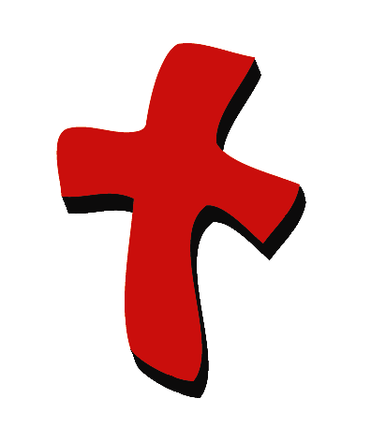 | 3  4 | Puppet Presentation  Bible Event | - Xiao Hung puppet  - shuttlecock  - Bible  - story props: purse, tie, apron, glasses without lenses, baseball cap, bandana
Small Group Application   | 6  6  7  8  8 | Activity 1:”Thank God for Dad Ribbon” Craft  Activity 2: “Nuts and Bolts” Snack  Activity 3: ”Filling Dad’s Shoes Relay” Game  Activity 4: “Connected Together”  Prayer Time | Activity 1:  - appendix copied on two colors of manila card  - two three-inch lengths of ribbon per child  - scissors (or cut out the craft in advance)  - glue  - pencil/pen  - tape and safety pins  Activity 2:  Choices of:  - Rocky sticks (nails)  - gold fish crackers (fishing)  - chocolate football wrappers (football)  - cream cracker (boards)  - serviettes  - paper cups  - water or juice  Activity 3:  - over-sized man shoes (one per team—can be bought at second-hand store)  - chairs  - table  - masking tape  Activity 4:  - a 5X8 Size of the paper  - scissors  - marker  - masking tape
Large Group Wrap-Up   | 9  9 | Singing (Optional)  Lesson Review with Puppet Skit | - optional music for the lesson  - Xiao Er Puppet

Pre-Session Singing: (10 minutes)
Purpose: When all children are in one group singing, it is easy for new children to join the group and immediately get involved. When the music can be correlated, it introduces the theme for the day. Choose two to three songs and list them here.

Large Group Opening: (15 minutes)
Purpose: The puppet demonstrates the need that will be met in today’s lesson. The scripts are not written verbatim, but give a story line in which the group leader can interact with the puppet. The children are introduced to the take home point and then interact with God’s word, as they experience the Bible event.

Supplies needed: Xiao Hung puppet; shuttlecock; Bible; story props: purse, tie, apron, glasses without lenses, baseball cap, bandana

Puppet Presentation:
Xiao Hung comes out carrying a shuttlecock. He asks the presenter why God made girls. Xiao Hung wanted to play baseball with Ting Ting before church but she was all dressed up for church and didn’t want to get dirty.

The presenter explains that God made both boys and girls because He knew the world needs both mommies and daddies, grandmas and grandpas, aunts and uncles, and, yes, brothers and sisters. God wanted there to be all different people in a family to do different things.

Xiao Hung remembers how his mom loves to draw with him and cook yummy chicken rice. His dad is teaching him how to fish and is a really good handyman. He can even set up a tent.

And, the presenter explains, Xiao Hung loves to play badminton all the time but Ting Ting only likes to play badminton when she is wearing play clothes. God made families to be made up of different people who have a different part in the family.

The presenter tells Xiao Hung that in today’s Bible event, the children are going to be learning how God made the first family. They are going to learn that God made their families and that we can thank God for families. The presenter tells Xiao Hung that today there is an extra reason to thank God for families. It is Father’s Day, a day to be thankful for our fathers or men who are like a father to us.

The presenter teaches Xiao Hung the take home point: *GOD MADE MY FAMILY—Thank You God for families. The presenter says the first line; Xiao Hung responds with the second line. After practicing it with Xiao Hung a few times, the presenter practices it with the children.

Bible Event: Imagination Theater
Imagination Theater is an audience participation drama, in which the Bible event is told in creative fashion, using children as actors. The Imagination Box contains the Bible and other special props used for the drama. Begin by removing the Bible and explain that this is God’s word, which tells us of the wonderful deeds God has done. Then, remove an imaginary hat from the box and place it on your head. This is your Imagination Hat. Invite the children to put on their imagination hats, as well. They will use their imaginations to picture the events the Bible tells us about. Some will even use their imaginations to help act out these events. Distribute props to volunteer actors, as they are called forward at the beginning of the presentation.

Pull six children on stage (three girls and three boys). Say:

Families are made up of many different people. (Give one of the girls a purse.) God made mothers, who buy clothes for us to wear, hug us when we are hurt, and give us good night kisses. (Put a tie on one of the boys.) God made fathers to play silly games with us, fix a bike when it’s broken, and teach us how to play ball. (Put an apron on a girl and the glasses on a boy.) God made grandmas and grandpas who are always happy when we visit and tell us how much we have grown. (Put the baseball cap on the last boy and the bandana on the head of the last girl.) God made brothers and sisters to play together, laugh together and to be friends with each other. God made aunts, uncles, and cousins, too.

God made families different. Some families are big. Some families are small. Some parents work outside the home. Some work in the home. Some grandparents live close by and some live faraway. Some children have lots of brothers and sisters and some children have no brothers or sisters.

Most important, God made families to work together, to play together, and to love one another. Families are so important, God made the first family in a special way.

God said “Let there be light and darkness. Let there be day and night. Let there be a sun, the moon and the stars. Let there be ground and water, plants and sky. Let there be fish, birds, insects and animals. Let the earth be filled with living things.”

But there still were no people.

Then God took some clay and shaped a man. He breathed into the man the breath of life. But the man was lonely. He was the only person. So God put the man to sleep and took a rib from the man. God took the rib and shaped it into a woman. And God made the woman alive. Then God woke the man up and showed him the woman and the man, Adam, was very happy. He named the woman Eve.

God told Adam and Eve they would have many children and fill the earth with people. That was the first family.

Soon, the first man and woman sinned. They did something God told them not to do. Now, all people are sinners, which keep us from God. That makes God sad. So, He sent Jesus to die on the cross and take the punishment for our sins. Now, the sins of all who trust in Jesus are forgiven and we are a part of God’s family.

Isn’t it wonderful that God gave us the gift of two families—our earthly family and God’s family? We can thank God for families.

Practice the take home point. You say the first part; the children respond with the second part. *GOD MADE MY FAMILY—Thank You God for families.
End with the following prayer:
Dear God,
Thank You for the best gifts.
Thank You for sending Jesus.
He’s our Savior and Your Son.
Thank You for the gift of family.
Thank You! Thank You! Thank You!
Amen.

Small Group Application: (30 minutes)
Purpose: Smaller groups enable children to develop closer relationships with adults and peers in the church. As you reinforce the take home point with a fun hands-on activity, discuss the Bible event. Be sure to repeat the take home point several times. Say the first part and have the children respond with the second phrase. Application questions help kids apply the take home point to their daily lives. Close this session by gathering your small group for prayer. Let the kids pray!

During small group application time, discuss the following questions and points:

How did God make the first family? (He created the first man, Adam, out of clay and breathed the breath of life into him. He then put Adam to sleep and took a rib from him, which He used to create Eve. God then told Adam and Eve they were to have children. Hint: you may need to break this down into smaller questions, for example, “What did God make Adam from?” Answer: clay)

How did God bring us into His family? (By sending Jesus to die for our sins so we could be adopted into His family.)

How is your family special? Your father? (Answers will vary but may include having a big family, doing a lot of things together as a family, dad plays ball with them, or daddy is really strong.)

I wonder how we can show our families we are thankful for them… Our fathers… (Answers will vary but may include helping around the house, telling them they are loved, or making a picture for them.)

Activity 1: “Thank God for Dad Ribbon” Craft
Supplies needed: appendix copied on two colors of manila card; two three-inch lengths of ribbon per child; scissors (or cut out the craft in advance); glue; pencil/pen; tape and safety pins

To make:
- Cut out the circles. (This step may be done before class for younger children or if time is limited.)
- Write your name on the circle that says ________’s Dad.
- Glue the smaller circle to the larger circle.
- Glue the ribbon to the backs of the circles so they hang down.
- Attach the pins to the back of the circles.

To discuss:

God loves us so much He gave us the gift of dads or people who are like dads to us. Why is your dad special? God also loves us so much that He sent Jesus to die for us so that our sins can be forgiven and we can be a part of God’s family. Now, we have the best dad of all—God our Father.

Practice the take home point. You say the first part; the children respond with the second part. *GOD MADE MY FAMILY—Thank You God for families.

Activity 2: “Nuts and Bolts” Snack
Supplies needed: Rocky sticks (nails); fish shaped biscuits (fishing); chocolate football wrappers (football); cream cracker (boards); serviettes; paper cups; water or juice

To make:
Let the children make a nuts and bolts snack that reminds them of fathers by choosing a few of each of the following snack items, or other items provided by your program:
- Rocky sticks (nails)
- Cream cracker squares (boards)
- Chocolate football wrapper (footballs)
- Fish shape biscuits (fishing)
To discuss:

Talk with the children about the ways the different snack items are reminders of fathers. Say:

Families are a gift from God. We can thank God for fathers, grandfathers, uncles and other men who are like dads to us. We can also thank God for our mothers, brothers, sisters, grandmas and grandpas and other people in our family. Who is someone special in your family? Why is that person special?

Did you know God has blessed us by giving us more than one family? We have our family on earth and, for all who love Jesus, we have God’s family that we belong to. Jesus died on the cross so our sins could be forgiven and we could be adopted into God’s family.

Practice the take home point. You say the first part; the children respond with the second part. *GOD MADE MY FAMILY—Thank You God for families.

Activity 3: “Filling Dad’s Shoes Relay” Game
Supplies needed: over-sized man shoes (one per team—can be bought at second-hand store); chairs; table; masking tape

To set up:
- Divide into two teams.
- Use the masking tape to create one line on the floor (for each team) that will serve as both the starting line and the finish line.
- Create an obstacle course using the chairs and table for the children to go over, under and around.
- Set the shoes at the starting line.

To play:
- At the count of three, the first child in line puts on the shoes, runs through the obstacle course and runs back to the starting line where he takes off the shoes and puts them on the line for the next child.
- The second child repeats the process and so on, until all the children are done.
- The first team to finish wins.

To discuss:
A dad’s shoes are too big for a child to fill. God is our Father and He wants someone to fill His shoes for us on earth. So He gives us our earthly fathers and those who are like fathers to us to love us and take care of us. We can thank God for fathers. (Be sensitive to children who may not have a father or a father who is not involved in their lives.)

Practice the take home point. You say the first part; the children respond with the second part. *GOD MADE MY FAMILY—Thank You God for families.

Activity 4: “Connected Together”
Purpose: Help kids to memorize and keep scriptures at heart. Using creative ways to help kids enjoy learning the key verse and in small group setting.

Supplies needed: a 5X8 Size of the paper; scissors; marker; masking tape

Memory Verse: 1 Corinthians 10:26 – “…The earth and everything on it belong to the Lord.” (NCV)

Memory Verse Learning:
The method of teaching this memory verse is like cut and clip. Take the prepared 5”X8” strip of pleated paper and cut the side that has a boy outline. Then cut the side that has the girl outline. Open out your cutting. Paste to a board or wall with masking tape. With a marker, write out the memory verse on the cutting as you teach.

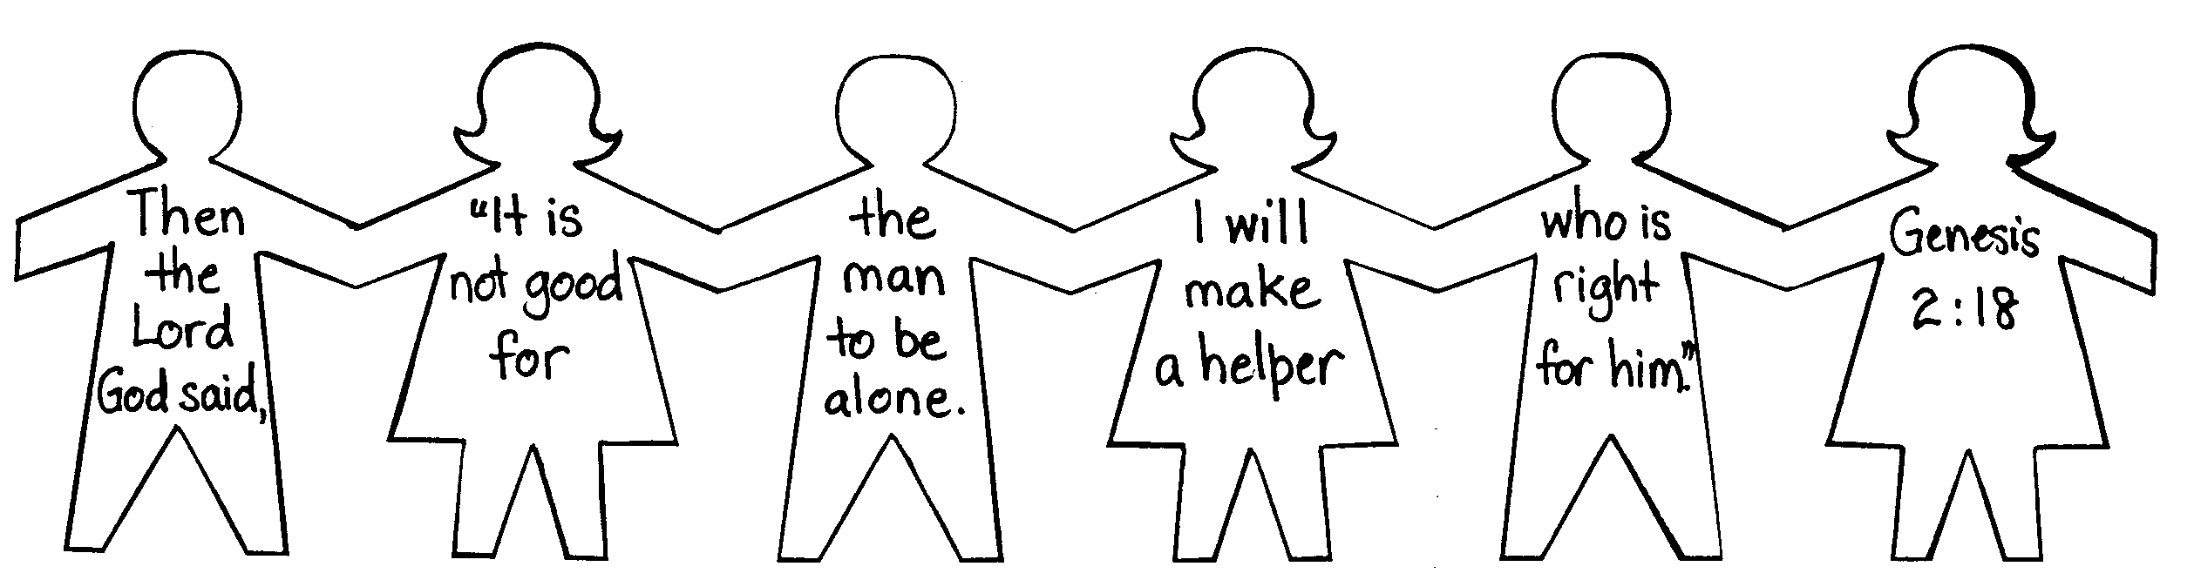

Divided the Bible verse like bleow:-
(1) 1 Cor. 10:26 (4) on it
(2) The earth (5) belong to
(3) and everything (6) the Lord.

Prayer Time:
Thank God for your father or someone who is like a father and other special people in your family.

Large Group Wrap-Up: (10 minutes)

Singing: (Optional)

Lesson Review with Puppet Skit:
Purpose: The crazy bird puppet, Xiao Er, struggles with learning the take home point. The leader shows an example of each small group application activity from this lesson and says the first phrase of the take home point. The kids respond with their phrase. They try to teach the puppet the take home point, but each time he confuses words or concepts. After three attempts, he finally gets it right and sings the correct take home point in a silly opera-like voice.

Xiao Er’s confused responses:

Activity 1: “Thank God for belly buttons.”
Activity 2: “Don’t put curry puffs in your nose.”
Activity 3: “Fill your dad’s shoes with jelly.”

Welcome guests and thank them for attending.
Supplies:

Quantity ()

Large Group Opening:
- Xiao Hung puppet
- shuttlecock
- Bible
- story props: purse, tie, apron, glasses without lenses, baseball cap, bandana

Small Group Application
Activity 1:
- appendix copied on two colors of manila card
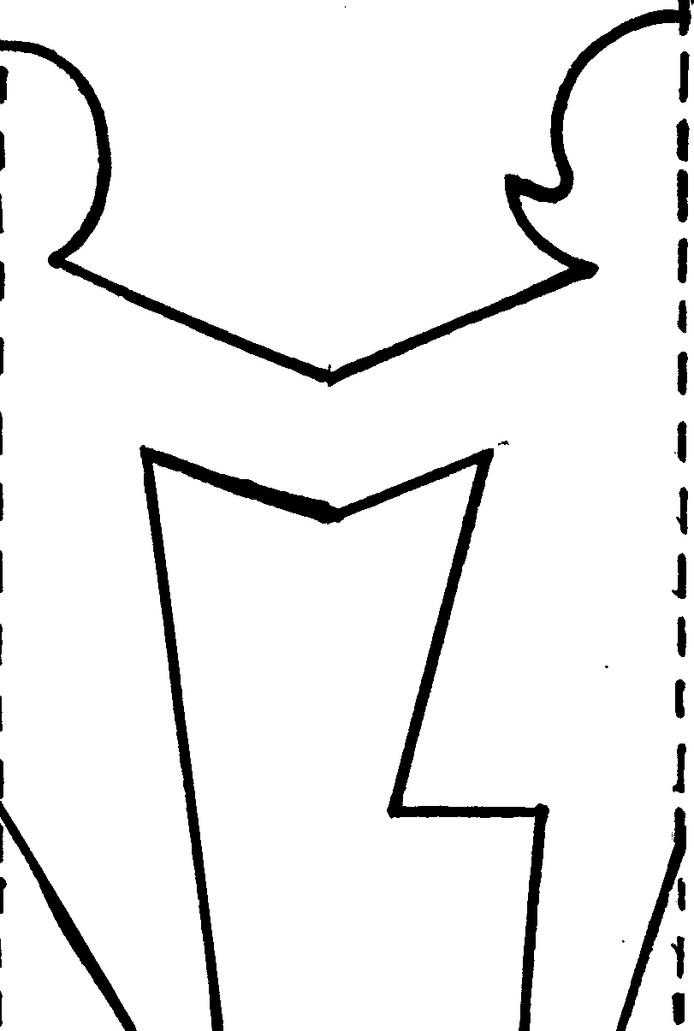
- two three-inch lengths of ribbon per child
- scissors (or cut out the craft in advance)
- glue
- pencil/pen
- tape and safety pins
Activity 2:
- Rocky sticks (nails)
- fish shaped biscuits (fishing)
- chocolate football wrappers (football)
- cream crackers (boards)
- serviettes
- paper cups
- water or juice
Activity 3:
- over-sized shoes (one per team—can be bought at second-hand store)
- chairs
- table
- masking tape
Activity 4:
- a 5X8 Size of the paper
(diagram provided)
- scissors
- marker
- masking tape

Large Group Wrap-Up
- Xiao Er puppet
- optional music

