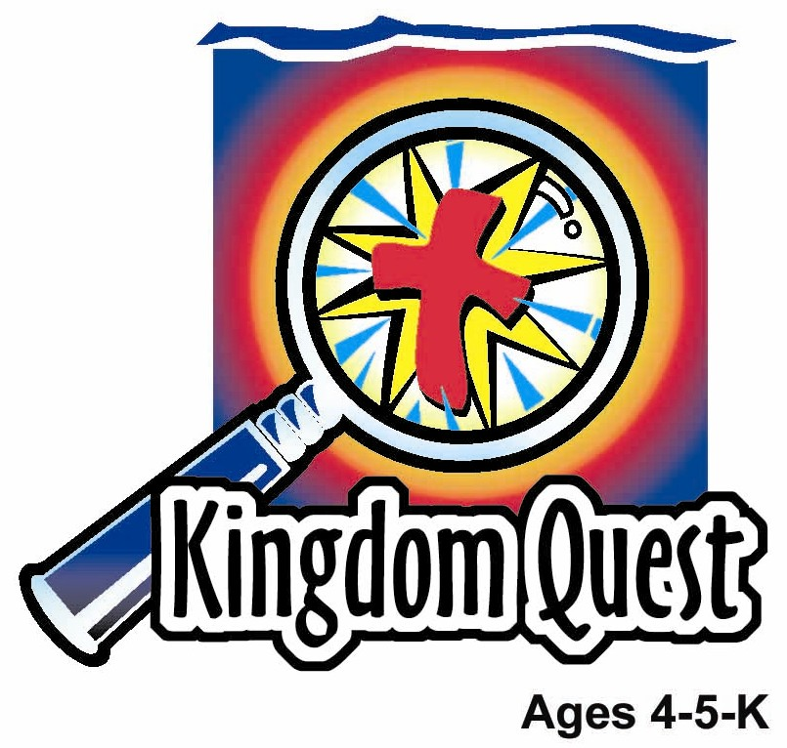
Date: ________________________
Series: God Made Everything (Jun-Aug)
Year 1, Lesson 5

God Rested

Take Home Point: *GOD BLESSED THE SEVENTH DAY—Spend time with God.
*Repeat this phrase throughout the lesson. The leader will say the first part of the phrase (CAPS). The children respond with the second part of the phrase (italics).

Bible Event: Genesis 2:2-3
Jesus Link: On our seventh day, we remember Jesus and find rest with God.

We will help children know:
- The Bible event of God resting on the seventh day after finishing the work of creation.
- God set a pattern for our lives: six days of work then a day to spend time with him.
- Spending time with God includes going to church, reading the Bible, praying, singing and worshiping God.

We will help the children feel:
- Special that God would set aside a day to spend time with him.
- Loved that God created everything.
- Thankful and refreshed to stop their “work” and enjoy a day of rest.

We will help the children do:
- Participate in the retelling of the six days of creation and learn that the seventh day was set apart and made special.
- Make and eat sundaes as a reminder that the seventh day is special.
- Play a game marking the seventh day as special.
THIS LESSON’S ROADMAP

DESTINATION | PAGE # | DISCOVERIES ON YOUR JOURNEY | SUPPLIES NEEDED
Large Group Opening   | 3  3 | Puppet Presentation  Bible Event | - Ting Ting  - book  - Bible  - Rocking or comfortable chair  - God Made Our World (Bible Big Book)
Small Group Application   | 5  5  5  6  6 | Activity 1: “ Book” Craft  Activity 2: “Celebration Sundaes” Snack  Activity 3: “Seven Is Special” Game  Activity 4: “Calendar Memory Verse”  Prayer Time | Activity 1:  - pre-made book  - colored pencils  Activity 2:  - ice cream  - ice cream cones  - sprinkles  - crushed peanuts  - ice cream scoop  - serviettes  Activity 3:  - seven 1.5-liter bottles  - ball (soccer ball, basketball, rubber playground ball)  - blue colour paper to cover six of the bottles  - red colour paper to cover one of the bottles  - marker (to write numbers on bottles)  - tape  - tit bits for prizes  - basket for prizes  Activity 4:  - old calendar with columns and Bible verse written on it
Large Group Wrap-Up   | 7  7 | Singing (Optional)  Lesson Review with Puppet Skit | - optional music for the lesson  - Xiao Er Puppet

Pre-Session Singing: (10 minutes)
Purpose: When all children are in one group singing, it is easy for new children to join the group and immediately get involved. When the music can be correlated, it introduces the theme for the day. Choose two to three songs and list them here.

Large Group Opening: (15 minutes)
Purpose: The puppet demonstrates the need that will be met in today’s lesson. The scripts are not written verbatim, but give a story line in which the group leader can interact with the puppet. The children are introduced to the take home point and then interact with God’s word, as they experience the Bible event.

Supplies needed: Ting Ting; book; Bible ; rocking or comfortable chair; God Made Our World (Bible Big Book); holder for book (easel)

Puppet Presentation:

Ting Ting is excited to be at church. She has a book taped to her hand. The large group presenter asks her what some of the things she enjoys about church are. Ting Ting says she enjoys learning about people in the Bible and what Jesus has done. She also enjoys singing, drawing, and making crafts. And, there are people that love her here. She loves to come to church and looks forward to coming. That means this day is special. The large group presenter shares with her and the boys and girls that they are going to find out in the Bible event today that God made a day special for spending time with him. Remember *GOD BLESSED THE SEVENTH DAY—Spend time with God.

Bible Event: Interactive Storytelling

Boys and girls, we’ve been learning the Bible event of how God made everything these last several days. I would like you to help me tell the story. To do this, I would like you to finish what I’m saying. I’ll start and say, “And it was” and you’ll finish by saying the word “good.” Let’s practice, “And it was...” (Indicate to the children to say the word “good.”)

In the beginning, God was there all by Himself. Then, God made the world. On the first day, He made light. And it was… (Indicate to the children to say the word “good.”). On the second day, He made the sky above and the waters below. And it was… (good). On the third day, He made the dry land appear and on it grew all the green grass, trees and flowers. And it was… (good). On the fourth day, He filled the sky with the sun, moon, and stars. And it was… (good). On the fifth day, he filled the oceans with fish and the sky with birds. And it was… (good). On the sixth day, He made all the animals and He made people, too. And it was…(good).

What did He make on the seventh day? Can anyone guess? God didn’t make anything. Instead, He decided to make the seventh day special. God set apart the seventh day for people to have rest and remember all that He has done. This is a day God said; “I will stop all My work and remember what I’ve done. It will be special for you, too. You stop doing your work and remember your time with Me.”

Bring a rocking or comfortable chair on stage, sit there with the big book God Made Our World and invite a child to come sit on your lap (if they wish) and read with you. As you do, ask the children who likes to be rocked by their parents and read to.

Would you come up and sit on my lap and rest with me? This is kind of nice, isn’t it? Do you like this kind of rest? I wonder how that is like going to church. Let’s read this book.

Read God Made Our World (Bible Big Book) to the children. It would be helpful to have someone else hold the book and turn the pages as you or he/she reads.

Continue to explain as the child is on your lap.

It usually feels very safe and comfortable to sit on your parents’ lap and have them read to you and explain things. This is also what God wants to do with us. But, we can’t see God. We can’t sit on His lap. So how do we set aside time where we can learn from Him? Where could this happen? He doesn’t have a big rocking chair that we can sit in. I wonder what we can do. Does anyone have a guess? Guesses may include devotions at home. Lead answers to coming to church. Yes, when we come church, we talk to God when we sing songs to Him and pray. He talks to us when we discover what the Bible says. This is like sitting on God’s lap and resting with Him. Remember *GOD BLESSED THE SEVENTH DAY - Spend time with God.

Small Group Application: (30 minutes)
Purpose: Smaller groups enable children to develop closer relationships with adults and peers in the church. As you reinforce the take home point with a fun hands-on activity, discuss the Bible event. Be sure to repeat the take home point several times. Say the first part and have the children respond with the second phrase. Application questions help kids apply the take home point to their daily lives. Close this session by gathering your small group for prayer. Let the kids pray!

Activity 1: “Book” Craft
Supplies needed: pre-assembled booklets from the appendix template; colour pencils

Have the children follow along as you read the book. When finished, have them color the pages. As you are coloring, talk about the ways you can spend time with God. Answers may include going to church, praying, singing, worshiping and listening to Bible stories.

God finished the work of creating everything and rested from all his work on the seventh day. God blessed the seventh day and made the seventh day holy. It is a day set aside to take time to enjoy his creations. On this special day, we bring him our prayers, songs, worship, and read the Bible.

Practice the take home point. *GOD BLESSED THE SEVENTH DAY - Spend time with God.

Activity 2: “Celebration Cones” Snack
Supplies needed: ice cream; wafer cones; ice cream scoop; optional – sprinkles, crushed peanuts; serviettes

To celebrate the special day of rest, make ice cream cones. You can also provide sprinkles and crushed peanuts.

It’s not often we get ice cream in Sunday school. Ice cream is a special treat. Often, it is served at special occasions like birthdays with family and friends. That’s why we wanted to celebrate the seventh day of creation with ice cream today, because God blessed and made the seventh day special.

Practice the take home point. *GOD BLESSED THE SEVENTH DAY - Spend time with God.

Activity 3: “Seven Is Special” Game
Supplies needed: seven 1.5-liter bottles; ball (soccer ball, basketball, rubber playground ball); blue colour paper to cover six of the bottles; red colour paper to cover one of the bottles; marker (to write numbers on bottles); tape; tit bits for prizes; basket for prizes

To set up:
- Cover six 1.5-liter bottles with blue colour paper and one two-liter bottle with red colour paper.
- Write the numbers one through six on the blue paper and the number seven on the red paper.
- Line up the seven bottles in a straight line across.
- Make a line with tape ten feet away from the bottles.
- Choose two children to be the pinsetters. Rotate, so everyone has a turn setting pins.

To play:
- Have children stand behind the line and take turns rolling a ball at the bottles.
- Every time the red one with the number seven written on it is knocked down, all the kids sit down and rest. Option: Every time the red bottle is knocked down, a prize is put in a basket for each child to receive at the end of the game.

This red pin is special, to help remind you that the seventh day is special.

Practice the take home point. *GOD BLESSED THE SEVENTH DAY - Spend time with God.

Activity 4: “Calendar Flip”
Purpose: Help kids to memorize and keep scriptures at heart. Using creative ways to help kids enjoy learning the key verse and in small group setting.

Supplies needed: old calendar with columns and Bible verse written on it

Memory Verse: 1 Corinthians 10:26 – “…The earth and everything on it belong to the Lord.” (NCV)

Memory Verse Learning:
Paste calendar on wall or whiteboard stand to learn and to memorize the Bible verse. Then called out the child’s birth date and have him/her recite the Bible verse.

Prayer Time:
Give thanks and praise to God for making the world and blessing the seventh day to spend time with Him.

Large Group Wrap-Up: (10 minutes)

Singing: (Optional)

Lesson Review with Puppet Skit:
Purpose: The crazy bird puppet, Xiao Er, struggles with learning the take home point. The leader shows an example of each small group application activity from this lesson and says the first phrase of the take home point. The kids respond with their phrase. They try to teach the puppet the take home point, but each time he confuses words or concepts. After three attempts, he finally gets it right and sings the correct take home point in a silly opera-like voice.

Xiao Er’s crazy responses:

Activity 1: “Don’t eat glitter.”
Activity 2: “Don’t eat a bookworm.”
Activity 3: “Don’t eat spinach with a hippopotamus on a slide.”

Welcome guests and thank them for attending.
Supplies:

Quantity ()

Large Group Opening:
- Ting Ting
- book
- Bible
- rocking or comfortable chair
- God Made Our World (Bible Big Book)

Small Group Application
Activity 1:
- pre-made book taken from the appendix
- colored pencils
Activity 2:
- ice cream
- ice cream cones
- sprinkles
- crushed peanuts
- ice cream scoop
- serviettes
Activity 3:
- seven 1.5-liter bottles
- ball (soccer ball, basketball, rubber playground ball)
- blue colour paper to cover six of the bottles
- red colour paper to cover one of the bottles
- marker (to write numbers on bottles)
- tape
- tit bits for prizes
- basket for prizes
Activity 4:
- old calendar with columns and Bible verse written on it (see page 11)

Large Group Wrap-Up
- Xiao Er puppet
- optional music
- 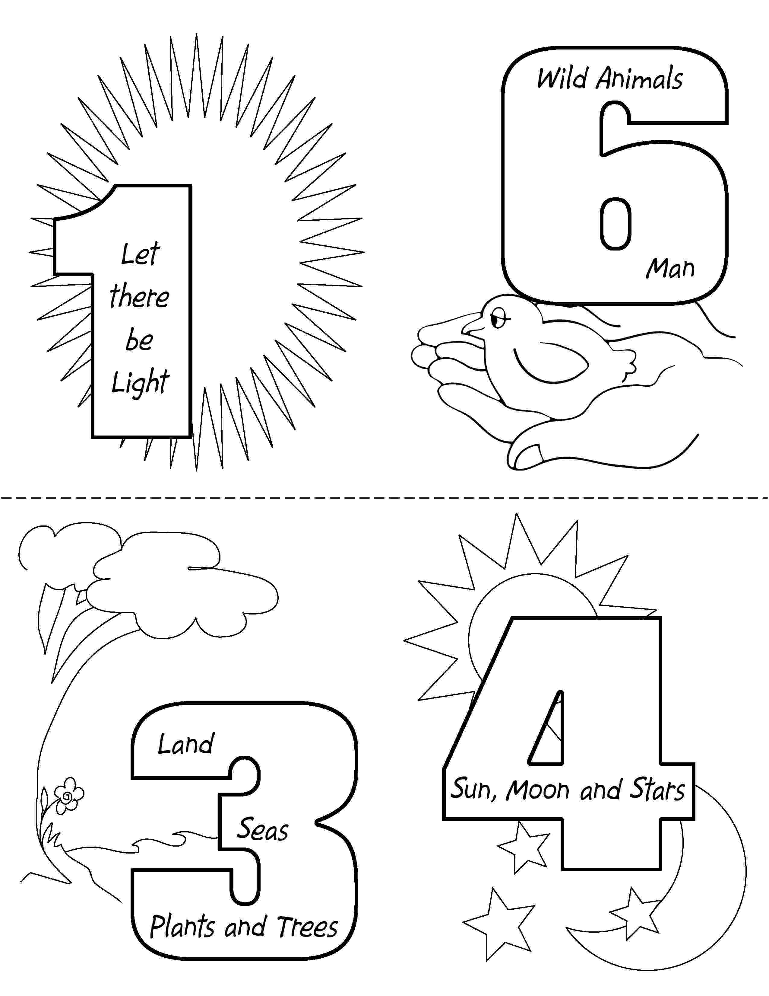

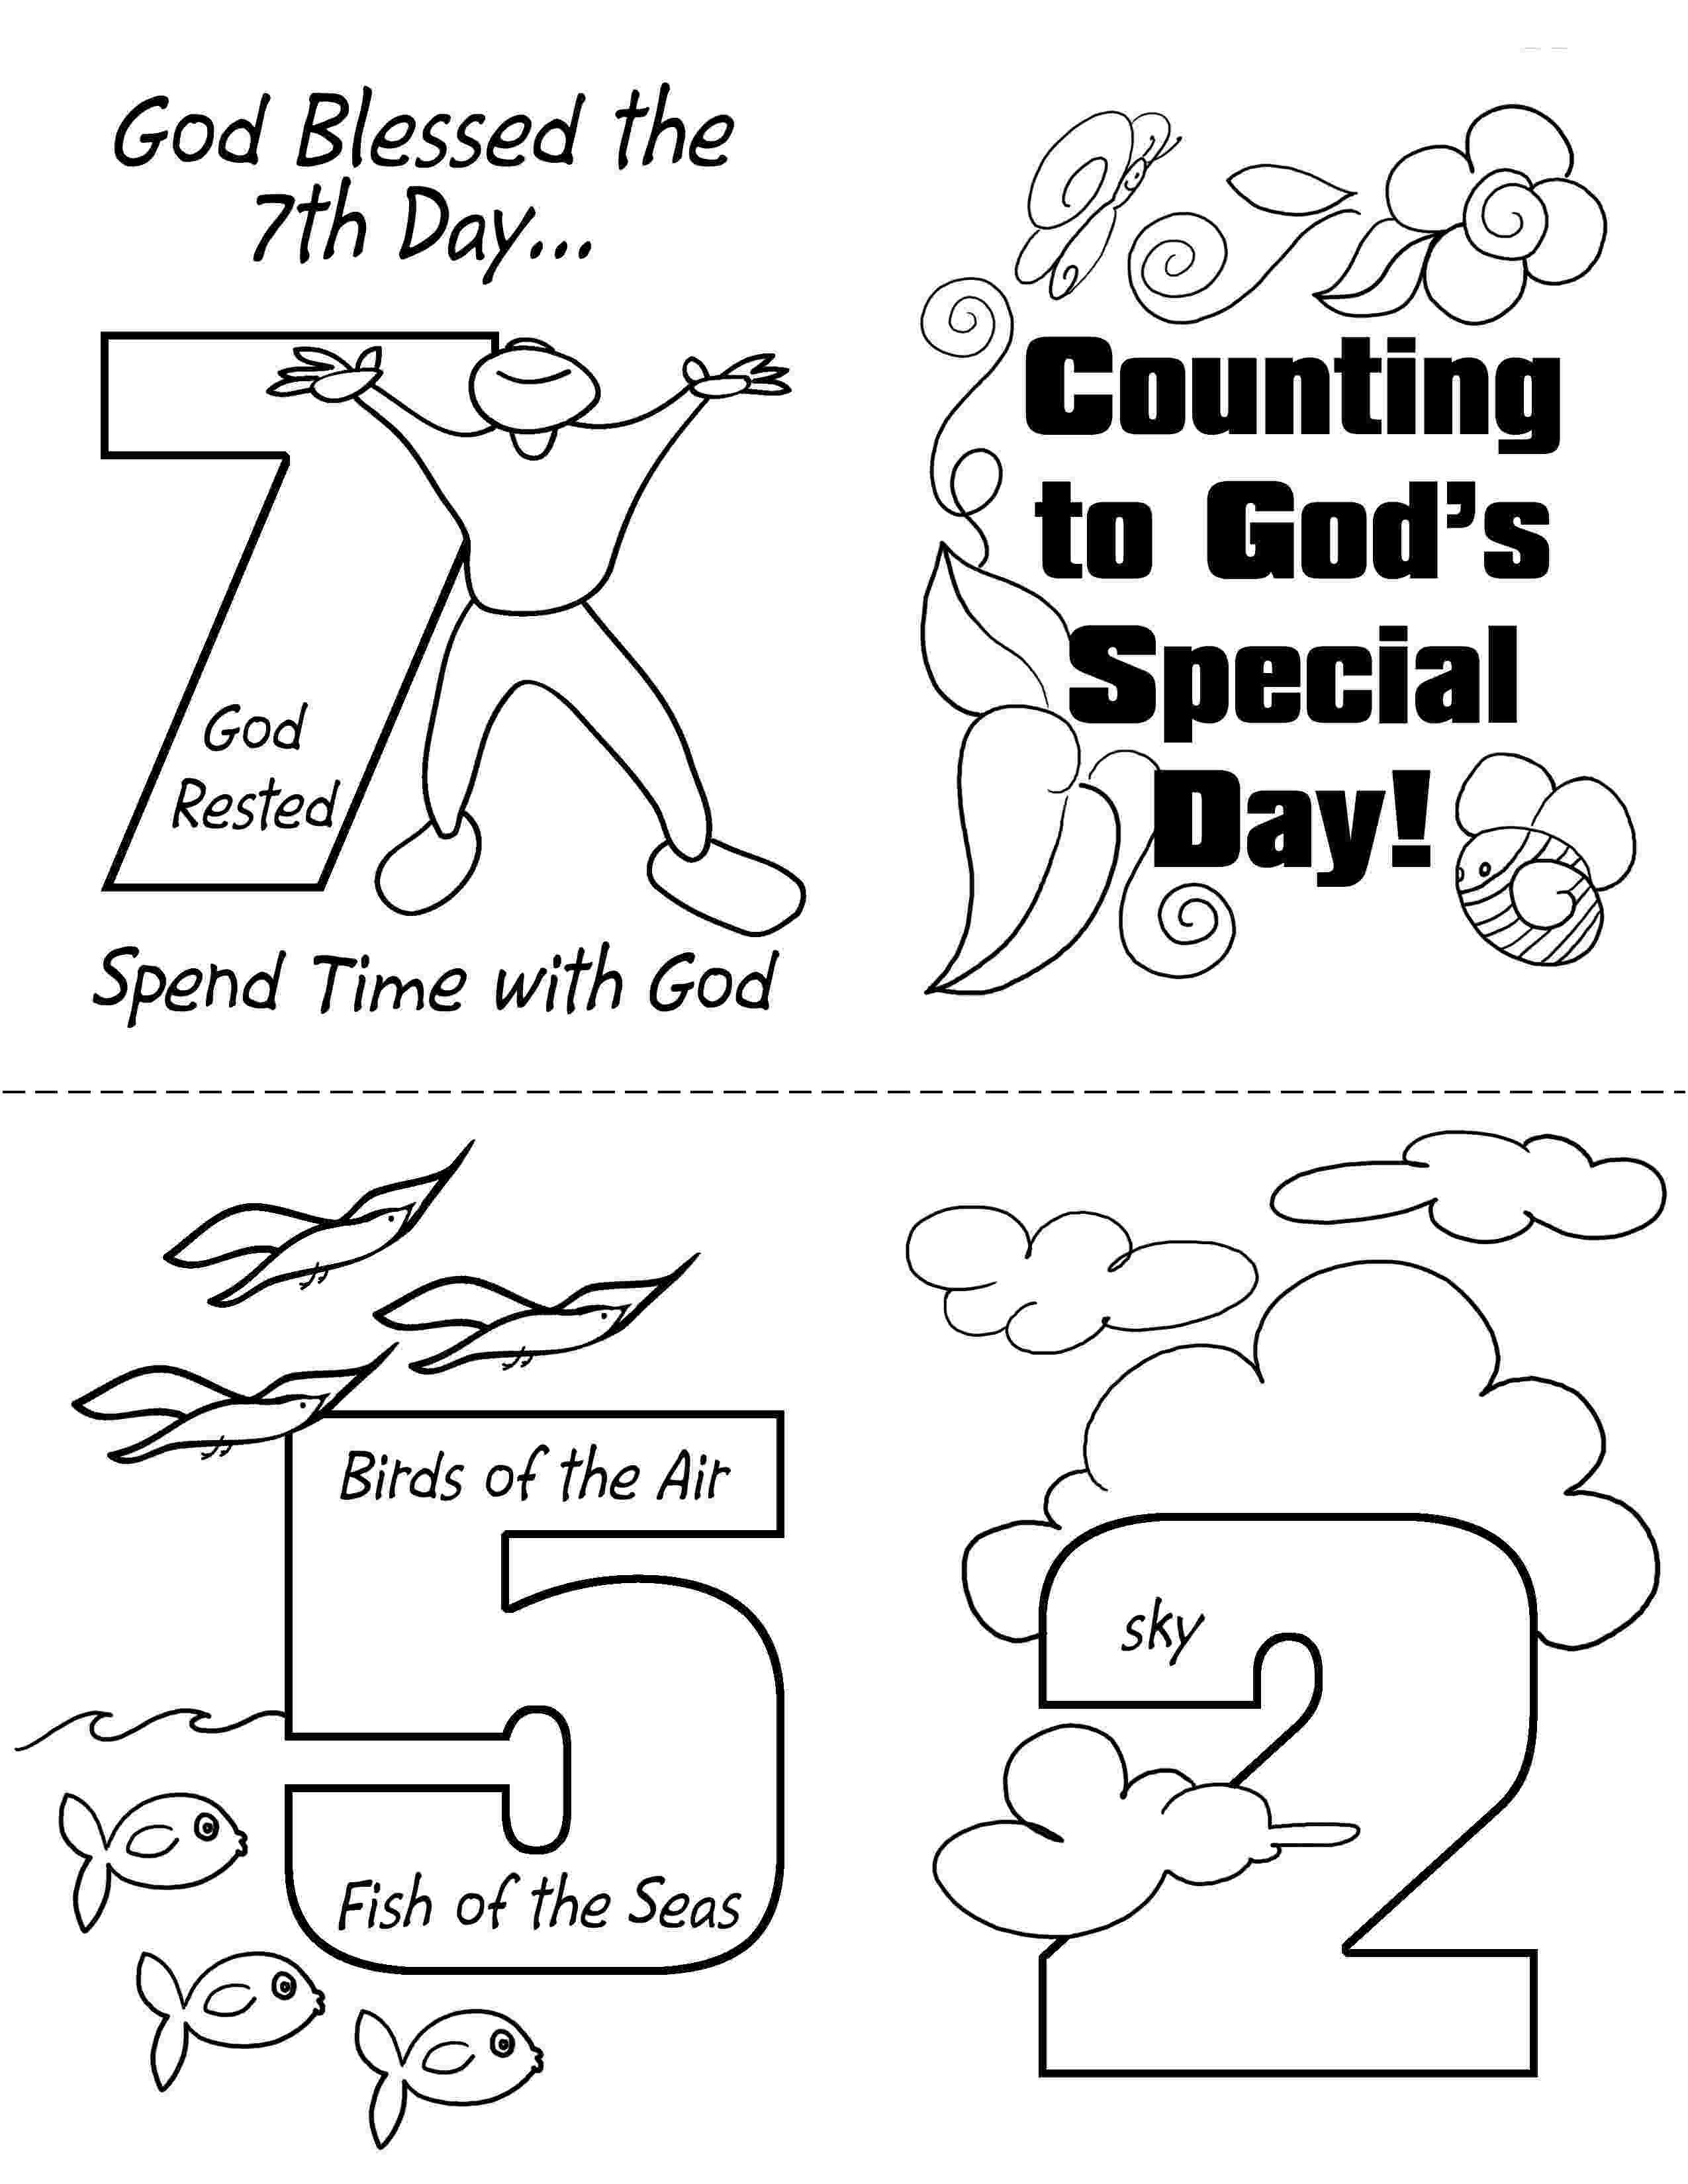

May 2006
The earth and

1 Cor. 10:26

on it belong

everything
to the Lord.

Sun | Mon | Tue | Wed | Thu | Fri | Sat
 | 1 | 2 | 3 | 4 | 5 | 6
7 | 8 | 9 | 10 | 11 | 12 | 13
14 | 15 | 16 | 17 | 18 | 19 | 20
21 | 22 | 23 | 24 | 25 | 26 | 27
 | 29 | 30 | 31

