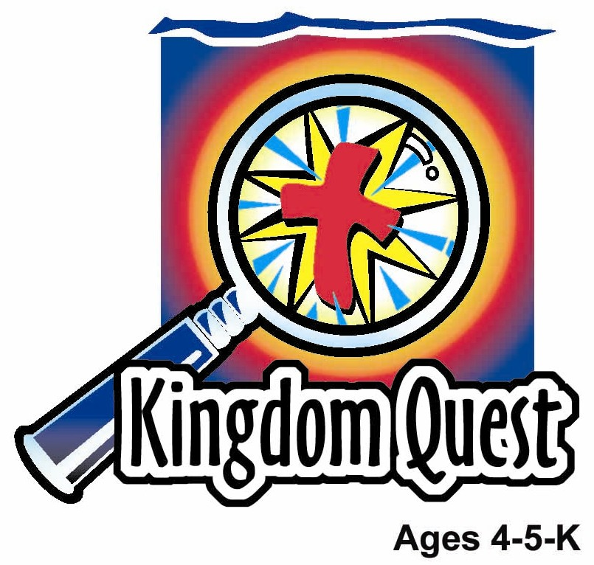
Date: ________________________
Series: God Made Everything (Jun-Aug)
Year 1, Lesson 6

People Care for God’s Earth

Take Home Point: *GOD GAVE US EVERYTHING - Take care of God’s stuff.
*Repeat this phrase throughout the lesson. The leader will say the first part of the phrase (CAPS). The children respond with the second part of the phrase (italics).

Bible Event: Genesis 1:28-30
Jesus Link: God takes care of us most of all by giving us Jesus.

We will help children know:
- God gave us everything.
- The best thing God gave us was Jesus.
- We take care of God’s creation in many ways. Some of those ways include being kind to animals, throwing away garbage, letting flowers grow at the park, and recycling.

We will help the children feel:
- Thankful to God for His gift of creation and His gift of Jesus.
- Desire to show appreciation to God for His gifts by taking care of God’s creation.
- Responsible to God for the care of His creation.

We will help the children do:
- Participate in an imagination theater telling of the Bible event.
- Make and eat a “Bird Seed Snack” and brainstorm ways to take care of God’s creation.
- Play a game, “Animal Scramble,” and review the creation and care of God’s animals.
THIS LESSON’S ROADMAP

DESTINATION | PAGE # | DISCOVERIES ON YOUR JOURNEY | SUPPLIES NEEDED
Large Group Opening  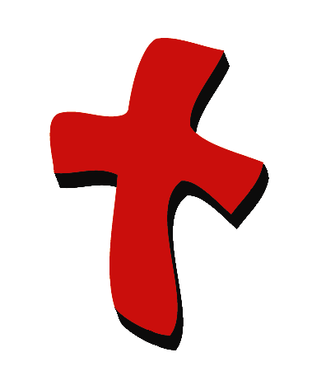 | 3  3 | Puppet Presentation  Bible Event | - Ting Ting puppet  - Imagination Box  - a mango  - Bible  Items from lesson 2:  - white sheet(s)  - rope or string  - room dividers (optional)  - clothespins or clips  - lamp, spotlight, or flashlight  - paper sun, moon, stars, waves, land, plants, flowers, fish and birds  - stuffed animals  - tape or sticky tack
Small Group Application   | 7  7  7  8  9 | Activity 1: “Bird Picture” Craft  Activity 2: “Bird Seed” Snack”  Activity 3: ”Animal Scramble” Game  Activity 4: “Bottled Verse”  Prayer Time | Activity 1:  - copies of appendix  - crayons  - bird seed  - glue  - snack-sized zipper bag  Activity 2:  - biscuits  - butter or melted sugar  - sesame seeds  - plastic plates  - serviettes  - plastic knives  Activity 3:  - chairs: one less than the number of children  Activity 4:  - 7 mineral bottles  - strips of paper  - magnets tied to a rod like  fishing rod  - paper clips
Large Group Wrap-up   | 9  9 | Singing (Optional)  Lesson Review with Puppet Skit | - optional music for the lesson  - Xiao Er Puppet

Pre-Session Singing: (10 minutes)
Purpose: When all children are in one group singing, it is easy for new children to join the group and immediately get involved. When the music can be correlated, it introduces the theme for the day. Choose two to three songs and list them here.

Large Group Opening: (15 minutes)
Purpose: The puppet demonstrates the need that will be met in today’s lesson. The scripts are not written verbatim, but give a story line in which the group leader can interact with the puppet. The children are introduced to the take home point and then interact with God’s word, as they experience the Bible event.

Supplies needed: Ting Ting puppet; Imagination Box; a mango; Bible

Puppet Presentation:
Ting Ting comes in carrying a mango. She is happy. She got to eat fresh mango, right from her garden this morning before church. Mangoes are her absolute favorite fruit.

The large group presenter asks Ting Ting if she knew it is her job to take care of mango tree.

Ting Ting says no, it’s not her job. Her jobs are to pick up her bedroom, make her bed and help set the table for dinner.

The large group presenter explains that God gave everybody the job of taking care of His creation, including mango trees. In today’s Bible event, the children are going to learn that when God made Adam and Eve, He put them in a garden and told them to take care of the garden. He also wants us to take care of the earth, the plants, animals, and all of his creation. How can Ting Ting help take care of the mango tree?

Ting Ting thinks for a moment and then gives a couple ideas. She can water the mango tree and shoo the birds away. She can also help pick up the mangoes when her daddy plucks them as they ripens and, of course, help eat them!

The presenter likes Ting Ting’s ideas.

The presenter teaches Ting Ting the take home point: *GOD GAVE US EVERYTHING—Take care of God’s stuff! The presenter says the first line; Ting Ting responds with the second line. After practicing it with Ting Ting a few times, the presenter practices it with the children.

Bible Event: Imagination Theater
Imagination Theater is an audience participation drama, in which the Bible event is told in creative fashion, using children as actors. The Imagination Box contains the Bible and other special props used for the drama. Begin by removing the Bible and explain that this is God’s word, which tells us of the wonderful deeds God has done. Then, remove an imaginary hat from the box and place it on your head. This is your Imagination Hat. Invite the children to put on their imagination hats, as well. They will use their imaginations to picture the events the Bible tells us about. Some will even use their imaginations to help act out these events. Distribute props to volunteer actors, as they are called forward at the beginning of the presentation.

Supplies needed: white sheet(s); rope or string; room dividers (optional); clothespins or clips; lamp, spotlight, or flashlight; paper sun, moon, stars, waves, land, plants, flowers, fish and birds; stuffed animals; tape or sticky tack

Set up the stage to resemble the finished product from lesson 2’s large group event. It should look as follows:
- A sheet is hung between two room dividers or on a line or other apparatus that works for your program.
- Lights are turned down and a light is shining behind the sheet.
- Attached to the front of the sheet are land, waves, clouds, sun, moon, stars, trees, flowers, fish, and birds.
- Place several stuffed animals on the floor in front of the scene.

Hold up the Bible and quickly review the creation, saying:

The Bible tells us that God made everything—praise God. He made everything with only His word. He said, “Let there be light,” and there was light. God said, “Let there be water (point to the water). Let there be clouds (point to clouds). Let there be land (point to land).” And there was water, clouds, and land. God said, “Let there be flowers (point to flowers), trees (point to trees) and all kinds of living plants.” And there were flowers, trees, and all kinds of living plants. “God said, “Let there be fish (point to fish), birds (point to birds) and all kinds of animals” (point to stuffed animals). And it was so. By only His word, God created everything, everything except man. There were still no people upon the earth.

God looked at everything He had created and He said, “It is good.”

But God wasn’t done creating. God formed man in a special way. He took the dirt of the ground and formed it into the shape of a man and breathed the breath of life into him. The first man was named Adam.

God still wasn’t done creating, though. He still had not made woman. So He put the man to sleep and He took a rib from him. From that rib He formed the first woman. Her name was Eve.

God put the man and woman, Adam and Eve, in a beautiful garden called Eden. The garden was filled with all of God’s animals—the flyers, the hoppers, the runners and the swimmers, birds and beasts of all shape, sizes and colors. God filled the garden with green grass, tall trees, bright colored flowers and flowing rivers.

Now God was done with His creation. He looked at it and said, “It is good. It is very, very good.”

God was done with His work, but man was not. For God gave man some work to do. Today, we will learn about that work.

Call up several children. God gave Adam and Eve the job of taking care of His creation. One of the ways Adam took care of the garden was by naming all of the animals. He named a colorful, winged insect “butterfly.” He called wiggly swimmers “fish.” And He named the hopping pouched animal “kangaroo.”

Now, I am going to whisper the names of other animals into these children’s ears and they will make the sound of that animal. You are to guess the names of the animals whose sounds they are making.

Name several animals into the helpers’ ears and have them make the animals’ noises. The children in the audience can guess which animals they are demonstrating. Some good animals to use are birds, bees, cows, dogs, lions, pigs and sheep.

Very good, boys and girls!

Adam and Eve took good care of the animals and of the plants in the garden. The Bible doesn’t tell us exactly how they took care of the garden. Maybe they watered the plants, fed the animals and picked the fruit and vegetables. But we do know that Adam and Eve enjoyed their work. God had given them a wonderful gift and they enjoyed showing God they were thankful by taking care of that gift—God’s creation.

God has also given us the gift of creation. He tells us to also take care of His gift. We can take care of the earth by being kind to animals, picking up litter and throwing away garbage, leaving flowers at the park for others to enjoy, and reusing things like water bottles and paper.

We want to take care of God’s creation, not only because it is His gift, but also because God has given us another gift. He has taken care of us by sending Jesus to die for our sins. God loves us and gives us His gifts. We love Him back and show Him our love by taking care of His gifts.

Practice the take home point. You say the first part; the children respond with the second part. *GOD GAVE US EVERYTHING—Take care of God’s stuff!

End with the following prayer:
Dear God,
Thank You for the best gifts.
Thank You for sending Jesus.
He’s our Savior and Your Son.
You made me special.
Thank You! Thank You! Thank You!
Amen.

Small Group Application: (30 minutes)
Purpose: Smaller groups enable children to develop closer relationships with adults and peers in the church. As you reinforce the take home point with a fun hands-on activity, discuss the Bible event. Be sure to repeat the take home point several times. Say the first part and have the children respond with the second phrase. Application questions help kids apply the take home point to their daily lives. Close this session by gathering your small group for prayer. Let the kids pray!

During small group application time, discuss the following questions and points:

What gift did God give Adam and Eve? (His creation—the plants, the animals, the earth and the water.)

What job did God give to Adam and Eve? (Taking care of the garden, including the animals.)

What gifts did God give us? (All of creation and His Son Jesus to die for us.)

I wonder how we can take care of God’s creation… (Answers will vary but may include feeding birds, picking up garbage, and recycling.)

Activity 1: “Bird Picture” Craft
Supplies needed: copies of appendix; colour pencils; bird seed; glue

To make:
- Color the bird.
- Glue on birdseed.
- Put some birdseed in a plastic bag to take home and scatter outside for the birds.

To discuss:

One way we can take care of God’s stuff is by feeding the birds. I wonder how else we can take care of God’s creation. (Stress that we do not only take care of God’s stuff by taking care of nature, but also by taking care of toys, bedrooms, and other “stuff” we own, because everything we have is a gift from God.)

The best gift God gave us is the gift of Jesus to die on the cross so our sins can be forgiven. By sending Jesus, God took care of us.

Practice the take home point. You say the first part; the children respond with the second part. *GOD GAVE US EVERYTHING—Take care of God’s stuff!

Activity 2: “Bird Seed Snack”
Supplies needed:

To make:
- Spread butter or melted sugar on the biscuit..
- Sprinkle sesame seeds on the biscuit.
- Eat!

To discuss:

Review the Bible event and discuss ways to take care of God’s stuff.

Practice the take home point. You say the first part; the children respond with the second part. *GOD GAVE US EVERYTHING—Take care of God’s stuff!

Activity 3: “Animal Scramble” Game
Supplies needed: chairs: one less than the number of children

To play:
- Put enough chairs in a circle for every child but one.
- Have the children sit on the chairs, except for the extra child, who stands in the middle.
- Assign an animal to each child. The animals can all be different or, if your group is larger, two or more children can be assigned to the same animal. Be sure to remember which animals you have assigned.
- Name two or more animals. The children whose animals are named must get up and run to the open chair, while the child in the middle does the same. The child who does not get a chair stays in the middle.
- Repeat, using different animals.
- Occasionally say, “Animal Scramble!” at which time all children must change spots.
- Play as time and interest allows.

To discuss:

Animals are a gift from God. How many of you have pets? (Let the children tell about their pets.) How can we take care of pets? How can we take care of other animals?

When God told Adam and Eve to take care of the garden, He did not mean for work to be hard or boring. He meant for all people to enjoy work. But, because of sin, work has become hard sometimes. God loves us enough to have even answered that sin problem. He sent Jesus to die for our sins. Now, when we someday go to heaven, we will have jobs to do, but they will never be hard. Just as we enjoy doing some of our work now, in heaven we will have fun doing all of our jobs.

Taking care of God’s stuff is a way to show him we love Him and we are thankful for His gifts.

Practice the take home point. You say the first part; the children respond with the second part. *GOD GAVE US EVERYTHING—Take care of God’s stuff!

Activity 4: “Bottled Verse”
Purpose: Help kids to memorize and keep scriptures at heart. Using creative ways to help kids enjoy learning the key verse and in small group setting.

Supplies needed: 7 mineral bottles; strips of paper; magnets tied to a rod like fishing rod; paper clips

Memory Verse: 1 Corinthians 10:26 – “…The earth and everything on it belong to the Lord.” (NCV)

Memory Verse Learning:
The Bible verse is break up into seven parts and written on the strips of paper. The strips are folded and held by the paper clips. They are then stuffed into the mineral bottles. Each student is given one bottle during activity time to fish out the strip of paper. The teacher then help them arranged the strips of paper according to the Bible verse and at the same time learn the Bible verse.

Prayer Time:
Thank God for His gifts of creation and for His gift of Jesus. Ask Him to help you take care of His stuff.

Large Group Wrap-Up: (10 minutes)

Singing: (Optional)

Lesson Review with Puppet Skit:
Purpose: The crazy bird puppet, Xiao Er, struggles with learning the take home point. The leader shows an example of each small group application activity from this lesson and says the first phrase of the take home point. The kids respond with their phrase. They try to teach the puppet the take home point, but each time he confuses words or concepts. After three attempts, he finally gets it right and sings the correct take home point in a silly opera-like voice.

Xiao Er's crazy responses

Activity 1: “Now give me that birdseed.”
Activity 2: “Didn’t you hear me the last time?”
Activity 3: “Don’t kiss a buffalo on the nose.”

Welcome guests and thank them for attending.

Supplies:

Large Group Opening:
- Ting Ting puppet
- a mango
- Bible
- Items from lesson 2:
  - white sheet(s)
  - rope or string
  - room dividers (optional)
  - clothespins or clips
  - lamp, spotlight, or flashlight
  - paper: sun, moon, stars, waves, land, plants, flowers, fish and birds
  - stuffed animals
  - tape or sticky tack

Small Group Application
Activity 1:
- copies of appendix
- colour pencils
- bird seed
- glue
- plastic bags
Activity 2:
- biscuits
- butter or melted sugar
- sesame seeds
- plastic plates
- serviettes
- plastic knives
Activity 3:
- chairs: one less than the number of children
Activity 4:
- 7 mineral bottles
- strips of paper
- magnets tied to a rod like fishing rod
- paper clips

Large Group Wrap-Up
- Xiao Er puppet
- optional music
