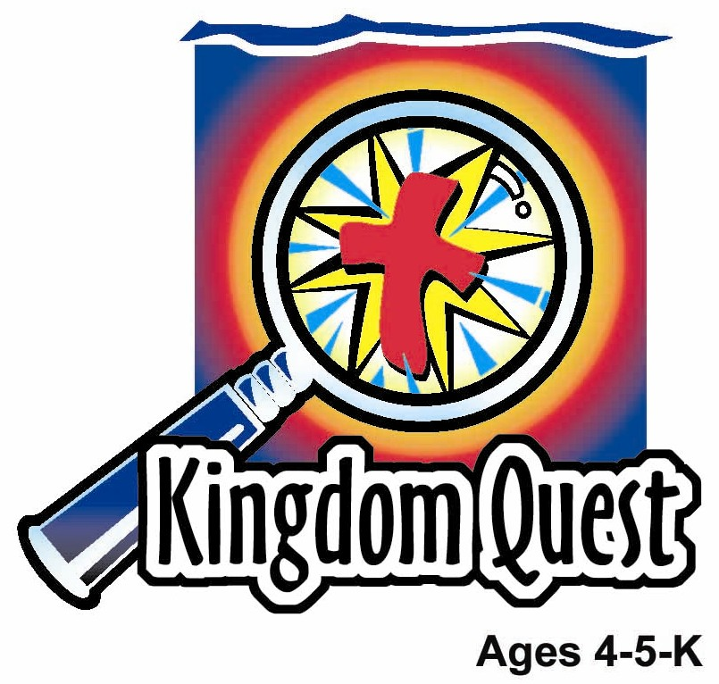
Date: _____________________
Series: God Saves and Protects Us (Jun-Aug)
Year 1, Lesson 8

Cain and Abel

Take Home Point: *GOD SEES OUR SIN, BUT—God still loves us.
*Repeat this phrase throughout the lesson. The leader will say the first part of the phrase (CAPS). The children respond with the second part of the phrase (italics).

Bible Event: Genesis 4:1-16, 25
Jesus Link: God loves us enough to send Jesus to forgive our sin.

We will help children know:
- The story of Cain and Abel.
- Even after Cain killed Abel, God loved him and protected him.
- Even after we sin, God still loves us and protects us through His Son Jesus’ death on the cross.

We will help the children feel:
- Repentant for their sins.
- Reassured that, because of Jesus, they are forgiven.
- Eager to turn from sin and to righteousness.

We will help the children do:
- Listen to a storyteller retell the Bible event of Cain killing his brother Abel out of jealousy, and God still protecting Cain.
- Make and eat a “Healthy Heart Snack” and learn that God gives us healthy hearts by loving us even when we sin and sending His Son Jesus to rescue us from our sin sickness.
- Play a game, “Messy Hearts,” and learn that sin makes our hearts messy but Jesus cleans our hearts.
THIS LESSON’S ROADMAP

DESTINATION | PAGE # | DISCOVERIES ON YOUR JOURNEY | SUPPLIES NEEDED
Large Group Opening  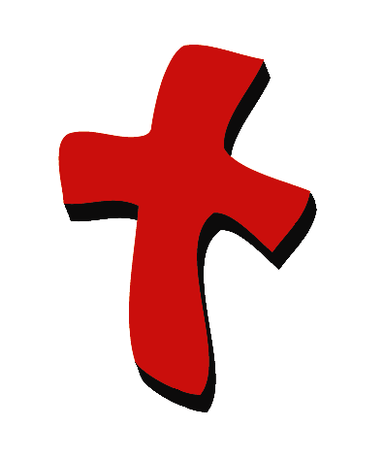 | 3  4 | Puppet Presentation  Bible Event | - Xiao Hung puppet  - cup  - Bible  - mystery box  - farmer and shepherd’s props  - red “popset” paper heart on white paper  - white manila card heart on white paper  - black crayon
Small Group Application   | 6  7  8  8  9 | Activity 1: “Broken Heart Picture” Craft  Activity 2: “Healthy Hearts” Snack  Activity 3: ”Heart Balloon Pop Up” Game  Activity 4: “Musical Marking”  Prayer Time | Activity 1:  - copy appendix on red paper  - scissors  - tape  - colour pencils  Activity 2:  - serviettes  - ballpoint pen  - circle-shaped oat cereal  - raisins or small healthy snacks  Activity 3:  - inflated heart-shaped balloon for every group -Option: regular large balloon with a heart drawn on it  - one dark water based marker  - wet wipe with cross made with permanent marker Option: paper towel with cross  Activity 4:  - whiteboard or mahjong paper with Bible verse written  - one balloon  - player and cd  - stickers
Large Group Wrap-Up   | 9  9 | Singing (Optional)  Lesson Review with Puppet Skit | - optional music for the lesson  - Xiao Er Puppet

Pre-Session Singing: (10 minutes)
Purpose: When all children are in one group singing, it is easy for new children to join the group and immediately get involved. When the music can be correlated, it introduces the theme for the day. Choose two to three songs and list them here.

Large Group Opening: (15 minutes)
Purpose: The puppet demonstrates the need that will be met in today’s lesson. The scripts are not written word for word, but give a story line in which the group leader can interact with the puppet. The children are introduced to the take home point and then interact with God’s word as they experience the Bible event.

Supplies needed: Xiao Hung puppet; cup; Bible; mystery box; farmer and shepherd’s props; red “popset” paper heart on white paper; white manila card heart on white paper; black crayon

Puppet Presentation:
Xiao Hung comes out carrying a cup and with his head down. He is visibly upset. The large group presenter asks Xiao Hung what the problem is. Xiao Hung asks the presenter to look in his cup. The presenter peeks in and screams, “Aaack!” Xiao Hung responds, “That’s exactly what my mom said.”

Xiao Hung explains that inside his cup is his pet worm, Herman. His sister Ting Ting gave his mother a dandelion bouquet and his mother hugged her, kissed her, and said, “What a sweet thing to do!” Xiao Hung wanted his mom to like him, too, so he tried to give his mom his pet worm, Herman, but she just said, “Aaack!” Xiao Hung really loved Herman and he doesn’t know why his mom wouldn’t, too.

The presenter comments that Xiao Hung must have felt really bad when his mother screamed. Xiao Hung tells the presenter, “Yes,” but he was angry, too. The presenter is confused. Why is Xiao Hung angry? Xiao Hung says he was angry with Ting Ting because Mom loved her more. So, he hit Ting Ting and his mother made him sit in time out. Now, not only is mom upset with him, but also he thinks Ting Ting might try to hit him back the next time she sees him. It just isn’t fair!

The presenter tells Xiao Hung that his problem reminds him of today’s Bible event. In the Bible event, two brothers, Cain and Abel, had a similar problem. Abel gave a gift to God and God liked it a lot. But when Cain tried to give a gift to God, God didn’t like it as much. Why? God saw that Cain’s heart wasn’t very thankful even when he gave a gift. So - Cain got angry because God didn’t like his gift as much as his brother’s. Xiao Hung asks if Cain hit Abel.

The presenter says that Xiao Hung will have to listen to the Bible event to find out what happened. In the meantime, Xiao Hung needs to understand that his mother still loves him and she won’t let Ting Ting hit him back.

The presenter teaches Xiao Hung the take home point: *GOD SEES OUR SIN BUT—God still loves us. The presenter says the first line; Xiao Hung responds with the second line. After practicing it with Xiao Hung a few times, the presenter practices it with the children.

Bible Event: Mystery Box
The Mystery Box contains objects that will help the presenter tell the Bible event in creative fashion. These objects can be lifted out and shown as the story is told. Another option is to have a hole cut in the top of the box, so that a child could put a hand into it and guess what the object is before it is shown.

Props:
- Farmer’s prop such as a cangkul, plant or straw hat
- Shepherd’s prop such as a piece of sheepskin or shepherd’s staff

The large group presenter takes out the Bible and says:

This is God’s word, the Bible. It tells us the truth. This is what really happened at the beginning of the Bible. Remember last week how we learned about Adam and Eve? They were the first people God made. Even though they lived in a perfect garden, they disobeyed God and God made them leave the garden. Then they had two sons. They named their sons Cain and Abel. Cain and Abel grew up to be very different from one another. Cain was a farmer who grew crops. Show farmer’s prop. Abel was a shepherd who took care of flocks of animals. Show shepherd’s prop.

But that wasn’t the only way Cain and Abel were different from one another. Take out the red heart picture. Fix it to an easel. Abel’s heart was filled with love for the Lord, just like this red heart reminds us of love. But look at Cain’s heart. Take out white heart picture. Cain’s heart wasn’t filled with God’s love. It was empty. Because it was empty, it had room for something very ugly to grow in it. And that is exactly what happened.

One day, Abel, who loved the Lord, gave one of his animals as a sacrifice to God. Because God knew Abel’s heart and knew the sacrifice was given with love, it pleased him. Cain also gave a sacrifice. He was a farmer, so he gave some of his crops to God. But God knew Cain’s heart was not filled with love. God was not pleased with Cain’s sacrifice. Remember, Cain’s heart was empty. It was not filled with love. Take out a black crayon and scribble in the white heart. So now something ugly filled his empty heart. Cain’s heart was filled with selfishness. His heart was filled with anger. His heart was filled with hatred. He didn’t just want to hit his brother, he wanted to kill his brother.

God loved Cain and warned him about sinning. “Cain,” God said, “if you do what is right, I will accept you. But if you do not do what is right, sin is waiting to take over your life.” What do you think happened? Cain did not listen to God’s love. Instead, he listened to the hate in his heart. Cain invited Abel to a field where he attacked him and Abel died. Cain sinned terribly. Show the farmer’s prop striking as a weapon. God knew what had happened. He saw it. So, God came to Cain and asked, “Where is your brother?” Cain said, “I don’t know. Am I supposed to take care of my brother?” God then told Cain, “I saw what you did. You hurt your brother, Abel, and he died. You must be punished. You can no longer be a farmer here. Instead, you must wander the earth with no place to call home.” Cain was frightened and said, “The punishment is too great.” He continued, “People will see me and kill me.”

God still loved him even though He punished him. God said, “I will protect you. No one will hurt you.” God put a mark on Cain’s head and said, “Whoever hurts Cain, will be punished even greater!” So no one tried to hurt Cain. Isn’t that something? God saw Cain’s sin, but God still loved him. Later, God showed love to Adam and Eve by giving them another son named Seth. Seth loved God as much as Abel.

We sin, too. Maybe we haven’t done a sin as big as killing someone. But God hates all sin—even little ones. We sin when we hit a brother, yell at a sister, refuse to share with a friend, or disobey a parent. Will God still love us and protect us? Of course he will. In fact, He loved us enough that while we were sinners, He sent His Son Jesus to take our punishment so we will be forgiven. Jesus died on the cross to take our punishment. Since we have Jesus, we don’t have to be afraid of God or afraid of His punishment. Instead, we know that He loves us. Remember how God put a mark on Cain? God takes His finger (bring a child up and show how the mark might be applied) and makes an imaginary mark on our foreheads. It’s the mark of the cross. That means, because of Jesus, our sins are forgiven and we know God loves us.

Practice the take home point. You say the first part; the children respond with the second part. * GOD SEES OUR SIN BUT—God still loves us.
End with the following prayer:
Dear God,
Thank You for the best gifts.
Thank You for sending Jesus.
He’s our Savior and Your Son.
Because of Jesus, You forgive us.
Thank You! Thank You! Thank You! Amen.
Small Group Application: (30 minutes)
Purpose: Smaller groups enable children to develop closer relationships with adults and peers in the church. As you reinforce the take home point with a fun hands-on activity, discuss the Bible event. Be sure to repeat the take home point several times. Say the first part and have the children respond with the second phrase. Application questions help kids apply the take home point to their daily lives. Close this session by gathering your small group for prayer. Let the kids pray!

During small group application time, discuss the following questions and points:

How were Cain and Abel different from one another? (Cain was a farmer, Abel a shepherd. Abel’s heart was filled with love; Cain’s heart was empty.)

What did Cain do? Why? (He killed Abel because he was jealous that God accepted Abel’s sacrifice and not his.)

Even though God loved Cain, what punishment did he receive for killing his brother? (He told Cain that he could no longer farm and would roam the land away from God, but that God would keep others from killing him.)

I wonder how do we sin like Cain? (Answers will vary but may include name-calling, fighting, hitting, disobeying parents, etc.)

How does God show us that he still loves us? (He sent Jesus to die on the cross to take the punishment for our sins. Now we are forgiven.)

Activity 1: “Broken Heart Picture” Craft
Supplies needed: copy appendix on red paper; scissors; tape; colour pencils

To make:
- Cut the hearts out of the two reproducibles.
- Decorate the heart that says, “God still loves us.”
- Cut in half the heart that says, “God sees our sins” and tape it over the other heart so it opens in the middle.
- “Read” the outside heart then opens the heart and “read” the inside heart.
- Children decorate the hearts with colour pencils.

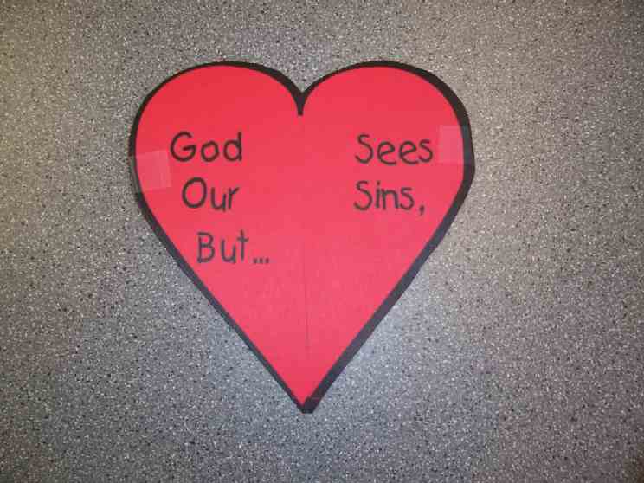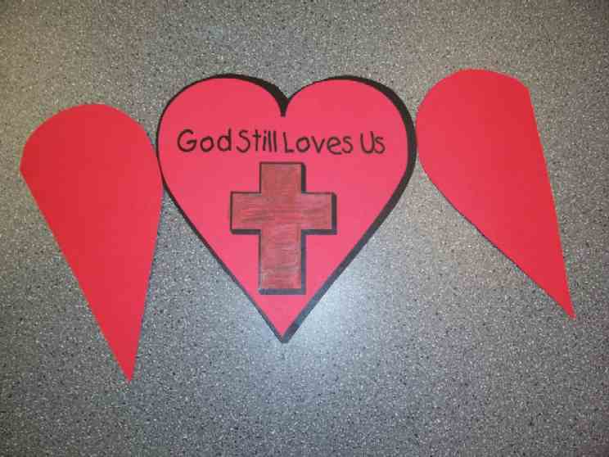
To discuss:

When we sin, it is like our hearts are closed. But Jesus died so we can be forgiven and our sinful hearts can be healed. I wonder what sins we do that we should ask God to forgive.

Practice the take home point. You say the first part; the children respond with the second part.*GOD SEES OUR SIN BUT—God still loves us.

Activity 2: “Healthy Heart Snack”
Supplies needed: serviettes; ballpoint pen; circle-shaped oat cereal; raisins or small healthy snacks
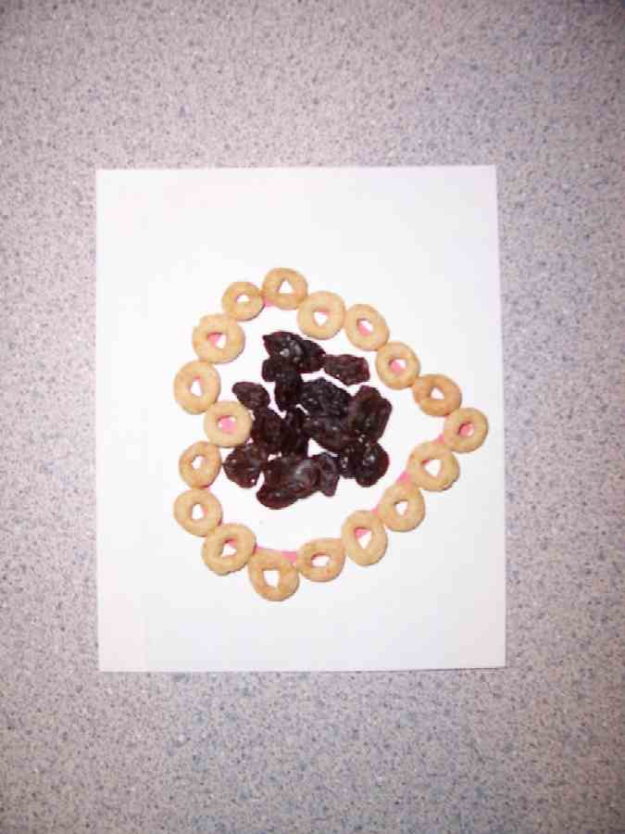
To make:
- Give each child a napkin and draw a heart on each napkin with a ballpoint pen.
- Trace the heart with the cereal.
- Fill in the heart with the raisins or other snack.
- Eat!

To discuss:

Review the Bible event. Say: Because we, too, are sinners, it is like our hearts are sick. But God makes our hearts healthy by loving us even when we sin and by sending Jesus to rescue us. Jesus rescued us by dying on the cross and taking our punishment so our sins can be forgiven.

Practice the take home point. You say the first part; the children respond with the second part. *GOD SEES OUR SIN—But God still loves us.

Activity 3: “Heart Balloon Pop Up” Game
Supplies needed: inflated heart-shaped balloon for every group -Option: regular large balloon with a heart drawn on it; one dark water based marker; wet wipe with cross made with permanent marker- Option: paper towel with cross

Kids as a group will try to pop up the balloon, keeping it airborne and not letting it hit the ground.

Begin with them standing in a circle, being free to move around. After they have done this successfully, hold the balloon and say,

This balloon reminds us of offering our love to God. This is like Abel who offered him a sacrifice. A sacrifice is a way of giving something to God, saying, “I love you.” We give our hearts to God when we tell him that we love him and want to do things for him and want to serve him by helping others.

Let them continue the game. When the balloon hits the ground, take a water-based marker and scribble on it. Explain there are times when we don’t show God’s love, when we sin. It’s just like marking the balloon with this marker.

Next, have the kids on their knees continuing the pop up game. Now when the balloon hits the floor, scribble some more on it with the marker. Tell the kids it indicates times we’ve been mean or when we’ve hurt others.

Have all the children sit cross-legged and play pop up. The balloon will continue to hit the floor. Mark the balloon as you did previously.

At the close, gather the children in a circle and have them look at the balloon.

Sometimes our heart can be filled with sin. How do we get rid of it? The Bible says that God sees our sin, but he still loves us. God gave us a way to remove our sins. Who knows what that is? Show the wet wipes with the cross marked on it. The cross reminds us of what Jesus did to take away our sins. Let’s see what happens when we rub this over the marks. Marks come off. Again, this reminds us of the take home point: *GOD SEES OUR SIN BUT—God still loves us.

Activity 4: “Musical Marking”
Purpose: Help kids to memorize and keep scriptures at heart. Using creative ways to help kids enjoy learning the key verse and in small group setting.

Supplies needed: whiteboard or mahjong paper with Bible verse written; one balloon; player and cd; stickers

Memory Verse: Acts 10:43a – “Everyone who believes in Jesus will be forgiven.”

Memory Verse Learning:
Recite the memory verse written on the whiteboard or mahjong paper with the children prior to the game. You might like to sign it as what they have learnt last week.

Sit the children in a circle. Have the children to pass a balloon as the music is played. When the music stops, the child who holds the balloon will get a sticker on his hand from the teacher. At the same time, he needs to recite the memory verse to the class. Play a few times till a few children get a few marking. The child with the most stickers gets to give each of his friends a sticker on their hand.

Explain to the children that God place a mark on Cain, so that it would be a warning to anyone who met him not to kill him. God forgave Cain for killing his brother and God protects him from harm. In the same way, when we admit to God that we have done wrong, God will forgive us.

Prayer Time:
Tell God one way you sometimes sin and ask him to forgive you. Thank Jesus for dying for your sins.

Large Group Wrap-Up: (10 minutes)

Singing: (Optional)

Lesson Review with Puppet Skit:
Purpose: The crazy bird puppet, Xiao Er, struggles with learning the take home point. The leader shows an example of each small group application activity from this lesson and says the first phrase of the take home point. The kids respond with their phrase. They try to teach the puppet the take home point, but each time, he confuses words or concepts. After three attempts, he finally gets it right and sings the correct take home point in a silly opera-like voice.

Xiao Er’s crazy responses:

Activity 1: “You broke my heart.” (sob)
Activity 2: “I see a snack that I want.”
Activity 3: “I ride in a yellow school bus.”

Welcome guests and thank them for attending.
Supplies:

Quantity ()

Large Group Opening:
- Xiao Hung puppet
- cup
- Bible
- mystery box
- farmer’s props: cangkul, plant or straw hat
- shepherd’s props: a piece of sheepskin or shepherd’s staff
- red “popset” paper heart on white paper
- white manila card heart on white paper
- black crayon

Small Group Application
Activity 1:
- copy appendix on red paper
- scissors
- tape
- colour pencils
Activity 2:
- Serviettes
- ballpoint pen
- circle-shaped oat cereal
- raisins or small healthy snacks
- cups
- water or juice
Activity 3:
- inflated heart-shaped balloon for every group -Option: regular large balloon with a heart drawn on it
- one dark water based marker
- wet wipe with cross made with permanent marker, Option: paper towel with cross
Activity 4:
- whiteboard or mahjong paper with Bible verse written
- one balloon
- player and cd
- stickers

Large Group Wrap-Up
- Xiao Er puppet
- optional music

