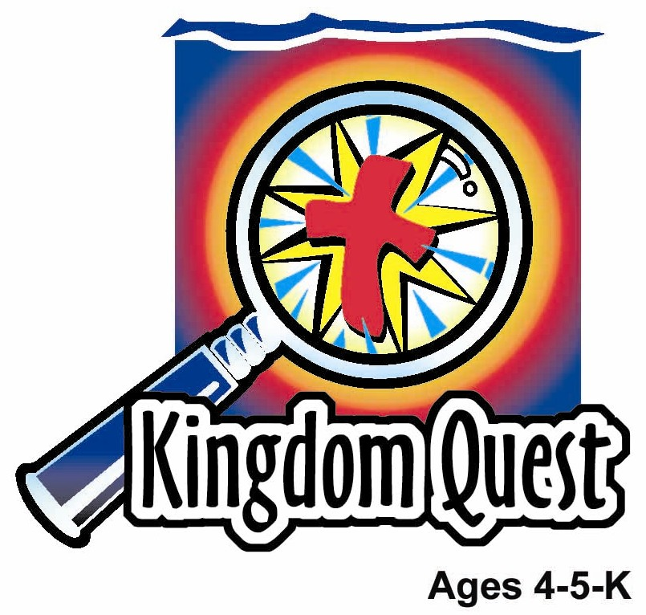
Date: _____________________
Series: God Talks To Me (Sept-Nov)

Year 1, Lesson 26

Review Lesson – The Kings of Israel

Take Home Point: *GOD IS OUR KING – Pray to the King.

*Repeat this phrase throughout the lesson.

Bible Event: 1 and 2 Kings
Jesus Link: We can pray to God the King because His Son Jesus died for us.

We will help children know:
- The basic facts of the Bible events in the “God is Our King” series.
- God is their King.
- They can pray to God.

We will help the children feel:
- Worshipful of the King.
- Eager to pray to the King.
- Confident that the King answers prayer.

We will help the children do:
- Help the puppet Xiao Er correctly tell what happened next in the game show, “Guess What Happened…”
- Make a bread crown for snack.
- Play an active version of Bible Trivia.
THIS LESSON’S ROADMAP

DESTINATION | PAGE # | DISCOVERIES ON YOUR JOURNEY | SUPPLIES NEEDED
Large Group Opening   | 3  3-7 | Puppet Presentation  Bible Event | - Xiao Er puppet  - obnoxious-sounding buzzer or horn  - bell  - optional: Index cards with Bible events written on them  - children’s Bible  - chocolate coins (one per child)  - optional: tape or CD player and instrumental “game show” music
Small Group Application   | 8  8  8-9  10  10 | Activity 1: “King’s Crown” Craft  Activity 2: “Bread Crown” Snack  Activity 3: “Bible Trivia” Game  Activity 4: “Prayer box”  Prayer Time | Activity 1:  - reproducible of King’s crown (1 per child)  - scissors ( younger children may need this cut out ahead of time)  - bright colors of colour paper scraps  - glue  - tape  Activity 2:  - bread cut in the shape of crown  - colourful sprinkle  - cut cherries  - soft margarine.  Activity 3:  option 1:  - masking tape  option 2:  - crown made from reproducible  - sequins  - glue  - list of Bible Trivia questions  Activity 4:  - White board  - Marker  - Box  - individual cards with individual words from the memory verse  - masking tape or blue tack  - CD or cassette player.
Large Group Wrap-up   | 10  9 | Lesson Review with Puppet Skit  Singing (Optional) | - Xiao Er puppet  - sample materials from small group activities  - choose two or three songs from your church music library

Pre-Session Singing: (10 minutes)
Purpose: When all children are in one group singing, it is easy for new children to join the group and immediately get involved. When the music can be correlated, it introduces the theme for the day.

Choose two to three songs.

Large Group Opening: (15 minutes)
Purpose: The puppet demonstrates the need that will be met in today’s lesson. The scripts are not written verbatim, but give a story line in which the group leader can interact with the puppet. The children are introduced to the take home point and then interact with God’s Word, as they experience the Bible event.

Supplies needed: Xiao Er puppet; obnoxious-sounding buzzer or horn; bell; optional: Index cards with Bible events written on them; children’s Bible; chocolate coins (one per child); optional: tape or CD player and instrumental “game show” music

Puppet Presentation:
This review lesson uses the Xiao Er puppet for the Bible event and therefore does not use a puppet skit for Ting Ting or Xiao Hung.

Bible Event:
The script for this Bible event is meant only as a guideline. Feel free to edit or adlib it as desired. The key is to not sound scripted. Hint: The leader can be holding index cards with the Bible events written on them. He can then read the Bible events to Xiao Er, similar to a real game show host reading a clue or trivia question to a contestant.

Game show music begins playing and game show host (can be large group leader) comes onstage. Music fades. Game show host begins speaking:

Leader: Boys and girls, today we are going to play a game show “Guess What Happened…” Our puppet friend Xiao Er will be the contestant on our game show. I will tell him a Bible event and his job is to tell what happened next in the Bible event. If he guesses wrong then you, our audience, will be able to help him. Today our Bible events will focus on the special words, *GOD IS OUR KING – Pray to the King. (Look towards the puppet stage.) Okay, Xiao Er. Come on out.

Music plays. Xiao Er enters. Music fades.

Leader: Xiao Er, are you ready to play the game?

Xiao Er: Yep. I sure am! I’m going to win, win, win!

Leader: We’ll see, Xiao Er. Now here’s how you play the game. I will read a Bible event and you must finish it. If you finish it correctly, you will receive a point. If you answer incorrectly, the buzzer will sound and the audience will be given a chance to finish the story. If the audience answers correctly, they get a point. When the game is over, if you have more points than the audience, you win. If the audience has more points, they win. Remember, all our Bible events for this game will focus on our special words, *GOD IS OUR KING – Pray to the King. Let’s get started.

Leader: (reading from index card 1)
In the days before Jesus was born, God’s people had a special box, called the Ark of the Covenant, which reminded them that God was their King. At one time, the Ark of the Covenant was kept at the farm of a man named Obed-Edom. King David wanted to take the ark back to the temple in Jerusalem. So he and some priests went to Obed-Edom’s farm to get the ark. The priests picked up the ark and walked six steps. Then they put it down. Guess what happened next …

Xiao Er: A spaceship swooped down, picked up the ark, and took it to another planet!

Buzzer sounds.

Leader: Xiao Er, I’m sorry, that’s not right. Now the audience gets a chance to finish the Bible event. Boys and girls, after the priests put down the ark, they and David did what? Watch me. I’m going to give you a clue. (Leader dances and then the children guess. Bell rings several times.) That’s correct! David and the priests danced and shouted and sang songs to God! And we, too, can dance, shout and sing for the King! One point for the audience!

Leader: (reading from index card 2)
When Solomon became the king of Israel, he was still a young man. In a dream, God told King Solomon he could ask for one thing. Solomon did not ask to be rich or famous. He didn’t ask to be powerful, or to rule every country. King Solomon did not even ask for all the candy in the world, or for every day to be his birthday. What did King Solomon ask for? Guess what happened next…

Xiao Er: King Solomon asked for a year’s supply of Twiggies!

Buzzer sounds.

Leader: Xiao Er, I’m sorry, that’s not right. Now the audience gets a chance to finish the Bible event. Boys and girls, what did King Solomon ask for? (Point to temple several times. Children answer. Bell rings several times.) That’s right boys and girls! King Solomon asked to be smart. He asked for wisdom to know right from wrong so he could rule Israel well. God gave King Solomon his wish. He made Solomon wise. In fact, Solomon was so wise that when one time two ladies were arguing over which one was the mother of a baby, King Solomon figured out which lady was the real mommy and gave her the baby. With God’s help, we, too, can use our minds to serve God, the King. Another point for the audience!

(Reading from index card 3):
When Jehoshaphat was king, a giant army from the land of Edom came to make war against God’s people. King Jehoshaphat and the people knew they were not a big enough army to win the war. So they fasted. That means that for a while they did not eat any food; instead, they prayed to God for help. Then King Jehoshaphat and the army marched out to meet Edom’s army. As they marched, they sang and praised God. Before they got to the battle, God confused the Edomites and they all fought and killed each other. When King Jehoshaphat’s army arrived at the battle, they knew… Xiao Er, guess what happened next…

Xiao Er: They knew that it was time to brush their teeth!

Buzzer sounds.

Leader: Xiao Er, I am sorry, but that is not right. Now, the boys and girls get a turn. Xiao Er, you have no points and the children have two points. Will they get a third point? Children, when King Jehoshaphat’s army reached the Edomite army, what did they know? (Point to heaven and then hold up one finger. Children answer. Bell rings several times.) That’s right boys and girls, God had won the battle for King Jehoshaphat and his army. One more point for the children! Just like God helped King Jehoshaphat win, when we have problems, we can pray to God and he will help us win.

Leader: (reading from Index card 4)
Another king, King Hezekiah, had a problem similar to King Jehoshaphat’s problem. A big army came to fight his army. The army was from the country of Assyria and King Sennacherib was their leader. King Hezekiah made a plan to protect his country. He kept the Assyrian army from getting water. He had the wall around Jerusalem fixed and new towers built. He had more weapons and shields built and picked more army officers. Even so, the Assyrians were stronger. They teased King Hezekiah and his people and threatened to fight them. So King Hezekiah, like King Jehoshaphat, prayed to God with his people. The next morning, the people of God woke up and looked at the Assryian army outside the city of Jerusalem. To their surprise, everyone in the Assyrian army was… Xiao Er, guess what happened next…

Xiao Er: Everyone in the Assyrian army was playing “Ring-A-Ring-A-Roses.”

Buzzer sounds.

Leader: Xiao Er, I’m sorry, but you are wrong again. Let’s see if the audience knows. Boys and girls, when the people of God looked outside the city, they saw that everyone in the Assyrian army was what? (Pose as if dead. Children answer. Bell rings several times.) Another point for the audience! The whole Assyrian army was dead. Because King Hezekiah had prayed for help, God had helped him win the war. We, too, can pray to God for help when we have problems. The audience now has four points. Xiao Er, we are now going for the last and final point. Let’s see if you can get this point.

Leader: (reading from index card 5)
When Josiah was only eight years old, he became king of God’s people. At that time, the people had fallen away from God and worshipped false gods. When King Josiah grew up, he decided to clean out and fix the temple. While the temple was being cleaned, the high priest Hilkiah found God’s Word, the book of the law. Josiah had never seen God’s Word before. So, when the book was brought to King Josiah he… Xiao Er, guess what happened next…

Xiao Er: King Josiah wrapped up the book and gave it away as a birthday present.

Buzzer sounds.

Leader: Xiao Er, I am sorry. You are wrong again. Let’s see if the audience can answer this question. Boys and girls, guess what happened next… (Pantomime reading a book. Children answer. Bell rings several times.) You are right, boys and girls! King Josiah had the book read to him. When he realized that he and his people were not following God’s laws, King Josiah felt so bad that he had God’s Word read to all the leaders of the country. Then, King Josiah and the whole country promised to follow God’s Word. We, too, can listen to God’s Word. God’s Word tells us that we make wrong choices and sin, but because Jesus died for us, our sins can be forgiven. God’s Word tells us that God loves us and we can show him we love him by listening to and obeying God’s Word.

Well, boys and girls, you have five points! (Bell rings.) Xiao Er, I am sorry, but you did not get any points. (Buzzer sounds.) But we do have a great parting prize for you, Xiao Er. You win a children’s Bible. Maybe, if you study God’s Word, next time on “Guess What Happened Next…” you will do better.

Music plays. Xiao Er leaves. Music fades.

Boys and girls, the words of God our King are a treasure and for doing so well on “Guess What Happened Next…” we have a Treasure for each of you—a chocolate treasure box! Remember the special words, *GOD IS OUR KING – Pray to the King and thank you for playing, “Guess What Happened Next…” (Music plays. Pass out the chocolate Treasures.)

End with a prayer.

Small Group Application: (30 minutes)
Purpose: Smaller groups enable children to develop closer relationships with adults and peers in the church. As you reinforce the take home point with a fun hands-on activity, discuss the Bible event. Be sure to repeat the take home point several times. Say the first part and have the children respond with the second phrase. Application questions help kids apply the take home point to their daily lives. Close this session by gathering your small group for prayer. Let the kids pray!

During the small group application time, discuss the following questions and points:

What does a king do? (Answers will vary.)

Who is our King? (God.)

How does God our King help us? (Answers will vary, but may include taking care of us, keeping us safe, and loving us. This is a good time to remind the children that the best thing God our King did for us was to send his son Jesus to die on the cross for us and take away our sins, the wrong choices we make, so that we can go to heaven.)

When we have a problem, how can we turn to God our King? (Pray to him. Practice the take home point, *GOD IS OUR KING – pray to the King. Remind the children that we can pray to God our King because Jesus died for us. We are sinful. But, because Jesus died for us, we are forgiven, so God will hear our prayers.)

Activity 1: “King’s Crown” Craft
Supplies needed: reproducible of King’s crown (1 per child); scissors ( younger children may need this cut out ahead of time); bright colors paper scraps; glue; tape

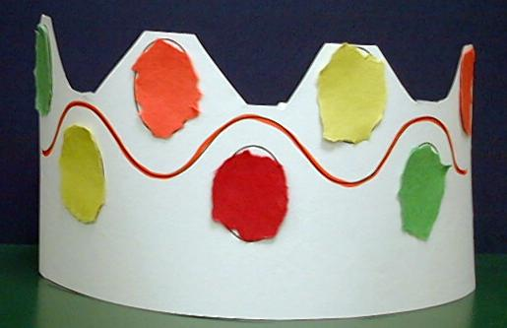
To make a crown:
- Cut along the lines of the crown reproducible.
- Tear small pieces of colour paper to resemble jewels and glue on the front of the crown.
- Tape the crown in a circle, fitting it to the head of the child. Use an extra paper strip, if necessary, for additional length.

As the children work, review the Bible event and the take home point, *GOD IS OUR KING – Pray to the King.

Activity 2: “Bread Crown” Snack
Supplies needed: bread cut in the shape of crown; colourful sprinkles; cut cherries; soft margarine.

To make bread crown, give each child a crown which is cut out from a piece of bread. Spread some soft margarine on the bread. Decorate the bottom of the crown with some colourful sprinkles and cut cherries around the edges so that it resembles a crown. The children can then eat the bread. As the children work and eat, review the Bible event and remind them that God is our King. Practice the take home point, *GOD IS OUR KING – Pray to the King. Remind the children that we can pray to God because his Son, Jesus, died for us on the cross and took away our sins. Because our sins are gone, God hears our prayers.

Activity 3: “Bible Trivia” Game
Supplies needed: option 1- masking tape; option 2- crown made from reproducible
Sequins and glue; list of Bible Trivia questions

This Bible Trivia game is meant to be a review of the Bible events in the “God is Our King” series. Choose one of the two following options for playing the game.

Option 1: (active)
- Line up the children against the wall.
- Make a line of masking tape 15-20 feet away from the children (or have them play to the other side of the room).
- The purpose of the game is to review the Bible events by having the children answer trivia questions and for the whole group to get from one side of the room to the tape or the other side of the room.
- Give the group a trivia question from below. If the children answer correctly they move one step. If they answer incorrectly, they stay. Vary the ways the children move using baby steps, giant steps, hops, tiptoeing, jumping, normal steps, etc.
- If the group makes it to the other side of the room before the trivia questions run out, they win. If they don’t make it, the teacher wins.
- After the game, remind the children who our real king is—God. Practice the take home point. **GOD IS OUR KING – Pray to the King.

Option 2: (quiet)
Play the same as option one, only, instead of having the children move each time they answer correctly, they glue a sequin on a crown. The group must glue on a predetermined number of sequins (the number will vary by the size of the group) to win the game.

Bible Trivia Questions:
- The Ark of the Covenant was a special box that reminded the people of Israel that God was their…? (King)
- After the priest picked up the ark and carried it six steps, they put it down and did what? (worshipped God, shouted to God, sang, danced—any of those answers are acceptable)
- When Solomon became king, God gave him one wish. What did Solomon wish for? (To be wise or to know how to rule.)
- God answered King Solomon’s prayer and made him wise. In fact, he was so wise, that when two ladies were fighting over a baby, what did King Solomon figure out? (Who the baby’s mommy was.)
- When King Jehoshaphat faced an army from Edom, he and God’s people did not eat for a while. This is called “fasting.” What else did they do instead of eating? (They prayed.)
- What did God help King Jehoshaphat and his army do? (Win the war.)
- King Hezekiah had a problem like King Jehoshaphat. What was his problem? (An army wanted to fight against his people.)
- King Hezekiah made a plan to protect his people and they prayed to God. What did God do? (He rescued his people and killed the enemy army—accept either answer.)
- When Josiah was king, the people of God worshipped idols, which means false gods. Josiah had his people clean and fix the temple of God. What did the priest find there? (God’s Word.)
- What did Josiah and the people do with God’s Word? (They read it, asked God to forgive them and followed God’s Word—accept any of those answers and remind the children of the other answers.)

Activity 4: “Prayer Box”
Purpose: Help kids to memorize and keep scriptures at heart. Using creative ways to help kids enjoy learning the key verse and in small group setting.

Supplies needed: White board, marker, box, individual cards with individual words from the memory verse, masking tape or blue tack,
_________ to
_______ and
___ will
answer ________.
Jeremiah __ __ : __
CD or cassette player.

Memory Verse: Jeremiah 33:3 ~ Pray to Me

and I will answer you.

Memory Verse Learning:
Before class, write the memory verse with blanks as above. Recite the memory verse a few times with the children. Get the children to sit in a circle on the floor. The children need to pass the prayer box around as the music is turned on. When the music stop, the child who is holding the box, takes a card from the box and read the word out loud. Then he pastes the card in the correct blank using masking tape or blue tack. Continue to play until the whole memory verse in formed. When the memory verse is formed, recite the memory verse together.

Prayer Time:
Have the children take turns praying to the King by taking their prayer requests to God. You may need to give them ideas for prayer requests, such as helping someone who is sick, or keeping someone safe who is traveling.

Large Group Wrap-Up: (10 minutes)
Purpose: The crazy bird puppet, Albie, struggles with learning the take home point. The leader shows an example of each small group application activity from this lesson and says the first phrase of the take home point. The kids respond with their phrase. They try to teach the puppet the take home point, but each time he confuses words or concepts. After three attempts, he finally gets it right and sings the correct take home point in a silly opera- like voice.

Supplies needed: Xiao Er puppet; sample materials from small group activities; choose two or three songs from your church music library

Singing: (Optional)

Lesson Review with Puppet Skit:
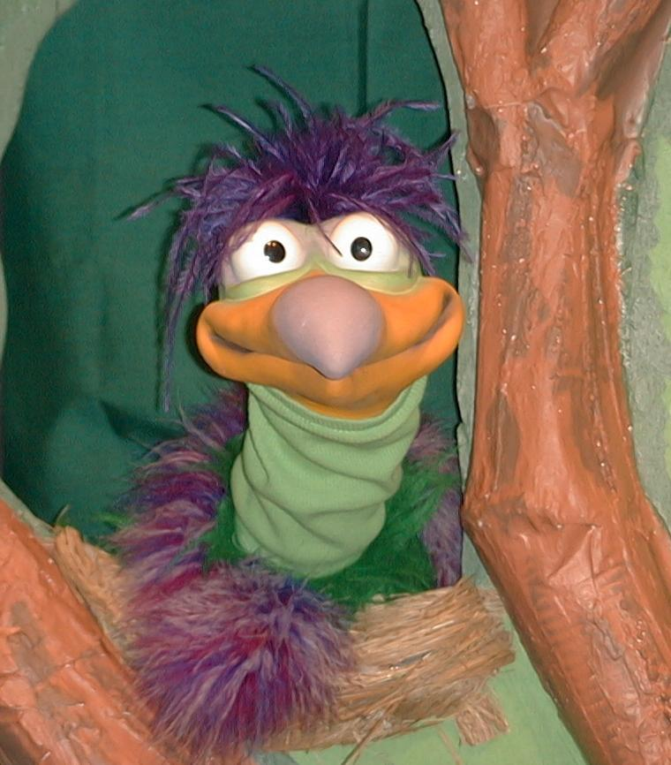
Presenter shows Xiao Er craft made in Activity 1. Then the kids attempt to teach Xiao Er the take home point.

Presenter says to kids: “God is our King…”
Kids say: “…pray to the King.”
Presenter says to Xiao Er: “God is our King…”
Xiao Er says: “Never feed peanut butter to angry Hippopotumus-ssesesss.”

Presenter shows an example of the next activity done in small group and repeats first phrase to kids. The kids say the correct response trying to teach Xiao Er the take home point. Continue in this manner with Presenter showing example of each activity. Here are Xiao Er’s responses:

Xiao Er’s response to Activity 2 sample: “Cook crown cookies carefully, ‘cause Crown Cookies can cause coo-coo for co-co puffs.”
Xiao Er’s response to Activity 3 sample: “And I like to sing!!!”
Xiao Er’s response to Activity 4 sample: “I will pray, yeah! Yeah! Yeah!”

Presenter says: “Xiao Er, listen one last time.
God is our King…”
Kids response: “…pray to the King.”
Presenter says to Xiao Er: “God is our King…”
Xiao Er’s response: (Warms up his singing voice with “Mee, mee, mee, mee, mee…” and sings in a silly dramatic opera-like voice) “GOD IS OUR KING – PRAY TO THE KING.”

Welcome guests and thank them for attending.
Lesson 26

Large Group Opening:
- Xiao Er puppet
- obnoxious-sounding buzzer or horn
- bell
- optional: Index cards with Bible events written on them
- children’s Bible
- chocolate coins (one per child)
- optional: tape or CD player and instrumental “game show” music

Small Group Application:
Activity 1:
- reproducible of King’s crown (1 per child)
- scissors ( younger children may need this cut out ahead of time)
- bright colors of construction paper scraps
- glue
- tape
Activity 2:
- bread cut in the shape of crown
- colourful sprinkle
- cut cherries
- soft margarine
Activity 3:
- option 1:
- masking tape
- option 2:
- crown made from reproducible
- sequins
- glue
- list of Bible Trivia questions
Activity 4:
- White board
- Marker
- Box
- individual cards with individual words from the memory verse
- masking tape or blue tack
- CD or cassette

Large Group Wrap-Up:
- Xiao Er puppet
- sample activities
- choose two or three songs from your church music library

