
Date: _____________________
Series: God Is Powerful (Sept-Nov)
Year 1, Lesson 22

Year 1, Lesson 19

Daniel and the Lions’ Den

Take Home Point: *GOD IS POWERFUL – God tames our fears.

*Repeat this phrase throughout the lesson.

Bible Event: Daniel 6:1-23, 25-28
Jesus Link: Because of Jesus, God’s power is for us too!

We will help children know:
- The story of Daniel and the lions’ den.
- God’s power is for us, too.
- We can give our fears to God.

We will help the children feel:
- Trust in God’s power.
- Secure that God’s power is for them, too.
- Reassurance in the face of fear.

We will help the children do:
- Make a lion snack.
- Practice giving their fears to God using a balloon game.
THIS LESSON’S ROADMAP

DESTINATION | PAGE # | DISCOVERIES ON YOUR JOURNEY | SUPPLIES NEEDED
Large Group Opening   | 3  3-4 | Puppet Presentation  Bible Event | - Xiao Hung puppet  - lion tamer’s whip (may be as simple as a pencil with a string tied to it)  - VCR  - video, The Beginner’s Bible: The Story of Daniel and the Lion’s Den (Sony Music Entertainment Inc. and Time-Life Video and Television, 1995)  - cue the video to the spot where King Darius takes over Babylonia
Small Group Application   | 4  5  5  5 | Activity 1: “Balloon Activity”  Activity 2: “Lion” Snack  Activity 3: “Tame Our Fears” Craft  Activity 4: “Belalang and Belatuk”  Prayer Time | Activity 1:  - large, deflated balloon  - permanent marker  Activity 2:  - Serviettes for every child  - One Marie biscuit for each child  - Chicken floss  - “Mimi” snack  - chocolate chips  Activity 3:  - one sheet of white paper per child  - colour pencils  - masking tape  Activity 4:  - white board  - marker  - masking tape
Large Group Wrap-up   | 5-6  5 | Lesson Review with Puppet Skit  Singing (Optional) | - Xiao Er puppet  - sample projects from small group time  - choose two or three songs from your church music library

Pre-Session Singing: (10 minutes)
Purpose: When all children are in one group singing, it is easy for new children to join the group and immediately get involved. When the music can be correlated, it introduces the theme for the day.

Choose two to three songs.

Large Group Opening: (15 minutes)
Purpose: The puppet demonstrates the need that will be met in today’s lesson. The scripts are not written verbatim, but give a story line in which the group presenter can interact with the puppet. The children are introduced to the take home point and then interact with God’s Word, as they experience the Bible event.

Supplies needed: Xiao Hung puppet; lion tamer’s whip (may be as simple as a pencil with a string tied to it); VCR; video, The Beginner’s Bible: The Story of Daniel and the Lion’s Den (Sony Music Entertainment Inc. and Time-Life Video and Television, 1995) cue the video to the spot where King Darius takes over Babylonia

Puppet Presentation:
Xiao Hung comes out with a whip. He wants to be a lion tamer. The presenter asks why. Xiao Hung responds that he thinks there are lions in the woods behind his house. He wants to learn to tame lions, so he doesn’t have to be scared anymore.

The presenter assures Xiao Hung that lions don’t live around here. Then he asks Xiao Hung if he knows what the word “tame” means. Xiao Hung responds, “yes,” and then explains that “tame” means making a wild animal nice, so it doesn’t eat you up.

This reminds the presenter of today’s story. It’s about how God tamed some lions and kept them from eating up Daniel. It also reminds the presenter of today’s take home point. *GOD IS POWERFUL – God tames our fears.

Sometimes our fears are like wild animals that roar at us. But because God is powerful, He can keep us safe and take away our fears. How can God help tame our fears? We can pray to Him for help.

Bible Event:
Introduce the story by saying:

Can you roar like a lion? I wonder what a hungry lion sounds like. Boy, you guys sound very hungry! I would be afraid of so many hungry lions. Keep on sounding like a hungry lion. (Let the children roar for 5-10 seconds.) Now, be perfectly quiet.

That’s what happened in today’s Bible event. A man named Daniel was put into a room full of hungry lions, but God stopped them from eating him. He closed their mouths. That reminds me of today’s special words. * GOD IS POWERFUL – God tames our fears.

Show the video from the point where King Darius takes over Babylonia until the end of the video. After the video, practice the take home point one more time. *GOD IS POWERFUL – God tames our fears.

End with a prayer.

Small Group Application: (30 minutes)
Purpose: Smaller groups enable children to develop closer relationships with adults and peers in the church. As you reinforce the take home point with a fun hands-on activity, discuss the Bible event. Be sure to repeat the take home point several times. Say the first part and have the children respond with the second phrase. Application questions help kids apply the take home point to their daily lives. Close this session by gathering your small group for prayer. Let the kids pray!

During the small group application time, discuss the following questions and points:

Why was Daniel thrown into the lion’s den? (He would only pray to God and not to King Darius.)

How did God save him? (He shut the mouths of the lions.)

How would you feel if you were thrown into a lion’s den?

What makes you afraid? (Answers will vary.)

Who can we turn to when we are afraid? Why? (God, because He is powerful enough to help us.)


Activity 1: “Balloon Activity”
Supplies needed: large, deflated balloon; permanent marker

Blow up a balloon, but do not tie it. Use the permanent marker to draw a lion face on the balloon. Have the children tell things that make them scared. Write their fears on the balloon. Explain that our fears can sometimes be as frightening as a lion. Have the children roar. Sometimes our fears seem to roar at us. But we know *GOD IS POWERFUL – Gods tames our fears.

Let go of the balloon and watch it deflate. God’s power lets the air out of our fears and they fly away. As time permits, repeat the activity or let the children take turns letting the balloon deflate.

Activity 2: “Lion” Snack
Supplies needed: One Marie biscuit for each child; chicken floss; “Mimi” snack; chocolate chip

Have each child make a lion snack by using the chocolate chips for the eyes and nose on a marie biscuit, “Mimi” snack for the whiskers and chicken floss for the mane. As the children eat their snacks, practice the take home point: * GOD IS POWERFUL – God’s power tames our fears.
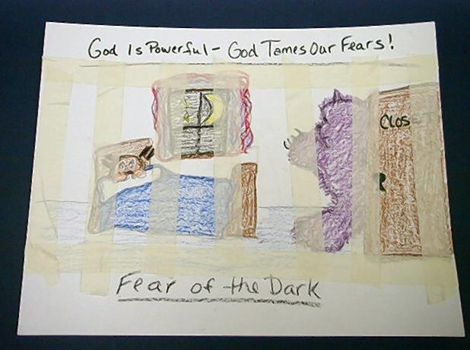
Activity 3: “Tame Our Fears” Craft
Supplies needed: one sheet of white paper per child; colour pencils; masking tape

Have the children draw a picture of their fears. When they are finished, help them use masking tape to put “bars” over their fears. Remind them of the take home point. * GOD IS POWERFUL – God tames our fears.

Activity 4: “Belalang and Belatuk”
Purpose: Help kids to memorize and keep scriptures at heart. Using creative ways to help kids enjoy learning the key verse and in small group setting.

Supplies needed: white board, marker, masking tape.

Memory Verse: Psalm 54:1 ~ God, save me
because of who You are.
Belalang
Belatuk
Memory Verse Learning:
Before the class, mark two squares 4 to 6 feet apart from one another on the floor using the masking tape. Recite the memory verse a few times with the children. Then divide the children into two groups. Name one group as “Belalang” and the other as “Belatuk. Direct the two groups to squares which each representing their respective home. Get all the children to stand in one straight line in the center between the two squares. When the shepherd shouts out “Belalang”, the “Belalang” group is to chase after the “Belatuk” and touch them so that “Belalang could claim more members in their group. Then those “Belatuk” who are saved in their home are to recite the memory verse together. It goes the same as when the shepherd shouts out “Belatuk”. Repeat the game till time is up.

Prayer Time:
Pray by asking God to use his powers to help take away our fears. Encourage the children to name specific fears. End in Jesus’ name and then say the Lord’s Prayer.
Large Group Wrap-Up: (10 minutes)
Purpose: The crazy bird puppet, Albie, struggles with learning the take home point. The presenter shows an example of each small group application activity from this lesson and says the first phrase of the take home point. The kids respond with their phrase. They try to teach the puppet the take home point, but each time he confuses words or concepts. After three attempts, he finally gets it right and sings the correct take home point in a silly opera like voice.

Supplies needed: Xiao Er puppet; sample projects from small group time; choose two or three songs from your church music library

Singing: (Optional)

Lesson Review with Puppet Skit:
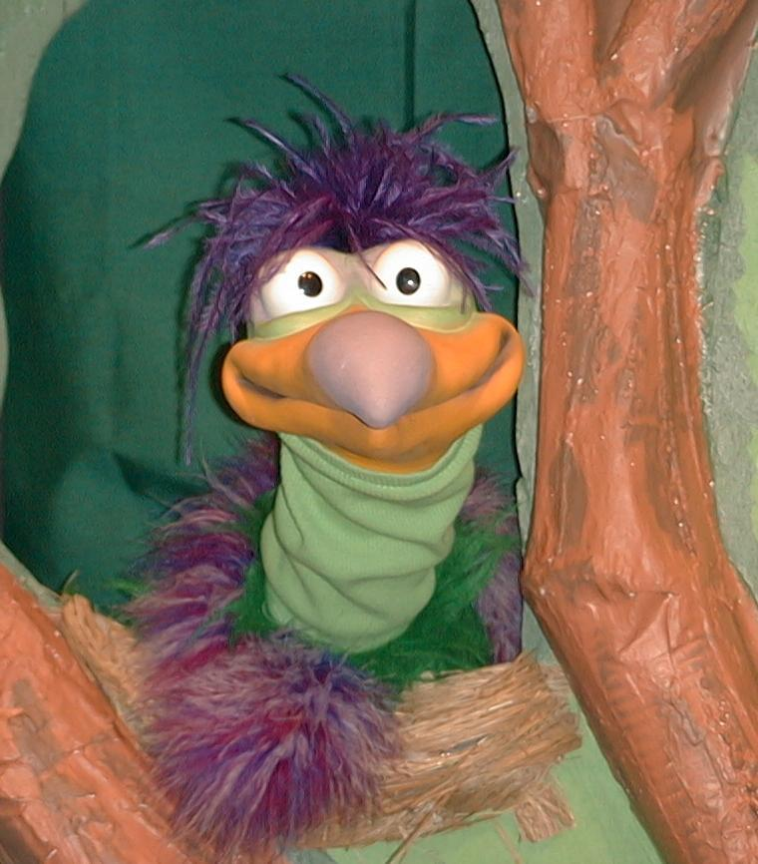
Presenter shows Xiao Er a craft made in Activity 1. Then the kids attempt to teach Xiao Er the take home point.

Presenter says to kids: “God is powerful…”
Kids say: “…God tames our fears.”
Presenter says to Xiao Er: “God is powerful…”
Xiao Er says: “Look out…a Lion!!! “ (hide)

Presenter shows an example of the next activity done in small group and repeats first phrase to kids. The kids say the correct response trying to teach Xiao Er the take home point. Continue in this manner with Presenter showing example of each activity. Here are Xiao Er’s responses:

Xiao Er’s response to Activity 2 sample: (pretend to be a lion) “Roar” I’m a lion!
I need a Snack!”
Xiao Er’s response to Activity 3 sample: “God tames our TEARS.”
Xiao Er’s response to Activity 4 sample: “God saves me because of who He is!”

Presenter says: “Xiao Er, listen one last time. God is powerful…”
Kids say: “…God tames our fears.”
Presenter says to Xiao Er: “God is powerful…”
Xiao Er’s response: (Warms up his singing voice with “Mee, mee, mee, mee, mee…” and sings in a silly dramatic opera-like voice) “GOD IS POWERFUL – GOD TAMES OUR FEARS.”

Welcome guests and thank them for attending.

LESSON 22

Large Group Opening:
- Xiao Hung puppet
- lion tamer’s whip (may be as simple as a pencil with a string tied to it)
- VCR
- video, The Beginner’s Bible: The Story of Daniel and the Lion’s Den (Sony Music Entertainment Inc. and Time-Life Video and Television, 1995) cue the video to the spot where King Darius takes over Babylonia

Small Group Application:
Activity 1:
- large, deflated balloon
- permanent marker

Activity 2:
- serviettes for each child
- one Marie biscuit for each child
- chicken floss
- “Mimi” snack
- chocolate chip

Activity 3:
- one sheet of white paper per child
- colour pencils
- masking tape

Activity 4:
- white board
- marker
- masking tape

Large Group Wrap-Up:
- Xiao Er puppet
- sample projects from small group time
- choose two or three songs from your church music library

