
Date: _____________________
Series: God Is Powerful (Sept-Nov)
Year 1, Lesson 24

Year 1, Lesson 19

Elijah and the Prophets of Baal

Take Home Point: *GOD IS POWERFUL – Pray to God for help.
*Repeat this phrase throughout the lesson.

Bible Event: 1 Kings 18:16-39
Jesus Link: We pray in Jesus’ name.

We will help children know:
- The story of Elijah and the prophets of Baal.
- God is more powerful than all of our problems.
- God is powerful enough to answer all our prayers.

We will help the children feel:
- Strength in God’s power.
- Confident that God is powerful enough to answer our prayers.
- Compelled to take their problems to God in prayer.

We will help the children do:
- Participate in a Bible event competition between Elijah and the prophets of Baal.
- Use a “weight lifting” activity to discuss God’s power.
THIS LESSON’S ROADMAP

DESTINATION | PAGE # | DISCOVERIES ON YOUR JOURNEY | SUPPLIES NEEDED
Large Group Opening   | 4  4-7 | Puppet Presentation  Bible Event |  | - Ting Ting puppet  - barbell (Use the one for Activity 2)  - sweatband for Ting Ting (optional)  - “kingly” adult-sized robe  - king’s crown  - bathrobe (adult size)  - altar made by covering a cardboard box with brown paper torn in random shapes  - newspaper rocks  - two large slabs of “meat”  - four empty, plastic gallon milk jugs each filled with about a cup of water  - flash paper  - lighter  - 6-12 sticks  - toy or real microphone  - picture of the story “Elijah and the Prophets of Baal”  - masking tape
Small Group Application   | 8  8-9  9  10 | Activity 1: “Altar Pictures”  Activity 2: “Weight Lifting”  Activity 3: “Elijah’s Altar Snack”  Activity 4: “Praying Hands Song” |  | Activity 1:  - one piece of blue manila card per child  - 1/2 piece of gray colour paper per child  - red, orange, and yellow crepe paper cut into 2-inch squares. 2-3 pieces of each color per child  - glue  - labels with take home point  Activity 2:  - two barbells made from paper towel tube and two balloons.  Activity 3:  - one square banana cake per child  - three finger biscuits per child  - three/four red preserve plum pieces per child  - one serviettes per child  Activity 4:  - marker  - enlarged praying hands
Large Group Wrap-up   | 11  10 | Lesson Review with Puppet Skit  Singing (Optional) |  | - Xiao Er puppet  - sample activities  - choose two or three songs from your church music library

Pre-Session Singing: (10 minutes)
Purpose: When all children are in one group singing, it is easy for new children to join the group and immediately get involved. When the music can be correlated, it introduces the theme for the day.

Choose two to three songs.

Large Group Opening: (15 minutes)
Purpose: The puppet demonstrates the need that will be met in today’s lesson. The scripts are not written verbatim, but give a story line in which the group presenter can interact with the puppet. The children are introduced to the take home point and then interact with God’s Word, as they experience the Bible event.

Supplies needed: Ting Ting puppet; barbell (Use the one for Activity 2); sweatband for Ting Ting (optional); “kingly” adult-sized robe; king’s crown ; bathrobe (adult size); altar made by covering a cardboard box with brown paper torn in random shapes; newspaper rocks ; two large slabs of “meat”; four empty, plastic jug or mug each filled with about a cup of water; lighter; 6-12 sticks; toy or real microphone; picture of the story “Elijah and the Prophets of Baal”; masking tape

Puppet Presentation:
Ting Ting comes out wearing a sweatband, lifting a “barbell” up and down while huffing and puffing. The presenter asks her what she is doing. Ting Ting explains that she thinks there are monsters in her closet. (Adults should not react as if there could be monsters.) She’s trying to get strong so she can fight them and be safe.

The presenter assures Ting Ting there are no monsters in her closet and says that lifting weights will make her strong, but there is someone even more powerful who can help her with anything. That someone is God. He’s more powerful than anybody in the world. He’s also powerful enough to make our fears go away. Ting Ting or any of us can pray to God, and he is powerful enough to help us. Share the take home point. *GOD IS POWERFUL – pray to God for help.

Bible Event:
Set up:
Before the children arrive, set the stage area as follows:
- The box altar should be placed on one side of the stage area, with several sticks assembled on top of it to look like a fire. Place one of the slabs of “meat” on top of the wood.
- On the other side of the stage, the paper rocks and wood should be scattered and scrambled, with the “meat” laid to the side.
- The skit requires two extra men—one dressed as King Ahab in a crown and “kingly” robe, and the other dressed as Elijah in costume or a simple plain robe. Elijah should have the crumbled flash paper hidden under his robe. An announcer holding a microphone will also be needed.

Character introduction
Raise your hand if you like a contest. Good. Today our Bible event is going to be a contest.

Hold up the picture of Elijah and the prophets of Baal. Point to the people you refer to in the dialogue. If you do not have a picture of the Bible event, point to the actors.

This is Elijah. He’s a prophet. That means he speaks God’s Word. He’s the good guy in our contest. Can you say, “Yeaaa”?

These are the prophets of Baal. They believe in a false god. They’re the bad guys in our contest. Can you say, “Boooo?”

This is King Ahab. He follows the false prophets. Can you say, “Boooo?”

King Ahab and Elijah are having a contest to find out which god is the true and powerful God.

Invite six children forward to be the prophets of Baal. Explain to them that they are going to pretend to be the bad guys. They will say things that no one should say because these prophets worshipped Baal, a false God. Remember, you are just pretending and helping me act out this story.

Contest introduction
Announcer: (Holding microphone.) Good morning, boys and girls, children of Israel! Welcome to Mount Carmel and the showdown between Elijah and the prophets of Baal. And now let’s have them come out. This is Elijah. (Point to Elijah.) And this is King Ahab. (Point to King Ahab.) With King Ahab, are the many prophets of Baal, which he followed. (Point to children on stage.) Now, of course, back in Bible days there were no announcers when you had contests like this, but I am here today to help you learn this important truth: *GOD IS POWERFUL – pray to God for help. Let’s try it. I say the first part and you say the second. *GOD IS POWERFUL – pray to God for help. Any time you here me or Elijah say the first part of that, you remember to say your part. One more time: *GOD IS POWERFUL – pray to God for help.
Who is more powerful?
And the big question of the day is, “Which god is powerful?”

(Turns to King Ahab.) King Ahab, which god do you say is powerful? Who do you think will win today’s contest? (Holds microphone to Ahab.)

King Ahab: Why, Baal, of course! The prophet Elijah is just a troublemaker. His God is a joke! I worship Baal!

Announcer: (Speaking into microphone.) Thank you, King Ahab. Now we turn to Elijah. Elijah, which god do you say is powerful? Which god will win today’s contest? (Holds microphone to Elijah.)

Elijah: Only the Lord God is the true God. Today everyone will know that the power belongs to the Lord God.

Announcer: Thank you, men. And now, we begin our competition. The prophets of Baal are up first. You may take your place around your altar. (Have the children playing the prophets of Baal circle the box altar.)

Announcer: (Turning to the audience.) The purpose of this contest is to pray to the gods for fire. The altar that starts on fire belongs to the true and powerful God. *GOD IS POWERFUL – pray to God for help. Prophets of Baal, you may begin praying.

Baal is called
Have King Ahab shout phrases and the children repeat them. Use the following phrases or any additional phrases you come up with:
- Baal, give us fire!
- You can do it, Baal!
- Burn, Baal!
- Go get ‘em, Baal!

Elijah: Come on. Your god must do better than that.

Have the Baal prophets hold hands and walk around the altar while chanting the above phrases. Have Elijah heckle them using the following phrases:
- Where is your god? Is he sleeping?
- Is your god taking a trip?
- Did Baal forget his people?

Announcer: (Looking at prophets.) Prophets of Baal, it is now evening and your god has not answered.

(Turning towards audience.) Children of Israel, it seems to me that the god Baal is not a powerful god. But we know the one and only true *GOD IS POWERFUL – pray to God for help.

(Turning back to the prophets of Baal.) Since your god is not answering your prayers, He must not be powerful. He must not be the true God. You may sit down, prophets of Baal. (Have the children playing the prophets, sit around the altar.)

Announcer: King Ahab, what do you have to say now about Baal?

King Ahab: The contest is not over yet! Let’s just see if the Lord God does any better!

Announcer: (Looking at the audience.) I guess King Ahab is not a very good loser! (Looking at Elijah.) Elijah, you’re up next for the showdown at Mount Carmel.

An altar built and water poured
King Ahab: Ha! Elijah doesn’t even have a decent altar!

Elijah goes over and fixes his altar. Have the children help him count out the 12 rocks for the 12 tribes of Israel. Use a couple strips of masking tape to hold the altar together. Put “meat” on top. Elijah then picks up the shovel and pretends to dig a trench around it. In the meantime, have King Ahab make rude comments like, “What does he think he’s doing?” or ”What a joke!”

Elijah: (Turning to audience.) Children of Israel, I need a few good helpers. We will show King Ahab and the prophets of Baal that *GOD IS POWERFUL – pray to God for help.

Elijah picks out four children to be helpers. Each child is given a plastic jug or mug and told to “pour” the “water” over the altar by sprinkling from the plastic jugs or mugs. Have the children do this twice more and then sit down with their group.

Elijah: Look at the altar. It is soaked with water. Why, there is even water running through the trench I dug! No man can make a fire in that! But *GOD IS POWERFUL – pray to God for help. Now I will do just that.

Prayer and fire
(Raising his hands.) Oh Lord, you are the God of these people. Please answer my prayer so these people will know you are the Lord God and they will turn their hearts back to you.

During Elijah’s prayer, King Ahab walks up to the altar and turns his back on the audience. He "humphs" and makes other noises that indicate he disbelieves Elijah. At the end of the prayer, the actor playing Elijah walk out from the front stage. with his back to the audience lights the flash paper with a lighter and throws it into the air. This must be practiced ahead of time so it can be done safely.

Announcer: Look at that fire! (Points to the altar.) It is on the altar, on the wood and even in the water! Now we know the Lord God is the true God and *GOD IS POWERFUL – pray to God for help. The Lord God has won the showdown at Mount Carmel! Children of Israel, let’s bow down to the true God. (Lead children in a bow.)

Group time ends with a short prayer.

Small Group Application: (30 minutes)
Purpose: Smaller groups enable children to develop closer relationships with adults and peers in the church. As you reinforce the take home point with a fun hands-on activity, discuss the Bible event. Be sure to repeat the take home point several times. Say the first part and have the children respond with the second phrase. Application questions help kids apply the take home point to their daily lives. Close this session by gathering your small group for prayer. Let the kids pray!

During the small group application time, discuss the following questions and points:

Tell me about the contest at Mount Carmel. (Review the story with the children. Ahab worshipped Baal; Elijah worshipped the Lord God. The prophets of Baal prayed to Baal to send fire on their altar; Elijah prayed to the Lord God. Baal did not send a fire. The Lord God did—even on a wet altar!)

What can we learn from this story? (*GOD IS POWERFUL – pray to God for help.)

When can you pray to God for help?

Tell me about one of your prayers God has answered.

Jesus was sacrificed on the cross so our sins will be forgiven. When we trust in Jesus and we pray in Jesus’ name to God, he will help us. We pray in Jesus’ name.

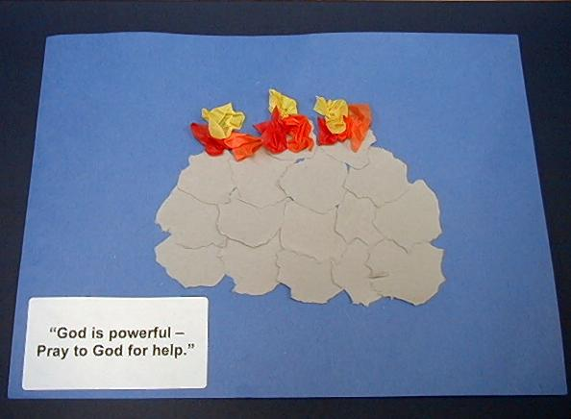
Activity 1: “Altar Pictures” Craft
Supplies needed: one piece of blue manila card per child; 1/2 piece of gray colour paper per child; red, orange, and yellow crepe paper cut into 2-inch squares. 2-3 pieces of each color per child; glue; labels with take home point

Have the children tear the gray colour paper into rock shapes and glue it in the form of an altar onto the blue construction paper. Next, have them crumple the crepe paper and glue it on the altar to make a “fire.”

As they work, review the story and discuss the times they can pray to God for help. Say the take home point: *GOD IS POWERFUL – pray to God for help.

Activity 2: “Weight Lifting” Game
Supplies Needed: two barbells made from kitchen towel tube and two balloons

Barbell made from a paper towel tube, two balloons filled with air and tied off, and one large rubber band. Tie the rubber band on the first balloon’s knot and stick the rubber band in the tube. With a hook or clamp, reach in the tube for the rubber band. Pull the rubber band down sufficiently to wrap around the second balloon’s knot. Release the balloon and the rubber band will hold the two balloons snug to the tube.



Sit in a circle and place the barbells in the center of the circle. Tell the children that today they get to be weight lifters. One at a time, have the children come into the middle of the circle and lift the barbells as all the children say, “God is more powerful than…” Have the child in the center of the circle finish the sentence.

After each child has had a turn, go around a second time. This time, have them finish the phrase, “God is powerful enough to…” It may be difficult for some children to finish these sentences. If so, help them using the following ideas (or allow them to copy one another’s ideas).

God is more powerful than:
- Floods
- Big Dogs
- Dinosaurs
- Bad Dreams
- Bullies

God is powerful enough to:
- Keep me safe
- Answer my prayers
- Take care of me
- Send fire on a wet altar
- Help me when I need him
- Do anything

Activity 3: “Elijah’s Altar” Snack
Supplies needed: one square banana cake per child; three finger biscuits per child; three/four red preserve plum pieces per child; one serviettes per child

Hand out the serviettes. Give each child one banana cake. Lay the finger biscuits on the cake crisscrossed to resemble the wood in the fire. Place the red preserved plum on top to look like fire.

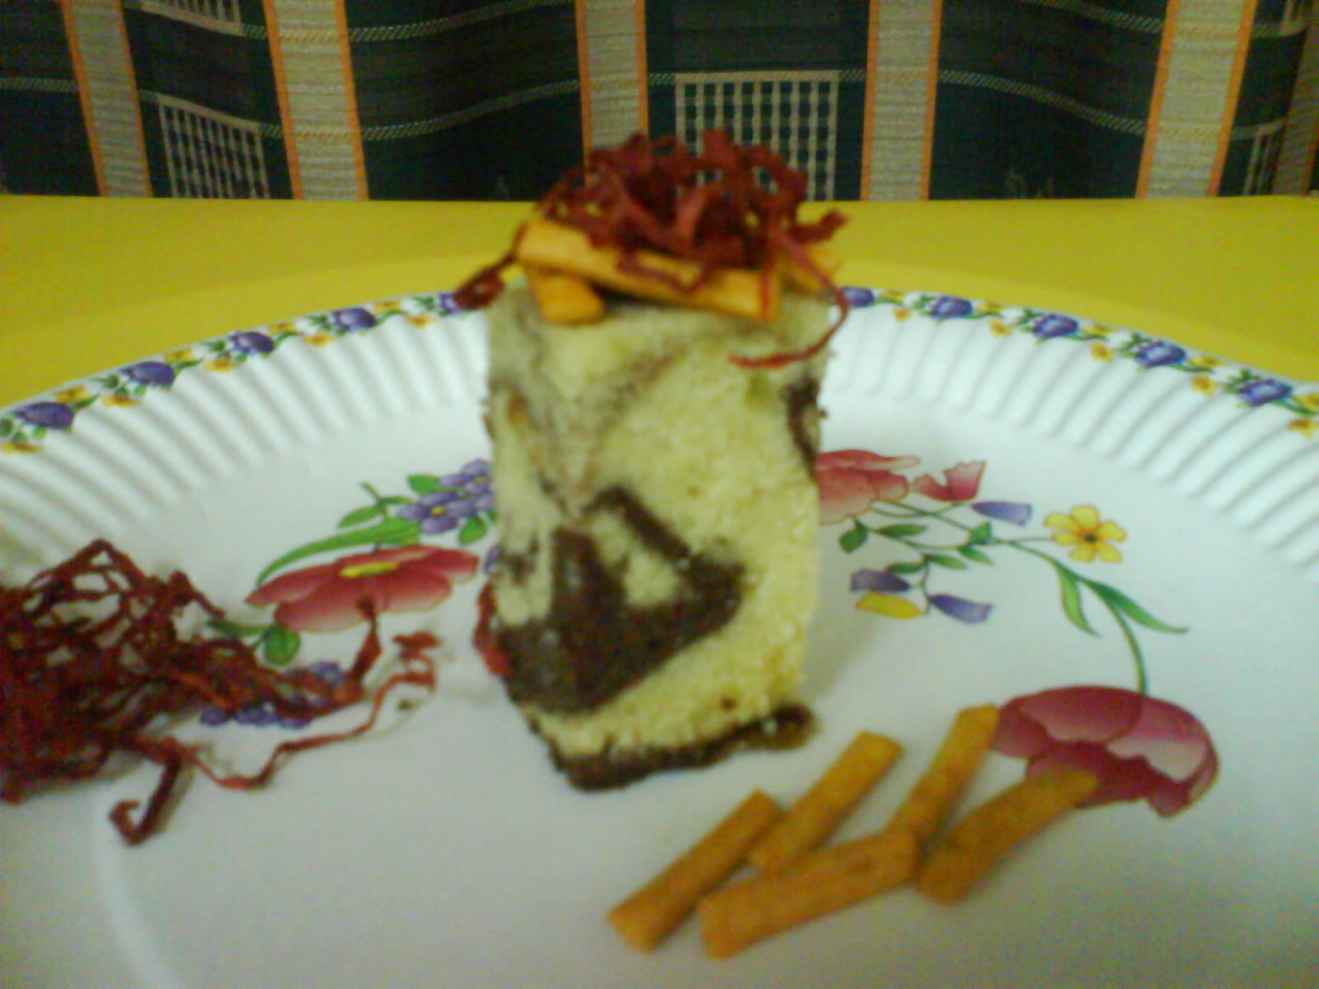

As the children work, review the story. Remind them that fire doesn’t burn in water. But because God is powerful, He could make fire even in water. Review the take home point. *GOD IS POWERFUL – pray to God for help. Ask the children to name times they need to pray to God for help—when they are sick, when they are afraid, when they are naughty and need to be forgiven, etc.

Activity 4: “Praying Hands Song”
Purpose: Help kids to memorize and keep scriptures at heart. Using creative ways to help kids enjoy learning the key verse and in small group setting.

Supplies needed: Enlarged praying hands, marker.

Memory Verse: Jeremiah 33:3 ~ Pray to me and I will answer you. (NCV)

Memory Verse Learning:
Paste the praying hands on the wall before class. Sit the children down as they learn this memory verse together. The words of the Bible verse are all dotted or tinted. Get each child to trace a word as their names are being called. After tracing the words, recite the memory verse a few times with the children. Then get the children to sing the memory verse to the tune of “London Bridge”.

“Pray to me and I will answer you,
I will answer you,
I will answer you,
Pray to me and I will answer you,
Jeremiah triple three.”

Pray
to me
and
answer
I will
you.
Jer. 33:3

Prayer Time:
Explain to the children that Christians often pray “in Jesus’ name.” Because of Jesus, we have the power to pray to God. As you pray today, ask God for his help with problems. End with the words, “In Jesus’ name. Amen.” Finish your prayer time with the Lord’s Prayer.

Large Group Wrap-Up: (10 minutes)
Purpose: The crazy bird puppet, Xiao Er, struggles with learning the take home point. The presenter shows an example of each small group application activity from this lesson and says the first phrase of the take home point. The kids respond with their phrase. They try to teach the puppet the take home point, but each time he confuses words or concepts. After three attempts, he finally gets it right and sings the correct take home point in a silly opera like voice.

Supplies needed: Xiao Er puppet; sample activities; choose two or three songs from your church music library

Singing: (Optional)

Lesson Review with Puppet Skit:

Presenter shows Xiao Er a craft made in Activity 1. Then the kids attempt to teach Xiao Er the take home point.

Presenter says to kids: “God is powerful…”
Kids say: “…pray to God for help.”
Presenter says to Xiao Er: “God is powerful…”
Xiao Er says: “Bears live in caves.”

Presenter shows an example of the next activity done in small group and repeats first phrase to kids. The kids say the correct response trying to teach Xiao Er the take home point. Continue in this manner with Presenter showing example of each activity. Here are Xiao Er’s responses:

Xiao Er’s response to Activity 2 sample: “Bats live in caves.”
Xiao Er’s response to Activity 3 sample: “(Presenter’s name) lives in a cave.”
Xiao Er’s response to Activity 4 sample: “Whoa! God’s big hands can save me.”

Presenter says: “Xiao er, listen one last time.
God is powerful…”
Kids’ response: “…pray to God for help.”
Presenter says to Xiao Er: “God is powerful…”
Xiao Er’s response: (Warms up his singing voice with “Mee, mee, mee, mee, mee…” and sings in a silly dramatic opera-like voice) “GOD IS POWERFUL – PRAY TO GOD FOR HELP.”

Welcome guests and thank them for attending.

Lesson 24

Large Group Opening:
- Ting Ting puppet
- barbell (Use the one for Activity 2)
- sweatband for Ting Ting (optional)
- “kingly” adult-sized robe
- king’s crown
- bathrobe (adult size)
- altar made by covering a cardboard box with brown paper torn in random shapes
- newspaper rocks – to make out of newspaper
- two large slabs of “meat”
- four empty, plastic jugs or mugs each filled with about a cup of water. (Be sure to clean well and poke several holes in the top of each jug.)
- lighter
- 6-12 sticks
- toy or real microphone
- picture of the story “Elijah and the Prophets of Baal”
- masking tape

Small Group Application:
Activity 1:
- one piece of blue manila card per child
- 1/2 piece of gray colour paper per child
- red, orange, and yellow crepe paper cut into 2-inch squares. 2-3 pieces of each color per child
- glue
- labels with take home point
Activity 2:
- two barbells made from paper towel tube and two balloons. Connect two filled balloons with rubber band through the tube.
Activity 3:
- one square banana cake per child
- three finger biscuits per child
- three/four red preserve plum pieces per child
- one serviettes per child
Activity 4:
- marker
- enlarge the praying hands on p.14 to A3 size. The words of the Bible verse can be dotted or tinted.

Large Group Wrap-Up:
- Xiao Er puppet
- sample activities
- choose two or three songs from your church music library
Pray
to me
and
answer
I will
you.
Jer. 33:3

