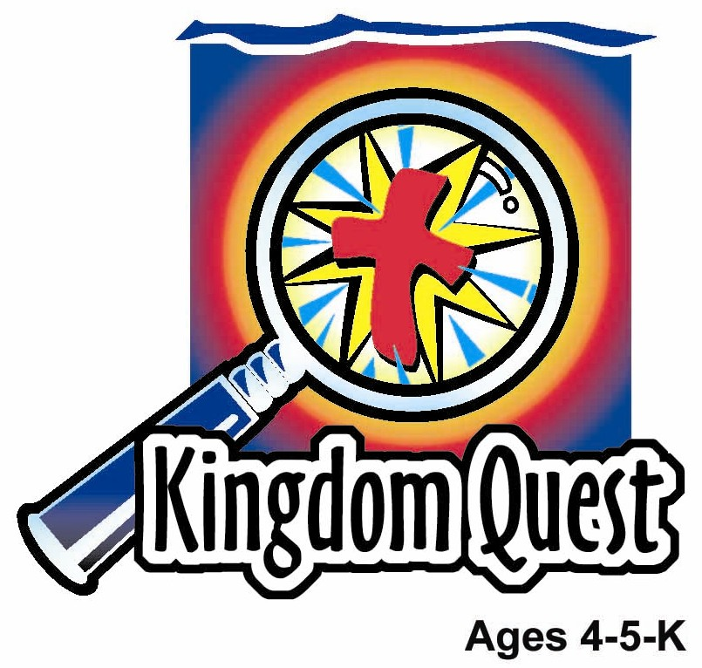
Date: _____________________
Series: God Is Our King (Sept-Nov)

Year 1, Lesson 18

God Wins a Battle for King Jehoshaphat

Take Home Point: * GOD IS OUR KING – God will help us win.
*Repeat this phrase throughout the lesson.

Bible Event: 2 Chronicles 20:1-29

Jesus Link: We can feel like winners, no matter what, when Jesus is in our hearts.

We will help children know:
- When King Jehoshaphat went to war, God helped him.
- When we have problems, God also helps us.

We will help the children feel:
- Confident in God’s power.
- Secure knowing that God wants to help them.

We will help the children do:
- Play a game that will remind them to turn to God.
- Learn and practice a cheer that reminds them of God’s power.
- Ask God to help them with their problems.
THIS LESSON’S ROADMAP

DESTINATION | PAGE # | DISCOVERIES ON YOUR JOURNEY | SUPPLIES NEEDED
Large Group Opening   | 3  3-5 | Puppet Presentation  Bible Event | - Xiao Hung puppet  - cloth, such as a blanket, to be used as a superhero cape  - paper crown  - stop sign
Small Group Application   | 6  6  7  7 | Activity 1: “Winning Ribbon” Craft  Activity 2: “Turn” Game  Activity 3: “Trophy“ Snack  Activity 4: “Strong and Safe”  Prayer Time | Activity 1:  - one photocopied ribbon sheet per child  - colour pencils  - cellophane tape  - two, 4-inch strands of wide ribbon per child  - several scissors per group  - glue  Activity 2:  - none  Activity 3:  - a cream cracker for each child  - ½ “Kuih Lapis” for each child  - a patterned snack for each child  - serviettes  Activity 4:  - whiteboard  - marker  - four chairs
Large Group Wrap-up   | 8  8 | Lesson Review with Puppet Skit  Singing (Optional) | - Xiao Er puppet  - sample material from each activity  - choose two or three songs from your church music library

Pre-Session Singing: (10 minutes)
Purpose: When all children are in one group singing, it is easy for new children to join the group and immediately get involved. When the music can be correlated, it introduces the theme for the day.

Choose two to three songs.

Large Group Opening: (15 minutes)
Purpose: The puppet demonstrates the need that will be met in today’s lesson. The scripts are not written verbatim, but give a story line in which the group leader can interact with the puppet. The children are introduced to the take home point and then interact with God’s Word, as they experience the Bible event.

Supplies needed: Xiao Hung puppet; cloth, such as a blanket, to be used as a superhero cape; paper crown; stop sign

Puppet Presentation:
Xiao Hung jumps out wearing a “superhero cape” around his neck. The leader asks Xiao Hung why he is dressed like a superhero. Xiao Hung shares that a standard 3 bully has been teasing him on the playground. With the cape around his neck, he is a superhero and can fight and win against the bully.

The leader asks Xiao Hung if he really thinks the cape makes him more powerful. Xiao Hung thinks for a moment and then answers that it probably doesn’t make him stronger. Now Xiao Hung is worried.

The leader tells Xiao Hung that today the children are going to learn that God is more powerful than the bully, and God will help Xiao Hung. The leader encourages Xiao Hung to ask God to help him with the bully. Then the leader shares today’s special words. *GOD IS OUR KING – God will help us win.

Bible Event:
In this Bible event the leader will lead and act out the narrative, and the children will act out the narrative with him.

Introduce the story by saying:

Boys and girls, today you are going to pretend to be Israelites and help me tell the Bible event. As I tell the story and do the actions, you do the actions with me. (Some of the action queues are in parentheses, but feel free to make up your own.)

Many years ago, there was a king in Israel named Jehoshaphat. Can you say Jehoshaphat? (Crown is placed on head.) King Jehoshaphat was a godly king who wanted to serve God. He knew that really God was the king. He was about to find out that with God on his side, God would help him win.

One day, some men came running (run in place) up to King Jehoshaphat. They were worried. (Make a worried face.) A big army had come to attack their country and they had come to tell the king.

King Jehoshaphat was also worried, so he decided to ask God for help. He asked the Israelites to fast, which means to not eat any food. Instead, they would spend the time praying (fold hands) to God. When people did this, they were showing they were counting on God (point up) to help them more than just their own strength (flex arm muscles) that comes from eating food. All the people agreed and from all over the country they came to the temple. This was the church in Jerusalem. There they prayed (fold hands) instead of eating (rub stomachs) and counted on (point up) God’s help to save them.

Then King Jehoshaphat said a special prayer. (Fold hands, palm-to-palm, in front of chest.)

Oh Lord God, you are in heaven and you rule the earth. You are powerful. No one can stand against you. An army is trying to fight against us. We cry for your help. You will hear us and save us. We don’t know what to do, so we look to you for help.

After the prayer, a man named Jahaziel gave the people a message from God. He said, “This is what the Lord says, ‘Don’t be afraid because they have a big army.’ God will fight for you because it is His battle, not yours.” God would win their war!

So the Israelites knew, *GOD IS OUR KING – God will help us win.

The next day the Israelites marched to battle. (March in place.) King Jehoshaphat led the way. As they (march in place) marched they began to make music and praise God. While the Israelites praised God and they were still a long way away from their enemies, God confused the other army and they began to fight against one another.

The Israelites (march in place) marched into the camp. They found all their enemies dead. They were saved! (Hold hands up in the air and wave them.) They all yelled together, “Yaaaay!” They had learned, *GOD IS OUR KING—God will help us win. King Jehoshaphat led the soldiers back to Jerusalem singing and rejoicing. (Make a horn with hands and toot.)

God didn’t only help the Israelites. When we have problems, God can help us too! Let’s practice our special words. *GOD IS OUR KING – God will help us win!

Teach the children a game. They will have a problem and act out their feelings. You then say the first half of the take home point and they respond with the second half. Use the following scenarios:

- Let’s pretend it’s bedtime. You think there is a monster in your closet. Can you act scared? (Show children how to hug themselves and shiver.) But...stop! *GOD IS OUR KING—God will help us win!

- Let’s pretend it is the first day of school. You are going into a new class and you’re worried. (Show children how to “nibble” their fingernails and wiggle their bodies.) But…stop! *GOD IS OUR KING—God will help us win!

- Pretend you are playing on the playground and your friend takes a ball away from you and runs away. Can you show me how sad you are? (Show children how to pretend cry.) But…stop *GOD IS OUR KING—God will help us win!)

End with a brief prayer.

Small Group Application: (30 minutes)
Purpose: Smaller groups enable children to develop closer relationships with adults and peers in the church. As you reinforce the take home point with a fun hands-on activity, discuss the Bible event. Be sure to repeat the take home point several times. Say the first part and have the children respond with the second phrase. Application questions help kids apply the take home point to their daily lives. Close this session by gathering your small group for prayer. Let the kids pray!

During the small group application time, discuss the following questions and points:

Why were King Jehoshaphat and the Israelites scared in the Bible event? (A big army wanted to fight them.)

What scares you?

How did the Israelites look for God’s help? (They fasted, prayed, and praised God.)

How did God help the Israelites to win? (He confused the other army so they fought each other.)

If you want God’s help, what should you do? (Pray, read God’s Word, sing, etc.)

Who was God’s Son, sent to help you, so that your sins can be taken away and you could be friends forever with God? (Jesus.)

Activity 1: “Winning Ribbon” Craft
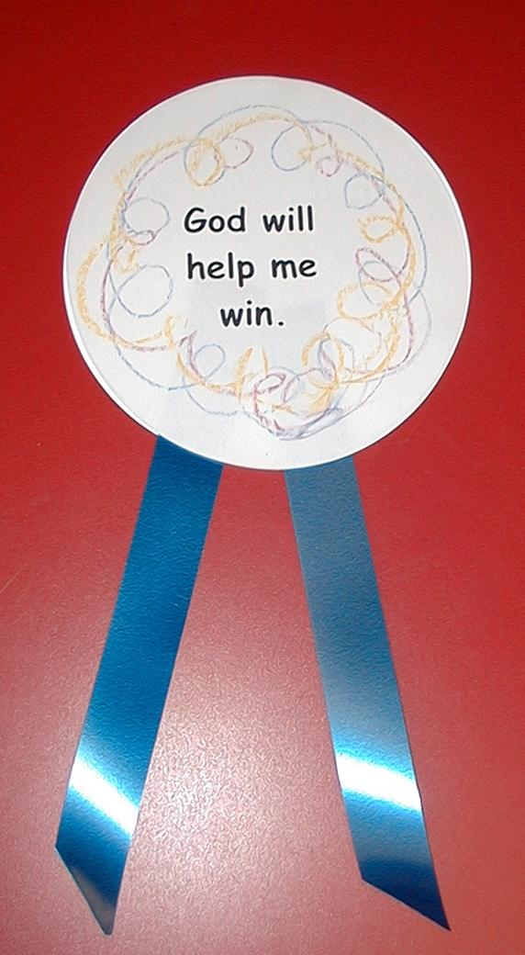
Supplies needed: one photocopied ribbon sheet per child; colour pencils; glue; two, 4-inch strands of wide ribbon per child; several scissors per group; cellophane tape

Hand out the photocopied sheets. Let the children color the circle with the words. Have them cut out the circles and glue the ribbons onto the plain circle. (Some children may need help cutting. To save time cut out more than one circle at a time.) Glue the circle with the words on top of the circle with the ribbons. When they are finished with their “ribbons,” tape them to their clothes.

As the children work, practice the take home phrase. You say the first part, the children say the second phrase. *GOD IS OUR KING – God will help us win! Explain that they are ribbon winners because Jesus loves them and God helps them when they have problems.

Activity 2: “Turn” Game
Supplies needed: none

Have the children stand in a line facing away from you. Tell them an activity and have them do the activity until you say, “Turn!” The children must stop the activity and turn around as quickly as possible. Use the following activities:
- run in place
- jump up and down
- wiggle your whole body
- do knee bends (Children may need to be taught how to do knee bends.)
- do jumping jacks (Again, children may need to be taught how to do jumping jacks.)
- march in place
- kick your legs in the air
- bend your body up and down
- wave your arms in the air
- shake your legs

Have the children sit down and take some deep breaths to calm down. Explain that, just like they turned to you, when they have problems, they can turn to God and he will help them. They can turn to God by praying, singing, or listening to a Bible book. Practice the take home point. *GOD IS OUR KING – God will help us win!

Activity 3: “Trophy” Snack
Supplies needed: a cream cracker for each child, ½ “Kuih Lapis” for each child,
a patterned snack for each child, serviettes and/or hand wipes

Give each child ½ kuih lapis. Have the children stick their ‘kuih lapis’ on the cream cracker base. Give each child a patterned snack and have them stick their doughnuts into the ‘kuih lapis’. They now have a #1 trophy.

As the children work, discuss who gets trophies—usually
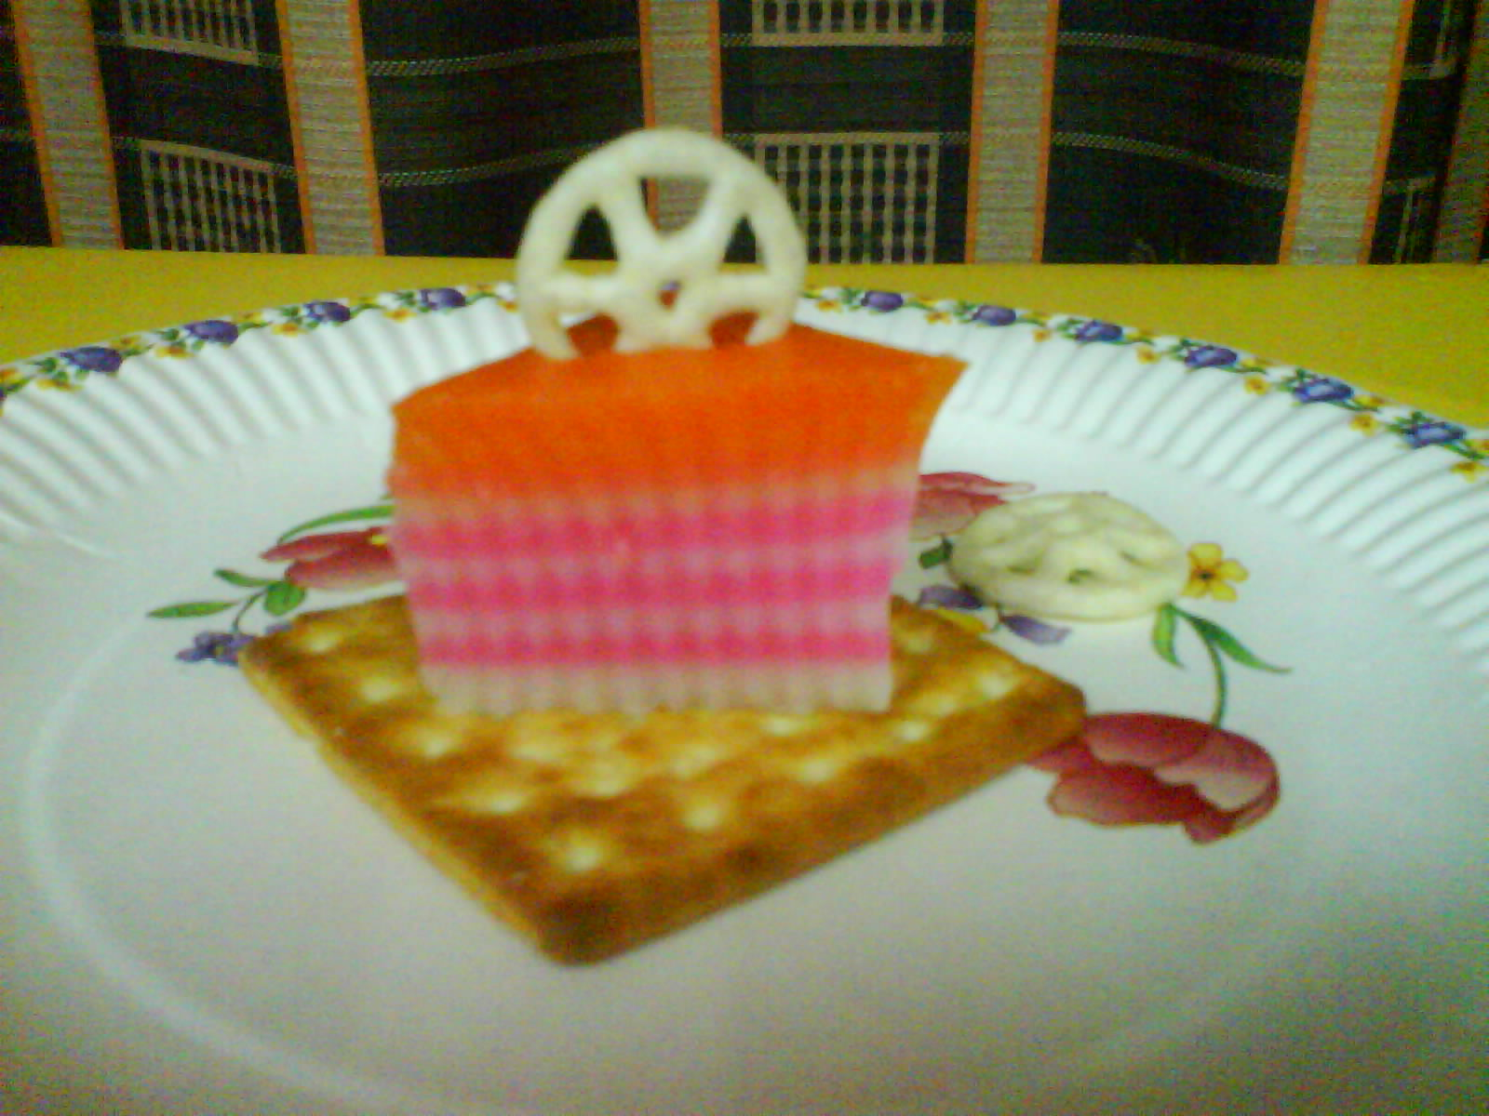
a person or team that wins something. Say:

With God, we are all winners, only we don’t win a trophy. We win God’s help. And we don’t win because we did something good. We win because God loves us and Jesus died for us. That’s the best news of all!

Practice the take home point. *GOD IS OUR KING – God will help us win!

Activity 4: “Strong and Safe”
Purpose: Help kids to memorize and keep scriptures at heart. Using creative ways to help kids enjoy learning the key verse and in small group setting.

Supplies needed: whiteboard, marker, four chairs

Memory Verse: 2 Chronicles 20: 17 ~ Just stand strong in your place. You will see the Lord save you.

Memory Verse Learning:
Before class, arrange four chairs in a roll. At the beginning of session, recite the memory verse with the children a few times. Then tell the children you believe that they are strong enough to walk across the chairs. Now they can have a turn but first they must recite the memory verse before walking. (Shepherds need to watch over each child or to hold their hands as they walk on the chairs.) Allow the children to have as many rounds as time permits. Finally, recite the memory verse together before Prayer Time.

Prayer Time:
Gather in a circle and have the children pray by completing the following sentence prayer:
Dear God, please help me…

End with the Lord’s Prayer.

Large Group Wrap-Up: (10 minutes)
Purpose: The crazy bird puppet, Xiao Er, struggles with learning the take home point. The leader shows an example of each small group application activity from this lesson and says the first phrase of the take home point. The kids respond with their phrase. They try to teach the puppet the take home point, but each time he confuses words or concepts. After three attempts, he finally gets it right and sings the correct take home point in a silly opera like voice.

Supplies needed: Xiao Er puppet; sample material from each activity; choose two or three songs from your church music library

Singing: (Optional)

Lesson Review with Puppet Skit:
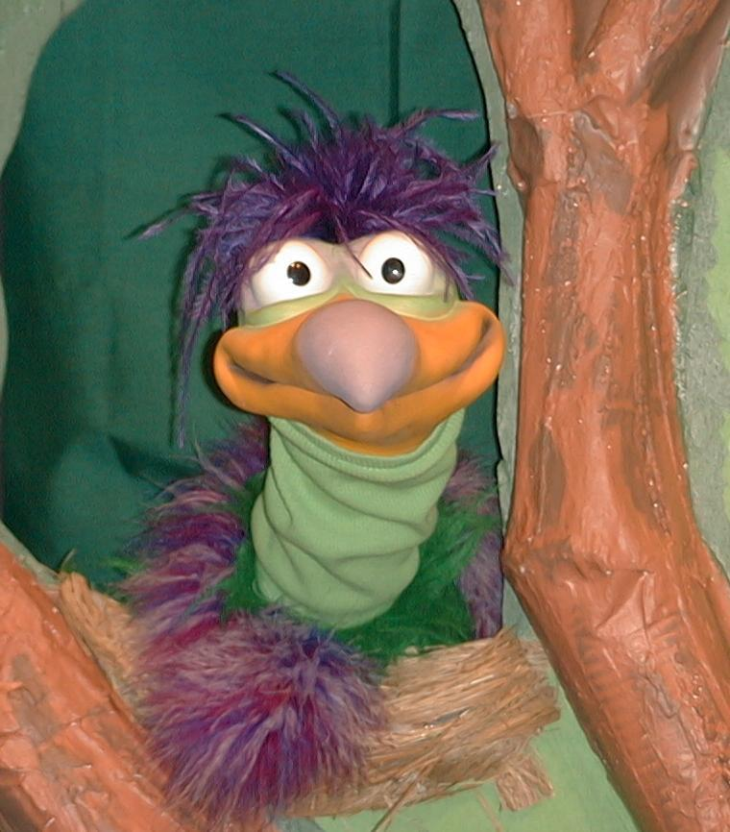
Presenter shows Xiao Er a craft made in Activity 1. Then the kids attempt to teach Xiao Er the take home point.

Presenter says to kids: “God is our King…”
Kids say: “…God will help us win.”
Presenter says to Xiao Er: “God is our King…”
Xiao Er says: “I’m glad I’m not named” Jes-ophatty-catty-ding-dong.”

Presenter shows an example of the next activity done in small group and repeats first phrase to kids. The kids say the correct response trying to teach Xiao Er the take home point. Continue in this manner with Presenter showing example of each activity. Here are Xiao Er’s responses:

Xiao Er’s response to Activity 2 sample: “Turn, turn, turn.” (Make Xiao Er
turn back towards children)
Xiao Er’s response to Activity 3 sample: “Mmmm…marshmallows….”

Presenter says: “Xiao Er, listen one last time.
God is our King…”
Kids response: “God will help us win.”
Presenter says to Xiao Er: “God is our King…”
Xiao Er’s response: (Warms up his singing voice with “Mee,
mee, mee, mee, mee…” and sings in a silly dramatic opera-like voice) “GOD IS OUR KING – GOD WILL HELP US WIN.”

Welcome guests and thank them for attending.

Lesson 18
Large Group Opening:
- Xiao Hung puppet
- cloth, such as a dishtowel, to be used as a superhero cape
- paper crown
- stop sign made from red, octagon-shaped paper taped to a tongue dispenser

Small Group Application:
Activity 1:
- one photocopied ribbon sheet per child (see attached)
- colour pencils
- glue
- two, 4-inch strands of wide ribbon per child
- several scissors per group
- cellophane tape

Activity 2:
- none

Activity 3:
- a cream cracker for each child
- ½ “Kuih Lapis” for each child
- a patterned snack for each child (purchased at pasar malam)
- peanut butter (frosting if peanut free environment)
- plastic knives or tongue depressors for each child
- serviettes and/or hand wipes

Activity 4:
- whiteboard
- marker
- four chairs

Large Group Wrap-up:
- Xiao Er puppet
- sample material from each activity

Optional Music for the Lesson:
- choose two or three songs from your church music library

God will

help me

win.

