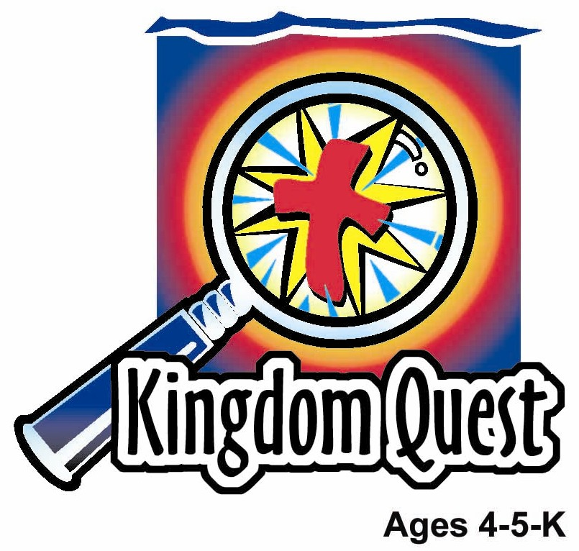
Date: _____________________
Series: God Is Our King (Sept-Nov)

Year 1, Lesson 19

King Hezekiah Prays and God Answers

Take Home Point: *GOD IS OUR KING – Pray to the King.

*Repeat this phrase throughout the lesson.

Bible Event: 2 Kings 18-19, 2 Chronicles 32:1-22
Jesus Link: We can pray to Jesus, too!

We will help children know:
- King Hezekiah prayed to God for help and God answered.
- We, too, can pray to God for help and He will answer.

We will help the children feel:
- Happy that they can talk to God in prayer.
- Certain that God answers prayer.
- Eager to pray to God.

We will help the children do:
- Make a prayer pouch to help them remember to pray at home.
- Play a game that helps them practice asking prayers.
THIS LESSON’S ROADMAP

DESTINATION | PAGE # | DISCOVERIES ON YOUR JOURNEY | SUPPLIES NEEDED
Large Group Opening   | 3  3-5 | Puppet Presentation  Bible Event | - Ting Ting puppet  - small stuffed animal  - paper crown  - one real or toy microphone  - “Yea!” and “Boo!” sign  - King Hezekiah costume
Small Group Application   | 5-6  6  6  7 | Activity 1: “Prayer Pouch” Craft  Activity 2: “Prayer Game”  Activity 3: “Folded Jam Sandwiches” Snack  Activity 4: “We’ve Got to Pray”  Prayer Time | Activity 1:  - paper plate for each child  - several pairs of scissors for each group  - stapler  - colour pencils  - Prayer Page for each child (see attached)  Activity 2:  - large plastic bag for each group  - large stack of newspapers  Activity 3:  - one slice of bread for each child  - one plastic knife or tongue depressor for each child  - paper towels or hand wipes  - jam  Activity 4:  - white board  - marker
Large Group Wrap-up   | 8  8 | Lesson Review with Puppet Skit  Singing (Optional) | - Xiao Er Puppet  - sample materials from each activity  - choose two or three songs from your church music library

Pre-Session Singing: (10 minutes)
Purpose: When all children are in one group singing, it is easy for new children to join the group and immediately get involved. When the music can be correlated, it introduces the theme for the day.

Choose two to three songs.

Large Group Opening: (15 minutes)
Purpose: The puppet demonstrates the need that will be met in today’s lesson. The scripts are not written verbatim, but give a story line in which the group leader can interact with the puppet. The children are introduced to the take home point and then interact with God’s Word, as they experience the Bible event.

Supplies needed: Ting Ting puppet; small stuffed animal; paper crown; one real or toy microphone; “Yea!” and “Boo!” sign; King Hezekiah costume

Puppet Presentation:
Ting Ting comes out holding a small stuffed animal she calls “Comel.” She tells the leader and the children that she talks to Comel whenever she’s happy or sad. Comel always listens to her, even when her mommy and daddy are busy.

The leader says how wonderful it is that Ting Ting can talk to Comel. Then he says there is someone else we can always talk to. That someone else is God the Father. When we talk to God, it is called prayer. We can also talk to Jesus. Share this week’s take home point. *GOD IS OUR KING – pray to the King.

Bible Event:
Introduce the Bible event by saying:

Today, during the Bible event, I am going to hold up a sign that says, “Yea!” and has a smiley face on one side, and says, “Boo!” and has a sad face on the other side. (Show the sign.) When I hold up the smiley face, I will say, “Yea!”, and you say, “Yea!”, also. When I hold up the sad face, I will say, “Boo!”, and you also say, “Boo!” (Practice a couple times.)

Today, we are going to hear about King Hezekiah who faced another king who wanted to fight his country. King Hezekiah prayed to God and God answered his prayer. To tell the story, I am going to interview someone who is pretending to be King Hezekiah. King Hezekiah, can you come out please?

Interviewer: Welcome, King Hezekiah. I understand that you and the Israelites have had some pretty hard problems recently.

King Hezekiah: Yes, we have. But we prayed to God for help and God answered our prayers. (Yea!)

Interviewer: Tell us what happened.

King Hezekiah: Sennacherib, the king of Assyria, came to fight against my country, Judah. (Boo!)

Interviewer: What happened then?

King Hezekiah: We blocked off the water from the other army. We also fixed our wall and made new walls, built towers, and made new weapons and shields. (Yea!)

Interviewer: I guess that made everyone feel a lot better.

King Hezekiah: I still thought my people might be worried, so I gathered them together. I told them not to be worried, because God is more powerful than the other army and would help us fight our battles. That made the people feel better. (Yea!)

Interviewer: Then what happened?

King Hezekiah: Later King Sennacherib started to tease us and try to make us afraid of him. He said he had beaten other kings and could win against our God, too. He even sent us a letter that made fun of God. (Boo!)

Interviewer: Did that scare your people?

King Hezekiah: A man of God named Isaiah and I prayed to God for help. God answered our prayer. We reminded God that this evil king had made fun of him, and said that his false god was much stronger than the true and living God. (Boo!) We knew our God was the only God. Our God would defend us and defend our name. (Yea!) After we prayed, we woke up the next morning and you won’t believe what we saw. Outside our city had been thousands and thousands and thousands of soldiers. Now they were all dead. In the middle of the night, God had sent and angel to fight and win against King Sennacherib and his army. God saved us! (Yea!)

Interviewer: That’s wonderful, King Hezekiah! Did you learn anything from that?

King Hezekiah: Yes, I did. I learned that the real King is God. I learned, *GOD IS OUR KING – pray to the King. (Yea!)

Interviewer: Wow, King Hezekiah! Those are the words we are learning today! Thank you for sharing your story with us. I hope you can come back sometime.

King Hezekiah exits. Thank helpers and have them sit down. End with a short prayer.

Small Group Application: (30 minutes)
Purpose: Smaller groups enable children to develop closer relationships with adults and peers in the church. As you reinforce the take home point with a fun hands-on activity, discuss the Bible event. Be sure to repeat the take home point several times. Say the first part and have the children respond with the second phrase. Application questions help kids apply the take home point to their daily lives. Close this session by gathering your small group for prayer. Let the kids pray!

During the small group application time, discuss the following questions and points:

What problem did King Hezekiah and his people face in today’s Bible event? (King Sennacherib wanted to conquer them.)

How did King Hezekiah and his people solve their problem? (They asked God for help by praying.)

What problems do you face? (Answers will vary.)

How can you get help when you have a problem? (Ask an adult and pray to God.)

Tell me a time when God answered one of your prayers. (This may be a difficult question for children to answer, so be prepared to share a time when God helped you.)
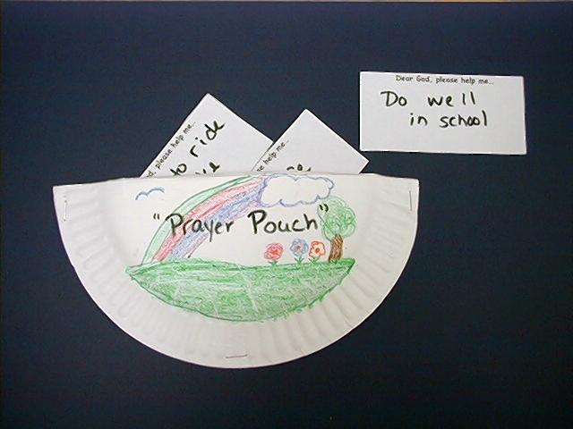
Activity 1: “Prayer Pouch” Craft
Supplies needed: paper plate for each child; several pairs of scissors for each group; stapler; colour pencils; Prayer Page for each child (see attached)

Have the children make prayer pouches using the following directions:

- Fold a paper plate in half.
- Cut down the fold.

- Decorate the backside of each half with colour pencils.
- Glue the two halves of the paper plate together, making a pouch. Be sure to leave the straight edge open.
- Cut apart the Prayer Page.
- Place the pieces of the Prayer Page in the pouch.
- If time allows, write the words “Prayer Pouch” on each child’s project.

As the children work, explain the purpose of the prayer pouches is to help them remember to pray to the King. They can take them home and draw pictures of prayers on the slips of paper. Then they can put those slips of paper in their pouches. At night they can take out the pictures and use them to help them pray. Remind them of the special words, *GOD IS OUR KING – pray to the King!

Activity 2: “Prayer Game”
Supplies needed: large plastic bag for each group; large stack of newspapers

The purpose of the game is to fill a plastic bag with the children’s prayers. Have the children wad up a bunch of newspapers into balls, and one-by-one, throw the balls into the plastic bag as they complete the sentence, “Dear God, please help me….” Some children may have difficulty finishing the sentence. Following are some ideas for prompting them:
- Learn to ride a bike.
- Be nice to my sister or brother.
- Be safe.
- Do well in school.
- Help my mom.
- Listen to my dad.
- Not be scared at night.
- Always love you.
Some children may be especially shy. Let them say their prayers in their heads. As the children play this game, remind them they can fill their lives with prayers, just as they filled the plastic bag with prayers. Review the special words, *GOD IS OUR KING – pray to the King.

Activity 3: “Folded Jam Sandwiches” Snack
Supplies needed: one slice of bread for each child; one plastic knife or tongue depressor for each child; paper towels or hand wipes; jam

Give each child a paper towel and a slice of bread. Spoon some jam onto each child’s bread and let them spread it with the tongue depressor or plastic knife. Have them fold the bread in half to make a sandwich. Have the children fold their hands to say a table prayer.

As the children eat, remind them that just as the sandwich is folded, they folded their hands to pray. But folding hands isn’t the only way to pray. Together review the ways they practiced praying during large group time. (Lying down, arms folded, hands folded, hands raised, etc.) Explain that prayer is simply talking to God. Review the take home point. *GOD IS OUR KING – pray to the King.

Activity 4: “ We’ve Got to Pray”
Purpose: Help kids to memorize and keep scriptures at heart. Using creative ways to help kids enjoy learning the key verse and in small group setting.

Supplies needed: white board, marker

Memory Verse: 2 Chronicles 20: 17 ~ Just stand strong in your place. You will see the Lord save you.

Memory Verse Learning:
Recite the memory verse a few times with the children. Sit the children in a circle. Ask a child to present a prayer request and the Shepherd prays with him. Then, get him to recite the memory verse. Every child would have a turn.

Prayer Time:
Gather in a circle and have the children raise their hands to pray. This is how the people often prayed in King Hezekiah’s time. Have them complete the following prayer sentence:

Dear God, I ask you to…

End with the Lord’s Prayer.

Large Group Wrap-Up: (10 minutes)
Purpose: The crazy bird puppet, Xiao Er, struggles with learning the take home point. The leader shows an example of each small group application activity from this lesson and says the first phrase of the take home point. The kids respond with their phrase. They try to teach the puppet the take home point, but each time he confuses words or concepts. After three attempts, he finally gets it right and sings the correct take home point in a silly oper- like voice.

Supplies needed: Xiao Er Puppet; sample materials from each activity; choose two or three songs from your church music library

Singing: (Optional)

Lesson Review with Puppet Skit:
Presenter shows Xiao Er a craft made in Activity 1. Then the kids attempt to teach Xiao Er the take home point.
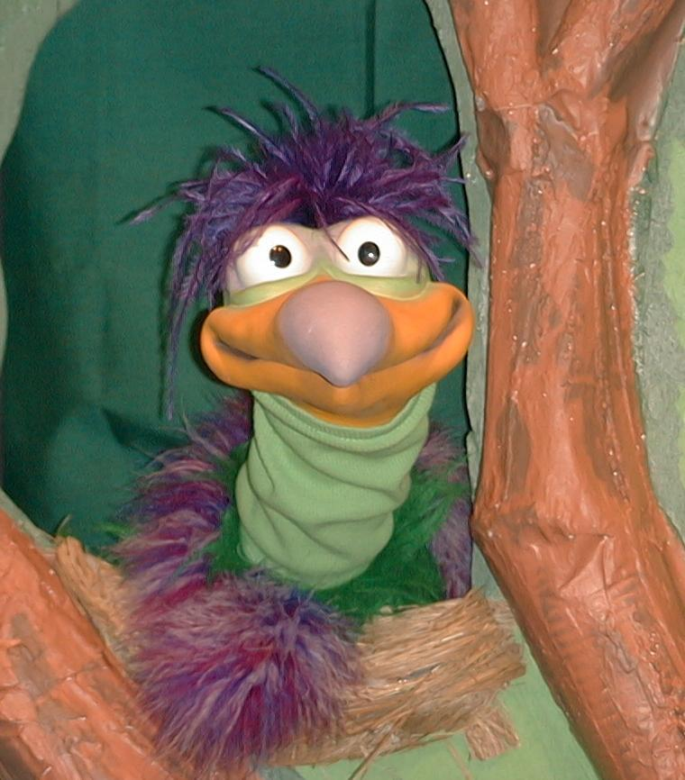
Presenter says to kids: “God is our King…”
Kids say: “…pray to the King.”
Presenter says to Xiao Er: “God is our King…”
Xiao Er says: “Phang picked pickled peppers playing ping-pong.”

Presenter shows an example of the next activity done in small group and repeats first phrase to kids. The kids say the correct response trying to teach Xiao Er the take home point. Continue in this manner with Presenter showing example of each activity. Here are Xiao Er’s responses:

Xiao Er’s response to Activity 2 sample: “Dear God, Help me get the snack!”

Xiao Er’s response to Activity 3 sample: “mmmmm…Jelly.” (pretend to drool)

Presenter says: “Xiao Er, listen one last time.
God is our King…”
Kids response: “…pray to the King.”
Presenter says to Xiao Er: “God is our King…”
Xiao’s response: (Warms up his singing voice with “Mee,
mee, mee, mee, mee…” and sings in a silly dramatic opera-like voice) “God is our King – Pray to the King.”

Welcome guests and thank them for attending.

Lesson 19
Large Group Opening:
- Ting Ting puppet
- small stuffed animal
- paper crown
- one real or toy microphone (A microphone can also be made by gluing a foam ball to a toilet paper tube.)
- “Yea!” and “Boo!” sign*
- King Hezekiah costume

*To make the “Yea!” and “Boo!” sign write “Yea!’ and a smiley face on a piece of manila card and “Boo!” and a frowning face on another piece of manila card. Glue the two pieces of manila card to opposite sides of a tongue depressor.

Small Group Application:
Activity 1:
- paper plate for each child
- several pairs of scissors for each group
- stapler
- crayons or markers
- Prayer Page for each child (see attached)

Activity 2:
- large plastic bag for each group
- large stack of newspapers

Activity 3:
- one slice of bread for each child
- one plastic knife or tongue depressor for each child
- paper towels or hand wipes
- jam

Activity 4:
- white board
- marker

Large Group Wrap-Up:
- Xiao Er Puppet
- sample materials from each activity

Optional Music for the Lesson:
- choose two or three related songs from your church music library

Lesson #19, Activity 1, Prayer Pouch
Dear God, please help me… | Dear God, please help me…
Dear God, please help me… | Dear God, please help me…
Dear God, please help me… | Dear God, please help me…
Dear God, please help me… | Dear God, please help me…

