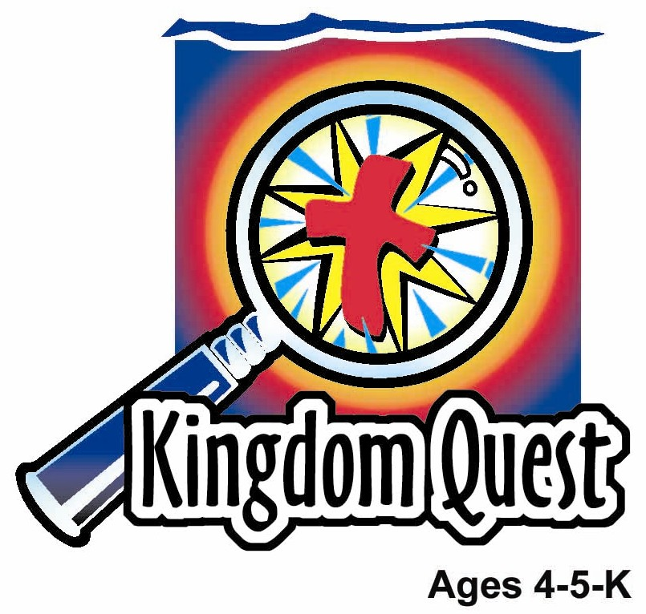
Date: _____________________
Series: God Is Our King (Sept-Nov)
Year 1, Lesson 20

Year 1, Lesson 19

Josiah Hears God’s Word

Take Home Point: *GOD IS OUR KING - God’s word rules!

*Repeat this phrase throughout the lesson.

Bible Event: 2 Chronicles 34:14-33
Jesus Link: God’s Word tells us about Jesus.

We will help children know:
- When King Josiah learned about God’s Word, he wanted to read and follow it.
- God wants us to read and follow His Word, too.
- God’s Word is true and it tells us the wonderful story of God’s love.

We will help the children feel:
- Eager to learn God’s Word.
- Confident that God’s Word is true.
- Happy that God’s Word shares God’s love.

We will help the children do:
- Tell the story of King Josiah using a puzzle.
- Ask God for help with their problems.
- Make a scroll to remind them that God’s Word rules.
THIS LESSON’S ROADMAP

DESTINATION | PAGE # | DISCOVERIES ON YOUR JOURNEY | SUPPLIES NEEDED
Large Group Opening  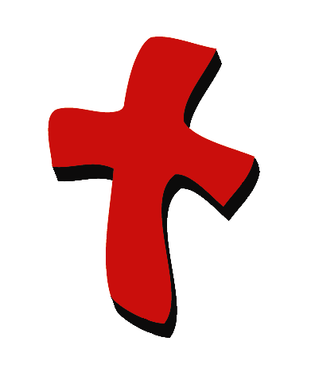 | 3  3-5 | Puppet Presentation  Bible Event | - Ting Ting and Xiao Hung puppets  - Several playing cards taped to Ting Ting and Xiao Hung’s hands. One of Ting Ting’s cards should be a king; one of Xiao Hung’s, an ace  - “kingly” robe  - king’s crown  - paper scroll made from two short broomsticks and a crumpled brown paper  - children’s Bible with the puzzle from the appendix cut apart and taped to it reassembled  - music stand
Small Group Application   | 6  6  7  7  7 | Activity 1: “Scroll Picture”  Activity 2: “Alphabet Snack”  Activity 3: “Follow the Leader”  Activity 4: “Show and Tell”  Prayer Time | Activity 1:  - 1 sheet of white paper for each child  - colour pencils for each group  - 12-inch length of yarn for each child  Activity 2:  - alphabet biscuits (enough for a handful per child, with some left over)  - serviette (1 per child)  - paper cups (1 per child)  Activity 3:  - No supplies  Activity 4:  - a circle (cut out from manila card) for each child  - Colour pencil
Large Group Wrap-up   | 8  8 | Lesson Review with Puppet Skit  Singing (Optional) | - Xiao Er puppet  - Samples of activities  - Choose 2 or 3 songs from your church music library

Pre-Session Singing: (10 minutes)
Purpose: When all children are in one group singing, it is easy for new children to join the group and immediately get involved. When the music can be correlated, it introduces the theme for the day.

Choose two to three songs.

Large Group Opening: (15 minutes)
Purpose: The puppet demonstrates the need that will be met in today’s lesson. The scripts are not written verbatim, but give a story line in which the group leader can interact with the puppet. The children are introduced to the take home point and then interact with God’s word, as they experience the Bible event.

Supplies needed: Ting Ting and Xiao Hung puppets; Several playing cards taped to Ting Ting and Xiao Hung’s hands. One of Ting Ting’s cards should be a king, one of Xiao Hung’s, an ace; “kingly” robe; king’s crown ; paper scroll made from two short broomsticks and a crumpled brown paper ; children’s Bible with the puzzle from the appendix cut apart and taped to it reassembled; music stand

Puppet Presentation:
Xiao Hung and Ting Ting come out arguing. They are playing the card game “War” and are arguing about whose card rules. Ting Ting says kings rule and therefore her card is the highest. Besides that, an ace is only worth one point. There is no way it can be the highest card.

Xiao Hung argues the ace is number one, so it rules. The leader tells Xiao Hung and Ting Ting that when something rules, it is at the top. Today we are going to learn that God’s Word is at the top. It is what really rules.

The Bible event is about a king who heard God’s Word for the first time. He was sad, because he knew his people had broken God’s rules. But God forgave him and he and his people started to follow God’s Word. Share today’s take home point. *GOD IS OUR KING – God’s Word rules!

Bible Event:
Introduce the story by saying:
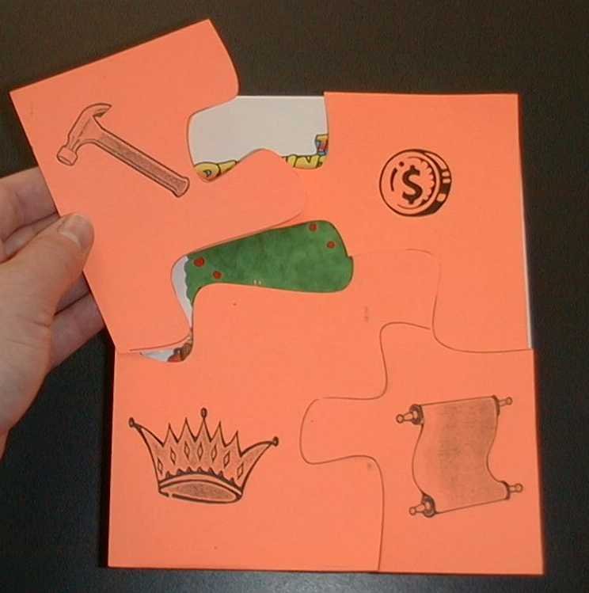
Today I have a puzzle for you to solve. On this stand is a puzzle (point to the Bible that is covered with the puzzle) that I am going take apart as I tell you today’s Bible event. Maybe you can guess what is on the other side. If you do guess it, please keep it to yourself, and we will find out at the end of the story who guessed right.

Take off the piece with the crown and begin the story:

There once was a king over God’s people named Josiah. He became king when he was only 8-years-old. Let me have a volunteer come up who I will dress as King Josiah. Everyone say, “King Josiah.”

After dressing King Josiah, give him the puzzle piece.

King Josiah became king of God’s people when he was only 8-years old. He was a good king, because he followed God’s ways. He was raised by the high priest, who taught him how to love God. While he was a very young man, he gave an important order to clean and repair the temple of the Lord. The temple of the Lord was a special place where people came to worship God. But before Josiah became king, people were not worshipping God there. Instead, they were leaving their trash there. They were even worshipping false gods there. They forgot how to use the temple at all.

Remove the money puzzle piece.

King Josiah knew it would take a lot of money to fix the temple and get it ready for people to worship. So King Josiah took some money and gave it to some people to help repair the temple.

May I have a volunteer to come forward?

Hand the volunteer the puzzle piece.

“Now, how many people do you think you will need to fix the temple?” King Josiah asked. “It will take many, and someone must know what to do. Let’s hire a priest who can help show us how to get the temple ready.” So, they hired a priest named Hilkiah to show them how to repair the temple.

Take off the puzzle piece with the hammer.

Hilkiah then hired the workers. Now, I need some workers to come and work on the temple. You will have to use your imagination.

Have three children come up.

Here are three volunteers. Can you show me how you would hammer? How you would saw? How you would pick up trash? For many, many days they were preparing God’s house for worship. Until one day, they made the most amazing discovery. The high priest, Hilkiah, was cleaning one of the rooms of the temple. Hidden away beneath the rubbish, he found this:

Show scroll.

He found a strange scroll. He looked at it carefully and then unrolled it. He began to read. He wondered what it was. Boys and girls, can you guess what it is?

Take off the last puzzle piece and put it on the scroll. The Bible is completely visible.

Hilkiah found the Bible. It was the book of God’s Word. Many years ago, Moses had commanded that this book of God’s Word would be read to everyone once, each seven years. But people forgot to do it. Then they forgot the book all together. The priest Hilkiah had found it. He was so excited, he quickly brought it to young King Josiah. King Josiah, too, was excited. It was the first time he had heard these words from God’s book. “Read me more,” he said. As God’s Words were read to him, King Josiah was alarmed. Now he knew how much the people had disobeyed God’s Word, by following other gods and not worshipping the true God. He knew the people deserved to be punished by God. He wanted to ask God for his forgiveness and for forgiveness for his people who had forgotten God. Do you think God heard his prayer? Yes, he did. God blessed and helped all of King Josiah’s people, as long as Josiah was alive. King Josiah knew how to help the people in the very best way. He had all the people come to him and he read from the book. As king, he promised to keep God’s Word and serve God with all of his heart. All the people made the same promise and obeyed. Now everyone knew that *GOD IS OUR KING – God’s Word rules.

The best thing the Bible tells us is that God loves us. In fact, God loves us so much He sent His Son Jesus to die for us. Because of Jesus, when we break God’s rules we are forgiven.

If time allows, teach the children a Bible version of “Bingo,” using the following words:

We are happy, God’s our King.
The Bible is His Wor-rd.
B-I-B-L-E
B-I-B-L-E
B-I-B-L-E
The Bible is God’s Wor-rd.

If time permits, teach the children to sing the song using hand clapping. End with a short prayer.

Small Group Application: (30 minutes)
Purpose: Smaller groups enable children to develop closer relationships with adults and peers in the church. As you reinforce the take home point with a fun hands-on activity, discuss the Bible event. Be sure to repeat the take home point several times. Say the first part and have the children respond with the second phrase. Application questions help kids apply the take home point to their daily lives. Close this session by gathering your small group for prayer. Let the kids pray!

During the small group application time, discuss the following questions and points:

What did the people find in the temple? (Scrolls, God’s Word.)
What did King Josiah do when he learned about God’s Word? (Became sad, tore his clothes, read God’s Word to the leaders of his country, followed God’s Word.)

Why is God’s Word important? (It tells us about God’s love, tells us about Jesus, tells us that God forgives, and teaches us how to follow God’s ways.)

When can you listen to God’s Word? (Answers will vary, but may include: at Kingdom Quest, at church, when you listen to a Bible story at home, when you listen to music about Jesus.)

Activity 1: “Scroll Picture” Craft
Supplies needed: 1 sheet of white paper for each child; colour pencils for each group; 12-inch length of yarn for each child

Hand out the paper and have the children draw a picture of Josiah’s temple. Remind the children of this week’s take home point. * GOD IS OUR KING – God’s Word rules! When the children are finished, show them how to roll the paper up from both ends, meeting in the middle. Help them tie a length of yarn around their “scrolls.”

Activity 2: “Alphabet” Snack
Supplies needed: alphabet biscuits (enough for a handful per child, with some left over; serviettes (1 per child); paper cups (1 per child)

Place a handful of alphabet biscuits on each child’s serviette. Help the children find the letters to make their names. If they do not have all the letters they need on their serviettes, find the additional letters from the extra biscuits. If it takes too long to sort the letters, help them find the first letter in their names or other letters they know.

Explain that their names help us know who they are. In the same way, the letter and words in the Bible help us know who God is and what he is like. Practice the take home point. * GOD IS OUR KING – God’s Word rules.
Activity 3: “Follow the Leader” Game
Supplies needed: No supplies

Play “Follow the Leader.” Have the children line up behind you and walk around the room using the following actions:

- Walking on tiptoes
- Taking giant steps
- Taking baby steps
- Hopping
- Flying like a bird
- Walking with hands up in the air
- Marching
- Walking crouched low
- Slow jogging
- Walking with legs kept straight

If your space is limited, do the same actions, but do them standing in one place. Explain to the children that they knew what to do by following you. In the same way, they know what to do in life by following God’s Word. We can follow God’s Word because God loves us and helps us. The most important thing the Bible teaches us, is that Jesus loves us and died for us and someday, we will get to see God. Practice the take home point. *GOD IS OUR KING – God’s Word rules!

Activity 4: “Show and Tell”
Purpose: Help kids to memorize and keep scriptures at heart. Using creative ways to help kids enjoy learning the key verse and in small group setting.

Supplies needed: a circle (cut out from manila card) for each child, colour pencil

Memory Verse: 2 Chronicles 20: 17 ~ Just stand strong in your place. You will see the Lord save you.

Memory Verse Learning:
Give each child a circle. Ask them to draw a smiley face on it. When they are done, the Shepherd stand and raise her smiley face as she recite the memory verse. Then, she gets a child to join her to do the same. Have one child to stand each time until everyone is standing and reciting the verse together.

Prayer Time:
Close with prayers asking God to help you follow his Word.

End with the Lord’s Prayer.

Large Group Wrap-Up: (10 minutes)
Purpose: The crazy bird puppet, Xiao Er, struggles with learning the take home point. The leader shows an example of each small group application activity from this lesson and says the first phrase of the take home point. The kids respond with their phrase. They try to teach the puppet the take home point, but each time he confuses words or concepts. After three attempts, he finally gets it right and sings the correct take home point in a silly opera like voice.

Supplies needed: Xiao Er puppet; Samples of activities

Singing: (Optional)

Lesson Review with Puppet Skit:
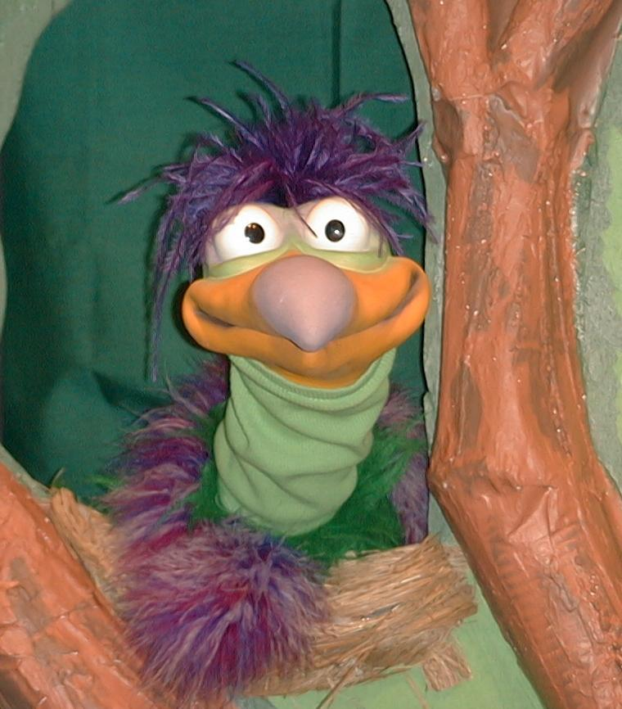
Presenter shows Xiao Er a craft made in Activity 1. Then the kids attempt to teach Xiao Er the take home point.

Presenter says to kids: “God is our King…”
Kids say: “…God’s Word rules.”
Presenter says to Xiao Er: “God is our King…”
Xiao Er says: “Big Dogs Drool!”

Presenter shows an example of the next activity done in small group and repeats first phrase to kids. The kids say the correct response, trying to teach Xiao Er the take home point. Continue in this manner, with Presenter showing example of each activity. Here are Xiao Er’s responses:

Xiao Er’s response to Activity 2 sample: “My name is Xiao Er…that starts with
“X”.”
Xiao Er’s response to Activity 3 sample: “I like to swim in pools!”

Presenter says: “Xiao Er, listen one last time.
God is our King…”
Kids response: “…God’s Word rules.”
Presenter says to Xiao Er: “God is our King…”
Xiao Er’s response: (Warms up his singing voice with “Mee, mee,
mee, mee, mee…” and sings in a silly dramatic opera-like voice) “God is our King – God’s Word rules.”

Welcome guests and thank them for attending.

Lesson 20
Large Group Opening:
- Ting Ting and Xiao Hung puppets
- several playing cards taped to Ting Ting and Xiao Hung’s hands. One of Ting Ting’s cards should be a king; one of Xiao Hung’s an ace
- “kingly” robe
- king’s crown
- paper scroll made from two short broomsticks and a crumpled brown paper
- children’s Bible with the puzzle (from the appendix) cut apart and taped to it reassembled
- music stand

Small Group application:
Activity 1:
- one sheet of white paper for each child
- colour pencils for each group
- 12-inch length of yarn for each child

Activity 2:
- alphabet biscuits (enough for a handful per child, with some left over)
- serviette (1 per child)
- paper cups (1 per child)

Activity 3:
- no supplies

Activity 4:
- a circle of 6” in diameter (cut out from manila card) for each child
- colour pencil

Large Group Wrap-up:
- Xiao Er puppet
- samples of activities

Optional Music for the Lesson:
- Choose two or three songs from church music library

Lesson #20, Bible Event, Puzzle


