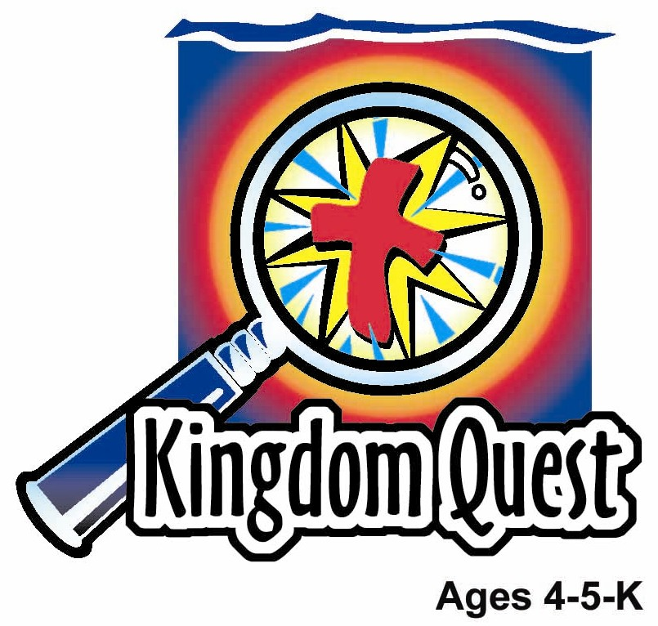
Date: _____________________
Series: God’s Rules Are Cool (Jun-Aug)
Year 1, Lesson 12

God Gives the Ten Commandments

Take Home Point: *GOD’S RULES ARE COOL!—Obey them.
*Repeat this phrase throughout the lesson. The leader will say the first part of the phrase (CAPS). The children respond with the second part of the phrase (italics).

Bible Event: Exodus 19:20-20:20
Jesus Link: Jesus kept God’s laws perfectly—then died for our sins.

We will help children know:
- The story of God giving the law through the Ten Commandments.
- The Ten Commandments are broken into two sets of rules—“love God” and “love others.” Love isn’t just something we feel; it is also something we do. By keeping the Ten Commandments, we are showing our love for God and for others.
- We love because God first loved us. The greatest way God showed His love for us was by sending Jesus to keep the Ten Commandments perfectly and then die for our sins.

We will help the children feel:
- Love for God and for others.
- Desire to show their love by keeping God’s cool rules.
- Repentant for the times they fail and are forgiven through the blood of Jesus.

We will help the children do:
- Experience, through an audience participation story, God’s giving of the law to Moses.
- Eat bread and strawberry jam for snack as a reminder that the law is really God’s gift of love to us.
- Play a game, “Heartscotch,” to reinforce the teaching that when we fail to keep God’s law perfectly, we are forgiven through Jesus.
THIS LESSON’S ROADMAP

DESTINATION | PAGE # | DISCOVERIES ON YOUR JOURNEY | SUPPLIES NEEDED
Large Group Opening   | 3  4 | Puppet Presentation  Bible Event | - Ting Ting puppet  - paper  - pencil  - Bible  - idol such as a Buddha doll, crystal, or golden calf  - optional: wedding veil  - small toy  - two similar toys but one smaller than the other
Small Group Application   | 7  8  8  9 | Activity 1: “Magnetic Commandments” Craft  Activity 2: “Bread and Strawberry Jam” Snack  Activity 3: ”Heartscotch” Game  Prayer Time | Activity 1:  - copy appendix – one per child  - ten small heart stickers per child  - brown colour pencils  - scissors  - magnetic tape  Activity 2:  - two pieces of bread with crust  cut off for per child  - strawberry jam  - plastic knives and plates  - serviettes  - cups  - water or juice  Activity 3:  - ten paper hearts numbered with large numerals 1-10  - masking tape  Activity 4:  - mahjong paper with Bible verse  written  - police hat
Large Group Wrap-Up   | 9  9 | Singing (Optional)  Lesson Review with Puppet Skit | - optional music for the lesson  - Xiao Er Puppet

Pre-Session Singing: (10 minutes)
Purpose: When all children are in one group singing, it is easy for new children to join the group and immediately get involved. When the music can be correlated, it introduces the theme for the day. Choose two to three songs and list them here.

Large Group Opening: (15 minutes)
Purpose: The puppet demonstrates the need that will be met in today’s lesson. The scripts are not written word for word, but give a story line in which the group leader can interact with the puppet. The children are introduced to the take home point and then interact with God’s word as they experience the Bible event.

Supplies needed: Ting Ting puppet; paper ; a pen or pencil ; Bible; idol such as a Buddha doll, crystal, or golden calf; optional: wedding veil; small toy; two similar toys but one smaller than the other

Puppet Presentation:
Ting Ting comes on stage carrying paper and a pen or pencil. She tells the large group presenter that she can’t wait until she grows up. The presenter asks why. Ting Ting says that when she grows up, she can make her own rules. Her mom is mean. She has too many rules. No sweets or gassy drinks at meals. No staying up too late. Can’t eat too many chocolates.

Ting Ting says she’s going to make her own rules. She hands the paper and pen to the presenter and asks him to write down the rules she’s going to make. Ting Ting then starts rattling off rules faster than the presenter can write them down: Eat chocolates, sweets, and other goodies for breakfast. Drink gassy drinks at every meal. Go to bed after midnight. Boss your brother around. Buy one of every toy in the toy store.

The presenter says to Ting Ting, “Whoa! I can’t keep up with you.” He tells Ting Ting that it sounds like she has a lot of rules, too. The presenter then asks what Ting Ting is going to do when she gets a stomachache from too much gassy drinks and sweets? What is she going to do when she gets sick because she hasn’t been sleeping enough? Who’s going to play with her when she’s too bossy? And where is she going to get the money for all the toys?

Ting Ting hadn’t thought of those questions and doesn’t know how to answer. The presenter explains that rules aren’t there to make us upset, but to help us. He asks what would happen to a toddler if he runs out in the street. Ting Ting says he might get run over by a car. The presenter agrees and then explains that his mother gives him that rule because she loves him and wants to keep him safe. Good rules really aren’t about being mean, but about love.

Today the children are going to learn about ten rules God gave to the Israelites and all people. They are called the Ten Commandments. The rules teach us how to love God and how to love others. Because that is what God is about—love. When we follow the rules, things go well. When we don’t follow them, trouble happens. But, because God loves us so much, He sent Jesus to follow His rules perfectly and then die for our sins and come back to life so we can be forgiven.

The presenter teaches Ting Ting the take home point: *GOD’S RULES ARE COOL—Obey them. The presenter says the first line; Ting Ting responds with the second line. After practicing it with Ting Ting a few times, the presenter practices it with the children

Bible Event: Imagination Theater
Imagination Theater is an audience participation drama in which the Bible event is told in creative fashion, using children as actors. The Imagination Box contains the Bible and other special props used for the drama. Begin by removing the Bible and explain that this is God’s word, which tells us of the wonderful deeds God has done. Then, remove an imaginary hat from the box and place it on your head. This is your Imagination Hat. Invite the children to put on their imagination hats, as well. They will use their imaginations to picture the events the Bible tells us about. Some will even use their imaginations to help act out these events. Distribute props to volunteer actors as they are called forward at the beginning of the presentation.

Hold up the Bible and say:

Our Bible event today is from a book in the Bible called Exodus. In that book we learn about how God gave the Israelites the law through Moses.

We have been learning how God led the Israelites out of Egypt. Last week we learned that God led them to the Red Sea and then parted the sea so they could walk across on dry ground and escape the Egyptians. Today we are going to learn that God wanted them to learn how to follow Him even better. So He gave them a special rock tablet with ten special rules on it called the Ten Commandments.

God led the Israelites to a mountain called Mount Sinai. Then He led Moses to the top of the mountain and God came down on the mountain. On Mount Sinai, God gave Moses a stone tablet with the ten rules we talked about, the Ten Commandments. The Ten Commandments were broken into two groups of rules. The first group taught the people how to love God. The second group taught them how to love each other. God wants all people all the time, including us, to follow, and obey, those ten cool rules. Let’s find out what those rules are.

Call one child up onto stage to help.

Hint: Different church bodies number the commandments in different ways. Find out how your church body numbers the commandments and use that system.

Say:

The first rule is: Keep God number one. (Have the child point one finger up.) We shouldn’t make toys, friends, or parents number one in our lives. Only God should have that special place.

The second rule is: Have no idols. Don’t worship fake gods. (Have the child stretch out both hands to block view of the idol. Head turn away and say “No!”) We are only to worship the true God.

The next rule is: Honor God’s name. Keep God’s name holy. (Have the child repeat the following phrases: “Praise God!” “I love you, God!” “Jesus, you are my Savior!”) We are to use God’s name only good ways. We are not to say “Oh, my God!” OR “Jesus Christ!” when we are angry, upset, or even just surprised. God’s name is very special and we show him love when we keep it special.

Another rule is: Honor God’s special day. (Have the child bow her head in prayer.) We pick one day a week to go to church, rest, and spend time with God. That is what you are doing right now!

Those are the rules that help us show love to God. Next God gave some rules on how to show love to others. (Bring up another child of the opposite sex.)

God said to honor our parents. (Have the first child pretend to cough and the other stroke the back of the “parent” who is coughing.) We honor our parents when we treat them well, obey them, and speak nice to them. That is how we show them love.

Next, God said: Don’t murder or even hurt others. (Have one child push the other child.) Instead, we are to help others when they are hurt and be kind to their bodies.

A rule God gave to husbands and wives was for them to love each other. (Have a boy and girl hold hands. Option: put a veil on the girl.) Husbands and wives should do everything they can to show love in their marriage.

Another one of God’s cool rules is: Never steal. (Give one child a toy and have the other child take it from him and run across the stage.) We shouldn’t take other people’s things but, instead, help them take care of their stuff.

God’s next cool rule was to never lie about others. (Have one child fake whisper into the other child’s ear and then point at a child in the audience.) We show love when we only say kind things about other people.

Another cool rule of God’s is to never be jealous of someone else’s stuff. (Give one child a bigger toy and one a smaller toy. Have the child with the smaller toy hang her head and pout.) We should, instead, be happy with the gifts God has given us and be happy for others when God has given them something nice.

God gave us His cool rules so we can love Him and love one another. But, do you know what the coolest thing is? God also shows us His love. He knows we can’t obey His rules perfectly, so He sent His Son Jesus to do it for us. Jesus kept God’s laws perfectly, then He died on the cross for our punishment. Three days later He came back to life to tell us we are forgiven. Now, we keep God’s laws not to keep from being punished, but because we love God and we love others. We love because God first loved us! Isn’t that cool?!

Practice the take home point. You say the first part; the children respond with the second part. GOD’S RULES ARE COOL!—Obey God.
End with the following prayer:
Dear God,
Your rules are cool.
Help us obey them.
Thank You for Jesus.
He will help us and forgive us.
Thank You! Thank You! Thank You!
Amen.

Small Group Application: (30 minutes)
Purpose: Smaller groups enable children to develop closer relationships with adults and peers in the church. As you reinforce the take home point with a fun hands-on activity, discuss the Bible event. Be sure to repeat the take home point several times. Say the first part and have the children respond with the second phrase. Application questions help kids apply the take home point to their daily lives. Close this session by gathering your small group for prayer. Let the kids pray!

During small group application time, discuss the following questions and points:

What are the two main parts of God’s cool rules, the Ten Commandments? (Love God. Love others.)

Why do we keep God’s Ten Commandments? (Because God loved us so we want to love Him back and love others.)

Which rule do you have trouble obeying? (Answers will vary but may include lying, disobeying parents, or fighting with a sister or brother. If the children cannot think of ways they sin, give some examples.)

How did God show us His love? (He sent Jesus to keep His rules perfectly and then die and rise again for our sins.)

Activity 1: “Magnetic Commandments” Craft
Supplies needed: copy appendix – one per child; ten small heart stickers per child; brown colour pencils; scissors; magnetic tape

To make:
- Cut out the tablets.
- Color the cross.
- Count out ten hearts and put on tablet.
- Attach magnetic tape to the back of the craft.

To discuss:

Count the ten hearts. Read the words on the craft. Say: The hearts are a reminder of God’s ten cool rules, His Ten Commandments. They are ways to show love to God and people. They remind us that God is about love. We love God because He first loved us. How has God shown His love for us? How can we show our love for Him and for others?

Activity 2: “Bread and Strawberry Jam” Snack
Supplies needed: two pieces of bread with crust cut off for each child; strawberry jam; plastic knives and plates; serviettes; cups; water or juice

To do:
- Have the children take two pieces of bread each. Say: These two pieces of bread are a reminder of God’s ten cool rules, the Ten Commandments.
- Look at the shape of the bread. Say: The bread look kind of like the shape of the Ten Commandments tablets. When we look at them, we can be reminded that God’s cool rules are all about love and that is why we obey them.
- Eat one piece of bread. (Do not let the children take a drink.) Say: When we eat bread alone, they are dry.
- Give the children some strawberry jam. Say: The cheese makes the bread taste better. In the same way, when we remember that rules, especially God’s Ten Commandments, are about love, they taste sweeter—they seem better also.

Activity 3: “Heartscotch” Game
Supplies needed: ten paper hearts numbered with large numerals 1-10; masking tape

To prepare:
Tape the paper hearts on the floor, about a foot from each other, in the following pattern:

- 8

10 3 2 7

4 1 6

5

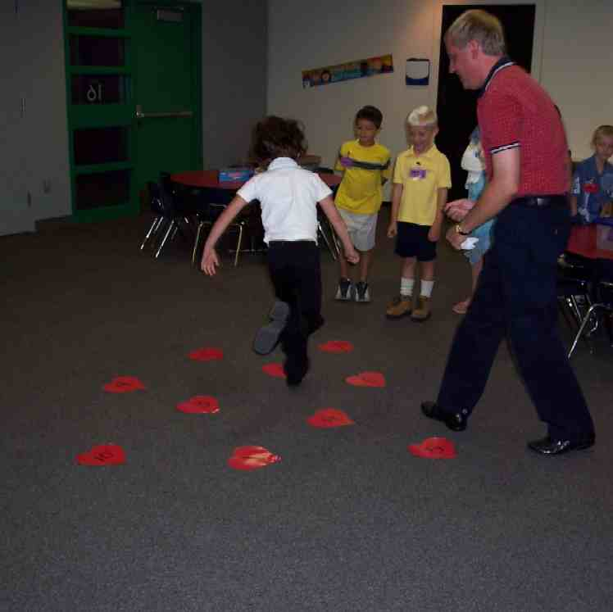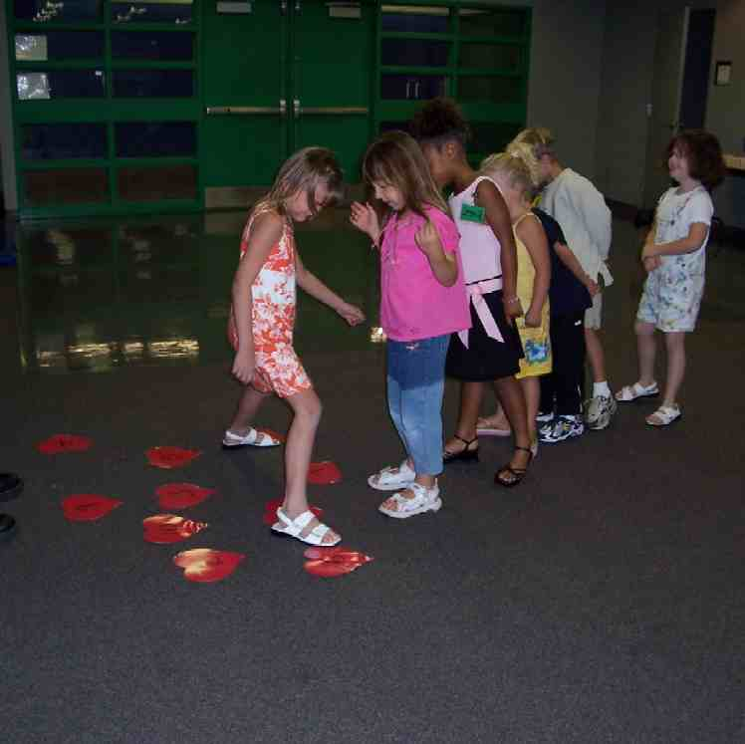

To play:
- Have one child at a time hop with both feet through the hearts in numerical order.
- Repeat the process, this time hopping on only one foot.
- Repeat a third time, this time hopping backward.
- Each time a child skips a number or doesn’t land on it correctly, put an “X” on that number.

To discuss:

Those Xs are all the mistakes we made. As a group, we couldn’t do the Heartscotch perfectly. In the same way, not even one person can keep God’s law and love Him and other people perfectly. Look at the Xs again. They are similar to crosses. It reminds us each time we say to God, “I’m sorry for sinning or doing wrong, God puts Jesus’ blood on the sin and Xs it out.

Activity 4: “Salute and Love.”
Purpose: Help kids to memorize and keep scriptures at heart. Using creative ways to help kids enjoy learning the key verse and in small group setting.

Supplies needed: whiteboard or mahjong paper with Bible verse written; police hat

Memory Verse: Romans 13:5 – “You must obey… because you know it is the right thing to do. “

Memory Verse Learning:
Sit the children in a circle. Have the children to read the memory verse which has already been written. Then put the paper away. Pass a police hat around and as the children take turns to wear the hat, and have the other children to salute them. The child who is wearing the hat needs to respond to the other children with a salute and recite the memory verse. After that, they are to name one action that shows either loving God or loving people. (The police hat represents our respect towards God, just as we respect authorities.)

Prayer Time:
Ask God to help you love him and love others. Tell him a time you didn’t love someone perfectly and ask him to forgive you because of Jesus.

Large Group Wrap-Up: (10 minutes)

Singing: (Optional)

Lesson Review with Puppet Skit:
Purpose: The crazy bird puppet, Xiao Er, struggles with learning the take home point. The leader shows an example of each small group application activity from this lesson and says the first phrase of the take home point. The kids respond with their phrase. They try to teach the puppet the take home point, but each time, he confuses words or concepts. After three attempts, he finally gets it right and sings the correct take home point in a silly opera-like voice.

Xiao Er’s crazy responses:

Activity 1: “(Put in Large Group Presenter’s Name) likes to drool.”
Activity 2: “I want a cheese filled pool.”
Activity 3: “My second cousin is a mule.”

Welcome guests and thank them for attending.
Supplies:

Quantity ()

Large Group Opening:
- Ting Ting puppet
- paper
- a pen or pencil
- Bible
- idol such as a Buddha doll, crystal, or golden calf
- optional: wedding veil
- small toy
- two similar toys but one smaller than the other

Small Group Application
Activity 1:
- copy appendix – one per child
- ten small heart stickers per child
- brown colour pencils
- scissors
- magnetic tape
Activity 2:
- two pieces of bread with crust cut off for per child
- strawberry jam
- plastic knives and plates
- serviettes
- cups
- water or juice
Activity 3:
- ten paper hearts numbered with large numerals 1-10
- masking tape
Activity 4:
- whiteboard or mahjong paper with Bible verse written
- police hat

Large Group Wrap-Up
- Xiao Er puppet
- optional music

Craft template
