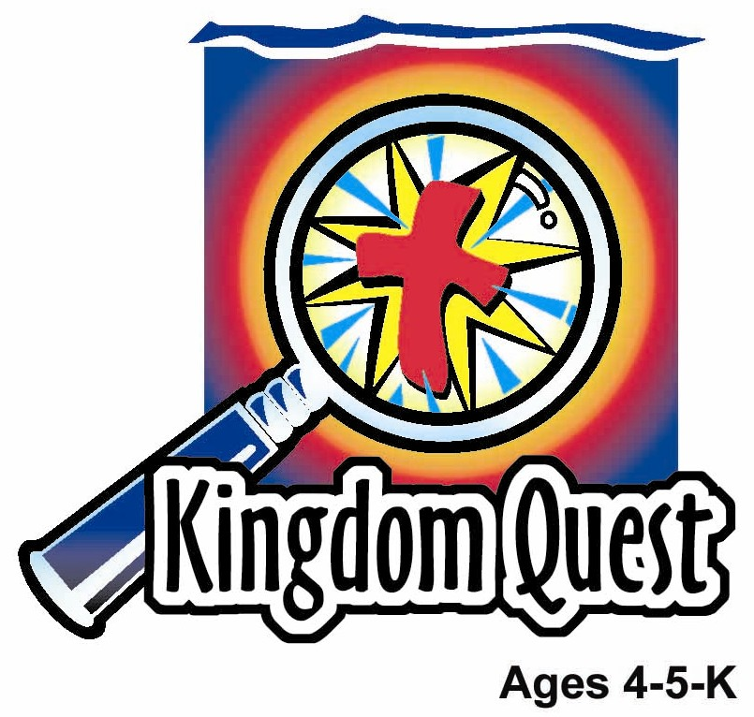
Date: ________________________
Series: Jesus Gave Himself for Me (Dec-Mar)
Year 1, Lesson 43

Palm Sunday: The King’s Parade

Take Home Point: *JESUS IS OUR KING – Praise Jesus.
*Repeat this phrase throughout the lesson. The presenter will say the first part of the phrase (CAPS). The children respond with the second part of the phrase (italics).

Bible Event: Matthew 21:1-11
Jesus Link: When we praise Jesus, we are worshiping God.

We will help children know:
- The story of Jesus’ triumphal entry into Jerusalem.
- They, too, are to praise Jesus, our King.

Ways in which they can praise Jesus.

We will help the children feel:
- Awe in Jesus as their King.
- Eagerness to praise Jesus.
- Joy in praising Jesus.

We will help the children do:
- Actively participate in Palm Sunday procession shouting praises to Jesus and waving palm branches.
- Make and eat “Palm Branches” for snack while reviewing the Bible event.
- Play a game, “Hosanna to the King.”

THIS LESSON’S ROADMAP

DESTINATION | PAGE # | DISCOVERIES ON YOUR JOURNEY | SUPPLIES NEEDED
Large Group Opening  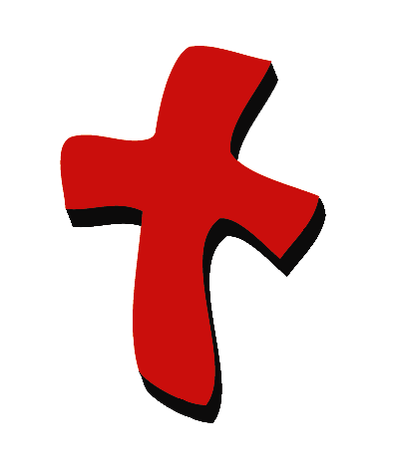 | 4  4 | Puppet Presentation  Bible Event | - Xiao Hung and Ting Ting puppets  - two puppet-sized crowns  - two puppet-sized scepters  - Imagination Box that includes: Bible  - Imagination Palm Branch for each child. This is made by taping together four two-foot lengths of streamers.  - one realistic-looking palm branch that could be real, plastic, or a paper cutout. This will be used to show the children what a palm branch looks like.  - child-sized Jesus costume  - several Bible character robes or pieces of fabric  - Option 1: donkey costume  - Option 2: stick horse  - microphone  - sing a Hosanna song, such as “Shout Hosanna,” from the tape Integrity Music Just-For-Kids, King of Kings, by Integrity Music, Inc. (optional)
Small Group Application   | 8  8  9  9  9 | Activity 1: “Praise Stick” Craft  Activity 2: “Palm Branches” Snack  Activity 3: ”Praise Races” Game  Activity 4: “Unveiling the News”  Prayer Time | Activity 1:  - one sheet of 11-inch x 17-inch white paper per child  - markers  - transparent tape  - scissors  - label with take home point printed on it.  - several pencils (optional)  Activity 2:  - half a slice of roti canai for each child  - plastic knives  - sardine spread  - shredded seaweed  - serviettes  - paper cups  - water or juice  Activity 3:  - Imagination Palm Branches from large group or praise sticks from earlier in the lesson  Activity 4:  - Mahjong paper cut in the shape of a palm leave  - white candle or white crayon  - paint brush  - green colour solution  - praise stick from activity 1.
Large Group Wrap-Up   | 10  10 | Singing (Optional)  Lesson Review with Puppet Skit | - Xiao Er puppet  - sample materials from small group activities

Pre-Session Singing: (10 minutes)
Purpose: When all children are in one group singing, it is easy for new children to join the group and immediately get involved. When the music can be correlated, it introduces the theme for the day. Choose two to three songs and list them here.

Large Group Opening: (15 minutes)
Purpose: The puppet demonstrates the need that will be met in today’s lesson. The scripts are not written verbatim, but give a story line in which the group presenter can interact with the puppet. The children are introduced to the take home point and then interact with God’s word, as they experience the Bible event.

Supplies needed: Xiao Hung and Ting Ting puppets; two puppet-sized crowns; two puppet-sized scepters; Imagination Box that includes: Bible, Imagination Palm Branch for each child—this is made by taping together four two-foot lengths of streamers, one realistic-looking palm branch that could be real, plastic, or a paper cutout. This will be used to show the children what a palm branch looks like, child-sized Jesus costume, several Bible character robes or pieces of fabric, Option 1: donkey costume, Option 2: stick horse, microphone, sing a Hosanna song, such as, “Shout Hosanna,” from the tape Integrity Music Just-For-Kids, King of Kings, by Integrity Music, Inc. (optional)

Puppet Presentation:
Ting Ting and Xiao Hung come out, each wearing a crown and carrying a scepter. They are discussing the game of “Kings and Queens” they are playing. Xiao Hung is the king; Ting Ting is the queen. They would like to pretend, along with the large group presenter and the audience, that they are in a parade. As the people of the village, the large group presenter and the audience will cheer for Xiao Hung and Ting Ting and bow as the “parade” goes by. After all, that’s what people do for kings and queens.

The presenter comments that their game reminds him of today’s Bible event. One day, Jesus rode a donkey into the city of Jerusalem. The people of Jerusalem recognized that Jesus was a King. However, they didn’t just bow to Jesus, they shouted praises to Him. They waved branches from palm trees at Jesus and laid their coats in the road for Him to ride over. Ting Ting and Xiao Hung are surprised to learn that not only is Jesus a King, but He is the King of everyone who knows Jesus. Everyone who knows Jesus is God’s Son and trusts Him, can follow Him as his or her King. Because Jesus is our King, we can praise Him.

The presenter teaches Xiao Hung and Ting Ting the take home point: *JESUS IS OUR KING – Praise Jesus! The presenter says the first line; Xiao Hung and Ting Ting respond with the second line. After practicing it with Xiao Hung and Ting Ting a few times, the presenter practices it with the children.

Bible Event: Imagination Theater
Imagination Theater is audience participation drama where the Bible event is told in creative fashion using children as actors. The Imagination Box contains the Bible and other special props used for the drama. Begin by removing the Bible and explain that it is God’s Word. Briefly, summarize the story, and then remove an imaginary hat and place it on your head. This is your Imagination Hat. Invite the children to put on theirs as well. They will also use their imaginations to picture the events the Bible tells us about. Some will even use their imaginations to help act out these events. Distribute props to actors as they are called forward at the beginning of the presentation. Have them sit to the side until they are called onstage.

Before the Bible event, dress an adult as the donkey if you are using option 1. Dress a smaller-sized child in a Jesus costume and have him sit on the stage near the presenter. Hide the “donkey” off to the side. (If using a stick horse, hide that.)

Mark the room with a road leading to the stage area by using masking tape on the floor. This will help the crowd know where to lay the palm branches and robes.

“Jesus Rides as a King in Jerusalem”

Take the Bible out of the Imagination Box and briefly summarize today’s Bible event.

Today’s Bible event comes from a book written by Matthew. Let me open it up. Oh my! This is the event where Jesus rides as a king into the city of Jerusalem.

Look what kind of animal He is riding. I wonder if you can listen and remember what kind of animal it is that Jesus will ride to Jerusalem as a king.

All the people are shouting as Jesus is coming to Jerusalem. What are they saying? They are waving something into the air and throwing it onto the road in front of Him. It’s some kind of branches. I wonder if you know what kind of branches they will put down in front of Him.

People are putting down something else, too. It’s a way to show they are praising the king. Let’s act out the story and find out what happened.

After you and the children put on your Imagination Hats, begin. Phrases that are underlined and italicized are to be repeated by the child actor or audience. Point the microphone to the actor to show when it is his or her turn.

(Open Imagination Box and pull out the Jesus costume.) I will need a special actor to be Jesus. Come forward and let’s put on your costume. Then wait over here to the side.

Now everyone else is going to have to get ready to be the people who will welcome the King. Let’s see how you can welcome Him. Let me look inside the Imagination Box and see what else we have.

Ah! This is a palm branch. (Show a sample palm branch.) It is something like this that the people pulled from the trees and waved in front of Jesus when He came as King to Jerusalem.

We don’t have any palm branches today, so we will have to use our imaginations. Let’s pretend that these (refer to streamers) are palm branches. Let me pass them out to the kids now. When you get one, you must go back and be seated by the sides of the road here. The road is a taped off area that Jesus will travel. In a moment, you will throw your palm branches on the road.

Look here. There’s something else we will need to throw on the road. (Take robes out of Imagination Box and pass them out.) Keep these in your hands until it is time to act out the story.

We will also need a donkey. We have one over here. Let’s get him ready. (Lead the donkey to the side of the stage or bring out the stick horse.)

Are you ready to begin? Let me look at the Bible so I can tell you what happened.

One day Jesus and His disciples, His helpers, were going into the city of Jerusalem. Jesus told two of His disciples to go into a village and bring back a certain animal. This animal goes, “Hee-haw! Hee-haw!” What kind of animal was it? Right! It’s a donkey.

So, Jesus said, “Go to the city.” Go to the city. “You will find a donkey.” You will find a donkey.

The disciples found a donkey and brought it back. (Lead the donkey to Jesus.) Jesus got onto the donkey. (Help Jesus onto the donkey’s back.) And He rode the donkey into town. (Begin down the path.)

As Jesus rode into town, a large crowd of people gathered. They were waiting for Jesus. They knew He was the King. Now He was coming into his royal city of Jerusalem. They were very excited so they threw their coats on the ground. (Children with robes throw them along the road.) Then they started waving their palm branches. Can you wave your palm branch just as the people did? (Children wave their palm branches.)

The people began to shout out praises to Jesus. Everyone needs to say it with me. “Hosanna!” Hosanna! Hosanna in the highest! Hosanna in the highest! Praise King Jesus! Praise King Jesus!

Optional: Sing a Hosanna song, such as, “Shout Hosanna,” from the tape Integrity Music Just-For-Kids, King of Kings, by Integrity Music, Inc.
Have the children continue repeating these phrases until Jesus goes down the path and back to the front of the room.

When Jesus arrived in Jerusalem, the whole city wondered who He was. Why did everyone praise Him? They praised Him because Jesus is the King. He is not only the King of that city, but He is also the King of every king who has ever lived. He is our King.

Jesus is our King because we know that Jesus came from God. God sent Him to us to save us from our sin and to fill us with His love. Now we can praise Jesus, too. We can praise Him with our palm branches. (Wave palm branches.) We can praise Him with singing, playing instruments, dancing, shouting, and saying prayers. We want to praise our King Jesus because He came to earth to give His life for us and to fill us with His love. Someday we will be able to be with Him in His kingdom in heaven. *JESUS IS OUR KING – Praise Jesus!

End with a brief prayer with children repeating after each line.

Dear God, (repeat)
Thank You for being here. (repeat)
Thank You for sending Jesus. (repeat)
Jesus gave Himself for us. (repeat)
Jesus is our King. Praise Jesus! (repeat)
Thank You! Thank You! Thank You! (repeat)
Amen. (repeat)

Small Group Application: (30 minutes)
Purpose: Smaller groups enable children to develop closer relationships with adults and peers in the church. As you reinforce the take home point with a fun hands-on activity, discuss the Bible event. Be sure to repeat the take home point several times. Say the first part and have the children respond with the second phrase. Application questions help kids apply the take home point to their daily lives. Close this session by gathering your small group for prayer. Let the kids pray!

During the small group application time, discuss the following questions and points:

When Jesus rode into Jerusalem on a donkey, what did the people do? (They shouted praises to him, put their coats on the road, and waved palm branches.)

Why did the people praise Jesus? (Because Jesus is the King.)
Jesus is our King, too. How can we praise Jesus? (Answers will vary but may include singing songs, shouting praises to Jesus, playing instruments, telling others about Jesus, or praying. If children are unable to think of ways to praise Jesus, feel free to help them.)

What was the greatest thing Jesus, our King, did for us? (He died on the cross so that someday we can go to His kingdom.)

Activity 1: “Praise Stick” Craft
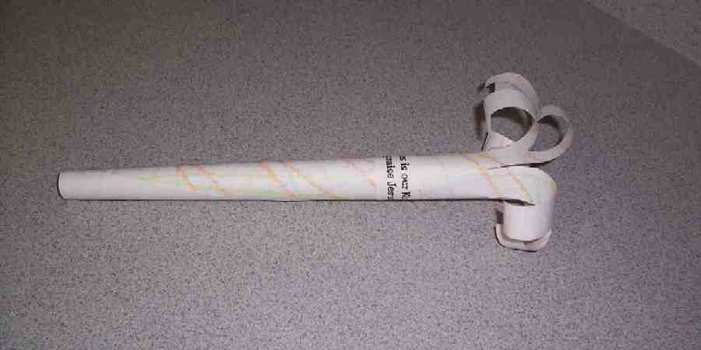
Supplies needed: one sheet of 11-inch x 17-inch white paper per child; markers; transparent tape; scissors; label with take home point printed on it; several pencils (optional)

Have the children make praise sticks:
- Use markers to color one side of the sheet of paper with bright colors.
- Roll the paper into a tube and tape it in place.
- At one end of the tube cut slits about four inches down and half-inch apart to make fringes.
- Bend the fringes back. Optional: Use the pencils to help bend the fringes.
- Attach the label to the praise stick.
- Practice the take home point: *JESUS IS OUR KING – Praise Jesus!
- Practice praising Jesus by shaking the praise sticks and using the phrases from the Bible event or other phrases the group thinks up.

Activity 2: “Palm Branches” Snack
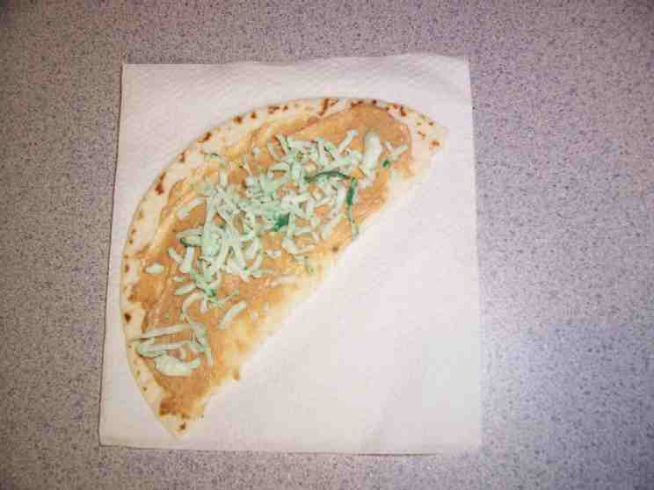
Supplies needed: half a slice of roti canai for each child; plastic knives; sardine spread; shredded seaweed; serviettes; paper cups; water or juice

To make a palm branch snack, spread the sardine or egg spread on half a slice of bread and sprinkle with shredded seaweed. As the children eat their snack, review the Bible event and practice the take home point:*JESUS IS OUR KING – Praise Jesus!

Activity 3: “Praise Races” Game
Supplies needed: Imagination Palm Branches from large group or praise sticks from earlier in the lesson

Have the children sit in a circle with their Imagination Palm Branches or praise sticks from earlier in the lesson. Explain that we will have praise races. One person will start. When the presenter taps him on the head, that person will stand and say, “Hosanna!” while lifting his palm branch high. This child immediately sits down, and the child on his right stands quickly to shout “Hosanna!” and lift her palm branch high. This child immediately sits down, and the child to her right does the same. In effect, this becomes a “wave” of praise going around the circle.

As soon as the children have mastered sending a praise wave around the circle a few times, the presenter will start a second praise wave after the first one is halfway around the circle. Now there will be a race to see if one praise wave will be able to catch the other one.

For an additional effect, have a “Hosanna” song playing in the background.

Activity 4: “Unveiling the News”
Purpose: Help kids to memorize and keep scriptures at heart. Using creative ways to help kids enjoy learning the key verse and in small group setting.

Supplies needed: Mahjong paper cut in the shape of a palm leave; white candle or white crayon; paint brush; green colour solution; praise stick from activity 1.

Memory Verse: Luke 19:38 ~ God bless the King who comes in the name of the Lord!

Memory Verse Learning:
Before the class, pre-write the memory verse on a palm leave mahjong paper with the white candle. Then, paste the mahjong paper on the white board. Tell the children that they are going to unveil the news of King Jesus by helping you colour the palm leave. The Shepherd will get volunteers to colour line by line. As each line is reveal, the children will read out the words that have been revealed. Do this till the whole verse is unveiled. The children can wave their “Praise Stick”, as they recite the memory verse for the last time.

Prayer Time:
Have each child say a prayer of praise and then wave his or her praise stick.

Large Group Wrap-Up: (10 minutes)
Purpose: The crazy bird puppet, Xiao Er, struggles with learning the take home point. The presenter shows an example of each small group application activity from this lesson and says the first phrase of the take home point. The kids respond with their phrase. They try to teach the puppet the take home point, but each time he confuses words or concepts. After three attempts, he finally gets it right and sings the correct take home point in a silly opera-like voice.

Supplies needed: Xiao Er puppet; samples from today’s small group activities

Singing: (Optional)

Lesson Review with Puppet Skit:
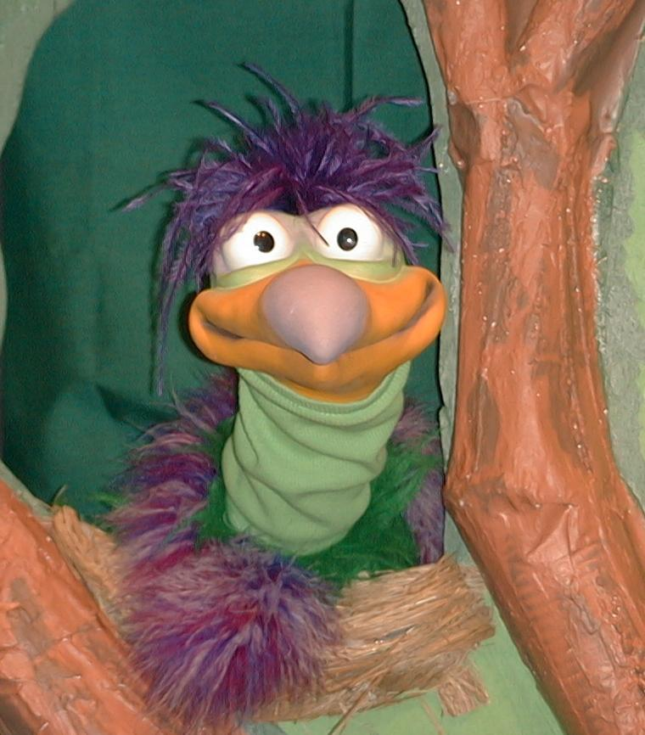
Presenter shows Xiao Er a craft made in Activity 1. Then the kids attempt to teach Xiao Er the take home point.

Presenter says to kids: “Jesus is our king…”
Kids say: “…Praise Jesus!”
Presenter says to Xiao Er: “Jesus is our king…”
Xiao Er says: “Don’t let a donkey sit on you!”

Presenter shows an example of the next activity done in small group and repeats first phrase to kids. The kids say the correct response trying to teach Xiao Er the take home point. Continue in this manner with Presenter showing example of each activity. Here are Xiao Er’s responses:

Xiao Er’s response to Activity 2 sample: “Palm branches are yummy!”
Xiao Er’s response to Activity 3 sample: “Always roller skate in circles!”
Xiao Er’s response to Activity 4 sample: “Look at how I wave my praise stick.”

Presenter says: “Xiao Er, listen one last time.
Jesus is our king…”
Kids’ response: “…Praise Jesus!”
Presenter says to Xiao Er: “Jesus is our king…”
Xiao Er’s response: (Warms up his singing voice with “Mee, mee, mee, mee, mee…” and sings in a silly dramatic opera-like voice) “JESUS IS OUR KING – PRAISE JESUS!”

Welcome guests and thank them for attending.

Lesson 43
Large Group Opening:
- Xiao Hung and Ting Ting puppets
- two puppet-sized crowns
- two puppet-sized scepters
- Imagination Box that includes: Bible
- Imagination Palm Branch for each child—this is made by taping together four two-foot lengths of streamers
- one realistic-looking palm branch that could be real, plastic, or a paper cutout. This will be used to show the children what a palm branch looks like.
- child-sized Jesus costume
- several Bible character robes or pieces of fabric
- Option 1: donkey costume
- Option 2: stick horse
- microphone
- sing a Hosanna song, such as, “Shout Hosanna,” from the tape Integrity Music Just-For-Kids, King of Kings, by Integrity Music, Inc. (optional)
Small Group Application:
Activity 1:
- one sheet of 11-inch x 17-inch white paper per child
- markers
- transparent tape
- scissors
- label with take home point printed on it
- several pencils (optional)
Activity 2:
- half a piece of roti canai
- plastic knives
- Sardine or egg spread
- Shredded seaweed
- serviettes
- paper cups
- water or juice
Activity 3:
  - Imagination Palm Branches from large group or praise sticks from earlier in the lesson
Activity 4:
- Mahjong paper cut in the shape of a palm leave. Get outline from page 12 but the words
should be written with white candle.
- white candle or white crayon
- paint brush
- green colour solution. Just add a few drops of food colouring to 50ml of water.
- praise stick from activity 1.

Large Group Wrap-Up:
- Xiao Er puppet
- samples from today’s small group activities

