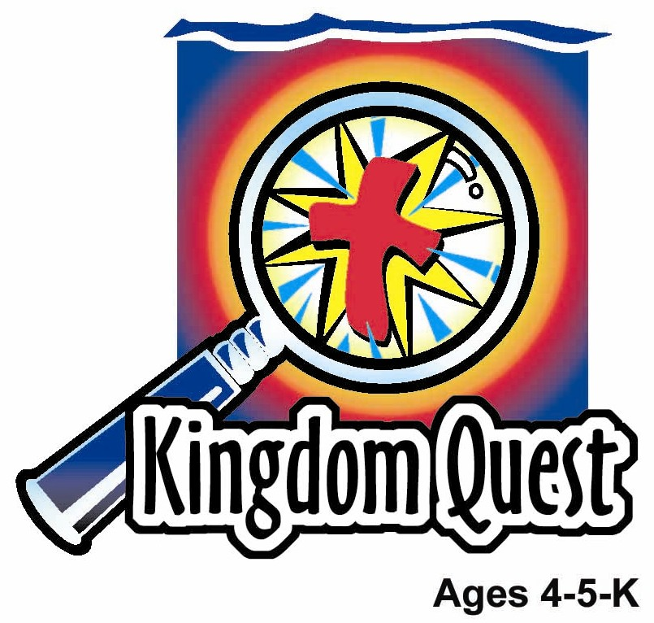
Date: ________________________
Series: Jesus Gave Himself for Me (Dec-Mar)
Year 1, Lesson 47

Jesus Goes to the Cross

Take Home Point: *JESUS IS MY SAVIOR – Jesus died and rose for me.
*Repeat this phrase throughout the lesson. The presenter will say the first part of the phrase (CAPS). The children respond with the second part of the phrase (italics).

Bible Event: Luke 23:33, 45-56
Jesus Link: Because of Jesus’ death, we now have power over death.

We will help children know:
- The story of Jesus being crucified.
- Jesus’ crucifixion was both a sad and a happy event—sad because of Jesus’ death, happy because it means we receive forgiveness for our sins and eternal life.

Jesus did not stay dead—three days later He rose from the dead.

We will help the children feel:
- Somber that Jesus died.
- Joy that Jesus died to forgive them of their sins.
- Hope in Jesus’ resurrection, the forgiveness of sins, and eternal life.

We will help the children do:
- Listen to a storyteller dramatically retell the story of Jesus’ crucifixion.
- Make and eat a pudding and cream cracker cross with sprinkles, and use it to learn why Jesus’ death is both sad and happy.
- Play a group game, “Stuck on the Cross.”

THIS LESSON’S ROADMAP

DESTINATION | PAGE # | DISCOVERIES ON YOUR JOURNEY | SUPPLIES NEEDED
Large Group Opening  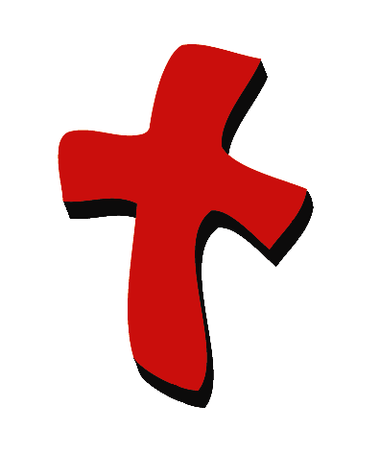 | 4  5 | Puppet Presentation  Bible Event | - Ting Ting puppet  - Tissue paper  - microphone backstage  - box decorated to look like a Mystery Box with the following objects inside:  - palm branch  - cup  - chappati, pita bread, or cracker  - flower or plant  - rooster picture  - tape or CD player  - tape or CD of sad music  - overhead image of a Calvary scene (three crosses on a hill) OR a cross shadow on the wall made with a spotlighted cross OR a cross on PowerPoint, OR felt board  - rocking chair or stool  - hammer  - piece of wood  - old sheet that can be torn  - metal sheeting (best option), mat board, poster board (this will be used to make the sound of thunder)
Small Group Application   | 9  9  10  10  10 | Activity 1: “Sad/Happy Cross” Craft  Activity 2: “Cream Cracker Cross” Snack  Activity 3: ”Stuck on the Cross” Game  Activity 4: “The Powerful Cross”  Prayer Time | Activity 1:  - cross cut from dark paper  - the words “Jesus died and rose for me” printed on a label.  - squares of brightly coloured crepe paper  - glue  Activity 2:  - serviettes  - plastic knives  - three cream cracker per child  - small amount of chocolate spread for each child  - multi-colored sprinkles  - hand wipes  - paper cups  - water/juice  Activity 3:  Option 1:  - 8-foot 2”x4” board  - two 3-foot 2”x4”s boards  Option 2:  - extra-wide masking tape  Activity 4:  - whiteboard and marker  - red poster paint  - brush  - a poster that has different parts of the human body (page 13)
Large Group Wrap-Up   | 11  11 | Singing (Optional)  Lesson Review with Puppet Skit | - Xiao Er puppet  - sample materials from small group activities

Pre-Session Singing: (10 minutes)
Purpose: When all children are in one group singing, it is easy for new children to join the group and immediately get involved. When the music can be correlated, it introduces the theme for the day. Choose two to three songs and list them here.

Large Group Opening: (15 minutes)
Purpose: The puppet demonstrates the need that will be met in today’s lesson. The scripts are not written verbatim, but give a story line in which the group presenter can interact with the puppet. The children are introduced to the take home point and then interact with God’s word, as they experience the Bible event.

Supplies needed: Ting Ting puppet; Tissue paper; microphone backstage; box decorated to look like a Mystery Box; tape or CD player; tape or CD of sad music by a classical composer such as Hector Berlioz; overhead image of a Calvary scene (three crosses on a hill) OR cross shadow on the wall made with a spotlighted cross OR a cross on PowerPoint OR felt board; rocking chair or stool; hammer; piece of wood; old sheet that can be torn; metal sheeting (best option), mat board, poster board (this will be used to make the sound of thunder)

Puppet Presentation:
Ting Ting comes in crying and wiping her eyes with a tissue paper. The group presenter asks her what is wrong. Ting Ting explains that she is both sad and scared. Her great-grandma died and she’s sad because she will never get to see her again. She is also scared because she’s afraid of dying.

The presenter expresses his sympathy to Ting Ting and says he understands why Ting Ting is sad and scared. Then he shares with Ting Ting that today’s Bible event might help her feel a little better. He explains that the Bible event is about Jesus dying on the cross. Upon hearing that Ting Ting becomes even more upset. The presenter calms her down and then agrees that Jesus’ death is a sad thing. But it is also happy. Now Ting Ting is very confused. How can death be happy?

The presenter explains that because we do bad things called sin, we need to be punished. When Jesus died, He took our punishment and it was like our sins died on the cross with Jesus. Because of that, if we love Jesus and believe that He died for us, our sins are forgiven. When God looks at us, He doesn’t see our sins. They’re gone! That’s happy! Because our sins are gone we don’t have to be afraid of dying. We know that when we die we’ll be with Jesus in heaven.

That means that Ting Ting will miss her grandma for a while, but someday she will get to see her again in heaven. Ting Ting now feels a little better but the presenter still has another piece of happy news for her. Jesus died on the cross, but He didn’t stay dead. On Easter He came back to life! While Ting Ting is still sad because she misses her great-grandma, she is feeling much better.

Teach Ting Ting the take home point: *JESUS IS OUR SAVIOR – Jesus died and rose for me. The presenter says the first line, Ting Ting responds with the second line. After practicing it with Ting Ting a few times, practice it with the children.

Bible Event: Mystery Box
The Mystery Box contains objects which will help the presenter tell the Bible even in creative fashion. They can be lifted out and shown as the story is told. Another option is to have a hole cut in the top of the box so that a child could put a hand in and guess what the object is before it is shown.

“Jesus Goes to the Cross”

This lesson will require an extra male voice. The sounds coming from offstage in this Bible event should be spoken into a microphone for optimal effect.

The presenter sits on rocking chair and begins. He omits key words in the text that are underlined and let’s children guess and fill them in.

Presenter: Boys and girls, I have a Mystery Box today. In the box are some objects that will help us remember some of the Bible events that we have learned. As a review of the Bible events, I am going to leave out some important words and I want you to tell them to me.

Take out palm branch.

Presenter: On Palm Sunday, Jesus rode into Jerusalem on a donkey. People lined the streets, throwing their coats on the ground and shouting praises to Jesus. The children waved palm branches. The people were shouting “Hosanna to the King!”

Put away palm branch and take out cup and bread or cracker.

Presenter: Several days later, Jesus had a special meal to help His disciples remember that He would die for them and always be with them. At the meal, Jesus taught His helpers that the (hold up bread) bread was His body and the (hold up cup) wine was His blood, given to them so they could be forgiven.

Put away bread and cup and bring out a flower or plant.

Presenter: After the special meal, Jesus and His disciples went to the Garden of Gethsemane to pray. Jesus asked His Father to help Him with the hard thing about to happen. That hard thing would be dying on the cross. After He was done praying, Jesus was arrested.

Put away flower and take out picture of rooster.

Presenter: While Jesus was standing before some men who were judging Him, someone asked Peter if he knew Jesus. Peter said, “No.” Three times people asked Peter if he knew Jesus and three times Peter said, “No.” Then there was a noise. It was the sound of the (hold out picture of rooster) rooster crowing. Suddenly, Peter knew he had lied and said “No” to Jesus. He felt bad and went away to cry.

Put away picture of rooster.

Presenter: Later that night, Jesus was sentenced to die. Let’s find out what happened.

Lights dim, so that only the cross scene is lighted. Somber music begins playing quietly in background.

Presenter: Jesus, along with two criminals, was led to a hill called Golgatha, where Jesus was nailed to a cross. (Hammering is heard offstage.) The two criminals were also nailed to a cross, one on Jesus’ left and one on His right. Jesus said:

Jesus’ voice offstage: Father, forgive them, for they do not know what they are doing.

Presenter: Above Jesus’ head, on the cross, was a sign that said, “Jesus, the King of the Jews.” The sign was meant to make fun of Jesus. The people did not realize it was true. The soldiers divided Jesus’ clothes between them. People who were walking by made fun of Jesus.

Voice offstage: Save Yourself! Come down from the cross if You are the Son of God!

Presenter: In the same way, the chief priests, teachers, and elders made fun of Jesus and said, “If You are the Son of God, save Yourself.”

One of the criminals who hung of the cross next to Jesus also made fun of Him, saying, “Aren’t you the Christ? Save Yourself and us!”

But the other criminal believed that Jesus was the Savior. He said, “We are being punished for the bad things we have done, but Jesus has done nothing wrong.” Then he asked Jesus, “Will You remember me when You come into Your kingdom?” Jesus answered:

Jesus’ voice offstage: I tell you the truth, today you will be with me in heaven.”

Presenter: Nearby were several women who loved Jesus. One was His mother Mary. She was very sad and was crying.

Crying heard from offstage.

Presenter: When Jesus saw His mother crying and His special disciple John, he said:

Jesus’ voice offstage: Woman, here is your son. Son, here is your mother.

Presenter: From that time on, John took Mary into his home. After that, the sky turned dark. After about three hours of darkness, Jesus called out again and said:

Jesus’ voice offstage: My God, my God, why have you left me alone?

Presenter: Now Jesus, knowing it was almost time for Him to die, said:

Jesus’ voice offstage: I am thirsty.

Presenter: Jesus was given a drink of wine vinegar on a stick. After He finished the drink, Jesus said:

Jesus’ voice offstage: It is finished. (In a loud voice.) Father, into your hands I commit my spirit!

Presenter: Then Jesus bowed His head and died. At that moment the curtain of the temple was torn from top to bottom.

Offstage a sheet is torn into a microphone.

Presenter: There was an earthquake. The earth shook and the rocks split.

Offstage the sheet metal is wobbled so that it makes a loud noise into the microphone.

Presenter: All the people were amazed and scared. One of the soldiers even said, “Surely He must be the Son of God.” After Jesus died, some of His followers took His body from the cross and buried it in a cave called a tomb, and all His followers were sad.

But, the story does not end there, because three days later something wonderful happened. Jesus came back to life! We will learn about that next week.

In the meantime, while it is sad that Jesus died, we can be happy to know that He died for us. We all make wrong choices and sin, but because Jesus took our punishment on the cross, we can be forgiven and, like the criminal, someday be with Jesus in heaven. It reminds me of our special words for today. *JESUS IS MY SAVIOR – Jesus died and rose for me!

Practice the take home point: *JESUS IS MY SAVIOR – Jesus died and rose for me! End with a brief prayer with children repeating after each line.

Dear God, (repeat)
Thank You for being here. (repeat)
Thank You for sending Jesus. (repeat)
Jesus is my Savior. (repeat)
Jesus died and rose for me. (repeat)
Thank You! Thank You! Thank You! (repeat)
Amen. (repeat)

Small Group Application: (30 minutes)
Purpose: Smaller groups enable children to develop closer relationships with adults and peers in the church. As you reinforce the take home point with a fun hands-on activity, discuss the Bible event. Be sure to repeat the take home point several times. Say the first part and have the children respond with the second phrase. Application questions help kids apply the take home point to their daily lives. Close this session by gathering your small group for prayer. Let the kids pray!

During the small group application time, discuss the following questions and points:

What was sad about today’s Bible event? (Jesus was nailed to a cross where he hurt and then died.)

What was the happy news? (Jesus did not stay dead—He came back alive. Because Jesus died on the cross, we are forgiven and will someday be with Him in heaven.)

Who did Jesus die for? (You, me, everyone.)

Why are you glad that Jesus died on the cross? (Let the children express what the good news means to them.)

The criminal on the cross was sorry, and believed that Jesus could forgive Him. If we, too, are sorry for our sins and believe that Jesus forgives them, we will be forgiven and go with Him to heaven.

Activity 1: “Sad/Happy Cross” Craft
Supplies needed: cross cut from dark paper; the words “Jesus died and rose for me”; printed on a label; squares of brightly coloured crepe paper; glue

To make the sad/happy crosses, have the children wad up the squares of crepe paper and glue them on a paper cross. Explain that Jesus’ death on the cross was sad. He never did anything wrong and it was painful for Him. His helpers and followers loved Him, and it hurt them inside to see Him die. We also don’t want Jesus to die, and so it is sad for us.

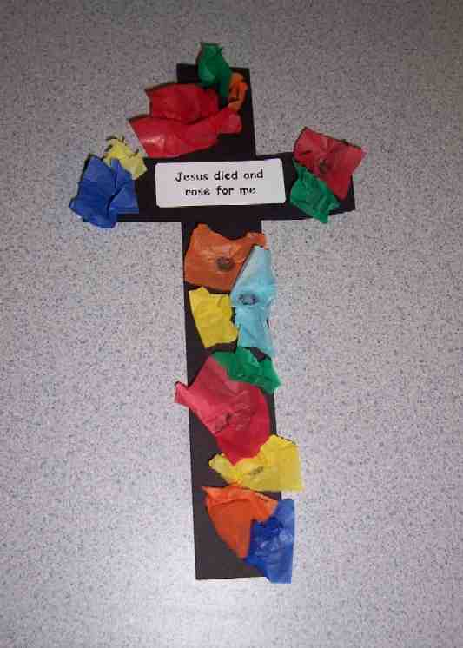
But, it was also a time of great joy. When Jesus died, He took the punishment for our sins. It was as if He nailed them to the cross. That is the best news of all! Because our sins are forgiven, someday we get to see Jesus in heaven.

Another reason Jesus’ death is happy is because He didn’t stay dead. Three days later, Jesus came out of the grave. He is alive! And we know that He is with us in our hearts now. The dark color of the cross is a reminder of the sadness of Jesus’ death. The bright colors of the tissue paper are a reminder of the joy of Jesus being alive again. Practice the take home point: *JESUS IS MY SAVIOR – Jesus died and rose for me!

Activity 2: “Cream Cracker Cross” Snack
Supplies needed: serviettes; plastic knives; three cream cracker per child; small amount of chocolate spread for each child; multi-colored sprinkles; hand wipes; paper cups; water or juice

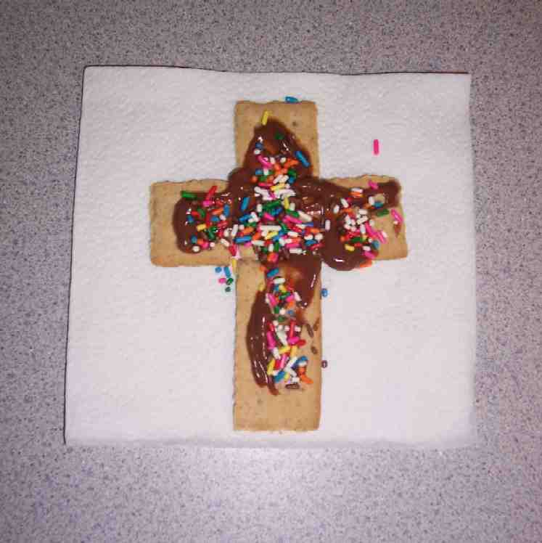
To make the cream cracker cross snack:
- Give each child three cream cracker rectangles. Have them break one cream cracker in half.
- Make the vertical beam, using the two longer cream cracker.
- Make the horizontal crossbeam, using the broken cream cracker.
- Use the plastic knives to spread chocolate spread on the cream cracker cross.
- Spread candy sprinkles on the cross.

As the children eat their snack, discuss why Jesus’ death is both happy and sad. Practice the take home point: *JESUS IS MY SAVIOR – Jesus died and rose for me!

Activity 3: “Stuck on the Cross” Game
Supplies needed: Option 1: 8-foot 2”x4” board, two 3-feet 2”x4”s boards; Option 2: extra-wide masking tape

Form a large cross on the floor, using the 2”x4” boards or wide masking tape. Have the children all try to stand towards the center of the cross at one time. They may get on the cross from any of the four points. The goal is for them to stay on the cross until the count of ten without anyone falling off. If someone falls off, they must start over. If the children have a hard time staying on the cross, they may receive adult help to balance them.

After they have achieved the goal, explain that just as they were on the cross, Jesus nailed their sins to the cross when he died. Our sins were buried with Jesus. While Jesus rose from the dead, our sins will remain buried forever, if we love and trust in Jesus. Practice the take home point: *JESUS IS MY SAVIOR – Jesus died and rose for me!

Activity 4: “The Powerful Cross”
Purpose: Help kids to memorize and keep scriptures at heart. Using creative ways to help kids enjoy learning the key verse and in small group setting.

Supplies needed: white board and marker; red poster paint; brush; a poster that has different parts of the human body (page 13)

Memory Verse: Romans 5:9 ~ We have been made right with God by the blood of Christ’s death.

Memory Verse Learning:
Pre-write the memory verse on the white board. Review the memory verse with the children. Discuss with the children sins that can be done with the different parts of our body. Stick one part of the body at a time. End every discussion for one part of the body by affirming the children that Jesus has forgiven our sins when He died on the cross. Choose a child to draw a cross with a brush on a part of the body. Everyone recite the memory verse after a cross is marked on that part of the body.

Prayer Time:
Have each child say one sin that they have done, and thank Jesus for dying on the cross to forgive that sin and all sins.

Large Group Wrap-Up: (10 minutes)
Purpose: The crazy bird puppet, Xiao Er, struggles with learning the take home point. The presenter shows an example of each small group application activity from this lesson and says the first phrase of the take home point. The kids respond with their phrase. They try to teach the puppet the take home point, but each time he confuses words or concepts. After three attempts, he finally gets it right and sings the correct take home point in a silly opera-like voice.

Singing: (Optional)

Lesson Review with Puppet Skit:
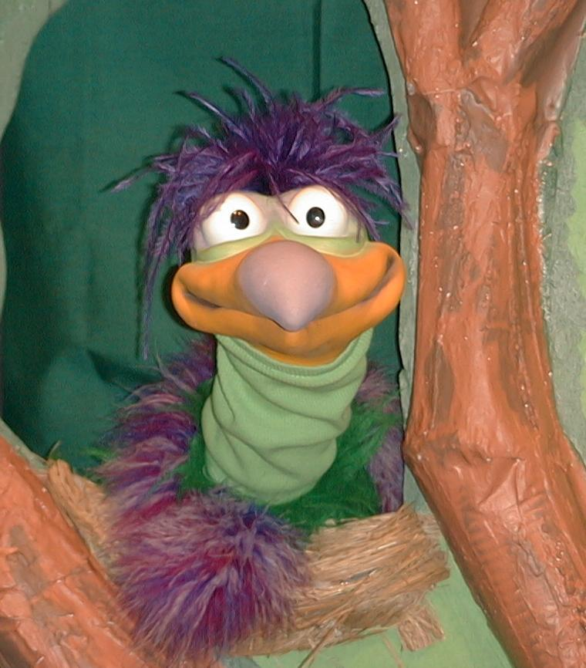
Presenter shows Xiao Er a craft made in Activity 1. Then the kids attempt to teach Xiao Er the take home point.

Presenter says to kids: “Jesus is my Savior…”
Kids say: “Jesus died and rose for me.”
Presenter says to Xiao Er: “Jesus is my Savior…”
Xiao Er says: “What did Jesus do again?!”

Presenter shows an example of the next activity done in small group and repeats first phrase to kids. The kids say the correct response trying to teach Xiao Er the take home point. Continue in this manner with Presenter showing example of each activity. Here are Xiao Er’s responses:

Xiao Er’s response to Activity 2 sample: “Jesus did something important on the cross!”
Xiao Er’s response to Activity 3 sample: “Did Jesus give His life for me?”
Xiao Er’s response to Activity 4 sample: “Am I right with God?”

Presenter says: “Xiao Er, listen one last time.
“Jesus is my Savior…”
Kids’ response: “Jesus died and rose for me.”

Presenter says to Xiao Er: “Jesus is my Savior…”

Xiao Er’s response: (Warms up his singing voice with “Mee, mee, mee, mee, mee…” and sings in a silly dramatic opera-like voice) “JESUS IS MY SAVIOR – Jesus died and rose for me.”

Welcome guests and thank them for attending.

Lesson 47
Large Group Opening:
- Ting Ting puppet
- Tissue paper
- microphone backstage
- box decorated to look like a Mystery Box with the following objects inside:
- palm branch
- cup
- chappati, pita bread, or cracker
- flower or plant
- rooster picture
- tape or CD player
- tape or CD of sad music by a classical composer such as Hector Berlioz
- overhead image of a Calvary scene (three crosses on a hill) OR cross shadow on the wall made with a spotlighted cross OR a cross on PowerPoint OR felt board
- rocking chair or stool
- hammer
- piece of wood
- old sheet that can be torn
- metal sheeting (best option), mat board, poster board (this will be used to make the sound of thunder)
Small Group Application:
Activity 1:
- cross cut from dark paper
- the words “Jesus died and rose for me” printed on a label.
- squares of brightly colored crepe paper
- glue
Activity 2:
- serviettes
- plastic knives
- three cream cracker per child
- small amount of chocolate spread for each child
- multi-colored sprinkles
- hand-wipes
- paper cups
- water or juice
Activity 3:
Option 1:
- 8-foot 2”x4” board
- two 3-foot 2”x4”s boards
Option 2:
- extra-wide masking tape
Activity 4:
- whiteboard and marker
- red poster paint
- brush
- a poster that has different parts of the human body (Enlarge page 13 to A3 size.)
Large Group Wrap-Up:
- Xiao Er puppet
- samples from today’s small group activities

