
Date: ________________________
Series: Jesus Is Our Friend (Dec-Mar)
Year 1, Lesson 34

Jesus Goes Home with Zacchaeus

Take Home Point: *JESUS IS OUR FRIEND – Bring Jesus home.
*Repeat this phrase throughout the lesson. The presenter will say the first part of the phrase (CAPS). The children respond with the second part of the phrase (italics).

Bible Event: Luke 19:1-10
Jesus Link: Jesus is a friend to everyone.

We will help children know:
- The Bible event of Jesus visiting the home of Zacchaeus, the tax collector.
- Because Jesus is our friend, we should bring Him home with us.
- Ways to bring Jesus home.

We will help the children feel:
- Forgiven.
- Loved by Jesus.
- Eager to share Jesus’ love with their families.

We will help the children do:
- See a drama of the story of Zacchaeus.
- Play a ping-pong ball game as a reminder to bring Jesus home.
- Make a snack of gorp.

THIS LESSON’S ROADMAP

DESTINATION | PAGE # | DISCOVERIES ON YOUR JOURNEY | SUPPLIES NEEDED
Large Group Opening   | 3  3 | Puppet Presentation  Bible Event | - Xiao Hung puppet  - small binoculars (two toilet paper tubes hot glued together)  - fake potted tree  - stepladder  - male Bible character puppet or actor
Small Group Application   | 6  6  7  7  7 | Activity 1: “Biscuits Feast”  Activity 2: “Ping Pong Ball Race” Game  Activity 3: ”Zacchaeus Book” Craft  Activity 4: “Write, God’s Friend”  Prayer Time | Activity 1:  - different kinds of biscuits available in ‘pasar malam’;  - two paper cups per child  - spoons  - water or juice  Activity 2:  - one ping-pong ball per child. Draw crosses on them using a permanent marker.  - several buckets with a sign saying “Home”  Activity 3:  - one photocopied sheet per child, cut into four small pages and stapled to make a book  - glue or cellophane tape  - one gold coin (alternatives: several yellow dot stickers or a yellow construction paper circle)  - about ten dot stickers per child  - magic pens  - crayons  - half sheet of manila card folded and stapled to book for cover  Activity 4:  - one photocopied sheet per last  week’s A3 visual  - worksheet on page 9  - crayons or colour pencils
Large Group Wrap-up   | 8  8 | Singing (Optional)  Lesson Review with Puppet Skit | - Xiao Er puppet  - sample materials from small group activities

Pre-Session Singing: (10 minutes)
Purpose: When all children are in one group singing, it is easy for new children to join the group and immediately get involved. When the music can be correlated, it introduces the theme for the day. Choose two to three songs and list them here.

Large Group Opening: (15 minutes)
Purpose: The puppet demonstrates the need that will be met in today’s lesson. The scripts are not written verbatim, but give a story line in which the group presenter can interact with the puppet. The children are introduced to the take home point and then interact with God’s word, as they experience the Bible event.

Supplies needed: Xiao Hung puppet; small binoculars; fake potted tree; stepladder; male Bible character puppet or actor

Puppet Presentation:
Xiao Hung comes out wearing binoculars around his neck. He is upset because he tried to follow the older boys in his neighborhood up into a tree house. They were going to be spying on people and he has binoculars so he could spy, too. But the boys wouldn’t let him go into the tree with them. They said he was too little. Now Xiao Hung is sad.

The presenter tells Xiao Hung that in today’s Bible event, there was a man who felt like him. He climbed into a tree to see Jesus because he was too short to see him over the crowd. He didn’t think Jesus would be his friend but he learned that Jesus wanted to be his friend, too. The presenter tells Xiao Hung that no matter what the big boys said, Xiao Hung always has a friend and that friend is Jesus. And he can take Jesus with him into a tree, to the park, and even home, because Jesus’ love is always in his heart.

Teach Xiao Hung the take home point: *JESUS IS OUR FRIEND – Bring Jesus home. Practice with Xiao Hung several times and then practice with the kids.

Bible Event: A Visit from a Dramatized Character
A costumed adult presents the Bible event by telling it from a first person point of view. Explain to the children that they will meet an actor, someone pretending to be a person in today’s Bible event. Ask the children to put on their Imagination Hats so they can imagine that this really is the person in the Bible event.

“Zacchaeus Goes Home with Jesus”

Zacchaeus will be speaking from the stepladder with the tree directly in front of him. He will look as if he is partially in a tree.

Another option is to have Zacchaeus presented as a puppet that is speaking from the tree. In this case, the puppeteer needs to be concealed or dressed in black so he is not noticed.

Here in the Bible is an event when a short man named Zacchaeus climbed a tree to try to see Jesus. He didn’t think Jesus would want to be his friend because he had cheated so many people out of their money. But Jesus had other plans. I wonder what they were. Let’s put on our Imagination Hats as we meet someone pretending to be Zacchaeus.

Zacchaeus: Hello. My name is Zacchaeus. I lived a long time ago when Jesus walked my land.

I am a tax collector. Tax collectors tell people, “You must give money to the king. I’ll take your money and give it to the king. It will be a tax.”

But people didn’t like to give me their money. That’s because they didn’t like the king. They were Jews and the king was Roman. They didn’t like being ruled by a Roman, and they didn’t like giving the king their money.

But worst of all, they thought I cheated them. They thought I collected too much money for the king and kept some for myself. And do you know what? They were right! I did cheat them.

I was stealing from them because I thought money was the most important thing. What do you think they thought of me? Do you think they liked me? No! Most of the people hated me. But I pretended not to care because I had lots of money.

Even though I had lots of money, I was still sad inside. I needed someone who would love me and accept me. I needed someone who would help me change from cheating people. And one day I met him…

It was Jesus! Jesus was coming to our village and everyone was excited. I had never met Him, but I had heard many wonderful things about Him. He could do miracles and cure sick people. He even made crippled people walk again.

Jesus talked all about God’s love. But I wondered if He would like me. I thought to myself, “He probably won’t like me when He finds out I am a tax collector.”

I decided to see Jesus. Now, I am very short and there was a great crowd of people gathered to watch Jesus come into our town. I didn’t want to be in that crowd. I couldn’t see over the people, and I didn’t want anyone in the crowd to hit me when no one else was looking.

I saw a tree right by the road where Jesus would come. I climbed up in the tree and watched and watched and watched.

There He came walking down the road with crowds of people. He walked right past me and then He stopped. He looked up in the tree and guess what. He knew my name!

Jesus said, “Zacchaeus, come down from the tree. I will be your friend. Let’s go to your house and eat dinner together.”

He said this in a kind way. He really did want to be my friend. But maybe He didn’t know I was a tax collector. Oh no, if He found that out, I’m sure He wouldn’t like me.

So, we went to my house to eat dinner. People all around were saying, “Jesus, don’t you know? That’s Zacchaeus the tax collector. Everybody hates him because he cheats the Jews.”

Jesus didn’t seem to mind at all. Instead, Jesus just looked at me and smiled.

That night when we had dinner together, Jesus talked to me about God’s kingdom. He explained that God loved me and wanted me to serve Him and not cheat people. He said that it’s never too late to turn back to God. He even explained that He was the Savior sent by God to help all of us be friends with God. Then He said, “I forgive you.”

Well, that did it! I was so happy I said, “Jesus, I’m changing right now. If I’ve ever cheated anyone, I’m going to give him back his money and give him much more money. I want to follow God’s way from now on. And it’s all because of you, Jesus. I brought you home with me and you changed my life.”

Boys and girls, maybe you can remember that, too. Jesus is God’s Son and He’s the Savior. *JESUS IS OUR FRIEND – Bring Jesus home.

Zacchaeus walks off stage. The presenter reviews the take home point: *JESUS IS OUR FRIEND – Bring Jesus home. End with a brief prayer with children repeating after each line.

Dear God, (repeat)
Thank You for being here. (repeat)
Thank You for sending Jesus. (repeat)
He is our friend. (repeat)
We can bring Him home with us. (repeat)
Thank You! Thank You! Thank You! (repeat)
Amen. (repeat)
Small Group Application: (30 minutes)
Purpose: Smaller groups enable children to develop closer relationships with adults and peers in the church. As you reinforce the take home point with a fun hands-on activity, discuss the Bible event. Be sure to repeat the take home point several times. Say the first part and have the children respond with the second phrase. Application questions help kids apply the take home point to their daily lives. Close this session by gathering your small group for prayer. Let the kids pray!

During the small group application time, discuss the following questions and points:

Why was Zacchaeus up in the tree? (He was short and wanted to see Jesus over the crowd, and he was afraid the people might hurt him because he had treated the people badly.)

How did Jesus show Zacchaeus He was his friend? (He went to Zacchaeus’ home and forgave him for his sins, the wrong choices he made.)

How does Jesus show us He is our friend? (He forgives us, gives us people to love us, keeps us safe, etc.. Children will need help answering this question.)

How can we bring Jesus home with us? (Share the Bible events at home, sing songs about Jesus, look at Bible picture books, pray, etc. Children will need prompting.)

Activity 1: “Biscuits Feast”
Supplies needed: different kinds of biscuit available in ‘pasar malam’; two paper cups per child; spoons; water or juice

When Jesus went to Zacchaeus’ house, they had a feast. Zacchaeus shared his food with Jesus and later he shared his money with many people. Today the kids can practice sharing by making a feast for a friend. Have the children make a snack for a partner by asking the partner which items they want, putting a spoonful of each item their partner chooses into a cup, and mixing it up. Then have them trade their cups with their partner and eat the snack.

While eating, practice the take home point: *JESUS IS OUR FRIEND – Bring Jesus home.

Activity 2: “Ping-Pong Ball Race” Game
Supplies needed: one ping-pong ball per child. Draw crosses on them using a permanent marker; several buckets with a sign saying, “Home”

The children race to take their ping-pong ball to the bucket. It must land in the bucket or it doesn’t count. They can use any part of the body except their hands. How many ways can they get the ball into the bucket? How many ways can they bring Jesus home? Practice the take home point: *JESUS IS OUR FRIEND – Bring Jesus home.

Activity 3: “Zacchaeus Book” Craft
Supplies needed: one photocopied sheet per child, cut into four small pages and stapled to make a book; glue or cellophane tape; one gold coin (alternatives: several yellow dot stickers or a yellow construction paper circle); about ten dot stickers per child; magic pens; crayons; half sheet of manila card folded and stapled to book for cover.

Have the children make a Zacchaeus book to help them bring Jesus home.

Directions:
- Frame 1: Glue on a gold coin or attach several yellow dot stickers or a yellow construction paper sticker.
- Frame 2: Stick on dot stickers and turn them into smiley faces.
- Frame 3: Draw Zacchaeus in the tree
- Frame 4: Draw stick figures of Jesus and Zacchaeus walking towards Zacchaeus’ house
- Optional cover: Write Zacchaeus Book by (child’s name). Children can decorate.

Practice the take home point: *JESUS IS OUR FRIEND – Bring Jesus home.

Activity 4: “Write, God’s friend”
Purpose: Help kids to memorize and keep scriptures at heart. Using creative ways to help kids enjoy learning the key verse and in small group setting.

Supplies needed: last week’s A3 visual, worksheets on page 9, crayons or colour pencils.

Memory Verse: Romans 5:11 ~ Through Jesus we are now God’s friends again.

Memory Verse Learning:
Bring out last week’s A3 visual aid. Review with the children and then, hand each child a worksheet. Provide crayons or colour pencils for the children to trace the words. When all have finished, get the children to recite the memory verse again. (Reserve the A3 visual for another week.)

Prayer Time:
Ask Jesus to be in your home and in the hearts of your family. End with the Lord’s Prayer.

Large Group Wrap-Up: (10 minutes)
Purpose: The crazy bird puppet, Xiao Er, struggles with learning the take home point. The presenter shows an example of each small group application activity from this lesson and says the first phrase of the take home point. The kids respond with their phrase. They try to teach the puppet the take home point, but each time he confuses words or concepts. After three attempts, he finally gets it right and sings the correct take home point in a silly opera-like voice.

Supplies needed: Xiao Er puppet; sample materials from small group activities

Singing: (Optional)

Lesson Review with Puppet Skit:
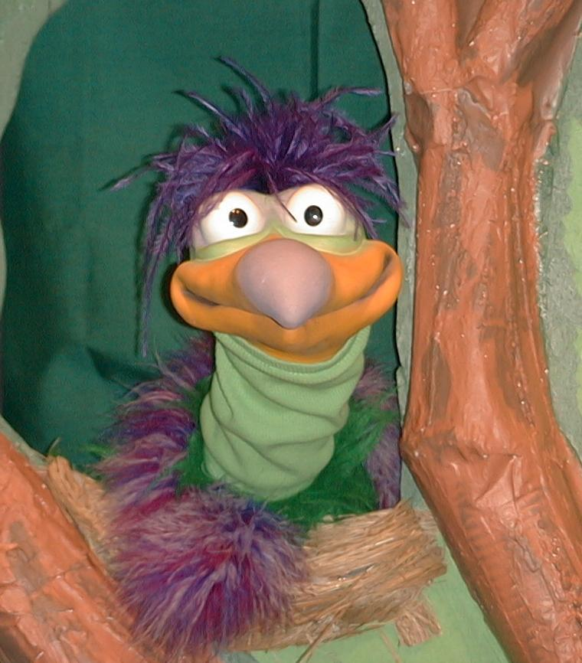
Presenter shows Xiao Er a craft made in Activity 1. Then the kids attempt to teach Xiao Er the take home point.

Presenter says to kids: “Jesus is our friend…”
Kids say: “…Bring Jesus home.”
Presenter says to Xiao Er: “Jesus is our friend…”
Xiao Er says: “I can eat marshmallows with my toes!”

Presenter shows an example of the next activity done in small group and repeats first phrase to kids. The kids say the correct response trying to teach Xiao Er the take home point. Continue in this manner with Presenter showing example of each activity. Here are Xiao Er’s responses:

Xiao Er’s response to Activity 2 sample: “Bring a ping-pong ball home!”
Xiao Er’s response to Activity 3 sample: “I want to make an Xiao Er book!”
Xiao Er’s response to Activity 4 sample: “I write on my own words!”

Presenter says: “Xiao Er, listen one last time.
Jesus is our friend…”
Kids’ response: “…Bring Jesus home.”
Presenter says to Xiao Er: “Jesus is our friend…”
Xiao Er’s response: (Warms up his singing voice with “Mee, mee, mee, mee, mee…” and sings in a silly dramatic opera-like voice) “JESUS IS OUR FRIEND – BRING JESUS HOME.”

Welcome guests and thank them for attending.

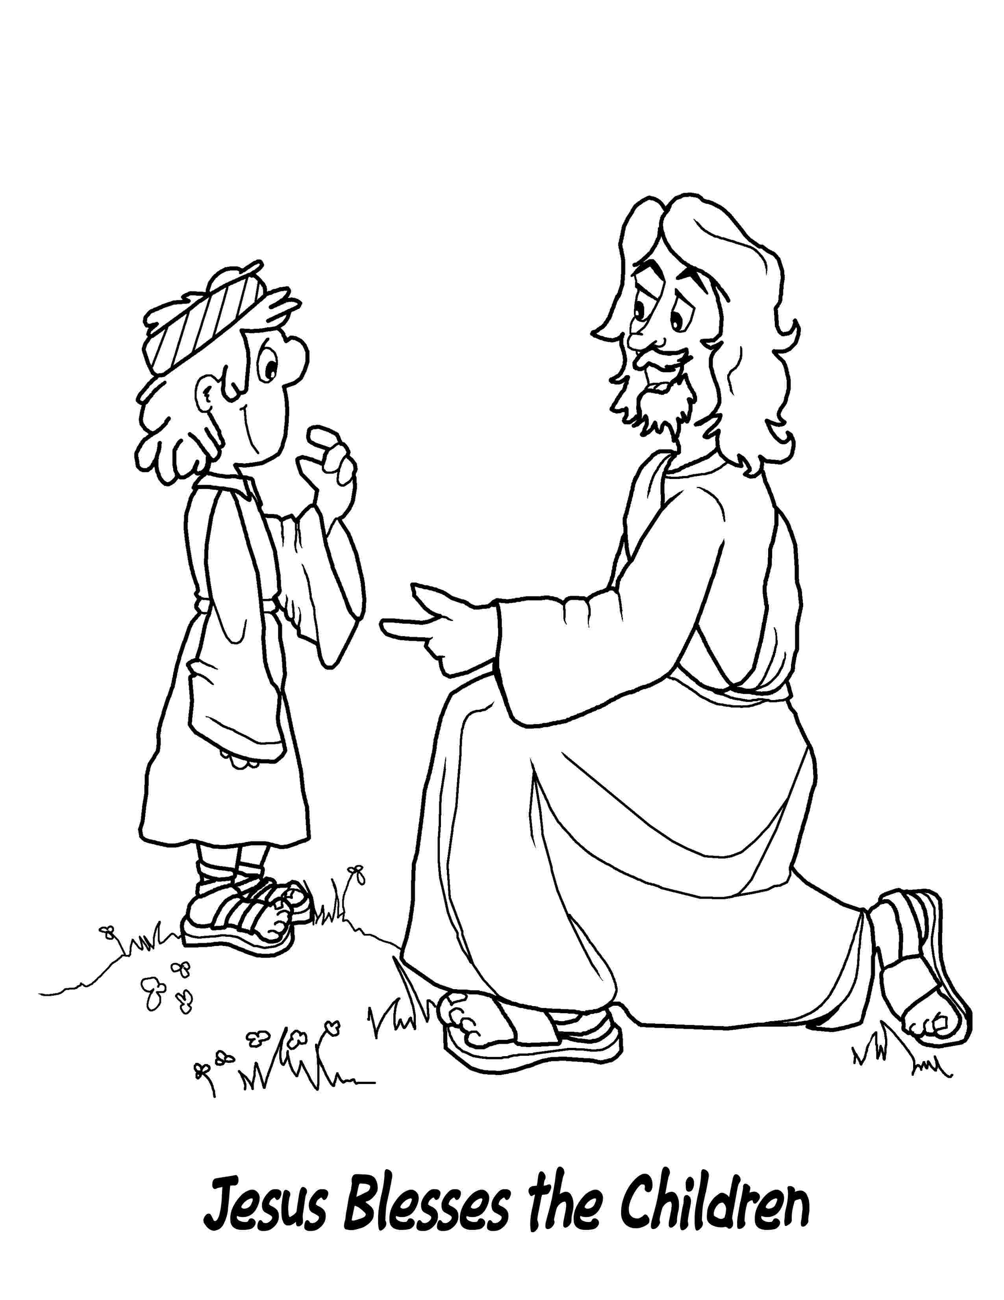
Romans 5:11 ~ Through Jesus we are now God’s friends again.

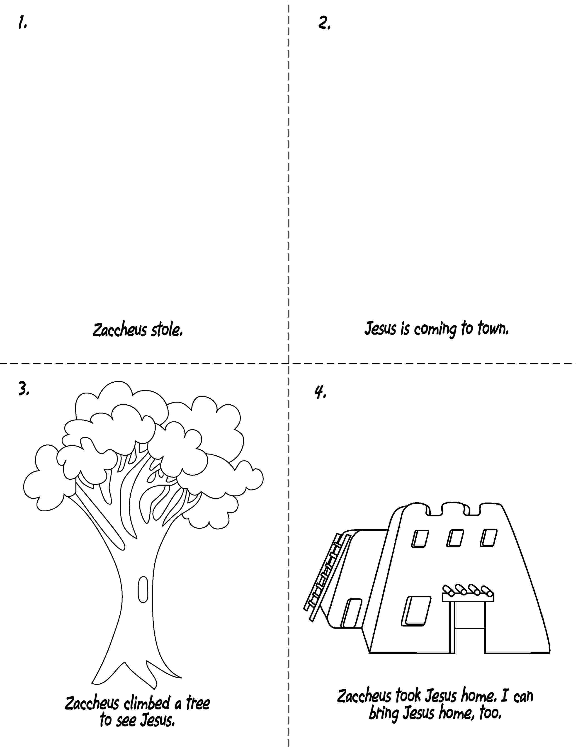

Lesson 34
Large Group Opening:
- Xiao Hung puppet
- small binoculars (two toilet paper tubes hot glued together)
- fake potted tree
- stepladder
- male Bible character puppet or actor
Small Group Application:
Activity 1:
- different kinds of biscuits available in ‘pasar malam’.
- two paper cups per child
- spoons
- water or juice
Activity 2:
- one ping-pong ball per child. Draw crosses on them using a permanent marker
- several buckets with a sign saying, “Home”
Activity 3:
- one photocopied sheet per child, cut into four small pages and stapled to make a book
- glue or cellophane tape
- one gold coin (alternatives: several yellow dot stickers or a yellow construction paper circle)
- about ten dot stickers per child
- magic pens
- crayons
- half sheet of manila card folded and stapled to book for cover
Activity 4:
- last week’s A3 visual (Reserve this for another week.)
- worksheet on page 9
- crayons or colour pencils

Large Group Wrap-Up:
- Xiao Er puppet
- sample materials from small group activities

