
Date: ________________________
Series: Jesus Is Our Friend (Dec-Mar)
Year 1, Lesson 35

The Woman at the Well

Take Home Point: *JESUS IS EVERYONE’S FRIEND – Love everyone, too.
*Repeat this phrase throughout the lesson. The presenter will say the first part of the phrase (CAPS). The children respond with the second part of the phrase (italics).

Bible Event: John 4:4-28
Jesus Link: Jesus does not think as the world does; He loves everyone.

We will help children know:
- The story of the woman at the well.
- Jesus loves everyone.
- We can love everyone, too.

We will help the children feel:
- Loved by Jesus.
- Love for other people.
- Friendship with other people.

We will help the children do:
- Act out the Bible event of the woman at the well.
- Make and eat bread and jam heart snacks.
- Play a song game, “Jesus at the Well.”

THIS LESSON’S ROADMAP

DESTINATION | PAGE # | DISCOVERIES ON YOUR JOURNEY | SUPPLIES NEEDED
Large Group Opening   | 3  3 | Puppet Presentation  Bible Event | - Ting Ting puppet  - small glass  - well: draw squares on mahjong paper and tape paper around a 10-15 gallons water container  - bucket of water with ladle (place it in the well)  - microphone  - Imagination Box that contains:  - Bible  - two Bible character headpieces
Small Group Application   | 7  7  8  8  8 | Activity 1: “Red Heart” Snack  Activity 2: “Jesus at the Well” Game  Activity 3: ”Friendship Gift” Craft  Activity 4: “Tell a Friend”  Prayer Time | Activity 1:  - one slice of bread per child  - heart-shaped cookie cutters  - strawberry jam  - plastic knives  - serviettes  - paper cups  - water or juice  Activity 2:  - no supplies needed  Activity 3:  - reproducible hearts from page  11  - UHU glue  - coloured stones  - 8” string for each child;  - puncher  Activity 4:  - last week’s A3 visual  - a handkerchief
Large Group Wrap-Up   | 9  9 | Singing (Optional)  Lesson Review with Puppet Skit | - Xiao Er puppet  - sample materials from small group activities

Pre-Session Singing: (10 minutes)
Purpose: When all children are in one group singing, it is easy for new children to join the group and immediately get involved. When the music can be correlated, it introduces the theme for the day. Choose two to three songs and list them here.

Large Group Opening: (15 minutes)
Purpose: The puppet demonstrates the need that will be met in today’s lesson. The scripts are not written verbatim, but give a story line in which the group presenter can interact with the puppet. The children are introduced to the take home point and then interact with God’s word as they experience the Bible event.

Supplies needed: Ting Ting puppet; small glass; well: draw squares on mahjong paper and tape paper around a10-15 gallons water container; bucket of water with ladle (place it in the well); microphone; Imagination Box that contains: Bible, two Bible character headpieces

Puppet Presentation:
Ting Ting comes in crying and carrying a small glass. The presenter asks her what is wrong. Ting Ting says that some kids were teasing her because she has (pick out an unusual characteristic of your Ting Ting puppet such as orange hair or blue skin.)

The presenter tells Ting Ting that he is sorry that her feelings were hurt and then asks why she has a glass. Ting Ting says, “I told my mom that I cried a bucket of tears and she gave me a glass of water to fill me back up. But I don’t feel better.”

The presenter tells Ting Ting that her problem reminds him of today’s Bible event the children will be learning. It’s about a woman who was teased by the other women in her village. She was sad, just like Ting Ting. But Jesus, God’s own Son, came to her village and told her He would be her friend. And Jesus is Ting Ting’s friend, too. The presenter then says, “And Ting Ting, we’ll all be your friends, too. Won’t we, kids?”

The presenter teaches Ting Ting today’s take home point: *JESUS IS EVERYONE’S FRIEND – Love everyone, too. After practicing several times with Ting Ting, the presenter practices the take home point with the children.

Bible Event: Imagination Theater
Imagination Theater is audience participation drama where the Bible event is told in creative fashion using children as actors. The Imagination Box contains the Bible and other special props used for the drama. Begin by removing the Bible and explain that it is God’s word. Briefly, summarize the story, and then remove an Imaginary Hat and place it on your head. This is your Imagination Hat. Invite the children to put on theirs as well. They will also use their imaginations to picture the events the Bible tells us about. Some will even use their imaginations to help act out these events. Distribute props to actors as they are called forward at the beginning of the presentation. Have them sit to the side until they are called on stage.

“Jesus Is a Friend to the Woman at the Well”

A well needs to be fashioned by decorating a round garbage can. This can be as simple as drawing squares on mahjong paper and taping it around the can. Place a bucket of water in the well.

Let’s see what’s in our Imagination Box. Here’s the Bible. It’s God’s word. It’s marked to a special page. Ah…This is the event when Jesus is a friend to the woman at the well.

While Jesus was waiting for the disciples at a well, He met a sinful woman who was coming to get water. Jesus asked the woman for a drink. The woman was surprised Jesus was being nice to her because everyone else was mean to her. Then Jesus said, “I am your friend.” The woman was very excited and told everyone they could also be friends with Jesus.

Phrases that are underlined and italicized are to be repeated by the child actor or audience. Point the microphone to the actor to show when it is his or her turn.

Let’s act it out. We’ll see what else we have in the Imagination Box. Here are some costumes. I’ll need a volunteer to be Jesus and one to be the woman at the well.

After the children have been costumed, have Jesus go offstage on one side. The woman at the well should go offstage on the opposite side.

Now I need everyone else to be helpers. All of the boys stand up. You’re going to be Jesus’ followers or disciples. Girls, you are going to be other women who lived in the village with the Samaritan woman. I’m going to ask you to repeat lines so you can help tell the story.

Disciples, stand up and start walking in place. Jesus, come here and start walking in place. And now we begin…

One day Jesus and His disciples were walking through the land of Samaria. The Jews did not like Samaria because Samaria was a different country than Israel and the people worshiped God in a different way.

When the disciples were walking through Samaria, they said, “Eeeew! Yuck – Samaria!” Eeeew! Yuck – Samaria!

As they walked through Samaria, Jesus and the disciples came to a well. Jesus told the disciples to go get some food while He rested.

“Go, get some food.” Go, get some food.

So, the disciples went to get some food. You can sit down now.

After the disciples left, a Samaritan woman came to the well where Jesus was. Most of the friends of Jesus would never talk to a Samaritan woman. They would say, “Eeew! Yuck!” Eeew! Yuck!

Now this woman came to the well by herself. That’s because she didn’t have many friends. She was a sinful woman. The other women in the village would talk about her. They would say, “Eeew! Yuck – a sinful woman!” I think I hear the women in the village talking now, “Eeew! Yuck – a sinful woman!” Eeew! Yuck – a sinful woman!

You can guess that this woman probably felt very much alone. When she came to the well, she didn’t expect Jesus to talk to her. After all, she was a Samaritan woman and she was sinful.

When Jesus saw the woman He asked, “Will you give me a drink?” Will you give me a drink?

It surprised the woman that Jesus talked to her. She asked Jesus, “Why are you being friendly to me?” Why are you being friendly to me?

Jesus said, “Let me tell you a riddle. If you knew who I was, you would ask me and I would give you living water. You would never be thirsty again.” (Pick up ladle and pour some water from the bucket.)

The Samaritan woman said, “I would like that kind of water. Then I wouldn’t have to come out to the well every day and bring water back.”

Jesus said, “No. Living water is not the kind of water you drink from a well. Living water means having Jesus as your friend and knowing that I love you. You need living water when you are thirsty in your heart. God fills you with his love!”

The Samaritan woman was confused. “Who are you? Are you the one who was promised from God?”

“Yes,” said Jesus. “I am the promised Savior from God. And listen to this: I am your friend.” I am your friend.

When the Samaritan woman heard this, she was excited. “Jesus, the Savior sent from God, will be my friend? Jesus must be everyone’s friend!”

The woman was so excited she went into town to tell everyone. “Come and meet Jesus!” Come and meet Jesus!

Have the girl playing the Samaritan woman go out into the audience and grab several kids and bring them onstage to sit at the well.

Do you see what the Samaritan woman did? After she learned Jesus loves her, she knew that Jesus loves everyone. This made her want to tell others about Jesus. She brought them to Him.

Maybe you can remember just like she did: *JESUS IS EVERYONE’S FRIEND – Love everyone, too.

End with a brief prayer with children repeating after each line.

Dear God, (repeat)
Thank You for being here. (repeat)
Thank You for sending Jesus. (repeat)
He is everyone’s friend. (repeat)
We can love everyone, too. (repeat)
Thank You! Thank You! Thank You! (repeat)
Amen. (repeat)

Small Group Application: (30 minutes)
Purpose: Smaller groups enable children to develop closer relationships with adults and peers in the church. As you reinforce the take home point with a fun hands-on activity, discuss the Bible event. Be sure to repeat the take home point several times. Say the first part and have the children respond with the second phrase. Application questions help kids apply the take home point to their daily lives. Close this session by gathering your small group for prayer. Let the kids pray!

During the small group application time, discuss the following questions and points:

How did the people feel about the Samaritan woman? Why? (Nobody liked her because she was a Samaritan and because she was sinful.)

How did Jesus feel about her? (He loved her and He was her friend.)

How do you think that made her feel? (Answers will vary—happy, loved, joyful.)

Jesus loves everyone and is everyone’s friend—including you. How does that make you feel? (Answers will vary—happy, excited, joyful.)

Jesus wants us to love everyone because He loves everyone. How can you show other people that you love them? (Answers will vary but may include—play with them, be their friend, tell them about Jesus, help them when they are hurt, etc.)
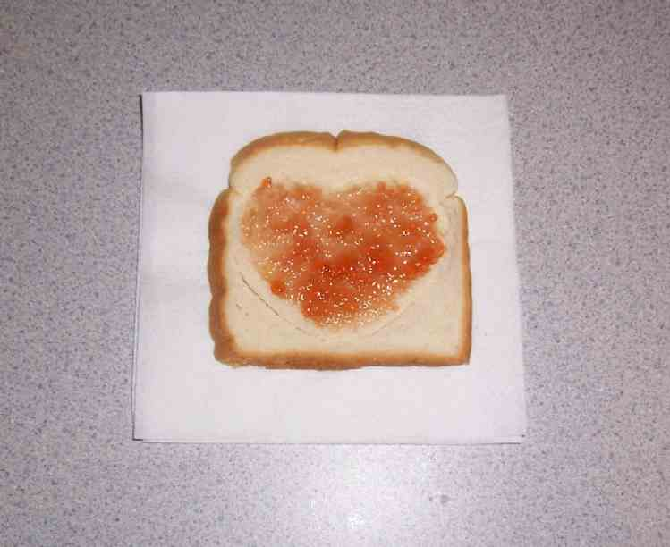
Activity 1: “Red Heart” Snack
Supplies needed: one slice of bread per child; heart-shaped cookie cutters; strawberry jam; plastic knives; serviettes; paper cups; water or juice

Have the children cut out a heart from the bread using the cookie cutter. Spread the jam on the bread. As the children eat, point out that the heart is a reminder that *JESUS IS EVERYONE’S FRIEND – Love everyone, too.

Activity 2: “Jesus at the Well” Game
Supplies needed: no supplies needed

This activity works best with 6-12 children. You may need to join smaller groups of children together to play the game.

Have the children hold hands to form a circle. One child will be in the middle as Jesus. The children walk in a circle around Jesus as they sing the song:

“Jesus at the Well”
(Tune: “The Farmer in the Dell”)

Jesus at the well.
Jesus at the well.
All-le-hey-loo-oo-ia,
Jesus at the well.

(Have Jesus grab a child and bring the child in the middle.)

Jesus takes a friend.
Jesus takes a friend.
All-le-hey-loo-oo-ia,
Jesus takes (child’s name).

(Have Jesus grab a child to bring in the middle and say that child’s name.)

Continue playing the game until every child is in the middle. After a child is brought into the middle, that child gets to choose the next person brought into the middle. End the song:

Jesus is our friend.
Jesus is our friend.
All-le-hey-loo-oo-ia,
Jesus is our friend.

Activity 3: “Friendship Gift” Craft
Supplies needed: reproducible hearts from page 11; UHU glue; coloured stones; 8” string for each child; puncher

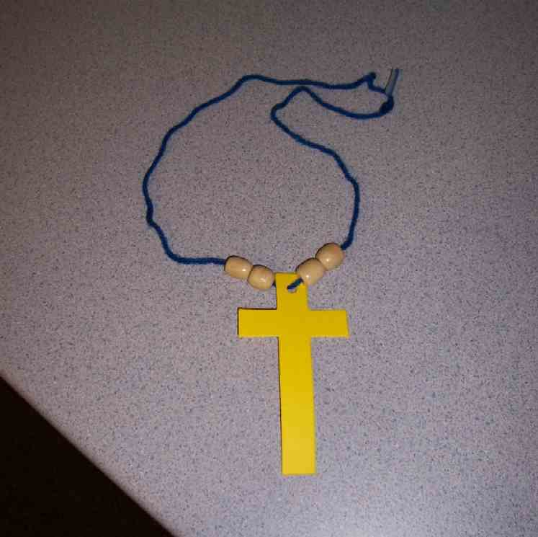
Cut out reproducible hearts – one for each child. Punch a hole at the top of the card. Give each child one heart. Have the children stick the coloured stones all around the heart with UHU glue that is only handled by shepherd. Tie the string at the top of heart.

Explain to the children that this craft is a way to show a friend that Jesus loves them. The children are to give the friendship necklace away to a friend and say “Jesus loves you.” Explain to the children that we are doing this project because *JESUS IS EVERYONE’S FRIEND – Love everyone, too.

Activity 4: “Tell a Friend”
Purpose: Help kids to memorize and keep scriptures at heart. Using creative ways to help kids enjoy learning the key verse and in small group setting.

Supplies needed: last week’s A3 visual; a handkerchief

Memory Verse: Romans 5:11 ~ “Through Jesus we are now God’s friends again.”

Memory Verse Learning:
Revise the memory verse with last week’s visual. Sit the children in a circle. This memory verse learning is based on the local “handkerchief” game. Choose a child to be “it” and stand outside the circle. Give him a handkerchief and he is to walk around the outside of the circle. While walking, he is to place the handkerchief behind the person whom he chooses. The child with the handkerchief is to stand and chase after “it”. “It” runs one round and sit at the friend’s former place. But “it” is only saved after he recites the memory verse. If he can’t, he has to be “it” again.

Prayer Time:
Have each child say a prayer, asking God to help him be a friend to______.

Large Group Wrap-Up: (10 minutes)
Purpose: The crazy bird puppet, Xiao Er, struggles with learning the take home point. The presenter shows an example of each small group application activity from this lesson and says the first phrase of the take home point. The kids respond with their phrase. They try to teach the puppet the take home point, but each time he confuses words or concepts. After three attempts, he finally gets it right and sings the correct take home point in a silly opera-like voice.

Supplies needed: Xiao Er puppet; sample projects from small group time

Singing: (Optional)

Lesson Review with Puppet Skit:

Presenter shows Xiao Er a craft made in Activity 1. Then the kids attempt to teach Xiao Er the take home point.

Presenter says to kids: “Jesus is everyone’s friend…”
Kids say: “…Love everyone, too.”
Presenter says to Xiao Er:“Jesus is everyone’s friend…”
Xiao Er says: “I have jam on my nose!”

Presenter shows an example of the next activity done in small group and repeats first phrase to kids. The kids say the correct response trying to teach Xiao Er the take home point. Continue in this manner with Presenter showing example of each activity. Here are Xiao Er’s responses:

Xiao Er’s response to Activity 2 sample: (singing) “…Xiao Er at the well!”
Xiao Er’s response to Activity 3 sample: “my friend has a stone heart!”
Xiao Er’s response to Activity 4 sample: “I have a handkerchief!!”

Presenter says: “Xiao Er, listen one last time.
Jesus is everyone’s friend…”
Kids’ response: “…Love everyone, too.”
Presenter says to Xiao Er: “Jesus is everyone’s friend…”
Xiao Er’s response: (Warms up his singing voice with “Mee, mee, mee, mee, mee…” and sings in a silly dramatic opera-like voice) “JESUS IS EVERYONE’S FRIEND – LOVE EVERYONE, TOO.”

Welcome guests and thank them for attending.

Lesson 35

Large Group Opening:
- Ting Ting puppet
- small glass
- well: draw squares on mahjong paper and tape paper around a 10-15 gallons water container
- bucket of water with ladle (place it in the well)
- microphone
- Imagination Box that contains:
- Bible
- two Bible character headpieces

Small Group Application:
Activity 1:
- one slice of bread per child
- heart-shaped cookie cutters
- strawberry jam
- plastic knives
- serviettes
- paper cups
- water or juice
Activity 2:
- no supplies needed
Activity 3:
- reproducible hearts from page 11
- UHU glue
- coloured stones
- 8” string for each child;
- puncher
Activity 4:
- last week’s A3 visual
- a handkerchief

Large Group Wrap-Up:
- Xiao Er puppet
- sample projects from small group time

Jesus
loves you
Jesus
loves you
Jesus
loves you
Jesus
loves you
Jesus
loves you
Jesus
loves you

