
Date: ________________________
Series: Jesus Is Our Helper (Dec-Mar)
Year 1, Lesson 37

Jesus Changes Water into Wine

Take Home Point: *JESUS HELPS US – Give Jesus your problems.
*Repeat this phrase throughout the lesson. The leader will say the first part of the phrase (CAPS). The children respond with the second part of the phrase (italics).

Bible Event: John 2:1-11
Jesus Link: Jesus died on the cross so He could pay for our problems.

We will help children know:
- The story of Jesus turning water into wine.
- We can take our problems to Jesus.

Jesus wants to help us.

We will help the children feel:
- Eager to share their problems with Jesus.
- Confident that Jesus will help them.
- Secure in Jesus’ love for them.

We will help the children do:
- Participate in an interactive Bible event drama.
- Reenact the Bible event through a snack time wedding feast.
- Play a game with ping-pong balls to practice giving problems to God.

THIS LESSON’S ROADMAP

DESTINATION | PAGE # | DISCOVERIES ON YOUR JOURNEY | SUPPLIES NEEDED
Large Group Opening   | 3  3-5 | Puppet Presentation  Bible Event | - Ting Ting puppet with a small basket or handful of flowers  - Imagination Box that includes:  - Bible  - one streamer for each child  - headpieces for Jesus, Mary, and one servant  - white headpieces for bride and groom  - microphone  - clear jug with food coloring on bottom (suggestions: mix red and blue to make purple and put it in the bottom of the jug the day before so that it dries.)  - jug of water  - party popper (optional)
Small Group Application   | 6  7  7  8  8 | Activity 1: “Wedding Feast” Snack  Activity 2: “Ping-Pong Fling” Game  Activity 3: ”Hidden Picture” Craft  Activity 4: “Tracing Verse”  Prayer Time | Activity 1:  - one cup per child  - enough water for each child  - sweetened fruit drink powder (such as black currant glucose)  - teaspoon  - party treat (cup cake, butter cakes )  - utensils needed to eat  Activity 2:  - one or more ping-pong balls  - cloth  Activity 3:  - one piece of A4 per child with a cross drawn on it using a white crayon  - label with the take home point printed on it  - flat box lid or pan  - red food colouring powder  - paintbrush  - cup of water  - pencils  Activity 4:  - two 10X50cm carton board with  Bible verse prepared on it
Large Group Wrap-Up   | 9  9 | Singing (Optional)  Lesson Review with Puppet Skit | - Xiao Er puppet  - sample materials from small group activities

Pre-Session Singing: (10 minutes)
Purpose: When all children are in one group singing, it is easy for new children to join the group and immediately get involved. When the music can be correlated, it introduces the theme for the day. Choose two to three songs and list them here.

Large Group Opening: (15 minutes)
Purpose: The puppet demonstrates the need that will be met in today’s lesson. The scripts are not written verbatim, but give a story line in which the group leader can interact with the puppet. The children are introduced to the take home point and then interact with God’s word, as they experience the Bible event.

Supplies needed: Ting Ting puppet with a small basket or handful of flowers; Imagination Box that includes: Bible, one streamer for each child, headpieces for Jesus, Mary, and one servant, white headpieces for bride and groom, microphone, clear jug with food coloring on bottom (suggestions: mix red and blue to make purple and put it in the bottom of the jug the day before so that it dries.), jug of water, party popper (optional)

Puppet Presentation:
Ting Ting enters with a small basket or a handful of flowers. She explains she is going to be a flower girl in a wedding, but she is worried. She is afraid she might make a mistake or not know what to do.

The presenter reassures her that she will do just fine. He also reminds her that anytime she is worried and she has a problem, she can talk to Jesus about it. Jesus helps us so we can give him our problems.

Ting Ting asks if Jesus could even help her take care of a small thing like getting her part right at the wedding. The presenter reassures her again, noting that Jesus’ first miracle was helping people at a wedding. Ting Ting wonders if Jesus helped the flower girl at the wedding. The presenter informs her that it wasn’t just the flower girl, but Jesus helped everyone at the wedding. If Ting Ting listens closely to today’s Bible event, she will discover what Jesus did.

Review the take home point: *JESUS HELPS US – Give Jesus your problems.

Bible Event: Imagination Theater
Imagination Theater is audience participation drama where the Bible event is told in creative fashion using children as actors. The Imagination Box contains the Bible and other special props used for the drama. Begin by removing the Bible and explain that it is God’s word. Briefly, summarize the story, and then remove an imaginary hat and place it on your head. This is your Imagination Hat. Invite the children to put on theirs as well. They will also use their imaginations to picture the events the Bible tells us about. Some will even use their imaginations to help act out these events. Distribute props to actors as they are called forward at the beginning of the presentation. Have them sit to the side until they are called onstage.

“Jesus Changes Water Into Wine”

Take the Bible out of the Imagination Box and briefly summarize today’s Bible event.

Let’s see what is in the Imagination Box today. Here is God’s word and it’s marked to a special Bible event in which Jesus helps people at a wedding. Jesus went to a wedding with his mother, Mary. At the wedding, they ran out of wine to drink. Mary didn’t want the wedding to be ruined so she asked Jesus to help. Jesus had some big jars filled with water and then something very special happened to the water. I wonder if you can figure it out.

I see that we will need several actors to act this out. (As children are called forward, let another assistant costume them and sit them offstage.)

I need someone to play Jesus, His mother Mary, a servant, a girl who can pretend she is getting married on her wedding day, and the man who will be marrying her.

We need the help of everyone else in the audience. I’m passing out streamers so you can help celebrate the wedding. Please pretend that you are now all guests at a big wedding party. When I hold my streamer high over my head and say “Yay!” then you do the same. If I take my other hand and touch it to my cheek and say “Uh oh!” then you put your hand on your cheek and say, “Uh oh!” Shall we practice? (Practice each with the children.)

After you and the children put on your Imagination Hats, begin. Phrases that are underlined and italicized are to be repeated by the child actor or the audience. Point the microphone to the actor to show when it is his or her turn.

Long ago in the town of Cana, a man and a woman were getting married. And everyone said, “Yay!” Yay!

They had a wedding party. Jesus and His mother were there. Everyone was having a fun time celebrating with the two people who were getting married. Yay! Yay!

There was dancing and music. There was lots of good food, and there was wine to drink. My, wasn’t this a fine wedding! Yay! Yay!

Until…(pause) they ran out of wine. When they had a wedding party in Jesus’ day, they were never supposed to run out of food or wine. Everyone said, “Uh oh!” Uh oh!

Jesus’ mother, Mary, was sad because she didn’t want to see the wedding ruined for the new husband and wife. She also said, “Uh oh!” Uh oh!

Where do you think Mary would go for help? Do you think she should go to Jesus? Do you think He could help her? You’re right! Mary asked Jesus for help. Yay! Yay!

Then Mary told the helpers there, “Do whatever Jesus says.” Do whatever Jesus says.

There were six jars and they were this tall. (Hold your hand five feet above the ground.) Let’s just imagine this clear jug is one of the jars and this is what happened.

Jesus told the servant, “Put some water in these jars.” Put some water in these jars.

So, that is what the servant did, and a most wonderful thing happened.

(Have the child pour water from a jug into the jug with the dried food coloring on the bottom.) The water turned into wine! And everybody said, “Yay!” Yay!

Then, the one in charge of the food and wine came and tasted it. He said, “This is the best wine we have ever had!” And everybody said, “Yay!” Yay!

(Escort the servant to take imaginary cups to the characters so they can have a pretend drink.) Then, the servant brought a drink for the bride and groom to taste. He also brought some for Mary and Jesus. Everyone said it was wonderful. They looked at Jesus and said, “Yay!” Yay!

Option: “Explode” a party popper at this point to celebrate what Jesus did. Warn the children to cover their ears so they are not startled.

What do we remember from this Bible event when Jesus changes water into wine? We remember that *JESUS HELPS US – Give Jesus your problems, even if they are little problems.

We can always remember that Jesus gives us His power over our problems because He gave His life for us. When Jesus died on the cross, He really helped us. He took away our sin and gave us the power of His love in our lives so we could live for Him. Remember: *JESUS HELPS US – Give Jesus your problems.

Dear God, (repeat)
Thank You for being here. (repeat)
Thank You for sending Jesus. (repeat)
Jesus helps us. (repeat)
So we give Him our problems. (repeat)
Thank You! Thank You! Thank You! (repeat)
Amen. (repeat)

Small Group Application: (30 minutes)
Purpose: Smaller groups enable children to develop closer relationships with adults and peers in the church. As you reinforce the take home point with a fun hands-on activity, discuss the Bible event. Be sure to repeat the take home point several times. Say the first part and have the children respond with the second phrase. Application questions help kids apply the take home point to their daily lives. Close this session by gathering your small group for prayer. Let the kids pray!

During the small group application time, discuss the following questions and points:

What problem did the bride and groom have in today’s Bible event? (They ran out of wine.)

How did Jesus help them? (He turned water into wine.)

What are some problems we might have? (Answers will vary but might include getting hurt, being afraid, or getting sick.)

How can we give Jesus our problems? (By telling him our problems in prayer.)

Activity 1: “Wedding Feast” Snack
Supplies needed: one cup per child; enough water for each child; sweetened fruit drink powder (such as black currant glucose); teaspoon; party treat (cup cake, butter cakes); utensils needed to eat

Tell the group that you are going to have a wedding party today. Make a big deal of the snacks as you pass them out. When you go to get the drinks make a fuss that all you have is water. Who wants a wedding party with nothing but water to drink?

Then “discover” the sweetened fruit drink powder under the table in a bag. Let each child put a teaspoon of the drink powder into his or her cup and then pour water into it. Act amazed as it changes into a fruit drink. Say a prayer and let the children eat their snack.

As the children eat, review the story. Stress that Jesus didn’t need a powder to change the water into wine. He could do it by himself because Jesus is God. And Jesus can help us with our problems. Practice the take home point: *JESUS HELPS US – Give Jesus your problems.

Activity 2: “Ping-Pong Fling” Game
Supplies needed: one or more ping-pong balls; cloth

Review the take home point: *JESUS HELPS US – Give Jesus your problems.

Lay the cloth out flat. (If space is limited, the cloth can be laid out on your group’s table.) Have the children circle the sheet, grab an edge, and hold it in the air, horizontally.

Have the children take turns throwing the ping-pong ball(s) onto the cloth and naming problems. If the children can’t think of the problems, suggest some ideas, such as:

- Being afraid of the dark
- Falling and skinning a knee
- Getting sick
- Being scared of dogs
- Being teased by a bully
- Fighting with a brother or sister

After one or more balls are on the cloth, act out “keeping” the problems by having the children jiggling the cloth. Then say the take home point: *JESUS HELPS US – Give Jesus your problems.

After saying the take home point, the children fling the cloth up high and fling their “problems”—the ping-pong balls—into the air, to give them to Jesus. Have them fling them up as high as possible. When they come down, have the children try to catch the balls and pretend that they are their problems all fixed by Jesus.

Activity 3: “Hidden Picture” Craft
Supplies needed: one piece of A4 per child with a cross drawn on it using a white crayon; label with the take home point printed on it; flat box lid or pan; red food colouring powder; paintbrush; cup of water; pencils

Explain to the children that the paper has a hidden picture that shows the most important way Jesus has helped us with our problems. Have the children take turns putting their paper in the box lid or pan and sprinkling a small amount of the food colouring powderon the paper. Then have them use the water to paint over the paper. The cross will appear. Explain that the best way Jesus helped us with our problems was by dying on the cross to take away our sins, all the bad choices we make. When they are finished, have them put the label on the paper.

Practice the take home point: *JESUS HELPS US – Give Jesus your problems. Help the children write their names on their papers. Finish by taking your sins to Jesus—pray for Jesus to forgive you when you sin and thank Him for dying on the cross for you.

Activity 4: “Tracing Verse”
Purpose: Help kids to memorize and keep scriptures at heart. Using creative ways to help kids enjoy learning the key verse and in small group setting.

Supplies needed: two 10X50cm carton board with Bible verse prepared on it

Memory Verse: John 14:6 ~ “I am the way, the truth and life.”

Memory Verse Learning:
Sit the children on the floor and pass out the first word strip – “I am the Way.” The object is to have the children feel the word “way” and “life.” As the children the first phrase, ask each child to trace the sandpaper word with their finger. Do the same for the second phrase.

Tell the children that Jesus can help us because He is the way, the truth and life. He is able to help us in all kinds of problems.

I am the Way,
cut out from sandpaper or from words form parcel strings so children can feel

the Truth and Life.

Prayer Time:
Have the children ask Jesus to help them with their problems.

Large Group Wrap-Up: (10 minutes)
Purpose: The crazy bird puppet, Xiao Er, struggles with learning the take home point. The leader shows an example of each small group application activity from this lesson and says the first phrase of the take home point. The kids respond with their phrase. They try to teach the puppet the take home point, but each time he confuses words or concepts. After three attempts, he finally gets it right and sings the correct take home point in a silly opera-like voice.

Supplies needed: Xiao Er puppet; sample materials from small group activities

Singing: (Optional)

Lesson Review with Puppet Skit:
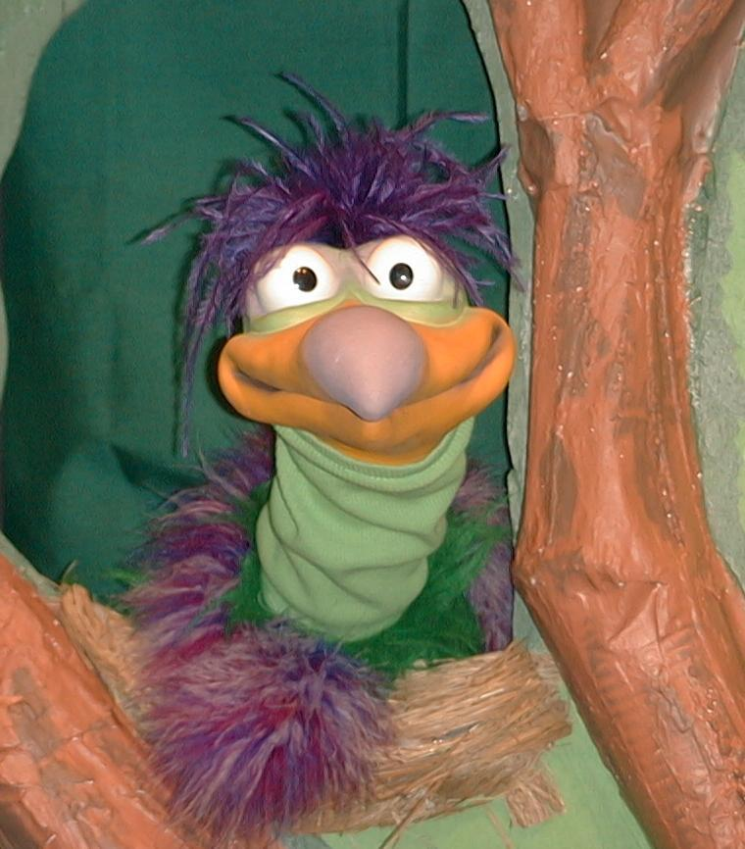
Presenter shows Xiao Er a craft made in Activity 1. Then the kids attempt to teach Xiao Er the take home point.

Presenter says to kids: “Jesus helps us…”
Kids say: “…Give Jesus your problems.”
Presenter says to Xiao Er: “Jesus helps us…”
Xiao Er says: “Eat upside down wedding cake!”

Presenter shows an example of the next activity done in small group and repeats first phrase to kids. The kids say the correct response trying to teach Xiao Er the take home point. Continue in this manner with Presenter showing example of each activity. Here are Xiao Er’s responses:

Xiao Er’s response to Activity 2 sample: “Pop more ping-pong balls!”
Xiao Er’s response to Activity 3 sample: “Don’t suck on your paintbrush!”
Xiao Er’s response to Activity 4 sample: “Don’t stick your finger to my nose!”

Presenter says: “Xiao Er, listen one last time.
Jesus helps us…”
Kids’ response: “…Give Jesus your problems.”
Presenter says to Xiao Er: “Jesus helps us…”
Xiao Er’s response: (Warms up his singing voice with “Mee, mee, mee, mee, mee…” and sings in a silly dramatic opera-like voice) “JESUS HELPS US – GIVE JESUS YOUR PROBLEMS.”

Welcome guests and thank them for attending.

Lesson 37
Large Group Opening:
- Ting Ting puppet with a small basket or handful of flowers
- Imagination Box that includes:
- Bible
- one streamer for each child
- headpieces for Jesus, Mary, and one servant
- white headpieces for bride and groom
- microphone
- clear jug with food coloring on bottom (suggestions: mix red and blue to make
purple and put it in the bottom of the jug the day before so that it dries.)
- jug of water
- party popper (optional)
Small Group Application:
Activity 1:
- one cup per child
- enough water for each child
- sweetened fruit drink powder (such as black currant glucose)
- small measuring spoon
- party treat (cup cake, butter cakes )
- utensils needed to eat
Activity 2:
- one or more ping-pong balls
- cloth
Activity 3:
- one piece of A4 per child with a cross drawn on it using a white crayon
- label with the take home point printed on it
- flat box lid or pan
- red food colouring powder
- paintbrush
- cup of water
- pencils
Activity 4:
- two 10X50cm carton board. Write Bible verse on it like diagram. But the words “way” and “life” should be cut out from sandpaper and glue onto carton board. You can also use strings instead.
I am the Way,
cut out from sandpaper or from words form parcel strings so children can feel

the Truth and Life.

Large Group Wrap-Up:
- Xiao Er puppet
- sample materials from small group activities

