
Date: ________________________
Series: Jesus Is Our Helper (Dec-Mar)
Year 1, Lesson 38

Jesus Heals Jairus’ Daughter

Take Home Point: *JESUS HELPS US – Give Jesus your worries.
*Repeat this phrase throughout the lesson. The presenter will say the first part of the phrase (CAPS). The children respond with the second part of the phrase (italics).

Bible Event: Mark 5:21-24, 35-43
Jesus Link: Jesus performed miracles when He was on earth, and He can perform miracles in our lives today.

We will help children know:
- Jesus loves them.
- How they can give Jesus their worries.

Because Jesus loves them, He will help them with their worries.

We will help the children feel:
- Loved by Jesus.
- Secure that they can take their worries to Jesus.
- Confident that Jesus will help them with their worries.

We will help the children do:
- Participate in a drama that portrays Jesus healing Jairus’ daughter.
- Use a balloon game to give their worries to Jesus.
- Make a cheese and cracker snack to portray the Bible event.

THIS LESSON’S ROADMAP

DESTINATION | PAGE # | DISCOVERIES ON YOUR JOURNEY | SUPPLIES NEEDED
Large Group Opening  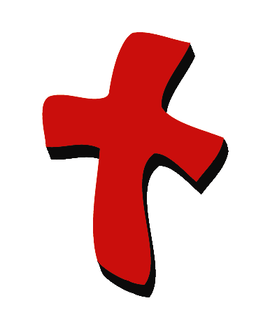 | 4  4 | Puppet Presentation  Bible Event | - Xiao Hung puppet  - small stuffed puppet  - Imagination Box that holds:  - Bible  - two blankets  - one pillow  - child-sized Bible character costumes for Jesus, Jairus, Jairus’ daughter, Jairus’ wife
Small Group Application   | 7  7  8  8 | Activity 1: “Jairus’ Daughter” Snack  Activity 2: “Don’t Worry Balloon Thump” Game  Activity 3: ”Worry Wart/Happy Heart Necklace” Craft  Activity 4: “Puzzle Race”  Prayer Time | Activity 1:  - half a cream cracker per child  - half a slice of cheese per child  - four finger biscuits per child  - serviettes  - paper cups  - water or juice  Activity 2:  - inflated balloon  - one plastic spoon per child with crosses drawn on them, using permanent markers (Option: Let the children draw the crosses on the spoons.)  Activity 3:  - 18 inch length of string per child  - one reproducible per child (use manila card) with the circle cut out (see pattern in index). Punch two holes at the top of the circle. Option: Kindergartners may enjoy cutting out the circle themselves, in that case you will need scissors.  - crayons  - label with the take home point printed on it  Activity 4:  - Bible verse on heart shape cards (see page 12,13)  - white board or metal plat
Large Group Wrap-Up   | 9  9 | Singing (Optional)  Lesson Review with Puppet Skit | - Xiao Er puppet  - sample materials from small group activities

Pre-Session Singing: (10 minutes)
Purpose: When all children are in one group singing, it is easy for new children to join the group and immediately get involved. When the music can be correlated, it introduces the theme for the day. Choose two to three songs and list them here.

Large Group Opening: (15 minutes)
Purpose: The puppet demonstrates the need that will be met in today’s lesson. The scripts are not written verbatim, but give a story line in which the group presenter can interact with the puppet. The children are introduced to the take home point and then interact with God’s word, as they experience the Bible event.

Supplies needed: Xiao Hung puppet; small stuffed puppet ; Imagination Box that holds: Bible, two blankets, one pillow, child-sized Bible character costumes for Jesus, Jairus, Jairus’ daughter, Jairus’ wife

Puppet Presentation:
Xiao Hung comes in carrying a stuffed puppy. He seems upset. He tells the presenter that he is worried. His family is going on a vacation and he has to leave his new puppy, “Rocky”, behind. The presenter asks if someone will be taking care of his puppy. Xiao Hung says yes, but Rocky might get cold or lonely. He might even run away. The presenter tells Xiao Hung that Jesus understands his worry.

The Bible event today is about a father who was very worried about his daughter who was sick, and Jesus helped him. Teach the take home point to Xiao Hung. *JESUS HELPS US – Give Jesus your worries. After practicing it with Xiao Hung, teach it to the children. End by helping Xiao Hung ask Jesus to keep Rocky safe when he is gone.

Bible Event: Imagination Theater
Imagination Theater is audience participation drama where the Bible event is told in creative fashion using children as actors. The Imagination Box contains the Bible and other special props used for the drama. Begin by removing the Bible and explain that it is God’s word. Briefly, summarize the story, and then remove an imaginary hat and place it on your head. This is your Imagination Hat. Invite the children to put on theirs as well. They will also use their imaginations to picture the events the Bible tells us about. Some will even use their imaginations to help act out these events. Distribute props to actors as they are called forward at the beginning of the presentation. Have them sit to the side until they are called onstage.

“Jesus Heals Jairus’ Daughter”

Let’s see what we have in today’s Imagination Box. Here is God’s word, and it’s marked to a special spot: Jesus heals Jairus’ daughter. Jairus was a presenter who learned to trust Jesus when his daughter became very sick. Jairus was worried that his daughter would die, but he believed Jesus could heal her. Before Jesus could come to the girl to heal her, the girl died. But Jesus said, “Little girl, get up!” and she did. Jairus’ daughter was alive again.

After you and the children put on your Imagination Hats, begin. Phrases that are underlined and italicized are to be repeated by the child actor or the audience. Point the microphone to the actor to show when it is his or her turn.

Here are the costumes for our special actors. (Dress the actors with the assistance of another adult, and have the children stand offstage.)

Here is a blanket and a pillow. Let’s pretend it is a bed. In Jesus’ day, people’s beds were usually blankets on the floor.

Now let me introduce some special people in today’s Bible event. This is Jairus and his wife. Jairus was a presenter who trusted God. He also loved his family very much, especially his daughter. Here she is now.

Jairus’ daughter loved to run and play with all the children. But there was something wrong with her. She was getting sicker and sicker. She could no longer run and play. She had to stay indoors. Finally, she had to just lie in bed. (Have Jairus’ daughter lie on floor and cover her with the blanket.)

Jairus and his wife were worried about their daughter. They thought their daughter would die. What could they do? Who could they turn to?

They heard of a wonderful teacher from God. His name was Jesus. People had said Jesus could heal the sick people.

Jairus hurried to find Jesus. Jesus was supposed to be visiting their area that day.

Here is Jesus now! Jairus ran up to Jesus and said, “Will you heal my daughter?” Will you heal my daughter? “I know you can.” I know you can.

Jesus smiled at Jairus. Jairus trusted Him. Jairus believed that if Jesus could just go to his daughter and place His hands on her, she would be healed.

Jesus wants us to trust Him and give Him all of our worries. So, Jesus followed Jairus to his home. When he got there, many people were crying. I think I can hear them now. (Points to the audience.) Can I hear you cry? Oh, you can cry more than that, can’t you? (Get the children to “boo hoo” and cry.)

Yes, it’s true. Everyone was sad at Jairus’ house. His daughter had died. The people told Jairus, “Don’t bother Jesus anymore. The girl is dead.”

But Jesus didn’t listen to them. Instead, He looked at Jairus and said, “Don’t be afraid. Just believe.” Don’t be afraid. Just believe.

(Cover Jairus’ daughter’s head with the blanket to symbolize her death.) Jesus heard all the people crying and moaning loudly. Can I hear you cry and moan? (Lead children in crying and moaning.)

Jesus said to them, “Why are you crying? She’s not dead. She’s only sleeping.” Why are you crying? She’s not dead. She’s only sleeping.

Then all the people laughed. Can I hear you laugh? But Jesus didn’t care. He took Jairus, Jairus’ wife, and His close disciples inside the little girl’s room. Jesus stood over her and said (whisper into Jesus’ ear and have him repeat into the microphone), “Little girl, get up!”

Then she did! The girl stood up and walked around. She was completely healed and alive!

Everyone was amazed at what Jesus had done. Especially Jairus and his wife! Remember how they were so worried for their little girl? They were worried that she would stay sick and die. But they learned to give their worries to Jesus, and He helped them just like He does for us today.

Remember Jesus gave His life for us, dying on the cross so we could be friends with Him forever and He could always help us. Remember: *JESUS HELPS US – Give Jesus your worries.

End with a brief prayer with children repeating after each line.

Dear God, (repeat)
Thank You for being here. (repeat)
Thank You for sending Jesus. (repeat)
Jesus helps us. (repeat)
Let us give Him our worries. (repeat)
Thank You! Thank You! Thank You! (repeat)
Amen. (repeat)

Small Group Application: (30 minutes)
Purpose: Smaller groups enable children to develop closer relationships with adults and peers in the church. As you reinforce the take home point with a fun hands-on activity, discuss the Bible event. Be sure to repeat the take home point several times. Say the first part and have the children respond with the second phrase. Application questions help kids apply the take home point to their daily lives. Close this session by gathering your small group for prayer. Let the kids pray!

During the small group application time, discuss the following questions and points:

What was Jairus worried about? (His daughter was sick and he was worried she might die.)

What did Jairus do with his worries? (He told them to Jesus and asked Jesus to help him.)

What do you worry about? (Answers will vary but may include having bad dreams, monsters, getting lost, that a parent might die. If children are unable to think of ideas, feel free to make a few suggestions.)

How can we give our worries to Jesus? (By praying and asking him to help.)

Activity 1: “Jairus’ Daughter” Snack
Supplies needed: half a cream cracker per child; half a slice of cheese per child; four finger biscuits per child; serviettes; paper cups; water or juice

Have the children lay a finger biscuits on a cracker and cover it with a cheese slice. This is Jairus’ daughter lying on her bed and covered with a blanket. The other stick biscuits are Jesus, Jairus, and Jairus’ wife. Before eating the snack, review the Bible event using the snack items. Have the children pretend that the little girl’s mother is crying. Jairus and Jesus come in. Jesus tells the little girl to get up. Make the finger biscuit under the cheese “jump up.” Jairus’ daughter is well! As the children eat the snack, review the take home point:*JESUS HELPS US –Give Jesus your worries.

Activity 2: “Don’t Worry Balloon Thump” Game
Supplies needed: inflated balloon; one plastic spoon per child with crosses drawn on them, using permanent markers (Option: Let the children draw the crosses on the spoons.)

Let the children take turns thumping the balloon in the air with the spoons. To thump a balloon with a plastic spoon, you can pull back the top and release it. Hold the handle and pull back the spoon, releasing it with a thump. If this is too difficult, simply have the kids hit the balloon with their spoon.

To begin, seat the children on the floor and tell them to remain seated for the game. When the balloon gets near you, thump it. See how many times you can thump it without it hitting the ground.

After the game, ask them to think about their worries such as being afraid of dark, worrying about getting sick, or worrying about bad dreams. Explain that the cross on the spoon is a reminder that Jesus took all our worries with Him when He died on the cross. It can thump our worries away as we give them to Jesus. *JESUS HELPS US –Give Jesus your worries.
Activity 3: “Worry Wart/Happy Heart Necklace” Craft
Supplies needed: 18 inch length of string per child; one reproducible per child (use manila card), with the circle cut out (see pattern in index). Punch two holes at the top of the circle. Option: Kindergartners may enjoy cutting out the circle themselves, in that case you will need scissors; crayons; label with the take home point printed on it

On the blank side of the circle, have the children draw a face of a “worry wart” (a sad face) and make several dots on the face. For each dot the children name a worry. If they cannot think of any worries make suggestions such as being late for school, not getting to go to a friend’s birthday party or their house might get robbed.

On the other side, have the children color the heart and affix the label over the top of it. Practice the take home point: *JESUS HELPS US –Give Jesus your worries. Lace the string through the holes and tie it. Explain to the children that when they wear the necklace close to their heart with the heart facing out, they can be reminded that they can have a happy heart because Jesus will help them with their worries.

Activity 4: “Memory in Heart”
Purpose: Help kids to memorize and keep scriptures at heart. Using creative ways to help kids enjoy learning the key verse and in small group setting.

Supplies needed: Bible verse on heart shape cards (see page 12,13), white board or metal plate

Memory Verse: John 14:6 ~ I am the way, and the truth, and the life.

Memory Verse Learning:
Arrange the memory verse cards on a magnetic white board or metal plate. Recite the memory verse with the children. Then, take down the magnetic heart and give each child a heart. As the whole group recites the memory verse, the child with the heart is to put up the heart when the word is being called out.

Prayer Time:
Have the children tell Jesus something that worries them and ask Jesus to help them.

Large Group Wrap-Up: (10 minutes)
Purpose: The crazy bird puppet, Xiao Er, struggles with learning the take home point. The presenter shows an example of each small group application activity from this lesson and says the first phrase of the take home point. The kids respond with their phrase. They try to teach the puppet the take home point, but each time he confuses words or concepts. After three attempts, he finally gets it right and sings the correct take home point in a silly opera-like voice.

Supplies needed: Xiao Er puppet; sample materials from small group activities

Singing: (Optional)

Lesson Review with Puppet Skit:
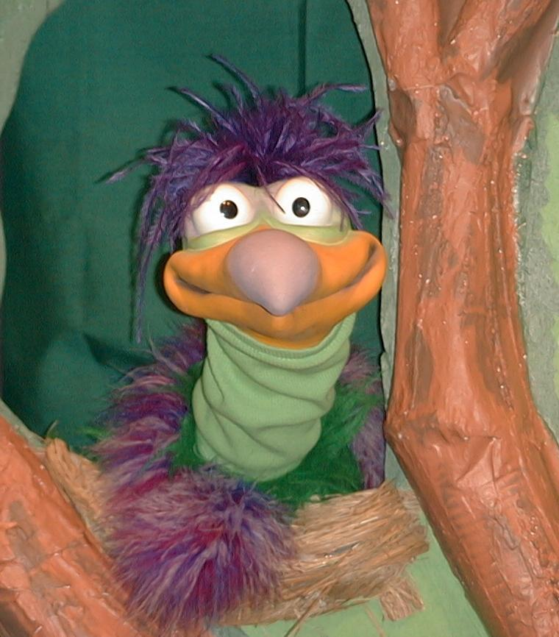
Presenter shows Xiao Er a craft made in Activity 1. Then the kids attempt to teach Xiao Er the take home point.

Presenter says to kids: “Jesus helps us…”
Kids say: “…Give Jesus your worries.”
Presenter says to Xiao Er: “Jesus helps us…”
Xiao Er says: “By giving us cheese crackers!”

Presenter shows an example of the next activity done in small group and repeats first phrase to kids. The kids say the correct response trying to teach Xiao Er the take home point. Continue in this manner with Presenter showing example of each activity. Here are Xiao Er’s responses:

Xiao Er’s response to Activity 2 sample: “To fly like a balloon!”
Xiao Er’s response to Activity 3 sample: “Xiao Er needs a necklace!”
Xiao Er’s response to Activity 4 sample: “Xiao Er win! Win! Win!”

Presenter says: “Xiao Er, listen one last time.
Jesus helps us…”
Kids’ response: “…Give Jesus your worries.”
Presenter says to Xiao Er: “Jesus helps us…”
Xiao Er’s response: (Warms up his singing voice with “Mee, mee, mee, mee, mee…” and sings in a silly dramatic opera-like voice) “JESUS HELPS US – GIVE JESUS YOUR WORRIES.”

Welcome guests and thank them for attending.

Lesson 38
Large Group Opening:
- Xiao Hung puppet
- small stuffed puppet
- Imagination Box that holds:
- Bible
- two blankets
- one pillow
- child-sized Bible character costumes for Jesus, Jairus, Jairus’ daughter, Jairus’ wife
Small Group Application:
Activity 1:
- half a cream cracker rectangle per child
- half a slice of cheese per child (to be blanket for Jarius’ daughter)
- four finger biscuits per child (a boarder one to represent people)
- serviettes
- paper cups
- water or juice
Activity 2:
- inflated balloon
- one plastic spoon per child with crosses drawn on them, using permanent markers (Option: Let the children draw the crosses on the spoons.)
Activity 3:
- 18 inch length of string per child
- one reproducible per child (use manila card), with the circle cut out (see pattern in index). Punch two holes at the top of the circle. Option: Kindergartners may enjoy cutting out the circle themselves, in that case you will need scissors.
- crayons
- label with the take home point printed on it one reproducible per child (use manila card), with the circle cut out (see pattern in index). Punch two holes at the top of the circle. Option: Kindergartners may enjoy cutting the circle themselves
Activity 4:
- Bible verse on heart shape cards (see page 12,13). Colour the heart shape cards, then attach a small piece of magnetic strip at its back.
- white board or metal plate

Large Group Wrap-Up:
- Xiao Er puppet
- sample materials from small group activities

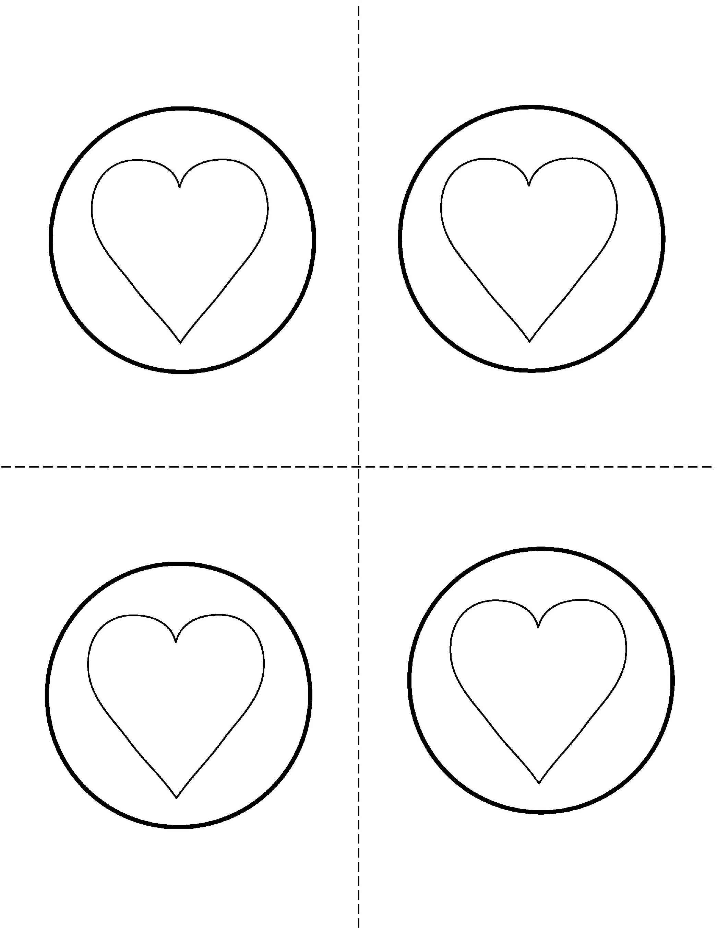

John
14:6
I
am
the way
and
the
truth,
and
the
life

