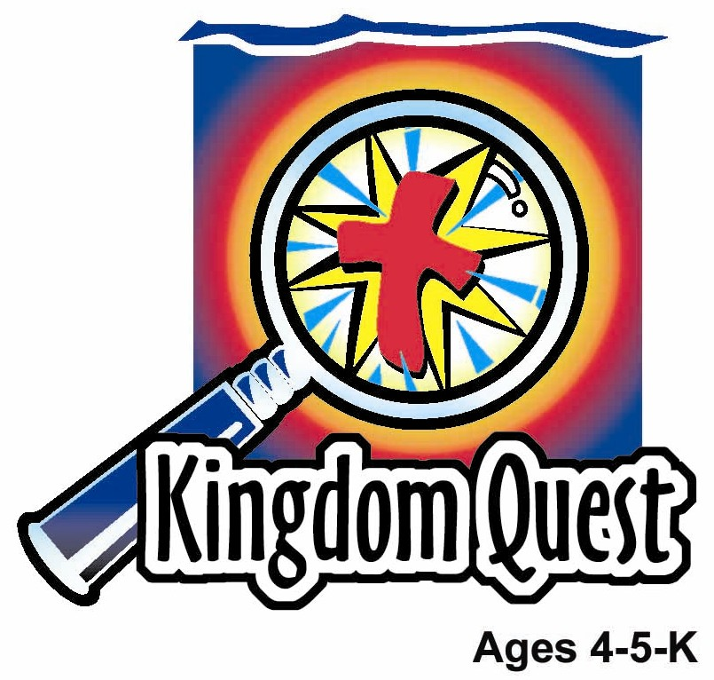
Date: ________________________
Series: Jesus Is Our Helper (Dec-Mar)
Year 1, Lesson 39

Jesus Calms

the Storm

Take Home Point: *JESUS HELPS US – Give Jesus your fears.
*Repeat this phrase throughout the lesson. The presenter will say the first part of the phrase (CAPS). The children respond with the second part of the phrase (italics).

Bible Event: Mark 4:35-41
Jesus Link: Jesus cannot take our problems unless we give them to Him.

We will help children know:
- The story of Jesus calming the storm.
- We can give Jesus our fears.

Jesus will either take away our fears or help us through them.

We will help the children feel:
- Peace in the midst of fearful times.
- Comforted by Jesus’ help.
- Secure in Jesus’ power to help.

We will help the children do:
- Dramatize the calming of the storm.
- Make the sound of rain with cream crackers to practice giving away their fears.
- Play a pillow relay and liken it to giving their fears to Jesus.

THIS LESSON’S ROADMAP

DESTINATION | PAGE # | DISCOVERIES ON YOUR JOURNEY | SUPPLIES NEEDED
Large Group Opening  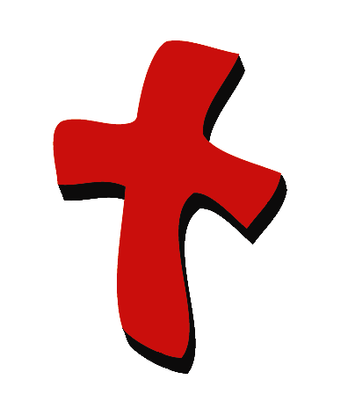 | 4  4 | Puppet Presentation  Bible Event | - Xiao Hung and Ting Ting puppets  - Imagination Box that includes:  - Bible  - Jesus costume and costumes for two or three disciples  - spray bottle with water in it  - blue tablecloth or tarp  - old rowboat or box or chairs to make a pretend boat  - stage waves or a ten-foot roll of blue tablecloth  - pillow  - streamers hanging from ceiling  - oscillating fan  - one manila card, tag board, or metal sheeting that, when shaken, sounds like thunder  - waves (this prop will be used in more than one lesson—see directions in supply list.)  - Bible with copy of today’s Bible event inserted in it  - several broomsticks or other poles to be used as paddles  - microphone
Small Group Application   | 7  8  9  9  9 | Activity 1: “Graham Cracker Storm” Snack  Activity 2: “Pillow Relay” Game  Activity 3: ”Stormy Seas Puppet” Craft  Activity 4: “Who’s Talking?”  Prayer Time | Activity 1:  - 2 pieces of sugar coated cream cracker for each child (hint: this activity needs two squares to make it work.)  - serviettes  - paper cups  - water or juice  Activity 2:  - pillow  - masking tape  Activity 3:  - Option 1: blue disposable cup with a slit on the bottom  - Option 2: clear disposable cup with a slit on the bottom, blue 1-inch squares of tissue paper  - Ice-cream stick (one per child)  - crayons  - boat reproducible copied and cut out (from appendix)  - tape  - label with take home point  Activity 4:  - white board  - marker  - cassette player  - cassette with recorded voices which recite the memory verse
Large Group Wrap-Up   | 11  11 | Singing (Optional)  Lesson Review with Puppet Skit | - Xiao Er puppet  - sample materials from small group activities

Pre-Session Singing: (10 minutes)
Purpose: When all children are in one group singing, it is easy for new children to join the group and immediately get involved. When the music can be correlated, it introduces the theme for the day. Choose two to three songs and list them here.

Large Group Opening: (15 minutes)
Purpose: The puppet demonstrates the need that will be met in today’s lesson. The scripts are not written verbatim, but give a story line in which the group presenter can interact with the puppet. The children are introduced to the take home point and then interact with God’s word as they experience the Bible event.

Supplies needed: Xiao Hung and Ting Ting puppets; Imagination Box that includes: Bible, Jesus costume and costumes for two or three disciples, spray bottle with water in it; blue tablecloth or tarp; old rowboat or box or chairs to make a pretend boat; stage waves or a ten-foot roll of blue tablecloth; pillow; streamers hanging from ceiling; oscillating fan; one manila card, tag board, or metal sheeting that, when shaken, sounds like thunder; waves (this prop will be used in more than one lesson—see directions below); Bible with copy of today’s Bible event inserted in it; several broomsticks or other poles to be used as paddles; microphone

Puppet Presentation:
Xiao Hung and Ting Ting come out and ask the presenter what he is talking about today. The presenter says that today the children are going to learn to give their fears to Jesus. Xiao Hung proudly says that he isn’t afraid of anything. Ting Ting pipes up and in a taunting voice reminds Xiao Hung of how he hid under his bed during the last storm. Ting Ting and Xiao Hung begin taunting each other with things they are afraid of. Following are some examples of things they are afraid of:

- the big dog down the street
- the clown at the circus
- loud noises
- creepy crawly bugs
- being alone in the dark
- monsters

The presenter breaks up Ting Ting and Xiao Hung’s bickering and tells them that everybody has things they are afraid of, even adults. For example, sometimes moms and dads are afraid that their children might get hit by a car or lost in a store.

The presenter asks the children what scares them. After several children answer, the presenter says that in today’s Bible event, Jesus’ helpers were afraid of a storm. But they learned that Jesus could help them. Teach Ting Ting and Xiao Hung the take home point: *JESUS HELPS US – Give Jesus your fears. Then practice it with the children.

Bible Event: Imagination Theater
Imagination Theater is audience participation drama where the Bible event is told in creative fashion using children as actors. The Imagination Box contains the Bible and other special props used for the drama. Begin by removing the Bible and explain that it is God’s word. Briefly, summarize the story, and then remove an imaginary hat and place it on your head. This is your Imagination Hat. Invite the children to put on theirs as well. They will also use their imaginations to picture the events the Bible tells us about. Some will even use their imaginations to help act out these events. Distribute props to actors as they are called forward at the beginning of the presentation. Have them sit to the side until they are called onstage.

“Jesus Calms the Storm”

To set up the stage:
- Lay the blue tablecloth or tarp on the stage floor with the boat resting in the middle of it and the pillow inside the boat.
- Place the waves in front of the boat.
- Have an adult ready to turn the fan on at the appropriate time and ready to turn the light on and off quickly several times when the presenter says, “lightening.”
- Give the poster board to one or more children and tell them that when you say the word “thunder” in the story they are to shake the pan.
- Have two children come up and sit at the ends of the prop waves – show them how to move the waves back and forth.

Take the Bible out of the Imagination Box and briefly summarize today’s Bible event.

Here we have the Bible. Today’s Bible event comes from a book written by Mark. Let me open it up. Oh my! I can see that this is the story about a storm. Jesus and His disciples were on a boat when a bad storm came. The disciples were very afraid, but they learned to give their fears to Jesus. Jesus did something very special to calm the storm. I wonder if you will find out what He did.

After you and the children put on your Imagination Hats, begin. Phrases that are underlined and italicized are to be repeated by the child actor or audience. Point the microphone to the actor to show when it is his or her turn.

Boys and girls, I want you to imagine that you were one of Jesus’ disciples in a boat and you were in the middle of a storm. I’m going to ask that everyone would help me act out this Bible event.

I need a few characters here onstage. As I call you up, I will have some adults take these costumes out of our Imagination Box and dress you. We need Jesus and three of His disciples.

One evening Jesus and His disciples got into a boat to go to the other side of the lake. Jesus was very tired. He went to the back of the boat and fell fast asleep. The disciples rowed the boat. Disciples (looks at child actors), use the oars to row the boat.

It was late at night and very dark. Before long, a wind began to blow. Boys and girls, can I hear you make the sound of wind? (Invite the children to make wind-blowing noises.)

I hear a storm coming. Now it’s started to rain. I hear some soft rain. (Pat hands softly on legs.) Boys and girls, can you help me make some soft rain? (Pat hands softly on legs.)

Then it started raining faster and faster. (Pat hands faster and harder.) Soon it was a full storm. (Make loud blowing noises.) The waves began to crash around the boat, and everyone was getting wet. (Spray the children with the water sprayer.)

There was lightening! (Lights go on and off.) And thunder! (Shake thunder board.) The storm was horrible. (Spray the water bottle at the children in the audience.)

The disciples tried to row the boat, but it was too hard. They were very scared! Show us how scared you are, disciples. They thought they were going to drown. I think I hear them yelling now. Aaaahhh! Aaaahhh!

There’s the thunder again! (Thunder board.) And the lightening. (Lights on and off.) Soon everyone was so afraid they were all yelling. Aaaahhh! Aaaahhh!

Do you think Jesus slept through all of this? Yes, He did. I guess He just must have known His Heavenly Father would take care of them.

Finally, the disciples shook Jesus. (Help disciples shake Jesus awake.) The disciples said, “We’re drowning! We’re drowning! Don’t you care?” Don’t you care?

Jesus stood up. (Have Jesus stand up.) He pointed His finger at the wind and the waves. (Jesus shakes finger.) And He said, “Quiet!” Quiet! “Be still!” Be still!

The rain stopped. The wind stopped. It was completely calm. Jesus asked His disciples, “Why are you afraid?” Why are you afraid?

Jesus wanted the disciples to have faith. Faith means you can trust God even if you can’t see Him. Faith means that instead of worrying, you believe God will take care of you. Faith is when we know that Jesus came to give His life for us so we can have our sins forgiven and be with Him forever.

The disciples were learning. Though they were afraid, they learned they could give Jesus their fears. So can we. Remember *JESUS HELPS US – Give Jesus your fears.

End with a brief prayer with children repeating after each line.

Dear God, (repeat)
Thank You for being here. (repeat)
Thank You for sending Jesus. (repeat)
Jesus helps us. (repeat)
We give Jesus our fears. (repeat)
Thank You! Thank You! Thank You! (repeat)
Amen. (repeat)

Small Group Application: (30 minutes)
Purpose: Smaller groups enable children to develop closer relationships with adults and peers in the church. As you reinforce the take home point with a fun hands-on activity, discuss the Bible event. Be sure to repeat the take home point several times. Say the first part and have the children respond with the second phrase. Application questions help kids apply the take home point to their daily lives. Close this session by gathering your small group for prayer. Let the kids pray!

During the small group application time, discuss the following questions and points:

Why were the disciples, Jesus’ helpers, afraid? (They were in a boat during a bad storm.)

How did Jesus help the disciples? (He calmed the storm.)

What is something that scares you? (Answers will vary, but some examples of a child’s fears are fear of dogs, the dark, monsters, and storms.)

When you are afraid, how can Jesus help you? (Tell Jesus your fears and he will help you be less afraid.)

Activity 1: “Cream Cracker Storm” Snack
Supplies needed: 2 sugar coated cream cracker for each child (hint: this activity will not work with a regular cream cracker); serviettes; paper cups; water or juice

Give each child two pieces of sugar coated cream crackers and a serviette. Have the children rub the sugar coated cream crackers together on the sugar sides to make the sound of rain. As they do so, have the children take turns saying a fear they have. For each fear, say a short prayer asking Jesus to help and then stop rubbing the crackers together. Tell the children that just as Jesus stopped the storm, He can calm their fears. If the children are unable to come up with fears, help them using the following list:
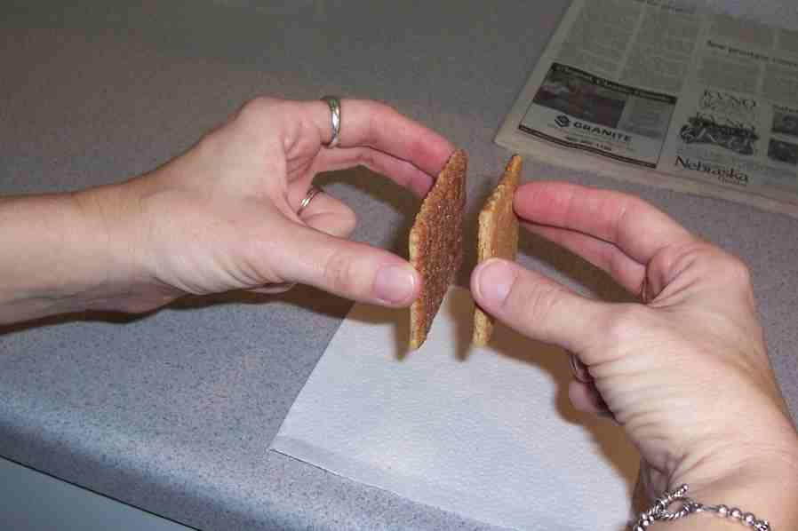
- Afraid of big dogs
- Afraid of the dark
- Afraid of monsters
- Afraid of storms
- Afraid of loud noises
- Afraid of heights
- Afraid of going to the doctor
- Afraid of bullies
- Afraid of getting lost
- Afraid of strangers

Practice the take home point: *JESUS HELPS US – Give Jesus your fears.

Activity 2: “Pillow Relay” Game
Supplies needed: pillow; masking tape

- Tape a line of masking tape on the floor, long enough for each child in the group to put his/her shoulders on it.
- Have the children lie on the floor and put their shoulders on the masking tape. The children should lie so that their feet are going in alternating directions. They would look something like a giant zipper.
- Give the pillow to the first child in the line. Explain that this is a race to pass the pillow down the line and back.
- Have the children pass the pillow above their bodies, going down the line and back, racing to beat the shepherd’s counting. The shepherd will count to a number (for example 10). If the children get the pillow down the line and back before the shepherd gets to the number, the children win. If the shepherd gets to the number first, the shepherd wins.
- Play several times, increasing the challenge by decreasing the count.
- After playing the game, explain to the children that in the Bible event, Jesus was asleep with His head on a pillow. The disciples became frightened by a storm and had to give their fears to Jesus so He could help them, just as the children gave the pillow to one another. The children can also give their fears to Jesus. They can give Jesus their fears, because Jesus died on the cross to take those fears a way.

Practice the take home point: *JESUS HELPS US – Give Jesus your fears.

Activity 3: “Stormy Seas Puppet” Craft
Supplies needed: Option 1: blue disposable cup with a slit on the bottom; Option 2: clear disposable cup with a slit on the bottom, blue 1-inch squares of crepe paper; Ice-cream stick/tongue depressor; crayons; boat reproducible copied and cut out; glue.

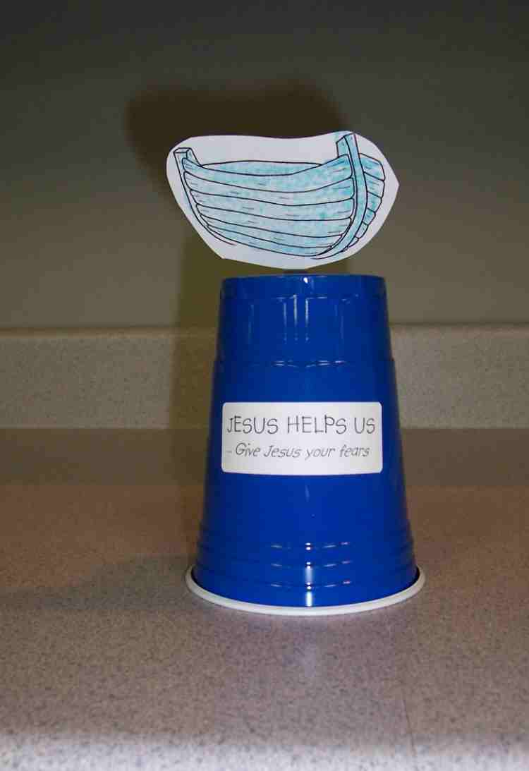
- Have the children color the boat reproducible and glue it to the ice cream stick.
- If you have chosen option 2 from above, have the children glue the blue crepe paper squares to the outside of the cups to look like water.
- Turn the cups up side down.
- Stick the ice cream sticks through the slit in the bottom of the cups so that the boat is resting above the bottom of the cup.
- Have the children put their hands in the cup and make the boat go up and down as if it is in the storm.
- Retell the Bible event using the puppet.
- Attach labels with take home point.
- Practice the take home point: *JESUS HELPS US – Give Jesus your fears.

Activity 4: “Memory Verse in Order”
Purpose: Help kids to memorize and keep scriptures at heart. Using creative ways to help kids enjoy learning the key verse and in small group setting.

Supplies needed: white board, marker, a set of word strips for each child, glue.

Memory Verse: John 14:6 ~ I am the way, and the truth, and the life.

Memory Verse Learning:
Pre-write the memory verse on the white board before class. Review the memory verse with the children. Then, give each child a set of word strips. Ask them to collect their craft of activity 3 to stick the words of the memory verse on the cup. When the children have finished, recite the memory verse again before prayer time.
I am | the | way | and | the
truth | and | the | John 14:6 | life

Prayer Time:
Have the children ask Jesus to help them with specific fears.

Large Group Wrap-Up: (10 minutes)
Purpose: The crazy bird puppet, Xiao Er, struggles with learning the take home point. The presenter shows an example of each small group application activity from this lesson and says the first phrase of the take home point. The kids respond with their phrase. They try to teach the puppet the take home point, but each time he confuses words or concepts. After three attempts, he finally gets it right and sings the correct take home point in a silly opera-like voice.

Supplies needed: Xiao Er puppet; sample materials from small group activities

Singing: (Optional)

Lesson Review with Puppet Skit:
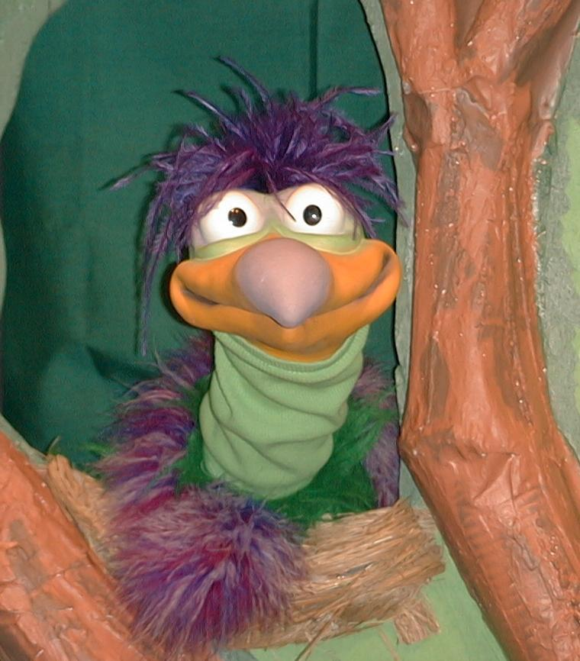
Presenter shows Xiao Er a craft made in Activity 1. Then the kids attempt to teach Xiao Er the take home point.

Presenter says to kids: “Jesus helps us…”
Kids say: “…Give Jesus your fears.”
Presenter says to Xiao Er: “Jesus helps us…”
Xiao Er says: “Xiao Er’s afraid of gorillas!”

Presenter shows an example of the next activity done in small group and repeats first phrase to kids. The kids say the correct response trying to teach Xiao Er the take home point. Continue in this manner with Presenter showing example of each activity. Here are Xiao Er’s responses:

Xiao Er’s response to Activity 2 sample: “Xiao Er’s afraid of giant pillows!”
Xiao Er’s response to Activity 3 sample: “Xiao Er’s afraid of blue paper cups!”
Xiao Er’s response to Activity 4 sample: “Xiao Er’s afraid of voices!”

Presenter says: “Xiao Er, listen one last time.
Jesus helps us…”
Kids’ response: “…Give Jesus your fears.”
Presenter says to Xiao Er: “Jesus helps us…”
Xiao Er’s response: (Warms up his singing voice with “Mee, mee, mee, mee, mee…” and sings in a silly dramatic opera-like voice) “JESUS HELPS US – GIVE JESUS YOUR FEARS.”

Welcome guests and thank them for attending.

Lesson 39
Large Group Opening:
- Xiao Hung and Ting Ting puppets
To make the waves:
- Cut to 8-foot lengths of cardboard into waves. One length should be 2 feet high. The other should be 18 inches high.
- Paint the cardboard waves blue.
- Attach the cardboard to an 8-foot 1x2
- Attach a 10-foot 1x2 to the back, center, of the wave so that the ends are sticking out to form handles
Attach blocks of wood between the wood strips to brace the prop.
- Imagination Box that includes:
  - Bible
  - Jesus costume and costumes for two or three disciples
  - spray bottle with water in it
  - blue tablecloth or tarp
  - old rowboat or box or chairs to make a pretend boat
  - stage waves or a ten-foot roll of blue tablecloth
  - pillow
  - streamers hanging from ceiling
  - oscillating fan
  - one manila card, tag board, or metal sheeting that, when shaken, sounds like thunder
  - waves (this prop will be used in more than one lesson—see directions below)
  - Bible with copy of today’s Bible event inserted in it
  - several broomsticks or other poles to be used as paddles
- microphone
Small Group Application:
Activity 1:
- 2 sugar coated cream cracker for each child (hint: this activity will not work with a regular cream cracker)
- serviettes
- paper cups
- water or juice
Activity 2:
- pillow
- masking tape
Activity 3:
  - Option 1: blue disposable cup with a slit on the bottom
  - Option 2: clear disposable cup with a slit on the bottom, blue 1-inch squares of tissue paper
  - Ice-cream stick/tongue depressor
  - crayons
  - boat reproducible copied and cut out
I am | the | way | and | the
truth | and | the | John 14:6 | life

  - glue
Activity 4:
  - white board
  - marker
  - a set of word strips for each child. Make word strips out from labels or computer printout using word program
  - glue
Large Group Closing:
- Xiao Er puppet
- sample materials from small group activities

Appendix:

