
Date: ________________________
Series: Jesus Is Our Helper (Dec-Mar)
Year 1, Lesson 42

Jesus Feeds 5,000

Take Home Point: *JESUS HELPS US – Pray for your needs.
*Repeat this phrase throughout the lesson. The presenter will say the first part of the phrase (CAPS). The children respond with the second part of the phrase (italics).

Bible Event: Luke 9:10-17, John 6:1-15
Jesus Link: We can pray to Jesus anytime; He is always ready to listen and answer us.

We will help children know:
- The story of Jesus feeding the 5,000.
- Jesus helps them with their needs.

They can pray to Jesus for both things they need and things they want.

We will help the children feel:
- Secure in Jesus’ care.
- Confident of Jesus’ help.
- Eager to bring their needs to Jesus in prayer.

We will help the children do:
- Participate in a drama of Jesus feeding the 5,000.
- Review the story with a fishy snack.
- Play a bowling ball game to help differentiate between wants and needs.

THIS LESSON’S ROADMAP

DESTINATION | PAGE # | DISCOVERIES ON YOUR JOURNEY | SUPPLIES NEEDED
Large Group Opening   | 4  4 | Puppet Presentation  Bible Event | - Xiao Hung puppet  - small pillow  - Imagination Box with Bible inside  - microphone  - paper lunch bag  - salted biscuits, Have enough for each child in the audience to have one.  - enough fish shaped biscuits for each child in the audience to have one  - several larger baskets (optional: 12 baskets)  - two towels per basket  - disciple costumes for shepherds (optional)
Small Group Application   | 7  8  8  9  9 | Activity 1: “Fishy Food” or “Fish and Bread” Snack  Activity 2: “Wants or Needs Bowling” Game  Activity 3: ”Fish and Loaves” Craft  Activity 4: “Fish Race”  Prayer Time | Activity 1:  - fish shaped biscuits  - salted biscuits  - serviettes  - paper cups  - juice or water  Activity 2:  - *2 liter bottle with a sign attached that reads “want”  - *2 liter bottle with sign attached that reads “need”  *Both bottles should be with water or sand. Lids should be hot glued on to prevent spilling.  - bell  - whistle  - option 1: tennis ball or bean bag  - option 2: ring large enough to fit over mouth of bottle  Activity 3:  - fish and loaves reproducible  - paper cup for each child  - paper punch  - half of a chenille wire per child  - scissors  - colors or markers  - labels that read “Hear my prayers.”  Activity 4:  - magnetic heart sharp  cards from lesson 38  - one sheet of newspaper  per team  - 2 fishes cut from A4  paper  - Masking tape  - Fish shaped biscuits as  reward
Large Group Wrap-up   | 10  10 | Singing (Optional)  Lesson Review with Puppet Skit | - Xiao Er puppet  - sample materials from small group activities

Pre-Session Singing: (10 minutes)
Purpose: When all children are in one group singing, it is easy for new children to join the group and immediately get involved. When the music can be correlated, it introduces the theme for the day. Choose two to three songs and list them here.

Large Group Opening: (15 minutes)
Purpose: The puppet demonstrates the need that will be met in today’s lesson. The scripts are not written verbatim, but give a story line in which the group presenter can interact with the puppet. The children are introduced to the take home point and then interact with God’s word, as they experience the Bible event.

Supplies needed: Xiao Hung puppet; small pillow; Imagination Box with Bible inside: microphone, paper lunch bag, salted biscuits, fish shaped biscuits. Have enough for each child in the audience to have one, several larger baskets (optional: 12 baskets), two towels per basket, disciple costumes for shepherds (optional)

Puppet Presentation:
Xiao Hung comes out yawning and carrying a puppet-sized pillow. He is very tired because he could not sleep last night. They were at Grandma and Grandpa’s house yesterday with all the cousins, and Xiao Hung had so much fun that he was too excited to fall asleep. He brought his pillow to Kingdom Quest in case he needs to rest his eyes “just for a minute.”

The presenter asks what Xiao Hung did when he couldn’t fall asleep. Xiao Hung replies that he looked at a book, tried to count sheep, and even had his mom come in and sing to him. The presenter asks if he prayed and asked Jesus to help him sleep. Xiao Hung did not think of that.

The presenter says that today the children are going to learn that Jesus helps us when we need help and we can even pray and ask him to help us. In fact, in today’s Bible event, Jesus was teaching a large group of people and they needed something to eat, so Jesus did a miracle. He made five small loaves of bread and two fish into enough food to feed thousands of people. Those people needed food, so Jesus helped them. And Xiao Hung needed to sleep last night, so he could have asked Jesus to help him.

Teach Xiao Hung the take home point: *JESUS HELPS US – Pray for your needs. The presenter says the first line, Xiao Hung responds with the second line. After practicing it with Xiao Hung a few times, practice it with the children.

Bible Event: Imagination Theater
Imagination Theater is audience participation drama where the Bible event is told in creative fashion using children as actors. The Imagination Box contains the Bible and other special props used for the drama. Begin by removing the Bible and explain that it is God’s word. Briefly summarize the story, and then remove an imaginary hat and place it on your head. This is your Imagination Hat. Invite the children to put on theirs as well. They will also use their imaginations to picture the events the Bible tells us about. Some will even use their imaginations to help act out these events. Distribute props to actors as they are called forward at the beginning of the presentation. Have them sit to the side until they are called onstage.
Advance preparation:
- Put five salted biscuits and two fish shaped biscuits in the paper lunch bag.
- Line the baskets with a towel, fill them half full with biscuits, and then place another towel on top to hide the biscuits.
- Secretly give a child in the audience the paper lunch bag.
- Select several shepherds to be the disciples and help pass out the biscuits and biscuits at the appropriate time.
- Optional: Have the shepherds that are helping dress up as disciples.

“Jesus Feeds Five Thousand”

Take the Bible out of the Imagination Box and briefly summarize today’s Bible event.

Here we have the Bible. Today’s Bible event comes from a book written by John. Let me open the Bible. Oh, my! I can see how Jesus has done a wonderful thing here to help people. This is the story about when there were more than 5,000 people who didn’t have anything to eat. But Jesus fed them all by doing a wonderful miracle.

It all started when a little boy shared his lunch. Then Jesus did something very special to help all the people have some food. Listen carefully and see if you can hear what Jesus did with the little boy’s lunch to make a miracle.

After you and the children put on your Imagination Hats, begin. Phrases that are underlined and italicized are to be repeated by the child actor or audience. Point the microphone to the actor to show when it is his or her turn.

Presenter: (Opens Bible and reads from script.) One day Jesus was teaching a huge crowd of people about heaven and He was healing those who were sick or hurt. It got to be late in the afternoon. The sun was starting to go down and the people had eaten nothing. They were very hungry and needed food, but Jesus and His disciples did not have enough money to buy food for that many people. There were about 5,000 men there, as well, as women and children. That would be like a large park filled with people. Where would the food come from? (Shepherds come up from audience.) Jesus’ disciples came up to Him and said:

Disciple: Send the people away so they can go into the villages and buy food.

Presenter: But Jesus told His disciples that they should feed the people. (Disciples go out into the crowd of children.) So the disciples went out into the crowd and found only one person with some food. (Disciples come back onto stage. One disciple is leading the child with the lunch bag.

Disciple: Here is a young child with his lunch. But he has only five small loaves of bread and two fish.

(The presenter takes the biscuits out of the lunch bag and, with the children, counts the five “loaves” and two “fish.”)

Presenter: Let’s count the lunch together. How many pieces of bread were there? One, two, three, four, five. How many fish? One, two.

Now the bread and the fish were really larger than these biscuits. But it still wasn’t a very big meal, was it? How could such a small lunch feed such a large crowd?

Jesus took the food (take out one biscuit and one fish), looked up to heaven, thanked God for the food, and broke it (break the salted biscuit in half). Then He told His disciples to pass out the food and feed the people.

Disciples, will you come up with baskets? Let me put some of this lunch into each one of these baskets and you can pass it out. (Have the disciples bring forward the baskets, receive one lunch item, discreetly move the top towels to the side, and begin giving each child an prawn cracker and a fish biscuits.)

When the disciples passed out the food, they were really surprised! They passed out the food and passed out the food and passed out the food! The food just kept coming until everyone in the crowd had plenty to eat.

Jesus had done a miracle! He had made the five loaves of bread and two fishes into enough food to feed thousands of people. But His miracle wasn’t finished.

When the people were done eating, the disciples went back into the crowd and gathered the leftover food and gathered it, and gathered it, and gathered it! In fact, they kept gathering the food until they had 12 whole baskets of leftover food. Let’s count to twelve. (If you have 12 baskets, count them. If not, count 12 imaginary baskets.)

The people needed food to eat, and Jesus provided what they needed and even more!

In the same way, Jesus gives us what we need—like food, houses, grown-ups to take care of us, clothes to wear, and more. And Jesus gives us some things we don’t need but want—like toys, treats, and special activities.

This reminds me of today’s special words: *JESUS HELPS US – Pray for your needs. The greatest need that Jesus has given us is the need to be forgiven and filled with his love. When Jesus died on the cross, we were forgiven of our sins and can now be filled with His love to do what He wants.

End with a brief prayer with children repeating after each line.

Dear God,
Thank You for being here. (repeat)
Thank You for sending Jesus. (repeat)
Jesus helps us. (repeat)
He takes care of all of our needs. (repeat)
Thank You! Thank You! Thank You! (repeat)
Amen. (repeat.)

Small Group Application: (30 minutes)
Purpose: Smaller groups enable children to develop closer relationships with adults and peers in the church. As you reinforce the take home point with a fun hands-on activity, discuss the Bible event. Be sure to repeat the take home point several times. Say the first part and have the children respond with the second phrase. Application questions help kids apply the take home point to their daily lives. Close this session by gathering your small group for prayer. Let the kids pray!

During the small group application time, discuss the following questions and points:

What did the people in the Bible event need? (Food.)

How did Jesus help them? (He turned five loaves of bread and two fish into enough food to feed all the people.)

What do we need? (Answers will vary but may include food, parents, house, clothes, etc. Remind the children that the greatest need we have is to be forgiven by God, and Jesus took care of that need by dying on the cross for us.)

When we need something, what can we do? (Ask Jesus to provide it.)

Activity 1: “Fish and Bread” Snack
Supplies needed: fish shaped biscuits; salted biscuits; serviettes; paper cups; water or juice

Help the children count out five salted biscuits and two fish shaped biscuits . Use the biscuits to review the Bible event. As they eat review the take home point: *JESUS HELPS US – Pray for your needs. This would be a good time to discuss the small group application questions.

Activity 2: “Wants or Needs Bowling” Game
Supplies needed: 2 liter bottle with a sign attached that reads “want”; *2 liter bottle with sign attached that reads “need”; *Both bottles should be with filled water or sand. Lids should be hot glued on to prevent spilling; bell; whistle; option 1: tennis ball or bean bag; option 2: ring large enough to fit over mouth of bottle

Directions:
- Spend a couple moments explaining that some things, like a vacation, are “wants.” These are things we would like but do not need to live. Other things like food are needs. We need these things to live.
- Divide the group into two teams. (If necessary, combine small groups for this activity.) Have the teams form two lines.
- Read an item from the list below. The first child in one line determines if it is a want or need and rolls the ball or beanbag at the correct ball, attempting to knock it over. Or, using option two, throws the ring at the correct bottle and attempts to ring the neck of the bottle.
- If the child gets the correct answer give that team a tally mark.
- If the child gets the correct answer and knocks over or rings the bottle, ring the bell and give the team two tally marks.
- If the child gets the incorrect answer, toot the bike horn and do not give the team any tally marks.
- Let the other team have a turn.
- Continue alternating teams and children until every child has a turn.
- Have the children help you count the tally marks. The team with the most tally marks wins.
- For added fun, have the team whose turn it is call out what they think is the correct answer. The child playing at the moment can use their help to answer the question.
- Explain that we can pray to Jesus and ask him to provide those things we need. We can also ask him for some of the things we want.
- Practice the take home point: *JESUS HELPS US – Pray for your needs.

Examples of wants or needs:

- Food (need)
- Place to live (need)
- Gum (want)
- Water (need)
- Candy (want)
- Toys (want)
- Love (need)
- Faith in Jesus (need)
- Birthday party (want)

- Hear God’s word (need)
- Adults to take care of you (need)
- Bike (want)
- Clothes (need)
- Go to a movie (want)
- Computer games (want)
- Doctor’s care when hurt bad or very sick (need)

Activity 3: “Fish and Loaves” Craft
Supplies needed: fish and loaves reproducible; paper cup for each child; paper punch; half of a chenille wire per child; scissors; colors or markers; labels that read “Hear my prayers.”
Make a fish and loaves craft:

- Have the children color the fish and loaves on the reproducible.
- Punch two holes in the paper cups.
- Have the children string their chenille wires through the holes and twist them into loops to make a handle on the cup. The cup is their basket.
- Attach the labels to the cups.
- Cut out the fish and loaves.
- Have the children count their fish and loaves.
- As a class, name a need for which you can pray to Jesus for each loaf. As you name a need, put the loaf in the cup.
- Name a want for which you can pray for each of the fish. As you name the want, put the fish into the “basket.”
- Explain to the children that while we should pray mostly for those things we need, Jesus loves us and also wants to give us some things we want. We can pray for those things, too.
- Practice the take home point: *JESUS HELPS US – Pray for your needs.

Activity 4: “Fish Race”
Purpose: Help kids to memorize and keep scriptures at heart. Using creative ways to help kids enjoy learning the key verse and in small group setting.

Supplies needed: magnetic heart sharp cards from lesson 38, one sheet of newspaper per team, 2 fishes cut from A4 paper, masking tape, fish shaped biscuits as reward.

Memory Verse: Luke 14:6 ~ I am the way, and the truth, and the life.

Memory Verse Learning:
Tape two parallel lines 8 feet apart before class starts. During small group, review last week’s memory verse with the children. Tell the children that we are going to play a game. The newspaper represents the loaf of bread and the paper fish as the fish.

When we play the game, let’s be reminded that Jesus is able to provide all that we need.

Divide the children into 2 groups. Have the two teams stand in a line at the starting line. At the shepherd’s indication, the first team member needs to get the fish to the other end by hitting the newspaper on the floor next to the paper fish. the little air will push the fish along. When he reaches the other end, he is to recite the memory verse before picking up the fish and run back to touch the next team member. The winning team will be rewarded with five fish shaped biscuits while the other team can have three.

Prayer Time:
Have each child pray for two things he/she needs and one thing he/she wants.

Large Group Wrap-Up: (10 minutes)
Purpose: The crazy bird puppet, Xiao Er, struggles with learning the take home point. The presenter shows an example of each small group application activity from this lesson and says the first phrase of the take home point. The kids respond with their phrase. They try to teach the puppet the take home point, but each time he confuses words or concepts. After three attempts, he finally gets it right and sings the correct take home point in a silly opera-like voice.

Supplies needed: Xiao Er puppet; samples from today’s small group activities

Singing: (Optional)

Lesson Review with Puppet Skit:
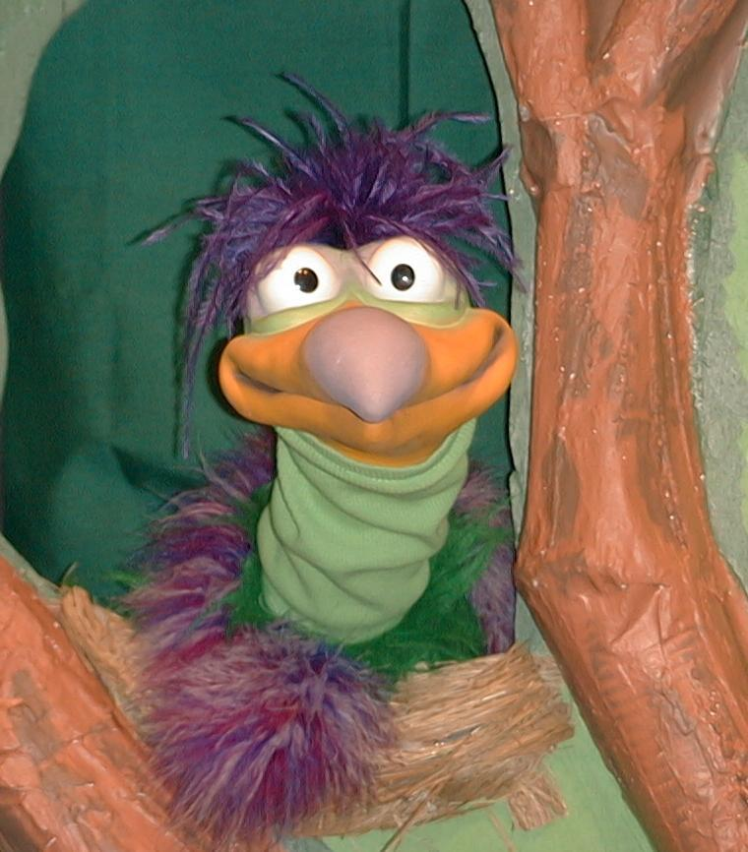
Presenter shows Xiao Er a craft made in Activity 1. Then the kids attempt to teach Xiao Er the take home point.

Presenter says to kids: “Jesus helps us…”
Kids say: “…Pray for your needs.”
Presenter says to Xiao Er: “Jesus helps us…”
Xiao Er says: “To eat fish, unless they are too slimy!”

Presenter shows an example of the next activity done in small group and repeats first phrase to kids. The kids say the correct response trying to teach Xiao Er the take home point. Continue in this manner with Presenter showing example of each activity. Here are Xiao Er’s responses:

Xiao Er’s response to Activity 2 sample: “To know that we need to play with pop bottles.”
Xiao Er’s response to Activity 3 sample: “To wear a basket over our head!”
Xiao Er’s response to Activity 4 sample: “Hit the fish to the end of the line!”

Presenter says: “Xiao Er, listen one last time.
Jesus helps us…”
Kids’ response: “…Pray for your needs.”
Presenter says to Xiao Er: “Jesus helps us…”
Xiao Er’s response: (Warms up his singing voice with “Mee, mee, mee, mee, mee…” and sings in a silly dramatic opera-like voice) “JESUS HELPS US – PRAY FOR YOUR NEEDS.”

Welcome guests and thank them for attending.

Lesson 42
Large Group Opening:
  - Xiao Hung puppet
  - small pillow
  - Imagination Box with Bible inside
  - microphone
  - paper lunch bag
  - salted biscuits, fish shaped biscuits. Have enough for each child in the audience to have one.
  - several larger baskets (optional: 12 baskets)
  - two towels per basket
  - disciple costumes for shepherds (optional)
Small Group Application:
Activity 1:
- fish crackers
- prawn crackers
- serviettes
- paper cups
- water or juice
Activity 2:
- *2 liter bottle with a sign attached that reads “want”
- *2 liter bottle with sign attached that reads “need”
*Both bottles should be with filled water or sand. Lids should be hot glued on to prevent spilling.
- bell
- whistle
- option 1: tennis ball or bean bag
- option 2: ring large enough to fit over mouth of bottle
Activity 3:
- fish and loaves reproducible
- paper cup for each child
- paper punch
- half of a chenille wire per child
- scissors
  - colors or markers
- labels that read “Hear my prayers.”
Activity 4:
- magnetic heart sharp cards from lesson 38
- one sheet of newspaper per team
- 2 fishes cut from A4 paper
- Masking tape
- Fish shaped biscuits as reward
Large Group Wrap-Up:
- Xiao Er puppet
- samples from today’s small group activities

