
Date: _______________________
Series: The Gifts from Jesus (Apr-May)
Year 1, Lesson 50

Jesus’ Ascension

Take Home Point: *EVEN WHEN WE CAN’T SEE HIM—Jesus is with us.
*Repeat this phrase throughout the lesson. The leader will say the first part of the phrase (CAPS). The children respond with the second part of the phrase (italics).

Bible Event: Acts 1:1-11
Jesus Link: Jesus is alive in Heaven and His Spirit is here to help us.

We will help the children know:
- The event of Jesus’ ascension.
- We can’t see Jesus but we can trust that Jesus is always with us.
- There are three ways we can know that Jesus is with us—we can listen to His word, we can feel His love through the people who love us, especially our parents, and we can feel His love in our hearts.

We will help the children feel:
- Confidence that while Jesus ascended to heaven, He is always with them.
- Secure in the knowledge that Jesus is always with them.
- Strength in Jesus’ presence.

We will help the children do:
- Watch a video of Jesus’ ascension.
- Make and eat an “Ascension Snack” and review the Bible event.
- Play a game, “Who’s Hiding?” and learn that, even though we cannot see Jesus, he is always with us.
THIS LESSON’S ROADMAP

DESTINATION | PAGE # | DISCOVERIES ON YOUR JOURNEY | SUPPLIES NEEDED
Large Group Opening   | 3  3 | Puppet Presentation  Bible Event | - Xiao Hung puppet  - video, “Animated Stories of the New Testament: He is Risen”  - VCR and television
Small Group Application   | 5  6  7  8 | Activity 1: “Pull-through Ascension Picture” Craft  Activity 2: “Ascension Snack”  Activity 3: ”Who’s Hiding?” Game  Activity 4: “A Reminder”  Prayer Time | Activity 1:  - reproducible (precut along the dotted lines using a cutter)  - scissors  - crayons  - cotton balls  - glue  Activity 2:  - cream crackers  - Teddy biscuits;  - whip cream or cotton candy  - serviettes  - cups  - water or juice  - Option: bread and water  Activity 3:  - room divider, table or other “wall”  - white sheet  Activity 4:  - white board  - marker  - the children’s work sheets from Activity 1  - a praying figure for each child  - pencils
Large Group Wrap-up   | 9  9 | Singing (Optional)  Lesson Review with Puppet Skit | - optional music for the lesson  - Xiao Er puppet

Pre-Session Singing: (10 minutes)
Purpose: When all children are in one group singing, it is easy for new children to join the group and immediately get involved. When the music can be correlated, it introduces the theme for the day. Choose two to three songs and list them here.

Large Group Opening: (15 minutes)
Purpose: The puppet demonstrates the need that will be met in today’s lesson. The scripts are not written verbatim, but give a story line in which the group leader can interact with the puppet. The children are introduced to the take home point and then interact with God’s word, as they experience the Bible event.

Supplies needed: Xiao Hung puppet; video, “Animated Stories of the New Testament: He is Risen”; VCR and television

Puppet Presentation:
Xiao Hung comes out trying to “feel” the air. The presenter asks him what he is doing. Xiao Hung explains that he is trying to “feel“ Jesus.

The presenter is now very confused and asks Xiao Hung why he is trying to feel Jesus. Xiao Hung says that his mom told him that Jesus is always with him but he can’t see Jesus, so he is trying to feel Jesus. The presenter says that Xiao Hung is right. Jesus is with us always and we can’t see Him but, just as we cannot feel the air, we cannot feel Jesus’ body.

Xiao Hung asks how we can know that Jesus is with us always if we cannot see Him, we cannot hear Him, and we cannot feel Him. The presenter says that there are several ways we can know that Jesus is with us always.

First, we can listen to the Bible. In today’s Bible event the children will learn that Jesus went back up to heaven, but, before He went to heaven, He made a promise to His disciples that He would be with them always. And Jesus always keeps His promises. Because Jesus is God, He can be everywhere at once.

Second, just as we can feel what the air does, like making us cold or tickling our faces, we can feel what Jesus does. We can feel His love through people, especially our parents, and we can feel His love in our hearts.

The presenter teaches Xiao Hung the take home point. *EVEN WHEN WE CAN’T SEE HIM—Jesus is with us. The presenter says the first part; Xiao Hung responds with the second part. After practicing it with Xiao Hung several times, the presenter teaches it to the children.

Bible Event: Video
Test your sound and video system beforehand. Cue the video to its precise beginning. For larger groups of children (15 or more), use a large screen TV or imager. Dim the lights before starting the video. To introduce a video, you might read from a Bible storybook and leave off the ending, inviting the children to see what happens by watching the video. You could also introduce the video by inviting the children to keep an eye out for special actions or words they will see during it.

Introduce the Bible event by having the children pretend that they are Jesus’ followers and they are going with him up to the hill where they last saw Him. Today the children are going to watch Jesus ascend, which means “go up,” to heaven. Together, pretend to climb the hill and then lie down.

Start the video, “Animated Stories of the New Testament: He Is Risen” by Nest Entertainment at 28:21. Start at the point where the narrator says, “The apostles returned to Jerusalem…” and stop at the end of the video. (Approximately 2 minutes.)

When the video clip is finished, have the children pretend to walk back down from the mountain. Then review the Bible event by having the children correct the mistakes you make (the underlined words) as you retell the story.

One day when Jesus came together with His puppy dogs (followers), He went with them to a swimming pool (hill). He promised them that He would be with them sometimes (always). Then Jesus was taken up to the moon (heaven). He was hidden by a giant tadpole (cloud). And then He was gone. As His followers stood looking up into the ocean (sky), two butterflies (angels) appeared. They asked the disciples, “Why are you looking into the rain forest (sky)? The same Jesus who you saw go to heaven will someday come back in the same way.”

Jesus wasn’t only with the disciples but He is also with us only when we’re giggling (always). You see, when Jesus makes a promise, He always keeps it!

Practice the take home point. You say the first part; the children respond with the second part. *EVEN WHEN WE CAN’T SEE HIM—Jesus is with us.

End with the following prayer:

Dear God,
Thank You for the best gifts.
Thank You for sending Jesus.
He’s our Savior and Your Son.
Thank You that Jesus is with us always.
Thank You! Thank You! Thank You!
Amen.
Small Group Application: (30 minutes)
Purpose: Smaller groups enable children to develop closer relationships with adults and peers in the church. As you reinforce the take home point with a fun hands-on activity, discuss the Bible event. Be sure to repeat the take home point several times. Say the first part and have the children respond with the second phrase. Application questions help kids apply the take home point to their daily lives. Close this session by gathering your small group for prayer. Let the kids pray!

During the small group application time, discuss the following questions and points:

What promise did Jesus make to His followers? (That He would be with them always.)

After Jesus made that promise, what happened? (He went up, ascended into heaven.)

What promise does Jesus make to us? (That He will be with us always.)

How do we know Jesus’ promise is true? (It says so in the Bible, and we can feel His love through people and in our hearts.)

How does it make you feel to know that Jesus is with you always? Why? (Answers will vary but may include happy, joyful, safe, etc. and “because he loves me,” “because I am never alone,” or “because I know that Jesus takes care of me.”)

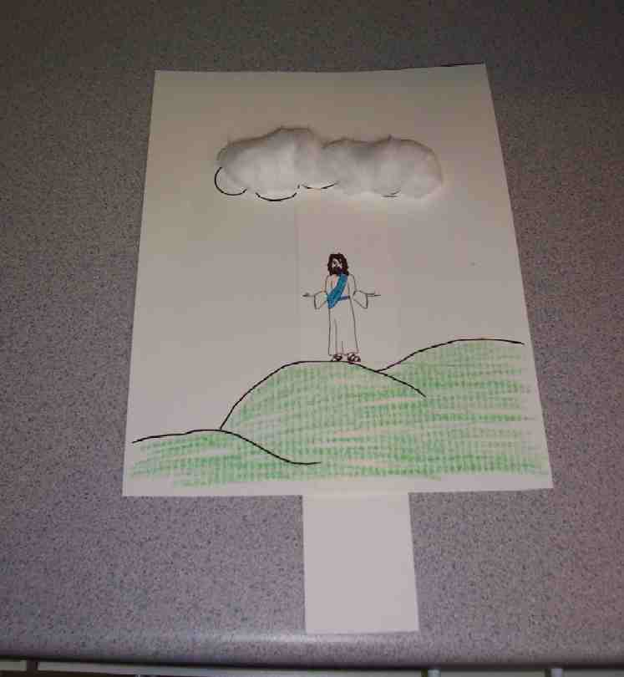
Activity 1: “Pull-through Ascension Picture” Craft
Supplies needed: reproducible (precut along the dotted lines using a cutter); scissors; crayons; cotton balls; glue

To make:
- Color the picture of Jesus and the hill.
- Glue cotton balls on the clouds.
- Cut the Jesus strip out.
- Weave the bottom of the Jesus strip through the bottom slit in the picture and the top of the strip through the top slit.

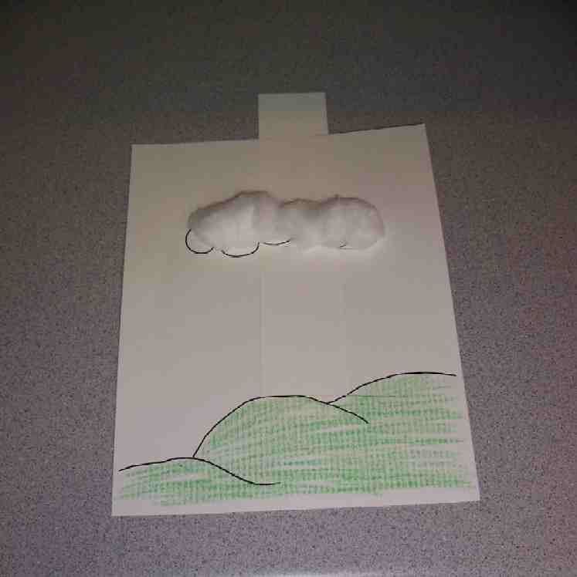
- Practice pulling Jesus upwards so that he “ascends” and “disappears” into “heaven.”

Review the Bible event. Say:

Jesus ascended because He was done with His job here on earth—to die for our sins—and He had a job in heaven—to prepare a place for us. But, even though Jesus went up to heaven, His Spirit is still with us. Remembering that Jesus is with us always can help us when we are afraid because we know that we are not alone. It can help us when we are lonely, because we can always talk to Jesus. And it can help us follow God’s word because Jesus is always there to give us His strength. What a wonderful gift we have! We always have the gift of Jesus!

Practice the take home point. You say the first part; the children respond with the second part. *EVEN WHEN WE CAN’T SEE HIM—Jesus is with us.

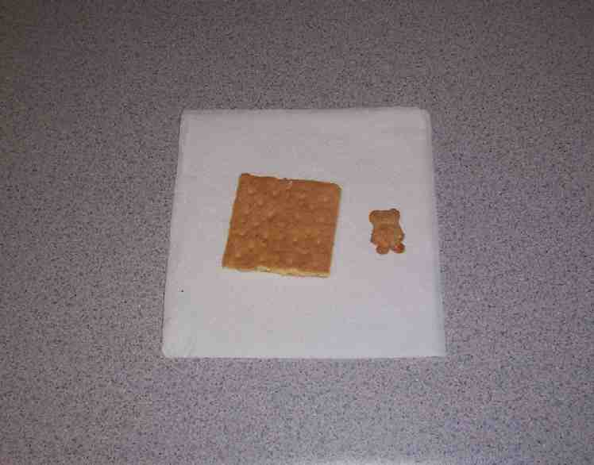
Activity 2: “Ascension Snack”
Supplies needed: cream crackers; Teddy biscuits;
whip cream or cotton candy; serviettes; cups; water or juice; Option: bread and water

To make:
- Squeeze whip cream on cream cracker to be cloud. (If you are unable to get whip cream, replace it with cotton candy.)
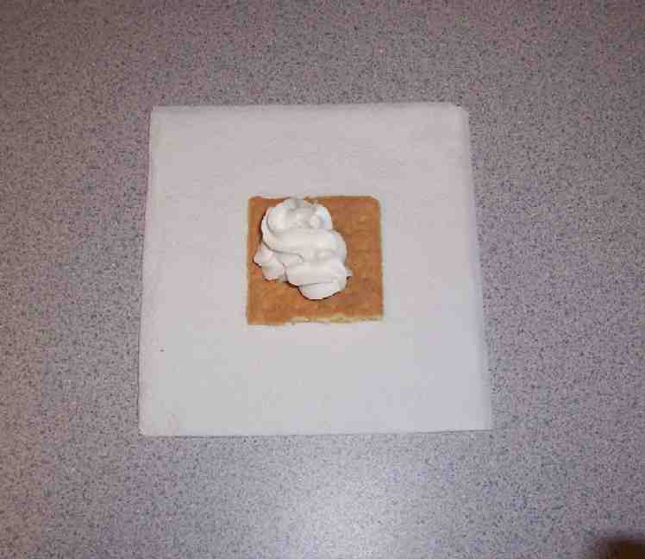

- Place the Teddy biscuits (Jesus) on the “cloud.”

- Eat!

Healthy Snack Option:
Supplies needed: Whole grain bread one slice per child; Gingerbread cookie cutter or scissors; Water; Cups; serviettes

Pour “living” water (Jesus) in a cup.

When Jesus left this earth, He gave us His Holy Spirit to be in us (drink the water). The water is still there inside of us even though we can’t see it anymore.

Use a gingerbread cookie cutter or scissors to cut out little figures in the bread slices.

Jesus gave His body for us so that we might be saved from sin. When we trust in Him, He comes to live in us. He is the “living bread” in us.

To discuss:
Review the Bible event. Say: “We can know that, even though Jesus went up to heaven, He is with us always. It says so in the Bible. We can know His love through the people who love us, like our parents. And we can feel His love in our hearts.

Practice the take home point. You say the first part; the children respond with the second part. *EVEN WHEN WE CAN’T SEE HIM—Jesus is with us.

Activity 3: “Who’s Hiding?” Game
Supplies needed: room divider; table or other “wall”; white sheet

To play:
- Divide into two teams.
- Hide one team (Team A) behind the barrier.
- Cover one child from Team A with a “cloud” (A sheet).
- Bring the covered child out.
- The shepherd asks the child three yes or no questions, which he or she must answer. Use the following questions:
- Are you a boy?
- Are you wearing sports shoes?
- Do you have black hair?
- After the questions have been answered, Team B must try to guess who is under the sheet. If Team B guesses correctly, they get a point.
- Switch teams and continue to play.
- The team with the most points at the end of the game wins.

To discuss:
The team that was hiding was with us, even though we could not see them. In the same way, even though we cannot see Jesus, we know He is with us.

Practice the take home point. You say the first part; the children respond with the second part. *EVEN WHEN WE CAN’T SEE HIM—Jesus is with us.

Activity 4: “A Reminder”
Purpose: Help kids to memorize and keep scriptures at heart. Using creative ways to help kids enjoy learning the key verse and in small group setting.

Supplies needed: white board; marker; the children’s work sheets from Activity 1; a praying figure for each child; pencils

Memory Verse: John 16:14 ~ The Spirit of truth will take what I say and tell it to you.

Memory Verse Learning:
Pre-write the memory verse on the white board before the class. Review the memory verse with the children a few times. Ask the children to take their work sheet done at Activity 1. Give each child a praying figure and ask them to glue it on the hillside area. This praying figure represent us. Next, ask the children to write the memory verse on the left side of the work sheet. When all the children have finished, get them to stand up, hold their work sheet in their hands and recite the memory verse another time.
Explain to the children that John 16:14 is the scripture verse Jesus told His friends before He went to heaven. Jesus gave us the Holy Spirit to help and guide us forever. The Holy Spirit tells us Jesus’ sayings so that we know what the right thing to do is. We can’t see the Holy Spirit, but He is with us all the time. We can always talk to Him in prayer.

Prayer Time:
Thank Jesus for being with you always.

Large Group Wrap-Up: (10 minutes)
Purpose: The crazy bird puppet, Xiao Er, struggles with learning the take home point. The leader shows an example of the each small group application activity from this lesson and says the first phrase of the take home point. The kids respond with their phrase. They try to teach the puppet the take home point, but each time he confuses words or concepts. After three attempts, he finally gets it right and sings the correct take home point in a silly opera-like voice.

Singing: (Optional)

Lesson Review with Puppet Skit:

The presenter shows an example of the activity done in small group and repeats first phrase to kids. The kids say the correct response trying to teach Xiao Er the take home point. Continue in this manner with the presenter showing examples of each activity.

Here are Xiao Er’s responses:

Activity 1: “…tigers don’t wear eyeglasses”
Activity 2: “…Jesus is in a tree.”
Activity 3: “…Teddy grahams are still tasty.”
Activity 4: “…I glue and I write, write, write.”

Welcome guests and thank them for attending.

Lesson 50
Large Group Opening:
- Xiao Hung puppet
- video, “Animated Stories of the New Testament: He is Risen”
- VCR and television

Small Group Application:
Activity 1:
    - reproducible (precut along the dotted lines using an Exacto knife)
    - scissors
    - crayons
    - cotton balls
    - glue
Activity 2:
- cream crackers
- Teddy biscuits;
- whip cream or cotton candy
- serviettes
- cups
- water or juice
- Option: bread and water
Activity 3:
  - room divider, table or other “wall”
  - white sheet
Activity 4:
  - white board
  - marker
  - the children’s work sheet from
Activity 1
  - a praying figure for each child
  - pencils

Large Group Wrap-up:
- optional music for the lesson
- Xiao Er puppet

