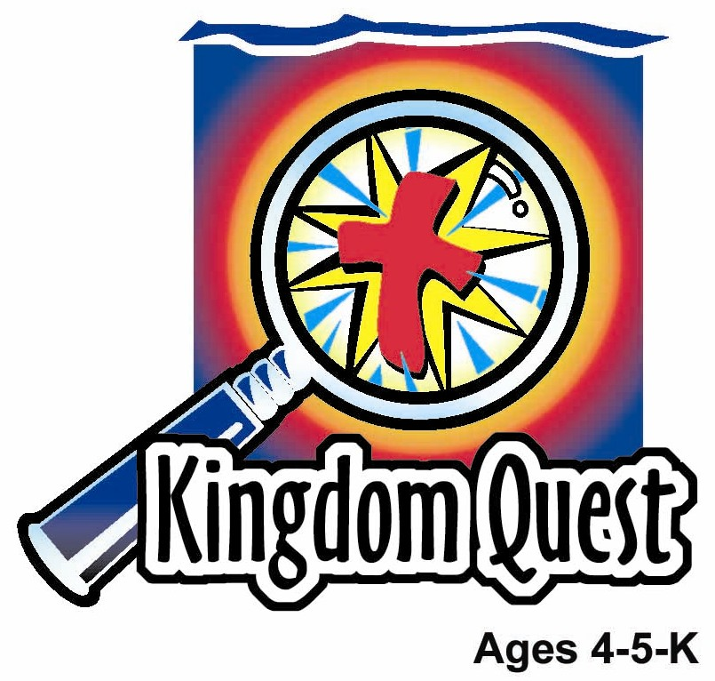
Date: ________________________
Series: The Gifts of Jesus (Apr-May)
Year 1, Lesson 51

The Spirit Comes at Pentecost

Take Home Point: *JESUS SENT HIS SPIRIT—He lives in me.
*Repeat this phrase throughout the lesson. The leader will say the first part of the phrase (CAPS). The children respond with the second part of the phrase (italics).

Bible Event: Acts 2:1-13

Jesus Link: We believe in Jesus. His Spirit gives us power to be witnesses.

We will help the children know:
- The event of Jesus sending His Spirit at Pentecost.
- When Jesus gives us the gift of His Spirit, He lives in us, which gives us the power to have faith in Him and share His gifts with others.
- People grow in their faith throughout their lives as the Holy Spirit continues to fill us with His presence.

We will help the children feel:
- Excited that Jesus lives in them.
- Comforted to know that Jesus is always with them.
- Empowered to do God’s work through the power of His Spirit.

We will help the children do:
- Help a storyteller tell the Bible event of the Spirit coming at Pentecost.
- Make and eat a Pentecost snack while reviewing the Bible event.
- Play a game, “Wind Power,” and learn that, because the Holy Spirit lives in us, we are given the power to share God’s love with others.
THIS LESSON’S ROADMAP

DESTINATION | PAGE # | DISCOVERIES ON YOUR JOURNEY | SUPPLIES NEEDED
Large Group Opening  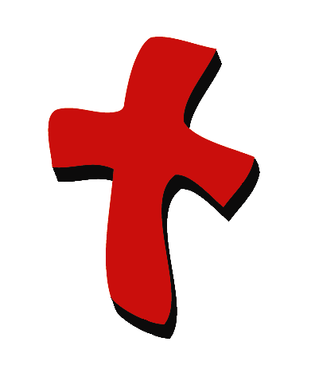 | 4  5 | Puppet Presentation  Bible Event | - Xiao Hung puppet  - inflated balloon  - uninflated balloon  - adult-sized female Bible character costume  - Bible  - microphone  - stool to sit on
Small Group Application   | 7  8  9  10  10 | Activity 1: “Spirit Wind Sock” Craft  Activity 2: “Pentecost Snack”  Activity 3: ”Wind Power” Game  Activity 4: “Be Filled”  Prayer Time | Activity 1:  - A4 size manila card per child  - yarn or thread  - paper punch  - red, yellow and orange ribbons or strips of crepe paper  - label with take home point printed on it.  - cellophane tape  Activity 2:  - salted biscuits  - broad finger biscuits  - coloured candy biscuits  - serviettes  - paper cups  - water of juice  Activity 3:  - masking tape  - ½ straw per child  - ping pong ball or cotton ball  Activity 4:  - plastic or paper cups  - 3”X3” paper with individual words of the verse  - satay sticks  - plastercine  - pitcher with blue colour water
Large Group Wrap-up   | 11  11 | Singing (Optional)  Lesson Review with Puppet Skit | - optional music for the lesson  - Xioa Er Puppet

Pre-Session Singing: (10 minutes)
Purpose: When all children are in one group singing, it is easy for new children to join the group and immediately get involved. When the music can be correlated, it introduces the theme for the day. Choose two to three songs and list them here.

Large Group Opening: (15 minutes)
Purpose: The puppet demonstrates the need that will be met in today’s lesson. The scripts are not written verbatim, but give a story line in which the group leader can interact with the puppet. The children are introduced to the take home point and then interact with God’s word, as they experience the Bible event.

Supplies needed: Xiao Hung puppet; inflated balloon; uninflated balloon; adult-sized female Bible character costume; Bible; microphone; stool to sit on

Puppet Presentation:
Xiao Hung comes out with an inflated balloon. He is very excited. He can finally blow up a balloon with air by himself. That is because he is 5-years-old and only big people, like 5-year-olds, can blow up a balloon.

The presenter takes the balloon from Xiao Hung and hits it a couple times before giving it back to Xiao Hung. Then he says that balloons sure are a lot of fun.

The presenter remarks that the balloon reminds him of today’s Bible event. In today’s Bible event, the disciples, Jesus’ followers, are in a room together when a strong wind comes into the room and tongues of fire rest on the disciples’ heads without burning them. At the same time they are filled up with Jesus’ Holy Spirit, just as the balloon was filled with air.

The air in the balloon is like the Holy Spirit that Jesus sent. The presenter asks Xiao Hung if he could see the air that he was breathing into the balloon. Bubba says, “no.” The presenter explains that Bubba couldn’t see the air, but he knew it was there because he saw what it did. It made the balloon bigger.

In the same way, the disciples couldn’t see the Spirit Jesus sent, but they could see what He did. When they were filled with the Holy Spirit, the disciples could speak in different languages. They were made brave to speak about Jesus. The Holy Spirit gave them the words to say. And the Holy Spirit brought other people to faith in Jesus on that day.

Xiao Hung says that he wishes he could be filled with the Holy Spirit like the disciples were. The presenter explains that just as the Holy Spirit filled the disciples, Jesus also gives believers today the gift of the Holy Spirit. Xiao Hung asks how the presenter knows that. The presenter explains that we can see what the Holy Spirit does, just as Xiao Hung saw the balloon getting bigger. Without the power of the Holy Spirit, we can’t believe that Jesus died for their sins. So the Holy Spirit creates faith. It is the Holy Spirit who fills our hearts with love. And it is only by the power of the Holy Spirit that we can do God’s work.

The presenter asks Xiao Hung what would happen if he blew more air into the balloon. Xiao Hung says that it would get bigger. In fact, it might even get so big it would pop.

The presenter shares that just as more air can be blown into the balloon, as we learn about Jesus through God’s word, we are filled with more and more of the Holy Spirit and our faith grows. The wonderful thing is that we will never pop!

The presenter teaches Xiao Hung the take home point. *JESUS SENT HIS SPIRIT—He lives in me. The presenter says the first part; Xiao Hung responds with the second part. After practicing it with Xiao Hung several times, the presenter teaches it to the children.

Bible Event: A Visit from a Dramatized Character
A costumed adult presents the Bible event, telling it from first person point of view. This person should be introduced by asking the children to put on their imagination hats and imagine that this really is the person in the Bible story.

Have the children put on their imaginary thinking caps. Explain that today you will be having a visitor who is dressed as a Bible woman. They need to pretend that she is one of the women who followed Jesus when he was on earth. She believes that Jesus is her Savior. This Bible event takes place after Jesus returned to heaven. Pick up the Bible, open it to Acts 2:1-13 and say:

The Bible is God’s word and tells us about the Holy Spirit’s coming. Let’s read about this event in the Bible book called Acts.

The Bible character comes out with a microphone and sits on the stool. She begins telling the story:

Good morning, boys and girls. My name is Mary. I have an exciting story to tell you.

After Jesus returned to heaven, many of His disciples, including me, would meet to share everything we remembered about Jesus. We comforted each other because we wouldn’t see Jesus any more. We were waiting for Him to send His Spirit as He promised.

One day we were meeting together. It was a special day, a Jewish religious festival called Pentecost. We were together in a house, when suddenly a strong blowing like a wind came down from heaven and filled the house! Close your eyes. Imagine what that wind must have sounded like. Help me make the sound of the wind. (After a couple moments, say) You can open your eyes.

Then, what looked like tongues of fire rested on each of our heads. But it didn't burn us! Imagine a tongue of fire resting on each of your heads. Make the crackling sound of fire and wiggle your fingers above your heads. (After a couple of moments, say) Great job! You can stop now.

We were filled with Jesus’ Holy Spirit! It reminded me of how God used to appear to his people in fire. He appeared to Moses in a burning bush that didn’t burn up, and He led His people in the desert by a pillar of fire at night. After we were filled with God’s Spirit, we began to speak in tongues—different languages that we had never learned to speak!

When we spoke in tongues, we really spoke a different language that we had never learned to speak! Let me teach you how to say the word “love” in several different languages: (Say each of the following words and have the children repeat them. You can also share what language they come from.)

Memanjakan (Indonesian)
Amor (Italian)
Zuri (Swahili)\
Liebe (German)
Kun Byams (Tibetan)

It was during the Pentecost festival when this wonderful gift of the Spirit came. There were many people from different countries visiting the city of Jerusalem, where we were. When the people heard the noise, they gathered near us. Peter and Jesus’ other disciples began to speak to the crowd. They told them about Jesus death and how He had risen from the dead. They told them that if they believed in Jesus, they could be forgiven of their sins and receive eternal life in heaven with Jesus. They told them that Jesus loves them. Because the disciples were speaking in different languages, each person heard them in their own language and they understood what the disciples said. They were able to hear the wonderful, true story of Jesus!

Jesus had kept His promise! I was so excited! My Savior, Jesus, had sent His Spirit to His followers so that we could know that He is always with us! Now we would have power to tell others about Him.

Boys and girls, I want to tell you the best part of the story! Not only did Jesus send His followers on that special Pentecost day, but He also gives His Spirit to His people today—including you!

What wonderful news! Jesus lives in the hearts of all people who believe that He died for their sins. He sends us His Spirit. It is by the power of the Spirit that we believe in Jesus, that we are filled with God’s love, and that we are able to do God’s work.

Thank you for listening to my story and may Jesus’ Spirit fill each of your hearts!

The storyteller leaves the stage and the presenter comes back on stage.

Practice the take home point. The presenter says the first part; the children respond with the second part. *JESUS SENT HIS SPIRIT—He lives in me.

End with the following prayer:

Dear God,
Thank You for the best gifts.
Thank You for sending Jesus.
He’s our Savior and Your Son.
Thank You that He sent us His Spirit.
Thank You! Thank You! Thank You!
Amen.

Small Group Application: (30 minutes)
Purpose: Smaller groups enable children to develop closer relationships with adults and peers in the church. As you reinforce the take home point with a fun hands-on activity, discuss the Bible event. Be sure to repeat the take home point several times. Say the first part and have the children respond with the second phrase. Application questions help kids apply the take home point to their daily lives. Close this session by gathering your small group for prayer. Let the kids pray!

During the small group application time, discuss the following questions and points:

What special gift did Jesus send His followers at Pentecost? (His Spirit.)

How did that gift change His followers? (It helped them know that Jesus is always with them. The Spirit made them bold to tell others about Jesus. The Spirit gave them the words to say and He helped them to say those words so that people could understand them.)

What gift does Jesus give us? (His Spirit. He lives in us.)

How does Jesus’ gift change us? (The Spirit helps us have faith in Jesus, fills us with God’s love, and helps us to do God’s work.)

How does it make you feel to know that Jesus lives in you? (Answers will vary but may include happy, joyful, loved, or excited.)

Activity 1: “Spirit Wind Sock” Craft
Supplies needed: A4 size manila card per child; yarn or thread; paper punch; red, yellow and orange ribbons or strips of crepe paper; label with take home point printed on it; tape

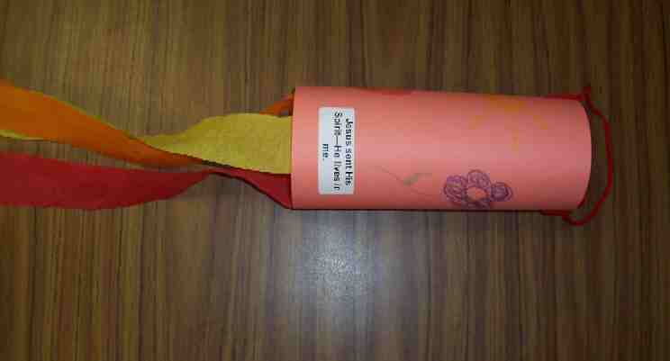
To make:
- Tape the streamers or ribbons to the bottom manila card.
- Add the label to the manila card and decorate with markers or crayons.
- Punch holes in the paper about ½ an inch from the top.
- Punch a second hole directly across from the first hole.
- Form a cylinder with the paper and tape the ends.
- Tie the ends of line into the punched holes.
- Take home and hang outside. (Be sure to bring in when there is rain.)

To discuss:
The wind, when it blows into the windsock, will catch the windsock and blow it in the direction of the wind. In the same way, when Jesus’ Spirit lives in our hearts, He will move us to do his work. What is some of God’s work the Spirit gives us the power to do?

Practice the take home point. You say the first part; the children respond with the second part. *JESUS SENT HIS SPIRIT—He lives in me.
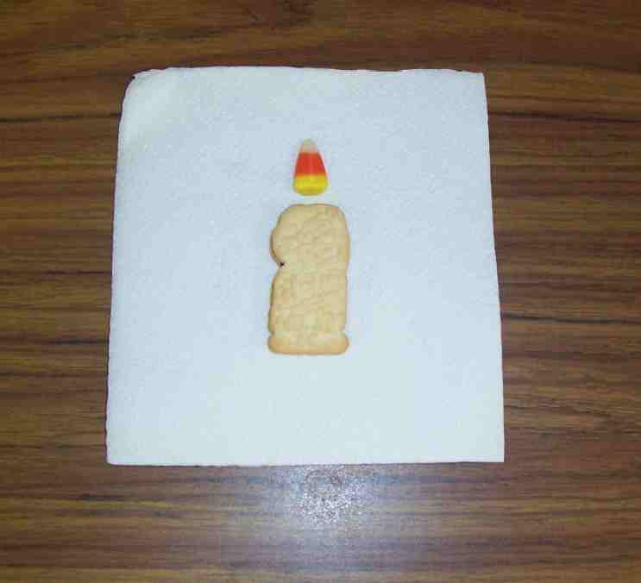

Activity 2: “Pentecost” Snack
Supplies needed: salted biscuits; broad finger biscuits; pink colour candy biscuits; serviettes
paper cups; water of juice

Lay a pink colour candy biscuit on top of a figure formed using salted biscuit as the head and finger biscuits as the body, hands and legs. This snack serves as a reminder of the tongues of fire resting on the heads of the disciples at Pentecost.
As the children eat, review the Bible event and say:

Just as Jesus sent His Spirit to the disciples at Pentecost, He gives His Spirit to Jesus’ followers today—including us. The disciples could see the Spirit at work when they were able to speak in different languages, when they spoke boldly about Jesus, and when they had the words to speak. How is the Spirit at work in our lives today?

Healthy Snack Option:
Some children are dangerously allergic to peanuts or peanut products. If you are not serving anyone allergic to peanuts, use peanuts that are still in their shell and roasted peanuts for this option. Talk about how the fire used to roast peanuts changed them, just as the “tongues of fire” changed the disciples. Did you know that when you soak your seeds or nuts in salt water and then roast them in the oven on low heat, they become much easier for our bodies to digest and absorb their plentiful nutrients? Note the imagery of water and flame from today’s Bible event. Water and flames… what a parallel!

Practice the take home point. You say the first part; the children respond with the second part. *JESUS SENT HIS SPIRIT—He lives in me.

Activity 3: “Wind Power” Game
Supplies needed: masking tape; ½ straw per child; ping pong ball or cotton ball

Instructions:
- Divide children into two teams.
- Make two lines of masking tape as far apart as possible.
- Line the teams up behind one strip of masking tape and give each child ½ a straw.
- Give the first child on each team a ping pong ball or cotton ball.
- On the word “Go!” the child must use the straw to blow the ball down to the other line and back.
- The next child must do the same thing so forth until every child has had a chance to play.
- The first team to finish wins.

To discuss:

In our game we used win from our breath to move the ball. I wonder how wind power is like Spirit power…

Practice the take home point. You say the first part; the children respond with the second part. *JESUS SENT HIS SPIRIT—He lives in me.

Activity 4: “Be Filled”
Purpose: Help kids to memorize and keep scriptures at heart. Using creative ways to help kids enjoy learning the key verse and in small group setting.

Supplies needed: plastic or paper cups; 3”X3” card with individual words of the memory verse; satay sticks; plastercine; pitcher with blue colour water
The

Memory Verse: John 16:14 ~ The Spirit of truth

will take what I say and tell it to you.

Memory Verse Learning:
Arrange the cups in random. Have a volunteer arrange
the verse into the right order. Recite with the children.
Tell them that the Spirit of truth or the Holy Spirit is in their
lives. These cups represent them; with opened mouth
ready to receive the water. One at a time, have a child
pour water into the cups and recite the memory verse
while pouring each one. Pour the water back to the pitcher before the next child takes his/her turn. Keep visuals for next week’s lesson.

Prayer Time:
Thank Jesus for sending His Spirit to all believers. Ask Him to fill you with more and more of His Spirit as you grow in faith.

Large Group Wrap-Up: (10 minutes)
Purpose: The crazy bird puppet, Xiao Er, struggles with learning the take home point. The leader shows an example of each small group application activity from this lesson and says the first phrase of the take home point. The kids respond with their phrase. They try to teach the puppet the take home point, but each time he confuses words or concepts. After three attempts, he finally gets it right and sings the correct take home point in a silly opera-like voice.

Supplies needed: optional music for the lesson; Xioa Er Puppet

Singing: (Optional)

Lesson Review with Puppet Skit:

The presenter shows an example of the activity done in small group and repeats first phrase to kids. The kids say the correct response trying to teach Xiao Er the take home point. Continue in this manner with the presenter showing examples of each activity.

Here are Xiao Er’s responses:

Activity 1: “…He lives in Cleveland?”
Activity 2: “…He lives in a zoo?”
Activity 3: “…He lives in a toy box.”
Activity 4: “…He lives in a cup.”

Welcome guests and thank them for attending.

Lesson 51
Large Group Opening:
- Xiao Hung puppet
- inflated balloon
- uninflated balloon
- adult-sized female Bible character costume
- Bible
- microphone
- stool to sit on

Small Group Application:
Activity 1:
- one paper cup per child
- yarn or thread
- scissors
- paper punch
- red, yellow and orange ribbons or strips of crepe paper
- label with take home point printed on it.
- tape

Activity 2:
- salted biscuits
- broad finger biscuits
- coloured candy biscuits
- serviettes
- paper cups
- water of juice

Activity 3:
- masking tape
- ½ straw per child
- ping pong ball or cotton ball
The
Activity 4:
  - plastic or paper cups with mouth piece paste on top of opening
  - 3”X3” card with individual words of the memory verse
  - satay sticks (cellophaned to the inside of cup)
  - pitcher with blue colour water

Large Group Wrap-up:
- optional music for the lesson
- Xiao Er puppet

