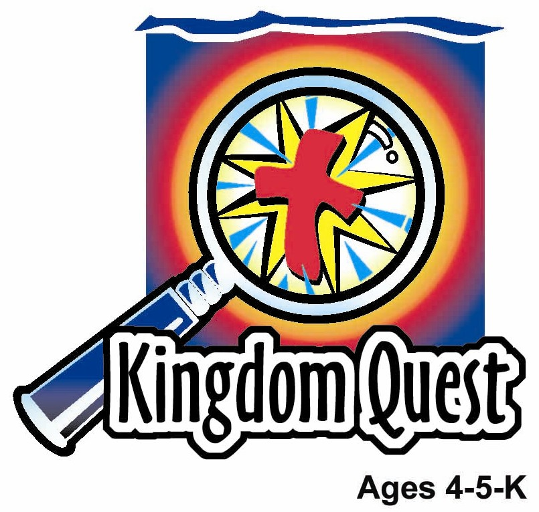
Date: ________________________
Series: The Gifts of Jesus (Apr-May)
Year 1, Lesson 52

3,000 Are Baptized

Take Home Point: *THE HOLY SPIRIT HELPS US BELIEVE—Believe in Jesus.
*Repeat this phrase throughout the lesson. The leader will say the first part of the phrase (CAPS). The children respond with the second part of the phrase (italics).

Bible Event: Acts 2:14-41
Jesus Link: The Holy Spirit shows us Jesus is Lord.

We will help the children know:
- The event of 3,000 people coming to faith in Jesus and being baptized on Pentecost.
- Through baptism, Jesus says, “You belong to me.”
- Baptism is a way of saying, “I belong to Jesus.”
- God’s Spirit helps us to believe in Jesus.

We will help the children feel:
- Faith in Jesus as their Savior.
- Empowered by the gift of God’s Spirit.
- Happy that Jesus brings us into His family.

We will help the children do:
- Listen to a dramatized character tell the story of 3,000 new believers being baptized.
- Make and eat a graham cracker cross and learn that it is because of the cross that we can become members of God’s family.
- Have a “Water Relay” and discuss water as a reminder of baptism and being filled with the Spirit.
THIS LESSON’S ROADMAP

DESTINATION | PAGE # | DISCOVERIES ON YOUR JOURNEY | SUPPLIES NEEDED
Large Group Opening   | 4  5 | Puppet Presentation  Bible Event | - Ting Ting puppet  - Option 1: candle  - Option 2: present  - adult-sized female Bible character costume  - Bible  - microphone  - stool to sit on
Small Group Application   | 7  8  8  9  9 | Activity 1: “Coffee Filter Art” Craft  Activity 2: “Cracker Cross” Snack  Activity 3: ”Water Relay” Game  Activity 4: ”Banner of Truth”  Prayer Time | Activity 1:  - newspaper  - coffee filters or disposable kitchen towels  - magic markers  - spray bottles  - paper plate  - glue  - label that says, “The Holy Spirit Spreads Faith. Believers are baptized.”  Activity 2:  - stick biscuits  - dip of choice, such as milk or soya bean drink  - cups  - serviettes  Activity 3:  - two five-gallon buckets per team  - water  - one paper cup per child  - plastic sheet to protect the floor  - timer  - permanent black marker  Activity 4:  - 3 1/2”X8” strip of paper for  every child  - cellophane tape  - satay sticks  - colour pencils  - 2 paper cups  - a pitcher of blue colour  water
Large Group Wrap-up   | 10  10 | Singing (Optional)  Lesson Review with Puppet Skit | - optional music for the lesson  - Xiao Er Puppet

Pre-Session Singing: (10 minutes)
Purpose: When all children are in one group singing, it is easy for new children to join the group and immediately get involved. When the music can be correlated, it introduces the theme for the day. Choose two to three songs and list them here.

Large Group Opening: (15 minutes)
Purpose: The puppet demonstrates the need that will be met in today’s lesson. The scripts are not written verbatim, but give a story line in which the group leader can interact with the puppet. The children are introduced to the take home point and then interact with God’s Word, as they experience the Bible event.

Supplies needed: Ting Ting puppet; Option 1: candle; Option 2: present; adult-sized female Bible character costume; Bible; microphone; stool to sit on

Puppet Presentation:
Option 1:
Ting Ting comes out with a candle. She is excited because today is her baptism birthday. On her baptism birthday, her family lights the candle as a reminder that she was baptized.

Option 2:
Ting Ting comes out carrying a candle. She is excited because she is going to her cousin’s baptism. It’s going to be a special event, and her aunt and uncle are going to have a special party for her cousin.

Both options:
After sharing her excitement, Ting Ting asks the presenter why baptism is so special. The presenter explains that baptism means that Jesus says, “You belong to me.” It means that you are a part of God’s family.

The presenter tells Ting Ting that in today’s Bible event, 3,000 people learn about Jesus and are baptized. The children will learn that one gift Jesus sent to His followers after he returned to heaven was to send the Spirit to help them believe in Jesus. We, too, believe in Jesus. We believe that Jesus died for our sins and came alive again. He returned to heaven to prepare a home for us there. One day He will return to earth to take us to heaven to live with Him always.

The presenter teaches Ting Ting the take home point. *THE SPIRIT HELPS US BELEIVE—Believe in Jesus. The presenter says the first part; Ting Ting responds with the second part. After practicing it with Ting Ting several times, the presenter teaches it to the children.

Bible Event: Visit From a Dramatized Character
A costumed adult presents the Bible event, telling it from first person point of view. This person should be introduced by asking the children to put on their imagination hats and imagine that this really is the person in the Bible story.

Have the children put on their imaginary thinking caps. Remind them of the woman, Mary, who visited last week. Say:

Remember, last week our visitor, Mary, pretended to be one of the women who followed Jesus when He was on earth. After He returned to heaven, she continued to believe that Jesus was her Savior. In last week’s Bible event she told about when Jesus’ followers were together in a room. A wind filled the room and tongues of fire rested on the believers’ heads. The believers were filled with Jesus’ Spirit, and His disciples were given the power to speak in different languages and share the good news that Jesus is alive. In today’s Bible event, Mary returns to tell what happened after the disciples shared the good news.

Pick up the Bible, open it to Acts and say:

It tells about this Bible event right here in the book named Acts.

Mary comes out with a microphone and sits on the stool. She begins telling the story:

Good morning, boys and girls. My name is Mary. I was a very good friend of Jesus. You may remember that I visited with you last week. I told you the story of the time I was with Jesus’ followers in a room when a sound like the wind rushed through the room. Can you make the sound of the wind? (Encourage the children to make the sounds of wind. After a few seconds, continue.) Then tongues of fire appeared on the believers. Jesus’ disciples were able to speak in different languages and tell the good news that Jesus is alive.

Today I want to tell you what happened after that.

Peter stood up with the other disciples. In a loud voice He told the crowds that Jesus is alive. What wonderful words! Can you help me say those words? (Say, “Jesus is alive!” several times with the children.)

Peter reminded the people that Jesus had done many wonderful miracles like making the blind see, healing the sick, and helping those who could not walk, walk.

Peter told the crowd that Jesus had been nailed to the cross and died. But then He came alive again. Help me say those wonderful words, “Jesus is alive!” (Again, say, “Jesus is alive!” with the children several times.)

When the people heard that Jesus had died on the cross because of them, they felt awful. “What must we do to be saved?” they asked. Peter told them, “Turn to God. Be sorry for your sins. Trust and believe in Jesus and what He did for you. God will forgive you and you will receive the Holy Spirit as a gift.” Change your ways. Say, “Thank you,”… AND be baptized in the name of Jesus.

Let’s count to a big number. Let’s count to 20. (Count to 20.) How many people do you think believed in Jesus that day and were baptized? Was it 20? Nooo. Was it 50? Nooo. Was it 100? Nooo. It wasn’t even 1,000. No, on that day about 3,000 people believed in Jesus and were baptized with water in the name of Jesus. What a wonderful thing to celebrate! More than 3,000 people were added to Jesus’ family on that day!

And that isn’t the end of the good news! Jesus wants us to be in His family, too. Baptism wasn’t only for those people. Baptism is also for us! He wants us to be forgiven and to receive His Spirit. He wants us to believe that he is God, that He died to take away our sins, and that He rose from the grave. Let’s say those wonderful words, “Jesus is alive!” once again. (Repeat several times.)

Next week you will learn the wonderful things that happened after the new believers joined Jesus’ family. But now, I must go. Shalom! Peace, my friends!

Mary walks off stage and large group presenter re-enters.

Practice the take home point. You say the first part; the children respond with the second part. *THE SPIRIT HELPS US BELIEVE—Believe in Jesus.

End with the following prayer:

Dear God,
Thank You for the best gifts.
Thank You for sending Jesus.
He’s our Savior and Your Son.
Thank You that His Spirit helps us believe.
Thank You! Thank You! Thank You!
Amen.

Small Group Application: (30 minutes)
Purpose: Smaller groups enable children to develop closer relationships with adults and peers in the church. As you reinforce the take home point with a fun hands-on activity, discuss the Bible event. Be sure to repeat the take home point several times. Say the first part and have the children respond with the second phrase. Application questions help kids apply the take home point to their daily lives. Close this session by gathering your small group for prayer. Let the kids pray!

During the small group application time, discuss the following questions and points:

What was the message the disciples gave the people in the Bible event? (Jesus died on the cross and was raised to life. When we believe, repent and are baptized, we receive the forgiveness of sins and the gift of the Spirit.)

What wonderful thing happened that day? (3,000 people believed, repented and were baptized.)

What does the Holy Spirit do to help us believe? (The Holy Spirit helps us know that we are sinners and shows us the need of Jesus as our Savior. He died and rose for our forgiveness.)

What does God tell us in baptism? (You are forgiven. You are a part of my family.)

Activity 1: “Coffee Filter Art” Craft
Supplies needed: newspaper; coffee filters or disposable kitchen towels; magic markers; spray bottles; paper plate; glue; label that says, “The Holy Spirit Spreads Faith. Believers are baptized.”

To make:
- Color the coffee filter with magic markers.
- Glue the coffee filter to the paper plate.
- Add the label.
- Lightly spray water on the coffee filter and watch the color spread.

To discuss:
Review the Bible event. Emphasize that just as the color on the coffee filter spread, on Pentecost the Holy Spirit spread to many people as they came to faith in Jesus and were baptized.

Practice the take home point. You say the first part; the children respond with the second part. *THE SPIRIT HELPS US BELIEVE—Believe in Jesus.

Activity 2: “Stick Biscuits Cross” Snack
Supplies needed: Stick biscuits ; dip of choice, such as milk or soya bean drink; cups; serviettes

To make:
- Lay one stick biscuit across the other stick biscuit to make a cross.
- To eat, dip the end of a stick biscuit into the drink.

To discuss:
When we believe in Jesus, we trust that He died on the cross so that our sins can be forgiven. When we dip the cracker we are reminded of baptism. What is the meaning of baptism? It means we belong to Jesus. God’s Spirit helps us to believe in Jesus.

Healthy Snack Option:
Use carrot or celery sticks to make a cross and dip them in water to remind the kids of baptism.

Practice the take home point. You say the first part; the children respond with the second part. *THE SPIRIT HELPS US BELIEVE—Believe in Jesus.

Activity 3: “Water Relay” Game
Supplies needed: two five-gallon buckets per team; water; one paper cup per child; towels, sheets, plastic sheet to protect the floor; timer; permanent black marker

To set up:
- Lay out the plastic sheet on the floor.
- At one end of the sheet put a bucket of water on the sheet.
- Put an empty bucket at the other end of the sheet.
- Give each child a cup and line them up, standing side by side, from one bucket to the other bucket.

To play:
- Set the timer for two minutes.
- Have the first child dip his/her cup into the bucket of water, fill it up and then pour it into the second child’s cup.
- The second child pours the water into the third child’s cup and so forth down the line.
- The last child in the line pours the water into the bucket.
- As soon as the first child pours the water into the second child’s cup he/she fills up the cup again and starts another line of water passing.
- Play continues in this manner until the time beeps.
- After the timer beeps, use the permanent marker to mark how high the water is in the bucket at the end of the line and then dump the water back into the first bucket.
- Set the timer for two minutes and repeat the game, trying to get more water into the end bucket.

Option: Play against another team and see which team gets the most water into the bucket at the end of the line.

To discuss:
This water relay is a reminder of baptism. It reminds us that God gives us His Spirit and that Jesus says, “You belong to me.”

Practice the take home point. You say the first part; the children respond with the second part. *THE SPIRIT HELPS US BELIEVE—Believe in Jesus.

Activity 4: “Banner of Truth”
Purpose: Help kids to memorize and keep scriptures at heart. Using creative ways to help kids enjoy learning the key verse and in small group setting.

Supplies needed: 3 1/2”X8” strip of paper for every child; cellophane tape; satay sticks; colour pencils; 2 cups paper cups; a pitcher of blue colour water

Memory Verse: John 16:14 ~ The Spirit of truth will take what I say and tell it to you.
John 16:14 ~ The Spirit of truth will take what I say
and tell it to you.

Memory Verse Learning:
Review the memory verse a few times with the children.
Then, give each child a piece of paper. Encourage the
children to write the memory verse down out from their
memory and allow those who are unable to copy from the
white board. Next, give 2 satay sticks to each child
and show them how to roll the ends like a scroll. Then
stick the satay sticks on to the sides of the two cups
so that their banner is stretched out. While pouring the
blue water into their cups, each child is to recite the memory verse.

Prayer Time:
Thank Jesus that because He died on the cross, all who believe in Him can be in His family. Thank Him for the gift of baptism, which means that we belong to Jesus.

Large Group Wrap-Up: (10 minutes)
Purpose: The crazy bird puppet, Xiao Er, struggles with learning the take home point. The leader shows an example of each small group application activity from this lesson and says the first phrase of the take home point. The kids respond with their phrase. They try to teach the puppet the take home point, but each time he confuses words or concepts. After three attempts, he finally gets it right and sings the correct take home point in a silly opera-like voice.

Supplies needed: optional music for the lesson; Xiao Er Puppet

Singing: (Optional)

Lesson Review with Puppet Skit:

The presenter shows an example of the activity done in small group and repeats first phrase to kids. The kids say the correct response trying to teach Xiao Er the take home point. Continue in this manner with the presenter showing examples of each activity.

Here are Xiao Er’s responses:

Activity 1: “…I love cheese!”
Activity 2: “…I believe I like tomatoes.”
Activity 3: “…believe in Jelly doughnuts.”
Activity 4: “…I believe in water.”

Welcome guests and thank them for attending.

Lesson 52
Large Group Opening:
- Ting Ting puppet
- Option 1: candle
- Option 2: present
- adult-sized female Bible character costume
- Bible
- microphone
- stool to sit on

Small Group Application:
Activity 1:
- newspaper
- coffee filters or disposable kitchen towels
- magic markers
- spray bottles
- paper plate
- glue
- label that says, “The Holy Spirit Spreads Faith. Believers are baptized.”

Activity 2:
- stick biscuits
- dip of choice such as milk or soya bean drink
- cups
- serviettes

Activity 3:
  - two five-gallon buckets per team.
  - water
  - one paper cup per child
  - platic sheet to protect the floor
  - timer
  - permanent black marker

Activity 4:
  - 3 ½”X8”strip of paper for every child
  - cellophane tape
  - satay sticks
  - colour pencils
  - 2 paper cups
  - a pitcher of blue colour water

Large Group Wrap-up:
- optional music for the lesson
- Xiao Er puppet

The Holy Spirit spreads faith……,
Believers are baptized.

_________ 16:14 ~ The __________ of _________ will take what I say and

tell it to you.

