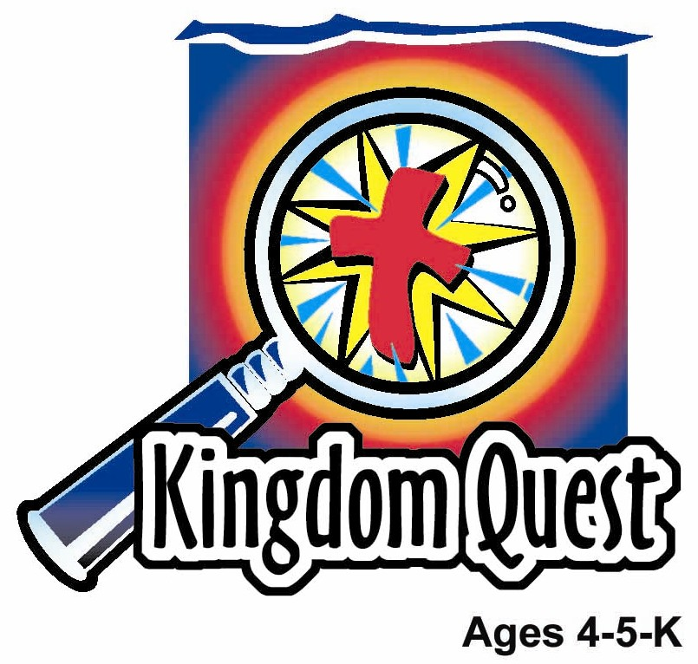
Date: ________________________
Series: The Gifts From Jesus (Apr-May)
Year 1, Lesson 53

What Disciples Do

Take Home Point: JESUS IS IN ME—I am a disciple too.
*Repeat this phrase throughout the lesson. The leader will say the first part of the phrase (CAPS). The children respond with the second part of the phrase (italics).

Bible Event: Acts 2:42-47
Jesus Link: Jesus lives in me; I have His love and His power to be a disciple.

We will help the children know:
- A disciple is someone who has Jesus’ love in his heart and lives his life for Jesus.
- Ways in which the early Christians lived as disciples.
- Ways in which they can live as disciples.

We will help the children feel:
- Filled up with the love of Jesus.
- An overflowing of love that demonstrates itself in an eagerness to live as a disciple of Jesus.
- Valued as a contributing member of God’s kingdom.

We will help the children do:
- Create a living “Discipleship Picture for Kids.”
- Demonstrate sharing with the body of Christ by making and sharing a snack of trail mix.
- Play a tag game called “Discipleship Chain” to demonstrate bringing others into the body of Christ.
THIS LESSON’S ROADMAP

DESTINATION | PAGE # | DISCOVERIES ON YOUR JOURNEY | SUPPLIES NEEDED
Large Group Opening  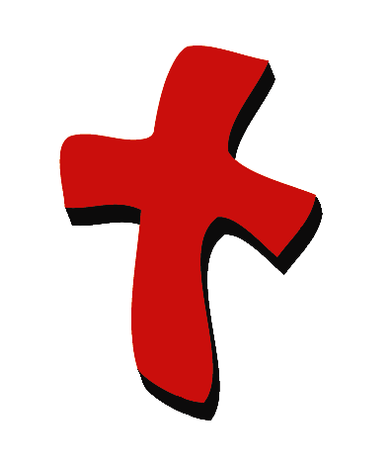 | 4  5 | Puppet Presentation  Bible Event | - Xiao Hung puppet  - item to represent a pastor, such as a clerical collar, tie, or robe  - microphone  - Bible  - small wrapped gift box  - enlarged heart with cross in it from appendix on manila card  - tape  - table or chair for volunteer
Small Group Application   | 8  8  9  10  10 | Activity 1: “Discipleship Picture for Kids” Craft  Activity 2: “Rojak” Snack  Activity 3: ”Discipleship Chain” Game  Activity 4: ”Clothesline”  Prayer Time | Activity 1:  - coloring sheet (Hint:  Reproduce on manila card.)  - watercolor paints, markers,  crayons, and glitter glue  - option 1: miniature bows,  heart, cross, Bible, and  praying hands stickers  - option 2: appendices copied,  pre-cutout, crayons, glue  - newspapers to cover the  tables  Activity 2:  - make a “rojak” with varieties of biscuits bought from ‘Pasar Malam’  - mixing bowl and spoon  - measuring spoon or cup  - serviettes  - paper cups  - water or juice  Activity 3:  - none  Activity 4:  - 3 meters long raffia string  - 3”X5” cards with individual words of the memory verse written on them  - 14 clothes pegs
Large Group Wrap-up   | 11  11 | Singing (Optional)  Lesson Review with Puppet Skit | - optional music for the lesson  - Xiao Er

Pre-Session Singing: (10 minutes)
Purpose: When all children are in one group singing, it is easy for new children to join the group and immediately get involved. When the music can be correlated, it introduces the theme for the day. Choose two to three songs and list them here.

Large Group Opening: (15 minutes)
Purpose: The puppet demonstrates the need that will be met in today’s lesson. The scripts are not written verbatim, but give a story line in which the group leader can interact with the puppet. The children are introduced to the take home point and then interact with God’s Word, as they experience the Bible event.

Supplies needed: Xiao Hung puppet; item to represent a pastor, such as a clerical collar, tie, or robe; microphone; Bible; small wrapped gift box; enlarged heart with cross in it from appendix on manila card; tape; table or chair for volunteer

Puppet Presentation:
Xiao Hung comes out wearing a clerical collar, robe, or tie, or carrying something that will remind the children of their pastor.

The presenter comments that Xiao Hung looks like the pastor.

Xiao Hung is pleased. He says that he wants to be a pastor when he grows up.

The presenter replies that the church does need pastors, then asks Xiao Hung why he decided to be a pastor when he grows up.

Xiao Hung says that he loves Jesus and wants to tell people about Jesus. He wants to live for Jesus.

The presenter tells Xiao Hung that he doesn’t have to be a pastor to tell people about Jesus and live for Jesus. He can do that right now. He can be a disciple. A disciple is someone who loves Jesus and lives for Jesus by serving Him. Even kids can be disciples.

Xiao Hung is surprised. “Are you sure I can be a disciple, too?” he asks.

The presenter assures Xiao Hung that he can be a disciple, too. When we have faith in Jesus as our Savior, He lives in us and helps give us the power to be His disciples.

Then the presenter shares that in today’s Bible event, the children will learn how the new believers in Jesus served Him as His disciples. The children will learn how they, too, can be disciples.
The presenter teaches Xiao Hung the take home point. *JESUS IS IN ME—I am a disciple too. The presenter says the first part; Xiao Hung responds with the second part. After practicing it with Xiao Hung several times, the presenter teaches it to the children.

Bible Event: Mystery Box
The Mystery Box contains objects that will help the presenter tell the Bible event in creative fashion. These objects can be lifted out and shown as the story is told. Another option is to have a hole cut in the top of the box, so that a child could put a hand into it and guess what the object is before it is shown.

Supplies: Increase the size of and copy the appendix sheet containing the heart with cross on it. Cut it out and have tape available so that it can be taped it to a child’s shirt, Bible, small gift wrapped package

Review Pentecost event:

Let me read to you from the Bible. Here, it talks about our lesson last week. This was after Jesus returned to heaven and when His followers or disciples were talking to others about Jesus.

They told people that Jesus was God’s Son. Jesus died on the cross so our sins would be forgiven, but He didn’t stay dead. He became alive again. Many people were listening to the disciples during a special holiday called Pentecost. Many, many people realized they needed Jesus. They came to trust Him as their Savior. They believed and were baptized – 3,000 of them!

Introduce today’s Bible event and get a volunteer.
Call up a volunteer. Stand the child facing the audience. Use a small platform or chair to raise the child higher and make him/her more visible. Have the mystery box nearby so the items may be taken out and attached or given to the child.

Let’s use our imagination. Let’s imagine that our volunteer is just like one of those people many years ago who heard about Jesus and trusted Him as Savior. This person became a disciple.

Did you know you, too, can become a disciple? You can become a disciple by trusting in Jesus. When you do, Jesus lives in your heart and you are a disciple like any other believing adult! So, just like the disciples followed Jesus many years ago, we can follow Him today.

What do disciples do? They do four things. Can you count to four? One… two… three… four. (Hold up your fingers as you encourage the children to count out loud.) Let’s learn those things now.

Disciples Pray:
Tape the paper cut out heart with cross and hands to the shirt of the volunteer.

This heart with the cross reminds us that we love Jesus. How do we tell Jesus we love Him? We pray. The disciples gathered often to pray. When they did, they also sang songs, worshiped Him and talked about how wonderful God is. The hands remind us that we lift our hearts to God in prayer and worship.

Disciples Read and Learn the Bible
Set the Bible at the foot of the volunteer.

I will put the Bible in front of the “disciple.” This reminds us that the disciples learned by reading the Bible often. There they found out about Jesus and what He did for them. It was truth they could stand on. They knew for sure that God was with them, and they belonged to Him. They knew God would use them to help many other people.

Disciples Invite Others

Look at this “disciple’s” hand. We’re going to ask the volunteer to make a motion with his/her hand that indicates to others, “Come over here,” or “I’m inviting you here.” Do you think disciples want more people to trust and follow Jesus? Yes. Moving our hands like this tells others, “Come over here. I’m inviting you.” (Beckon with your hand and show the volunteer how to do it.) You see, disciples invited others to get to know Jesus. They told their friends that Jesus was God’s Son. They explained how Jesus could be someone’s very best friend, even if you couldn’t see Him. Jesus would always be with them. Do you think we can be disciples, too, and invite our friends? Can we invite them to church… can we pray for them… can we tell them that Jesus loves them? Of course.

Share Gifts:
Now I’m going to ask the volunteer to hold his/her hand out and I’m going to put a present on it. Do you think this is a present that I’m giving the disciple? Or, do you think this disciple is giving a gift away?

This disciple is giving a gift away. This reminds us that disciples love to share with others. Disciples share their money, the things that they have, and even their time. Disciples share these things so others come to know Jesus and follow Him also.

Summary:
So let’s see if you remember the four things that disciples do. I’ll point to it and say it, and you repeat it after me. One, pray (pray), two read and learn about the Bible (read and learn about the Bible), three, invite others (invite others), and four, share gifts (share gifts). Who can do it by just remembering and looking at these pictures or symbols? (Take two or three children from the audience and see if they can recall the four points.) These are things that disciples do. You can be a disciple too. Remember, *Jesus is in me – I am a disciple too.

Practice the take home point. You say the first part; the children respond with the second part. *JESUS IS IN ME—I am a disciple, too.

End with the following prayer:

Dear God,
Thank You for the best gifts.
Thank You for sending Jesus.
He’s our Savior and Your Son.
Thank You for helping us be Jesus’ disciples.
Thank You! Thank You! Thank You!
Amen

Small Group Application: (30 minutes)
Purpose: Smaller groups enable children to develop closer relationships with adults and peers in the church. As you reinforce the take home point with a fun hands-on activity, discuss the Bible event. Be sure to repeat the take home point several times. Say the first part and have the children respond with the second phrase. Application questions help kids apply the take home point to their daily lives. Close this session by gathering your small group for prayer. Let the kids pray!

During the small group application time, discuss the following questions and points:

What does it mean to be Jesus’ disciple? (Jesus lives in us and we live for Him.)

Why do we want be Jesus’ disciple? (Because He loved us so much, He died on the cross for us so we can be forgiven and be a part of His family. Now we want to love Him back and share His love with others.)

How did the new believers live as disciples? (They learned about Jesus, trusted Jesus, met together, shared with one another, prayed, worshipped, and told others about Jesus.)

How can we live as disciples? (Answers will vary but should encompass the five areas: studying God’s Word, sharing God’s Word with unbelievers, sharing our gifts with God’s family, trusting Jesus, and worshipping and praying.)

Activity 1: “Little Disciple Picture” Craft
Supplies needed: coloring sheet (Hint: Reproduce on manila card.; watercolor paints, markers, crayons, and glitter glue; option 1: miniature bows, heart, cross, Bible, and praying hands stickers; option 2: appendices copied, pre-cutout, crayons, glue; newspapers to cover the tables

To make:
As you decorate and complete the “Little Disciple” picture with items from the appendix with markers, crayons, glitter, etc, review the different areas of discipleship:

- Heart and cross being lifted up by hands: Disciples lift their hearts to God in prayer. They worship Him when they tell Him, “We love you.”
- God’s word the Bible: Disciples read and learn the Bible.
- Beckoning hand: Disciples invite others to meet Jesus.
- Gifts: Disciple share gifts. We give offerings to God. We share belongings with others and even use our time to help others.

Option:
Children can simply color the “Little Disciple” picture.

Practice the take home point. You say the first part; the children respond with the second part. *JESUS IS IN ME—I am a disciple too.

Activity 2: “Rojak” Snack
Supplies needed: make a “rojak” with varieties of biscuits bought from ‘Pasar Malam’; mixing bowl and spoon; measuring spoon or cup; serviettes; paper cups; water or juice

To make:
Have the children help with different parts of snack preparations, including:
- Measuring and adding ingredients to the mix.
- Mixing the ingredients together.
- Setting the table.
- Dishing up the snacks.
- Eat!

To discuss:
In the Bible, those who loved Jesus would get together often to share meals. They would also share the things they owned with those who needed them. Just as Jesus showed His love for them on the cross, they wanted to show their love to Jesus’ family. Today we are sharing Jesus’ love with one another as we share and help each other at snack. What are some other ways we can show love to Jesus’ family?

Practice the take home point. You say the first part; the children respond with the second part. *JESUS IS IN ME—I am a disciple too.

Activity 3: “Discipleship Chain” Game
Supplies needed: none

To play:
Tape two lines on the floor, 15 feet a part. All children begin behind one line and try to run to the other line without getting tagged. One child is “it” and stands in the middle. As children are tagged by the one that is “it,” they join him/her as “it.” As children are tagged, this group grows. Finally, “it” will have all the kids.

Hint: If you have several groups using the same room, you may need to define the space for the game using chairs or tape.

To discuss:
Disciples don’t have to chase people, but when disciples invite others to church, that person may believe and trust in Jesus and become a disciple too. The discipleship chain gets longer and longer as people come to know and trust Jesus. Who can you invite to church or tell about Jesus?

Practice the take home point. You say the first part; the children respond with the second part. *JESUS IS IN ME—I am a disciple too.

Activity 4: “Clothesline”
Purpose: Help kids to memorize and keep scriptures at heart. Using creative ways to help kids enjoy learning the key verse and in small group setting.

Supplies needed: 3 meters long raffia string; 3”X5” cards with individual words of the memory verse written on them; 14 clothes pegs.

Memory Verse: Matthew 28:19 ~ So go and make followers of all the people in the world.

Memory Verse Learning:
Tie the raffia string like a clothesline and display the words of the memory verse at child’s height prior to class. Have the children sit down in front of the line and read the verse together with you a few times. When the children are ready, ask a volunteer to remove a word card from the line and ask the children to read the verse together. Repeat the steps until all the words are being removed from the line. If time permits, give each child a card and ask them to put the words back as the whole class recites the verse together.

Prayer Time:
Thank Jesus for showing you His love on the cross and filling you with that love. Ask Him to help you live as His disciple in specific ways.

Large Group Wrap-Up: (10 minutes)
Purpose: The crazy bird puppet, Xiao Er, struggles with learning the take home point. The leader shows an example of each small group application activity from this lesson and says the first phrase of the take home point. The kids respond with their phrase. They try to teach the puppet the take home point, but each time he confuses words or concepts. After three attempts, he finally gets it right and sings the correct take home point in a silly opera-like voice.

Supplies needed: optional music for the lesson; Xiao Er

Singing: (Optional)

Lesson Review with Puppet Skit:

The presenter shows an example of the activity done in small group and repeats first phrase to kids. The kids say the correct response trying to teach Xiao Er the take home point. Continue in this manner with the presenter showing examples of each activity.

Here are Xiao Er’s responses:

Activity 1: “…I am a good colorer.”
Activity 2: “…I am in a cup of rojak!”
Activity 3: “…I am a grasshopper too!”
Activity 4: “…I am a clothesline!”

Welcome guests and thank them for attending.

Lesson 53
Large Group Opening:
- Xiao Hung puppet
- item to represent a pastor such as a clerical collar, tie, or robe
- microphone
- Bible
- small wrapped gift box
- cut out heart with cross in it
- cut out praying hands
- worship song either on CD or tape… or a worship leader playing it on a piano or a guitar
- masking tape

Small Group Application:
Activity 1:
- coloring sheet (Hint: Reproduce on manila card.)
- watercolor paints, markers, crayons, and glitter glue
- option 1: miniature bows, heart, cross, Bible, and praying hands stickers
- option 2: appendices copied, pre-cutout, crayons, glue
- newspapers to cover the tables

Activity 2:
- make camping mix with varieties of biscuits bought from ‘Pasar Malam’
- mixing bowl and spoon
- measuring spoon or cup
- serviettes
- paper cups
- water or juice

Activity 3:
- none

Activity 4:
- 3 meters long raffia string
- 3”X5” cards with individual words of the memory verse written on them
- 14 clothes pegs

Large Group Wrap-up:
- optional music for the lesson
- Xiao Er puppet

