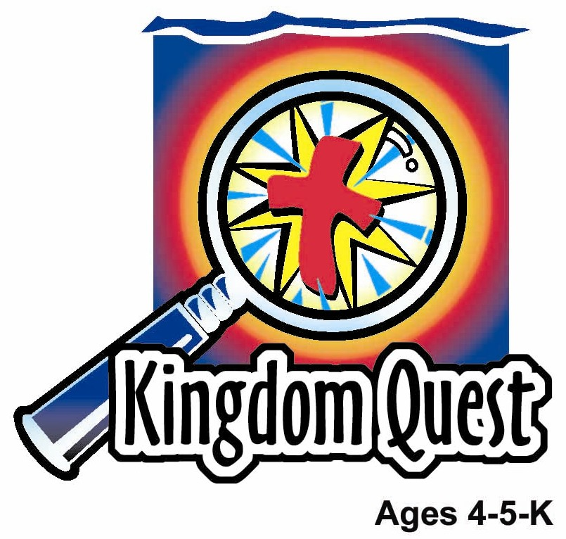
Date: _______________ __ _
Series: God Forgives Me (Sept-Nov)
Year 2, Lesson 15

Forgive Us Our Debts

Take Home Point: *GOD FORGIVES ME—I forgive others.
*Repeat this phrase throughout the lesson. The leader will say the first part of the phrase (CAPS). The children respond with the second part of the phrase (italics).

Bible Event: Matthew 18:21-35
Jesus Link: God forgives us because Jesus paid for our debt on the cross.

We will help children know:
- The parable of the unmerciful sinner.
- God forgives them of even their biggest sins.
- God wants them to forgive others.

We will help the children feel:
- Repentant of their sins.
- Confident of God’s forgiveness.
- Forgiving of others.

We will help the children do:
- Watch the video “Forgive Us Our Debts.”
- Count sins that are forgiven using snack items and then remember God’s forgiveness.
- Play a game, “Sinful/Forgiven.”

THIS LESSON’S ROADMAP

DESTINATION | PAGE # | DISCOVERIES ON YOUR JOURNEY | SUPPLIES NEEDED
Large Group Opening  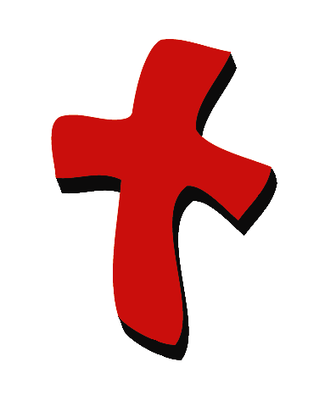 | 3 | Bible Event | - VCR  - TV  - video, Animated Stories of the New Testament: Forgive Us Our Debts from Nest Masters, 1991
Small Group Application   | 5  5  6  6 | Activity 1: “Cross Magnet” Craft  Activity 2: “Count the Sins” Snack  Activity 3: ”Sinful/Forgiven” Game  Activity 4: “Have a Heart”  Prayer Time | Activity 1:  - reproducible photocopied on cardstock and cut out  - sticky-backed magnetic tape  - green crayons  - paper cups  - PVA glue  - small items to glue on cross such as sequins, Cheerios, etc.  Activity 2:  - serviettes  - salted biscuits (11 per child)  - cups  - water or juice  HEALTHY SNACK OPTION:  - grapes or raisins  - water  Activity 3:  - small uninflated balloon with a smiley face drawn on it  - larger balloon with a big mouth  - Insert the smaller balloon into the larger balloon.  - Inflate the larger balloon and tie it closed. (Leave the smaller balloon uninflated.)  - Draw a smiley face on the larger balloon.  - dot stickers. Optional: draw a sad face on them beforehand  - needle  Activity 4:  - seven pieces of “heart” post-it  - whiteboard
Large Group Wrap-up   | 5  6 | Singing (Optional)  Lesson Review with Puppet Skit | - optional music for the lesson  - Xiao Er puppet  - sample materials from small group activities

Pre-Session Singing: (10 minutes)
Purpose: When all children are in one group singing, it is easy for new children to join the group and immediately get involved. When the music can be correlated, it introduces the theme for the day. Choose two to three songs and list them here.

Large Group Opening: (15 minutes)
Purpose: The puppet demonstrates the need that will be met in today’s lesson. The scripts are not written verbatim, but give a story line in which the group leader can interact with the puppet. The children are introduced to the take home point and then interact with God’s word, as they experience the Bible event.

Puppet Presentation:
There will be no puppet presentation today since we will be watching a video.

Bible Event: Video
Test your sound and video system beforehand. Cue the video to its precise beginning. For larger groups of children (15 or more), use a large screen TV or imager. Dim the lights before starting the video. To introduce a video, you might read from a Bible storybook and leave off the ending, inviting the children to see what happens by watching the video. You could also introduce the video by inviting the children to keep an eye out for special actions or words they will see during it.

Supplies needed: VCR;TV; video, Animated Stories of the New Testament: Forgive Us Our Debts from Nest Masters, 1991

Show the video. Then practice the take home point with the children. *GOD FORGIVES ME—I forgive others.

End with the following prayer. Have the children repeat each phrase.

Dear God, (repeat)
Thank You for sending Jesus. (repeat)
Thank You for forgiving me. (repeat)
Help me to forgive others. (repeat)
Thank You! Thank You! Thank You! (repeat)
Amen (repeat)

Small Group Application: (30 minutes)
Purpose: Smaller groups enable children to develop closer relationships with adults and peers in the church. As you reinforce the take home point with a fun hands-on activity, discuss the Bible event. Be sure to repeat the take home point several times. Say the first part and have the children respond with the second phrase. Application questions help kids apply the take home point to their daily lives. Close this session by gathering your small group for prayer. Let the kids pray!
During the small group application time, discuss the following questions and points:

What did the king do to the servant who owed him money? (He forgave him the debt.)

What did the servant do to another servant who owed him money? (Had him thrown in prison.)

For what does God forgive us? Why? (Our sins, because Jesus died for them.)

What are some sins others have done to you? What should you do back to them? (Answers will vary but may include hitting, breaking a toy, calling names, etc. We should forgive them.)

Activity 1: “Cross Magnet” Craft
Supplies needed: reproducible photocopied on cardstock and cut out; sticky-backed magnetic tape; green crayons; paper cups; PVA glue; small items to glue on cross such as sequins, Cheerios, etc.

To make:
- Read and practice the take home point as printed on the reproducible.
- Have the children color the hill a light green and stick the magnetic tape on the back of the reproducible.
- Give each child a paper cup.
- Take turns naming sins kids sometimes do. For each sin, have each child take a sequin (or other item) and put it in his cup.
- After a number of sins have been named, have the children fill their crosses with glue.
- Together say, ”GOD FORGIVES ME—I forgive others,” and take a sequin out of the cup and stick it in the glue. Continue until all the sequins have been used.

Remind the children that when Jesus died on the cross, our sins and the sins of all who believe were nailed on the cross with Him.

Activity 2: “Count the Sins” Snack
Supplies needed: serviettes; salted biscuits (11 per child); cups; water or juice

Use the salted biscuits to retell the Bible event:
- Count out ten salted biscuits and put in one pile.
- Explain that those ten crackers are a reminder of the pile of money the servant owed the king.
- The king forgave the servant all his debt. The man no longer owed him money.
- Have the children eat their crackers.
- Give the children one more cracker.
- Explain that this cracker is a reminder of the little bit of money another servant owed the first servant.
- The first servant wouldn’t forgive him even that little, tiny debt.
- When the king found out, he was angry and had the first servant thrown in prison.
- Because Jesus forgave us our many sins, we want to forgive others when they sin against us.
- Have the children eat the last cracker.

HEALTHY SNACK OPTION: Use grapes or raisins instead.

Practice the take home point. *GOD FORGIVES ME—I forgive others.

Activity 3: “Sinful/Forgiven” Game
Supplies needed: small uninflated balloon with a smiley face drawn on it; larger balloon with a smaller balloon into it; dot stickers. Optional: draw a sad face on them beforehand; needle

To play:
- Have the children imagine the balloon is a little girl named Maroobi. She’s having a very bad day and has done many sins.
- Have the children sit in a circle and bop the balloon between them.
- The teacher whistles, says stop, or blows a whistle.
- The child caught holding the balloon must name one sin Maroobi has done today and place a sticker on the balloon.
- Continue until all the children have had a turn.
- Point out that Maroobi is no longer smiling because she is covered with the sins she has done.
- Maroobi says, “God, take these sins away. I need Jesus to forgive me.”
- Pop the large balloon.
- “Find” the smaller balloon inside and inflate it.
- It has a smiley face because God has forgiven Maroobi!

Practice the take home point: *GOD FORGIVES ME—I forgive others.

Activity 4: “Have a Heart”
Purpose: Help kids to memorize and keep scriptures at heart. Using creative ways to help kids enjoy learning the key verse and in small group setting.

Supplies needed: seven pieces of “heart” post-it; whiteboard

Memory Verse: Matthew 18:35 ~ …Forgive your brother from your heart.

Memory Verse Learning:
Before class, write each word and the text in a piece of the “heart” post-it. During this section, stick the verse on to the board and have the children recite the verse three times. At an appropriate time, take off a heart and give it to a child and say “Have a Heart.” Then have the children repeat the verse. Continue to give out a heart at each round of reciting until all the hearts are not posted on the whiteboard.

Prayer Time:
Have children thank God for His forgiveness of sin through Jesus Christ.

Large Group Wrap-Up: (10 minutes)
Purpose: The crazy bird puppet, Xiao Er, struggles with learning the take home point. The leader shows an example of the each small group application activity from this lesson and says the first phrase of the take home point. The kids respond with their phrase. They try to teach the puppet the take home point, but each time he confuses words or concepts. After three attempts, he finally gets it right and sings the correct take home point in a silly opera-like voice.

Singing: (Optional)

Lesson Review with Puppet Skit:
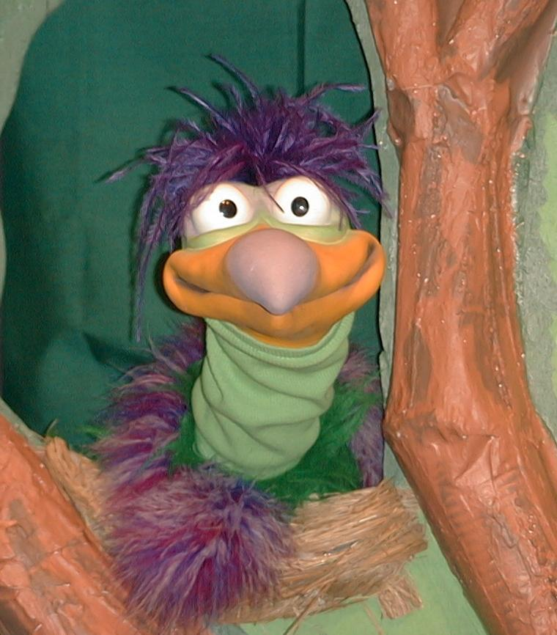
Presenter shows Xio Er a craft made in Activity 1. Then the kids attempt to teach Xiao Er the take home point.

Presenter says to kids: “God forgives me…”
Kids say: “…I forgive others.”
Presenter says to Xiao Er: “God forgives me…”
Xiao Er says: “I like peanut butter on my bananas”

Presenter shows an example of the next activity done in small group and repeats first phrase to kids. The kids say the correct response trying to teach Xiao Er the take home point. Continue in this manner with Presenter showing example of each activity. Here are Xiao Er’s responses:

Xiao Er’s response to Activity 2 sample: “I forget what I’m saying.”
Xiao Er’s response to Activity 3 sample: “I forgive small tiny little bugs that buzz around my ears.”

Presenter says: “Xiao Er, listen one last time.
God forgives me…”
Kids response: “…I forgive others.”
Presenter says to Xiao Er: “God forgives me …”
Xiao Er’s response: (Warms up his singing voice with “Mee, mee, mee, mee, mee…” and sings in a silly dramatic opera-like voice) “GOD FORGIVES ME—I FORGIVE OTHERS.”

Welcome guests and thank them for attending.

Lesson 15

Large Group Warm-up
- VCR
- TV
- video, Animated Stories of the New Testament: Forgive Us Our Debts from Nest Masters, 1991

Small Group Application
Activity 1:
- reproducible photocopied on cardstock and cut out
- sticky-backed magnetic tape
- green crayons
- paper cups
- PVA glue
- small items to glue on cross such as sequins, Cheerios, etc.
Activity 2:
- serviettes
- salted biscuits (11 per child)
- cups
- water or juice
HEALTHY SNACK OPTION:
- grapes or raisins
- water
Activity 3:
- small uninflated balloon with a smiley face drawn on it
- larger balloon with a big mouth
- Insert the smaller balloon into the larger balloon.
- Inflate the larger balloon and tie it closed. (Leave the smaller balloon uninflated.)
- Draw a smiley face on the larger balloon.
- dot stickers. Optional: draw a sad face on them beforehand
- needle
Activity 4:
- seven pieces of “heart” post-it
- whiteboard

Large Group Wrap-up
- optional music for the lesson
- Xiao Er puppet
- sample materials from small group activities

