
Date: ________________________
Series: God gives the Best Gifts (Dec-Feb)
Year 2, Lesson 29

John the

Baptist is

Born

Take Home Point: *GOD GIVES THE BEST GIFTS—Surprise! Surprise! Surprise!
*Repeat this phrase throughout the lesson. The leader will say the first part of the phrase (CAPS). The children respond with the second part of the phrase (italics).

Bible Event: Luke 1:5-25, 57-68
Jesus Link: Jesus is God’s best gift to us and He is a wonderful surprise!

We will help children know:
- The story of John the Baptist’s birth.
- John the Baptist was a surprise gift to Zechariah and his wife Elizabeth.
- God gave us a wonderful surprise gift—Jesus—and He is the best gift of all.

We will help the children feel:
- Surprise that Jesus is the best gift of all.
- Anticipation for Jesus’ birth.
- Excitement that Jesus is coming.

We will help the children do:
- Discover the gifts in a surprise gift box that help tell the story of John the Baptist’s birth.
- Make and eat a Bugle Angel Snack while talking about the surprises Zechariah received and the surprises they receive—especially the surprise of Jesus.
- Play a game, “Surprise Charades” as a review of the Bible event.

THIS LESSON’S ROADMAP

DESTINATION | PAGE # | DISCOVERIES ON YOUR JOURNEY | SUPPLIES NEEDED
Large Group Opening   | 3  3 | Puppet Presentation  Bible Event | - Xiao Hung puppet  - Christmas wreath  - matches  - Bible  - large gift wrapped box with lid wrapped seperately  - scroll  - something to demonstrate old age, such as a gray wig or beard, a strand of gray hair, a mask of an older person or Zechariah pictures  - incense (in a sensor if possible)  - white robe  - baby blanket
Small Group Application   | 6-7  7  7-8  8  9 | Activity 1: “Gift Picture” Craft  Activity 2: “Angel” Snack  Activity 3: “Surprise Charades” Game  Activity 4: “Passing the Gift”  Prayer Time | Activity 1:  - reproducible with bottom portion cut off before class  - crayons  - bow  - removable tape  Activity 2:  - slice cheese in triangle shape  - a salted biscuit per child  - white patterned snack  - plates  - serviettes  - cups  - water or juice  HEALTHY SNACK OPTION  - carrots, pretzels, grapes, celery  Activity 3:  - divider or place for one child and shepherd to hide behind  Activity 4:  - 7 gift boxes  - words of the memory verse on pieces of paper  - paper and pencil  - CD player  - children songs CD
Large Group Wrap-up   | 9  9 | Singing (Optional)  Lesson Review with Puppet Skit | - optional music for the lesson  - Xiao Er puppet

Pre-Session Singing: (10 minutes)
Purpose: When all children are in one group singing, it is easy for new children to join the group and immediately get involved. When the music can be correlated, it introduces the theme for the day. Choose two to three songs and list them here.

Large Group Opening: (15 minutes)
Purpose: The puppet demonstrates the need that will be met in today’s lesson. The scripts are not written verbatim, but give a story line in which the group leader can interact with the puppet. The children are introduced to the take home point and then interact with God’s Word as they experience the Bible event.

Supplies needed: Xiao Hung puppet; Christmas wreath; matches; Bible; large gift wrapped box with lid wrapped separately; Scroll; something to demonstrate old age, such as a gray wig or beard, a strand of gray hair, a mask of an older person or Zechariah pictures; incense (in a sensor if possible); white robe; baby blanket.

Puppet Presentation:

Xiao Hung comes on stage and is surprised to see a wreath. He asks the presenter what it is for. The presenter explains that it is about Christmas. And now the church is talking about the birth of Baby Jesus. In Sunday school we are going to count down to the coming of Jesus.

In several parts of the Christmas story, there are angels that point out or tell some important news. In this week’s Bible event, the angel pointed out to a man named Zechariah and his wife Elizabeth that they would have a baby. Zechariah and Elizabeth were old and so they were very surprised. Their baby would be named John. John would have a special job of pointing people to another surprise gift—Jesus. His job would be to tell everyone that Jesus is God’s Son, the Savior who came to save everyone from their sins.

The presenter teaches Xiao Hung the take home point. *GOD GIVES THE BEST GIFTS—Surprise! Surprise! Surprise! The presenter says the first part; Xiao Hung responds with the second part. After practicing it with Xiao Hung several times, the presenter teaches it to the children.

Bible Event: Mystery Box
The Mystery Box contains objects that will help the presenter tell the Bible event in creative fashion. These objects can be lifted out and shown as the story is told. For this series of lessons, the mystery box will be a gift wrapped box with a removable lid.

The presenter comes on stage with the gift wrapped mystery box. He begins:

Boys and girls, raise your hands if you like presents! We all love presents, don’t we? As Christmas comes closer, we know that we will soon be getting some gifts. As you can see, I have with me today a gift box. Inside this gift box are some surprises that will help us tell our Bible events as we wait for Jesus to come. Each week the gift box will hold some new surprises. Let’s take a look inside and see what surprises it holds for us this week.

Make a big deal of taking the lid off the gift box and peeking inside to see what surprises it holds. Bring out the Bible. Say:

Look, boys and girls, there is a Bible inside my gift box. I wonder why there is a Bible in the box. (Looks puzzled.) Hmmm… Well, I know that we are learning that God gives the best gifts. And the Bible is God’s Word. God’s Word is one of the best gifts we can have. (Face brightens.) I know why this Bible was in the gift box! Today’s Bible event is true. It really happened. And it tells about it right here in the Bible.

Take out the wig, picture of Zechariah, or other item that shows age. Say:

A long time ago, right around the time Jesus was born, there was a man named Zechariah. He and his wife Elizabeth had never been able to have children. Now they were too old to have children.

Take out the incense and light it. Say:

This is incense. Zechariah was a priest. That means he was like a pastor and did God’s work in the temple, the church. One of his jobs was to go into a special room where only the priest could go. He lit some incense while the people prayed.

Take out the white robe and say:

While Zechariah burned the incense, an angel suddenly appeared. Zechariah was very scared. The angel said, “Do not be afraid, Zechariah! God has heard your prayer.”

Take out the baby blanket and say:

The angel told Zechariah, “Your wife, Elizabeth, will have a baby. You are to name him John. He will give you joy. Many people will be glad he was born. His job will be to point people to God and show them the Savior, Jesus.”

Because he was old, Zechariah had a hard time believing the angel. “He said, “I am old and Elizabeth is past the age of having children. How can you prove this to me?”

The angel answered him. “My name is Gabriel! I see God’s face. God sent me to tell you this good news. But, because you didn’t believe me, you will no longer be able to speak until the baby is born.”

This is what happened to Zechariah. Mouth some words without speaking. He could no longer talk.

Pick up the baby blanket again and say:

After some time had passed, Elizabeth did have a baby. Her friends and relatives were happy for her and John. On the day the parents were to name the baby, they had a lot of visitors. The people asked Elizabeth if she would name the baby Zechariah. She answered, “No. His name is to be John.” They didn’t believe Elizabeth, so they asked Zechariah what he wanted to name the baby.

Take out the scroll and say:

Zechariah wrote “His name will be John!” As Zechariah wrote, he also spoke the words. Surprise! God gave him his voice back! He began to praise God, singing:

“Praise be to God!
He has come to take care of His people.
He will set them free from sin!
He has sent a Savior!
And this baby will point the way to the Savior!”

God sent Zechariah and Elizabeth a wonderful surprise. And He sends us a wonderful surprise too. Jesus, our Savior!

Practice the take home point. You say the first part; the children respond with the second part. *GOD GIVES THE BEST GIFTS—Surprise! Surprise! Surprise!

End with the following prayer:

Dear God,
Thank You for the best gifts.
Thank You for sending Jesus.
He’s our Savior.
He is the best surprise.
Thank You! Thank You! Thank You!
Amen.

Small Group Application: (30 minutes)
Purpose: Smaller groups enable children to develop closer relationships with adults and peers in the church. As you reinforce the take home point with a fun hands-on activity, discuss the Bible event. Be sure to repeat the take home point several times. Say the first part and have the children respond with the second phrase. Application questions help kids apply the take home point to their daily lives. Close this session by gathering your small group for prayer. Let the kids pray!

During small group application time, discuss the following questions and points:

What surprises did Zechariah receive? (An angel came and surprised him; he received a surprise baby; and he was surprised when he got his voice back.)

What are some surprises you have received? (Answers will vary but may include a special toy, a treat, a special visitor, or a trip.)

What is the best gift God gives us? Why? (Jesus, because He came to set us free from sin and die on the cross so we can be forgiven. He is our Savior.)

How does the gift of Jesus make you feel? (Happy, joyful, excited, thankful, etc.)

Activity 1: “Gift Picture” Craft
Supplies needed: reproducible with bottom portion cut off before class; crayons; bow; removable tape.

To make:
- Color the angel in the box.
- Fold on the dotted lines so that the corners of the box point into the center.
- Use removable tape to tape down the folded paper.
- Color the outside of the picture to look like a gift.
- Add a bow.
- Practice opening the picture and shouting, “Surprise!”

As the children work, read the words on the picture and discuss the following:

Zechariah received a lot of surprises. He was surprised by the angel. He was surprised to have a baby. And he was surprised to get his voice back. What are some surprises you have had? The best surprise God gave us was Jesus. It is a surprise that a tiny baby could be the Savior of the whole world. But Jesus grew up to die on the cross and take away our sins so we can be with God forever. What a wonderful gift! What a wonderful surprise!

Practice the take home point. *GOD GIVES THE BEST GIFTS—Surprise! Surprise! Surprise!

Activity 2: “Angel” Snack
Supplies needed: slice cheese in triangle shape; a salted biscuit per child; white patterned snack; plates; serviettes; cups; water or juice.

To make:
- Place the triangle cheese in the middle of the plate.
- Use the snack to form angel wings.
- The salted biscuit is the angel’s head. Lay it immediately above the cheese.
- Eat!

HEALTHY SNACK OPTION: Use pretzels or carrots for the angels wings, grapes for the angels head and celery for the body.

To discuss:
While the children make and eat the snack, review the Bible event, talking about the surprises in the story, surprises they have received, and the best surprise of all—Jesus.

Practice the take home point. *GOD GIVES THE BEST GIFTS—Surprise! Surprise! Surprise!

Activity 3: “Surprise Charades” Game
Supplies needed: divider or place for one child and shepherd to hide behind

To play:
- Pretend to be Zechariah going into the room in the temple by taking turns going behind the divider with the shepherd.
- The shepherd must whisper a charade to the child (Zechariah) and show how to act out without making a noise—like Zechariah.
- The child and shepherd come out from behind the divider and the shepherd gives the children a clue to what “Zechariah” will be acting out for them.
- Zechariah acts out the charade and the children guess.
- The child who guesses gets to be Zechariah next, unless he has already been Zechariah. In that case, a child who has not had a turn gets to be Zechariah.

Charade: Baby
Action: Rocking folded arms
Clue: This was one of Zechariah’s surprises

Charade: Older man
Action: Walking hunched over
Clue: Why Zechariah thought he couldn’t have a baby

Charade: Pray
Action: Fold hands
Clue: What the people were doing when Zechariah was burning incense

Charade: Singing
Action: Cup hands to mouth and sing
Clue: What Zechariah did after he could talk

Charade: Angel
Action: Flap arms
Clue: Someone who appeared to Zechariah

Charade: Afraid, fear
Action: Cross arms over chest and shiver, look scared
Clue: How Zechariah felt when he saw the angel Gabriel

Charade: Couldn’t talk
Action: Open and close mouth, without speaking
Clue: What happened to Zechariah when he didn’t believe Gabriel

Charade: Walked
Action: Walk in place
Clue: What Zechariah did to go inside the temple

Charade: Surprises
Action: Throw out arms and open mouth wide
Clue: God gives the best gifts…

To discuss:

Use each charade to review the part of the Bible event from which the charade is taken.

Practice the take home point. *GOD GIVES THE BEST GIFTS—Surprise! Surprise! Surprise!

Activity 4: “Passing the Gift”
Purpose: Help kids to memorize and keep scriptures at heart. Using creative ways to help kids enjoy learning the key verse and in small group setting.

Supplies needed: 7 gift boxes (to fit into one large box); words of the memory verse on pieces of paper; children songs CD; player.

Memory Verse: James 1:17 ~ “… every perfect gift is from God.”

Memory Verse Learning:
Before class, place the last word of the memory verse into the smallest box. As you place the smallest box into the subsequent box, remember to place the words of the memory verse in it. During class, gather the children to sit in a circle. Play the music and ask the children to pass the gift box around. When the music stop, the child who has the box, opens it and read out the word. Then paste the paper on the white board after which everybody is to read from the whiteboard. Repeat until all the words of the memory verse is revealed. Read the memory verse one last time before prayer time.

Prayer Time:
Thank God for the surprises He has given you, especially the surprise of Jesus.

Large Group Wrap-Up: (10 minutes)
Purpose: The crazy bird puppet, Xiao Er, struggles with learning the take home point. The leader shows an example of the each small group application activity from this lesson and says the first phrase of the take home point. The kids respond with their phrase. They try to teach the puppet the take home point, but each time he confuses words or concepts. After three attempts, he finally gets it right and sings the correct take home point in a silly opera-like voice.

Singing: (Optional)

Lesson Review with Puppet Skit:
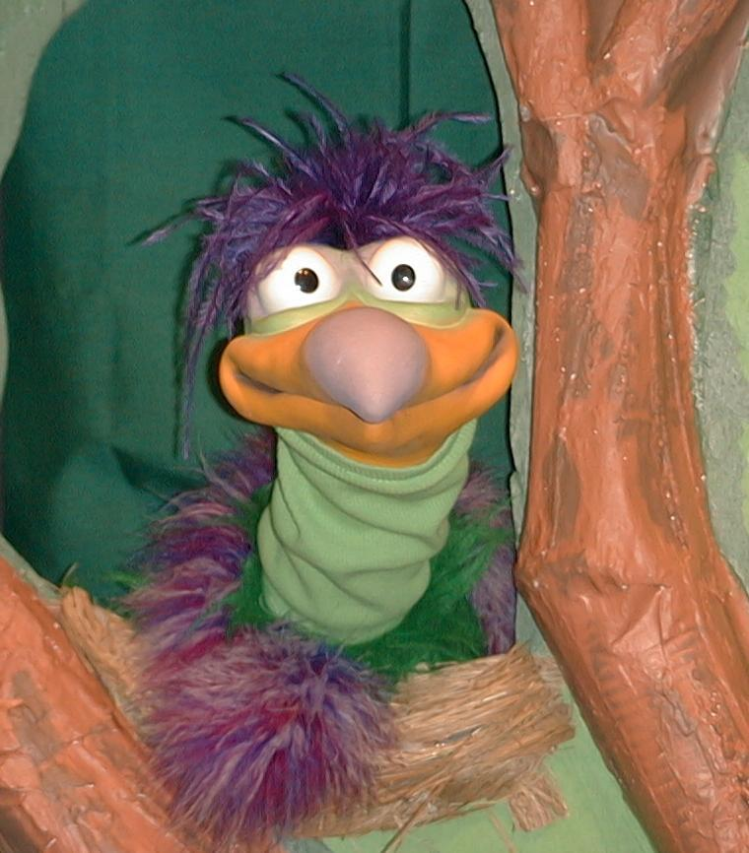
Presenter shows Xiao Er a craft made in Activity 1. Then the kids attempt to teach Xiao Er the take home point.

Presenter says to kids: “God Gives The Best Gifts…”
Kids say: “…Surprise! Surprise! Surprise!”
Presenter says to Xiao Er: “God Gives The Best Gifts…”
Xiao Er says: “…like crayons, crayons, crayons!”

Presenter shows an example of the next activity done in small group and repeats first phrase to kids. The kids say the correct response trying to teach Xiao Er the take home point. Continue in this manner with Presenter showing example of each activity. Here are Xiao Er’s responses:

Xiao Er’s response to Activity 2 sample: “…like cheese... (pretend to drool)”
Xiao Er’s response to Activity 3 sample: “…but don’t kiss tigers.”

Presenter says: “Xiao Er, listen one last time.
God Gives The Best Gifts…”
Kids response: “…Surprise! Surprise! Surprise!”
Presenter says to Xiao Er: “God Gives The Best Gifts…”
Xiao Er’s response: (Warms up his singing voice with “Mee, mee, mee, mee, mee…” and sings in a silly dramatic opera-like voice) “God Gives The Best Gifts – Surprise! Surprise! Surprise!”

Welcome guests and thank them for attending.

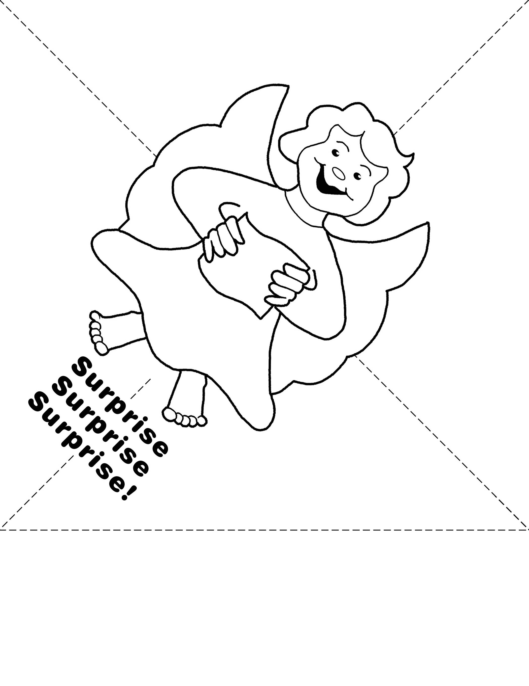

LESSON 29

Large Group Warm-up
- Xiao Hung puppet
- Christmas wreath
- matches
- Bible
- large gift wrapped box with lid wrapped separately
- scroll
- something to demonstrate old age, such as a gray wig or beard, a strand of gray hair, a mask of an older person or Zechariah pictures
- incense (in a sensor if possible)
- white robe
- baby blanket

Small Group Application
Activity 1:
- reproducible with bottom portion cut off before class
- crayons
- bow
- removable tape
Activity 2:
- slice cheese which is cut into triangle shape
- a salted biscuit per child
- white patterned snack (This round-pattern snack can be purchased at the pasar malam. It is a common snack food.)
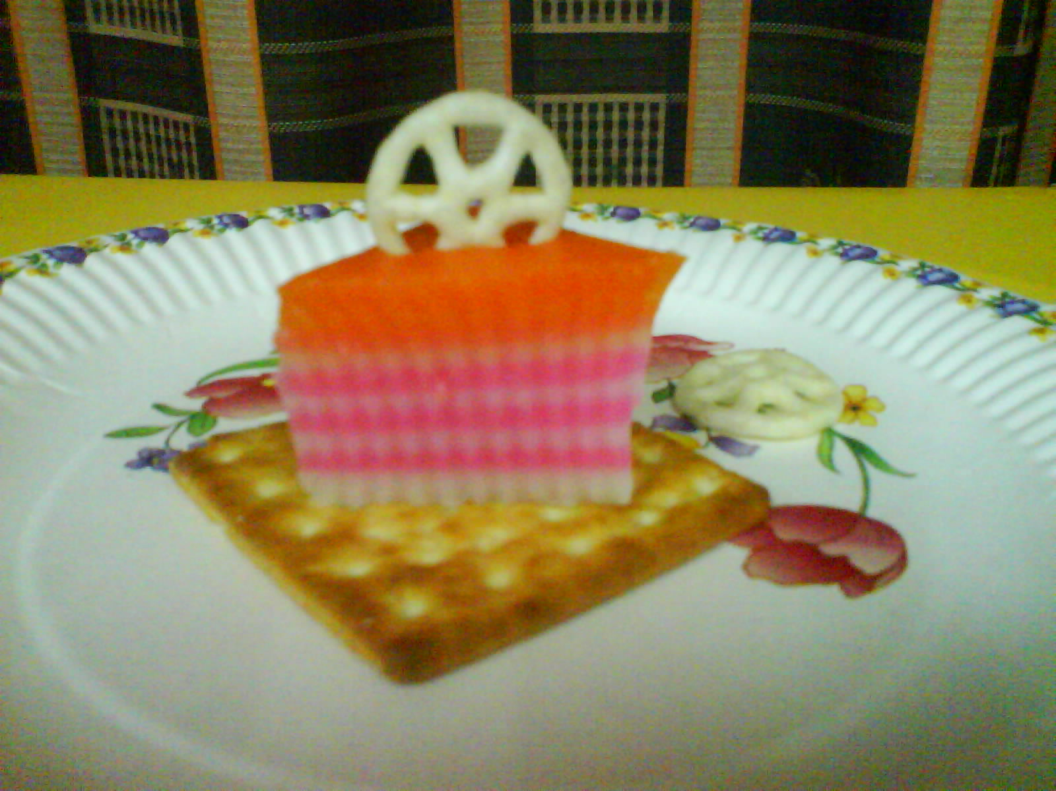
- plates
- serviettes
- cups
- water or juice
HEALTHY SNACK OPTION
- carrots, pretzels, grapes, celery
Activity 3:
- divider or place for one child and shepherd to hide behind
Activity 4:
- 7 gift boxes (smallest to the biggest – one can fit into the other until as one
large box)
- words of the memory verse on pieces of paper (Take a small note pad to write
one word of James 1:17 per piece of paper to fit into box.)
- children songs CD
- player

Large Group Wrap-up
- optional music for the lesson
- Xiao Er puppet

