
Date: ________________________
Series: God Gives The Best Gifts (Dec-Feb)
Year 2, Lesson 31

Shepherds

Spread the

Good News

Take Home Point: *GOD GIVES THE BEST GIFTS—Praise be to God!
*Repeat this phrase throughout the lesson. The leader will say the first part of the phrase (CAPS). The children respond with the second part of the phrase (italics).

Bible Event: Luke 2:8-18
Jesus Link: Because Jesus gave His best, we can praise God.

We will help children know:
- The story of the angels proclaiming Jesus’ birth to the shepherds.
- Just as the angels and shepherds praised God, we, too, can praise God.
- We praise God because He sent Jesus to be our Savior.

We will help the children feel:
- Excited about Jesus’ birth.
- Worshipful of both the Father and the Son.
- Eager to give their praises to the Father and the Son.

We will help the children do:
- Listen to and watch the story of the angels proclaiming Jesus’ birth to the shepherds, using the angels and shepherds from the nativity scene.
- Make and eat a “Sheep in the Fields” snack and retell the Bible event.
- Play a “Shepherd’s Staff Relay” and learn that the good news is that Jesus is born.

THIS LESSON’S ROADMAP

DESTINATION | PAGE # | DISCOVERIES ON YOUR JOURNEY | SUPPLIES NEEDED
Large Group Opening   | 3  3-5 | Puppet Presentation  Bible Event | - Ting Ting puppet  - Bible  - gift wrapped mystery box  - Nativity pieces from last week  - shepherds, sheep and angels from nativity  - Christmas tree
Small Group Application   | 6  6  6-7  7  7 | Activity 1: “Praise God Banner” Craft  Activity 2: “Sheep in the Fields “ Snack  Activity 3: ”Shepherd’s Staff Relay” Game  Activity 4: “Trace and Read”  Prayer Time | Activity 1:  - reproducible  - crayons  - scissors  - stapler  - glue  - 22-inch length of 1-inch wide ribbon  - Optional: jingle bells with a large hole at the top and a length of yarn.  Activity 2:  - cream cracker per child  - green frosting  - ½ a bun for each child  - plastic knives  - serviettes  - water or juice  - paper cups  HEALTHY SNACK OPTION:  - grapes  - carrots and pretzels  - serviettes  Activity 3:  - kitchen towel tube for each team  - masking tape  Activity 4:  - reproducible from page 11  - banner from activity 1  - colour pencils  - scissors
Large Group Wrap-up   | 7  8 | Singing (Optional)  Lesson Review with Puppet Skit | - optional music for the lesson  - Xiao Er puppet

Pre-Session Singing: (10 minutes)
Purpose: When all children are in one group singing, it is easy for new children to join the group and immediately get involved. When the music can be correlated, it introduces the theme for the day. Choose two to three songs and list them here.

Large Group Opening: (15 minutes)
Purpose: The puppet demonstrates the need that will be met in today’s lesson. The scripts are not written verbatim, but give a story line in which the group leader can interact with the puppet. The children are introduced to the take home point and then interact with God’s Word as they experience the Bible event.

Supplies needed: Ting Ting puppet; Bible; gift wrapped mystery box; Nativity pieces from last week; shepherds, sheep and angels from nativity, Christmas tree

Puppet Presentation:
Ting Ting comes on stage very excited. She has some good news. Her aunt and uncle have come to visit for Christmas and they brought their baby—Ting Ting’s new cousin. It makes Ting Ting giggle to see her dad hold the baby. He talks funny and makes silly faces at the baby. Ting Ting wants to share her good news about her baby cousin with everyone.

The presenter relates Ting Ting’s experience to today’s Bible event. He explains some shepherds are out in a field watching some sheep when an angel appears and tells them that Jesus has been born. Then the sky is filled with angels who praise God. The shepherds go to see Baby Jesus and are so excited they too praise God and cannot wait to share their good news with everyone, just as Ting Ting wants to share her good news.

Now Ting Ting has two pieces of good news to share—she has a new baby cousin and Baby Jesus was born. We praise God for Baby Jesus because He was born to be our Savior and take away our sins.

The presenter teaches Ting Ting the take home point. *GOD GIVES THE BEST GIFTS—Praise be to God! The presenter says the first part; Ting Ting responds with the second part. After practicing it with Ting Ting several times, the presenter teaches it to the children.

Bible Event: Mystery Box
The Mystery Box contains objects that will help the presenter tell the Bible event in creative fashion. These objects can be lifted out and shown as the story is told. For this series of lessons, the mystery box will be a gift wrapped box with a removable lid.

Note: Before class, set up the nativity as it was set up last week.
Put the gift wrapped mystery box under the tree. (If you do not have a Christmas tree, the gift can be put in a prominent location.)

Bring out the mystery box. Make a big deal of taking the lid off the gift box and peeking inside to see what surprises it holds. Bring out the Bible and say:

Here’s my Bible. I remember that the Bible is God’s Word. It is one of the best gifts we can have because it tells us about the best gift of all—Jesus! Last week we learned from the Bible that (point to the nativity scene on the altar) Baby Jesus was born. Jesus was born to be the Savior of the world. He came to save the people form their sins—including you and me. This week we will learn about some shepherds who learned that Jesus had been born. They were so excited they had to praise God and share the good news with everyone. It tells about it right here in the Bible.

Let’s peek inside the gift box to see what other surprises it holds for us.

Peek inside the gift box and take out the sheep and shepherds, put them near the stable and say:

Some shepherds were out in the field watching their sheep. In those days shepherds were just boys, maybe 12 or 13 years old. It was dark and cool outside. But something was about to happen that would light up the sky and made their hearts feel warm inside.

Peek inside the gift box and bring out one angel.

Suddenly the shepherds saw an angel and God’s glory brightened the night. Angels are big like giants and the shepherds had never seen God’s glory, so they were afraid.

But the angels spoke and told the shepherds, “Do not be afraid! I bring you good news. It will bring joy to everyone. Today in Bethlehem a baby has been born. That baby is the Savior, Jesus. He is Christ, the Lord. You will see a sign. You will see the baby wrapped in blankets and lying in a manger.”

Bring out the other angels.

Suddenly a huge crowd of angels appeared. They were praising God and saying: “Glory to God in the highest! And on earth, peace to all people!”

After the angels went back to heaven, the shepherds hurried into Bethlehem to see the newborn baby. (Move the shepherds into the stable.) After they saw Mary, Joseph, and Baby Jesus, they hurried off to praise God and tell everyone the good news that Jesus was born.
The shepherds were filled with joy because they saw the Savior, Jesus. We, too, are filled with joy because Jesus our Savior is born. He was born to save us from our sins, to make us children of God and to fill our hearts with praise for God.

Practice the take home point. You say the first part; the children respond with the second part. *GOD GIVES THE BEST GIFTS—Praise be to God!

End with the following prayer:

Dear God,
Thank You for the best gifts.
Thank You for sending Jesus.
He’s our Savior.
Praise be to God!
Thank You! Thank You! Thank You!
Amen.

Small Group Application: (30 minutes)
Purpose: Smaller groups enable children to develop closer relationships with adults and peers in the church. As you reinforce the take home point with a fun hands-on activity, discuss the Bible event. Be sure to repeat the take home point several times. Say the first part and have the children respond with the second phrase. Application questions help kids apply the take home point to their daily lives. Close this session by gathering your small group for prayer. Let the kids pray!

During small group application time, discuss the following questions and points:

What news did the angel give the shepherds? (That the Savior had been born and He was a baby in a manger.)

After the angel told the shepherds the good news that Jesus was born, what did the angels do? (They praised God.)

After the shepherds saw Baby Jesus, what did they do? (They told everyone the good news and praised God.)

How can we praise God? (Answers will vary but may include singing, praying, and telling others about Jesus.)

Why do we praise God? (Because He gave us the best gift—Jesus. Jesus came to be our Savior, to forgive our sins, and to fill our hearts with praise for God.)

Activity 1: “Praise God Banner” Craft
Supplies needed: reproducible; crayons; scissors; stapler; glue; 22-inch length of 1-inch wide ribbon; Optional: jingle bells with a large hole at the top and a length of yarn.

To make:
- Color the pictures on the reproducible.
- In the third panel, draw a picture of yourself.
- Cut apart the three panels.
- Glue the panels vertically onto the ribbon, with the angel at the top, the shepherd in the middle, and the drawing at the bottom. Leave several inches of ribbon at the top.
- Glue or staple the length of ribbon at the top of the hanging into a loop.
- Optional: String the bell onto the yarn, tie the yarn into a circle and attach to the bottom of the hanging.

To discuss:
The angels were praising God when they said, “Glory to God in the highest.” The shepherds praised God when they told everyone about Jesus. How can we praise God? Why should we praise God?

Practice the take home point. You say the first part; the children respond with the second part. *GOD GIVES THE BEST GIFTS—Praise be to God!

Activity 2: “Sheep in the Fields” Snack
Supplies needed: cream cracker per child; green frosting; ½ a bun for each child; plastic knives; serviettes; water or juice; paper cups
HEALTHY SNACK OPTION: grapes; carrots and pretzels; serviettes

To make:
- Spread green frosting on cream cracker to make a field.
- Tear several piece of bread from bun to look like sheep.
- Put the “sheep” on the field.
- Eat!

HEALTHY SNACK OPTION: Use grapes as the animals in the fields (use napkins). Use carrots with pretzels as shepherds and their staffs.

To discuss:
As the children make and eat their snack, review the Bible event. Point out that the shepherds were so excited about the angels’ message, they immediately left the fields to find the Baby Jesus. How can we show that we are excited that Jesus is born?

Practice the take home point. You say the first part; the children respond with the second part. *GOD GIVES THE BEST GIFTS—Praise be to God!

Activity 3: “Shepherd’s Staff Relay” Game
Supplies needed: cardboard core from the reel of cloth for each team; masking tape
To set up:
- Make two parallel lines of masking tape on the floor, as far from each other as possible. The lines should be about 12 feet long.
- Divide each team in half.
- Have one half of each team line up behind one line of masking tape (starting line) and the other half of each team line up behind the second line (finish line) of masking tape.
- Give the first child of each team at the starting line a cardboard tube (shepherd’s cane).

To play:
- On the word “go” the child holding the cane runs to the end of the line and shouts “Good News!”
- The first child in the line at the finish line grabs onto the shepherd’s cane.
- Both children holding the cane run back to the starting line and shout “Good News!”
- At the starting line, a third child grabs the cane and the group continues to run.
- Play continues in this manner until all the children on the team are holding the shepherd’s cane.
- The entire team continues running until they cross the finish line.
- The first team to cross the finish line with all the team members on the cane and to shout “Good News!” wins.

To discuss:
What is the good news? The good news is that Jesus was born. Why is this good news? Because Jesus was born to be our Savior, forgive our sins, and fill us with His goodness and praise for God.

Practice the take home point. You say the first part; the children respond with the second part. *GOD GIVES THE BEST GIFTS—Praise be to God!

Activity 4: “Trace and Read”
Purpose: Help kids to memorize and keep scriptures at heart. Using creative ways to help kids enjoy learning the key verse and in small group setting.

Supplies needed: reproducible from page 11; banner from activity 1; colour pencils; scissors

Memory Verse: James 1:17 ~ “… every perfect gift is from God.”

Memory Verse Learning:
Cut out the reproducible. Have the children recite James 1:17 for a few times. Give each child one cut-out and ask them to trace and read the words. Paste this cut-out on
to the ribbon of the banner from activity 1.

Prayer Time:
Praise God for sending Jesus to be your Savior. How many praise words can you use? (Ideas: praise, glory, Alleluia, wonderful, great, etc.)
Large Group Wrap-Up: (10 minutes)
Purpose: The crazy bird puppet, Xiao Er, struggles with learning the take home point. The leader shows an example of each small group application activity from this lesson and says the first phrase of the take home point. The kids respond with their phrase. They try to teach the puppet the take home point, but each time he confuses words or concepts. After three attempts, he finally gets it right and sings the correct take home point in a silly opera-like voice.

Supplies needed: optional music for the lesson; Xiao Er puppet

Singing: (Optional)

Lesson Review with Puppet Skit:
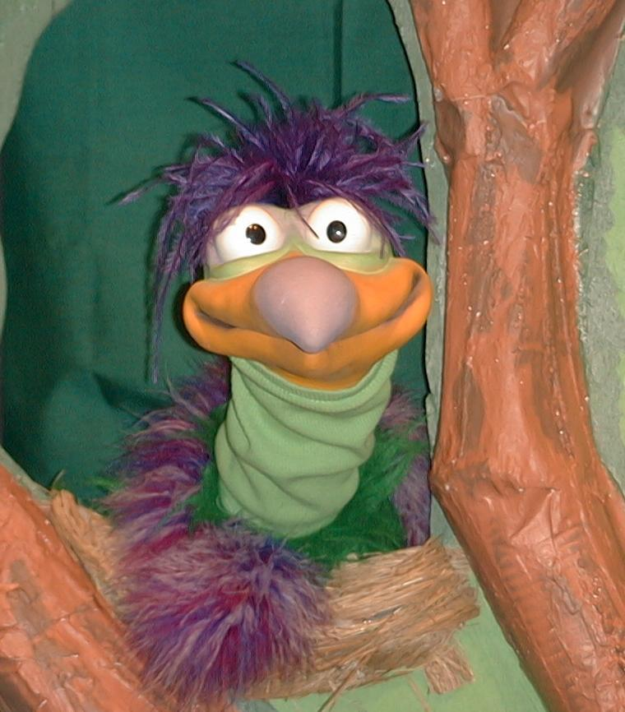
Presenter shows Xiao Er craft made in Activity 1. Then the kids attempt to teach Xiao Er the take home point.

Presenter says to kids: “God Gives The Best Gifts…”
Kids say: “…Praise be to God!”
Presenter says to Xiao Er: “God Gives The Best Gifts…”
Xiao Er says: “…Jingle bells, your feet smell.”

Presenter shows an example of the next activity done in small group and repeats first phrase to kids. The kids say the correct response trying to teach Xiao Er the take home point. Continue in this manner with Presenter showing example of each activity. Here are Xiao Er’s responses:

Xiao Er’s response to Activity 2 sample: “…don’t feed your dog marshmallows.”
Xiao Er’s response to Activity 3 sample: “…don’t invite a hippo to a tea party.”

Presenter says: “Xiao Er, listen one last time.
God Gives The Best Gifts…”
Kids response: “…Praise be to God!”
Presenter says to Xiao Er: “God Gives The Best Gifts…”
Xiao Er’s response: (Warms up his singing voice with “Mee, mee, mee, mee, mee…” and sings in a silly dramatic opera-like voice) “God Gives The Best Gifts – Praise be to God!”

Welcome guests and thank them for attending.

LESSON 31

Large Group Warm-up
- Ting Ting puppet
- Christmas wreath
- Bible
- giftwrapped mystery box
- Nativity pieces from last week
- shepherds, sheep and angels from nativity
- Christmas tree

Small Group Application
Activity 1:
- reproducible
- crayons
- scissors
- stapler
- glue
- 22-inch length of 1-inch wide ribbon
- Optional: jingle bells with a large hole at the top and a length of yarn.
Activity 2:
- cream cracker per child
- green frosting
- ½ a bun for each child
- plastic knives
- serviettes
- water or juice
- paper cups
HEALTHY SNACK OPTION:
- grapes
- carrots and pretzels
- serviettes
Activity 3:
  - kitchen towel tube each team
  - masking tape
Activity 4:
- reproducible from page 11
  - banner froam activity 1
  - colour pencils
  - scissors

Large Group Wrap-up
- optional music for the lesson
- Xiao Er puppet

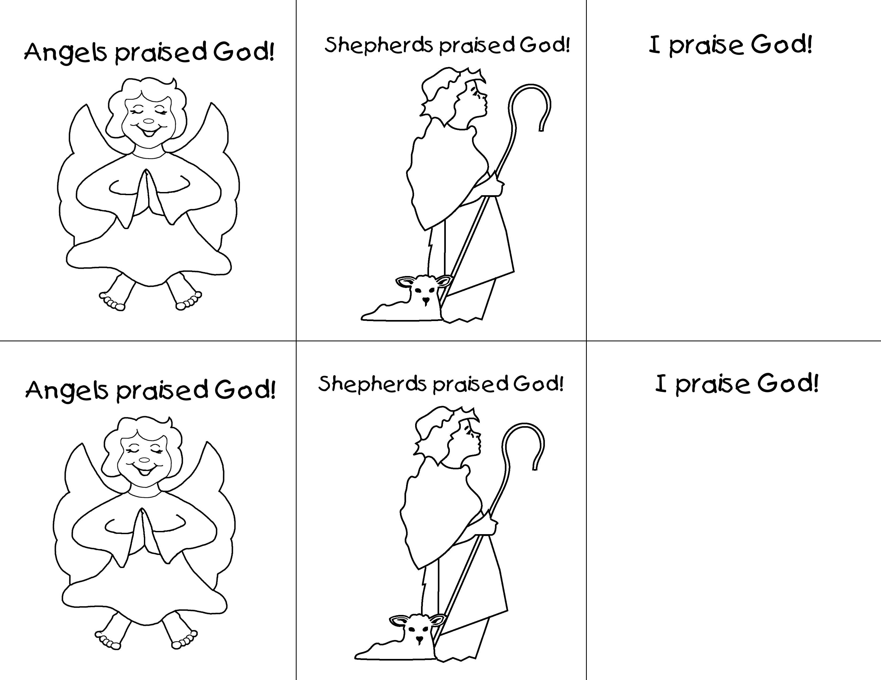
James 1:17  ...Every perfect gift is from God. | James 1:17  ...Every perfect gift is from God. | James 1:17  ...Every perfect gift is from God.
James 1:17  ...Every perfect gift is from God. | James 1:17  ...Every perfect gift is from God. | James 1:17  ...Every perfect gift is from God.

