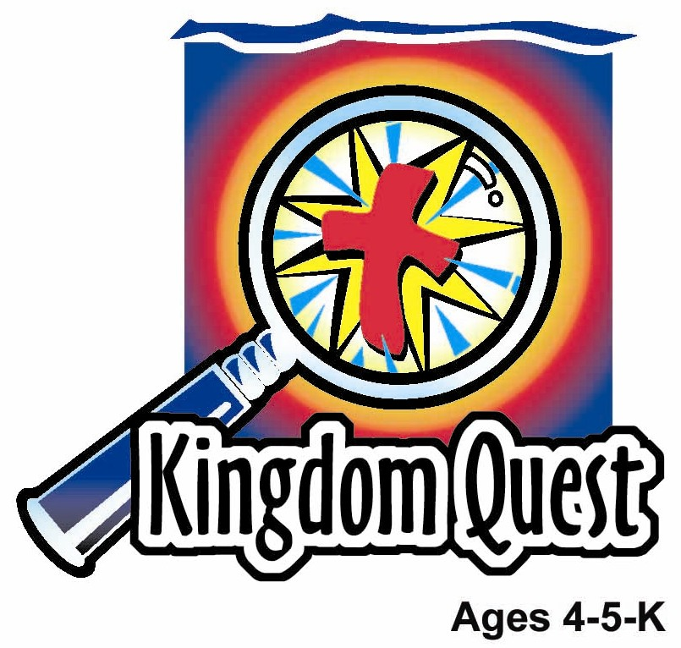
Date: ________________________
Series: God Keeps His Promises (Sept-Nov)

Year 2, Lesson 18

The Fall of Man

Take Home Point: *GOD KEEPS HIS PROMISES – I trust His forgiveness!
*Repeat this phrase throughout the lesson. The leader will say the first part of the phrase (CAPS). The children respond with the second part of the phrase (italics).

Bible Event: Genesis 3
Jesus Link: All have sinned. Forgiveness comes through Jesus.

We will help children know:
- The Bible event of Adam and Eve falling into sin.
- All people have sinned—including them.
- Through Jesus, they can be forgiven.

We will help the children feel:
- Sorrow for their sins.
- Trust in Jesus’ forgiveness.
- Joy that they have been forgiven.

We will help the children do:
- Listen to a character dressed as Adam tell the Bible event of man’s fall into sin.
- Dip turnip slices into a sweet dip and eat them as a reminder that God’s forgiveness is sweet.
- Play a game, “Fruit Basket Upset” and use it as a launch to review the Bible event.

THIS LESSON’S ROADMAP

DESTINATION | PAGE # | DISCOVERIES ON YOUR JOURNEY | SUPPLIES NEEDED
Large Group Opening   | 3-4  4-6 | Puppet Presentation  Bible Event | - Xiao Hung  - cookie with a bite taken out of it  - vest or other clothes that look like a sheepskin  - step stool  - female voice offstage
Small Group Application   | 7  7  7-8  8  9 | Activity 1: “Tree of Life” Craft  Activity 2: “Apple Slices and Sweet Dip” Snack  Activity 3: ”Fruit Basket Upset” Game  Activity 4: “Road of Words”  Prayer Time | Activity 1:  - reproducible  - green and brown crayons  - poster colour paint (red yellow, green, orange)  - two ice cream sticks for each child (one broken in half)  - glue  Activity 2:  - cups  - honey  - turnip  - cups  - water or juice  Activity 3:  - one chair for each child, minus one  - plastic fruit (optional)  Activity 4:  - six 4”X8” black mounting board and six 4”X8” white mounting board  - card board arrow  - Tricycle or pedal-car
Large Group Wrap-up   | 9  9 | Singing (Optional)  Lesson Review with Puppet Skit | - optional music for the lesson  - Xiao Er puppet  - sample materials from small group activities

Pre-Session Singing: (10 minutes)
Purpose: When all children are in one group singing, it is easy for new children to join the group and immediately get involved. When the music can be correlated, it introduces the theme for the day. Choose two to three songs and list them here.

Large Group Opening: (15 minutes)
Purpose: The puppet demonstrates the need that will be met in today’s lesson. The scripts are not written verbatim, but give a story line in which the group leader can interact with the puppet. The children are introduced to the take home point and then interact with God’s Word, as they experience the Bible event.

Supplies needed: Xiao Hung; cookie with a bite taken out of it; vest or other clothes that look like a sheepskin; step stool; female voice offstage

Puppet Presentation:
Xiao Hung comes out with a cookie that has obviously been bitten into. He is smacking his lips and saying, “Mmmmm…”

A woman’s voice from offstage calls, “Xiao Hung!” Xiao Hung panics and tries to give the cookie to the presenter. The presenter asks what he is doing. Xiao Hung is obviously worried. He says he wasn’t supposed to eat the cookie. His mom told him not to; it’s Ting Ting’s fault. She told him to take a cookie. The presenter says, “Xiaaaaoooo Huuuuunng” and gives him “the look” that says he doesn’t believe for one moment that Ting Ting made him eat it.

Xiao Hung’s mom calls out again, “Xiao Hung!” Xiao Hung tries wiping his face on his sleeve to clean it. He then blames his mom. She made the cookies too good. The presenter again says, “Xiaaaaoooo Huuuuunng,” and gives him “the look.”

Xiao Hung’s mom calls out again, “Xiao Hung!” Xiao Hung looks around wildly for a place to hide. He then tries to blame the dog. If the dog hadn’t been staring at the cookies, he would have forgotten about them. The presenter again says, “Xiaaaaoooo Huuuuunng,” and gives him “the look.”

Xiao Hung says, “Okay. I admit. I wasn’t supposed to eat the cookie. It wasn’t anybody’s fault but mine.”

The presenter tells Xiao Hung that it reminds him of today’s Bible event. God put Adam and Eve in a beautiful garden and told them to eat any fruit but the fruit from the tree in the center of the garden. Adam and Eve disobeyed and ate that fruit. Then they played the hide and blame game. First, they tried to hide. Then Adam blamed Eve, and Eve blamed the snake. Adam even tried to blame God, but God knew it was their fault. What they needed to do was tell God what they did wrong and tell Him they were sorry.

That is what Xiao Hung needs to do. He needs to take responsibility by telling his mom what he did wrong and tell her he’s sorry. He shouldn’t hide and blame.

The presenter teaches Xiao Hung today’s take home point. *GOD KEEPS HIS PROMISES – I trust His forgiveness. The presenter says the first half. Xiao Hung responds with the second half. After practicing it several times, the presenter practices it with the children.

Xiao Hung’s mom calls out again, “Xiao Hung!” The presenter asks Xiao Hung, “Xiao Hung, your mom is calling again. What do you think you should do?” Xiao Hung replies that he should tell his mom and God what he did and say he’s sorry. The presenter agrees. Xiao Hung exits.

Bible Event: A Visit from a Dramatized Character
A costumed adult presents the Bible event by telling it from a first person point of view. Explain to the children that they will meet an actor, someone pretending to be a person in today’s Bible event. Ask the children to put on their imagination hats so they can imagine that this really is the person in the Bible event.

A male dressed in sheepskin to look like Adam after he left the garden comes onstage, sits on the step stool, and begins: (Be sure to use a highly dramatic voice and a variety of hand gestures and other movements in this Bible event to keep it interesting.)

Boys and girls, put on your imagination hats. I want you to pretend that I really am Adam from the Bible event and I am telling you about the first time I sinned. Let’s begin.

Did you know I used to live in a garden? My, it was a beautiful place! It had flowers of every color and shape, birds that could soar through the trees and birds that liked to stay close to the ground. It had dogs and cats, horses and cows, zebras and elephants, lions, tigers, bears and even dinosaurs! It had the tall pine tree, the sweet smelling apple tree, and the giant sequoia tree. It had butterflies and ladybugs, a blue sky and green grass, and dark rich dirt and fine white sand. And it was located where three great rivers come together. Yes, it was a wonderful place! My wife, Eve, and I lived there and it was perfect!

(Looks sad.) Then something very bad happened. God told Eve and me that we could eat any fruit in the garden. We could eat the juicy grapes, tangy pineapples, and the nutty cashews. We could eat any fruit—except for one. God told us not to eat the fruit on the tree in the center of the garden. (Sighs.) I wish I had listened!

One day a serpent came up to Eve. A serpent is a snake. This serpent wasn’t just any serpent. It was Satan, the devil, disguised as a snake. He was very sneaky. “Did God really say that you must not eat from any tree in the garden?” He knew the answer, but he was trying to trick Eve.

“No,” said Eve. “He didn’t say that. We may eat fruit from any tree, except the one in the middle of the garden. We must not even touch that or we will die.”

“You will surely not die,” the sneaky snake told Eve. “God doesn’t want you to eat it because He knows your eyes will be opened and you will know the difference between good and evil, just like Him.”

Eve saw that the fruit was beautiful, pleasing to the eye, and would help her become wise. So, she took a piece of fruit and ate it. Then she gave it to me and I ate it.

Our eyes were opened. We knew we had done something terrible. We felt horrible! And we felt ashamed for we were not wearing any clothes. So, we sewed some fig leaves together to make some clothes.

Later we heard God walking in the garden. When He saw us, He would surely know what we had done. So we hid.

“Adammm! Eeeeve! Where are you?” God called out to us.

“I heard you walking in the garden and I was ashamed” I said.

“Did you eat from the tree I told you not to eat from?” God asked.

“You gave me that woman and she gave it to me,” I said. “And I ate it.”

“Eve, what have you done?” God asked.

“The serpent tricked me and I ate it,” Eve replied.

So, just what God said would happen, did. As humans, we would now die and we could no longer live in the garden. Then God put a curse on the serpent. It would wiggle on its belly and be hated. Someday the son of a woman would crush the snake.

God cursed Eve so her children would cause her pain and her husband would rule her. God cursed me, too, by telling me that I would now have to work hard for a living. He kicked Eve and me out of the garden, and told us that someday we would die.

God’s curses sometimes seem almost unbearable. I must work hard to dig holes to plant food. I must work hard to pick the food. And I must work hard to keep the weeds away from the food. My hands get soar, my back hurts, and I get very tired.

But God still loves me. And He hasn’t forgotten me. When we left the garden, He killed some animals and gave us some skins to wear. He promises that someday He will send a Savior so I can go to heaven.

(Take off costume.) Boys and girls, because of the mistake Adam and Eve made, everyone, except Jesus, has always been and will always be a sinner—including you and me. But all hope is not gone. Someday we will die and be taken to heaven, where we will live forever in happiness. Why? Because God keeps His promises. He sent Jesus to die for us so through Jesus we can be forgiven.

Practice the take home point with the children. *GOD KEEPS HIS PROMISES – I can trust His forgiveness.

End with the following prayer. Have the children repeat each phrase.

Dear God, (repeat)
I know that I have sinned. (repeat)
Thank You for sending Jesus. (repeat)
I trust that He forgives me. (repeat)
Now I can be with You. (repeat)
Thank You! Thank You! Thank You! (repeat)
Amen (repeat)

Small Group Application: (30 minutes)
Purpose: Smaller groups enable children to develop closer relationships with adults and peers in the church. As you reinforce the take home point with a fun hands-on activity, discuss the Bible event. Be sure to repeat the take home point several times. Say the first part and have the children respond with the second phrase. Application questions help kids apply the take home point to their daily lives. Close this session by gathering your small group for prayer. Let the kids pray!

During the small group application time, discuss the following questions and points:

What did God tell Adam and Eve not to do? (Eat from the tree in the middle of the garden.)

The serpent, Satan, convinced Adam and Eve to disobey God. What was their punishment? (They had to leave the garden, work hard, suffer pain, and die.)
How did God still show Adam and Eve His love? (He gave them clothes and promised them a Savior.)

Now everyone sins. What sins do children sometimes do? (Answers will vary but may include not sharing, disobeying parents, hurting someone.)

How does God show us that He loves us, even though we sin? (He takes care of us, and He sent Jesus to die for us so we can be forgiven.)

Activity 1: “Tree of Life” Craft
Supplies needed: reproducible; green and brown crayons; poster colour paints (i.e. red yellow, green, orange); two ice cream sticks for each child (one broken in half)
glue

To make:
- Fingerprint fruit onto the picture of the tree.
- Color the trees.
- Glue the ice cream over the trees to make a cross shape. Be sure the crossbeam sticks out from the trunk of the tree to look like an additional branch.

To discuss:
- In the Garden of Eden was a tree of life. God sent Adam and Eve out of the garden after they sinned so they would not eat from the tree of life and live forever.
- Later, there was another tree of life—the cross. When Jesus died on the cross, we were given forgiveness so someday we can live with Jesus forever in heaven.

Practice the take home point. *GOD KEEPS HIS PROMISES – I trust His forgiveness.

Activity 2: “Turnip Slices and Sweet Dip” Snack
Supplies needed: cups; honey; turnip; cups ; water or juice

Put some honey in a cup for each child and let them dip turnip into it before eating. As they eat review the Bible event and remind the children how sweet God’s forgiveness is.

Practice the take home point. *GOD KEEPS HIS PROMISES – I trust His forgiveness.

Activity 3: “Fruit Basket Upset” Game
Supplies needed: one chair for each child, minus one; plastic fruit (optional)

To play:
- Have the children sit on chairs in a circle. Make sure the circle is fairly large.
- Have one child stand in the middle.
- Assign a fruit to each child. Optional: If you have plastic fruit you might want to give them a fruit to remember what they are. Make sure that every fruit has at least two children. If your group is small, you might want to combine with another group for this game.
- Name a fruit. The children with that fruit stand up and run through the circle to an empty chair. The child in the middle also tries to get a chair.
- Keep naming different fruits and having the children run.
- Occasionally call, “Fruit basket upset!” All the children must get a new chair.
- Play as long as interest lasts.

To Discuss:
While processing the game, review the Bible event and remind the children that Adam and Eve could eat any fruit but one. When they ate the forbidden fruit, things were a big mess, just like when the leader said, “Fruit basket upset.”

Practice the take home point. *GOD KEEPS HIS PROMISES – I trust His forgiveness.

Activity 4: “Road of Words”
Purpose: Help kids to memorize and keep scriptures at heart. Using creative ways to help kids enjoy learning the key verse and in small group setting.

Supplies needed: six 4”X8” black mounting board and six 4”X8” white mounting board, card board arrow, tricycle or pedal-car.

Memory Verse: Mark 1:3 ~ Prepare the way for the Lord. Make the road straight for Him.

Prepare
the
the
way
for
Lord.

Mark 1:3

Make
the
road
straight
for
Him.
Prepare

Memory Verse Learning:
Prior to class, stick masking tape on the back of the flash cards. Gather the children at an opened space. Begin to lay out the first sentence and get the children to recite the memory verse together a few times. Then lay out the second sentence and repeat the same steps. Next bring out the red arrow and tell the children that this verse is taken from Mark 1:3. Explain to the children that this verse talks about preparing our hearts for the Lord to believe in His promise. After you have stuck the arrow to the car, allow the children to push the car along the road of words as they recite the verse.

Prayer Time:
Confess your sins and ask God to forgive them.
Large Group Wrap-Up: (10 minutes)
Purpose: The crazy bird puppet, Xiao Er, struggles with learning the take home point. The leader shows an example of each small group application activity from this lesson and says the first phrase of the take home point. The kids respond with their phrase. They try to teach the puppet the take home point, but each time he confuses words or concepts. After three attempts, he finally gets it right and sings the correct take home point in a silly opera-like voice.

Supplies needed: optional music for the lesson; Xiao Er puppet; sample materials from small group activities

Singing: (Optional)

Lesson Review with Puppet Skit:
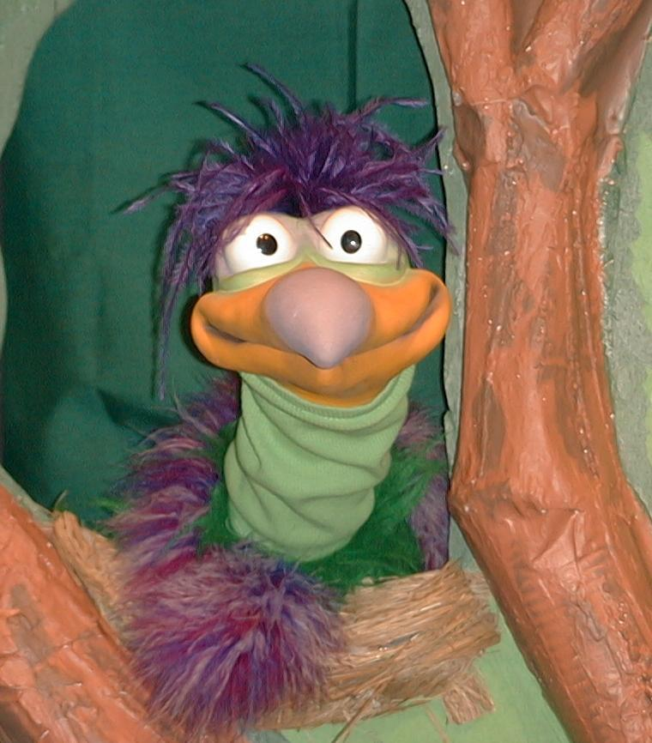
Presenter shows Xiao Er a craft made in Activity 1. Then the kids attempt to teach Xiao Er the take home point.

Presenter says to kids: “God keeps His promises…”
Kids say: “…I trust His forgiveness.”
Presenter says to Xiao Er: “God keeps His promises…”
Xiao Er says: “Don’t put jelly in your sister’s shoes.”

Presenter shows an example of the next activity done in small group and repeats first phrase to kids. The kids say the correct response trying to teach Xiao Er the take home point. Continue in this manner with Presenter showing example of each activity. Here are Xiao Er’s responses:

Xiao Er’s response to Activity 2 sample: “The best thing about apples is that they have worms in them.”
Xiao Er’s response to Activity 3 sample: “Plastic fruit never gets rotten.”
Xiao Er’s response to Activity 4 sample: “Red arrows and road are fun.”

Presenter says: “Xiao Er, listen one last time.
God keeps His promises…”
Kids response: “…I trust His forgiveness.”
Presenter says to Xiao Er: “God keeps His promises…”
Xiao Er’s response: (Warms up his singing voice with “Mee, mee, mee, mee, mee…” and sings in a silly dramatic opera-like voice) “GOD KEEPS HIS PROMISES – I TRUST HIS FORGIVENESS.”

Welcome guests and thank them for attending.

Lesson 18

Large Group Warm-up
- Xiao Hung puppet
- cookie with a bite taken out of it
- vest or other clothes that look like a sheepskin
- step stool
- female voice offstage

Small Group Application
Activity 1:
- reproducible
- green and brown crayons
- poster colour paints that are red yellow, green, orange
- two ice cream sticks for each child (one broken in half)
- glue
Activity 2:
- cups
- sweet dip: honey
- turnips
- cups
- water or juice
Activity 3:
- one chair for each child, minus one
- plastic fruit (optional)
Activity 4:
- six 4”X8” black mounting board and six 4”X8” white mounting board. (Write the
words of the memory verse like diagram below.)
- card board arrow (stick it on the tricycle or pedal-car)
- tricycle or pedal-car

Prepare
the
the
way
for
Lord.

Mark 1:3

Make
the
road
straight
for
Him.
Prepare

Large Group Wrap-up
- Xiao Er puppet
- sample materials from small group activities

Tree template


