
Date: ________________________
Series: God Keeps His Promises (Sept-Nov)
Year 2, Lesson 19

The Call of Abram

Take Home Point: *GOD KEEPS HIS PROMISES – I follow God.
*Repeat this phrase throughout the lesson. The leader will say the first part of the phrase (CAPS). The children respond with the second part of the phrase (italics).

Bible Event: Genesis 12:1-9
Jesus Link: We are brought into God’s family through Jesus.

We will help children know:
- God told Abram to follow Him to a new land; Abram believed God’s promise and followed God.
- God brings us into His family through Jesus.
- We, like Abram, believe God and follow Him.

We will help the children feel:
- Trust in God’s promises.
- Connected to God’s family through Jesus.
- Desire to follow God’s ways through their actions.

We will help the children do:
- Participate in an Imagination Theater dramatization of the Bible event.
- Make a kaya trail and follow it with a finger biscuit walking stick as a review of the Bible event. (Then eat it!)
- Play “Follow the Leader” and discuss how we follow God.

THIS LESSON’S ROADMAP

DESTINATION | PAGE # | DISCOVERIES ON YOUR JOURNEY | SUPPLIES NEEDED
Large Group Opening   | 3  3-5 | Puppet Presentation  Bible Event | - Xiao Hung and Ting Ting puppets  - two small lunch boxes  - Imagination Box  - costumes for Abram, Sarai, and Lot  - microphone
Small Group Application   | 6  7  7  8  8 | Activity 1: “Follow God Maze” Craft  Activity 2: “Walking Path and Walking Stick” Snack  Activity 3: ”Follow the Leader” Game  Activity 4: “Glide through the Road”  Prayer Time | Activity 1:  - reproducible  - glue  - dry oatmeal  - shallow pan or lid from a copy paper box  - crayons or markers (optional)  Activity 2:  - aluminum foil  - kaya  - finger biscuits  - cups  - water or juice  HEALTHY SNACK OPTION:  - celery sticks  - raisins  - water  Activity 3:  - no supplies are needed  Activity 4:  - black and white mounting boards (from last week’s lesson)  - skate board
Large Group Wrap-up   | 9  9 | Singing (Optional)  Lesson Review with Puppet Skit | - optional music for the lesson  - Xiao Er puppet  - sample materials from small group activities

Pre-Session Singing: (10 minutes)
Purpose: When all children are in one group singing, it is easy for new children to join the group and immediately get involved. When the music can be correlated, it introduces the theme for the day. Choose two to three songs and list them here.

Large Group Opening: (15 minutes)
Purpose: The puppet demonstrates the need that will be met in today’s lesson. The scripts are not written verbatim, but give a story line in which the group leader can interact with the puppet. The children are introduced to the take home point and then interact with God’s Word as they experience the Bible event.

Supplies needed: Xiao Hung and Ting Ting puppets; two small lunch boxes; Imagination Box: costumes for Abram, Sarai, and Lot; microphone

Puppet Presentation:
Xiao Hung and Ting Ting come in carrying lunch boxes. They are very excited because their mom and dad are taking them on a surprise trip after Sunday school. They don’t know where they’re going. With the presenter they come up with several ideas: to the zoo, on a picnic, to the lake, to a durian orchard or rabbit farm, or maybe to a wet land.

Then the presenter asks Xiao Hung and Ting Ting, “What if you’re not going anywhere fun at all? Maybe your mom and dad are just taking you to a parking lot or to a garbage dump.”

“Oh, no!” They reply. Their parents would never lie to them. They trust their mom and dad. Mom and Dad made a promise they would go somewhere fun and they believe them.

The presenter shares that he is reminded of today’s Bible event. God told Abram to follow him to a new land. He didn’t tell Abram where the new land would be. He didn’t tell Abram what the land would be like. He just said, “Follow me.” And Abram did because He trusted God to keep His promises. We, too, can trust God to keep His promises. We, too, can follow God.

The presenter teaches Xiao Hung and Ting Ting the take home point. *GOD KEEPS HIS PROMISES – I follow God. He says the first part and they respond with the second part. After practicing it with Xiao Hung and Ting Ting several times, the presenter teaches the take home point to the children.

Bible Event: Imagination Theater
Imagination Theater is audience participation drama where the Bible event is told in creative fashion using children as actors. The Imagination Box contains the Bible and other special props used for the drama. Begin by removing the Bible and explain that it is God’s Word, telling us of the wonderful deeds God has done. Then remove an imaginary hat and place it on your head. This is your Imagination Hat. Invite the children to put on theirs as well. They will also use their imaginations to picture the events the Bible tells us about. Some will even use their imaginations to help act out these events. Distribute props to actors as they are called forward at the beginning of the presentation. Have them sit to the side until they are called on stage.

Take the Bible out of the Imagination Box. Show it to the children and tell them that today’s Bible event comes from a book in the Bible called Genesis. Say:

Today’s event is about a man named Abram and a journey or trip that he went on. For our Bible event, I am going to have all of you children help me act it out. You will all have different parts.

Call forward two boys and a girl and dress them as Abram, his wife Sarai, and his nephew Lot. They are at the beginning of a train of people and animals that will be journeying to the Promised Land.

Next, call forward several children to be the servants in Abram’s household. Have them practice saying, “Are we there yet?” The next group of children will be the sheep. Have them practice making sheep noises.

Next, call forward some children to be the goats. Have them practice making goat noises. Have the remainder of the children be camels. Have them practice stomping on the ground and saying “clomp, clomp.”

For this drama you will be leading all the children around the room as you speak into the microphone. If your space is limited, this can also be done with the children standing in one spot. Each time you say, “Sheep,” the sheep should “baaaa.” Every time you say, “goats,” the goats should “maaa.” Every time you say, ”camel,” the camels should stomp and say, “clomp, clomp.” And every time you say, “servants,” Sarai, Lot, and the servants should ask, “Are we there yet?”

Begin:
One day a man named Abram heard the voice of God speak to him. This is what God said: (Speak in low voice with mouth close to microphone) “Abram. Leave your country, your people, and your father’s house and go to the land I will show you. I give you three promises:
- I will make you a great nation.
- I will give you land.
- I will bless you, and all people on earth will be blessed through you.”

So Abram packed up his pots and his pans, his tents and his clothes, his animals and his servants, and he headed on down the road not knowing where God was leading him.

(Begin walking around the room.) Was it a short trip? No! Abram, along with his sheep (sheep should “baaa”), goats (goats should say “maaa”), his camels (camels should stomp and say “clomp, clomp”), and his servants (servants, Sarai, and Lot ask “Are we there yet?”) walked for days and days and days.

They walked up steep hills (walk on tiptoes) and down into valleys (walk crouching low). They walked along riverbeds (make wave motion with hand) and in the hot, hot desert (swipe forehead with back of hand). Until the sheep (“baaa”) and the goats (“maaa”) and the camels (“clomp, clomp”) were all tired and the servants asked, “Are we there yet?” And Abram looked at God and asked, (have child playing Abram ask question into microphone) “Are we there yet?”

“No!” God answered. “Keep walking.”

So they walked and walked and walked. They walked a week. A week is seven days. Let’s count to seven. One, two, three, four, five, six, seven. They walked a month. They walked ten months. Let’s count to ten. (Count to ten.)

When the sheep (“baaa”) and the goats (“maaa”) and the camels (“clomp, clomp”) were almost too tired to walk, the servants again asked, “Are we there yet?”

God answered, “Yes. Abram, this is the land I will give you and your children and your children’s children.” And then God told Abram to pitch his tents in the hills near Bethel. Even though Abram did not yet get his land, he believed God’s promises and he continued to follow God.

When God called Abram to follow Him, God was making Abram a part of God’s family. We, too, are a part of God’s family. We are a part of God’s family because Jesus died on the cross to bring us into God’s family. Because we are a part of God’s family, we, too, can follow God. We follow God when we believe in Jesus, follow God’s rules, and point others to Jesus.

Practice the take home point with the children. *GOD KEEPS HIS PROMISES – I follow God.

End with the following prayer. Have the children repeat each phrase.

Dear God, (repeat)
Thank You for sending Jesus. (repeat)
Help me to follow You. (repeat)
Help me to act like Jesus. (repeat)
Thank You! Thank You! Thank You! (repeat)
Amen (repeat)
Small Group Application: (30 minutes)
Purpose: Smaller groups enable children to develop closer relationships with adults and peers in the church. As you reinforce the take home point with a fun hands-on activity, discuss the Bible event. Be sure to repeat the take home point several times. Say the first part and have the children respond with the second phrase. Application questions help kids apply the take home point to their daily lives. Close this session by gathering your small group for prayer. Let the kids pray!

During the small group application time, discuss the following questions and points:

What did God tell Abram to do? (Pack up all his stuff and follow God to a new land.)

Did Abram obey God? Why? (Yes. Because he believed God would keep His promise.)

How did God make us a part of His family and ask us to follow Him? (By Jesus’ death on the cross.)

How can we follow God? (Answers will vary but may include believing in Jesus, obeying God’s rules, sharing Jesus with others.)

Activity 1: “Follow God Maze” Craft
Supplies needed: reproducible; glue sticks; dry oatmeal; shallow pan or lid from a copy; paper box; crayons or markers (optional)

To make:
- Use the coloring page for this lesson. Copy on manila card.
- Using a glue stick, fill in the path with glue.
- Put the picture in the pan or lid and sprinkle oatmeal on the glue to look like a sandy path.
- Shake off the excess oatmeal in the pan or lid.
- Optional: If time allows, color the rest of the picture.

To discuss:
- Review the Bible event.
- Why do we want to follow God?
- How can we follow God?

Practice the take home point. *GOD KEEPS HIS PROMISES – I follow God.

Activity 2: “Walking Path and Walking Stick” Snack
Supplies needed: aluminum foil; kaya; finger biscuits; cups; water or juice

To do:
- Lay out a sheet of aluminum foil in front of each child.
- On the aluminum foil, spread a winding path of kaya.
- Give each child a finger biscuit for a walking stick.
- Let the children trace the path with their walking sticks.
- After tracing a portion of the path, the children can take a bite out of the walking stick before continuing the journey.

HEALTHY SNACK OPTION: Use celery sticks and raisins. Lay the celery out end-to-end and pretend the raisins are the people. Walk the raisins down the celery stick as the path.

To discuss:
- Tell about a trip you have taken.
- Review the journey Abram took.
- How can we follow God in our lives?

Practice the take home point. *GOD KEEPS HIS PROMISES – I follow God.

Activity 3: “Follow the Leader” Game
No supplies needed.

Play “Follow the Leader” but instead of leading the children around the room, lead them in a variety of actions. Use the following list for ideas:
- Jump up and down
- Hop on one leg
- Twirl in a circle
- Do jumping jacks
- Run in place
- Pat your head and rub your stomach
- Do sit ups
- Clap your hands in different locations (i.e. in front of the chest, to the side, above the head, etc.)
- March in place
- Sway like a tree
- Twist your hips
- Reach up to the sky and then bend down and touch your toes, repeat several times

To discuss:
- How did Abram follow God?
- How can we follow God? (Ideas: obey His rules, love Him, believe in Him, tell others about God, etc.)

Practice the take home point. *GOD KEEPS HIS PROMISES – I follow God.

Activity 4: “Glide through the Road”
Purpose: Help kids to memorize and keep scriptures at heart. Using creative ways to help kids enjoy learning the key verse and in small group setting.

Supplies needed: black and white flash card (from last week’s lesson), skate board

Memory Verse: Mark 1:3 ~ Prepare the way for the Lord. Make the road straight for Him.

Prepare
the
the
way
for
Lord.

Mark 1:3

Make
the
road
straight
for
Him.
Prepare

Memory Verse Learning:
Prior to class, paste the flash cards on the floor of an opened space. Gather the children in front of the flash cards and ask them to recite the memory verse together a few times. Then, allow the children to glide along the road of words with the condition that they are to recite the verse. As the finish the first sentence, they can make a U-turn to go to the beginning of the second sentence to glide and recite along. Encourage the children to repeat the process as many times as possible within the time permitted.

Prayer Time:
Confess your sins and ask God to forgive them.

Large Group Wrap-Up: (10 minutes)
Purpose: The crazy bird puppet, Xiao Er, struggles with learning the take home point. The leader shows an example of each small group application activity from this lesson and says the first phrase of the take home point. The kids respond with their phrase. They try to teach the puppet the take home point, but each time he confuses words or concepts. After three attempts, he finally gets it right and sings the correct take home point in a silly opera-like voice.

Supplies needed: optional music for the lesson; Xiao Er puppet; sample materials from small group activities

Singing: (Optional)

Lesson Review with Puppet Skit:
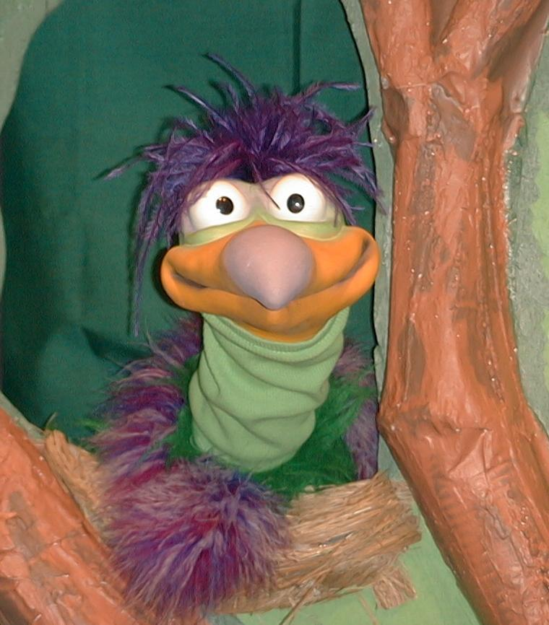
Presenter shows Xiao Er a craft made in Activity 1. Then the kids attempt to teach Xiao Er the take home point.

Presenter says to kids: “God keeps His promises…”
Kids say: “…I follow God.”
Presenter says to Xiao Er: “God keeps His promises…”
Xiao Er says: “Don’t use oatmeal as a pillow.”

Presenter shows an example of the next activity done in small group and repeats first phrase to kids. The kids say the correct response trying to teach Xiao Er the take home point. Continue in this manner with Presenter showing example of each activity. Here are Xiao Er’s responses:

Xiao Er’s response to Activity 2 sample: “I can eat a whole can of cheese at one time.”
Xiao Er’s response to Activity 3 sample: “I fall over God.”
Xiao Er’s response to Activity 4 sample: “Steady and clear along the road.”

Presenter says: “Xiao Er, listen one last time.
God keeps His promises…”
Kids response: “…I follow God.”
Presenter says to Xiao Er: “God keeps His promises…”
Xiao Er’s response: (Warms up his singing voice with “Mee, mee, mee, mee, mee…” and sings in a silly dramatic opera-like voice) “GOD KEEPS HIS PROMISES – I FOLLOW GOD.”

Welcome guests and thank them for attending.

Lesson 19

Large Group Warm-up
- Xiao Hung and Ting Ting puppets
- two small lunch boxes
- Imagination Box
- costumes for Abram, Sarai, and Lot
- microphone

Small Group Application
Activity 1:
- reproducible – use lesson coloring page and copy on cardstock.
- glue sticks
- dry oatmeal
- shallow pan or lid from a copy paper box
- crayons or markers (optional)
Activity 2:
- aluminum foil
- kaya
- finger biscuits
- cups
- water or juice
Activity 3:
- no supplies are needed
Activity 4:
- black and white mounting boards (from last week’s lesson)
- skate board

Large Group Wrap-up
- Xiao Er puppet
- sample materials from small group activities

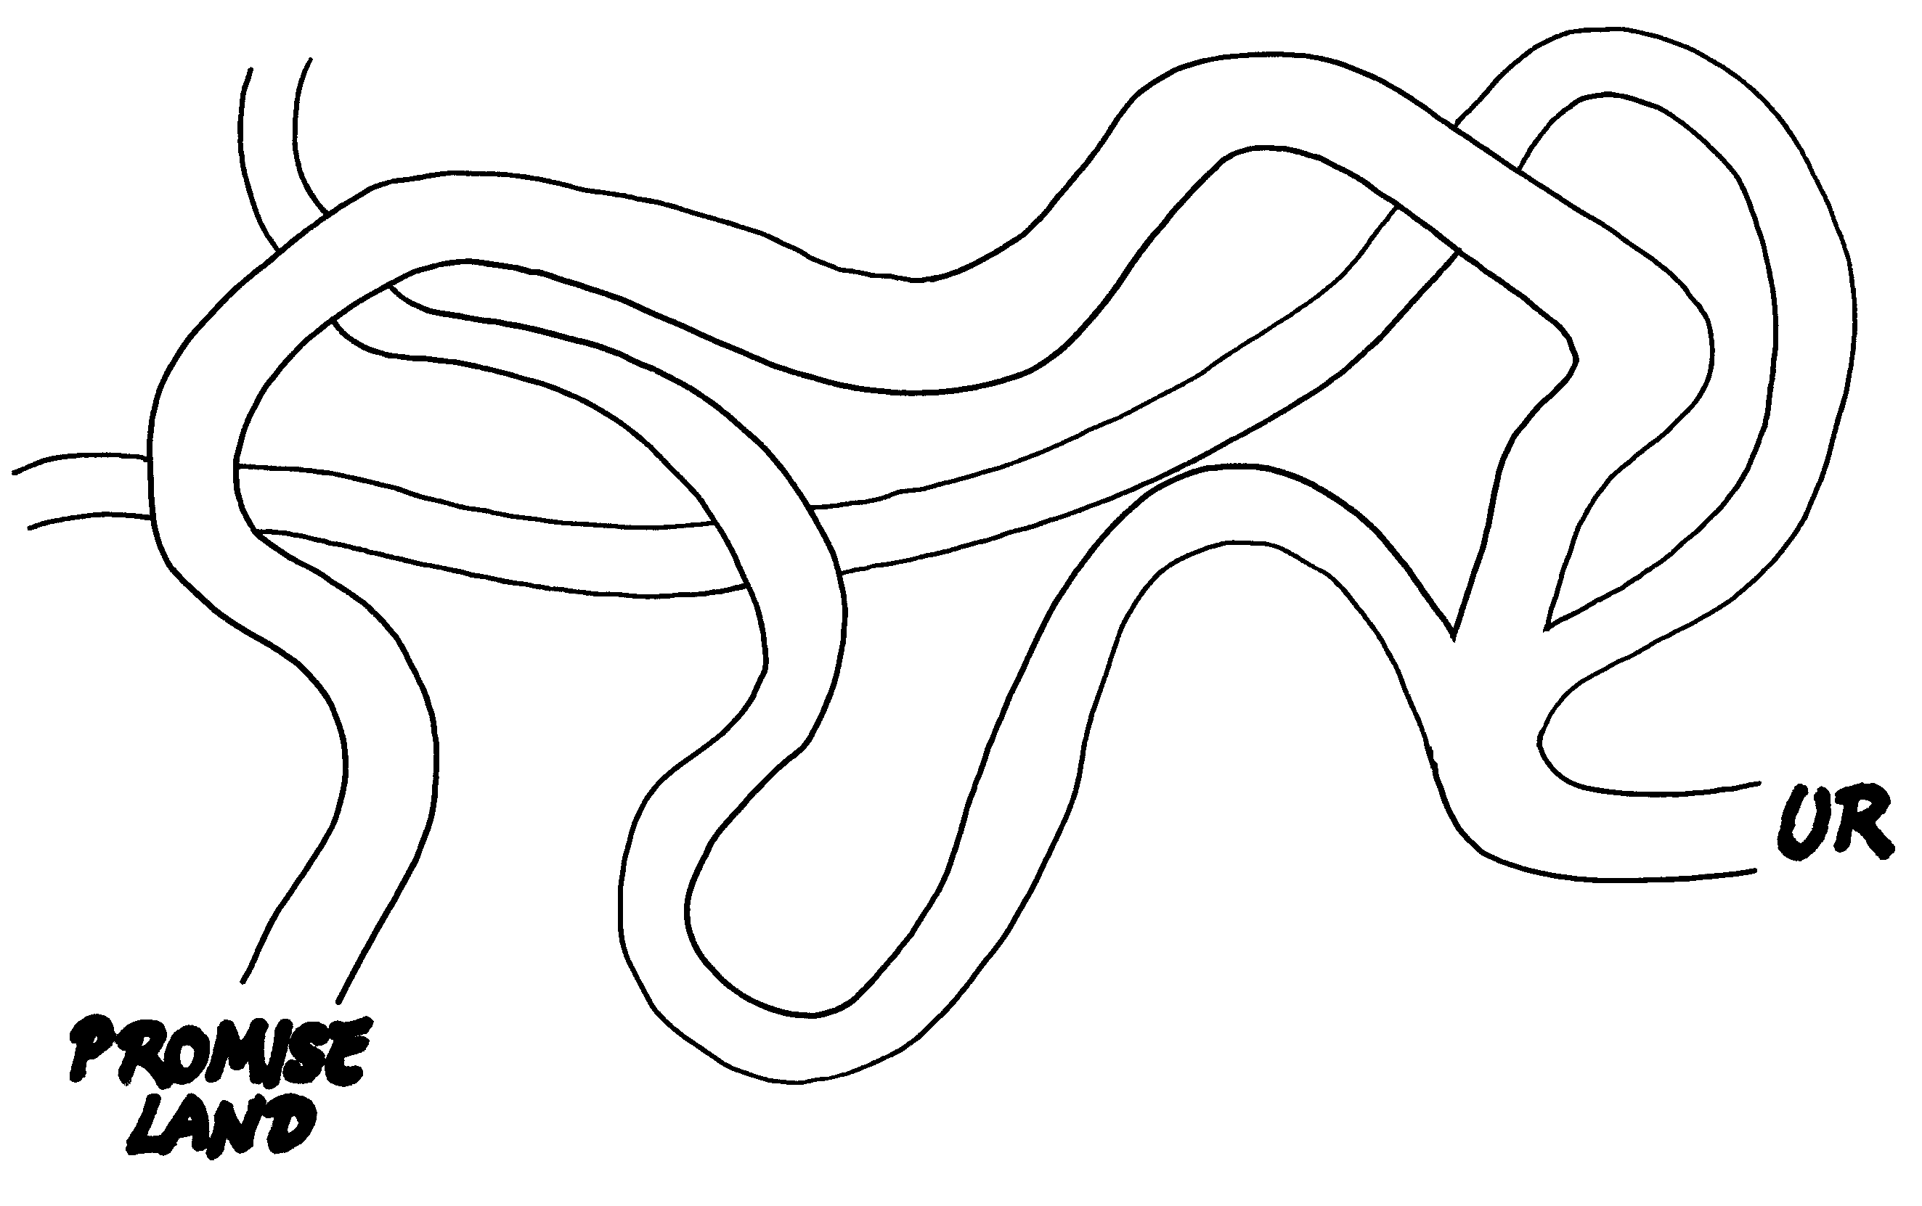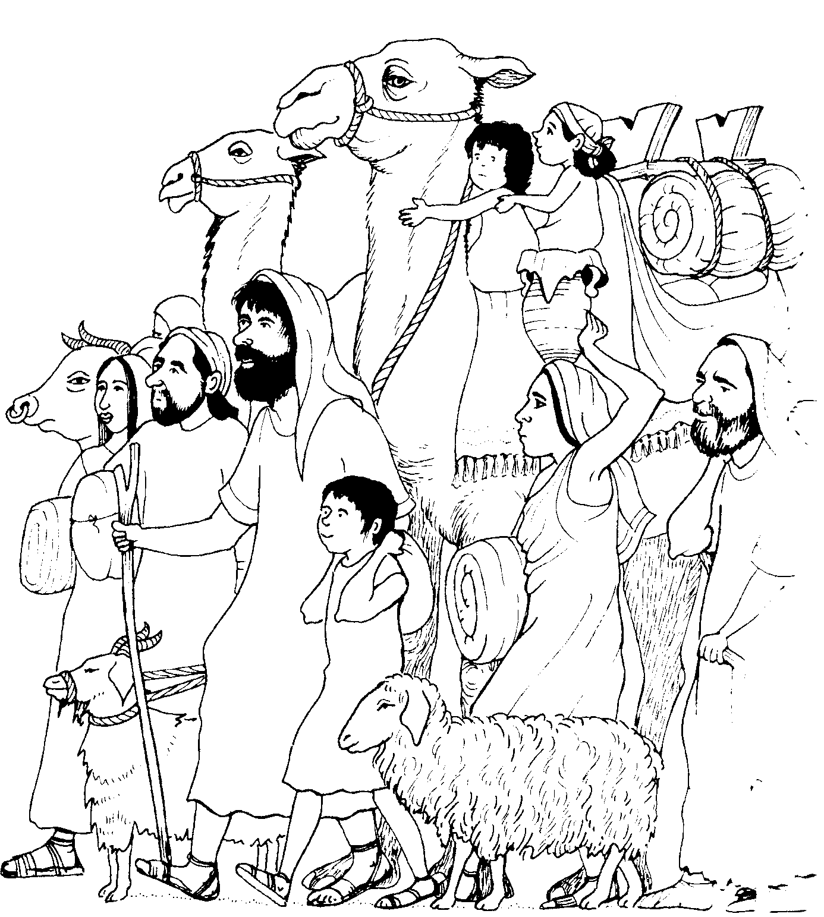
Promise
Land

