
Date: ____________ ___
Series: God Keeps His Promises (Sept-Nov)
Year 2, Lesson 20

God Promises Abram Children and Land

Take Home Point: *GOD KEEPS HIS PROMISES – I believe God.
*Repeat this phrase throughout the lesson. The leader will say the first part of the phrase (CAPS). The children respond with the second part of the phrase (italics).

Bible Event: Genesis 15:1-7
Jesus Link: I believe, because of Jesus, God will keep His promise to take me to heaven.

We will help children know:
- The story of God promising Abram children and land.
- God promised to send Jesus and He kept that promise.
- God promises us that if we believe in Jesus, we will someday go to heaven.

We will help the children feel:
- Confident that God keeps all His promises.
- Happy that God kept His promise to send Jesus.
- Trust that God will keep His promise to take them to heaven someday.

We will help the children do:
- Listen to a dramatized Abram recall the time God came to him and made two special promises.
- Make an edible sky filled with stars and review the Bible event while eating it.
- Do several impossible challenges to earn a prize and then be given the prize anyway as a reminder that Jesus is the fulfillment of God’s promise to send a Savior.
THIS LESSON’S ROADMAP

DESTINATION | PAGE # | DISCOVERIES ON YOUR JOURNEY | SUPPLIES NEEDED
Large Group Opening   | 3  3-5 | Puppet Presentation  Bible Event | - Xiao Hung puppet  - football  - Bible  - step stool  - microphone (optional)  - adult-sized Abram costume, including cane  - Option 1: twinkling Christmas tree lights  - Option 2: glow in the dark stars
Small Group Application   | 6-7  7  7-8  9 | Activity 1: “God Keeps His Promises Picture” Craft  Activity 2: “Stars in the Sky” Snack  Activity 3: ”Impossible Challenges” Game  Activity 4: “Pushing Car”  Prayer Time | Activity 1:  - “God Keeps His Promises” reproducible  - black and yellow crayons  - star attendance stickers  Activity 2:  - Honey Star cereal  - Paper plates  - paper cups  - water or juice  HEALTHY SNACK OPTION:  - strawberries  - water  Activity 3:  - masking tape  - one large, decorative star sticker per child  Activity 4:  - black and white mounting boards (from last week’s lesson)  - a toy car for every two children
Large Group Wrap-up   | 9  9 | Singing (Optional)  Lesson Review with Puppet Skit | - optional music for the lesson  - Xiao Er Puppet

Pre-Session Singing: (10 minutes)
Purpose: When all children are in one group singing, it is easy for new children to join the group and immediately get involved. When the music can be correlated, it introduces the theme for the day. Choose two to three songs and list them here.

Large Group Opening: (15 minutes)
Purpose: The puppet demonstrates the need that will be met in today’s lesson. The scripts are not written verbatim, but give a story line in which the group leader can interact with the puppet. The children are introduced to the take home point and then interact with God’s Word as they experience the Bible event.

Supplies needed: Xiao Hung puppet; football; Bible; step stool; microphone (optional); adult-sized Abram costume, including cane; Option 1: twinkling Christmas tree lights
Option 2: glow in the dark stars

Puppet Presentation:
Xiao Hung comes in carrying a football. He is obviously angry and upset. The presenter greets Xiao Hung and then asks him what is wrong. Xiao Hung says his friend Xiao Chiang promised him he could go over to his house on Saturday and play football. Xiao Chiang said he would call Xiao Hung but he never did. And Xiao Hung never got to go over to Xiao Chiang’s house. Now Xiao Hung is angry. He loves football. And besides, it’s not nice to break a promise.

The presenter sympathizes with Xiao Hung, agreeing that it is a bum deal when someone breaks a promise. It can make a person angry or hurt their feelings.

When someone breaks a promise to the presenter, one thing helps. The presenter remembers that God never breaks His promises. He promised Abram a son and He later sent Isaac. God promised the people of Israel He would send a Savior and He kept that promise. He also promises us that someday we will go to heaven if we believe and trust in Jesus. We can be sure God will keep that promise, too.

The presenter teaches Xiao Hung the take home point. *GOD KEEPS HIS PROMISES – I believe God. The presenter says the first portion, Xiao Hung responds with the second portion. After practicing it with Xiao Hung several times, the presenter practices it with the children.

Bible Event: Visit from a Dramatized Character
A costumed adult presents the Bible event by telling it from a first person point of view. Explain to the children that they will meet an actor, someone pretending to be a person to be a person in today’s Bible event. Ask the children to put on their imagination hats so they can imagine that this really is the person in the Bible event.

Boys and girls, today we will learn about Abram. Abram is someone who really lived in Bible times. (Open Bible.) In the Bible, God’s word, it tells the true story of when God gave Abram a special promise.

Introduce the character that is pretending to be Abram. Everyone needs to put on their Imagination Hats so they can imagine that it is Abram talking to them.

Have Abram hobble onto the stage, near the step stool. He has a cane. Abram picks up the Bible and microphone (if you have one) and begins speaking.

Option: Have someone backstage with a microphone play the
part of God and speak his words for this narrative.

Abram: Do you mind if I sit down? My old body just can’t stand too long anymore. (Sits down.)

Now, what was I going to tell you? Oh yes, I remember. I was going to tell you about the time God came to visit me and gave me a special promise.

One day, when I was already very old, God gave me a vision. A vision is like a dream but I was awake and the vision came from God. Close your eyes and imagine God coming to you to talk to you. (Remain silent for several seconds.) You can open your eyes now.

When God came to me, I was afraid. (Shiver in fear.) God knew that, so the first thing He said was…

God: Do not be afraid, Abram. I am your Shield and your very great Reward.

Abram: I answered God, “Lord, what can You give me? I do not have any children. When I die my servant is going to get everything I own.”

God: When you die your servant will not get everything you own. You will have a son.

Abram: Then God took me outside. It was late at night and very dark out. Cover your eyes and pretend it’s dark.

Have someone turn out the lights and turn on the twinkling lights (best option) or have glow-in-the-dark stars on the walls that will now glow.

Abram: You can now open your eyes. Look how dark it is. Look around the room. Can you see the twinkling stars? When God took me outside, He showed me the stars and told me to count them.

Let’s try to count the stars. (Count with the children up to ten.) My, my! There are more stars than we could ever count. When God took me outside, there were many, many more stars. There was no way I could ever count them.

Then God said…

God: You will have as many children, grandchildren, great grandchildren, and great, great grandchildren as there are stars in the sky.

Abram: And I believed God because I know that God always keeps His promises.

Then God said…

God: I am the Lord. I brought you out of your homeland. I will give you this land. It will be yours.

Abram: And I believed God because I know that God always keeps His promises. After that, I had to wait a long, long time. Then one day, God gave me a new baby son. But that is a story for another day. You will learn that story next week.

Abram goes off stage. The lights come back on and the group leader comes on stage. The group leader says to the children:

God made some promises to Abram, and Abram believed God because Abram knew that God always keeps His promises. Later He made a promise to His people that He would send a Savior. He kept that promise when He sent Jesus. Now, God gives us a promise. He promises us that if we believe Jesus died for our sins and we love and trust Jesus, we will someday go to heaven to be with Jesus. We can believe that promise because God always keeps His promises.

Practice the take home point with the children: GOD KEEPS HIS PROMISES – I believe God.

End with the following prayer. Have the children repeat each line.

Dear God, (repeat)
Thank You for being here. (repeat)
Thank You for sending Jesus. (repeat)
I believe Your promise (repeat)
That someday I will see Jesus. (repeat)
Thank You, thank You, thank You. (repeat)
Amen (repeat)

Small Group Application: (30 minutes)
Purpose: Smaller groups enable children to develop closer relationships with adults and peers in the church. As you reinforce the take home point with a fun hands-on activity, discuss the Bible event. Be sure to repeat the take home point several times. Say the first part and have the children respond with the second phrase. Application questions help kids apply the take home point to their daily lives. Close this session by gathering your small group for prayer. Let the kids pray!

During the small group application time, discuss the following questions and points:

What did God promise Abram? (He promised Abram children and land.)

Tell about a time someone made a promise to you. Did that person keep his or her promise?

What do we know about God’s promises? (He always keeps them.)

Tell about some promises God has kept. (He gave Abram a son Isaac and land. He sent Jesus. He takes care of us and forgives us.)

What promise can God’s children look forward to Him keeping? (Someday going to heaven to see Jesus.)

Activity 1: “God Keeps His Promises Picture” Craft
Supplies needed: “God Keeps His Promises” reproducible; black and yellow crayons; star attendance stickers

To make:
- Trace the cross on the reproducible with a black crayon.
- Color in the star with a yellow crayon.
- Decorate the paper with the star stickers.

When finished, discuss the meaning of the picture:

Count the stars on your picture. How many stars are there in the sky? There are too many to count. Yet, God promised Abram, who was old and had no children, that there would be more children, grandchildren, great-grandchildren, and great-great-grandchildren born into his family than there are stars in the sky. Abram believed God because God keeps His promises.

God also promised His people that a Savior would be born who would take away their sins. Look at the cross on the picture. It reminds us that the Savior was Jesus. God kept His promise.

Jesus was born not only for those who were waiting for Him, but for us, too. Jesus was born, lived, died on the cross, and came alive again so we can be forgiven of our sins and receive the gift of another promise. God promises us that someday those who believe and trust in Jesus will go to heaven to see and live with Jesus. That means you and me! We can believe that promise because God always keeps His promises.

Practice the take home point. *GOD KEEPS HIS PROMISES – I believe God.

Activity 2: “Stars in the Sky” Snack
Review the Bible event as you make the following snack:
- Give each child a paper plate. This is your sky.
- Scoop a spoonful of honey stars and spread them on the sky.
- How many stars do you have in your sky? Count them.
- Eat!

HEALTHY SNACK OPTION: Use strawberries and talk about the tiny seeds you see on each berry. There are too many to count, just as the number of stars in the sky!

Practice the take home point: *GOD KEEPS HIS PROMISES – I believe God.

Activity 3: “Impossible Challenge” Game
To prepare for this game place two lines of masking tape on the floor, four feet apart.

Objective:
The children will do five challenges. If they correctly complete even one challenge, they will receive a prize at the end of the game. The game was purposely created to make the challenges impossible for the children to complete. Even so, they will receive a prize at the end of the game as a lead in to discussing Jesus as the fulfillment of God’s promise to send a Savior.

Challenges:
- Reach arm overhead and touch bottom of ear with hand.
- Stand on one foot and touch the toes of the foot on the ground. Hold position for five seconds.
- Stand with both feet against the wall and bend at waist to touch toes without bending knees.
- Stand behind one line of masking tape and jump across other line. You have three tries.
- Put your elbow in your ear.

None of the children were able to complete even one challenge. Hand out the stickers. The children get stickers anyway because the stickers are a free gift. They do not need to do anything to get them.

To get to heaven is an impossible challenge, just as the game was an impossible challenge. It is impossible for us to get to heaven by ourselves. To do so we must never sin. But the Bible tells us that every one of us sins. Nobody is perfect. But God gave a free gift. He promised His people He would send a Savior who would save them from their sins.

God kept His promise to Abram to give him a son. He also kept His promise to His people to send them a Savior. That Savior is Jesus. He kept the impossible challenge for us. He lived a perfect life, died on the cross to take the punishment for our sins, and earned heaven for us. Now those who believe and trust in Jesus will someday go to heaven. It’s a free gift, just as the stickers were a free gift.

We too believe a promise God gives us. We believe God’s promise to someday take us to heaven to be with Him. We believe because God always keeps His promises.

Practice the take home point: *GOD KEEPS HIS PROMISES – I believe God.

Activity 4: “Pushing Car”
Purpose: Help kids to memorize and keep scriptures at heart. Using creative ways to help kids enjoy learning the key verse and in small group setting.

Supplies needed: black and white mounting board (from last week’s lesson), a toy car for every two children

Memory Verse: Mark 1:3 ~ Prepare the way for the Lord. Make the road straight for Him.

Memory Verse Learning:
Prior to class, paste the flash cards on the floor of an opened space. Gather the children to recite the memory verse together a few times. Then, pair the children up. Ask one child from each pair to sit at the beginning of one sentence and the other to sit at the other end of the sentence. Give each pair a toy car. Before the children can push the toy car to their partner, they have to recite the memory verse first. Allow the children to play as long as time permits.

Prayer Time:
Have the children thank God for keeping His promises. Children can pray about specific promises if they choose. Thank God for keeping His promise to send Jesus.
Large Group Wrap-Up: (10 minutes)
Purpose: The crazy bird puppet, Xiao Er, struggles with learning the take home point. The leader shows an example of each small group application activity from this lesson and says the first phrase of the take home point. The kids respond with their phrase. They try to teach the puppet the take home point, but each time he confuses words or concepts. After three attempts, he finally gets it right and sings the correct take home point in a silly opera-like voice.

Singing: (Optional)

Lesson Review with Puppet Skit:
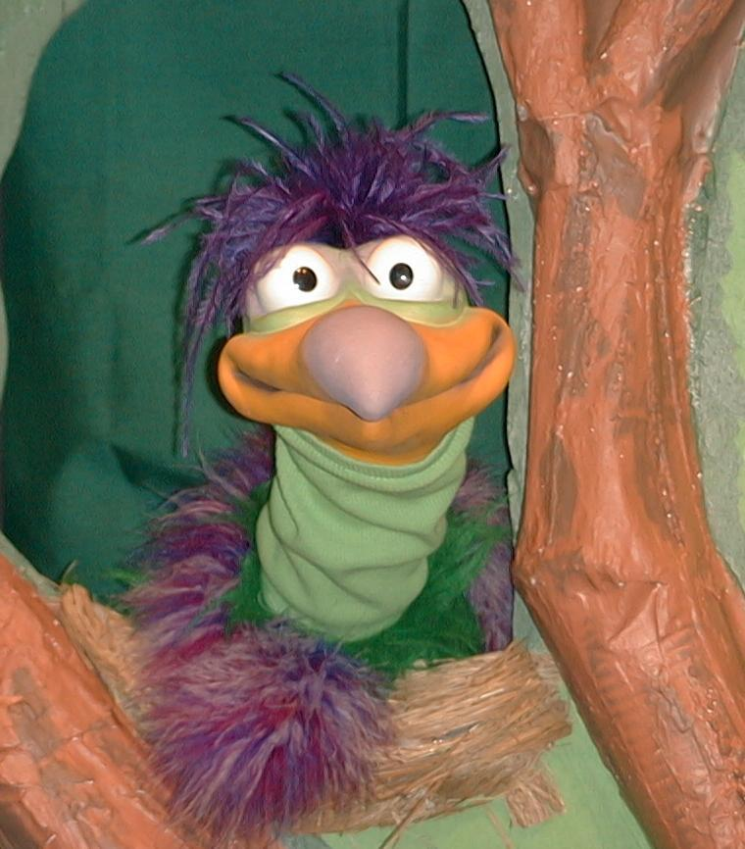
Presenter shows Xiao Er a craft made in Activity 1. Then the kids attempt to teach Xiao Er the take home point.

Presenter says to kids: “God keeps his promises…”
Kids say: “…I believe God.”
Presenter says to Xiao Er: “God keeps His promises…”
Xiao Er says: “I believe that is a beautiful picture..”

Presenter shows an example of the next activity done in small group and repeats first phrase to kids. The kids say the correct response trying to teach Xiao Er the take home point. Continue in this manner with Presenter showing example of each activity. Here are Xiao Er’s responses:

Xiao Er’s response to Activity 2 sample: “I believe that I am beautiful.”
Xiao Er’s response to Activity 3 sample: “I believe that you are not beautiful.”
Xiao Er’s response to Activity 4 sample: “I believe that you are not beautiful.”

Presenter says: “Xiao Er, listen one last time.
God keeps his promises…”
Kids response: “…I believe God.”
Presenter says to Xiao Er: “God keeps His promises…”
Xiao Er’s response: (Warms up his singing voice with “Mee, mee, mee, mee, mee…” and sings in a silly dramatic opera-like voice) “GOD KEEPS HIS PROMISES–I BELIEVE GOD.”

Welcome guests and thank them for attending.

Lesson 20

Large Group Warm-up
- Xiao Hung puppet
- football
- Bible
- step stool
- microphone (optional)
- adult-sized Abram costume, including cane
- Option 1: twinkling Christmas tree lights
- Option 2: glow in the dark stars

Small Group Application
Activity 1:
- “God Keeps His Promises” reproducible (page 9 of lesson)
- black and yellow crayons
- star attendance stickers
Activity 2:
- paper plate for each child
- honey stars
- paper cups
- water or juice
Activity 3:
  - masking tape
  - one large, decorative star sticker per child
Activity 4
  - black and white mounting boards (from last week’s lesson)
  - a toy car for every two children

Large Group Wrap-up
- optional music for the lesson
- Xiao Er puppet

Star template
