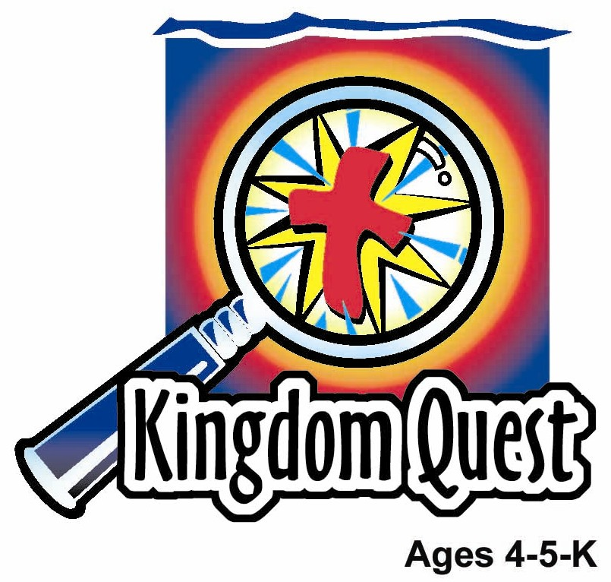
Date: ________________________
Series: God Teaches Me His Ways (Jun-Aug)
Year 2, Lesson 11

The Vine and the Branches

Take Home Point: *GOD TEACHES ME—to live for Him.
*Repeat this phrase throughout the lesson. The leader will say the first part of the phrase (CAPS). The children respond with the second part of the phrase (italics).

Bible Event: John 15:1-8

Jesus Link: When I’m connected to Jesus, I will live for Him.

We will help children know:
- The parable of the vine and the branches and its meaning—when we are connected to God, we are able to live for Him and produce good fruits (good works).
- Ways in which we can stay connected to God.
- Why we want to live for God—because Jesus lived and died for us.

We will help the children feel:
- Desire to stay connected to Jesus.
- Eager to live for God and produce good fruits.
- Motivated by the knowledge that Jesus lived and died for them.

We will help the children do:
- Participate in an Imagination Theater presentation of “The Vine and the Branches.”
- Make a fruit salad and discuss the different good fruits Christians produce.
- Play a game “Vine, Vine, Come Join the Grape Vine” as a way to remember to stay connected to Jesus.
THIS LESSON’S ROADMAP

DESTINATION | PAGE # | DISCOVERIES ON YOUR JOURNEY | SUPPLIES NEEDED
Large Group Opening  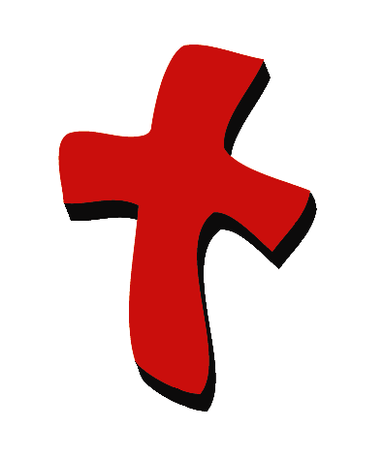 | 3  4-6 | Puppet Presentation  Bible Event | - Ting Ting puppet  - wilted dandelion or flower  - large pot of soil to hold cross  - three-foot cross - two-sticks wired together or two boards  - real or artificial vine (place one end in soil in pot, wrap upward around main trunk of cross and out around both limbs)  - two clusters of real or artificial grapes (wire or hot glue grapes on each arm of the cross)  - small, dead branch, possibly with shriveled leaves attached  - altar Bible with script, “The Vine and the Branches” inserted
Small Group Application   | 7  8  8  9  9 | Activity 1: “Thumbprint Grapevine” Craft  Activity 2: “Fruit Salad” Snack  Activity 3: ”Vine, Vine, Come Join the Grapevine” Game  Activity 4: “Stuffing Balloon”  Prayer Time | Activity 1:  - white paper  - purple ink pads or poster colour  - brown markers or crayons  - leaf stamp and green ink or green poster colour  - Label printed with the words “Jesus is the vine, I am the branches”  Activity 2:  - bananas  - grapes  - raisins  - cups  - plastic knives  - plastic spoons  - serviettes  - paper cups  - water or juice  Activity 3:  - no supplies needed  Activity 4:  - blown balloons  - label with student’s name on  - 1 adult’s white T-shirt  - Marker  - White board
Large Group Wrap-up   | 9  10 | Singing (Optional)  Lesson Review with Puppet Skit | - optional music for the lesson  - Xiao Er Puppet

Pre-Session Singing: (10 minutes)
Purpose: When all children are in one group singing, it is easy for new children to join the group and immediately get involved. When the music can be correlated, it introduces the theme for the day. Choose two to three songs and list them here.

Large Group Opening: (15 minutes)
Purpose: The puppet demonstrates the need that will be met in today’s lesson. The scripts are not written verbatim, but give a story line in which the group leader can interact with the puppet. The children are introduced to the take home point and then interact with God’s word as they experience the Bible event.

Supplies needed: Ting Ting puppet; wilted dandelion or flower; large pot of soil to hold cross; three-foot cross - two-sticks wired together or two boards; real or artificial vine (place one end in soil in pot, wrap upward around main trunk of cross and out around both limbs); two clusters of real or artificial grapes (wire or hot glue grapes on each arm of the cross); small, dead branch, possibly with shriveled leaves attached; Bible with script, “The Vine and the Branches” inserted

Puppet Presentation:
Purpose: The puppet demonstrates the need that will be met in today’s lesson. The scripts are not written verbatim, but give a story line in which the group leader can interact with the puppet.

Ting Ting comes out carrying a wilted dandelion. She is upset because it is “dead.” She explains that she picked it from her yard yesterday and it was so beautiful, but this morning when she got up it was dead.

The presenter says that dandelions need water and sun to stay alive. Ting Ting says that she put it in a glass of water and put it in a sunny window, but it still died. The presenter explains that it needs something else to stay alive. Can Ting Ting guess what it is?

Ting Ting guesses that it needs a ladybug, a whole field of yummy grass, and a mommy dandelion to stay alive. (Have Ting Ting say each these guesses dramatically.) Each time the presenter says “Noooo….”

Finally, the presenter explains that the dandelion needs roots that go down into the soil to stay alive. It needs roots and soil so that it can have nutrition, the food it needs to stay alive.
The presenter asks Ting Ting if she knew that we are like the dandelion. Ting Ting asks “How?” The presenter says:

The dandelion needed to stay connected to its plant to stay alive and we need to stay connected to Jesus to grow in our love for God and others. If we are cut off from Jesus, just like the dandelion was cut off from the plant, we won’t grow and we won’t produce good fruit—like showing Jesus’ love to others and doing the good works Jesus has for us to do.

In the Bible event today, the children are going to learn about a vine, branches, good fruits, and how they can stay connected to the vine and have good fruits.

The presenter teaches Ting Ting the take home point. *GOD TEACHES ME—to live for Him. Practice it with Ting Ting several times. The presenter says the first part and Ting Ting responds with the second part. After practicing it with Ting Ting several times, practice it with the children.

Bible Event: Mystery Box
Test your sound and video system beforehand. Cue the video to precise beginning. For larger groups of children (15 or more), use a large screen TV or imager. Dim the lights before showing. To introduce a video, you might read from a Bible storybook and leave off the ending, inviting them to see what happens by watching the video. Also, you can introduce the video by inviting them to watch for special actions or words.

Note: Today’s Bible event follows the format of the mystery box, but because the props are too large for the box, the box will be omitted.

Option: You may want to use a larger size box to retain the mystery box format in its entirety.

Bring out the two plants and begin:

Boys and girls, look at these two plants. Can you see what is different about them?

Point to potted plant. One plant has grapes growing on it and looks like it is alive. It is planted in this dirt. It must get food from the soil.

Point to dead branch. Look at this branch here. Do you think it is alive or dead? What happened to it? Yes. It must have pulled apart from the plant that it was attached to and it couldn’t get any more food or water.

These plants remind me of a story that Jesus told. The story describes people. Listen to John 15. Open Bible and read script for “The Vine and the Branches.”

“The Vine and the Branches”

Jesus said, “I am the vine. You are the branches.” Can a branch live by itself if it is not attached to a vine? No! Can a branch make grapes by itself if it is not attached to a vine? No! Can a branch be green and growing by itself, if it is not attached to a vine? No!

Jesus said He is like this vine.” Point to the potted vine. You are like these branches.” Point to the arms. If you stay connected to Jesus, you can grow and grow and grow. You will be just like this branch that produces fruit or grapes. End script.

Presenter puts down Bible and says:

So how do we stay connected to the vine? Look at this. Unwrap the grapevine revealing the cross. Bring a child forward and have her hang onto a vine.

Presenter asks children:
Did you know Jesus is God’s own Son? Did you know that Jesus died on the cross to pay the price for sin and all the wrong things we’ve ever done? Do you trust Jesus to live in your life? If that is so, then you are hanging onto Jesus. You are trusting Jesus as your Savior. You are like a branch connected to the vine.

Have the child hang onto the cross. Will grapes now start growing out of this child’s hand? No! But this person will start doing wonderful things to show God’s love to others because he is connected to Jesus. Those wonderful things that he can do are just like the yummy fruit that a grape branch produces when it is connected to a vine.

So, let me ask you a question. Who is the vine? Jesus! Who can be the branches? Point to one. Can you point to yourself? Now point to each other.

If we trust Jesus, do we make grapes? No! But we do special things to show our love and -- that is what Jesus says is making fruit for Him.

Practice the take home point with the children. *GOD TEACHES ME—to live for Him.

End with a brief prayer.

Small Group Application: (30 minutes)
Purpose: Smaller groups enable children to develop closer relationships with adults and peers in the church. As you reinforce the take home point with a fun hands-on activity, discuss the Bible event. Be sure to repeat the take home point several times. Say the first part and have the children respond with the second phrase. Application questions help kids apply the take home point to their daily lives. Close this session by gathering your small group for prayer. Let the kids pray!

During the small group application time, discuss the following questions and points:

What happens to a branch or a flower when it is not connected to its plant? (It dies.)

What happens to a branch when it is connected to its plant? (It lives. It is green and healthy. It produces leaves, flowers, or fruit.)

How is Jesus like the vine and how are we like the branches? (When we are connected to Jesus by trusting that He loves us and died to take away our sins, then we are alive, healthy, and produce good fruits.)

What is a good fruit? (Any way we show that we love Jesus and we love others.)

What are some good fruits you can show? (Answers will vary. Examples may include: sharing with a friend, pick up toys when asked, and saying something nice to a brother or sister.)

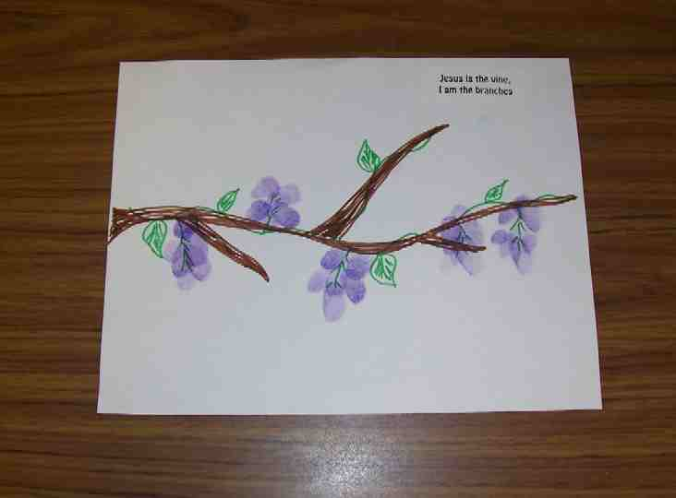
Activity 1: “Thumbprint Grapevine” Craft
Supplies needed: white paper; purple ink pads or poster colour; brown markers or crayons; leaf stamp and green ink or green poster colour; Label printed with the words “Jesus is the vine, I am the branches”

To make:
- Use the brown markers to draw a long twisting vine with branches on the paper.
- Add green leaves with a marker or stamp.
- Add purple by making thumbprints on the vine. (Hint: Use washable inkpads.) Option: If you do not have purple stamp pads, purple poster colour also work well. Just color the thumb purple and make a thumbprint as usual.
- Add the label.

To discuss:
- As the children work, review the Bible event.
- Discuss the application questions.
- As a group, brainstorm ways the children can stay connected to Jesus. For example, they can listen to Bible stories, listen to Bible tapes, watch Bible videos, and attend Kingdom Quest and Kids Church.

Practice the take home point. *GOD TEACHES ME—to live for Him.

Activity 2: “Fruit Salad” Snack
Supplies needed: bananas; grapes; raisins; cups; plastic knives; plastic spoons; serviettes; paper cups; water or juice

To make:
- Slice one-third a banana into several thin slices and put in cup.
- Cut three grapes in half and add.
- Add one spoonful of raisins.
- Mix well.
- Eat.

To discuss:
- As the children eat their snack, brainstorm good fruits the children can produce in their lives.
- Remind the children that they can have good fruits because Jesus lived for them and died to take away their sins. Now when they trust in Jesus, they are connected to Him and He helps them produce good fruits.

Practice the take home point. *GOD TEACHES ME—to live for Him.

Activity 3: “Vine, Vine, Come Join the Grapevine” Game
Supplies needed: No supplies needed.

To play:
- Teach the children the chant, “Vine, vine, come join the grapevine. Come join the grapevine and you will be mine.” Practice several times.
- Explain to the children that “you will be mine,” means that when they join the grapevine, they will belong to Jesus. They join Jesus’ grapevine when they trust that Jesus died for their sins.
- The leader (shepherd) pretends to be Jesus and weaves in and out of the children while the group says the chant.
- When the chant is finished, the leader chooses a child to join the grapevine.
- The child crawls under a chair the leader’s legs and then grabs the leader’s waist, joining the grapevine.
- The group repeats the chant. This time both the leader and the child (still hanging onto the leader’s waist) weave in and out of the children.
- When the chant is finished, another child is chosen. This time the child must go under the legs of both the leader and the child who is attached to the leader, before joining the grapevine.
- Play continues in this fashion until every child has been chosen. Each time the grapevine grows longer, making the child who has just been chosen crawl under more legs.

Activity 4: “Stuffing Balloon”
Purpose: Help kids to memorize and keep scriptures at heart. Using creative ways to help kids enjoy learning the key verse and in small group setting.

Supplies needed: inflated balloons; label with student’s name; 1 adult’s white T-shirt; marker; white board.

Memory Verse: John 15:4 ~ Remain in me, and I will remain in you.

Memory Verse Learning:
Pre-write the memory verse on the white board. Get the children to read aloud the memory verse several times. Then, have a volunteer to wear the adult’s T-shirt. He or she is representing God. Give each a blown balloon and a label with their name on it. Tell them to stick the label on the balloon. The balloon represents the child. “God” will be standing in front of the class. Ask the children to take turns to go to “God”. “God” would say, ‘Remain in me’ and before the child place the balloon on “God” (inside the T-shirt, in the hands, between the legs, etc.), he or she has to respond by saying, ‘...and I will remain in You.” Explain to the children that as we give our lives to God, He will hold us in His hands and help us to do good as He has always wanted us to. Repeat the activity by allowing other children become “God”.

Prayer Time:
Ask God to help you stay connected to Him and to live for Him by doing good works. Thank God for sending Jesus to live and die for us.

Large Group Wrap-Up: (10 minutes)
Purpose: The crazy bird puppet, Xiao Er, struggles with learning the take home point. The leader shows an example of each small group application activity from this lesson and says the first phrase of the take home point. The kids respond with their phrase. They try to teach the puppet the take home point, but each time he confuses words or concepts. After three attempts, he finally gets it right and sings the correct take home point in a silly opera-like voice.

Supplies needed: optional music for the lesson; Xiao Er Puppet

Singing: (Optional)

Lesson Review with Puppet Skit:

Xiao Er’s confused phrases:

Activity 1: “To live for…hey wait… I don’t have thumbs!”
Activity 2: “Fruit salad, yummy, yummy.”
Activity 3: “To live for lollypops.”
Activity 4: “Stuff stuff the balloons.”

Welcome guests and thank them for attending.

Lesson 11
Large Group Warm-up
- Ting Ting puppet
- wilted dandelion or flower
- large pot of soil to hold cross
- three-foot cross - two-sticks wired together or two boards
- real or artificial vine (place one end in soil in pot, wrap upward around main trunk of cross and out around both limbs)
- two clusters of real or artificial grapes (wire or hot glue grapes on each arm of the cross)
- small, dead branch, possibly with shriveled leaves attached
- altar Bible with script, “The Vine and the Branches” inserted

Small Group Application
Activity 1:
- white paper
- purple ink pads or poster colour
- brown markers
- leaf stamp and green ink or green poster colour
- label printed with the words “Jesus is the vine, I am the branches”
Activity 2:
- bananas
- grapes
- raisins
- cups
- plastic knives
- plastic spoons
- serviettes
- paper cups
- water or juice
Activity 3:
- no supplies needed
Activity 4:
- ready blown balloons to the number of children in the class
- label with student’s name on
- 1 adult’s white T-shirt
- White board
- marker

Large Group Wrap-up
- optional music for the lesson
- Xiao Er Puppet

