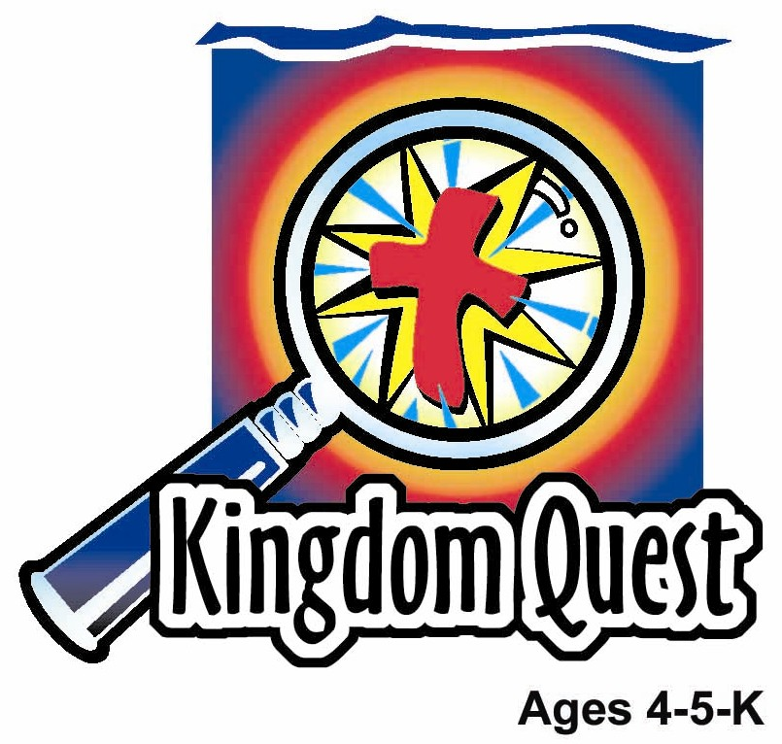
Date: ________________________
Series: God Teaches Me His Ways (Jun-Aug)
Year 2, Lesson 12

The Good Samaritan

Take Home Point: *GOD TEACHES ME—to be a friend.
*Repeat this phrase throughout the lesson. The leader will say the first part of the phrase (CAPS). The children respond with the second part of the phrase (italics).

Bible Event: Luke 10:25-27
Jesus Link: Jesus is our friend and wants to heal us.

We will help children know:
- The parable of the Good Samaritan and what it means to be a friend.
- Ways in which Jesus has been a friend to them.
- How they can be friends to others.

We will help the children feel:
- Joy that Jesus is their friend.
- Enthusiastic about friendship.
- Eager to be a friend to others.

We will help the children do:
- Participate in an echo pantomime, “The Good Samaritan.”
- Make and share pudding with another child.
- Play a series of “Help-a-Friend” races.

THIS LESSON’S ROADMAP

DESTINATION | PAGE # | DISCOVERIES ON YOUR JOURNEY | SUPPLIES NEEDED
Large Group Opening  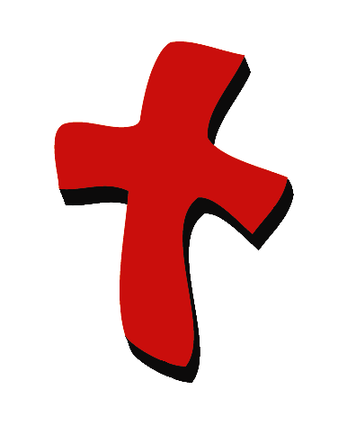 | 3-4  4-6 | Puppet Presentation  Bible Event | - Xiao Hung puppet  - puppet-sized ace bandage  - copy of story “The Very Best Friend”
Small Group Application   | 7  7  8  8  9 | Activity 1: “Care Package” Craft  Activity 2: “Friendship Pudding” Snack  Activity 3: ”Help-a-Friend Races” Game  Activity 4: “Balancing Ping Pong”  Prayer Time | Activity 1:  - one 5”x8” plastic bag per child  - one 6 inches long paper ribbon per child  - one or two new crayons per child  - two pieces of sweets per child  - one or two stickers per child  - reproducible “You are my friend” copied onto manila card. On the backside, copy the “You are invited…” reproducible. One reproducible per four children. Quarter with paper cutter.  - label that says, “Care package: Jesus loves me and I love you!”  - stickers and craft items to decorate a bag (optional)  Activity 2:  - large bowl of “Tow Foo Fah” (option: white or brown syrup)  - cups  - sprinkles  - plastic spoons  - paper cups  - water or juice  Activity 3:  - masking tape  - strips of cloth to tie around ankles for three-legged race  Activity 4:  - white board  - marker  - an A3 size board cut from firm carton box  - Ping pong balls
Large Group Wrap-up   | 9  9 | Singing (Optional)  Lesson Review with Puppet Skit | - optional music for the lesson  - Xiao Er Puppet

Pre-Session Singing: (10 minutes)
Purpose: When all children are in one group singing, it is easy for new children to join the group and immediately get involved. When the music can be correlated, it introduces the theme for the day. Choose two to three songs and list them here.

Large Group Opening: (15 minutes)
Purpose: The puppet demonstrates the need that will be met in today’s lesson. The scripts are not written verbatim, but give a story line in which the group leader can interact with the puppet. The children are introduced to the take home point and then interact with God’s word as they experience the Bible event.

Supplies needed: Xiao Hung puppet; puppet-sized ace bandage; copy of story “The Very Best Friend”

Puppet Presentation:
Purpose: The puppet demonstrates the need that will be met in today’s lesson. The scripts are not written verbatim, but give a story line in which the group leader can interact with the puppet.

Xiao Hung is wearing a bandage around his arm. The presenter asks what happened to him. Xiao Hung tells a very exciting story with surprising ending.

He was riding his bike. He pedaled up the hill and went zooming down the hill. He went over a bump and around a tree. He even went off his steps. He was Electro Xiao Hung, World Class BMX biker! He was winning “The Big Contest!” Then he lifted his arms in the air for a victory wave—and he crashed. Now he wasn’t Electro Xiao Hung. Instead, he needed an Electroplaster.

Throughout this story, the presenter says “Oh,” “Whoa,” “Wow,” and other exclamations. When Xiao Hung finishes, the presenter says, “Oh! Xiao Hung! Those weren’t very safe things to do.”

Xiao Hung replies, “I know that now,” and he looks at the plaster.

The presenter asks, “What happened then?”

Xiao Hung says, “That is the surprising part.” He then tells the presenter that he sat on the ground crying when a boy from his neighborhood, Ah Seng, came over to help him. He picked up Xiao Hung’s bike and asked Xiao Hung if he was all right. Then he helped Xiao Hung get up. He even walked Xiao Hung into his house where his mom fixed him up with a plaster.

The presenter asks why that was so surprising. Xiao Hung explains that he and Ah Seng used to be friends, but then they got in a fight. Xiao Hung wouldn’t share his toys with Ah Seng, and Ah Seng started to cry. Xiao Hung says that he then did something really mean. He called Ah Seng a big baby. He didn’t think Ah Seng would ever like him after that. But then Ah Seng came and helped him when he was hurt. Xiao Hung was surprised!

The presenter comments that Ah Seng’s behavior shows that he really is a good friend. Xiao Hung should be happy to have a friend like that. It reminds the presenter of today’s Bible event. He briefly summarizes the story of the Good Samaritan.

The presenter teaches Xiao Hung today’s take home point. *GOD TEACHES ME – to be a friend. The presenter says the first part, Xiao Hung responds with the second part. After practicing it several times, the presenter practices it with the children.

Bible Event: Imagination Theater
Imagination Theater is audience participation drama where the Bible event is told in creative fashion, using children as actors. The Imagination Box contains the Bible and other special props used for the drama. Begin by removing the Bible and explain that it is God’s Word, telling us of the wonderful deeds God has done. Then remove an imaginary hat and place it on your head. This is your Imagination Hat. Invite the children to put on theirs as well. They will also use their imaginations to picture the events the Bible tells us about. Some will even use their imaginations to help act out these events. Distribute props to actors as they are called forward at the beginning of the presentation. Have them sit to the side until they are called on stage.

Boys and girls, for our Bible event today, I am going to need your help. We are going to do an echo pantomime. I will say some words and do an action. When I stop, you say the same words and do the same action I did.

“The Very Best Friend”

A Participation Story

(Have the children copy the leader’s actions.)

Walk, walk, walk. Walk in place and continue through the word “trip.” A man went walking, walking down the road to take a trip. When suddenly out from the rocks jumped robbers. Jump forward and make hands claw air in front of you. They beat up the man, (punch air with fists) stole his money and clothes, (grab in the air) and left him to die on the road. Put head on hands to die.

Through the following refrain sway and rub body.
Moan, moan.
Groan, groan.
The man was hurt
And all alone.
But not for long! Point finger in air. Soon a man, (walk in place) came walking down the road. Walk, walk, walk, walk. He was a church leader, a priest. When he saw the man, (put hand to forehead salute style and look around) did he stop? Noooo! He just walked (walk in place) right on by, even though the man was a Jew, just like him.
Through the following refrain sway and rub body.
Moan, moan.
Groan, groan.
The man was hurt
And all alone.

But not for long! Point finger in air. Soon another man (walk in place) came walking down the road. Walk, walk, walk, walk. That man was an important person at his church. Surely he would stop. But did he? Noooo! When he saw the hurt man, he just walked faster. Walk in place faster. And walked right by, Even though he was a Jew, just like the hurt man.

Through the following refrain sway and rub body.
Moan, moan.
Groan, groan.
The man was hurt
And all alone.

But not for long! Point finger in air. Soon another man walk in place came walking down the road. Walk, walk, walk, walk. Would he stop? He was a Samaritan. The man who was hurt was a Jew. In those days, Samaritans and Jews did not like each other. Surely, he would not stop. Shake head “no.”

Surprise! Fling arms wide. The man stopped! He put bandages on the man. Pretend to wrap your arm. He put medicine on the man’s sores. Pretend to swab your arm. Heave ho! Pretend to lift something heavy. Heave ho! He picked up the man. Plop! Pretend to put something down. And put him on his donkey.

Through the following refrain sway and rub body.
Moan, moan.
Groan, groan.
The man was hurt
Happier voice But not alone!

The Samaritan took the donkey’s rope and walked off. Clippity clop. Gallop in place. Clippity clop. Walk, walk, walk, walk. Walk in place. They walked on down the road. Where did they go? Lift arms up. Palms up. They went to an inn, where travelers sleep.

The Samaritan lifted the man off the donkey. Heave ho! Pretend to lift something heavy. Heave ho! This is heavy, don’t you know? He walked into the inn. Flop. Pretend to put something down. He put the man on a soft bed. He gave the innkeeper one, two, (hold up one, then two fingers) silver coins. “Take care of this man,” he said. “When I come back, I will pay you what he owes.”

Through the following refrain sway and rub body.
Moan, moan.
Groan, groan.
The man was hurt
Happier voice. But not alone!

The man wasn’t alone anymore because the Samaritan was not only a good friend, he was the very best friend.

Boys and girls, do you know who our very best friend is? Our very best friend is Jesus. He is our very best friend because He does not leave us alone with our sins. He died on the cross to take away our sins. And when we have problems, Jesus does not leave us alone. He helps us. He is always with us. Because Jesus is our best friend, we can be a friend to others.

Practice the take home point with the children. *GOD TEACHES ME—to be a friend.

End with a brief prayer.

Small Group Application: (30 minutes)
Purpose: Smaller groups enable children to develop closer relationships with adults and peers in the church. As you reinforce the take home point with a fun hands-on activity, discuss the Bible event. Be sure to repeat the take home point several times. Say the first part and have the children respond with the second phrase. Application questions help kids apply the take home point to their daily lives. Close this session by gathering your small group for prayer. Let the kids pray!

During the small group application time, discuss the following questions and points:

How did the Samaritan show that he was a good friend? (He helped the injured traveler by bandaging him, taking him to an inn, and paying for him to stay there.)

How does Jesus show us that He is our good friend? (Answers will vary but may include “He keeps us safe,” “He helps us when we are hurt,” and “He listens to our prayers.” Make sure to emphasize that the best way Jesus showed us He is our friend was by dying on the cross and taking the punishment for our sins, the wrong things we choose to do.)

Who are your friends? (Kids will share names of friends. Then explain that anyone we show love to is our friend.)
How can you be a friend to others? (Answers will vary but may include “by helping someone who is hurt,” “sharing my toys,” and “no fighting with them.” Emphasize that the very best way to be a friend is by telling others about Jesus.)

Activity 1: “Care Package” Craft
Supplies needed: one 5”x8” plastic bag per child; one 6 inches long ribbon per child; one or two new crayons per child; two pieces of sweets per child; one or two stickers per child; reproducible “You are my friend” copied onto manila card. On the backside, copy the “You are invited…” reproducible. One reproducible per four children. Quarter with paper cutter; label that says, “Care package: Jesus loves me and I love you!”; stickers and craft items to decorate a bag (optional)

To make:
- Have the children put one or two new crayons, a copy of the reproducible, one to two stickers, and one to two pieces of small snack packet in a bag and close.
- Attach the reproducible to the outside of the bag.
- Optional: Decorate the bag with additional stickers or other craft items.

To discuss:
- Explain that the children get to practice being a friend to others. Today they are making care packages to give to a friend. The best part of the care package is that it has an invitation to Sunday School in it so the friend can learn about his best friend, Jesus.
- In what other ways can the children be good friends?

Practice the take home point. *GOD TEACHES ME—to be a friend.

Activity 2: “Friendship ‘Tow Foo Fah’” Snack
Supplies needed: large bowl of ‘Tow Foo Fah’ (option: white sugar or brown syrup; cups; sprinkles; plastic spoons; paper cups; water or juice

To make:
- Spoon some “Tow Foo Fah” into a cup.
- Pour white or brown sugar syrup as the child chooses.
- Give the “Tow Foo Fah” to the child on your right.

To discuss:
- Jesus was a friend to us by dying on the cross for our sins. Now each of us can be a friend to others. One way is by making and giving them special things, like this snack.
- In what other ways can you be a friend to others?

HEALTHY SNACK OPTION: Just as Jesus was a friend to us by dying for us, He is also our friend because He created food that rejuvenates our bodies physically. Try raisins, and dried apples and other fruits. Make a trail mix type of snack and put it in a special sandwich bag. Have the children draw a special picture on the bag and give it to their neighbor at the table.

Practice the take home point. *GOD TEACHES ME—to be a friend.

Activity 3: “Help-a-Friend Races” Game
Supplies needed: masking tape; strips of cloth to tie around ankles for three-legged race

To play:
- Put a line of masking tape on the floor about 15 feet from a wall.
- Have the children work in pairs to race to the wall and back to the line.
- Choose from the following races that require two children to work together as friends:
- Three-Legged Race: Tie two legs together and race
- Hug-a-Friend Race: Race to the wall and back side-by-side, with an arm around the waist of a friend
- Snake Race: One child in front, one child behind. The child behind holds onto the waist of the child in front. Race.
- Wheelbarrow Race: One child puts his hands on the floor, the other child grabs his legs. Race. (Note: This only works if no girls with dresses have to be the child whose legs are held.)
- Leap Frog Race: One child squats on the floor, head down, back up. The other child hops over her and then squats in the same position. Now the first child to squat gets up and hops over the second child and then squats again. Continue back and forth, to the wall and back.

To discuss:
- Which race was the hardest? Which was the easiest?
- Sometimes being a friend is easy. Sometimes being a friend is hard. What are some ways you find it is hard to be a friend? (Children may need prompting. For example, ask, “Is it hard to be a friend and share a new toy? Is it hard to be a friend to a sister or brother who called you a name?”)
- Jesus had to do something very hard to be our friend. He had to die on the cross to take the punishment for our sins, the wrong things we choose to do. But He loved us so much that He did it. Now that is a great friend!

Practice the take home point. *GOD TEACHES US—to be a friend.

Activity 4: “Balancing Ping Pong”
Purpose: Help kids to memorize and keep scriptures at heart. Using creative ways to help kids enjoy learning the key verse and in small group setting.

Supplies needed: White board; marker; an A3 size board cut from firm carton box;
ping pong balls

Memory Verse: John 15:4 ~ Remain in me, and I will remain in you.

Memory Verse Learning:
Pre-write the memory verse on the white board. The Shepherd to say the first part of the verse and the children would respond to say the second part of the verse. Then, get the children to say the whole verse a few times. Pair the children up and give each pair a board and a ping pong ball. Tell the children that they are going to do a balancing act by holding each end of the board and try to balance so that the ping pong ball would not fall off the board. If the ball falls, the pair would need to say the verse together. Then, they can continue playing. Change partner if time permits. Explain to the children that when we want to be a friend with others, we need to learn to play together. Jesus can help us to be a good friend to others.

Prayer Time:
Thank Jesus for being your friend, and ask Him to help you be a friend to others.

Large Group Wrap-Up: (10 minutes)
Purpose: The crazy bird puppet, Xiao Er, struggles with learning the take home point. The leader shows an example of each small group application activity from this lesson and says the first phrase of the take home point. The kids respond with their phrase. They try to teach the puppet the take home point, but each time he confuses words or concepts. After three attempts, he finally gets it right and sings the correct take home point in a silly opera-like voice.

Supplies needed: optional music for the lesson; Xiao Er Puppet

Singing: (Optional)

Lesson Review with Puppet Skit:

Xiao Er’s confused phrases:

Activity 1: “Not to try and kiss and alligator.”
Activity 2: “To be a good kangaroo.”
Activity 3: “To be a good French fry.”
Activity 4: “To be a good ping pong.”

Welcome guests and thank them for attending.

Lesson 12

Large Group Warm-up
- Xiao Hung puppet
- puppet-sized ace bandage
- copy of story, The Very Best Friend

Small Group Application
Activity 1:
- one 5”x8” plastic bag per child
- one 6 inches long paper ribbon per child
- one new crayons per child
- two pieces of candy per child
- one or two stickers per child
- reproducible “You are my friend” copied onto cardstock paper. On the backside copy the “You are invited…” reproducible. One reproducible per four children. Quarter with paper cutter.
- label that says, “Care package: Jesus loves me and I love you!”
- stickers and craft items to decorate a bag (optional)
Activity 2:
- large bowl of “Tow Foo Fah (option: white or brown syrup)
- cups
- sprinkles
- plastic spoons
- paper cups
- water or juice
Activity 3:
- masking tape
- strips off cloths to tie around ankles for three-legged race
Activity 4:
- white board
- marker
- an A3 size board cut from firm carton box per pair of children
- Ping pong balls enough for each pair

Large Group Wrap-up
- optional music for the lesson
- Xiao Er puppet

