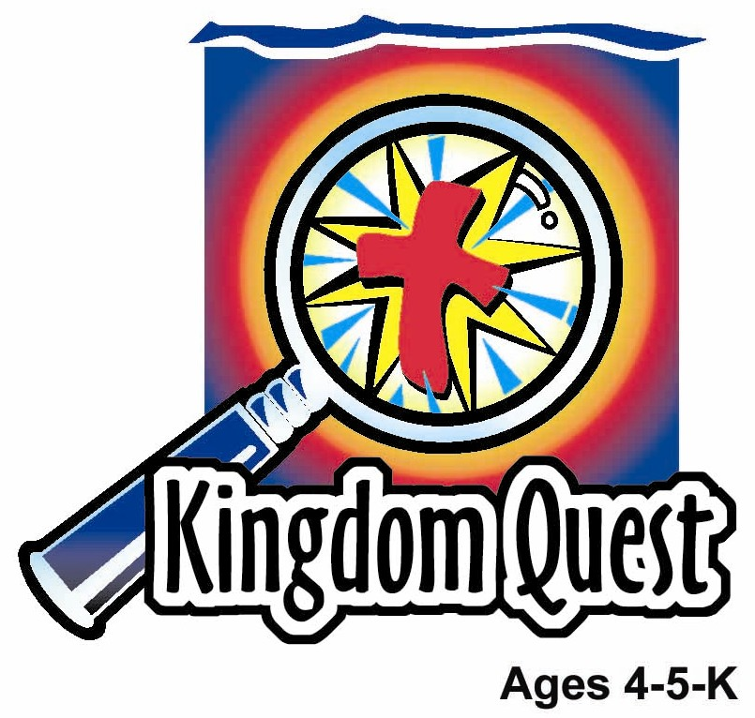
Date: ________________________
Series: God Teaches Me His Ways (Jun-Aug)
Year 2, Lesson 13

The Sheep and the Goats

Take Home Point: *GOD TEACHES ME—to share with others.
*Repeat this phrase throughout the lesson. The leader will say the first part of the phrase (CAPS). The children respond with the second part of the phrase (italics).

Bible Event: Matthew 25:31-46
Jesus Link: Jesus shared His life with me.

We will help children know:
- Jesus’ teaching about when He returns at the end of the world. He will separate the people into those who served Him and those who didn’t serve Him.
- Everything a person who loves Jesus does for others will be counted as if it has been done for Jesus.
- We share with others because Jesus shared His life on the cross for us.

We will help the children feel:
- Thankfulness that Jesus shared His life on the cross.
- Love for all people.
- Desire to share with others.

We will help the children do:
- Participate in an imagination theater presentation of the story “The Least of These.”
- Sort snack items while reviewing the Bible event.
- Play a game, “Red, Green, Chase, Run” as a fun way to recall Jesus sorting out the people.
THIS LESSON’S ROADMAP

DESTINATION | PAGE # | DISCOVERIES ON YOUR JOURNEY | SUPPLIES NEEDED
Large Group Opening   | 3  4-6 | Puppet Presentation  Bible Event | - Ting Ting puppet  - baby doll wrapped in a blanket  - video clip of people feeding, clothing, and helping the hungry (optional)  - microphone  - Imagination Box containing:  - Bible  - child-sized Jesus costume and king’s crown  - cup  - loaf of bread  - toy house or picture of house  - jacket  - thermometer  - toy handcuffs
Small Group Application   | 7  8  8  8 | Activity 1: “Spreading Love” Craft  Activity 2: “Sort and Eat” Snack  Activity 3: ”Red, Green, Chase, Run” Game  Activity 4: “Catch  Prayer Time | Activity 1:  - heavy white paper  - plastic or newspaper  - three bright colors of poster paint  - eye dropper or plastic spoon  - label that reads, “We spread Jesus’ love”  Activity 2:  - serviettes  - snack mix with two items (2 different snacks which can be bought from ‘Pasar Malam’)  HEALTHY SNACK OPTION:  - nuts and grapes  - paper cups  - water or juice  Activity 3:  - red and green pieces of paper  - masking tape  Activity 4:  - white board  - marker  - ball
Large Group Wrap-up   | 8  8 | Singing (Optional)  Lesson Review with Puppet Skit | - optional music for the lesson  - Xiao Er Puppet

Pre-Session Singing: (10 minutes)
Purpose: When all children are in one group singing, it is easy for new children to join the group and immediately get involved. When the music can be correlated, it introduces the theme for the day. Choose two to three songs and list them here.

Large Group Opening: (15 minutes)
Purpose: The puppet demonstrates the need that will be met in today’s lesson. The scripts are not written verbatim, but give a story line in which the group leader can interact with the puppet. The children are introduced to the take home point and then interact with God’s word as they experience the Bible event.

Supplies needed: Ting Ting puppet; baby doll wrapped in a blanket; video clip of people feeding, clothing, and helping the hungry (optional); microphone; Imagination Box containing.

Puppet Presentation:
Purpose: The puppet demonstrates the need that will be met in today’s lesson. The scripts are not written verbatim, but give a story line in which the group leader can interact with the puppet.

Ting Ting comes out carrying a baby doll wrapped in a blanket. In Ting Ting’s puppet world, the doll is not a toy but a real, live baby. It is her baby cousin, Abby. The presenter and Ting Ting “ooh” and ‘’aah” over the baby for a moment. Ting Ting smiles at the doll, talks to it, and even kisses it.

Then Ting Ting shares how she feels bad. All the grown-ups have been giving Abby special gifts like blankets, clothes, and toys. Ting Ting loves her new cousin and wants to be able to give her something too.

The presenter responds that Ting Ting has given Abby something very special. She gave Abby a smile, a kiss, her arms to hold her, and loving words. Those are the best gifts of all—they are the gift of love. In fact, in today’s Bible event, Jesus teaches His helpers whenever we share our love with another person, we are sharing our love with Jesus. That is how important Jesus sees the gift of love.

Practice the take home point with Ting Ting. *GOD TEACHES ME – to share with others. The presenter says the first half of the phrase, Ting Ting responds with the second half. After practicing it several times with Ting Ting, practice it with the group.

Bible Event: Imagination Theater
Imagination Theater is audience participation drama where the Bible event is told in creative fashion, using children as actors. The Imagination Box contains the Bible and other special props used for the drama. Begin by removing the Bible and explain that it is God’s word, telling us of the wonderful deeds God has done. Then remove an imaginary hat and place it on your head. This is your Imagination Hat. Invite the children to put on theirs as well. They will also use their imaginations to picture the events the Bible tells us about. Some will even use their imaginations to help act out these events. Distribute props to actors as they are called forward at the beginning of the presentation. Have them sit to the side until they are called on stage.

Take the Bible out of the prop box and explain to the children that today’s Bible event is a teaching from God’s word, the Bible. Jesus tells the disciples that when He comes back to take us to heaven, He will sort the people into two groups—those who loved Jesus and showed that love to others, and those who did not love Jesus and did not share that love with others.

Optional: Show a video clip of people helping people (for only 30 seconds).

Have 13 volunteers come on stage. Have one child dress in the Jesus costume. Give each of the following items to a different child: a cup, a loaf of bread, a toy house or picture of a house, a jacket, a thermometer, and handcuffs. Six children will not have anything. (If you have fewer than 13 children in your program, you can have fewer children with empty hands and the children holding the items can each have more than one item.)

Boys and girls, I want you to put on your imagination caps. Presenter puts an “invisible” imagination cap on his head. I want you to pretend that you are Jesus’ disciples, His special helpers, and He is teaching you about when He comes back to take His followers to heaven. This is what Jesus said.

When Jesus comes in all His glory and all His angels come with Him, He will sit on His heavenly throne, because Jesus is the King. Take out the crown and put it on the head of the child playing Jesus.

Jesus will then divide all the people into two groups—those who belong to His kingdom and those who do not belong to His kingdom. He calls the believers, sheep and the unbelievers, goats. Divide the children on stage into two groups. Put the children who are holding an object on the right side of Jesus. Put the other children on Jesus’ left side.

The children on Jesus’ right side belong to His kingdom because they know Jesus shared His life for them on the cross and they love Jesus. He says they are His sheep. The children on Jesus’ left side do not belong to His kingdom because they do not believe Jesus shared His life for them and they do not love Jesus. Because of this, He calls them goats.

Then the King, Jesus, will say to those on His right: Have Jesus repeat the following underlined phrases into the microphone.

- Come into My kingdom.

- Pull forward the child with the bread. I was hungry / and you gave Me food.

- Pull forward the child with the cup. I was thirsty / and you gave Me a drink.
- Pull forward the child with the house. You brought Me into your home.
- Pull forward the child with the jacket. I needed clothes / and you gave Me clothes.

- Pull forward the child with the thermometer. I was sick / and you took care of Me.

- Pull forward the child with the handcuffs. I was in prison / and you visited Me.

Then those people will scratch their heads, (have the children who were pulled forward scratch their heads) and ask, “When did we do those things for You?” Have the children, including the audience ask that question.

Jesus will say, “Whenever you did those things / for another person, / you did those things / for Me.”

Then the King Jesus will say to those on His left: Have Jesus repeat the following underlined phrases into the microphone.

- Go away from Me!
- I was hungry / and you did not feed Me.
- I was thirsty / and you did not give Me a drink.
- You did not take Me / into your home.
- I needed clothes / and you did not clothe Me.
- I was sick / and you did not care for Me.
- I was in prison / and you did not visit Me.

Then those people will scratch their heads have the children on the left scratch their heads and ask, “When did we not do those things for You?” Have the children, including the audience ask that question.

Jesus will say, “Whenever you did not do those things / for another person, / you did not do those things / for Me.”

Then Jesus will take those who loved Him home to heaven with Him and He will send the others away from Him.

Boys and girls, when Jesus was teaching this to His disciples, He was teaching them whenever we share our love with another person, we are sharing our love with Jesus. And why do we want to share our love with others and with Jesus? Because He shared His love for us when He died on the cross to take away our sins!

Practice the take home point with the children. *GOD TEACHES ME – to share with others. End with a brief prayer.

Small Group Application: (30 minutes)
Purpose: Smaller groups enable children to develop closer relationships with adults and peers in the church. As you reinforce the take home point with a fun hands-on activity, discuss the Bible event. Be sure to repeat the take home point several times. Say the first part and have the children respond with the second phrase. Application questions help kids apply the take home point to their daily lives. Close this session by gathering your small group for prayer. Let the kids pray!

During the small group application time, discuss the following questions and points:

Who belongs to the kingdom of God? (Those who know Jesus, love Jesus, and show that love to others. Jesus calls them His sheep.)

Who does not belong to the kingdom of God? (Those who do not love Jesus and who do not share His love with others. Jesus calls these unbelievers, goats.)

How did Jesus share His love with us? (He shared His life on the cross so our sins could be forgiven and we can someday live with Him in heaven.)

How can we show Jesus we love Him? (By loving others by sharing food, clothing, and other things with them and helping them when they have problems, such as being sick or hurt.)

Activity 1: “Spreading Love” Craft
Supplies needed: heavy white paper; plastic or newspaper; three bright colors of poster paint; eye dropper or plastic spoon; label that reads, “We spread Jesus’ love”

To make:
- The child folds the paper in half and then reopens it.
- The shepherd uses the spoon or eyedropper to drop six drops of paint on the paper (two of each color).
- For each drop, the shepherd names one way in which we can share God’s love with others as taught in the Bible event: share food, share drinks, share clothes, share home, help the sick, and visit those in prison.
- The child refolds the paper in half.
- The child then rubs the paper so the paint spreads out.
- Open the paper to reveal a beautiful design created by the paint.
- Add the label.

To discuss:
- Just as the paint spread out, when we share with others, we are spreading Jesus’ love.
- When the paint spread out, it made a beautiful picture. When we share with others, we are spreading the beauty of Jesus’ love with the world.

Practice the take home point. *GOD TEACHES ME – to share with others.

Activity 2: “Sort and Eat” Snack
Supplies needed: serviettes; snack mix with two items (Examples: 2 different types of snack which can be bought from “Pasar Malam”.)
HEALTHY SNACK OPTION: nuts and grapes; paper cups; water or juice

Give each child a handful of snack mix. Before they eat the mix, have them sort it into two groups. As they do so, review the Bible event.

HEALTHY SNACK OPTION: Refer to the nuts as the group that doesn’t know Jesus—they’re nuts for not loving him! The grapes are sweet on Jesus and bursting with love for Him!

Practice the take home point. *GOD TEACHES ME – to share with others.

Activity 3: “Red, Green, Chase, Run” Game
Supplies needed: red and green pieces of paper; masking tape

To set up the game:
- Place a strip of masking tape on the floor down the center of the playing area.
- Use either the walls or place a strip of masking tape on each side of the first. These strips must be parallel to and 10-15 feet away from the first strip.
- Divide the children in half and line them up, facing each other, on both sides of the masking tape.
- The shepherd stands at the head of the lines, facing the children.

To play:
- The shepherd holds up the red and green papers, one on each side of the line.
- The group with the red paper flees to the wall or the line of masking tape behind them.
- The group with the green paper must chase them and try to tag them.
- If a child is tagged, he must go over to the other team.
- Continue playing as time and interest allows, mixing up the colors so that the teams never know which color they will get.
- If all the children end up on one side, that team wins. Otherwise, the team with the most kids at the end of the time wins.

To discuss:
- In this game, you were sorted into two groups. In the Bible event, how did Jesus sort the children into two groups?
- How were the groups in the Bible event different?
- How can you be like the group on Jesus’ right, the group that was entering the kingdom of heaven?
- Why should we want to show love to others by sharing with them?
- How did Jesus share His love for us?

Practice the take home point. *GOD TEACHES ME – to share His love.

Activity 4: “Catch and Say”
Purpose: Help kids to memorize and keep scriptures at heart. Using creative ways to help kids enjoy learning the key verse and in small group setting.

Supplies needed: White board; marker; ball

Memory Verse: John 15:4 ~ Remain in me, and I will remain in you.

Memory Verse Learning:
Pre-write the memory verse on the white board. Ask the children to recite the memory verse a few times together. Erase the memory verse on the board. Then, get them to stand in a circle. The Shepherd will demonstrate by calling the child’s name and throw the ball to him or her. When a child catches the ball, everyone claps or cheers for the child. He/she then throws back to the shepherd who will comment “Good job.” The child who catches the ball needs to recite the memory verse before calling another child’s name. The Shepherd is to make sure that everyone gets a chance to play. Repeat the game as many rounds as time permits. End the game by saying the memory verse together.

Prayer Time:
Ask God to show us how to share His love and with whom.

Large Group Wrap-Up: (10 minutes)
Purpose: The crazy bird puppet, Xiao Er, struggles with learning the take home point. The leader shows an example of each small group application activity from this lesson and says the first phrase of the take home point. The kids respond with their phrase. They try to teach the puppet the take home point, but each time he confuses words or concepts. After three attempts, he finally gets it right and sings the correct take home point in a silly opera-like voice.

Supplies needed: optional music for the lesson; Xiao Er Puppet

Singing: (Optional)

Lesson Review with Puppet Skit:

Xiao Er’s confused phrases:

Activity 1: “Spread love not boogies.”
Activity 2: “To always share with your bird friends… gimme, gimme.”
Activity 3: “To share with otters.”
Activity 4: “To throw the ball and say “Good Job”.

Welcome guests and thank them for attending.

Lesson 13

Large Group Warm-up
- Ting Ting puppet
- baby doll wrapped in a blanket
- video clip of people feeding, clothing, and helping the hungry (optional)
- microphone
- Imagination Box containing:
- Bible
- child-sized Jesus costume and king’s crown
- cup
- loaf of bread
- toy house or picture of house
- jacket
- thermometer
- toy handcuffs

Small Group Application
Activity 1:
- heavy white paper
- plastic or newspaper
- three bright colors of washable tempera paint
- eye dropper or plastic spoon
- label that reads, “We spread Jesus’ love”
Activity 2:
- serviettes
- snack mix with two items (Examples: cereal, candies, Teddy Grahams, crackers, pretzels, nuts, raisins)
- paper cups
- water or juice
Activity 3:
- red and green pieces of paper
- masking tape
Activity 4:
- white board
- marker
- ball

Large Group Wrap-up
- optional music for the lesson
- Xiao Er puppet

