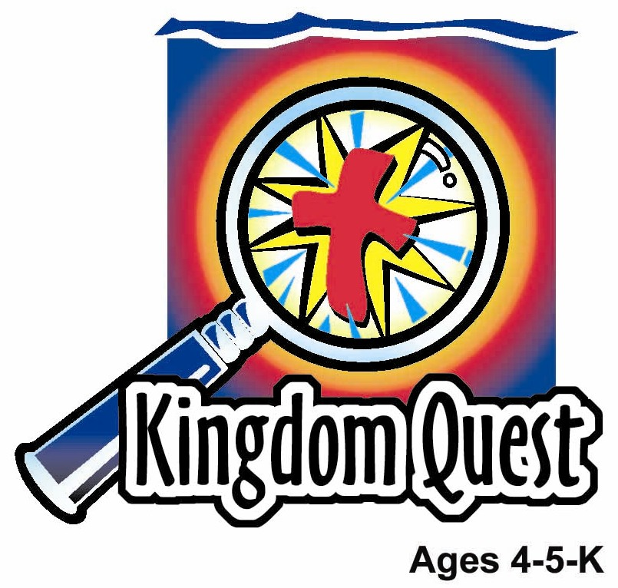
Date: ________________________
Series: God Teaches Me His Ways (Jun-Aug )
Year 2, Lesson 14

Small But Wise Creatures

Take Home Point: *GOD TEACHES ME—to do big things for Him.
*Repeat this phrase throughout the lesson. The leader will say the first part of the phrase (CAPS). The children respond with the second part of the phrase (italics).

Bible Event: Proverbs 30:24-28
Jesus Link: Jesus said, “Unless you… become like little children, you will never enter the kingdom of heaven.” (Matthew 18:2)

We will help children know:
- How ants, grasshoppers, lizards, and beavers are small but wise.
- How they can be wise to do big things for God.
- Jesus commended little children for having big faith, faith to enter the kingdom of heaven.

We will help the children feel:
- Equipped to do big things.
- Important parts of God’s kingdom.
- Eager to do big things for God.

We will help the children do:
- Participate in a mystery box presentation of the Bible event.
- Make and eat “Ants On a Log” to review the Bible event.
- Compete against the shepherd to do activities that children can do better than adults and relate it to the take home point.

THIS LESSON’S ROADMAP

DESTINATION | PAGE # | DISCOVERIES ON YOUR JOURNEY | SUPPLIES NEEDED
Large Group Opening  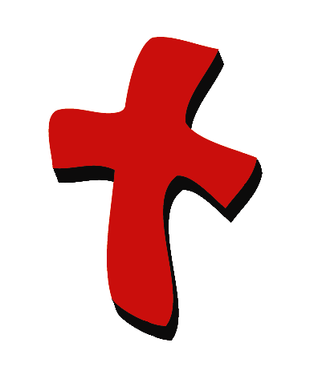 | 3  3-5 | Puppet Presentation  Bible Event | - Xiao Hung puppet  - toy hammer  - one or two small blocks of wood  - Mystery Box  - toy animals or pictures of animals: ant, grasshopper, lizard, and beaver
Small Group Application   | 6  6  6-7  8  8 | Activity 1: “Animal Banner” Craft  Activity 2: “Ants On a Log” Snack  Activity 3: ”Challenge Course” Game  Activity 4: “Remember and Write”  Prayer Time | Activity 1:  - reproducible of animals  - scissors  - glue sticks  - paper punch  - two foot strips of two inch wide ribbon for each child  - one foot strip of narrow ribbon  - crayons, colored pencils, or markers  Activity 2:  - “log”: finger biscuit  - “glue”: honey, peanut butter, cream cheese, cheese spread or “kaya”  - “ants”: chocolate chips or raisins  - serviettes  - plastic knives  - cups  - water or juice  Activity 3:  - broom stick  - two chairs  - hula hoop  - small toy or object  - Pringles or tennis ball container  - ping-pong ball  Activity 4:  - white board  - marker  - worksheet  - colour pencils  - glue  - craft from Activity 1
Large Group Wrap-up   | 8  8 | Singing (Optional)  Lesson Review with Puppet Skit | - Xiao Er puppet  - Sample materials from small group activities

Pre-Session Singing: (10 minutes)
Purpose: When all children are in one group singing, it is easy for new children to join the group and immediately get involved. When the music can be correlated, it introduces the theme for the day. Choose two to three songs and list them here.

Large Group Opening: (15 minutes)
Purpose: The puppet demonstrates the need that will be met in today’s lesson. The scripts are not written verbatim, but give a story line in which the group leader can interact with the puppet. The children are introduced to the take home point and then interact with God’s Word as they experience the Bible event.

Supplies needed: Xiao Hung puppet; toy hammer; one or two small blocks of wood; Mystery Box: toy animals or pictures of animals: ant, grasshopper, lizard, and beaver

Puppet Presentation:
Purpose: The puppet demonstrates the need that will be met in today’s lesson. The scripts are not written verbatim, but give a story line in which the group leader can interact with the puppet.

Carrying a hammer, Xiao Hung is excited because his dad is teaching him how to build a tree house. The presenter shares his excitement and expresses that Xiao Hung’s dad sure trusts him to help with such a big job. The presenter relates it to today’s Bible event in which the children will learn that small animals are wise enough to do big things and small children can do big things for God.

The presenter teaches the take home point to Xiao Hung, practicing it several times before teaching it to and practicing it with the children. *GOD TEACHES ME – to do big things for Him.

Bible Event: Mystery Box
The Mystery Box contains objects that will help the presenter tell the Bible event in creative fashion. They can be lifted out and shown as the story is told. Another option is to have a hole cut in the top of the box so that a child could put a hand in and guess what the object is before it is shown.

Note: In today’s Bible reading, a coney or rock badger is mentioned. Because most children will be unfamiliar with a coney, the same concept will be taught using a beaver.

Bring out the Mystery Box with the toy animals or animal pictures in it.

Boys and girls, today we have our Mystery Box. Inside the Mystery Box are some things that will help me tell you our Bible event. Close your eyes and imagine what might be in the Mystery Box. Imagine something very tiny with six tiny little legs and two small feelers. Next, imagine something furry with a big flat tail. Now imagine something green or brown that likes to hop through grass. Finally, imagine something long and skinny, with scaly skin.

Boys and girls, you can open your eyes now. If you were busy imagining with me, I bet you solved the mystery of what is in my Mystery Box. I bet you were imagining different animals.

Today we are going to learn that some animals are very wise. Even though they are small, they can do big jobs. Small children can do big jobs for God, too!

Pick up Bible and turn to Proverbs. In the Bible is a book called Proverbs. Proverbs tells us all about wisdom. One thing it tells us about wisdom is that there are four small but wise animals.

Take the ant or any picture out of the box. One animal the Bible tells us about is the ant. The ant has almost no strength. Can you show me weak muscles? Hang limp. Even though ants have very little strength, in the summer they are able to gather all the food they need for the winter.

Put the ant aside and take out the beaver. Show me what a beaver does. Put hands under chin, fingers pointing out and down, and make jaw go up and down rapidly, making smacking sounds. Beavers never took a class on carpentry; they aren’t very educated. They don’t have any schooling. But beavers are smart enough to build their own homes.

Put aside beaver and take out grasshopper. Another animal the Bible tells us about is the grasshopper. Show me a grasshopper jumping up and down. Jump in place several times. Grasshoppers have no king, yet they go places together like an army going to war.

Put aside grasshopper and take out lizard. The last animal the Bible tells us about is the lizard. Can you slither like a lizard? Put arms out, palms down, and wiggle upper body in a “slithery” motion. Lizards are so easy to catch; a person can catch one with his hands. Yet, lizards are wise enough to sneak into the palace of a king.

Did you know that little children are like these animals? It says so here in my Bible. Let me read you a verse. Turn to Matthew 18:3-4. In Matthew 18:3-4, Jesus says, “I can guarantee this truth: Unless you change and become like little children, you will never enter the kingdom of heaven. Whoever becomes like this little child is the greatest in the kingdom of heaven.”

Close the Bible and put it down. In those verses, Jesus is saying that grown-ups need to become like little children if they want to go to heaven. Why? Because even though children are small like the animals, they can do big things like the animals.

Jesus said children are humble. Children don’t think they can get to heaven by themselves. Some grown-ups think they can earn their way to heaven, but children know they need Jesus. They know they need His love. They know they can go to heaven because Jesus loves them. In fact, Jesus loves us so much, He did something big for us. He died on the cross so we can be forgiven.

That reminds me of today’s special words. *GOD TEACHES ME – to do big things for Him. Children do big things when they are humble and love and trust Jesus. And children do big things when they share Jesus’ love with others.

Practice the take home point with the children. *GOD TEACHES ME – to do big things for Him.

End with a brief prayer.

Small Group Application: (30 minutes)
Purpose: Smaller groups enable children to develop closer relationships with adults and peers in the church. As you reinforce the take home point with a fun hands-on activity, discuss the Bible event. Be sure to repeat the take home point several times. Say the first part and have the children respond with the second phrase. Application questions help kids apply the take home point to their daily lives. Close this session by gathering your small group for prayer. Let the kids pray!

During the small group application time, discuss the following questions and points:

How are the four animals in the Bible event each wise? (Ants: store food for winter; beavers: make a home to live in; grasshoppers: go places together; and lizards: get into king’s palaces.)

How are little children wise according to Jesus? (They have great faith in, trust in, and love for Jesus.)

What big things can little kids do for Jesus? (Answers will vary, but may include telling others about Jesus, sharing Jesus’ love, or bringing a friend to Sunday School.)

What big thing did Jesus do for you? (He died on the cross so our sins can be forgiven.)

Activity 1: “Animal Banner” Craft
Supplies needed: reproducible of animals; scissors; glue sticks; paper punch; two foot strips of two inch wide ribbon for each child; one foot strip of narrow ribbon; crayons, colored pencils, or markers

To make:
- Color the animal pictures.
- Cut the picture in four sections.
- Punch a hole at the top of the wide ribbon. (An adult may need to help with this step.)
- Glue the pictures to the wide ribbon in a vertical line.
- String the narrow ribbon through the hole in the wide ribbon and tie in a loop.
- Use the loop to hang the banner on a doorknob or elsewhere.
To discuss:
Note: Tell the children to leave a space on the wide ribbon for the memory verse learning worksheet.
- Why was each type of animal wise?
- What are some big things you can do for God, even though you are small?
- Why are adults to become like little children?

Practice the take home point. *GOD TEACHES ME – to do big things for Him.

Activity 2: “Ants On a Log” Snack
Supplies needed: “log”: finger biscuit; “glue”: honey, peanut butter, cream cheese, cheese spread or “Kaya”; “ants”: chocolate chips or raisins; serviettes; plastic knives; cups; water or juice

To make:
- Have the children spread the “glue” on the “logs” using a plastic knife.
- Attach about three “ants” on the log by placing them in the “glue.”
- Eat!

HEALTHY SNACK OPTION: Use the natural choices listed in the Roadmap

To discuss:
- As the children eat their snacks, review the Bible event.
- What are some big things little kids can do for God?

Practice the take home point. *GOD TEACHES ME – to do big things for Him.

Activity 3: “Challenge Course” Game
Supplies needed: broom stick; two chairs; hula hoop; small toy or object; Pringles or tennis ball container; ping-pong ball

Objective:
Demonstrate that, because of their small size, children are able to more easily do some activities that are difficult for adults and relate that to the teaching that even little children can do big things for God.

To play:
- All the children will do each of five different challenge activities. (They all do one activity before proceeding to the next activity.)
- If a child has difficulty doing the activity, allow the ability of the group to do the activity count for the child.
- After all of the children do an activity, the shepherd does the activity.
- Most of the activities should be difficult for the shepherd to do because of size—they are structured for smaller bodies. If the shepherd is able to do an activity, the shepherd should “make a show” of not being able to do it.
- Each time the children are able to do an activity and the shepherd is not able to do the activity, the children get a point.
- At the end of the game, the children, because they got all the points, are the winners. Their prize is a label that says “I can do big things for God.”

Activities:
- Set the bar across two low chairs. Have the children and then the shepherd stoop to walk under the bar without touching it or bumping it off the chairs.
- Have one person hold the hula hoop vertical with the ground, so that part of it is touching the ground and part of it is in the air. Have the children and then the shepherd stoop to jump through it.
- Set the small object near the wall. Have the children and then the shepherd take turns putting their heels next to the wall. Bend the knees low enough to pick up the object and then stand upright without moving the feet.
- Everyone must touch their toes to their nose.
- Drop a ping-pong ball into the Pringles can or tennis ball container. Each person must reach into the container, grab the ball, and get it out without tilting the can.

To discuss:
- Why were the activities easier for the children than the shepherd?
- What big things can little kids do for God?
- Review the meaning of the Bible verse, “I tell you the truth, unless you change and become like little children, you will never enter the kingdom of heaven. Therefore whoever humbles himself like this child is the greatest in the kingdom of heaven.” (Matthew 18:3-4 NIV)

Practice the take home point. *GOD TEACHES ME – to do big things for Him.

Activity 4: “Remember and Write”
Purpose: Help kids to memorize and keep scriptures at heart. Using creative ways to help kids enjoy learning the key verse and in small group setting.

Supplies needed: White board; marker; ¼ of the worksheet cut out for each child; colour pencils; glue; craft from Activity 1.

Memory Verse: John 15:4 ~ Remain in Me, and I will remain in you.

Memory Verse Learning:
Pre-write the memory verse on the white board. Review the memory verse with the children. Then, give each child a piece of the memory verse worksheet. Tell the children to read the memory verse as they trace the words with colour pencils. Attach the worksheet on the craft from Activity 1. Explain to the children that when we remain in God and God remains in us, we can do big things for Him. Recite the memory verse together when everyone has finished.

Prayer Time:
Ask God to teach us how to serve Him.

Large Group Wrap-Up: (10 minutes)
Purpose: The crazy bird puppet, Xiao Er, struggles with learning the take home point. The leader shows an example of each small group application activity from this lesson and says the first phrase of the take home point. The kids respond with their phrase. They try to teach the puppet the take home point, but each time he confuses words or concepts. After three attempts, he finally gets it right and sings the correct take home point in a silly opera-like voice.

Singing: (Optional)

Lesson Review with Puppet Skit:

Xiao Er’s confused phrases:

Activity 1: “To do little itty, bitty, teeny weenie, itsy bitsy things for him.”
Activity 2: “God teaches me to eat ants.”
Activity 3: “That elephants are bigger than my house.”
Activity 4: “I like to write and read.”

Welcome guests and thank them for attending

Lesson 14

Large Group Warm-up
- Xiao Hung puppet
- toy hammer
- one or two small blocks of wood
- Mystery Box
- toy animals or pictures of animals: ant, grasshopper, lizard, and beaver

Small Group Application
Activity 1:
- reproducible of animals
- scissors
- glue sticks
- paper punch
- two foot strips of two inch wide ribbon for each child
- one foot strip of narrow ribbon
- crayons, colored pencils, or markers
Activity 2:
- “log”: finger biscuit
- “glue”: honey, peanut butter, cream cheese, cheese spread or “Kaya”
- “ants”: chocolate chips or raisins
- serviettes
- plastic knives
- cups
- water or juice
Activity 3:
- broom stick
- two chairs
- hula hoop

- small toy or object
- Pringles or tennis ball container
- ping-pong ball
Activity 4:
- white board
- marker
- worksheet (cut out 1/4 of an A4
reproducible per child)
- colour pencils

Large Group Wrap-up
- optional music for the lesson
- Xiao Er Puppet

