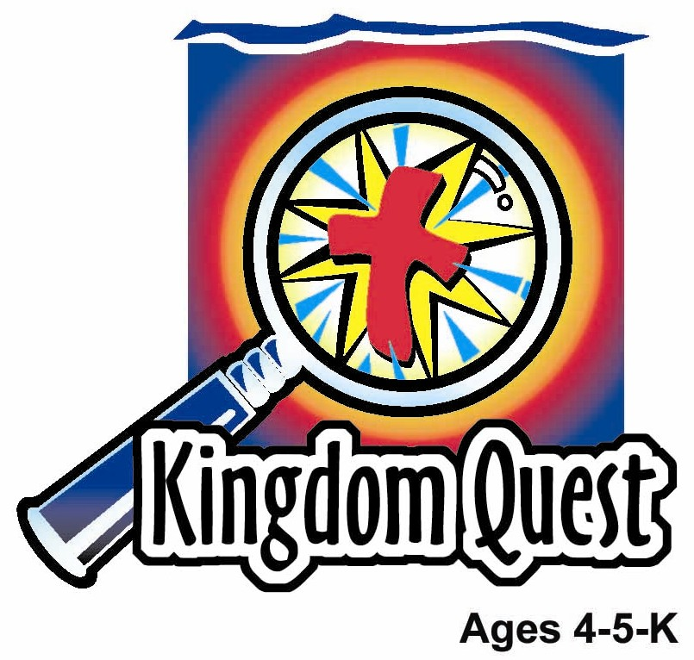
Date: ________________________
Series: God is Awesome (Jun-Aug)
Year 2, Lesson 7

Joshua Fights the Battle at Jericho—and God Wins!

Take Home Point: *GOD IS AWESOME—Do what God says.
*Repeat this phrase throughout the lesson. The leader will say the first part of the phrase (CAPS). The children respond with the second part of the phrase (italics).

Bible Event: Joshua 6:1-21
Jesus Link: Jesus won the battle over our sin.

We will help children know:
- The story of the Battle of Jericho.
- When we do what God says, He helps us with our problems.
- Jesus won our battle over sin when He died on the cross.

We will help the children feel:
- Eager to follow what God says.
- Assured that God can help them with their problems.
- Confident in God’s power.

We will help the children do:
- Divide into three groups and dramatize the battle of Jericho.
- Eat Bugles for a snack, while reviewing the Bible event.
- Play the game, “The Walls of Jericho,” as an active way to learn how we can do what God says and trust in His power to help us.
THIS LESSON’S ROADMAP

DESTINATION | PAGE # | DISCOVERIES ON YOUR JOURNEY | SUPPLIES NEEDED
Large Group Opening  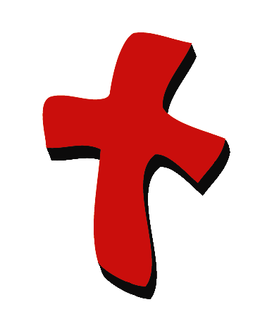 | 3  3-5 | Puppet Presentation  Bible Event | - Xiao Hung puppet  - black headband for Xiao Hung to wear  - two shields (toy shields or cardboard shields)  - trumpet (real trumpet or ram’s horn will work the best but a kazoo or even a homemade horn will work)  - Ark of the covenant (something as simple as a box spray painted gold and attached to two dowel rods can be used)  - Bible costume for Joshua
Small Group Application   | 5-6  6  6-7  7  8 | Activity 1: “Israelite Horns” Craft  Activity 2: “Bugles” Snack  Activity 3: “The Walls of Jericho” Game  Activity 4: “Toot and Shout!”  Prayer Time | Activity 1:  - toilet paper tube for each child  - wax paper  - rubber band for each child  - labels with take home point printed on it  - materials to decorate the horn, such as tissue paper squares and glue, markers, ribbons to tape to the ends, paints, stickers or other items available to your program.  Activity 2:  - Bugle snacks  - serviettes  - cups  - water or juice  HEALTHY SNACK OPTION:  - bananas or celery sticks  - water  Activity 3:  - seven blocks  - table or other defined area to circle around  Activity 4:  - white board  - marker  - “Israelite Horn” from Activity 1
Large Group Wrap-up   | 8  8 | Singing (Optional)  Lesson Review with Puppet Skit | - optional music for the lesson  - Xiao Er Puppet

Pre-Session Singing: (10 minutes)
Purpose: When all children are in one group singing, it is easy for new children to join the group and immediately get involved. When the music can be correlated, it introduces the theme for the day. Choose two to three songs and list them here.

Large Group Opening: (15 minutes)
Purpose: The puppet demonstrates the need that will be met in today’s lesson. The scripts are not written verbatim, but give a story line in which the group leader can interact with the puppet. The children are introduced to the take home point and then interact with God’s word as they experience the Bible event.

Supplies needed: Xiao Hung puppet; black headband for Xiao Hung to wear; two shields (toy shields or cardboard shields); trumpet (real trumpet or ram’s horn will work the best but a kazoo or even a homemade horn will work); Ark of the covenant (something as simple as a box spray painted gold and attached to two dowel rods can be used); Bible costume for Joshua

Puppet Presentation:
Purpose: The puppet demonstrates the need that will be met in today’s lesson. The scripts are not written verbatim, but give a story line in which the group leader can interact with the puppet.

Xiao Hung comes out wearing a black headband. There’s a bully at school named Hwai Tan. Xiao Hung wants to beat him up. He’s going to use karate on Hwai Tan. He will hide behind a tree and when Hwai Tan walks by, Xiao Hung is going to kick him in the back. Then, when Hwai Tan turns around, Xiao Hung’s going to kick him in the front. Then, Xiao Hung’s going to run away and Hwai Tan will learn that he can’t be mean anymore. The presenter asks Xiao Hung if beating up Hwai Tan is God’s way of doing things. At first, Xiao Hung thinks so. After all, Hwai Tan is mean to everybody. After the presenter and Xiao Hung talk for a minute, Xiao Hung realizes that this really isn’t God says. God’s way is to pray to him for help, tell an adult about what Hwai Tan is doing, and look for ways to be nice to Hwai Tan, not hurt him. The presenter uses this to lead into the story of Joshua and the battle of Jericho. Joshua followed God’s way, even though it didn’t make sense, and God won the battle for the Israelites.

Teach Xiao Hung the take home point. *GOD IS AWESOME– Do what God says. The presenter says the first part and Xiao Hung responds with the second part. After the presenter practices it with Xiao Hung several times, he teaches it to the kids.

Bible Event:
Purpose: The Bible event is written in a creative fashion so children can recall major points of the event. The take home point is reinforced. The leader says the first part of the take home point and the children respond with their phrase.

Divide the children up into three groups, one small group and two larger groups. Have the smaller group huddle close to one another in the center of the room. This group represents Rahab and her family. The second group should hold hands and circle Rahab’s family to form the walls of Jericho. The third group is Joshua and the Israelites. This group forms a line. At the front of the group is a child carrying a shield. Then comes the leader with a horn. Next, come several priests, carrying the Ark of the Covenant. Following the priests is Joshua, dressed in a costume. The remainder of the children will follow Joshua, ending with a soldier carrying a shield.

Begin:

The people of Israel had spent 40 years in the desert, traveling to a new home in the land of Canaan. When they arrived, they came to the city of Jericho. Before they could enter the new country that God was going to give them, they had to fight against the people of Jericho and win. The city of Jericho was surrounded by big walls and would be hard to defeat, so Joshua prayed to God and asked Him what to do. God told him to take His people and walk around the city while blowing the ram’s horn. The armed guard was to be in front of the priests, with seven priests behind them carrying trumpets. Then came the Ark of the Covenant, followed by another armed guard. They were to march around the city of Jericho for six days, blowing their trumpets each time and doing nothing else. Let’s do what God commanded.

Have the Israelites march around the city once while you blow the trumpet, then sit down. Repeat this six times.

When the children sit down after the sixth day, say:

On the seventh day, God had the Israelites do something different. He told them to circle the city six times, the same way they had the last six days. So, they did.

Group circles the city six times.

After they were finished, God told them to circle the city a seventh time, this time shouting as the priest blew the ram’s horn. Then, the walls fell down and the Israelites could enter the city. They destroyed everything except for a woman named Rahab and her family, because she had helped the people of Israel. Then, the Israelites helped Rahab and her family safely out of the city.

Have the children circle the city a seventh time, blowing the horn and shouting, “God will win!” repeatedly. When they get around the city, the children playing the wall fall to the ground. The Israelites run into the city and grab the hands of Rahab and her family and pull them out of the city. Have all the children sit down.

The people of Israel had fought the battle God’s way and had won the victory. We also can live our lives God’s way and have victory over sin and problems. We can do that because Jesus fought our battle against sin on the cross and Jesus won!

Practice the take home point. *GOD IS AWESOME– Do what God says.

End with a brief prayer.

Small Group Application: (30 minutes)
Purpose: Smaller groups enable children to develop closer relationships with adults and peers in the church. As you reinforce the take home point with a fun hands-on activity, discuss the Bible event. Be sure to repeat the take home point several times. Say the first part and have the children respond with the second phrase. Application questions help kids apply the take home point to their daily lives. Close this session by gathering your small group for prayer. Let the kids pray!

During the small group application time, discuss the following questions and points:

How do people usually fight wars? (Answers will vary, but may include fighting, shooting, etc.)

How did God have Joshua and the Israelites fight the Battle of Jericho? (They were to peacefully march around the city, blowing trumpets. On the last day, they also shouted.)

What problems do we have in our lives? (Answers will vary, but may include bullies, sickness, falling and getting hurt, etc.)

How can we live our lives God’s way? (Answers will vary, but may include asking God for help, following God’s rules, loving God, showing love to other people, etc.)

Remember that when the Israelites followed God’s ways, He helped them win the battle. When we live our lives God’s way, He will help us also. Most importantly, He already helped us win the battle over sin, by sending Jesus to fight for us by dying on the cross. Now, when we fail to live our lives God’s way, we can be forgiven because of Jesus. The victory is already ours! God is awesome!

Activity 1: “Israelite Horns” Craft
Supplies needed: toilet paper tube for each child; wax paper; rubber band for each child
labels with take home point printed on it; materials to decorate the horn, such as tissue paper squares and glue, markers, ribbons to tape to the ends, paints, stickers or other items available to your program.

To make:
- Decorate the toilet paper tube, using materials from the list above, or other craft supplies available to your program.
- Put a 4-inch square of wax paper over one end of the tube, using a rubber band to hold it in place.
- Affix the label to the tube.
- To play the horn, toot into the open end of the tube.

To discuss:
- Read the take home point on the horns to the children.
- Review the Bible event.
- Ask, “How did God show Joshua and the Israelites that he was awesome?”
- Ask, “How has God showed you in your life that he is awesome? “
- Toot the horns to praise God, for being awesome and taking care of his people, when they live their lives his way.
- Ask, “What are some ways you fail to do what God says?”
- Toot the horns a second time, for praising Jesus, for winning the battle against sin on the cross, so you can be forgiven, when you fail to live life as God says.

Activity 2: “Trumpet” Snack.
Supplies needed: Ice cream cones; serviettes; cups; water or juice; HEALTHY SNACK OPTION: bananas or celery sticks; water

To make:
Give the children a snack of trumpet. Point out that the Trumpets are a reminder of the trumpets the Israelites blew. As they eat, use the time to review the Bible event, discuss the small group application questions and practice the take home point. *GOD IS AWESOME– Do what God says.

HEALTHY SNACK OPTION: Children are great at pretending and being resourceful. Use celery sticks or even bananas as a horn to remind them of the trumpets the Israelites blew. Again, practice the take home point. *GOD IS AWESOME– Do what God says.

Activity 3: “The Walls of Jericho” Game
Supplies needed: seven blocks; table or other defined area to circle around

Objective:
Use different movements to go around Jericho seven times, each time adding a block to a tower and thinking of a way to live life God says. Collapse the tower when finished.

To play:
- Choose one child to be a leader. That child chooses a way to move (for example, hop or skip) and lead the entire group around the table. If the kids have already made their trumpets, they can toot them while they go around the table.
- Before the group follows the leader around the table, they must think of one way they can live their lives God says. (For example, obey parents, follow God’s rules, love Jesus, trust God, etc.)
- After they have finished going around the table, the shepherd puts a block on the table. They are building a block tower that represents the city of Jericho.
- Choose a new leader and repeat.
- Continue playing until the children have walked around the city seven times and you have built a tower seven blocks tall. On the seventh time, have the children chant, “God is awesome!”
- Have the children gather around the table and try to collapse Jericho by blowing on the blocks all at once from different sides.

Ideas for movements:
- Skip 6. Run
- Hop 7. March
- Gallop 8. Walk backwards
- Baby steps 9. Crawl
- Giant steps 10. Jump

To discuss:

Joshua was the leader of the Israelites, but their real leader was God. Who are leaders in your life that God give you to follow? (Parents, teachers, etc.) Just as Joshua and the Israelites followed God’s way, we are to follow God says. God’s way to live is the best, because God loves us and cares for us, and He wants to help us.

Practice the take home point. *GOD IS AWESOME– Do what God says.

Activity 4: “Toot and Shout”
Purpose: Help kids to memorize and keep scriptures at heart. Using creative ways to help kids enjoy learning the key verse and in small group setting.

Supplies needed: white board; marker; “Israelite Horn” from Activity 1.

Memory Verse: Psalm 96:4 ~ The Lord is great; He should be praised at all times.

Memory Verse Learning:
Pre-write the memory verse on the white board. Ask the children to read the memory verse a few times together. Then, teach them to sing the verse as follow to the tune of “God is so Good”.
The Lord is great,
He should be praised
At all times.
Psalm ninty-six verse four

After singing the song a few times, allow the children to hold their “Israelite Horn” which they have made in Activity 1 as they march around the classroom while singing the song. At the end of the song, they may toot their horns and shout out “Hallelujah!”

Prayer Time:
Pray for our leaders that they might follow God says.

Large Group Wrap-Up: (10 minutes)
Purpose: The crazy bird puppet, Xiao Er, struggles with learning the take home point. The leader shows an example of each small group application activity from this lesson and says the first phrase of the take home point. The kids respond with their phrase. They try to teach the puppet the take home point, but each time he confuses words or concepts. After three attempts, he finally gets it right and sings the correct take home point in a silly opera-like voice.

Singing: (Optional)

Lesson Review with Puppet Skit:
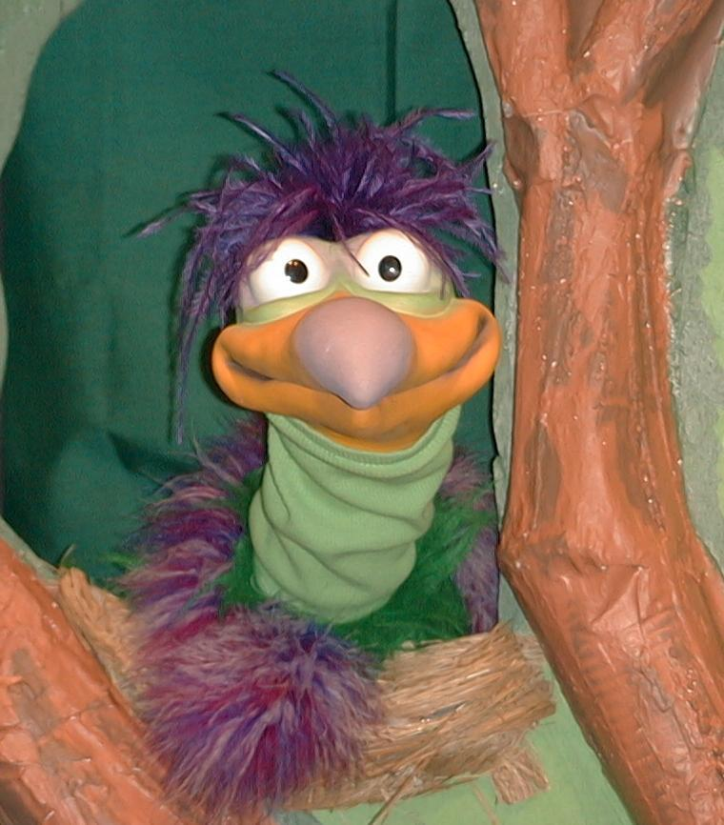
Presenter shows Xiao Er a craft made in Activity 1. Then the kids attempt to teach Xiao Er the take home point.

Presenter says to kids: “GOD IS AWESOME…”
Kids say: “…Do what God says.”
Presenter says to Xiao Er: “GOD IS AWESOME…”
Xiao Er says: “Live your life with horns?”

Presenter shows an example of the next activity done in small group and repeats first phrase to kids. The kids say the correct response trying to teach Xiao Er the take home point. Continue in this manner with Presenter showing example of each activity. Here are Xiao Er’s responses:

Xiao Er’s response to Activity 2 sample: “Toot-tootlytoot-toot (playing a trumpet.)”
Xiao Er’s response to Activity 3 sample: “Hey, I thought the big bad wolf blew down the walls of Jericho.”
Xiao Er’s response to Activity 4 sample: “Sing, toot and shout! I like it…”

Presenter says: “Xiao Er, listen one last time.
GOD IS AWESOME…”
Kids response: “…Do what God says.”
Presenter says to Xiao Er: “GOD IS AWESOME…”
Xiao Er’s response: (Warms up his singing voice with “Mee, mee, mee, mee, mee…” and sings in a silly dramatic opera-like voice) “GOD IS AWESOME– Do what God says.”

Welcome guests and thank them for attending.

Lesson 7

Large Group Warm-up
- Xiao Hung puppet
- black headband for Xiao Hung to wear
- two shields (toy shields or cardboard shields)
- trumpet (real trumpet or ram’s horn will work the best but a kazoo or even a homemade horn will work)
- Ark of the covenant (something as simple as a box spray painted gold and attached to two dowel rods can be used)
- Bible costume for Joshua

Small Group Application
Activity 1:
- toilet paper tube for each child
- wax paper
- rubber band for each child
- label with take home point printed on it
- materials to decorate the horn, such as tissue paper squares and glue, markers, ribbons to tape to the ends, paints, stickers or other items available to your program.
Activity 2:
- ice cream cones
- serviettes
- cups
- water or juice
Activity 3:
- seven blocks
- table or other defined area to circle around
Activity 4:
- white board
- marker
- “Israelite Horn” from Activity 1

Large Group Wrap-up
- optional music for the lesson
- Xiao Er Puppet

