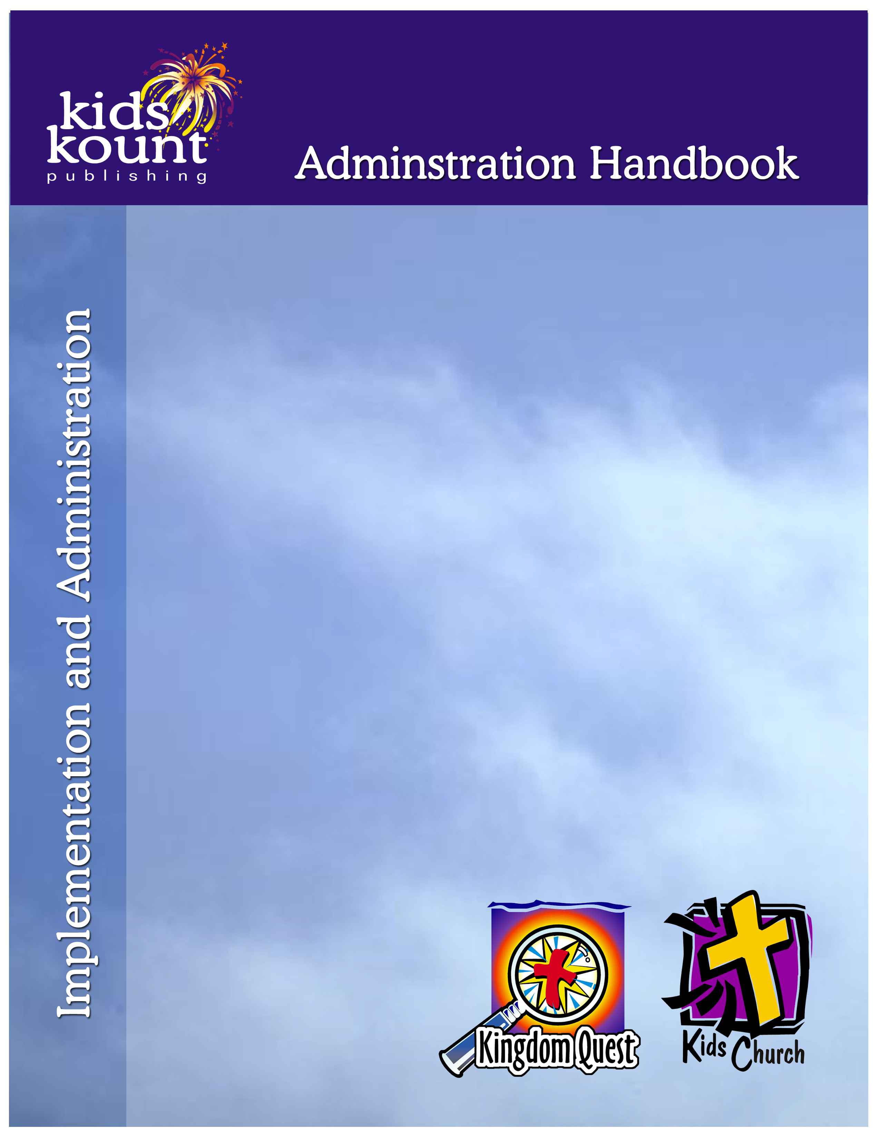

ADMINISTRATION HANDBOOK

for the
Director of Children’s Ministry
and
Supply Coordinator

Multiple resources to administrate children’s ministry and
implement Kingdom Quest Curriculum and/or Kids Church Curriculum.

Name: _____________________________

Serving As: ________________________

Copyright © 2018 Kids Kount Publishing

11615 “I” Street, Omaha, NE 68137
www.kidskountpublishing.com
All rights reserved.

Written by Dr. Roger Theimer
Safety and Security: Safety and security procedures are important for each church to carefully define and implement according to their unique needs. The security, safety, illness and accident procedures described in this curriculum are provided for example purposes only and may not be appropriate, applicable or adequate for every situation. Each church is responsible for determining whether any security, safety, illness and accident procedures contained in the curriculum are appropriate, applicable or adequate for its unique situation. The activities described in this curriculum require adult supervision and may not be suitable for each child and each situation. Each church is responsible for ensuring that adequate adult supervision is provided for all activities and for determining whether an activity is appropriate for each child and each situation. Kids Kount Publishing disclaims all liability for the implementation of any procedures or the performance of any activities described in this curriculum.
Administration Handbook
TABLE OF CONTENTS

SECTION GS: Getting Started
GS-1 Title Page
GS-2 How to Use the Administration Handbook
GS-3 Tabs
GS-4 How to Decide: “Can we do this?”
GS-5 Five Most Important Things to Do When Beginning…
GS-6 How to Answer Challenges
GS-7 Statement of Faith
GS-8 Letter to Church Leaders: “Let’s try Kingdom Quest.”
GS-9 Letter to Parents: Kingdom Quest
GS-10 Letter to Ministry Partners: Kingdom Quest
GS-11 Understanding the Philosophy of Ministry: Kingdom Quest
GS-12 What Happens in Kingdom Quest—Ages 2 and 3?
GS-13 What Happens in Kingdom Quest—Age 4,5,K?
GS-14 What Happens in Kingdom Quest—Grades 1-4 and 5-6?
GS-15 Letter to Church Leaders: “Let’s try Kids Church.”
GS-16 Letter to Parents: Kids Church
GS-17 Letter to Ministry Partners: Kids Church
GS-18 Understanding Kids Church Philosophy
GS-19 What Happens in Kids Church—Age 4,5,K?
GS-20 What Happens in Kids Church—Grades 1-4?

SECTION CD: Countdown
CD-1 Title Page
CD-2 Eight Weeks Before Opening Sunday
CD-3 Seven Weeks Before Opening Sunday
CD-4 Six Weeks Before Opening Sunday
CD-5 Five Weeks Before Opening Sunday
CD-6 Four Weeks Before Opening Sunday
CD-7 Three Weeks Before Opening Sunday
CD-8 Two Weeks Before Opening Sunday
CD-9 One Week Before Opening Sunday

SECTION Dr: Director
Dr-1 Title Page
Dr-2 How to Be an Effective Children’s Ministry Director
Dr-3 Organizational Principles for High Impact Discipleship
Dr-4 How to Invite Someone to Serve as a Ministry Partner
Dr-5 How to Design an Enlistment Campaign
Dr-6a An Invitation to Serve…Kingdom Quest Shepherd—Ages 4,5,K
Dr-6b An Invitation to Serve…Kingdom Quest Shepherd—Grades 1-4
Dr-6c An Invitation to Serve…Kingdom Quest Shepherd—Grades 5-6
Dr-6d An Invitation to Serve…Kids Church—Ages 2 and 3, and Ages 4,5,K
Dr-6e An Invitation to Serve…Kids Church—Grades 1-4
Dr-6f An Invitation to Serve…Kingdom Quest Shepherd’s Coach
Dr-6g An Invitation to Serve…Kingdom Quest Large Group Presenter
Dr-6h An Invitation to Serve…Kids Church Large Group Presenter
Dr-6i An Invitation to Serve…Large Group Presenter’s Coach
Dr-6j An Invitation to Serve…Puppet Teams
Dr-6k An Invitation to Serve…Nursery—Welcome Team Greeter
Dr-6l An Invitation to Serve…Kingdom Quest—Welcome Team Greeter
Dr-6m An Invitation to Serve…Kids Church—Welcome Team Greeter
Dr-6n An Invitation to Serve…Kingdom Quest—Welcome Team Coach
Dr-7 How to Solve the Absentee Problem
Dr-8 Enlisting and Training Ministry Partners
Dr-9 How to Divide Age Groupings
Dr-10 How to Assign Groups
Dr-11 Oversee Training and Support of Ministry Partners
Dr-12 Ministry Partner Handbook—Table of Contents
Dr-13 How to Cast a Vision for your Children’s Ministry
Dr-14 How to Build a Team
Dr-15 How to Raise the Value of Children’s Ministry
Dr-16 How to Insure Safety and Security

SECTION SCo: Supply Coordinator
SCo-1 Title Page
SCo-2 How to Be an Effective Supply Coordinator
SCo-3 Simple Ways to Copy and Assemble Lessons
SCo-4 How to Use Storage Tubs
SCo-5 How to Collect Character Costumes
SCo-6 How to Order Puppets
SCo-7 Effective Puppetry Tools

SECTION FA: Facility Adjustments
FA-1 Title Page
FA-2 How to Make Your Facility Work for Small Group Ministry
FA-3 How to Make Your Facility Work for Large Group Ministry
FA-4 How to Adjust if you only Have Classrooms
FA-5 How to Adjust if you only Have a Large Open Space
FA-6 How to Adjust if Sunday School only Happens During Church Service
FA-7 How to Decorate For Children’s Ministry in Multi-use Space

SECTION SML: Small, Medium or Large Church
SML-1 Title Page
SML-2 Ratios Regardless of Size
SML-3 How to Adapt the Curriculum to One Age Group
SML-4 Small Church—10 or fewer children in attendance
SML-5 Medium Church—11-30 children in attendance
SML-6 Large Church—31-100 children in attendance
SML-7 Extra Large Church—100-500 children in attendance
SML-8 XXL Church—500 or more children in attendance

SECTION Fo: Forms
Fo-1 Title Page
Fo-2 Ministry Covenant
Fo-3 Our Commitment to You
Fo-4 Incident Report
Fo-5 Kids Kount Registration Form
Fo-6 Large Group Presenters Schedule
Fo-7 Ministry Partner Application Form
Fo-8 Substitute Form
Fo-9 Video Release Form

