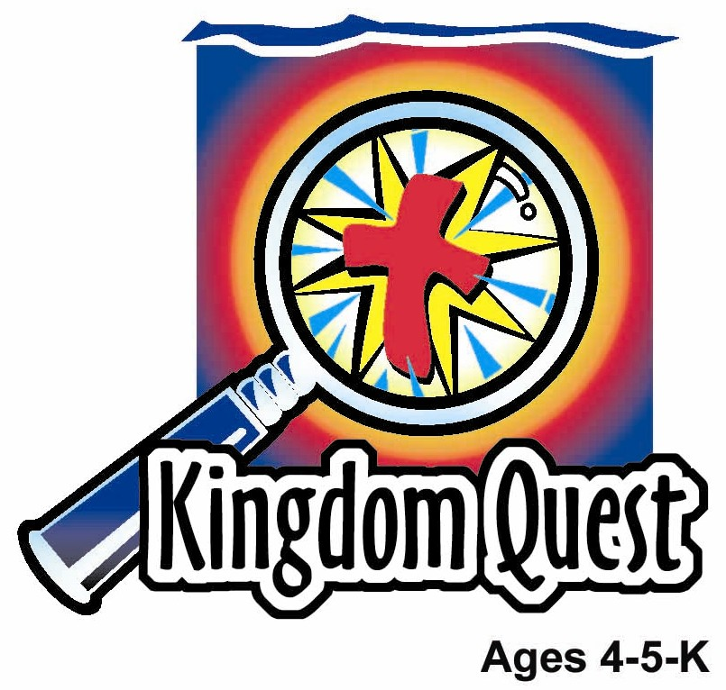
Date: _________ ______
Series: God is There in Tough Times (Sept-Nov)

Year 2, Lesson 22

Jacob Tricks Isaac

Take Home Point: *WHEN I SIN—God still loves me.
*Repeat this phrase throughout the lesson. The leader will say the first part of the phrase (CAPS). The children respond with the second part of the phrase (italics).

Bible Event: Genesis 27:1-41, 28:5
Jesus Link: Because Jesus gave His life for me, I am forgiven.

We will help children know:
- The story of Jacob tricking Isaac and getting Esau’s blessing.
- Because of his sin, Jacob had problems, but God still loved him.
- When we sin, God still loves us—even when we get in trouble for our sins.

We will help the children feel:
- Sorrow at sin.
- Sorry for their sins.
- Secure in God’s unconditional love.

We will help the children do:
- Watch the presenter tell the Bible event using the mystery box.
- Make and eat a “Hairy Arm” for snack and review the Bible event.
- Play a game, “Steal the Blessing” and use it to discuss the wrongness of sinning by hurting others, and the truth of God’s forgiveness and unfailing love.
THIS LESSON’S ROADMAP

DESTINATION | PAGE # | DISCOVERIES ON YOUR JOURNEY | SUPPLIES NEEDED
Large Group Opening   | 4  4-6 | Puppet Presentation  Bible Event: | - Ting Ting puppet  - small backpack  - travelling bag with mystery box and items  - low stool for sitting on  - Bible  - toy bow and arrow  - adult-sized Bible character robe  - lamb’s fleece cloth  (optional: tack on elastic. Slip over arm during presentation)  - plate  - toy food chicken leg  - bread (real or play)
Small Group Application   | 6-7  7  7-8  8  9 | Activity 1: “Textured Heart” Craft  Activity 2: “Hairy Arm” Snack  Activity 3: ”Steal the Blessing” Game  Activity 4: “Save the Ball”  Prayer Time | Activity 1:  - copy appendix, one per child  - ½ sheet of sandpaper per child  - tape  - red crayons (Hint: This works best if the paper is taken off.)  Activity 2:  - short satay stick per child  - one large kuih per child  - grated coconut  - small paper plates  - cups  - juice or water  HEALTHY SNACK OPTION  - rambutan or kiwi fruit  Activity 3:  - cup with “God’s Blessings” on it  - masking tape  - small strips of paper  - pencil  - paper lunch sack  Activity 4:  - white board  - white board marker  - ball
Large Group Wrap-up   | 10  10 | Singing (Optional)  Lesson Review with Puppet Skit | - optional music for the lesson  - Xiao Er puppet

Pre-Session Singing: (10 minutes)
Purpose: When all children are in one group singing, it is easy for new children to join the group and immediately get involved. When the music can be correlated, it introduces the theme for the day. Choose two to three songs and list them here.

Large Group Opening: (15 minutes)
Purpose: The puppet demonstrates the need that will be met in today’s lesson. The scripts are not written verbatim, but give a story line in which the group leader can interact with the puppet. The children are introduced to the take home point and then interact with God’s Word as they experience the Bible event.

Supplies needed: Ting Ting puppet; small backpack; travelling bag with mystery box and items: low stool for sitting on, Bible, toy bow and arrow, adult-sized Bible character robe, lamb’s fleece cloth, (optional: tack on elastic. Slip over arm during presentation), plate, toy food chicken leg, bread (real or play)

Puppet Presentation:
Ting Ting comes in wearing a small backpack. She’s running away from home. The presenter asks why. Ting Ting explains that a friend, Sammy, called to invite Xiao Hung to go to a movie. Ting Ting wanted to go, so she lied and told Sammy that Xiao Hung was sick, but she could go. It wasn’t true. Xiao Hung wasn’t really sick.

Ting Ting went to the movie and had fun. But then, Sammy asked Xiao Hung if he was feeling better and Xiao Hung found out what Ting Ting had done. Now, Xiao Hung is really angry at Ting Ting and Ting Ting is running away so he won’t hit her.

The presenter tells Ting Ting that what she did was very wrong. She lied and she stole something that belonged to Xiao Hung. Ting Ting doesn’t think she stole. The presenter explains that she took away his chance to go to a movie—she stole his fun. The presenter says that what she did was a sin.

Then the presenter says that it reminds him of today’s Bible event. In the Bible event, a man named Jacob tricks his dad and steals a very special blessing from his brother, Esau. Esau is very angry and Jacob has to run away to protect himself.

In the Bible event, the children will learn that even when we sin, God still loves us, and when we are sorry, He forgives us and helps us. In fact, God wants to forgive Ting Ting. Instead of running away, Ting Ting should tell her brother, Sammy and her parents that she is sorry and receive God’s forgiveness because, even though she sinned, God still loves her.

The presenter teaches Ting Ting the take home point. *WHEN I SIN—God still loves me. The presenter says the first part. Ting Ting responds with the second part. After practicing it with Ting Ting a few times, the presenter teaches it to the children.

Bible Event: Mystery Box
The Mystery Box contains objects will help the presenter tell the Bible event in creative fashion. They can be lifted out and shown as the story is told. Another option is to have a hole cut in the top of the box so that a child could put a hand in and guess what the object is before it is shown.

For today’s Bible event, instead of using the mystery box, the presenter will be using a travelling bag.

The presenter comes out carrying the travel bag. He sits down and begins:

Boys and girls, today for our Bible event we are going to have a mystery box. Only, instead of a box I brought my travel bag. I want you to listen to the Bible event closely so you can learn why I brought my travel bag.

Take out the Bible and open it. Our Bible event today comes from a book in the Bible called Genesis. It is about a family. The father is Isaac. The mother is Rebekah. And the grown up sons are Jacob and Esau. They’re twins.

Put the Bible down. Isaac was getting very old and it was almost time for him to die. Not only was he old, but he had a hard time seeing. Cover your eyes and pretend to be blind. Cover eyes for a moment or two. You can open your eyes.

A long, long time ago, when Isaac lived, when the fathers were close to the end of their life, they would say a prayer to bless their oldest child. They would tell the child all the good things they wanted that child to have. And that is what Isaac was going to do for Esau. Even though Jacob and Esau were twins, Esau was just a tiny bit older than Jacob. That made him the oldest son.

Isaac called Esau into his tent. Take out bow and arrow. Load the arrow in the bow and pretend to point it at a target away from the children. He told Esau to go hunt a wild animal, cook it and bring it to him and he would bless Esau. So Esau hurried away to do as his father asked. Pat your legs and pretend you are Esau hurrying off. Pat legs quickly, with both hands, for a moment or two)

Cup hand to ear. Now, mother Rebekah was listening as Isaac spoke. When Esau left the tent, Rebekah hurried off to find Jacob. She told Jacob to get two goats and she would cook them the way Isaac liked and Jacob could get Esau’s blessing.

Jacob did as his mother asked. Take out plate, chicken leg, and bread. Rebekah baked some bread and cooked the meat for Jacob to give to his father. Take out robe and put it on. Then Rebekah gave Jacob some of Esau’s best clothes to dress in. Take out fake lamb’s fleece. Finally, she covered his hands and neck with goatskins, and Jacob went in to see his father.

When Jacob went in to see Isaac, Isaac couldn’t see him but he heard Jacob’s voice. This confused Isaac. “You smell like Esau, but sound like Jacob,” he said. When Isaac felt Jacob’s hands and neck, he believed that Jacob was Esau. And he gave Jacob Esau’s blessing.

“You will be in charge of the family,” Isaac said. “You will become rich from the land. And God will be good to those who are good to you and bad things will happen to those who are bad to you.”

Put away food and take out bow and arrow. Shortly after Jacob left the tent, Esau came in. “Who are you?” Isaac asked. “I am your son, Esau,” Esau answered. Then both Esau and Isaac knew that Jacob had tricked them.

Esau was so angry, that he decided to kill Jacob after Isaac died. Because of that, Jacob had to run away to his uncle’s house to live until Esau stopped being angry.

What Jacob did was a sin. He lied to his father. He stole the blessing that belonged to his brother. Because of that he had to leave his home and could no longer live with his family. But God never stopped loving Jacob. Even though he sinned, God kept him safe and Esau did not kill him. Next week, we will learn that God was with Jacob when he traveled to a far away land.

Who knows why I brought my travel bag instead of the mystery box? (Because Jacob had to travel far away.)

We, like Jacob, are sinners. We do things that are wrong. Sometimes we whine when we are told to pick up our toys. Other times, we take toys away from a sister, brother or friend. We throw temper tantrums, yell at people and do things that we are told not to do. When we sin, God does not like our sins. But God still loves us. When we sin, we might have to be given a time out or not be allowed to do something we want to do. But God still loves us. And when we are sorry, God forgives us. God forgives us because He loves us so much that He sent Jesus to die for us because we sin.

Practice the take home point with the children. *WHEN I SIN—God still loves me.

End with the following prayer. Have the children repeat each phrase.

Dear God, (repeat)
Even when times are tough, (repeat)
Thank You for being there. (repeat)
Even when I sin, (repeat)
Thank You for loving me. (repeat)
I believe You sent Jesus. (repeat)
He died for my sins. (repeat)
Thank You! Thank You! Thank You! (repeat)
Amen. (repeat)

Small Group Application: (30 minutes)
Purpose: Smaller groups enable children to develop closer relationships with adults and peers in the church. As you reinforce the take home point with a fun hands-on activity, discuss the Bible event. Be sure to repeat the take home point several times. Say the first part and have the children respond with the second phrase. Application questions help kids apply the take home point to their daily lives. Close this session by gathering your small group for prayer. Let the kids pray!

During small group application time, discuss the following questions and points:

What sins did Jacob do? (He lied to Isaac and stole Esau’s blessing.)

What happened because of Jacob’s sins? (Esau was angry and wanted to kill him. Jacob had to leave home. But God still loved him and kept him safe.)

What are some sins that we do? (Answers will vary but may include lying, stealing, fighting with brothers and sisters, etc.)

God does not like the sin we do, but He still loves us. How has God showed us that, when we sin, He still loves us? (He sent Jesus to die for us. When we are sorry, He forgives us.)

Activity 1: “Textured Heart” Craft
Supplies needed: copy appendix, one per child; ½ sheet of sandpaper per child; tape; red crayons (Hint: This works best if the paper is taken off.)

To make:
- Tape the sandpaper behind half of the heart.
- Use the red crayon to color over the heart. If the paper is taken off the crayons, lay the crayon on the side to color.
- Take the sandpaper off the paper.

When finished, discuss the meaning of the picture:
When we look at the paper, we see that the part of the heart that had the sandpaper behind it is bumpy looking, like the sandpaper. The other part of the heart is smooth. This can remind us of Jacob. He had smooth skin but he put goatskins on to make his skin feel hairy and trick his father. After Jacob sinned, his life got bumpy. Esau was angry at him and Jacob had to leave home. Even so, God still loved Jacob. God kept Esau from killing Jacob and God was with Jacob.

When we sin, we also cause bumpy problems. God doesn’t like our sins. And our sins can get us into trouble. Even so, God still loves us. In fact, He loved us enough to send Jesus to die for us so that our sins can be forgiven.

Practice the take home point: *WHEN I SIN—God still loves me.

Activity 2: “Hairy Arm” Snack
Supplies needed: short satay stick per child; one large kuih per child; grated coconut; small paper plates; cups; juice or water; HEALTHY SNACK OPTION: rambutan or kiwi fruit

To make:
- Stick a piece of kuih on a short satay stick.
- Pour a little grated coconut into the plate and roll the kuih in it until the kuih is covered.
- You now have a hairy arm like Esau’s. Eat and enjoy!

HEALTHY SNACK OPTION: Use rambutan fruit for the hairy arm. Have them cut already and just pass one around for fun, or use kiwi fruit and feel the fuzz for hair. Hairy fruit!

As the children work, review the Bible event and practice the take home point. *WHEN I SIN—God still loves me.

Activity 3: “Steal the Blessing” Game
Supplies needed: cup with “God’s Blessings” on it; masking tape; small strips of paper; pencil; paper lunch sack

To set up:
- Make three lines of masking tape parallel to each other but 6-10 feet apart.
- Set the blessing cup on the center of the middle line of tape.
- Divide the group into two teams,
- Give each child on a team a number, starting with one.
- If there are more children on one team than the other, give two of the children on the team with more the same number.
- Write numbers on slips of paper to correspond with the numbers of the children. There need be only one slip of paper for all the children with that number.
- Put the slips of paper in the paper bag.

To play:
- Line the children up on the tape facing one another.
- The shepherd draws a number from the bag and reads it aloud.
- The children with that number race to the cup to get it and bring it back to their team.
- If a child from the other team tags the child with the cup before he or she gets away, he or she can steal the blessing.
- The children must not cross the centerline.
- When the child returns to his team with the cup, his or her team gets a point.
- The cup is returned to the centerline, the number thrown back into the bag, and play resumes as before.

To discuss:

How did you feel when someone stole the blessing cup from you? How do you think Esau felt when Jacob stole his blessings? Sin causes sadness, anger and many other problems. Sin causes hurt. If we call our sister a name, it can hurt her feelings. If we hit our brother, it can hurt his body. And when we get sent to our room for a time out or can’t play at the park any more because we did something wrong, it hurts us.

We have a great blessing though. God doesn’t like sin but He always loves us—even when we sin. That is why He sent the blessing of Jesus. Jesus died on the cross for our sins. Now when we are sorry and want to change, God forgives us.

Practice the take home point.* WHEN I SIN—God still loves me.

Activity 4: “Save the Ball”
Purpose: Help kids to memorize and keep scriptures at heart. Using creative ways to help kids enjoy learning the key verse and in small group setting.

Supplies needed: white board; white board marker; ball

Memory Verse: Psalm 27:1 ~ The Lord is my light and the one who saves me.

Memory Verse Learning:
Write the memory verse on the board before class begins. Gather the children in front of the white board and recite the memory verse a few times together. Then ask the children to stand in a circle. Tell them that we are going to catch the ball as our friend throw to us. When any of us save the ball, we are to catch the ball and recite the memory verse, before throwing the ball to our other friend. Repeat the game as long as time permits.

Prayer Time:
Have the children tell God things they do wrong. Thank God for loving them, even when they sin. Ask God to forgive them and thank Him for Jesus who died so they can be forgiven.

Large Group Wrap-Up: (10 minutes)
Purpose: The crazy bird puppet, Xiao Er, struggles with learning the take home point. The leader shows an example of each small group application activity from this lesson and says the first phrase of the take home point. The kids respond with their phrase. They try to teach the puppet the take home point, but each time he confuses words or concepts. After three attempts, he finally gets it right and sings the correct take home point in a silly opera-like voice.

Supplies needed: optional music for the lesson; Xiao Er puppet

Singing: (Optional)

Lesson Review with Puppet Skit:
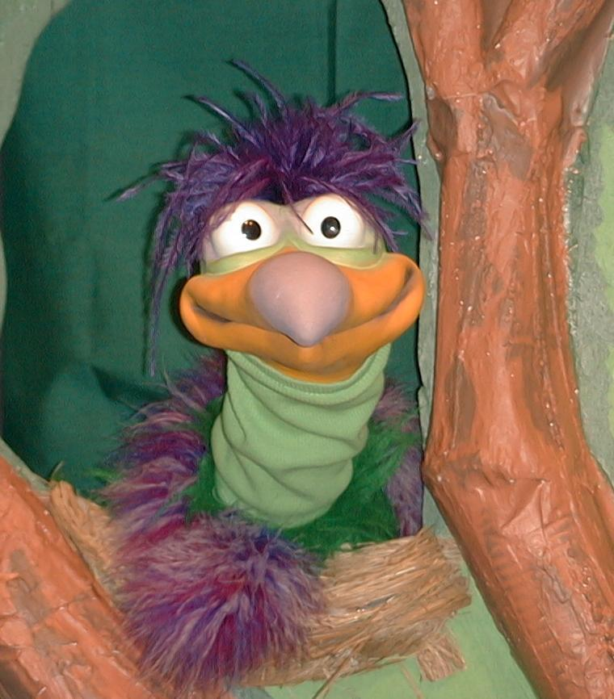
Presenter shows Xiao Er a craft made in Activity 1. Then the kids attempt to teach Xiao Er the take home point.

Presenter says to kids: “When I sin…”
Kids say: “…God still loves me.”
Presenter says to Xiao Er: “When I sin…”
Xiao Er says: “I feel like crying.”

Presenter shows an example of the next activity done in small group and repeats first phrase to kids. The kids say the correct response trying to teach Xiao Er the take home point. Continue in this manner with Presenter showing example of each activity. Here are Xiao Er’s responses:

Xiao Er’s response to Activity 2 sample: “I feel like eating a hairy arm.”
Xiao Er’s response to Activity 3 sample: “I feel like wrestling an alligator.”

Presenter says: “Xiao Er, listen one last time.
When I sin…”
Kids response: “…God still loves me.”
Presenter says to Xiao Er: “When I sin…”
Xiao Er’s response: (Warms up his singing voice with “Mee, mee, mee, mee, mee…” and sings in a silly dramatic opera-like voice) “WHEN I SIN—GOD STILL LOVES ME.”

Welcome guests and thank them for attending.

Lesson 22

Large Group Warm-up
- Ting Ting puppet
- small backpack
- travelling bag with mystery box and items
- low stool for sitting on
- Bible
- toy bow and arrow
- adult-sized Bible character robe
- lamb’s fleece cloth
(optional: tack-on elastic. Slip over arm during presentation)
- plate
- toy food chicken leg
- bread (real or play)

Small Group Application
Activity 1:
- reproducible –heart. Use die cut or make your own heart.
- ½ sheet of sandpaper per child
- tape
- red crayons (Hint: This works best if the paper is taken off.)
Activity 2:
- one short satay stick per child
- one large kuih per child
- grated coconut
- small paper plates
- cups
- juice or water
Activity 3:
- cup with the words “God’s Blessings” written on it
- masking tape
- small strips of paper
- pencil
- paper lunch sack
Activity 4:
- white board
- white board marker
- ball

Large Group Wrap-up
- optional music for the lesson
- Xiao Er puppet

Heart template

