Date: ________________________
Series: I Am God’s Child (Jun-Aug)
Year 2, Lesson 1

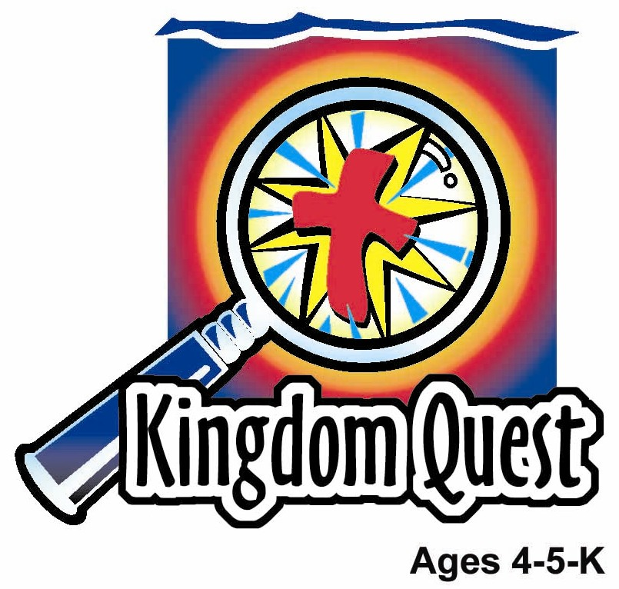

Foot Washing Fun

Take Home Point: *JESUS SERVED US—We serve others.
*Repeat this phrase throughout the lesson. The leader will say the first part of the phrase (CAPS). The children respond with the second part of the phrase (italics).

Bible Event: John 13:1-17
Jesus Link: Jesus served us by giving Himself for our sin.

We will help children know:
- Jesus served others to teach us examples of how to serve.
- Giving and serving others is the greatest example we can do.
- Jesus served us in the greatest way by dying on the cross.

We will help the children feel:
- Serviceable by learning from Jesus’ teachings and examples.
- Helpful by serving and showing they care about each other.
- Humble by learning the least is the greatest.

We will help the children do:
- Listen to a story of Jesus serving others by washing their feet and observe the Bible Event presenter washing a child’s feet in the same manner.
- Serve others by serving each other’s snack.
- Play a game, “Shoe Scramble” as a way to help serve each other.
THIS LESSON’S ROADMAP

DESTINATION | PAGE # | DISCOVERIES ON YOUR JOURNEY | SUPPLIES NEEDED
Large Group Opening  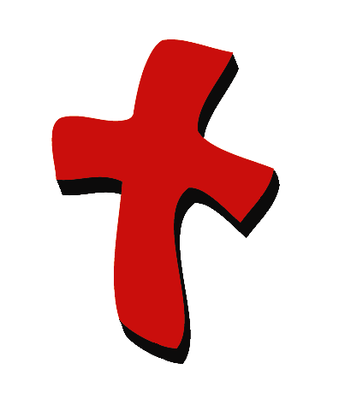 | 3  3-4 | Puppet Presentation  Bible Event | - Xiao Hung  - Bible  - pitcher of water  - towel  - basin or bucket  - sand  - large zip lock bag  - sandles
Small Group Application   | 5  5  5-6  6-7  8 | Activity 1: “Foot Washing” Craft  Activity 2: “Table Service” Snack  Activity 3: ”Shoe Scramble” Game  Activity 4: “Hands, Feet and Heart  Prayer Time | Activity 1:  - A4 paper  - crayons  - blue water color paint  - pre-printed label “Jesus washed the disciples’ feet.”  - newspaper or paper towels  Activity 2:  - snack food  - tray  - serviettes  - plates  - cups  - water or juice  HEALTHY SNACK OPTION:  - use fruits, veggies, nuts or whole grain breads.  - Water is definitely the healthier choice over juice unless you’re juicing the fruit in a juicer!  Activity 3:  - hula hoop  Activity 4:  - word cards (see appendix)  - flannel board
Large Group Wrap-up   | 8  8 | Singing (Optional)  Lesson Review with Puppet Skit | - optional music for the lesson  - Xiao Er Puppet

Pre-Session Singing: (10 minutes)
Purpose: When all children are in one group singing, it is easy for new children to join the group and immediately get involved. When the music can be correlated, it introduces the theme for the day. Choose two to three songs and list them here.

Large Group Opening: (15 minutes)
Purpose: The puppet demonstrates the need that will be met in today’s lesson. The scripts are not written verbatim, but give a story line in which the group leader can interact with the puppet. The children are introduced to the take home point and then interact with God’s word, as they experience the Bible event.

Puppet Presentation:
Purpose: The puppet demonstrates the need that will be met in today’s lesson. The scripts are not written verbatim, but give a story line in which the group leader can interact with the puppet.

Supplies needed: Xiao Hung; Bible; pitcher of water; towel; basin or bucket; sand; large zip lock bag; sandles

Xiao Hung is complaining that his parents want him to do chores. Xiao Hung thinks he shouldn’t have to do all this stuff. They treat me like I’m a servant. They want him to clean up crayons, make his bed and pick up his clothes and toys. And, if you can imagine, they don’t pay Xiao Hung an allowance for the chores. His parents said that helping around the house is part of serving the family.

The presenter shares with Xiao Hung that Jesus served in many ways – by healing, comforting, giving forgiveness and washing feet. For example, Jesus washed the feet of the disciples to help them learn what it really means to be the greatest. Xiao Hung is confused. Why would Jesus, God’s Son, the King of Kings, wash the other grown up’s feet? They know how to wash their own feet.

Back then, they wore sandals and walked on dirt roads. Their feet would be very dusty and dirty. One day they were already in a house and Jesus knew that their feet didn’t need washing because they had already washed them once. Jesus began to wash the disciples’ feet to teach them about serving each other. Some of the disciples didn’t want Jesus to wash their feet because He was their Lord and Master. Jesus wanted them to remember that even though He is their Lord and Master, He would be willing to serve them by washing their feet. So Jesus had given them an example that if He washes their feet, they should be willing to wash one another’s feet. They should be willing to serve others as Jesus served them.

The presenter teaches Xiao Hung the take home point: *JESUS SERVED US – We serve others. The presenter says the first phrase and Xiao Hung responds with the second phrase. After practicing it with Xiao Hung a few times, the presenter practices it with the children.

Bible Event: Mystery Box
The Mystery Box contains objects will help the presenter tell the Bible even in creative fashion. They can be lifted out and shown as the story is told. Another option is to have a hole cut in the top of the box so that a child could put a hand in and guess what the object is before it is shown.

Bring the Mystery Box and all of its contents on stage for the Bible event. Begin:

Boys and girls, our Mystery Box is filled with some things that we may have used before. The mystery is how they used the things back in Bible times. (Take the Bible out of the Mystery Box.) The Bible tells a story how Jesus taught the disciples to serve each other. The disciples were wondering who would be the greatest in heaven. Jesus wanted to teach His disciples that they should serve each other. (Take out the sandals and bag of wet sand.) The people back in this time wore sandals. Their feet would become very dusty and dirty because they walked on dirt or sand roads. Before entering a house or sitting down to eat, they would clean their feet by washing in a basin or bowl. (Take out basin and pitcher of water and towel.) Jesus began to wash their feet. The disciples were surprised that Jesus was washing their feet because they had already washed them. (Bring a child up to wash his/her feet. Have the child stick his foot in the bag and then help put his foot in the water and clean and dry the foot/feet.) Just like I washed his foot/feet, Jesus washed His disciples’ feet. Jesus explained to His disciples how they should treat each other as He has treated them. Jesus served them by washing their feet. The lesson for the disciples and for us is this; the most important one is the one whose gives and serves others.

Jesus came to help save us but He also came to teach us. Jesus served in many ways during His teachings on earth. Ultimately, Jesus served all of us in the greatest way by dying on the cross. That’s how much Jesus loves us!

Practice the take home point. You say the first part; the children respond with the second part. *JESUS SERVED US – We serve others.

Small Group Application: (30 minutes)
Purpose: Smaller groups enable children to develop closer relationships with adults and peers in the church. As you reinforce the take home point with a fun hands-on activity, discuss the Bible event. Be sure to repeat the take home point several times. Say the first part and have the children respond with the second phrase. Application questions help kids apply the take home point to their daily lives. Close this session by gathering your small group for prayer. Let the kids pray!
During the small group application time, discuss the following questions and points:

How did Jesus serve His disciples? (He washed their feet.)

What did Jesus want us to learn from this washing? (That giving and serving others is the greatest thing we can do.)

How did Jesus serve us in the greatest way of all? (By dying on the cross.)

Activity 1: “Foot Washing” Craft
Supplies needed: A4 paper; crayons; blue water color paint; pre-printed label “Jesus washed the disciples’ feet.”; newspaper or paper towels

Children will trace their shoe or foot with a crayon. Next, they will paint the foot with blue watercolor.

Option: Color entire foot and water color the rest of the paper. Remind the children that Jesus served His disciples by washing their feet and He wants us to serve others. Ask the children what are other ways we can serve others.

Practice the take home point. You say the first part; the children respond with the second part. *JESUS SERVED US – We serve others.

Activity 2: “Table Service” Snack
Supplies needed: snack food; tray; serviettes; plates; cups; water or juice

Choose any appropriate snack. The children will serve each other at the table. Have all the snacks on a tray in the middle of the table so they can all see what’s available to choose. Number the children off by 1’s and 2’s. The 1’s will ask the 2’s what snack they want and then serve them that snack. Then they reverse roles and the 2’s ask the 1’s what they would like to eat for a snack. Remind the children that they served each other by getting each other snacks.

“Table Service” Healthy Snack Option
Make the snacks naturally good by using fruits, veggies, nuts or whole grain breads. Water is definitely the healthier choice over juice unless you’re juicing the fruit in a juicer!

Practice the take home point. You say the first part; the children respond with the second part. *JESUS SERVED US – We serve others.

Activity 3: “Shoe Scramble” Game
Supplies needed: hula hoop

To play:
- Everyone takes off one shoe and puts it in the hula hoop.
- Everyone sits in a circle around the hula hoop.
- Everyone gets a turn by going around the circle one child at a time in order to find another child’s shoe from the pile.
- Before they give it to the appropriate child, they will say, “I have your shoe”.
- They cannot find their own shoe.
- Do not put on shoe until everyone has his or her own shoe.
- When everyone has their own shoe, they try to put them on as fast as they can.

To discuss:
- We helped serve each other by finding each other’s shoes. Jesus helped serve His disciples by washing their feet.
- Practice the take home point. You say the first part; the children respond with the second part. *JESUS SERVED US – We serve others.

Activity 4: “Hands, Feet and Heart”
Purpose: Help kids to memorize and keep scriptures at heart. Using creative ways to help kids enjoy learning the key verse and in small group setting.

Supplies needed: word cards (see appendix); flannel board.

Memory Verse: Ephesians 6:7 ~ Work as if you were serving the Lord, and not men.

Memory Verse Learning:
Place all the word cards in the arrangement of the memory verse on the flannel board. Gather the children in front of the board. Recite the memory verse a few times with the children. Then, remove one word at a time as the children recite the verse a few more times. As there are a few word cards off the board, get volunteers to take a card and place it at the right place, as all the children recite the verse together. Repeat this till all the word cards are placed correctly. Finally, recite one more time before prayer. Tell the students that when we serve God, we use our hands, feet and heart to serve.

Prayer Time:
Name some ways you can serve others. Ask Jesus to help you have a heart for service. Thank Him for serving the greatest way possible by dying on the cross.

Large Group Wrap-Up: (10 minutes)
Purpose: The crazy bird puppet, Xiao Er, struggles with learning the take home point. The leader shows an example of the each small group application activity from this lesson and says the first phrase of the take home point. The kids respond with their phrase. They try to teach the puppet the take home point, but each time he confuses words or concepts. After three attempts, he finally gets it right and sings the correct take home point in a silly opera-like voice.

Supplies needed: optional music for the lesson; Xiao Er Puppet

Singing: (Optional)

Lesson Review with Puppet Skit:

Xiao Er’s confused phrases:

Activity 1: “I’m not washing YOUR stinky feet!”
Activity 2: “Now you should serve me a snack.”
Activity 3: “We should all trade shoes with a friend!”
Activity 4: “I serve God with hands, feet and heart!”

Welcome guests and thank them for attending.

Lesson 1

Large Group Warm-up
- Xiao Hung
- Bible
- pitcher of water
- towel
- basin or bucket
- sand
- large zip lock bag
- sandles

Small Group Application
Activity 1:
- A4 paper
- crayons
- blue water color paint
- pre-printed label “Jesus washed the disciples’ feet.”
- newspaper or paper towels
Activity 2:
- snack food
- tray
- serviettes
- plates
- cups
- water or juice
Activity 3:
- hula hoop
Activity 4:
- Word cards (enlarge appendix to A3 size. Cut out the word card and iron ”facing” cloth or sand paper behind each card.)
- Flannel board

Large Group Wrap-up
- optional music for the lesson
- Xiao Er Puppet


Work
Ephesians
6:7
as if

you were
the Lord
serving

and
not men

