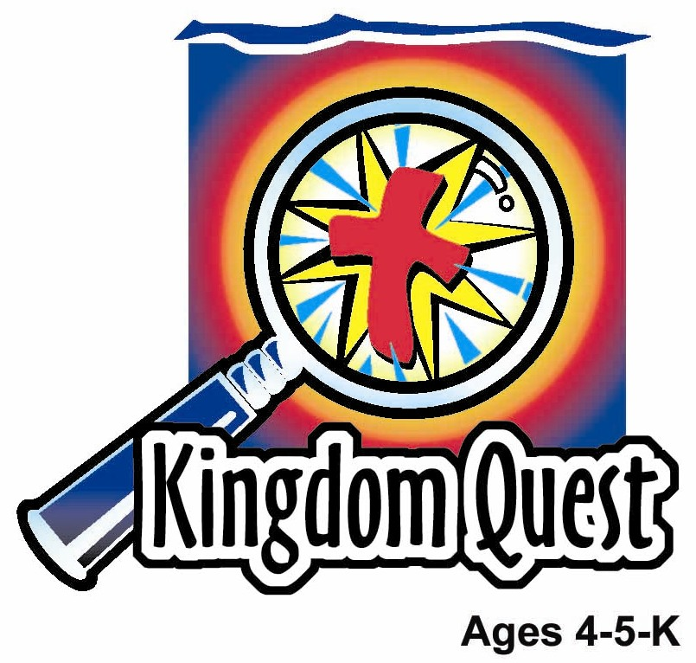
Date: ________________________
Series: I Am God’s Child (Jun-Aug)
Year 2, Lesson 2

Samuel is Dedicated to the Lord

Take Home Point: I AM GOD’S CHILD – I give my life to Jesus.
*Repeat this phrase throughout the lesson. The leader will say the first part of the phrase (CAPS). The children respond with the second part of the phrase (italics).

Bible Event: 1 Samuel 1
Jesus Link: Jesus gave His life for us so we give our lives to Him.

We will help children know:
- The story of Hannah dedicating Samuel to God.
- Jesus gave His life to make us God’s children.
- We can give our lives to Jesus.

We will help the children feel:
- Special as a child of God.
- Love for Jesus and their heavenly Father.
- Eager to live as children of God.

We will help the children do:
- Participate in an interactive drama about Hannah dedicating Samuel to God.
- Talk about the ways they can give their lives to Jesus, as they eat Life cereal.
- Play a hula hoop game in which they reenact the Bible event.
THIS LESSON’S ROADMAP

DESTINATION | PAGE # | DISCOVERIES ON YOUR JOURNEY | SUPPLIES NEEDED
Large Group Opening  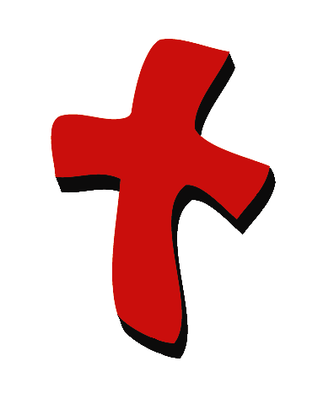 | 3  3-5 | Puppet Presentation  Bible Event | - Ting Ting puppet  - small blanket  - robes and headpieces for Hannah, Eli and Samuel  - Bible  - altar  - microphone  - baby doll wrapped in a blanket
Small Group Application   | 6  6  6-7  7  8 | Activity 1: “Life Offering” Craft  Activity 2: “Life Cereal” Snack  Activity 3: “Samuel at the Temple” Game  Activity 4: “Fill in the Temple”  Prayer Time | Activity 1:  - one reproducible with words “I give my life to Jesus” and “name: __________” printed on it for each child.  - one envelope per child  - crayons, markers, stickers or other items to decorate envelope and draw a picture on the reproducible  - offering plate or basket  Activity 2:  - Life noodle – “Wan Tan Noodle”  - bowl  - serviettes  - cups  - water or juice  Activity 3:  - hula hoop (two if the group is large)  - giant dice  - one carpet-square, yarn circle or piece of paper per child minus one, numbered 1 through 6 (it is okay to use the numbers more than once)  Activity 4:  - word cards and flannel  board (from last week’s  lesson)  - worksheets  - one set of answer cards  for each child.
Large Group Wrap-up   | 7  7 | Singing (Optional)  Lesson Review with Puppet Skit | - optional music for the lesson  - Xiao Er Puppet

Pre-Session Singing: (10 minutes)
Purpose: When all children are in one group singing, it is easy for new children to join the group and immediately get involved. When the music can be correlated, it introduces the theme for the day. Choose two to three songs and list them here.

Large Group Opening: (15 minutes)
Purpose: The puppet demonstrates the need that will be met in today’s lesson. The scripts are not written verbatim, but give a story line in which the group leader can interact with the puppet. The children are introduced to the take home point and then interact with God’s Word as they experience the Bible event.

Supplies needed: Ting Ting puppet; small blanket; robes and headpieces for Hannah, Eli and Samuel; Bible; altar; microphone; baby doll wrapped in a blanket

Puppet Presentation:
Purpose: The puppet demonstrates the need that will be met in today’s lesson. The scripts are not written verbatim, but give a story line in which the group leader can interact with the puppet.

Ting Ting comes out with her special blanket. She tells the large group presenter that when she woke up, she climbed on her mommy’s lap and snuggled with her. She loves her mommy and her mommy loves her. She wants to be with her and be close to her. The leader likens that to today’s Bible event. We are God’s children. He is our father. He loves us and we love Him. Also Jesus loves us and we love Jesus. We want to be close to God and Jesus, just like Ting Ting wants to be close to her mommy. In the Bible event, a woman named Hannah had a baby boy named Samuel. When Samuel no longer drank milk from his mother, she gave him to God and he lived in God’s house. While we do not climb into God’s lap, when we love Jesus, want to be close to him and want to share our lives with him, we are giving ourselves to God. We do not have to live in God’s house to do that. We can give our lives to Jesus no matter where we are, because He loves us and we love Him.

Practice the take home point with Ting Ting several times. *I AM GOD’S CHILD – I give my life to Jesus. After practicing it with Ting Ting, practice it with the children.

Bible Event:
Purpose: The Bible event is written in a creative fashion so children can recall major points of the event. The take home point is reinforced. The leader says the first part of the take home point and the children respond with their phrase.

Before the Bible event, choose three child volunteers to be Hannah, Eli and Samuel and dress them in costumes. Have the children stand to the side of the stage.

The presenter begins:

Show the Bible. My Bible tells me a true story about a woman named Hannah, who lived long before Jesus was born. Hannah walks onto stage. Hannah loved the Lord very much and knew the Lord loved her. She had a home, a husband who loved her, and food to eat. You might think Hannah had a perfect life. But one thing made her sad. Hannah shows a sad face. Hannah did not have any children. Hannah wanted to be a mommy. She wanted a baby very much. But God had not given her a baby. This made Hannah cry. Hannah cries.

Each year Hannah went with her husband to God’s house to worship the Lord. Hannah walks over to altar. And each year, Hannah prayed that God would give her a baby. Hannah kneels beside altar and folds hands in prayer. This happened year after year. And year after year, God did not give Hannah a baby.

Finally, one year something special happened. As usual, Hannah went with her husband to God’s house. And as always, Hannah prayed at the altar for a baby. Hannah prays. This time, Hannah prayed so hard that tears streamed down her face and her body shook. Hannah continues to pray and her body shakes. Hannah’s heart was broken.

Hannah thought she was alone, but she wasn’t. Someone was watching her. That someone was Eli, the priest. Eli walks on stage. Hannah was praying quietly, so Eli couldn’t hear her. When he saw her, he thought Hannah had been drinking too much wine and that was why she was shaking. When Hannah got up he told her:

Have Eli repeat the words into the microphone: Get rid of your wine.

Have Hannah repeat each underlined phrase into the microphone: I was not drinking. I am very sad. I was praying to God. I am not a bad woman. I was praying because I was sad.

Eli answered her: Have Eli repeat underlined phrases. Go in peace. May the God of Israel give you what you have prayed for. Eli walks to side of stage.

Hannah left happy. The next morning she came back and worshiped God. Hannah holds hands up in the air. Then she went home with her husband. Hannah walks off stage. A year later Hannah had a baby. Hannah walks back on stage carrying a doll. She was so happy! She named her baby Samuel, which means “heard of God” because God heard her prayers. Hannah walks back off stage.

When Samuel grew old enough that he did not need to get milk from his mother, Hannah brought him to God’s house. Hannah walks on stage, holding the hand of the child playing Samuel. Before Samuel was born, Hannah had promised God that, if he gave her a baby, she would give her child back to God. She had come to God’s house to keep her promise.

Eli comes on stage. Hannah found Eli and told him:

Hannah repeats underlined phrases into microphone: I am the woman who stood here and prayed to God. I prayed for this child. God answered my prayer. Now I give him to the Lord. For his whole life, he will belong to the Lord.

So Samuel stayed at the house of the Lord.

Just as God gave Hannah a son, He gave us His son, Jesus, to die for us and forgive us our sins, the wrong things we choose to do. Because we believe in Jesus and love Him, we are God’s children. Hannah gave Samuel to God. We can give our lives to Jesus. We do not have to live in God’s house to do that. We give our lives to Jesus when we love him, serve him and follow his rules. We give our lives to Jesus, because we are God’s children. He loves us and we love Him. Let’s practice our special words to help us remember that. *I AM GOD’S CHILD—I give my life to Jesus.

End with a short prayer.

Small Group Application: (30 minutes)
Purpose: Smaller groups enable children to develop closer relationships with adults and peers in the church. As you reinforce the take home point with a fun hands-on activity, discuss the Bible event. Be sure to repeat the take home point several times. Say the first part and have the children respond with the second phrase. Application questions help kids apply the take home point to their daily lives. Close this session by gathering your small group for prayer. Let the kids pray!

During the small group application time, discuss the following questions and points:

What was Hannah’s prayer? (To have a baby.)

How did God answer her prayer? (Samuel was born.)

How did Hannah show God her thanks for her baby? (She gave Samuel back to God.)

Why did God give us His son, Jesus? (To die on the cross so we can be forgiven.)

Because of Jesus, we are God’s children. How can we show God our thanks? (By giving our lives to Jesus.)
How do we give our lives to Jesus? (Answers will vary, but will be on the lines of loving Him, serving Him and obeying Him.)

Activity 1: “Life Offering” Craft
Supplies needed: one reproducible with words “I give my life to Jesus” and “name: __________” printed on it for each child; one envelope per child; crayons, markers, stickers or other items to decorate envelope and draw a picture on the reproducible
offering plate or basket

Have the children draw pictures that show how they can give their lives to Jesus. Ideas include telling others about Jesus, reading God’s Word, helping others, and worshiping God in song. Have the children decorate the envelopes, put the picture in them, and put them in the offering basket. Explain to the children that anything they do to show God they love Him and to serve Him is a way to give themselves to God. By doing so, they are offering God their hearts and that is the offering God wants the most. We can give ourselves to God, because He sent His son Jesus to earth to die for us and forgive us our sins. Now, when God helps us believe in Jesus and trust Him, we become God’s children.

Practice the take home point. *I AM GOD’S CHILD—I give my life to Jesus. At the end of the morning, let the children take their envelopes home.

Activity 2: “Life Noodle” Snack
Supplies needed: Life noodle – “Wan Tan Noodle”; bowl; serviettes; cups; water or juice

Give each child a small portion of Life noodle. Explain that the Life noodle can remind them to give their lives to Jesus. Have the children think of ways they can give their lives to Jesus. For each idea, have all the children put a strand of life noodle in the bowl on the center of the table. Explain that it is like they are giving their lives as offerings to Jesus. If the children cannot think of ideas, the shepherd can give ideas, which may include praying, reading the Bible, attending Sunday School, obeying parents, and helping a friend. Remind the children that they can give their lives to Jesus because He gave His life for them on the cross so that their sins can be forgiven. And, when they love Jesus, God helps them live their lives for Him.

Practice the take home point. *I AM GOD’S CHILD—I give my life to Jesus. Give children another small portion of noodle and let them eat it.

Activity 3: “Samuel at the Temple” Game
Supplies needed: hula hoop (two if the group is large); giant dice; one carpet-square, yarn circle or piece of paper per child minus one, numbered 1 through 6 (it is okay to use the numbers more than once)
To play the game:
Choose one child to be Hannah and another to be Samuel. Each child must stand on a number, one child per number. The shepherd rolls the dice. When the number is called, Hannah must get the child off that number (or numbers) and put that child in the hula hoop, which represents the temple. You may want to have Hannah say a phrase such as, “Samuel, I give you to God.” The challenge of the game is to have Hannah put each child, one by one, into the temple. Each child must try to fit some part of their bodies, such as their heel or toe, touching the floor inside the temple (hula hoop). If time permits, play the game again using a different Hannah.

Discuss the game:
Remind the children that just as Hannah gave Samuel to God, they can give their lives to Jesus, only they do not have to go live at church to give their lives to Jesus. Because Jesus died for them and His love lives in their hearts, they are God’s children. They give their lives to Jesus by loving Him back and serving Him.

Practice the take home point. *I AM GOD’S CHLD—I give my life to Jesus.

Activity 4: “Fill in the Temple”
Purpose: Help kids to memorize and keep scriptures at heart. Using creative ways to help kids enjoy learning the key verse and in small group setting.

Supplies needed: word cards; flannel board (from last week’s lesson); worksheets; one set of answer cards for each child.

Memory Verse: Ephesians 6:7 ~ Work as if you were serving the Lord, and not men.

Memory Verse Learning:
Place all the word cards in the arrangement of the memory verse on the flannel board. Recite the memory verse a few times with the children. Hand out the memory verse work sheet to each child and also a set of cards with words that correspond with the blanks they are about to fill in. Explain the children that they are to find the right word and stick it in the right blank.

Ephesians 6:7
______ as if ____ were serving the _______, and not _______.

Prayer Time:
Have the children hold their hands in front of their bodies, palms up, while they pray as a visual reminder of giving their lives to Jesus. Have them ask Jesus to help them live their lives for Him and name specific ways they want to give their lives to Jesus.

Large Group Wrap-Up: (10 minutes)
Purpose: The crazy bird puppet, Xiao Er, struggles with learning the take home point. The leader shows an example of each small group application activity from this lesson and says the first phrase of the take home point. The kids respond with their phrase. They try to teach the puppet the take home point, but each time he confuses words or concepts. After three attempts, he finally gets it right and sings the correct take home point in a silly opera-like voice.

Supplies needed: optional music for the lesson; Xiao Er Puppet
Singing: (Optional)

Lesson Review with Puppet Skit:

Xiao Er’s confused phrases:

Activity 1: “I give my crayons to my sister.”
Activity 2: “I give my feathers to doggies.”
Activity 3: “I give my life cereal to my mommy.”
Activity 4: “ I give my life to the church.”

Welcome guests and thank them for attending.

Lesson 2

Large Group Warm-up
- Ting Ting puppet
- small blanket
- robes and headpieces for Hannah, Eli and Samuel
- Bible
- altar
- microphone
- baby doll wrapped in a blanket

Small Group Application
Activity 1:
- one reproducible with words “I give my life to Jesus” and “name: __________” printed on it for each child.
- one envelope per child
- crayons, markers, stickers or other items to decorate envelope and draw a picture on the reproducible
- offering plate or basket
Activity 2:
- Life noodle – “Wan Tan Noodle”
- bowl
- serviettes
- cups
- water or juice
Activity 3:
- hula hoop (two if the group is large)
- giant dice
- one carpet-square, yarn circle or piece of paper per child minus one, numbered 1 through 6 (it is okay to have use the numbers more than once)
Activity 4:
- word cards and flannel board (from last week’s lesson)
- worksheets
- one set of answer cards for each child.

Large Group Wrap-up
- optional music for the lesson
- Xiao Er Puppet

Lesson 2-reproducible

I GIVE MY LIFE
FOR JESUS!

NAME:

I GIVE MY LIFE
FOR JESUS!

NAME:

I GIVE MY LIFE
FOR JESUS!

NAME:

Ephesians 6:7

________ as if _______ were serving the ________, and not ________.

Work | you
Lord | men

