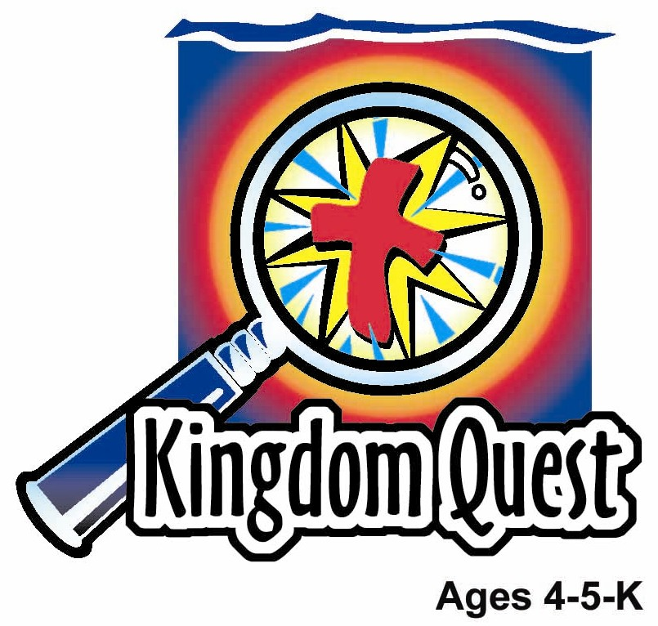
Date: ________________________
Series: I Am God’s Child (Jun-Aug)
Year 2, Lesson 3

God Calls Samuel

Take Home Point: *I AM GOD’S CHILD—I listen to God’s word.
*Repeat this phrase throughout the lesson. The leader will say the first part of the phrase (CAPS). The children respond with the second part of the phrase (italics).

Bible Event: 1 Samuel 3:1- 4:1
Jesus Link: The best thing God’s word tells me is that Jesus came to save me.

We will help children know:
- The story of God calling Samuel.
- God calls them and speaks to them through His word.
- God’s word tells them about Jesus.

We will help the children feel:
- Set apart by God.
- Eager to hear and listen to God’s word.
- Happy that God’s word tells them about Jesus.

We will help the children do:
- Participate in dramatic storytelling of Samuel being called.
- Listen to Rice Krispies and talk about how we listen to God’s word and what it tells us.
- Play a whispering game and talk about listening to and following God’s word.

THIS LESSON’S ROADMAP

DESTINATION | PAGE # | DISCOVERIES ON YOUR JOURNEY | SUPPLIES NEEDED
Large Group Opening   | 3  3-5 | Puppet Presentation  Bible Event | - Xiao Hung puppet  - Earphones  - Bible  - adult sized Samuel costume
Small Group Application   | 6  6  7  8  9 | Activity 1: “Big Ears” Craft  Activity 2: “Talking Cereal ” Snack  Activity 3: ”Whisper, Whisper” Game  Activity 4: “Whose voice is this?”  Prayer Time | Activity 1:  - one copy of big ears per child (best copied on manila card)  - one headband per child (use template or cut your own 1-2” wide strips from manila card long enough to fit around a child’s head)  - scissors  - tape  - crayons  - pre-made stickers with the take home point printed on them  Activity 2:  - Rice Krispies or similar cereal  - milk  - plastic spoons  - cups  - water or juice  - serviettes  Activity 3:  - none needed  Activity 4:  - word cards  - flannel board (from the first week memory verse learning)  - blindfold for each child  - microphone (toy/paper)
Large Group Wrap-up   | 7  7 | Singing (Optional)  Lesson Review with Puppet Skit | - optional music for the lesson  - Xiao Er Puppet

Pre-Session Singing: (10 minutes)
Purpose: When all children are in one group singing, it is easy for new children to join the group and immediately get involved. When the music can be correlated, it introduces the theme for the day. Choose two to three songs and list them here.

Large Group Opening: (15 minutes)
Purpose: The puppet demonstrates the need that will be met in today’s lesson. The scripts are not written verbatim, but give a story line in which the group leader can interact with the puppet. The children are introduced to the take home point and then interact with God’s Word as they experience the Bible event.

Puppet Presentation:
Purpose: The puppet demonstrates the need that will be met in today’s lesson. The scripts are not written verbatim, but give a story line in which the group leader can interact with the puppet.

Supplies needed: Xiao Hung puppet; earphones; Bible; adult sized Samuel costume

Xiao Hung comes in wearing earphones. He has trouble hearing the presenter until he takes off the earphones. When the presenter asks why he was wearing the earphones, Xiao Hung says that his sister Ting Ting is annoying him with all her silly talk. He doesn’t want to listen to her. After they talk for a minute about why Xiao Hung doesn’t want to listen to Ting Ting, the presenter tells him about someone we should always listen to—God. Xiao Hung is surprised. He’s never heard God talk to him. The presenter shares that in today’s Bible event Samuel, Hannah’s baby, is now a boy living in God’s house and one night God calls out to him.

While we don’t hear God the way Xiao Hung hears Ting Ting and Samuel heard God, God does talk to us. He talks to us through His word, the Bible. He tells us we sin. He tells us, even though we sin, He loves us. And He tells us He sent Jesus to take the punishment for our sins by dying on the cross so He could forgive us. God also tells us how we can follow Him. Now Xiao Hung is excited and wants to listen to God’s word—without the earphones.

The presenter teaches Xiao Hung the take home point. *I AM GOD’S CHILD—I listen to God’s word. After practicing it with Xiao Hung a few times, the presenter practices it with the children.

Bible Event:
Purpose: The Bible event is written in a creative fashion so children can recall major points of the event. The take home point is reinforced. The leader says the first part of the take home point and the children respond with their phrase.

An extra male adult is needed to stand backstage and play the voice of God using a microphone. The presenter comes on stage dressed like an adult Samuel. He begins:

Boys and girls, today I am pretending to be Samuel after he grew up and became an adult. I am pretending to remember something that happened when I was a child, and I need your help. Every time I do an action, I want you to do the same action.
One night when I was a young boy, Eli was asleep and I was lying down in the temple Rest head on hands as if sleeping. The lamp of God was still burning and the light was flickering. Flicker fingers. Suddenly, I heard a voice.

Voice of God: Samuel! Samuel!

Stretch body upwards and look around.

Samuel: I ran to Eli’s bed. Briefly run in place. “Here I am; you called me,” I said. But Eli said that he had not called me and told me to go back and lie down. So I went back to my bed and again I laid down. Rest head on hands. And again I heard a voice. Lift up head and look around.

Voice of God: Samuel! Samuel!

Samuel: Again I ran to Eli’s bed. Briefly run in place. And again Eli said he had not called me. So again I went back to my bed and laid down. Rest head on hands. And again I heard a voice. Lift up head and look around.

Voice of God: Samuel! Samuel!

Samuel: Again I ran to Eli’s bed. This time Eli realized it was God calling me. Eli told me to go lie down again and this time, if God called me again I was to say, “Speak, Lord, your servant is listening.” Again I went back to my bed and laid down. Rest hands on head. Again the Lord called me.

Voice of God: Samuel! Samuel!

Samuel: This time I answered the Lord. Cup hands around mouth. I said, “Speak, Lord, your servant is listening.” The Lord said to me:

Voice of God: Eli’s sons have done evil things. Eli has not stopped them. So now I will bring judgment on them for the wicked things they have done. Bad things will happen to Eli and his sons because of the evil things his sons have done.

Samuel: After God finished speaking, I went back to bed. Rest hands on head. I couldn’t sleep. I laid there until morning. When morning came, I got up and opened the doors of God’s house. Pretend to swing open two doors. I was afraid to tell Eli about the vision. Then Eli called me and told me to tell him what happened. He told me not to hide anything. So I told Eli everything and he told me, “He is God. Let Him do whatever He thinks is good.” From that day on, God repeatedly came to me and told me His words. Everything He said happened and I told all of Israel God’s words.

Conclusion: You, too, have God’s Word. You may not hear the voice of God calling you, but He gives you His word in His book, the Bible. (Hold up Bible.) When someone reads you God’s word, the Bible, you can listen to God. Today as you listened to the Bible event, you listened to God’s word. You can hear God’s word because you are God’s child. The best thing God’s word tells you is that God loves you so much He sent His Son to die for your sins, so you do not have to be punished as Eli and his sons were punished. What a wonderful thing to hear! That reminds me of our take home point. *I AM GOD’S CHILD—I listen to God’s word.

Close with a brief prayer.

Small Group Application: (30 minutes)
Purpose: Smaller groups enable children to develop closer relationships with adults and peers in the church. As you reinforce the take home point with a fun hands-on activity, discuss the Bible event. Be sure to repeat the take home point several times. Say the first part and have the children respond with the second phrase. Application questions help kids apply the take home point to their daily lives. Close this session by gathering your small group for prayer. Let the kids pray!

During the small group application time, discuss the following questions and points:

Who was calling Samuel? (God)

What did God tell Samuel? (Because Eli’s sons were evil and Eli did not stop them, Eli and his sons would be punished.)

How does God talk to you? When do you hear God’s word? (Through His word, the Bible, when you listen to someone read the Bible, listen to Christian music, go to Kingdom Quest, etc.)

What is the best thing God’s word tells you? (That Jesus died to take the punishment for our sins.)

Activity 1: “Big Ears” Craft
Supplies needed: one copy of big ears per child (best copied on manila card); one headband per child (use template or cut your own 1-2” wide strips from manila card long enough to fit around a child’s head); scissors; tape; crayons; pre-made stickers with the take home point printed on them

To make:
Have the children cut out the ears and headband and color them with crayons. When they are finished, measure the headbands to fit their heads and tape.
To discuss:
Read the words on the headband and explain that while our ears aren’t big, we want to listen to God’s Word as if listening with big ears.

We want to listen carefully to learn what God’s word tells. When do we listen to God’s word? (When our parents read us a Bible story, when we come to Kingdom Quest, when we listen to Bible music, etc.) What does God’s word tell us? (God loves us, Jesus died for us, God forgives us our sins, God’s laws, God takes care of us, Bible stories, etc.)

Practice the take home point. *I AM GOD’S CHILD—I listen to God’s word.

Activity 2: “Talking Cereal ” Snack
Supplies needed: Rice Krispies or similar cereal; milk; plastic spoons; cups; water or juice; serviettes

Give each child a small bowl of cereal and milk. Before eating the snack, have the children listen quietly as the cereal “talks” to them. In the quiet of the night, God spoke to Samuel. Sometimes we must listen quietly to hear God talk to us. God talks to us through His Word, the Bible, through our parents and teachers as they tell us about Jesus, and through His Spirit that reminds us in our hearts about the things God has taught us. What does the cereal say? What did God tell Samuel? The best thing God tells us is that Jesus died for our sins.

“Talking Cereal ” Healthy Snack Option: Munching on carrots or other crunchy natural snacks would be another option here. The children could play telephone and whisper a message to their neighbor while eating their snack, helping them to practice listening.

Practice the take home point. *I AM GOD’S CHILD—I listen to God’s word.

Activity 3: “Whisper, Whisper” Game
No supplies needed.

Directions:
“Whisper, Whisper” is played like Simon Says only instead of saying Simon Says, the teacher whispers all the directions. The children must listen closely. If they do not correctly follow a direction, they must sit down for several plays.

To discuss:
Explain to the children that just as they had to listen closely to the directions, it is important to listen closely to God’s word because it tells us some important things. What are some of the important things God’s word tells us? Let the children give some examples. Be sure to share that the best thing God’s word tells us is that Jesus died for us.

Practice the take home point. *I AM GOD’S CHILD—I listen to God’s word.

Sample directions for Whisper, Whisper:
- Tiptoe in place
- Jump up and down three times
- Bend over and touch the floor
- Spin around twice
- Run in place
- Do two jumping jacks
- Wiggle your whole body
- Hug a friend
- Throw a hug to Jesus
- Take five giant steps

Activity 4: “Whose voice is that?”
Purpose: Help kids to memorize and keep scriptures at heart. Using creative ways to help kids enjoy learning the key verse and in small group setting.

Supplies needed: Flash cards; flannel board (from the first week memory verse learning); microphone (toy/paper); blindfold for each child

Memory Verse: Ephesians 6:7 ~ Work as if you were serving the Lord, and not men.

Memory Verse Learning:
Place all the flash cards in the arrangement of the memory verse on the flannel board. Recite the memory verse a few times with the children. Then turn the flannel board around. Tell the children that they are going to play a voice guessing game. Give the children a blindfold each and ask them to wear it. After they have worn the blindfold, choose a child quietly to recite the memory verse using the microphone. Then, the rest of the children would guess whose voice is that. Repeat the game as time permits.

Prayer Time:
Ask God to help you be good listeners and thank Him for different things His word, the Bible, tells us.
Large Group Wrap-Up: (10 minutes)
Purpose: The crazy bird puppet, Xiao Er, struggles with learning the take home point. The leader shows an example of each small group application activity from this lesson and says the first phrase of the take home point. The kids respond with their phrase. They try to teach the puppet the take home point, but each time he confuses words or concepts. After three attempts, he finally gets it right and sings the correct take home point in a silly opera-like voice.

Singing: (Optional)

Lesson Review with Puppet Skit:

Xiao Er’s confused phrases:

Activity 1: “(whispering) *unintelligible*.”
Activity 2: “I listen to Crunchy Crackers”
Activity 3: “I listen to Tigers’ tummies.”
Activity 4: “I hear my friends.”

Welcome guests and thank them for attending.

Lesson 3

Large Group Warm-up
- Xiao Hung puppet
- earphones
- Bible
- adult sized Samuel costume

Small Group Application
Activity 1:
- one copy big ears per child (best copied on cardstock)
- one headband per child (use template or cut your own 1-2” wide strips from manila card long enough to fit around a child’s head)
- scissors
- tape
- crayons
- pre-made stickers with the take home point printed on them
Activity 2:
- Rice Krispies or similar cereal
- milk
- plastic spoons
- cups
- water or juice
- Serviettes
Activity 3:
- none needed
Activity 4:
- Word cards and flannel board (from the first week memory verse learning)
- Blindfold for each child
- Microphone (toy/paper)

Large Group Wrap-up
- optional music for the lesson
- Xiao Er Puppet

