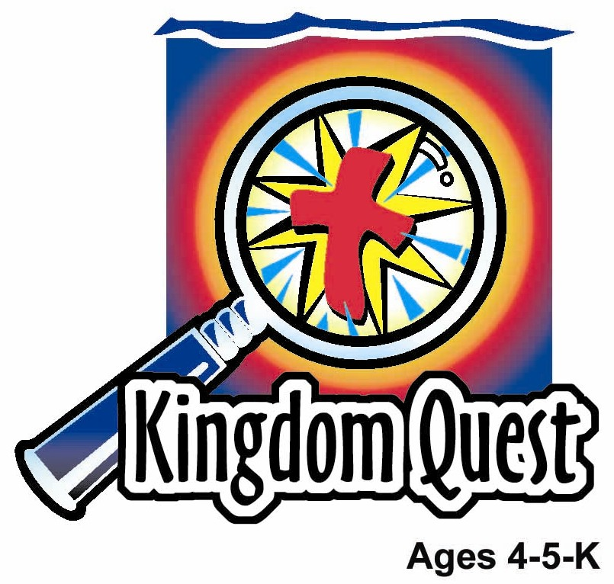
Date: ________________________
Series: I Am God’s Child (Jun-Aug)
Year 2, Lesson 4

God is Our Father—We Are His Children

Take Home Point: *I AM GOD’S CHILD—I am happy God loves me.
*Repeat this phrase throughout the lesson. The leader will say the first part of the phrase (CAPS). The children respond with the second part of the phrase (italics).

Bible Event: 2 Corinthians 6:1-18
Jesus Link: God sent Jesus so we could be with our Heavenly Father forever.

We will help children know:
- God gave us our earthly fathers and other people who are special to us.
- God, our heavenly Father, loves us.
- We are God’s children because Jesus died for us.

We will help the children feel:
- Happy to be God’s children.
- Thankful for their earthly fathers, or other special people God has given them.
- Thankful to God, the Father, for the ways He has shown them His love, especially through Jesus.

We will help the children do:
- Use clues to guess special activities children do with their earthly fathers and ways their heavenly father shows them His love.
- Eat a special snack to celebrate fathers.
- Play Father’s Day Charades to review ways both God, the Father, and our earthly fathers demonstrate their love.
THIS LESSON’S ROADMAP

DESTINATION | PAGE # | DISCOVERIES ON YOUR JOURNEY | SUPPLIES NEEDED
Large Group Opening  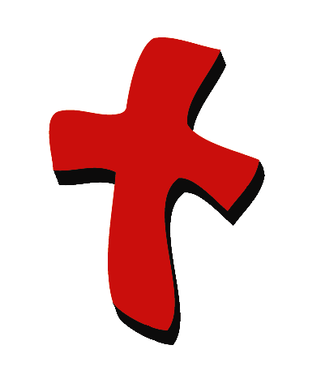 | 3  4-6 | Puppet Presentation  Bible Event | - Xiao Hung  - fishing pole for Xiao Hung  - large bag with the following items hidden in it: football, hammer, ice cream bucket and scoop, book, plaster  - second large bag with the following items hidden in it: heart, plastic food, stethoscope (may be a toy), cross, Bible with inserted paper that has 2Corinthians 6:18 written on it
Small Group Application   | 7  7-8  8  9  9 | Activity 1: “Father’s Day Picture” Craft  Activity 2: “Father’s Day Sundaes” Snack  Activity 3: “Father’s Day Charades” Game  Activity 4: “Pointing and Reading”  Prayer Time | Activity 1:  - reproducible from appendix (reproduce on Manila card)  - pencils  - coloured paper  - glue  - poster colour  - medium sized paint brushes  - tub of water and dry towels for washing hands  Activity 2:  - individual ice cream sundae cups  - plastic spoons  - cups  - water or juice  - serviettes  Activity 3:  - none needed  Activity 4:  - 10 plastic cups labeled with individual words from the verse  - Small gifts as reward
Large Group Wrap-up   | 10  10 | Singing (Optional)  Lesson Review with Puppet Skit | - optional music for the lesson  - Xiao Er Puppet

Pre-Session Singing: (10 minutes)
Purpose: When all children are in one group singing, it is easy for new children to join the group and immediately get involved. When the music can be correlated, it introduces the theme for the day. Choose two to three songs and list them here.

Large Group Opening: (15 minutes)
Purpose: The puppet demonstrates the need that will be met in today’s lesson. The scripts are not written verbatim, but give a story line in which the group leader can interact with the puppet. The children are introduced to the take home point and then interact with God’s Word as they experience the Bible event.

Puppet Presentation:
Purpose: The puppet demonstrates the need that will be met in today’s lesson. The scripts are not written verbatim, but give a story line in which the group leader can interact with the puppet.

Supplies needed: Xiao Hung; fishing pole for Xiao Hung; large bag with the following items hidden in it: football, hammer, ice cream bucket and scoop, book, plaster; second large bag with the following items hidden in it: heart, plastic food, stethoscope (may be a toy), cross, Bible with inserted paper that has 2Corinthians 6:18 written on it.

Xiao Hung comes out carrying a fishing pole. He is excited because he and his father are going on a fishing trip together. They are going to pack a picnic lunch, rent a fishing boat and spend the day catching fish. Xiao Hung thinks he might even catch a fish as big as a whale.

The presenter reacts with excitement to Xiao Hung’s upcoming adventure. He tells Xiao Hung that it is wonderful to be able to do special things with one’s dad or other special people. He then asks Xiao Hung if he knows that we all have another father. Xiao Hung acts surprised. The presenter tells Xiao Hung that God is our heavenly Father. He explains that, just like Xiao Hung is going to have a special time with his father, we all can have special times with God, our Father, such as: prayer times, times when we hear His words, when we visit His house, and when we praise Him.

But, even when we are not thinking about God, our Father, He is always with us. He always loves us, watches over us, protects us, and cares for us. The best thing God, our Father, did for us, was to make us His children. He made us His children by sending Jesus to die for us on the cross, so that He could forgive us our sins. In doing that, He brought us into His family and made us His children.

Now, when Xiao Hung goes fishing with his dad, he can know that he is also with God the Father.

Teach Xiao Hung the take home point. *I AM GOD’S CHILD—I am happy God loves me! After practicing it with Xiao Hung several times, practice it with the children.

Bible Event: Mystery Box
The Mystery Box contains objects that will help the presenter tell the Bible event in creative fashion. They can be lifted out and shown as the story is told. Another option is to have a hole cut in the top of the box so that a child could put a hand in and guess what the object is before it is shown.

“The Dad Bags”
Hold up the first large bag and introduce it as the “dad bag.” You have several items in this bag that remind you of the special things children do with their dads, or with other special father figures. You will give the child one or two clues for each item and they must guess what the item is. After they guess the item correctly, take it out and show it to the group.

- Items: Football
Clue 1: I have one item that I use when I play a ball game.
Clue 2: The item is for kicking.

After the children guess correctly that you have football, take out of the bag and throw the ball up in the air as you catch it.

Say: Thank you, God, for giving us dads who play with us.

- Item: Hammer
Clue 1: I have something in my bag that I use to make things.
Clue 2: I use it to pound nails.

After the children guess correctly that you have a hammer, take it out of the bag and pound an imaginary nail several times.

Say: Thank you, God, for dads who teach us to do many things, such as how to make things, how to ride a bike, or how to draw pictures. Thank you for people like dads who teach us.

- Items: Ice cream bucket and scoop
Clue 1: I have two things in my bag that I need for a special treat.
Clue 2: One item is used for scooping. The other item holds a cold sweet treat.

After the children guess correctly that you have an ice cream scoop and bucket, take them out of the bag and use them to pretend to scoop up and eat a bowl of ice cream.

Say: Thank you, God, for dads or other special people who give us fun treats.

- Item: Book
Clue 1: I have something in my bag that helps me settle down to go to sleep at night.
Clue 2: I love it when someone reads it to me.

After the children guess correctly that you have a book, take it out and read a page or two to them.

Say: Dear God, thank You for dads, or other people like them, who read to us and give us hugs and snuggles.

- Item: Band-Aid
Clue 1: I have something that helps me when I am hurt.
Clue 2: I put it on a sore, a cut, or a scrape to cover it, protect it, and keep it safe.

After the children guess Band-Aid, take it out and put it on a child who has a sore.

Say: Dear God, thank You for dads who help us feel better when we get hurt.

Put all of the items back in the first “dad bag.” Take out the second “dad bag,” which reminds us of our heavenly Father. Say:

Dads, and other special people, are wonderful and we love them. But we cannot always be with our dads. They have to go to work. Sometimes they take business trips. Other times, our dads live far away from us, or maybe we don’t even know our dad. That might make us sad. But I have some very happy news! We have another dad who loves us very much and is always with us. That special dad is God, our heavenly Father. The Bible tells us that He will never leave us. So when we miss our earthly dad, we can remember our heavenly Father and be happy. In my second bag, I have some items that remind us of the wonderful things God, our Father, has done for us. Just as with the other bag, I will give you clues, you will guess the items and then I will show them to you.

- Item: Paper or other kind of toy heart
Clue 1: I have something in my bag that reminds me of a part of my body.
Clue 2: It helps me to remember that I am loved.

After the children correctly guess that you have a “heart,” take it out and hug it close to your body.

Say: God, thank You for being the Father who loves me forever and for always. You are always with me, thank you.

- Item: Plastic food
Clue 1: I have something in my bag that I need to live.
Clue 2: I eat it.

After the children correctly guess that you have “food,” take it out of the bag and show it.

Say: Father God gives us all that we need – our food, our home, and our families. Thank You for giving us everything we have.

- Item: Stethoscope
Clue 1: I have something in my bag that the doctor uses when I visit him.
Clue 2: The doctor uses it to listen to my heart.

After the children correctly guess that you have a stethoscope, take it out and have a child come up and listen to his or her heart for several seconds.

Say: Heavenly Father, when we are hurt or sick, or have other problems, thank You for coming to help us feel better and healing us. Thank You for protecting us and helping us when we’re hurt.

- Item: Cross
Clue 1: I have something in my bag that reminds me of God’s son, Jesus.
Clue 2: Jesus died on this.

After the children correctly guess that you have a cross, take it out and have them stretch out their arms in the shape of the cross.

Say: Dear Father in heaven, the best thing You ever did for us was to send Jesus to die on the cross to take away our sins. Because Jesus died on the cross, we can become Your children and we can be filled up with Your love. Thank You, very much.

- Item: 2 Corinthians 6:18 written out on a slip of paper and inserted into a Bible
Clue 1: I have something in my bag that helps me learn about God.
Clue 2: It is a special book.

After the children correctly guess that you have a Bible, take it out and read the verse, Corinthians 6:18, as you pray.

Say: Dear God, thank You for the Bible. It says this, “The Lord Almighty says, I will be your Father and you will be My sons and daughters.” We know that You don’t lie. You tell us the truth in the Bible. Thank You, that You will be our Father, and we will be Your sons and daughters. *I AM GOD’S CHILD—I am happy God loves me. In Jesus’ name. Amen.

Small Group Application: (30 minutes)
Purpose: Smaller groups enable children to develop closer relationships with adults and peers in the church. As you reinforce the take home point with a fun hands-on activity, discuss the Bible event. Be sure to repeat the take home point several times. Say the first part and have the children respond with the second phrase. Application questions help kids apply the take home point to their daily lives. Close this session by gathering your small group for prayer. Let the kids pray!
During the small group application time, discuss the following questions and points:

Why are you thankful for your dad or some other special person? (Answers will vary.)

Who is your heavenly father? (God.)

How does God, your heavenly Father, show you that He loves you? (Answers will vary but may include sending Jesus, keeping me safe, giving me food, etc.)

How can you show God that you are thankful for His fatherly love? (Answers may vary but may include telling him in prayer, loving others, learning about Jesus, etc.)

Activity 1: “Father’s Day Picture” Craft
Supplies needed: reproducible from appendix (reproduce on Manila card); pencils
Coloured paper; glue; poster colour; medium sized paint brushes; tub of water and dry towels for washing hands.

To do:
- Hand out the poems and have the children write their names on the papers.
- Explain that the children will be making a special Father’s Day picture to give to their dads or someone who is like a dad to them, for example a grandpa, uncle, or family friend.
- Read the poem to the children.
- Glue the poem to the colour paper.
- Use the paintbrushes to spread poster colour on both hands.
- Make handprints of each hand under the poem.
- Wash hands and let the paintings dry.

To discuss:

There are many ways our fathers show their love for us. On Father’s Day we want to share our love for them and show that we thank God for our dads. How has your dad, or someone who is like a dad to you, shown you his love? What other ways can you show your dad that you are thankful God gave him to you?

Remind the children that we also have a heavenly Father. Practice the take home point. *I AM GOD’S CHILD—I am thankful God loves me.

Activity 2: “Father’s Day Sundaes” Snack
Supplies needed: individual ice cream sundae cups; plastic spoons; cups; water or juice; serviettes.

Before passing out the sundaes, explain that today’s snack is a celebration of fathers – both God, our heavenly Father, and our earthly fathers, or other special people in our lives. As the children eat their sundaes, talk about the special things we do with our fathers, or other special people, and the special things God, our Father, has done for us.
“Father’s Day” Healthy Snack Option: To celebrate Father’s Day, try thanking our Heavenly Father for the healthy snacks He has created for us to help give our bodies good nutrition. Talk about the snacks/food that is mentioned in the Bible like honey, figs, milk, almonds, etc. Thank You, God, for loving us so much!

Practice the take home point. *I AM GOD’S CHILD—I’m happy God loves me!

Activity 3: “Father’s Day Charades” Game
No supplies needed.

To do:
- Explain that today the children will be playing a game that reminds them of special activities kids do with their fathers, or with other special people in their lives, and the special things that God does for us.
- Whisper into one child’s ear an activity that children do with their fathers -OR- something God, the Father, does for them. (Use the list below for ideas.)
- Have the child act out the activity without using words.
- The other children must guess what the child is acting out. You may need to give a simple explanation of the significance of some of the activities (suggestions are given below)
- The first child to guess correctly is “IT” next.
- Make sure each child gets a turn. If one or more children do not guess correctly let them have a turn to be “IT” in place of a child who has already been “IT.”

To discuss:

There are many ways our earthly fathers and God, our Father, show love for us. How can we show them our thanks and that we love them?

Practice the take home point: *I AM GOD’S CHILD—I am happy God loves me!

Charade activity suggestions:
- Fishing
- Eating (God provides us food.)
- Jesus dying on the cross
- Taking care of a cut (Both our earthly fathers and our heavenly Father help us when we are hurt.)
- Playing football
- Reading a book
- Giving a hug (God the Father and our earthly fathers give us their love)
- Taking a walk
- Praying (God listens to our prayers)
- Playing at the park (if the child cannot think of a way to demonstrate this activity suggest pretending to go back and forth as if swinging and going down a slide)

Activity 4: “Pointing and Reading”
Purpose: Help kids to memorize and keep scriptures at heart. Using creative ways to help kids enjoy learning the key verse and in small group setting.

Supplies needed: 10 plastic cups labeled with individual words from the verse; small gifts as reward.

Memory Verse: Galatians 3:27 ~ We are all children of God through faith in Christ Jesus.

Memory Verse Learning:
Stack the cups into the shape of a pyramid (following the arrangement as below). Get the children to read the verse as the Shepherd points to the corresponding word using a 12 inched ruler. After reading a few times, each child will get a chance to read the verse by using the ruler to point at the corresponding word. Reward each child who does it without toppling the cups with a small gift. Tell the children that when we love our father, we will listen and obey our fathers.

Galatians
Prayer Time:
Have the children thank God for the special things they have done with their fathers, or with other special people, for
3:27
We are
God their heavenly Father, and for the ways God has shown them His love.
all
children
of God

faith in
through
Christ
Jesus.

Large Group Wrap-Up: (10 minutes)
Purpose: The crazy bird puppet, Xiao Er, struggles with learning the take home point. The leader shows an example of each small group application activity from this lesson and says the first phrase of the take home point. The kids respond with their phrase. They try to teach the puppet the take home point, but each time he confuses words or concepts. After three attempts, he finally gets it right and sings the correct take home point in a silly opera-like voice.

Supplies needed: optional music for the lesson; Xiao Er Puppet

Singing: (Optional)

Lesson Review with Puppet Skit:

Xiao Er’s confused phrases:

Activity 1: “I am happy that God made Daddies.”
Activity 2: “I am happy for ice cream and chocolate.”
Activity 3: “Hey, look… a charade (just act silly).”
Activity 4: “I can point and read.”

Welcome guests and thank them for attending.

Lesson 4

Large Group Warm-up
- Xiao Hung
- fishing pole for Xiao Hung
- large bag with the following items hidden in it: football, hammer, ice cream bucket and scoop, book, plaster
- second large bag with the following items hidden in it: heart, plastic food, stethoscope (may be a toy), cross, Bible with inserted paper that has 2Corinthians 6:18 written on it

Small Group Application
Activity 1:
- reproducible from appendix (reproduce on manila card)
- pencils
- coloured paper
- glue
- poster colour
- medium sized paint brushes
- tub of water and dry towels for washing hands
Activity 2:
- individual ice cream sundae cups
- plastic spoons
- cups
- water or juice
- serviettes
Activity 3:
- none needed
Activity 4:
- 10 plastic cups labeled with individual words from the verse (see diagram)
- Small gift as reward

Large Group Wrap-up
- optional music for the lesson
- Xiao Er Puppet
Galatians

3:27
We are

all
children
of God

faith in
through
Christ
Jesus.

