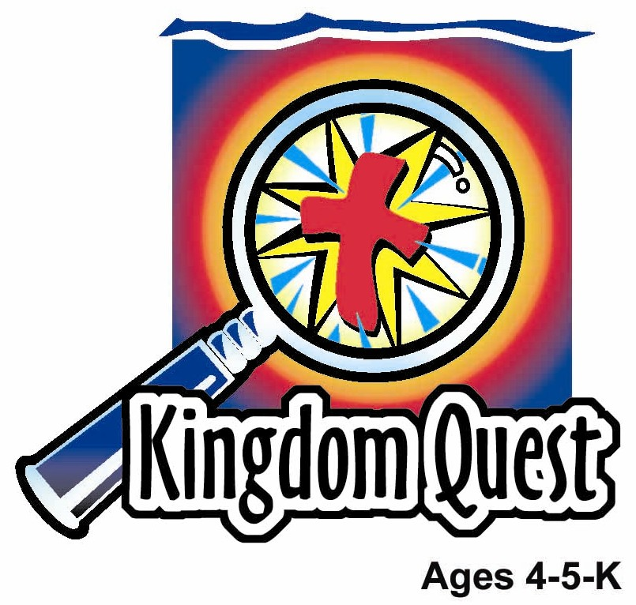
Date: ________________________
Series: I Am God’s Child (Jun-Aug)
Year 2, Lesson 6

Small David Defeats Big Goliath

Take Home Point: *I AM GOD’S CHILD—Little kids can do big things.
*Repeat this phrase throughout the lesson. The leader will say the first part of the phrase (CAPS). The children respond with the second part of the phrase (italics).

Bible Event: 1 Samuel 17
Jesus Link: Jesus gives me the power to do big things.

We will help children know:
- The story of David and Goliath.
- Even though they are little, they can do big things for God.
- They have the power to do big things through the power of Jesus.

We will help the children feel:
- Confident in their ability to do big jobs through the power of Jesus.
- Thankful for God’s help.
- Awed by God’s power at work in their lives.

We will help the children do:
- Act out the story of David and Goliath.
- Make and eat an edible stone.
- Play the game, “Shepherd’s Toss” to learn about the jobs God has for them.
THIS LESSON’S ROADMAP

DESTINATION | PAGE # | DISCOVERIES ON YOUR JOURNEY | SUPPLIES NEEDED
Large Group Opening  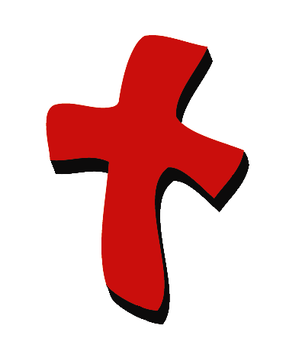 | 4-5  5-7 | Puppet Presentation  Bible Event | - Xiao Hung puppet  - police badge  - slingshot  - tennis ball  - costumes - David and Goliath  - long spear  - crown  - three or four spears  - microphone
Small Group Application   | 8  8  9  9  9 | Activity 1: “Shepherds Pouch” Craft  Activity 2: “Edible Stones” Snack  Activity 3: “Shepherd’s Toss” Game  Activity 4: “Throw the Stones!”  Prayer Time  Hint*: Save the balls from Shepherd’s Toss. They will be used again in Lesson #8. | Activity 1:  - one reproducible per child  - one paper plate per child  - stapler  - labels that say, “Little kids can do big things”  - paper punch  - two foot length of yarn per child  - crayons or markers  - scissors  Activity 2:  - one soft bun per child  - zip-lock – milo powder  - serviettes  - cups  - water or juice  Activity 3:  - three large buckets  - slips of paper with various jobs (see appendix)  Hint: copy the sheet and cut a part one sheet per bucket.  - stack of newspaper  - masking tape  Activity 4:  - 10 plastic cups from last week’s memory verse learning  - masking tape
Large Group Wrap-up   | 10  10 | Singing (Optional)  Lesson Review with Puppet Skit | - optional music for the lesson  - Xiao Er Puppet

Pre-Session Singing: (10 minutes)
Purpose: When all children are in one group singing, it is easy for new children to join the group and immediately get involved. When the music can be correlated, it introduces the theme for the day. Choose two to three songs and list them here.

Large Group Opening: (15 minutes)
Purpose: The puppet demonstrates the need that will be met in today’s lesson. The scripts are not written verbatim, but give a story line in which the group leader can interact with the puppet. The children are introduced to the take home point and then interact with God’s word as they experience the Bible event.

Supplies needed: Xiao Hung puppet; police badge; slingshot; tennis ball; costumes - David and Goliath; long spear; crown; three or four spears; microphone.

Puppet Presentation:
Purpose: The puppet demonstrates the need that will be met in today’s lesson. The scripts are not written verbatim, but give a story line in which the group leader can interact with the puppet.

Xiao Hung comes out wearing a police badge. He tells the presenter that when he grows up, he is going to be a policeman and do an important job like catching robbers. Then everyone will know how important he is. Then Xiao Hung tells the presenter that he wishes he were grown up right now, so that he could do something important. In fact, he wishes kids could do important things.

The presenter tells Xiao Hung that kids can do important things. He says:

I want to tell you a special Bible event today and show you what happened. See if you can guess who in the Bible I am talking about. This is a true story that happened to a small boy who didn’t think he would ever do anything important. But, God did something important through him, even though he was a little boy. This is what he used. Show slingshot and tie one string to your wrist. When he was a little boy, he would be out in the countryside and he would put a rock into the slingshot, like this. Put tennis ball in fabric pouch and hold loose end of string with the same hand the other string is tied to. Then, he would swing it back and forth, (begin swinging slingshot) until finally, he swung it like this in a full circle. Swing slingshot in full circle. Then, he let go of one rope and out flew the rock. Let go of end of rope—be sure to point in a safe direction. He had a wonderful time doing target practice and shooting at trees and large stones. Then, he discovered that God could use him to help protect the sheep he was taking care of. When a lion came by, he would swing, swing, swing, let go of the rope, and poof. He would knock the lion out. Or even a bear. Swing, swing, swing—he would knock the bear out.

Then one day, God chose him to do a very big thing for God’s people. Now do you know who I am talking about? Everyone shouts out David. That’s right! David! That reminds me of our take home point.

The presenter teaches Xiao Hung the take home point. *I AM GOD’S CHILD—Little kids can do big things. The presenter says the first line and Xiao Hung responds with the second line. After practicing it with Xiao Hung a few times, the presenter practices it with the children.

Bible Event: Imagination Theater
Imagination Theater is audience participation drama where the Bible event is told in creative fashion, using children as actors. The Imagination Box contains the Bible and other special props used for the drama. Begin by removing the Bible and explain that it is God’s word, telling us of the wonderful deeds God has done. Then remove an imaginary hat and place it on your head. This is your Imagination Hat. Invite the children to put on theirs as well. They will also use their imaginations to picture the events the Bible tells us about. Some will even use their imaginations to help act out these events. Distribute props to actors as they are called forward at the beginning of the presentation. Have them sit to the side until they are called on stage.

- Have the largest male adult you can find be the giant Goliath, preferably a guest.
- Have a child come forward to be David. Give him an imaginary slingshot and have him pretend to swing it around several times, as the leader demonstrated earlier.
- Have a second child come forward to be King Saul and give him the crown.
- Choose three or four other children to be Saul’s soldiers.
- Have all the characters begin offstage.

Line the three soldiers of Saul on stage left. Place Saul behind them. Goliath enters from stage right.

Presenter begins:

The people of Israel were at war against the Philistines. The Philistines had a mighty warrior. He was a giant named Goliath. Let’s call him right now. Let’s all say, “Thump, thump, thump, Goliath.” Repeat twice in a low, sing-song voice. Here he comes marching in. Goliath was over nine feet tall and he wore a suit made out of a heavy metal. He would stand on the hill and look out to the other hill where the Israelite army was. Behind him, all the soldiers of the Philistine army would cheer, “Yeah, Goliath!” Let me hear you say that. And Goliath would yell bad things at the Israelites. Goliath can ad lib insults at this point: “You’re ugly. Your king is stupid. Your mamma dresses you funny.” But most of all, “Our god is bigger, and way more powerful than your God.”
Goliath was so big and scary, that when the people would hear him yell, they would all scream and run away. Let’s hear your “I’m afraid” scream, as the soldiers all drop their spears and run away. The soldiers drop their spears and run offstage.

Goliath made a suggestion. He said, “You choose a man, and let him be your champion. I will be the champion for the Philistines. Have him come down, and we will fight together. If he kills me, then you win and we will serve you. But, if I kill him, then we win, and you will serve us.”

So Saul said, “If anyone will be our champion and fight Goliath, I will make him a hero. He can marry my daughter, and I’ll make him rich.” But no one could be found to fight Goliath. For 40 days, Goliath yelled his insults. Goliath, do you have any more insults for us to hear? “Sure.” Have Goliath ad lib more insults: Not only are you ugly, but your dog is ugly. And you’re nothing but a big, fat ‘fraidy cat. Most of all, my god is stronger than your God.”

And what did the Israelite soldiers do? They were afraid, and stayed away. Pretend to be those soldiers again, and let me hear your ‘fraidy cat’ yell.

But now, the little boy, David, had come to see his brothers, who were serving in the army. David had been far away, taking care of the sheep. Most thought he was only good for bringing lunch to his brothers. But when David arrived, he heard the giant, Goliath, yell terrible things to Saul and his armies, and insult God, himself. So David said, “Who is this loser? How can he make fun of God and his army?”

The other soldiers were surprised to hear such a young boy talk so bravely against the giant. But when David heard that they were looking for someone to fight Goliath, David said, “Please, send me. I will go.” So Saul sent him. At first, Saul wanted David to wear his special royal armor. This meant a big chest protector, a heavy shield and long sword, like this. Show props, if possible.

But, David said, “I can’t wear this. I’m not used to fighting this way. Let me use what God has given me to fight with.” And David pulled out this. It was the slingshot. David told King Saul that when he was a shepherd, he could kill a lion, or even a bear, that tried to attack the sheep. And if God let him do that, then God would certainly let him kill this giant, who had insulted God, his king, and the army.

David chose five smooth stones and put them into his pouch. Can you count with me? Count, “One, two, three, four, five.” With his slingshot in his hand, he went up to Goliath. When Goliath saw David, he started to tease him. He said, “Do you think I’m a dog?” That’s because Goliath saw David coming at him with sticks and rocks. Goliath said, “You’re just a boy. What chance do you have?”

But David answered, “You come at me with sword and spear, but I come against you in the name of the Lord Almighty. The Lord saves. The battle belongs to God. He will defeat you.”

Then David ran up to Goliath. He reached into his bag. Took out a stone. Slung it and struck Goliath on the forehead. Goliath fell to the ground and died. The Israelites cheered. Soldiers, can I hear you cheer? All the soldiers in the audience? And then they chased all the bad Philistines away. Through a little boy, God had won a big victory!

What can we remember from this? *I AM GOD’S CHILD—little kids can do big things.

Small Group Application: (30 minutes)
Purpose: Smaller groups enable children to develop closer relationships with adults and peers in the church. As you reinforce the take home point with a fun hands-on activity, discuss the Bible event. Be sure to repeat the take home point several times. Say the first part and have the children respond with the second phrase. Application questions help kids apply the take home point to their daily lives. Close this session by gathering your small group for prayer. Let the kids pray!

During the small group application time, discuss the following questions and points:

What big job did David have to do? (Kill the giant Goliath.)

Who helped David do the job? (God.)

What big jobs does God give you? (Answers will vary but may include helping parents with chores, cleaning up room, sharing Jesus with a friend, praying for someone, etc.)

Who gives you the power to do a big job? (Jesus.)

Activity 1: “Shepherds Pouch” Craft
Supplies needed: one reproducible per child; one paper plate per child; stapler; labels that say, “Little kids can do big things”; paper punch; two foot length of yarn per child; crayons or markers; scissors.

To make the shepherds pouch:
- Fold the paper plate in half.
- Staple so that only the top is open.
- Put the label on the pouch.
- Color with markers or crayons.
- Punch a hole in each corner at the top of the pouch.
- Tie each end of the yarn into one of the holes.
- Cut apart the reproducible.
- Explain that each strip is a big job that God has for the children to do.
- Read each slip and have the children wad them up into a ball and put them in the pouch, as a reminder that David was able to do his big job with God’s help, and we can do our big jobs, through the power of Jesus.

Practice the take home point. *I AM GOD’S CHILD—Little kids can do big things.

Activity 2: “Edible Stones” Snack
Supplies needed: One soft bun per child; zip-lock bag – milo powder; serviettes; cups; water

To make:
- Tear a portion of bread from the bun to make it look like a ball.
- Count five bread balls (“stones”) put them in the milo powder, close the zip-locked bag and take turns shaking.
- Repeat procedure until all the “stones” have been covered with milo powder mixture.
- Eat!

Hint: hand wipes are recommended for wiping the milo powder
off the children’s hands.

HEALTHY SNACK OPTION: To check for the healthiest bread, check the label to make sure the first ingredient is whole grain.

To discuss:
- As you count out five of the children’s “stones,” remind them that David chose five stones to put in his pouch. But he needed only one stone to do the job God had given him, because God can help little kids do big things.
- What big jobs does God give you? Remember, God can help you do big things too!

Practice the take home point. *I AM GOD’S CHILD—Little kids can do big things.

Activity 3: “Shepherd’s Toss” Game
Supplies needed: three large buckets; slips of paper with various jobs (see appendix); stack of newspaper; masking tape

After the paper balls have been made, group the children into three groups. Each child gets five “balls” to toss in the buckets. The object of the game is to throw the handmade paper ball in a bucket. When a child makes the ball go into the bucket, he/she may draw a slip of paper from the bucket and do the activity reinforcing the point: *I AM GOD’S CHILD—Little kids can do big things.

To make:
- Use the sheets of newspaper to wad into 2-3” balls.
- Use the masking tape to seal the paper ball into its shape.
- Mark a starting point on the floor with masking tape. Place buckets 8-10’ from the line.

To discuss:
- Remind kids of how many stones David had to kill Goliath.
- Review how small David was to Goliath’s height and how God helped David protect the people.
- Kids will see that the “little” things they do can be “big” things to God and to others.

While doing these activities, reinforce the take home point: *I AM GOD”S CHILD—Little kids can do big things.

Activity 4: “Throw the Stones!”
Purpose: Help kids to memorize and keep scriptures at heart. Using creative ways to help kids enjoy learning the key verse and in small group setting.

Supplies needed: 10 plastic cups from last week’s memory verse learning; paper balls from activity 3

Memory Verse: Galatians 3:27 ~ We are all children of God through faith in Christ Jesus.

Memory Verse Learning:
Stack the cups into the shape of a pyramid prior to class. Recite the memory verse a few times with the children. Tell the children that they will have a chance to throw the paper ball at the stacked cups after they have recited the memory verse. Every child will have three chances to knock down the cups. After each child’s attempt, cups can be arranged randomly. Recite the memory verse together before proceeding to prayer time.

Prayer Time:
Ask Jesus to give you the power to do both big jobs and jobs that seem little but in God’s eyes are really big.
Large Group Wrap-Up: (10 minutes)
Purpose: The crazy bird puppet , Xiao Er, struggles with learning the take home point. The leader shows an example of the each small group application activity from this lesson and says the first phrase of the take home point. The kids respond with their phrase. They try to teach the puppet the take home point, but each time he confuses words or concepts. After three attempts, he finally gets it right and sings the correct take home point in a silly opera-like voice.

Singing: (Optional)

Lesson Review with Puppet Skit:

Xiao Er’s confused phrases:

Activity 1: “Little birds are really cute.”
Activity 2: “…Don’t really eat rocks.”
Activity 3: “Big kids can do little things…?”
Activity 4 “I can throw the paper balls!”

Welcome guests and thank them for attending.

Lesson 6

Large Group Warm-up:
- Xiao Hung puppet
- police badge
- slingshot: square of medium weight fabric. (2) 3’ chords attached to opposite sides of the fabric
- tennis ball
- costumes - David and Goliath
- long spear
- crown
- three or four spears
- microphone

Small Group Application
Activity 1:
- one reproducible per child
- one paper plate per child
- stapler
- labels that say, “Little kids can do big things”
- paper punch
- two foot length of yarn per child
- crayons or markers
- scissors
Activity 2:
- one soft bun per child
- zip-lock bag – milo powder
- serviettes
- cups
- water or juice
Activity 3:
- three large buckets
- slips of paper with various jobs (see appendix) Hint: copy the sheet and cut apart one sheet per bucket.
- stack of newspaper
- masking tape
Activity 4:
  - 10 plastic cups labeled from last week’s memory verse learning
  - paper balls from activity 3

Large Group Wrap-up
- optional music for the lesson
- Xiao Er Puppet
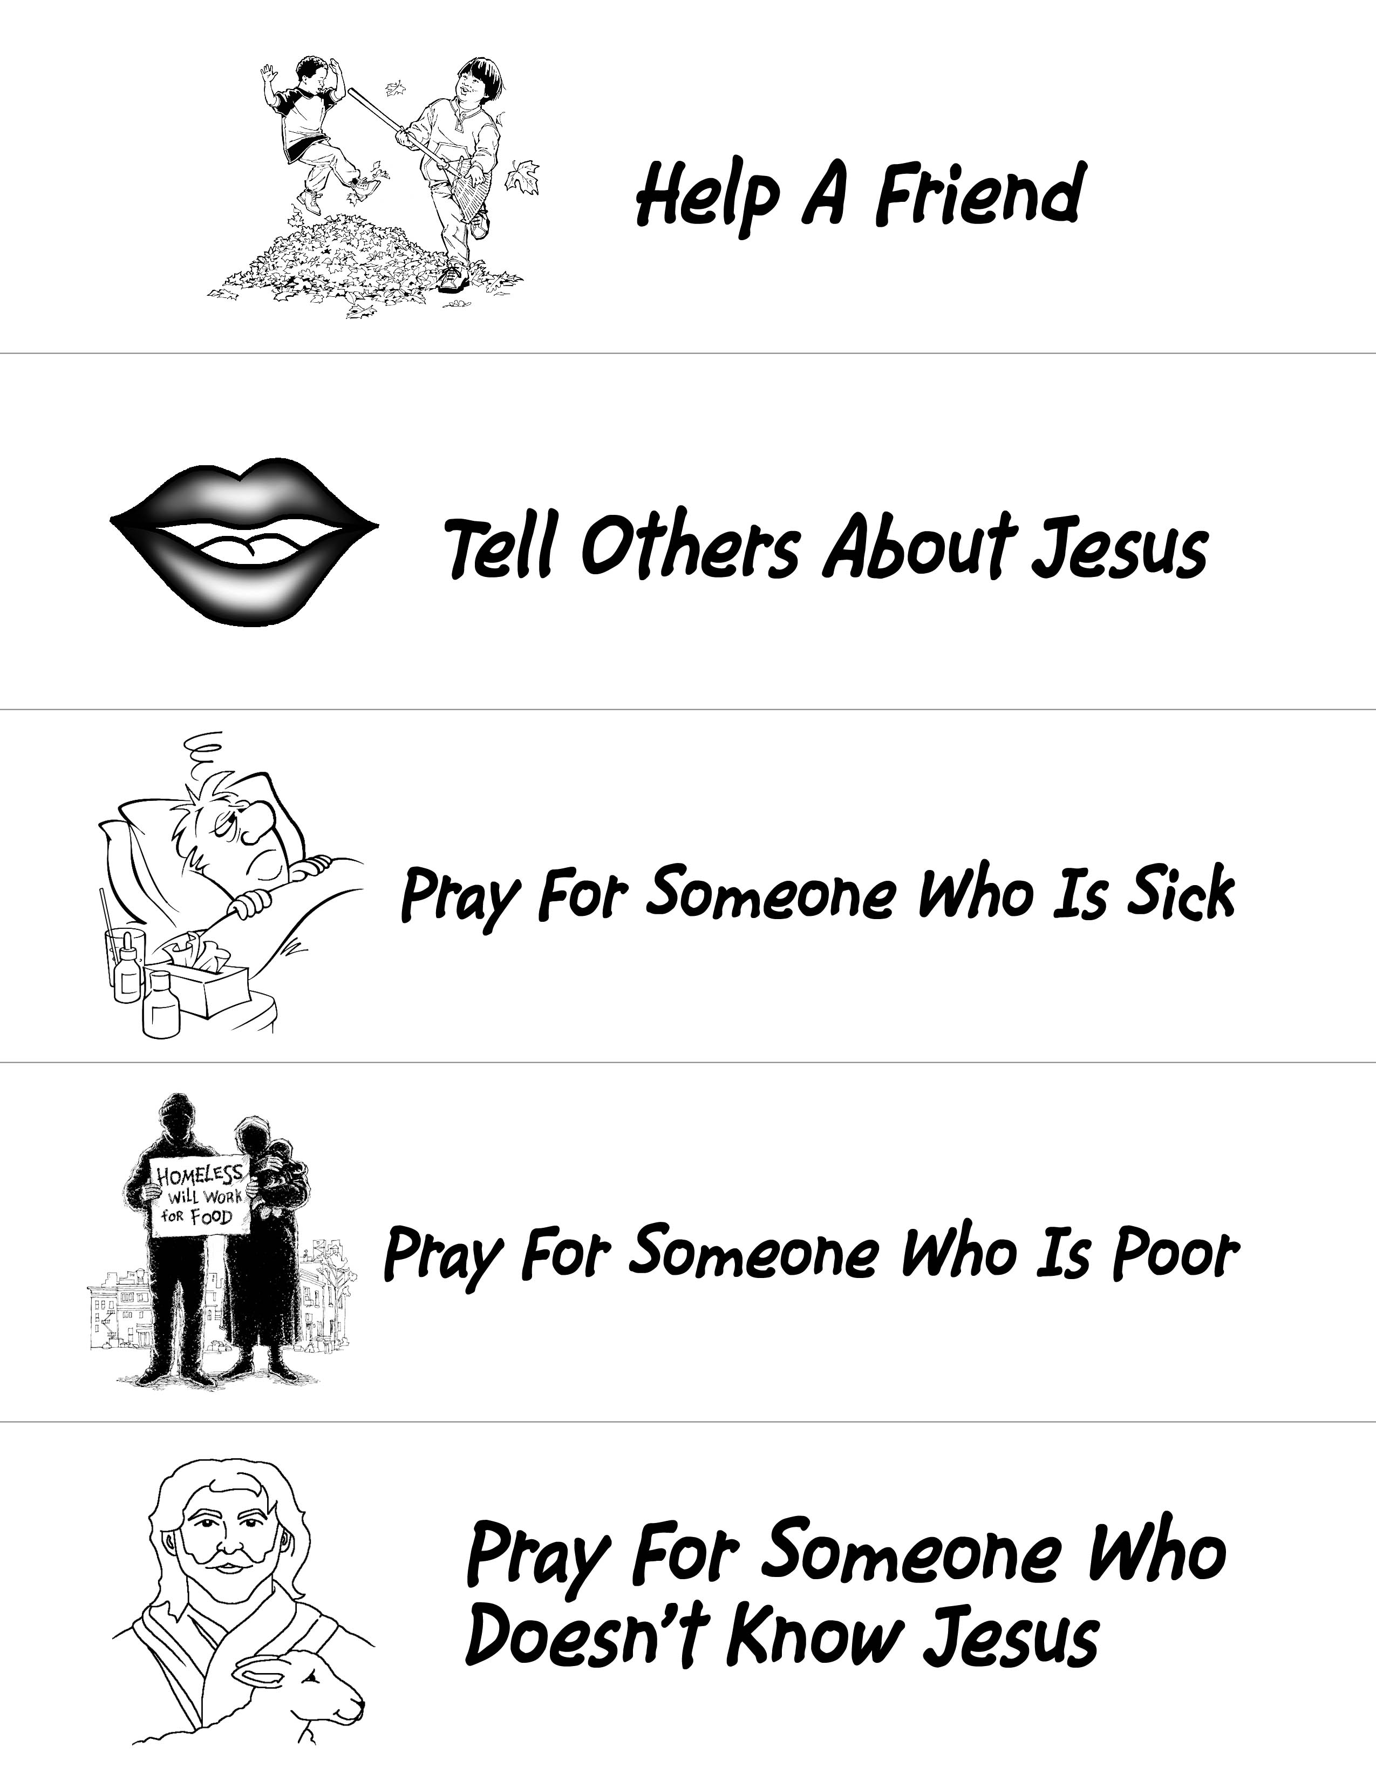
APPENDIX:

