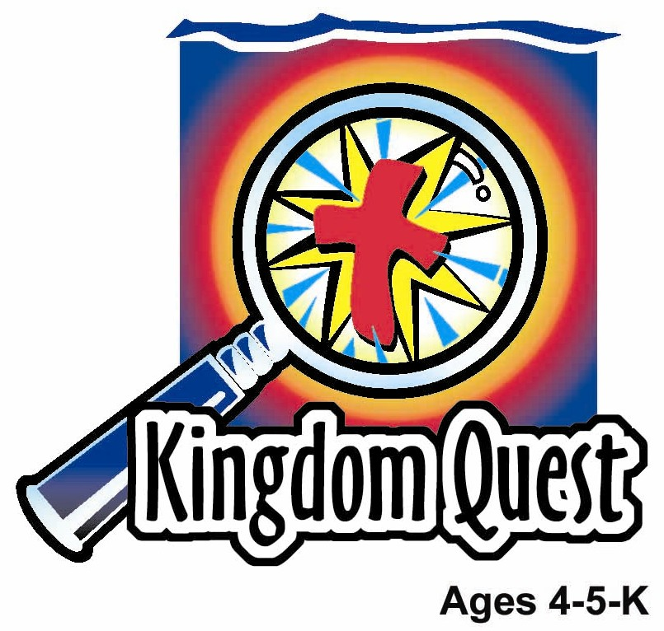
Date: ________________________
Series: Jesus Gave His Life for Me (Dec - Mar)
Year 2, Lesson 42

Here Comes

the King

Take Home Point: *HERE COMES THE KING—Praise Jesus!
*Repeat this phrase throughout the lesson. The leader will say the first part of the phrase (CAPS). The children respond with the second part of the phrase (italics).

Bible Event: Matthew 21:1-11
Jesus Link: As King, Jesus deserves all of our worship, honor and praise.

We will help children know:
- The story of Jesus riding into Jerusalem on Palm Sunday.
- Jesus, the King of Kings, is also their Savior.
- We praise Jesus the King.

We will help the children feel:
- Joy that Jesus is their King.
- Desire to worship Jesus the King.
- Hearts of worship for Jesus the King.

We will help the children do:
- Dramatize the Bible event in an imagination theater.
- Make and eat a snack, “Palm Branch Delight,” while reviewing the Bible event.
- Play “Donkey Relays” and discuss that one way we follow Jesus is by worshipping Him and praising Him.
THIS LESSON’S ROADMAP

DESTINATION | PAGE # | DISCOVERIES ON YOUR JOURNEY | SUPPLIES NEEDED
Large Group Opening  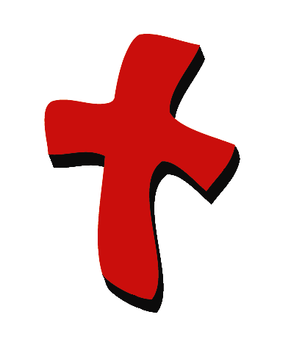 | 3  3-6 | Puppet Presentation  Bible Event | - Xiao Hung puppet  - several stalk of flowers  - Imagination Box that includes:  - Bible  - masking tape  - imagination palm branch for each child: from reproducible.  - child-sized Jesus costume  - several robes or fabric  - Option 1: donkey costume  - Option 2: stick horse  - microphone  - Hosanna song, e.g. “Shout Hosanna,” from Integrity Music Just-For-Kids, King of Kings, by Integrity Music, Inc. (optional)
Small Group Application   | 7  7-8  8  8-9 | Activity 1: “Palm Branch” Craft  Activity 2: “Palm Branch Delight” Snack  Activity 3: ”Donkey Relays” Game  Activity 4: “Raise the Banner High”  Prayer Time | Activity 1:  - palm branch reproducible  - scissors  - black markers  - ice-cream sticks or straws  - cellophane tape  - labels with take home point on them  Activity 2:  - oval shape biscuits  - green frosting  - Rocky sticks  - plastic knives  - serviettes  - cups  - hand wipes  - water or juice  Activity 3:  - one donkey headband per team  - masking tape  Activity 4:  - banner
Large Group Wrap-up   | 10  10 | Singing (Optional)  Lesson Review with Puppet Skit | - optional music for the lesson  - Xiao Er puppet

Pre-Session Singing: (10 minutes)
Purpose: When all children are in one group singing, it is easy for new children to join the group and immediately get involved. When the music can be correlated, it introduces the theme for the day. Choose two to three songs and list them here.

Large Group Opening: (15 minutes)
Purpose: The puppet demonstrates the need that will be met in today’s lesson. The scripts are not written verbatim, but give a story line in which the group leader can interact with the puppet. The children are introduced to the take home point and then interact with God’s Word as they experience the Bible event.

Supplies needed: Xiao Hung puppet; several stalk of flowers; Imagination Box that includes: Bible, masking tape, imagination palm branch for each child: from reproducible, child-sized Jesus costume, several robes or fabric, Option 1: donkey costume, Option 2: stick horse, microphone, Hosanna song, e.g. “Shout Hosanna,” from Integrity Music Just-For-Kids, King of Kings, by Integrity Music, Inc. (optional)

Puppet Presentation:
Xiao Hung comes out with several stalk of flowers. He is excited to tell the presenter about a parade he went to. The flowers was thrown to the people at the parade and he collected it. The presenter asks Xiao Hung several questions about who was in the parade, such as: “Were there any clowns in the parade?” or “Tell me about the floats in the parade.” Xiao Hung responds to each question.

The presenter says that the parade Xiao Hung went to reminds him of another parade that happened nearly 2000 years ago, one the children will be learning about today. Xiao Hung is shocked. He didn’t know there was parades way back in those olden days.

The presenter shares that this parade was special. In the parade Xiao Hung went to, those in the parade threw flowers to those on the street. In the parade 2000 years ago, the people on the street were the ones doing the throwing. The parade was for Jesus. He was riding into Jerusalem on a donkey for a special holy holiday called Passover. The people lined the streets to see Jesus. They threw down their coats on the road for Jesus to ride on and they waved palm branches, shouting praises to Jesus.

The presenter teaches Xiao Hung the take home point: *HERE COMES OUR KING – Praise Jesus! The presenter says the first line; Xiao Hung responds with the second line. After practicing it with Xiao Hung a few times, the presenter practices it with the children.

Bible Event: Imagination Theater
Imagination Theater is audience participation drama where the Bible event is told in creative fashion using children as actors. The Imagination Box contains the Bible and other special props used for the drama. Begin by removing the Bible and explain that it is God’s Word. Briefly summarize the story, and then remove an imaginary hat and place it on your head. This is your Imagination Hat. Invite the children to put on theirs as well. They will also use their imaginations to picture the events the Bible tells us about. Some will even use their imaginations to help act out these events. Distribute props to actors as they are called forward at the beginning of the presentation. Have them sit to the side until they are called on stage.

Before the Bible event, dress an adult as a donkey if you are using option 1. Dress a smaller-sized child in a Jesus costume and have him sit on the stage near the presenter. Hide the “donkey” off to the side. (If using a stick horse, hide that.)

Mark the room with a road leading to the stage area by using masking tape on the floor. This will help the crowd know where to lay the palm branches and robes.

Jesus Rides as a King in Jerusalem

Take the Bible out of the Imagination Box and briefly summarize today’s Bible event.

Today’s Bible event comes from a book written by Matthew. Let me open it up. Oh my! This is the event where Jesus rides as a king into the city of Jerusalem.

Look what kind of animal He is riding. I wonder if you can listen and remember what kind of animal it is that Jesus will ride to Jerusalem as a king.

All the people are shouting as Jesus is coming to Jerusalem. What are they saying? They are waving something into the air and throwing it onto the road in front of Him. It’s some kind of branches. I wonder if you know what kind of branches they will put down in front of Him.

People are putting down something else, too. It’s a way to show they are praising the King. Let’s act out the story and find out what happened.

After you and the children put on your Imagination Hats, begin. Phrases that are underlined and italicized are to be repeated by the child actor or audience. Point the microphone to the actor to show when it is his or her turn.

(Open Imagination Box and pull out the Jesus costume.) I will need a special actor to be Jesus. Come forward and let’s put on your costume. Then wait over here to the side.

Now everyone else is going to have to get ready to be the people who will welcome the king. Let’s see how you can welcome Him. Let me look inside the Imagination Box and see what else we have.

Ah! This is a palm branch. (Show a sample palm branch.) It is something like this that the people pulled from the trees and waved in front of Jesus when He came as king to Jerusalem.

We don’t have any real palm branches today, so we will have to use our imaginations. Let’s pretend that these (refer to paper palm branches) are palm branches. Let me pass them out to the kids now. When you get one, you must go back and be seated by the sides of the road here. The road is a taped off area that Jesus will travel. In a moment, you will throw your palm branches on the road.

Look here. There’s something else we will need to throw on the road. (Take robes out of Imagination Box and pass them out.) Keep these in your hands until it is time to act out the story.

We will also need a donkey. We have one over here. Let’s get him ready. (Lead the donkey to the side of the stage or bring out the stick horse.)

Are you ready to begin? Let me look at the Bible so I can tell you what happened.

One day Jesus and His disciples, His helpers, were going into the city of Jerusalem. Jesus told two of His disciples to go into a village and bring back a certain animal. This animal goes, “Hee haw! Hee haw!” What kind of animal was it? Right! It’s a donkey.

So, Jesus said, “Go to the city.” Go to the city. “You will find a donkey.” You will find a donkey.

The disciples found a donkey and brought it back. (Lead the donkey to Jesus.) Jesus got onto the donkey. (Help Jesus onto the donkey’s back.) And He rode the donkey into town. (Begin down the path.)

As Jesus rode into town, a large crowd of people gathered. They were waiting for Jesus. They knew He was the King. Now He was coming into His royal city of Jerusalem. They were very excited so they threw their coats on the ground. (Children with robes throw them along the road.) Then they started waving their palm branches. Can you wave your palm branch just as the people did? (Children wave their palm branches.)

The people began to shout out praises to Jesus. Everyone needs to say it with me. “Hosanna!” Hosanna! Hosanna in the highest! Hosanna in the highest! Praise King Jesus! Praise King Jesus!

Optional: Sing a Hosanna song, such as, “Shout Hosanna,” from the tape Integrity Music Just-For-Kids, King of Kings, by Integrity Music, Inc.
Have the children continue repeating these phrases until “Jesus” goes down the path and back to the front of the room.

When Jesus arrived in Jerusalem, the whole city wondered who He was. Why did everyone praise Him? They praised Him because Jesus is the King. He is not only the King of that city, but He is also the King of every king who has ever lived. He is our King.

Jesus is our King because we know that Jesus came from God. God sent Him to us to save us from our sin and to fill us with His love. Now we can praise Jesus, too. We can praise Him with our palm branches. (Wave palm branches.) We can praise Him with singing, playing instruments, dancing, shouting, and saying prayers. We want to praise our King Jesus because He came to earth to give His life for us and to fill us with His love. Some day we will be able to be with Him in His kingdom in heaven. *JESUS IS OUR KING – Praise Jesus!

Practice the take home point. You say the first part; the children respond with the second part. *HERE COMES THE KING—Praise Jesus!

End with a brief prayer with children repeating after each line.

Dear God, (repeat)
Thank You for being here. (repeat)
Thank You for sending Jesus. (repeat)
Jesus gave Himself for us. (repeat)
Jesus is our King. Praise Jesus! (repeat)
Thank You, thank You, thank You! (repeat)
Amen. (repeat)

Small Group Application: (30 minutes)
Purpose: Smaller groups enable children to develop closer relationships with adults and peers in the church. As you reinforce the take home point with a fun hands-on activity, discuss the Bible event. Be sure to repeat the take home point several times. Say the first part and have the children respond with the second phrase. Application questions help kids apply the take home point to their daily lives. Close this session by gathering your small group for prayer. Let the kids pray!

During the small group application time, discuss the following questions and points:

When Jesus rode into Jerusalem on a donkey, what did the people do? (They shouted praises to Him, put their coats on the road, and waved palm branches.)

Why did the people praise Jesus? (Because Jesus is the King.)

Jesus is our King, too. How can we praise Jesus? (Answers will vary but may include singing songs, shouting praises to Jesus, playing instruments, telling others about Jesus, or praying. If children are unable to think of ways to praise Jesus, feel free to help them.)

What was the greatest thing Jesus, our King, did for us? (He died on the cross so that someday we can go to His kingdom.)

Activity 1: “Palm Branch” Craft
Supplies needed: palm branch reproducible; scissors; black markers; ice-cream sticks or straws; cellophane tape; labels with take home point on them

To make:
- Cut out the palm branch reproducible. Make several “v” shaped notches on it to make it look like a palm branch.
- Use the black markers to make lines for the veins of the branches. (You may have to demonstrate this to the children.)
- Add the label to the front of the palm branch.
- Tape the straw or ice-cream stick to the back.

To discuss:
As the children work, review the Bible event. Say: Jesus is our King because He is God. The best thing Jesus did for us as King was to lay down His life for us on the cross, just as the people laid down their cloaks on the road for Jesus. When Jesus died on the cross for us, He brought us into His kingdom as His children. We are children of King Jesus! Let’s praise Jesus. Practice waving the palm branches and praising Jesus with phrases such as Hosanna! Hosanna to the King! Praise King Jesus!

Practice the take home point. You say the first part; the children respond with the second part. *HERE COMES THE KING—Praise Jesus!

Activity 2: “Palm Branch Delight” Snack
Supplies needed: oval shape biscuits; green frosting; Rocky sticks; plastic knives; serviettes; cups; hand wipes; water or juice

To make:
- Spread green frosting on the biscuit.
- Add a Rocky stick for the stem of the palm branch,
- Eat!

To discuss:
In the Bible event the people praised King Jesus by laying their coats on the road for Him, waving palm branches, and shouting praises. What are some ways we can praise Jesus? (Singing, shouting praises, dancing, playing instruments, and saying prayers.) Why do we praise Jesus? (He is God. He is our King. He is our Savior who died on the cross for us and fills us with love.)

Practice the take home point. You say the first part; the children respond with the second part. *HERE COMES THE KING—Praise Jesus!

Activity 3: “Donkey Relays” Game
Supplies needed: one donkey headband per team ; masking tape

To do:
- Make two short, simple, and identical paths out of masking tape on the floor.
- Divide the group into two teams and have them line up at the beginning of the two paths.
- Give the first person in each line a set of donkey ears to put on their heads.
- On the word “Go!” the first person (donkey) from each team follows the path either by crawling or walking.
- When the donkey is finished following the path, he gives the donkey ears to the next child in line and the process is repeated.
- The first team to have all its donkeys follow the path wins.

To discuss:
In our game, the donkey followed the path just as the donkey in the Bible event followed the road in Jerusalem. We follow Jesus. We follow Jesus because He is our God, our King and our Savior who died for us and fills us with love. One way we follow Jesus is by praising Him.

Practice the take home point. You say the first part; the children respond with the second part. *HERE COMES THE KING—Praise Jesus!

Activity 4: “Raise the Banner High”
Supplies needed: banner

Memory Verse: Matthew 20:28a ~ “The Son of Man... came to serve others...”
MV Presentation:
Tell the children that in many parades there are teams who hold up a banner to tell a message. Raise up the memory verse banner and read with the children the verse. Explain to the children that from this verse we can understand that King Jesus did not come to be served, though He received many praises as He entered Jerusalem that day. But Jesus came to earth actually to take care of people and especially to die on the cross so that we can receive forgiveness of sin when we believe in Him. Spend the time helping the children recite the memory verse through the banner. Then have volunteers hold each side of the banner by the broomsticks and everybody recites the verse while the volunteers wave the banner together. Leave the banner standing in the classroom.

Prayer Time:
Pray a prayer of praise, praising Jesus for being God, being King and being your Savior. How else can you praise Jesus?

Large Group Wrap-Up: (10 minutes)
Purpose: The crazy bird puppet, Xiao Er, struggles with learning the take home point. The leader shows an example of the each small group application activity from this lesson and says the first phrase of take home point. The kids respond with their phrase. They try to teach the puppet the take home point, but each time he confuses words or concepts. After three attempts, he finally gets it right and sings the correct take home point in a silly opera-like voice.

Singing: (Optional)

Lesson Review with Puppet Skit:
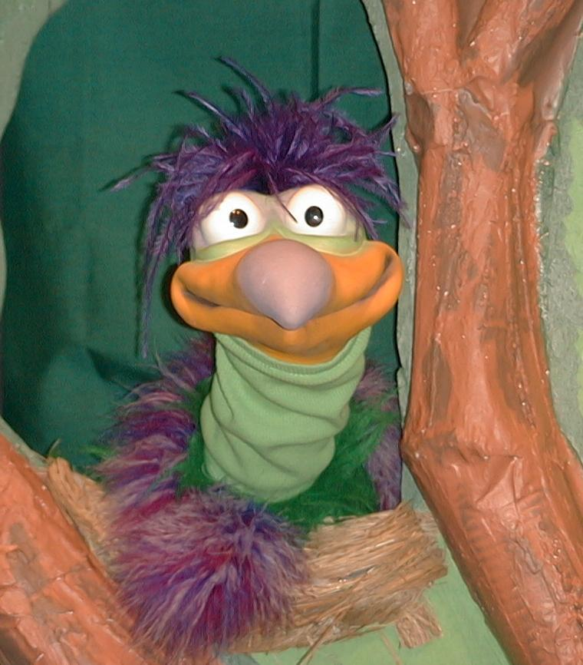
Presenter shows Xiao Er a craft made in Activity 1. Then the kids attempt to teach Xiao Er the take home point.

Presenter says to kids: “Here comes the King…”
Kids say: “…Praise Jesus!”
Presenter says to Xiao Er: “Here comes the King…”
Xiao Er says: “…Praise tigers!”

Presenter shows an example of the next activity done in small group and repeats first phrase to kids. The kids say the correct response trying to teach Xiao Er the take home point. Continue in this manner with Presenter showing example of each activity. Here are Xiao Er’s responses:

Xiao Er’s response to Activity 2 sample: “…Raise my allowance.”
Xiao Er’s response to Activity 3 sample: “…Everybody shout.”

Presenter says: “Xiao Er, listen one last time.
Here comes the King…”
Kids response: “…Praise Jesus!”
Presenter says to Xiao Er: “Here comes the King…”
Xiao Ers response: (Warms up his singing voice with “Mee, mee, mee,
mee, mee…” and sings in a silly dramatic opera-like
voice) “Here comes the King – Praise Jesus!”

Welcome guests and thank them for attending.

Lesson 42

Large Group Opening
- Xiao Hung puppet
- several stalk of flowers
- Imagination Box that includes:
- Bible
- masking tape
- imagination palm branch for each child: from reproducible.
- child-sized Jesus costume
- several robes or fabric
- Option 1: donkey costume
- Option 2: stick horse
- microphone
- Hosanna song, e.g. “Shout Hosanna,” from Integrity Music Just-For-Kids, King of Kings, by Integrity Music, Inc. (optional)

Small Group Application
Activity 1:
- palm branch reproducible
- scissors
- black markers
- ice-cream sticks or straws
- cellophane tape
- labels with take home point on them
Activity 2:
- oval shape biscuits

Matthew 20:28 The Son of Man
came to serve others.
- green frosting
- Rocky sticks
- plastic knives
- serviettes
- cups
- hand wipes
- water or juice
Activity 3:
  - one donkey headband per team
- masking tape
Activity 4:
- banner. Cut a mahjong paper into two and join the sides so as to make a long strip. Write the memory verse with a permanent marker but in outline. Then tape a broomstick on to each sides.

Large Group Wrap-up
- optional music for the lesson
- Xiao Er puppet
Lesson 42-Activity One – Palm Branch
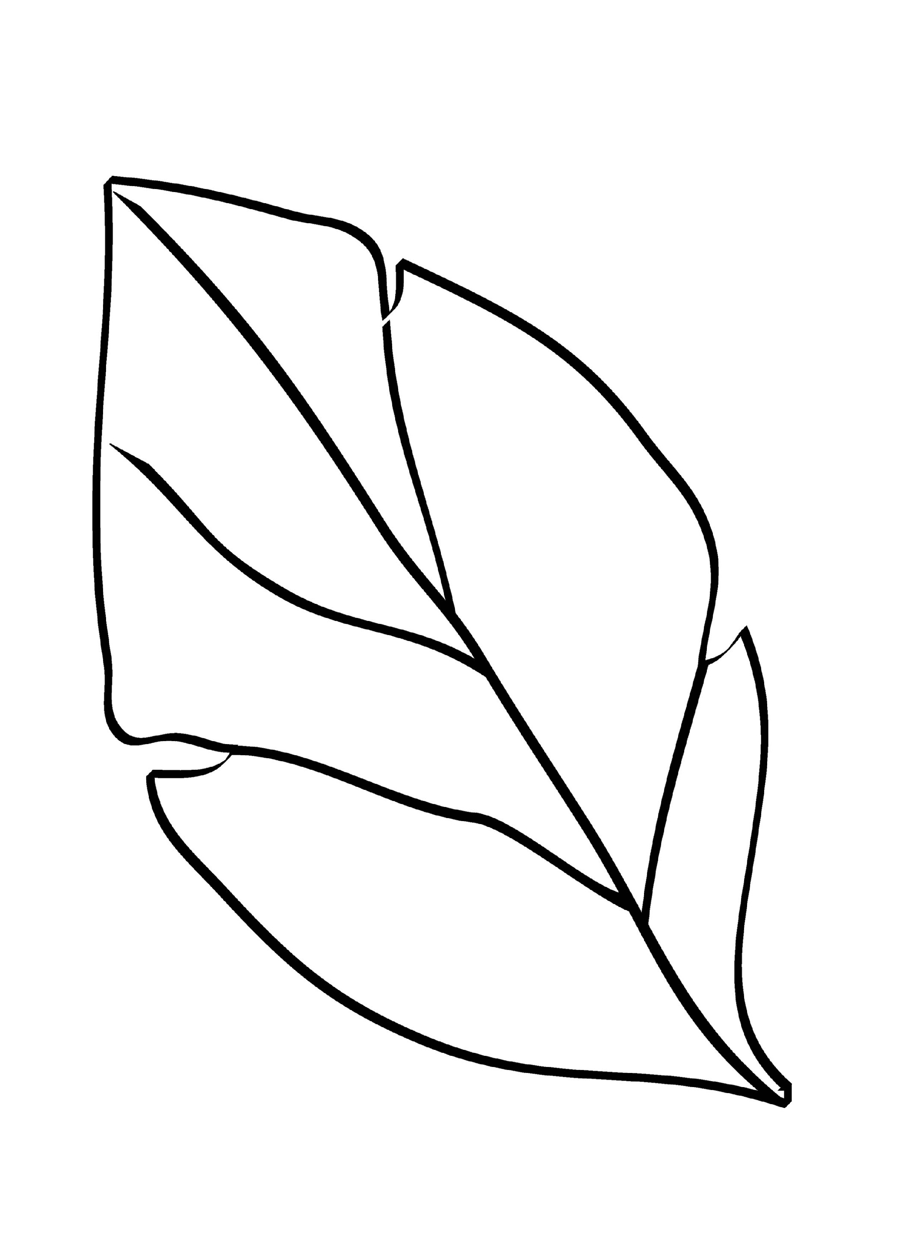

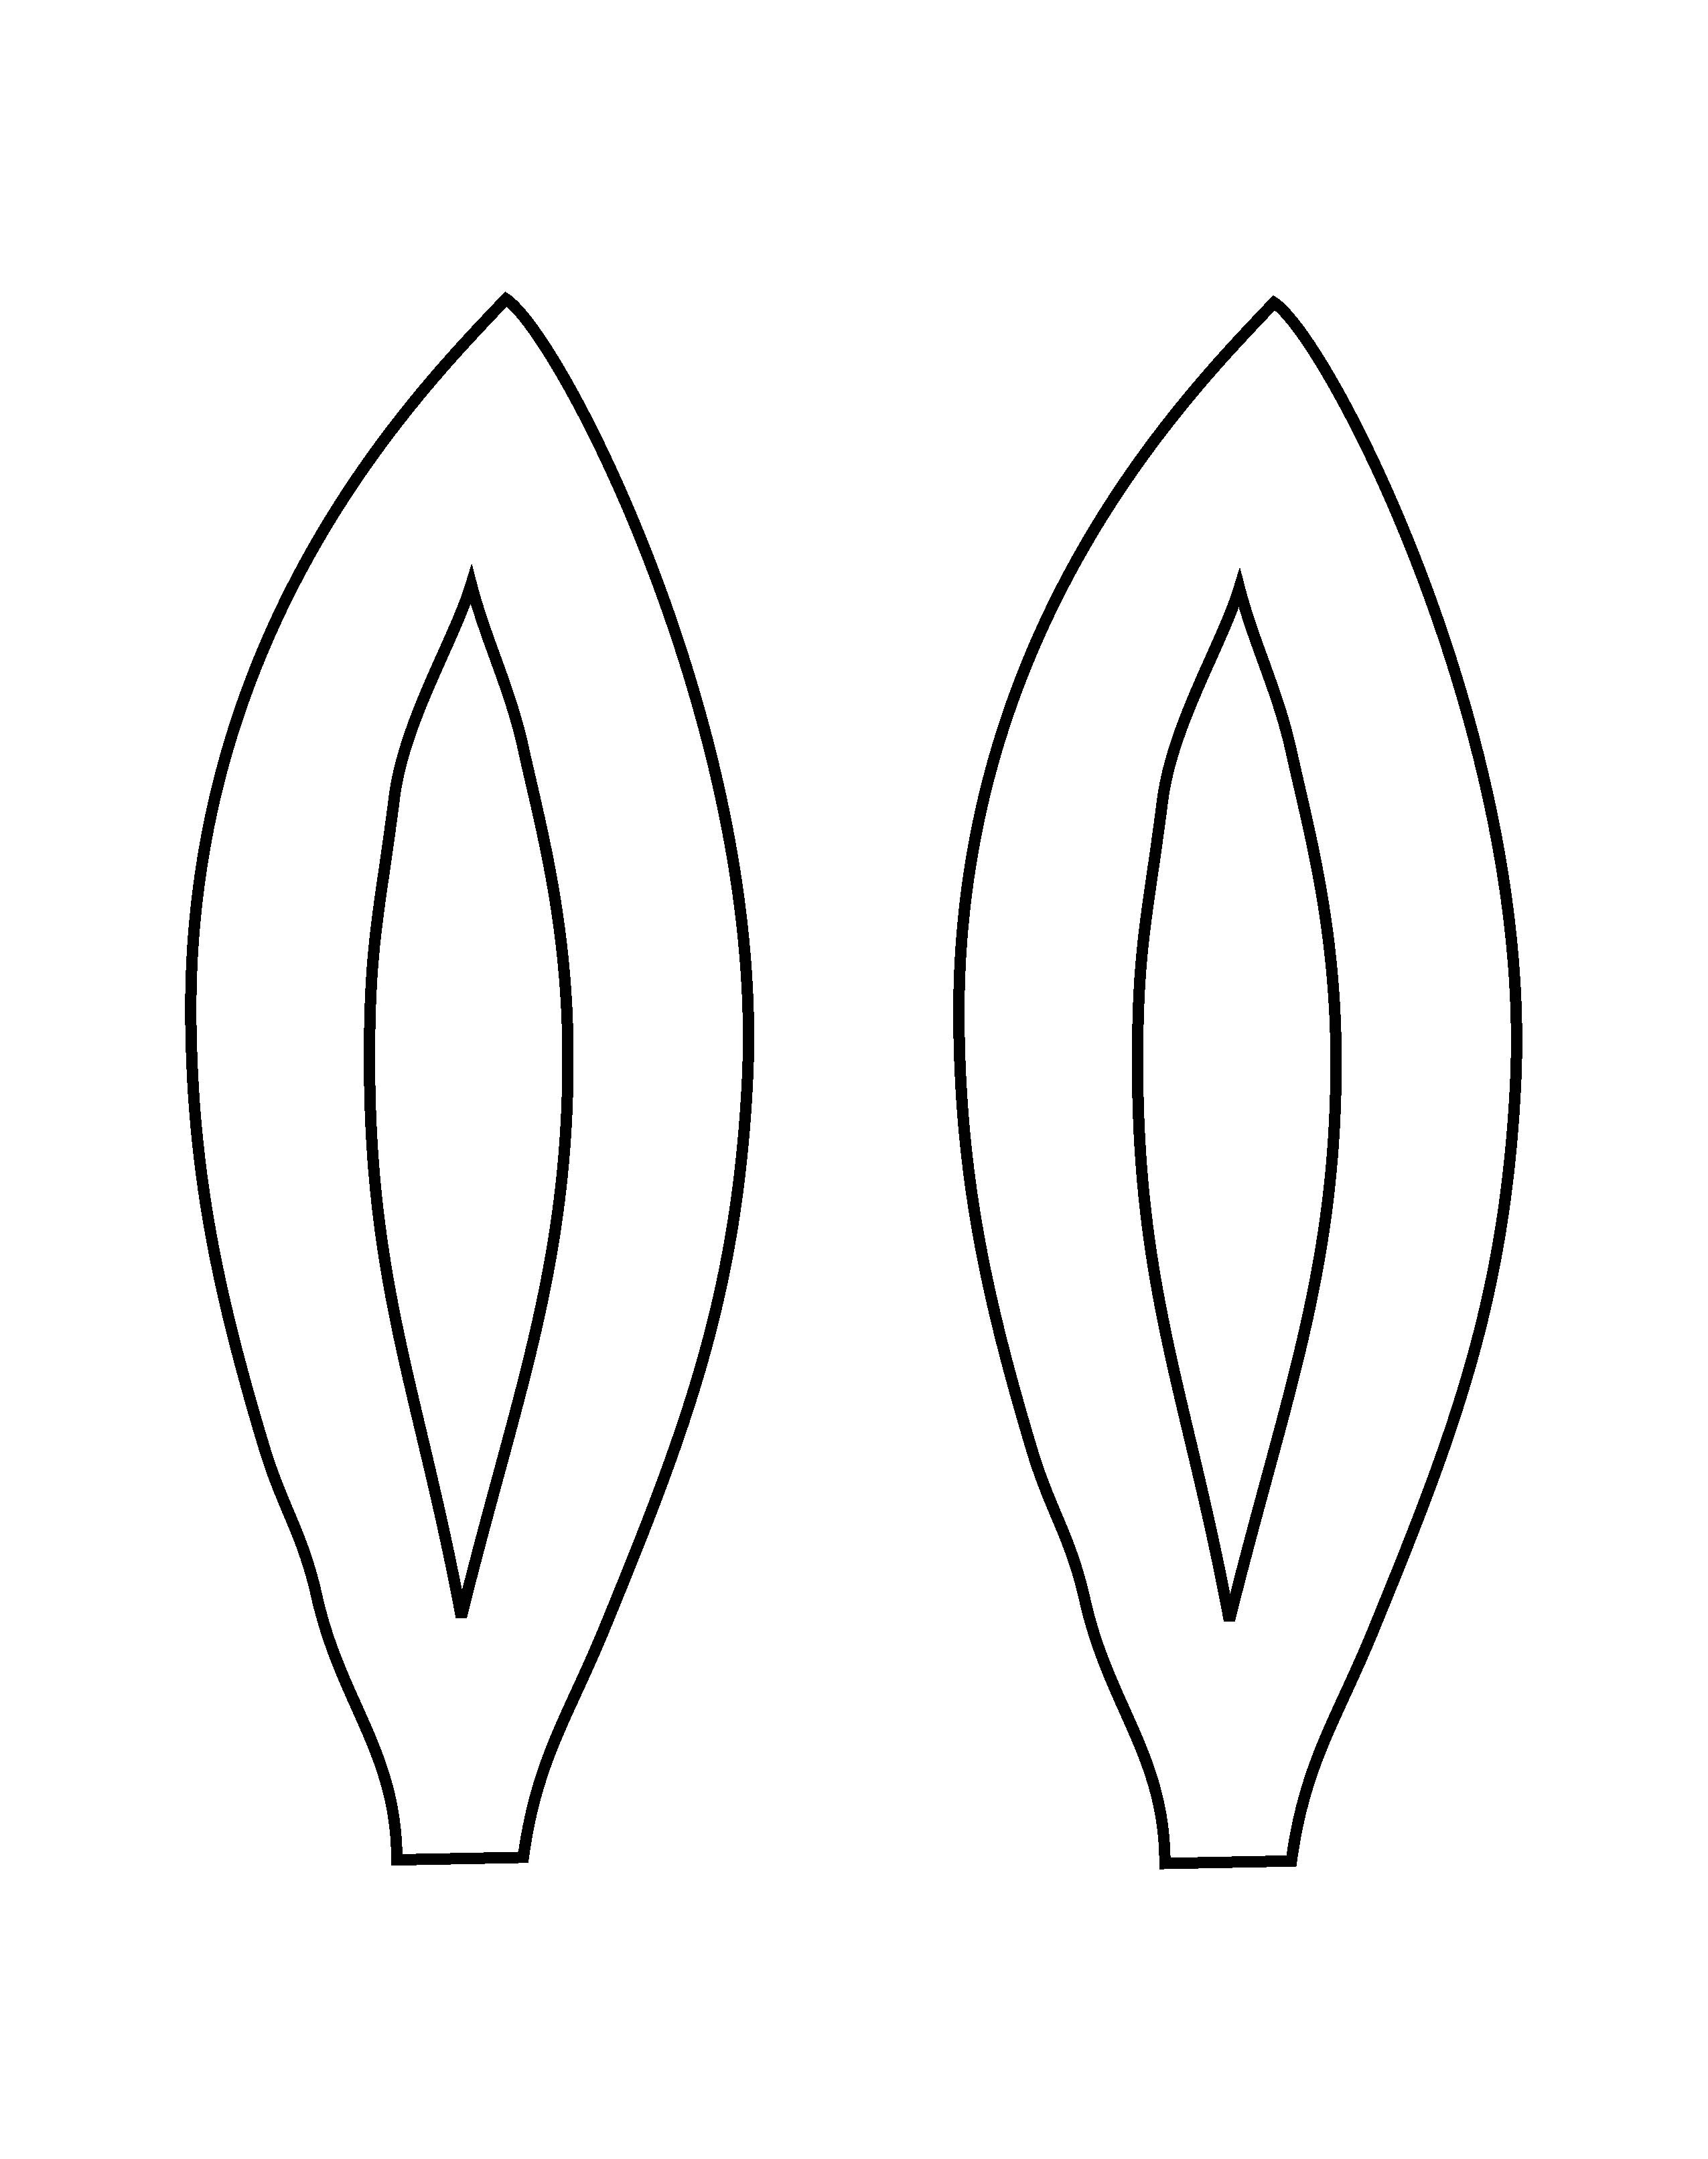
Lesson 42 – Activity Three – Donkey Ears

