
Date: _____________________
Series: Jesus Gave His Life for Me (Dec-Mar)
Year 2, Lesson 43

Woman

Perfumes

Jesus’ Feet

Take Home Point: *JESUS FORGIVES US—We love Jesus.
*Repeat this phrase throughout the lesson. The leader will say the first part of the phrase (CAPS). The children respond with the second part of the phrase (italics).

Bible Event: Luke 7:36-50
Jesus Link: Jesus loves us—He died for our sins.

We will help children know:
- The Bible event of the sinful woman anointing Jesus’ feet as an act of love.
- How to show Jesus we love Him, not by anointing His feet, but by giving our praise and our worship and by obeying Him.
- We all need to identify our sin, so we see the need for Jesus as our Savior, and experience His love and acceptance and love for us.

We will help the children feel:
- Love for God through their worship and praise.
- Secure in knowing that God loves them in spite of their sin.

We will help the children do:
- Experience through audience participation the Bible event for the day, especially connecting with the sense of smell.
- Make a craft of paper feet to be painted with heavily fragranced paint.
- Have a game reminding them of how humbling it is to wash someone else’s feet.
- Eat a snack as a reminder of the Bible event for today of the woman washing Jesus’ feet.
THIS LESSON’S ROADMAP

DESTINATION | PAGE # | DISCOVERIES ON YOUR JOURNEY | SUPPLIES NEEDED
Large Group Opening   | 3  4-5 | Puppet Presentation  Bible Event | - a paper heart pinned to Ting Ting’s hand  - costume for Jesus  - costume for Simon  - costume for woman  - long wig or hair attachment  - a plate for dinner setting  - spray perfume bottle  - water bucket with water and towel  - two money bags  - a pair of sandals
Small Group Application   | 6  6-7  7  7 | Activity 1: “Smelly Feet” Craft  Activity 2: “Washing Feet” Game  Activity 3: ”Feet” Snacks  Activity 4: “Parade March”  Prayer Time | Activity 1:  - reproducible sheet  - dry tempera paint  - small Styrofoam plates  - perfume and water to mix in the paint  Activity 2:  - small towel handkerchief for each pair  - bucket  - perfume  Activity 3:  - oval crackers  - cheese spread  - raisins, Mini M&M’s, or chocolate chips  Activity 4:  - banner
Large Group Wrap-up   | 8  8 | Singing (Optional)  Lesson Review with Puppet Skit | - optional music for the lesson  - Xiao Er puppet

Pre-Session Singing: (10 minutes)
Purpose: When all children are in one group singing, it is easy for new children to join the group and immediately get involved. When the music can be correlated, it introduces the theme for the day. Choose two to three songs and list them here.

Large Group Opening: (15 minutes)
Purpose: The puppet demonstrates the need that will be met in today’s lesson. The scripts are not written verbatim, but give a story line in which the group leader can interact with the puppet. The children are introduced to the take home point and then interact with God’s Word as they experience the Bible event.

Supplies needed: a paper heart pinned to Ting Ting’s hand; costume for Jesus; costume for Simon; costume for woman; long wig or hair attachment; a plate for dinner setting ; spray perfume bottle; water bucket with water and towel; two money bags; a pair of sandals

Puppet Presentation:
Ting Ting enters with a paper heart taped to her hand. This is a card for her mother. Ting Ting explains that she wanted a very special way to tell her mother that she loved her. This is due to the fact that yesterday she had to spend half of the day in time-out. She had done something very naughty and her mother was very upset with her. The presenter asked what Ting Ting did that was so bad, but Ting Ting won’t tell because it was so naughty.

The presenter asks the audience if they think Ting Ting’s mother will still love her even though she did something very naughty. (Children will respond with “yes.”) The presenter goes on to tell about a woman in our Bible event today who was very worried about being loved and accepted by Jesus. This woman had done something very naughty, too. Ting Ting wants to know what she had done. But the presenter goes on to explain that it was so naughty that no one talked about it. Ting Ting explains that she knows how this woman feels!

This woman didn’t make Jesus a card to say she loved Him. She didn’t just tell Him that she loved Him. She didn’t just give Him a hug, but she did something very special with perfume. Listen to today’s story and see if you can discover how this woman said “I love You, Jesus” in the way she used perfume. Remember *JESUS FORGIVES US – we love Jesus.

Bible Event: Imagination Theater
Imagination Theater is an audience participation drama in which the Bible event is told in a creative fashion, using children as actors. The Imagination Box contains the Bible and other special props used for the drama. Begin by removing the Bible and explain that this is God’s Word, which tells us of the wonderful deeds God has done. Then remove an imaginary hat from the box and place it on your head. This is your imagination hat. Invite the children to put on their imagination hats, as well. They will use their imaginations to picture the events the Bible tells us about. Some will even use their imaginations to help act out these events. Distribute props to volunteer actors as they are called forward at the beginning of the presentation. You will need another adult to assist you while you storytell.

1) Finding helpers to act out the Bible event:

Today’s Bible event is from a book in the Bible called Luke. This is a story of a woman who did something very naughty, but wanted to know if Jesus still loved her and cared about her. I will need someone who is being a good listener to pretend be this woman. (Pull out the costume for this woman and put it on the helper.)

The dinner Jesus was invited to was at the home of a very rich religious leader named Simon. I need another helper to pretend to be Simon. (Pull out the costume for Simon and have the child put it on.) Also, we will need another helper who is being a very good listener to pretend to be Jesus. (Pull out the costume for Jesus, making sure to have sandals for the helper to wear.)

2) Jesus’ feet anointed:

Jesus and Simon walked into the house and took off their shoes. That was the way they did things in Jesus’ day. They didn’t wear shoes in the house. Their feet were very dirty because they usually wore sandals. (Have the child pretending to be Simon walk with Jesus onto the stage.) They sat down and began eating. (The children sit down and pretend to eat.)

A woman who had done something very naughty, who the people called a sinner, came into the house. Let’s all pretend that we were watching and we say what the people said. “Oo-oo, a sinner!”(The child pretending to be the sinful lady walks on stage. Kids repeat the phrase, “Oo-oo, a sinner!” and point at her.) She knelt down by Jesus’ feet and began to wash them. (The girl uses the washcloth and wipes Jesus’ feet.) The Bible tells us that she began to cry. Let’s get very quiet and see if we can hear her sob. (Wait for a sob.) She used her hair to wipe Jesus’ feet dry. She used some very expensive perfume to spray on Jesus’ feet. (The helper should spray perfume from the spray bottle onto Jesus’ feet.) I wonder what that meant. What do you think? How many of you think it means, “I love you.” You’re right. It was a very special way to say, “I love you.”

3). Simon was offended and Jesus’ response:

Simon said to himself, “Oo, yuck. She’s a sinner.” (Have Simon repeat this.) I wouldn’t let her touch me. (Simon repeats.) Jesus knew what Simon was thinking. Do you think He was happy at what Simon thought about the sinful lady? No, so He told him a story.

There was a man who had a lot of money, (Jesus holds up two bags of money; one of the bags is bigger than other) and he let one man borrow $500 which is a lot of money, and another borrow $50. $500 is a lot more money than $50. These two men were not able to pay the money back. But, the man who lent them the money said, “That’s okay. You don’t have pay me back. I’ll give you that money instead.” Whoa. How do you think they felt? They were very happy. Do you think they liked the man? Yes, but who do you think liked him the most? The one who was forgiven a whole bunch of money or the one who was forgiven just a little? (The children should respond with the one who borrowed a lot of money.) You’re right! It was the one who was forgiven the whole bunch of money. Simon answered correctly.

Jesus told Simon to look at the woman. (Simon looks at the woman) “When I came into your house you did not wash My feet, give Me a kiss, or spray Me with perfume as this woman has done. Because she loved Me very much, her sins are forgiven.” The woman left very happy. (The helper pretending to be the woman leaves with a big smile on her face.) Simon left with a sad face. (The helper pretending to be Simon leaves the stage very sad.) Jesus left with a smile on His face, for He is very happy for the woman and He loved her very much and was glad she loved Him back. (The child pretending to be Jesus leaves with a smile on his face. Gather the costumes.)

(The presenter continues to talk with the children.) Have you ever done anything wrong before? Sometimes we might do something a little wrong and sometimes we might do something really naughty, just like Ting Ting and like the woman in our story. Anytime we do something wrong, it is called sin. All of us are sinners. God loves us so much that He sent His only son, Jesus, to die on the cross to forgive our sins. That way He can forgive us a whole lot, just like the lady was forgiven a whole lot. So let’s remember today *JESUS FORGIVES US—we love Jesus. (Have the children repeat the take home point.)

End with the following prayer:
Dear God,
Thank You for forgiving us.
Thank You for loving us
even when we do something naughty.
Thank You for sending Jesus.
We love You, Jesus.
Amen.

Small Group Application: (30 minutes)
Purpose: Smaller groups enable children to develop closer relationships with adults and peers in the church. As you reinforce the take home point with a fun hands-on activity, discuss the Bible event. Be sure to repeat the take home point several times. Say the first part and have the children respond with the second phrase. Application questions help kids apply the take home point to their daily lives. Close this session by gathering your small group for prayer. Let the kids pray!

Activity 1: “Smelly Feet” Craft
Supplies needed: reproducible sheet; dry tempera paint; small Styrofoam plates; perfume and water to mix in the paint

To make:
- Mix dry tempera paint with perfume and water to correct consistency.
- Put paint on small Styrofoam plates.
- Children need to put on paint shirts or plastic bags to cover their clothes. Now, have the children make a fist and put the bottom part of their hand (where their pinky is curled) into the paint.
- The children need to press their painted hand onto the reproduced handout. It should look like a foot.
- With their pointer finger, have the children dip their finger into the paint and dab it onto the already painted foot to make toes.

To discuss:
This is a reminder of the sinful woman in our Bible event who showed Jesus how much she loved Him by washing His feet. We are not able to wash Jesus’ feet today, but we can show Him how much we love Him by giving Him our praise and worship and by obeying Him. For *JESUS FORGIVES US—we love Jesus.

Activity 2: “Washing Feet” Game
Supplies needed: small towel handkerchief for each pair; bucket; perfume

To prepare:
Have handkerchiefs that have been soaking in water scented with perfume for each pair of children.

To play:
- Have the children pair up.
- Each child should take off their shoes and put them in a pile. (Have them take off their socks but hang on to them to put on later.)
- Give each pair a handkerchief and instruct the children to take turns “washing” each other’s feet.
- When everyone is done, the children need to put on their socks. When the shepherd says “go,” the children need to find their shoes in the pile and put them back on.

To discuss:
It may feel funny to have someone wash your feet today. But, when Jesus was alive on earth, the people had to walk a lot. They didn’t have cars to ride in. So, their feet got very dirty. When a person went to someone else’s home, the owner of the home would wash their feet. It was a way of saying, “I love you and I care about you.”

The sinful woman was showing Jesus how much she loved Him and cared about Him. How can we show Jesus we love and care about Him today? (Some answers may be pray to Him, sing to Him, obey Him.) When we help others and do kind things for them, it’s just like helping and doing it for Jesus.

Activity 3: “Feet” Snacks
Supplies needed: oval crackers; raisins, Mini M&M’s, or chocolate chips

To do:
- Have children count out two crackers.
- Have children count out ten raisins, mini M&M’s, or chocolate chips.
- Let the children put the raisins, M&M’s, or chocolate chips on the crackers for toes.

To discuss:
As the children eat their “feet,” remind them that we no longer wash feet to say we love someone. But what are some other ways we can say we love someone else or say we love Jesus? (Children may respond by doing nice things for someone, obeying our parents, singing to God, praying to God.)

Activity 4: “Parade March”
Supplies needed: banner

Memory Verse: Matthew 20:28a ~ “The Son of Man... came to serve others...”

MV Presentation:
Show the children the memory verse banner (from lesson 42). Recite with the children several times. Now tell the children that everybody is going on a parade and each person can take turn to hold the banner. As the children march around the room, everybody is to recite Matthew 20:28. Leave the banner in classroom for lesson 44.

Prayer Time:
Thank Jesus for loving even the worst sinner and providing the way to get to heaven.

Large Group Wrap-Up: (10 minutes)
Purpose: The crazy bird puppet, Xiao Er, struggles with learning the take home point. The leader shows an example of each small group application activity from this lesson and says the first phrase of the take home point. The kids respond with their phrase. They try to teach the puppet the take home point, but each time he confuses words or concepts. After three attempts, he finally gets it right and sings the correct take home point in a silly opera-like voice.

Singing: (Optional)

Lesson Review with Puppet Skit:
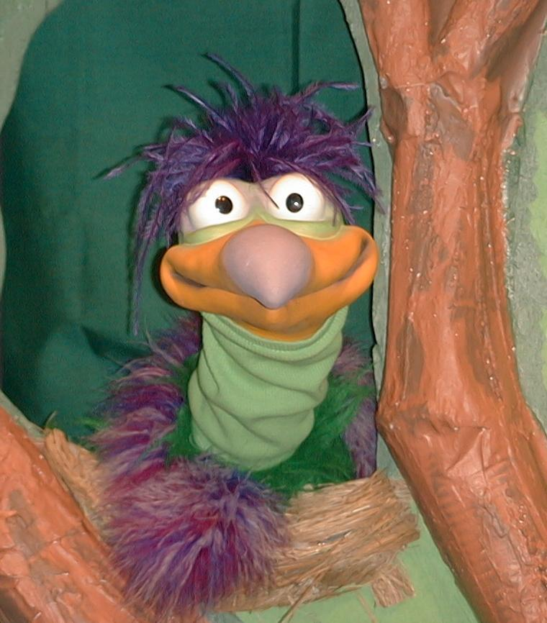
Presenter shows Xiao Er a craft made in Activity 1. Then the kids attempt to teach Xiao Er the take home point.

Presenter says to kids: “Jesus forgives us…”
Kids say: “…We love Jesus.”
Presenter says to Xiao Er: “Jesus forgives us…”
Xiao Er says: “…and paints our feet with
stinky paint.”

Presenter shows an example of the next activity done in small group and repeats first phrase to kids. The kids say the correct response trying to teach Xiao Er the take home point. Continue in this manner with Presenter showing example of each activity. Here are Xiao Er’s responses:

Xiao Er’s response to Activity 2 sample: “…even when we don’t take a bath.”
Xiao Er’s response to Activity 3 sample: “…even if we eat with our feet.”

Presenter says: “Xiao Er, listen one last time.
Jesus forgives us…”
Kids response: “…We love Jesus.”
Presenter says to Xiao Er: “Jesus forgives us…”
Xiao Er’s response: (Warms up his singing voice with “Mee, mee, mee,
mee, mee…” and sings in a silly dramatic opera-like
voice) “Jesus forgives us – We love Jesus.”

Welcome guests and thank them for attending.

Lesson 43

Large Group Opening
- a paper heart pinned to Ting Ting’s hand
- costume for Jesus
- costume for Simon
- costume for woman
- long wig or hair attachment
- a plate for dinner setting
- spray perfume bottle
- water bucket with water and towel
- two money bags
- a pair of sandals

Small Group Application
Activity 1:
- reproducible sheet
- dry tempera paint
- small plates
- perfume and water to mix in the paint
Activity 2:
- small towel handkerchief for each pair
- bucket
- perfume
Activity 3:
- oval crackers
- cheese spread
- raisins, Mini M&M’s, or chocolate chips
Activity 4:
- banner

Large Group Wrap-up
- optional music for the lesson
- Xiao Er puppet
Lesson 43 Craft – Option One
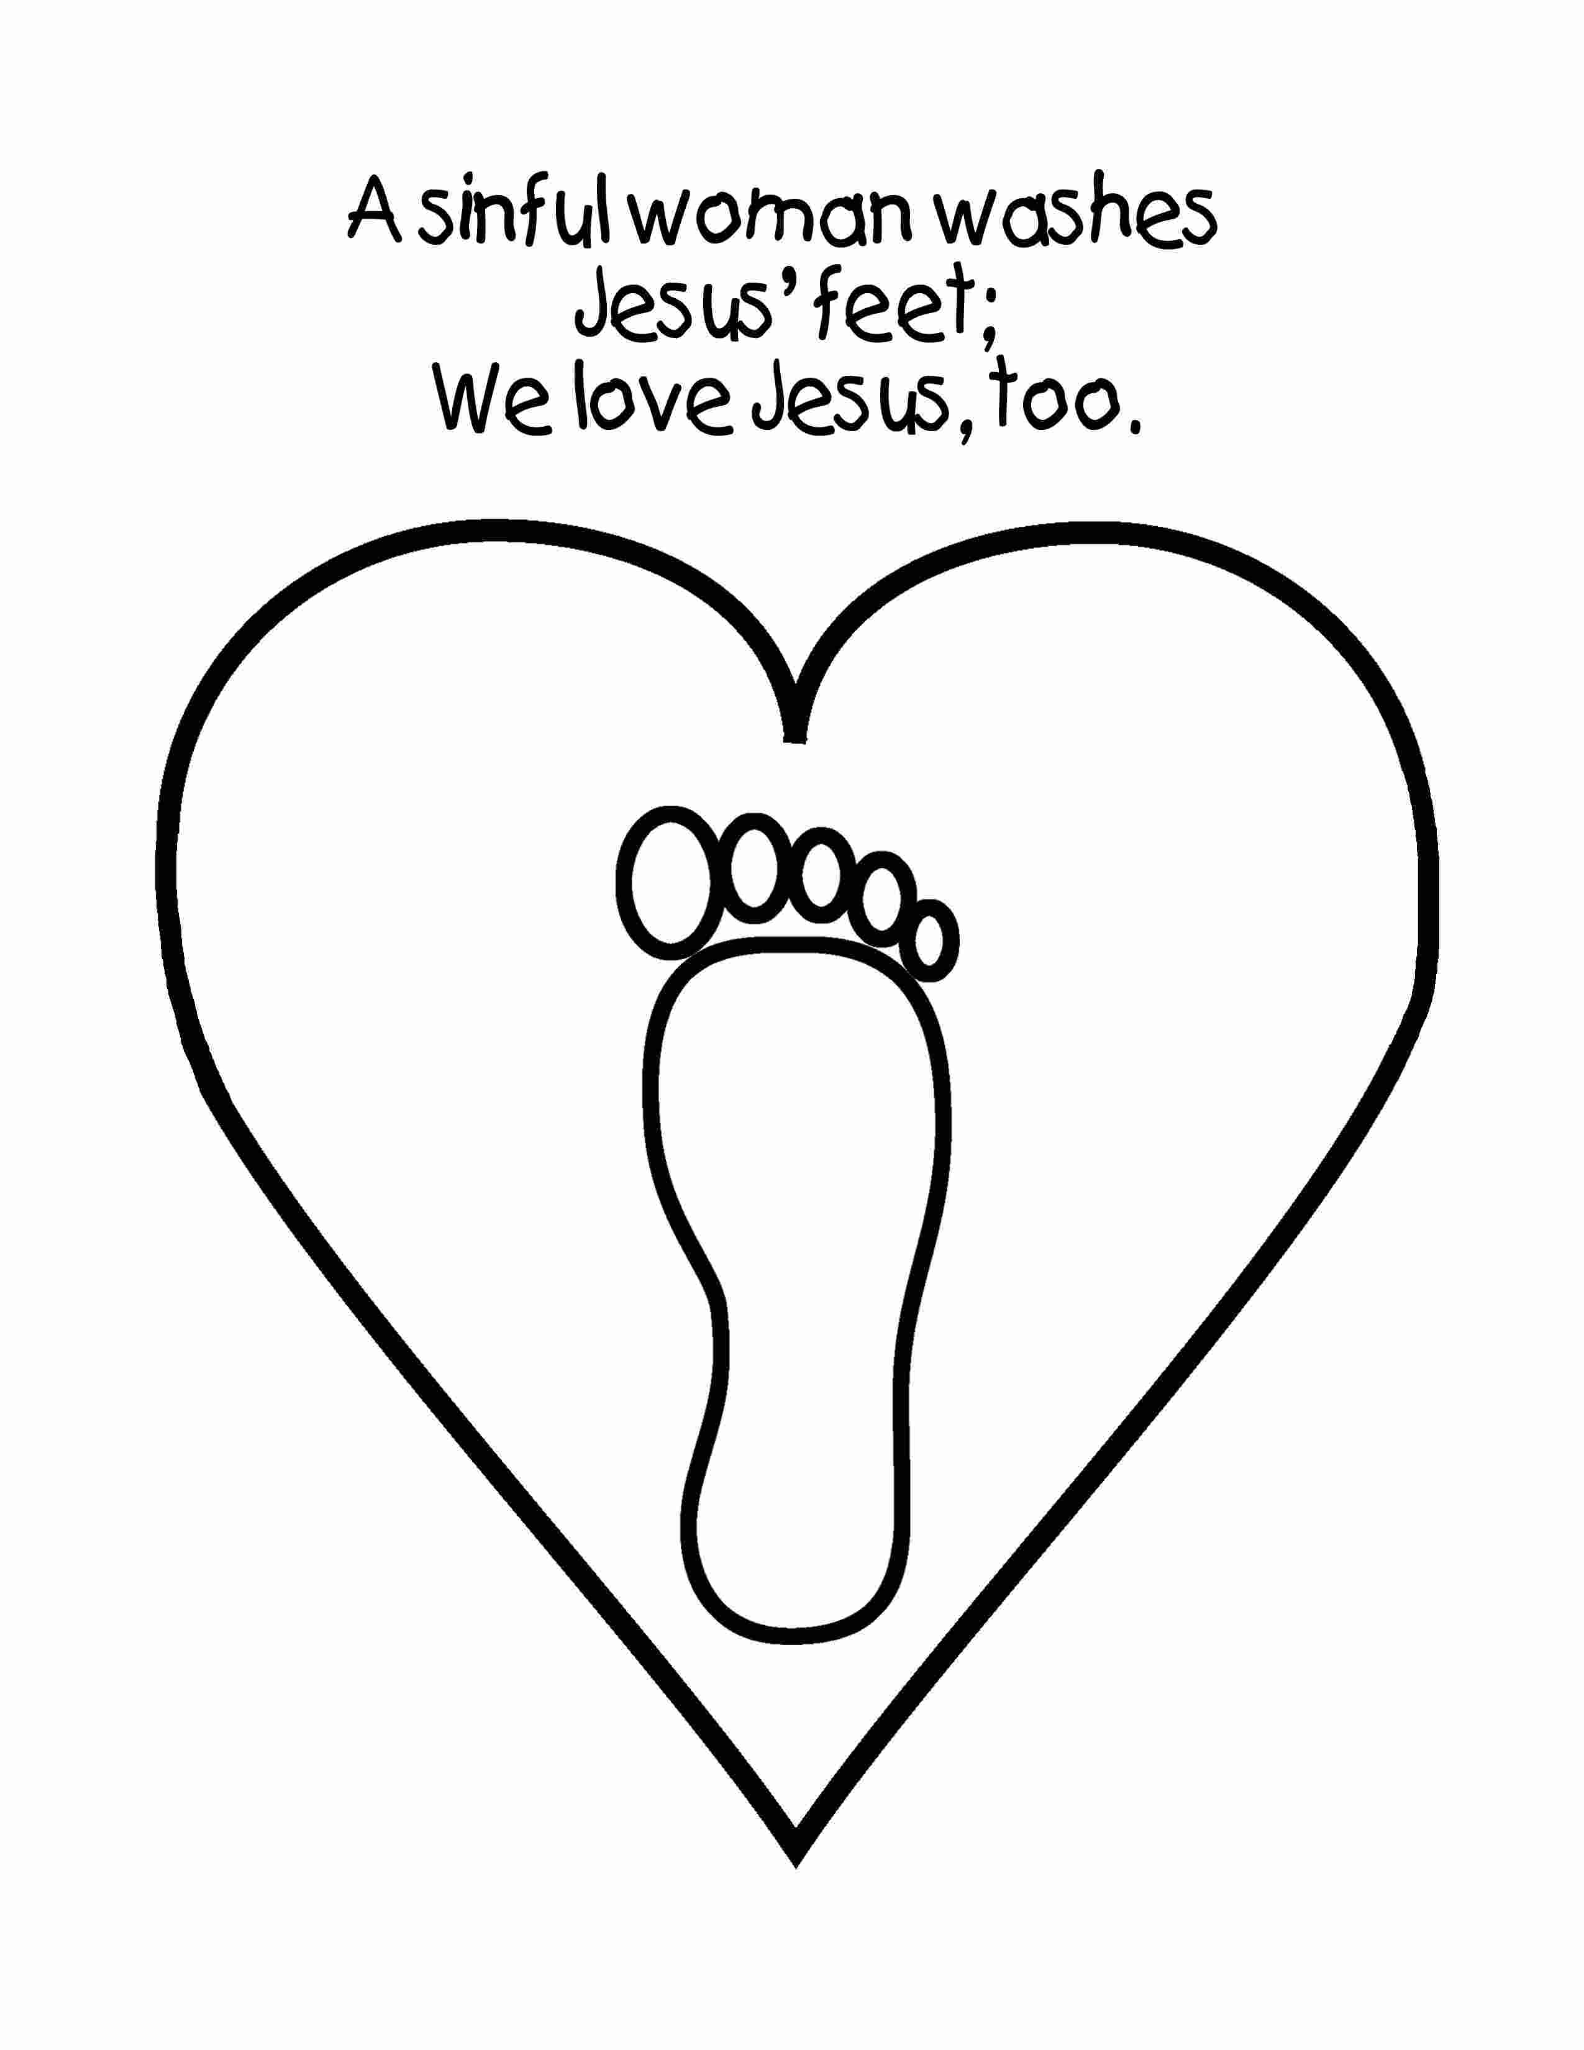

Craft- Option Two


