
Date: ________________________
Series: Jesus Gave His Life for Me (Dec-Mar)
Year 2, Lesson 45

Jesus Prays

on the Mount

of Olives

Take Home Point: *JESUS PRAYED FOR GOD’S HELP—God helps me, too.
*Repeat this phrase throughout the lesson. The leader will say the first part of the phrase (CAPS). The children respond with the second part of the phrase (italics).

Bible Event: Luke 22:39-46
Jesus Link: We are able to pray to God because when Jesus died on the cross for us and rose again, He provided the way to God, the Father.

We will help children know:
- Jesus prayed to His father for comfort and strength.
- They can pray to God for help.
- Prayer is a great “tool” to use anytime, anywhere for anything.

We will help the children feel:
- Connected to God through the power of prayer.
- Comforted that God can help us in time of need.
- Confident that God hears all our prayers.

We will help the children do:
- Paint a rock and hear a poem that will remind us to pray.
- Kneel and pray for the “Mystery Snack.”
- Play “Sleeping, Sleeping, Wake-Up” game to be alert to pray.
THIS LESSON’S ROADMAP

DESTINATION | PAGE # | DISCOVERIES ON YOUR JOURNEY | SUPPLIES NEEDED
Large Group Opening   | 3  3-5 | Puppet Presentation  Bible Event | - Xiao Hung puppet  - blanket
Small Group Application   | 6  6  6  7 | Activity 1: “Prayer Rock” Craft  Activity 2: ”Mystery Sack” Snack  Activity 3: ”Sleeping, Sleeping, Wake-up” Game  Activity 4: “Lifesaver Verse”  Prayer Time | Activity 1:  - medium-size river rock  - assorted colors of Tempera paint  - cotton swabs  - paper towels  - plastic bags to take rock home  - prayer rock poem (appendix)  - small Styrofoam plates to put dabs of paint on  Activity 2:  - brown paper bag  - snack of choice  - serviettes  - water or juice  Activity 3:  - no items needed  Activity 4:  - eight life saver with memory verse written
Large Group Wrap-up   | 8  8 | Singing (Optional)  Lesson Review with Puppet Skit | - optional music for the lesson  - Xiao Er puppet

Pre-Session Singing: (10 minutes)
Purpose: When all children are in one group singing, it is easy for new children to join the group and immediately get involved. When the music can be correlated, it introduces the theme for the day. Choose two to three songs and list them here.

Large Group Opening: (15 minutes)
Purpose: The puppet demonstrates the need that will be met in today’s lesson. The scripts are not written verbatim, but give a story line in which the group leader can interact with the puppet. The children are introduced to the take home point and then interact with God’s Word as they experience the Bible event.

Supplies needed: Xiao Hung puppet; blanket

Puppet Presentation:
Xiao Hung comes in clutching his blanket for comfort. The presenter asks Xiao Hung what’s wrong. Xiao Hung says he needs to get an injection at the doctor’s office. He doesn’t understand why. He knows it’s going to hurt. Xiao Hung asks the children if they have ever had an injection. The presenter explains that his parents are having him get an injection because they love him. Xiao Hung looks confused. Xiao Hung whines that if his parents really love him they wouldn’t put him through the pain of getting an injection. The presenter calmly states that the injection will help you from even greater pain. Xiao Hung wonders what would be a greater pain than getting an injection. The presenter explains the injection keeps you from getting really sick. So, your parents want to protect you from getting very sick. Your health is worth more than a little pinprick from the injection, and therefore, the injection is more important than the little pain it causes. The presenter asks Xiao Hung if he knows that Jesus did something that caused Him pain and hurt. Xiao Hung doesn’t know and asks the children for help. Kids respond with Jesus died on the cross. The presenter asks if Xiao Hung thinks Jesus asked His Dad, God, if He didn’t have to die on the cross. Xiao Hung is not sure. The presenter explains that yes He did, but He obeyed His Father in heaven because it would help so many people.

The presenter asks the children if they are ever worried. (Call on three children.) Did Jesus hug a blanket like Xiao Hung to comfort Him? No! The presenter tells them Jesus did something much better. He prayed to God and God strengthened Him.

The presenter teaches Xiao Hung the take home point. JESUS PRAYED FOR GOD’S HELP - God helps me, too. The presenter says the first line. Xiao Hung responds with the second line. After Xiao Hung practices it several times, the presenter practices it with the children.

Bible Event: Simple Storytelling
Reading a Bible story or telling the Bible event can be done effectively with expressive voice and dramatic gestures. Children can express part of the story by repeating a phrase or acting out the motions.

We are going to do some actions together to tell the story. When I do an action with my legs, arm, hands, face, etc., you do the same thing. When I am not doing any actions, you just listen. We will start now.

For three years Jesus has been teaching people about God. He told them that God loves them very much. But He also told them that He was God’s Son and God’s Son must die for the sins of the world. Now the time had come. It was a special night, the night before Jesus died on the cross. Jesus knew that He must get ready for what would happen the next day. Then He took His special friends, His eleven disciples, and He went to a garden to pray. As He was walking into the garden (walk in place), He stopped (stop), turned (turn) to eight of them and said, “Wait here. Please pray for Me. I need your help. You can help by praying. (Fold hands.)

Then, He pointed (point) to Peter, James and John and told them to follow Him. (Motion like you want someone to follow.) He went further (walk in place) into the garden. Then He stopped (Stop). He turned to them (turn) and said, “Please, pray for Me (Fold hands). Don’t go to sleep. I need your help. You can help me by praying.” (Walk in place.) Jesus went the rest of the way by Himself. He came to a lonely spot where He fell to the ground and began to pray (drop to your knees, fold your hands and bow your head) to His Heavenly Father. He was worried and sad when He thought about what would happen the next day. (Lift head and express emotions.)

The next day He would be punished for the sins of the world when He died on the cross. (Spread out arms like on the cross.) He knew that it would hurt very much. He knew that He would be left all alone and He knew (facial expressions) that God, the Father, could save Him if He wanted. So He asked His Heavenly Father, (praying position) “Is there any other way than to die on the cross tomorrow? Is there another way you could forgive the sins of the world, so I won’t have to die?” He cried as He prayed, “Please Father, find another way.” (Stand.) Then, He got up from His prayer to check on His friends, Peter, James and John. (Walk in place.) Guess what He found them doing? Sleeping. (Lay head on arms like a sleeping position.) “Wake up,” He said. I need you to pray for Me.” Then, Jesus went back to pray some more. (Walk in place, stop, kneel and pray.)

Again, He asked His Heavenly Father, “Is there any other way to forgive the sins of the world? Do I have to die on the cross?” (Spread out arms.) He was very sad to think about it. (Express sadness, then get up and walk in place.) He got up to see His disciples once again. What do you think they were doing? Right. They were sleeping again. (Fold arms). “Wake up,” Jesus said. “I know you try to do well, but your body is tired. Please try to stay awake and pray.” (Walk, kneel and pray.) Jesus went back to His spot to pray one last time. This time He said, “Okay, Father, if there is no other way to forgive the sins of the world but by My dying on the cross (spread out arms), I will do it. Your will be done.” Then an angel from God came to Him and strengthened Him. Jesus knew that He was doing just what God wanted Him to do and that helped Him be strong. (Facial expression of peace and satisfaction.) He felt at peace even though the next day He knew He would have to die on the cross. (Walk in place.) When Jesus returned to His disciples, He said, “Get up.” Why do you think Jesus said that? Right. They were sleeping again. But this time Jesus said, “Now is the time for us to leave because the one who is going to turn Me over to the soldiers is coming and we must be ready.

Next week we will discover what happened next. This week we remember that Jesus prayed and God helped Him. We can remember that, too. When we pray, God will help us also.

Practice the take home point. *JESUS PRAYED FOR GOD’S HELP – God helps me, too.

End with a brief prayer with children repeating after each line.

Dear God, (repeat)
Thank You for sending Jesus. (repeat)
We know He connects us to You. (repeat)
Jesus trusted You with His prayers. (repeat)
We want to trust You too. (repeat)
Help us to always pray. (repeat)
Thank You! Thank You! Thank You! (repeat)
Amen. (repeat)

Small Group Application: (30 minutes)
Purpose: Smaller groups enable children to develop closer relationships with adults and peers in the church. As you reinforce the take home point with a fun hands-on activity, discuss the Bible event. Be sure to repeat the take home point several times. Say the first part and have the children respond with the second phrase. Application questions help kids apply the take home point to their daily lives. Close this session by gathering your small group for prayer. Let the kids pray!

During the small group application time, discuss the following questions and points:

When we need courage or strength to do something we don’t like, what can we do? (We can pray to God to help us receive courage and strength.)

Can we ask others to pray to God for us? (Jesus asked His disciples to pray for Him. We can ask friends and family to pray for us, too.)

Do we always get what we pray for? (No. We may not like it, but you can trust God and Jesus, who love you so much, to give you what is best.)

Activity 1: “Prayer Rock” Craft
Supplies needed: medium-size river rock; assorted colors of Tempera paint; cotton; swabs; paper towels; plastic bags to take rock home; prayer rock poem (appendix); small Styrofoam plates to put dabs of paint on

Children will paint their “prayer rock.” While painting, the shepherd will read the “prayer rock” poem (see appendix). When the rock is dry, put the rock in a plastic bag. Remind the children that Jesus prayed to God for help at any time of day.

Practice the take home point. *JESUS PRAYED FOR GOD’S HELP – God helps me, too.

Activity 2: “Mystery Sack” Snack
Supplies needed: brown paper bag; snack of choice; serviettes; water or juice

Place the sack with the mystery snack in the middle of the table. The children will kneel. The shepherd will ask them what kind of snack we should pray for. (Direct them away from what is really in the bag.) Then have them pray for that bag.

Dear God,
Thank You for snacks. We pray that _______ snack is in the bag. (Look in bag.) Tell the children that the bag does not have that snack in it and we will try a different prayer. Dear God, Thank You for our snack. We trust You will give us good things. Amen.

Explain to the children that God always hears our prayers even though we might not get exactly what we want. We will trust God to give us what is best for us. Practice the take home point. *JESUS PRAYED FOR GOD’S HELP – God helps me, too.

Activity 3: “Sleeping, Sleeping, Wake up!” Game
Supplies needed: no item needed

This is played like the game “Duck, Duck, Goose!” The children will sit in a circle and one child will go around the outside of the circle while touching the children and saying Sleeping, Sleeping,…etc. When the child says “wake up” and touches the head of a child, that child will try to catch the other child who will run, get in a spot in the circle and fold hands in prayer before being caught. Repeat.

Remind the children that Jesus asked the disciples to pray for Him but they kept falling asleep. We must be alert to pray for others when they are in need. Practice the take home point. *JESUS PRAYED FOR GOD’S HELP – God helps me, too.

Activity 4: “Lifesaver Verse”
Supplies needed: eight life saver with memory verse written

Memory Verse: Matthew 20:28b ~ “...The Son of Man came to give His life to save many people.”

MV Presentation:
Hand eight children a lifesaver each. Ask them to turn it over with shepherd telling the words written on them. The shepherd then arranges the children according to the memory verse while the children hold out the lifesaver in front of themselves. Have the children recite the verse as shepherd points it out to lifesavers. Explain to the children that in lesson 42-44 we had learnt the first part of Matthew 20:28. The lifesavers tell us the second part of Matthew 20:28 which said that Jesus had rescue us from eternal death and now we have life forever with Him in heaven. If time permits, give the lifesavers to other volunteers and do the same until the children are confident in reciting the verse.

Prayer Time:
Remind the children that God is always available in times of need.

Large Group Wrap-Up: (10 minutes)
Purpose: The crazy bird puppet, Xiao Er, struggles with learning the take home point. The leader shows an example of each small group application activity from this lesson and says the first phrase of the take home point. The kids respond with their phrase. They try to teach the puppet the take home point, but each time he confuses words or concepts. After three attempts, he finally gets it right and sings the correct take home point in a silly opera-like voice.

Singing: (Optional)

Lesson Review with Puppet Skit:
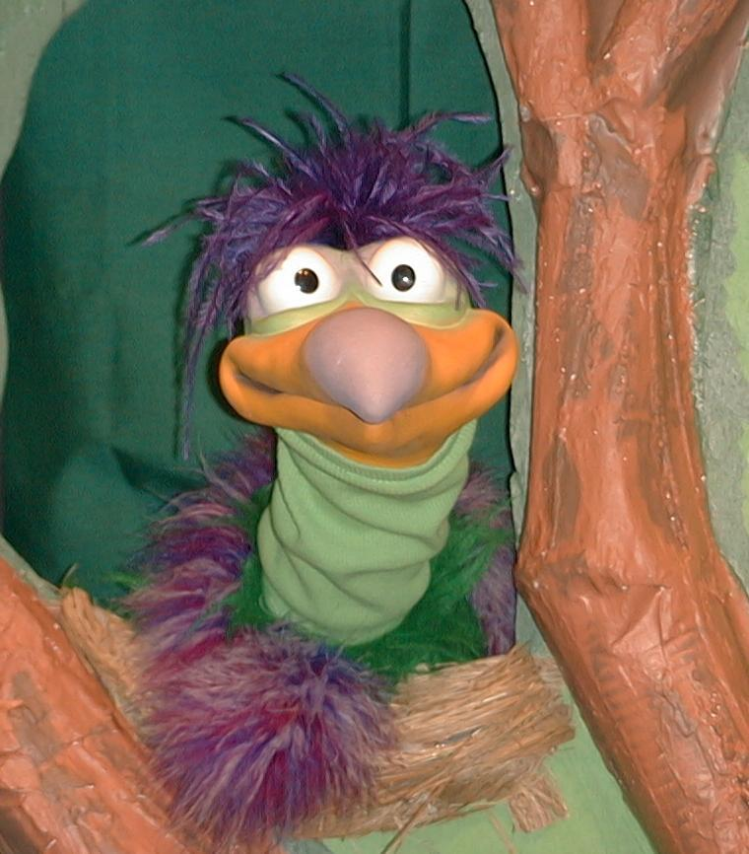
Presenter shows Xiao Er a craft made in Activity 1. Then the kids attempt to teach Xiao Er the take home point.

Presenter says to kids: “Jesus prayed for God’s help”
Kids say: “…God helps me, too.”
Presenter says to Xiao Er: “Jesus prayed for God’s help”
Xiao Er says: “…Never kiss a tiger on the
mouth.”

Presenter shows an example of the next activity done in small group and repeats first phrase to kids. The kids say the correct response trying to teach Xiao Er the take home point. Continue in this manner with Presenter showing example of each activity. Here are Xiao Er’s responses:

Xiao Er’s response to Activity 2 sample: “…I can pray for a new race car.”
Xiao Er’s response to Activity 3 sample: “…I like to eat bugs.”

Presenter says: “Xiao Er, listen one last time.
Jesus prayed for God’s help…”
Kids response: “…God helps me, too.”
Presenter says to Xiao Er: “Jesus prayed for God’s help…”
Xiao Er’s response: (Warms up his singing voice with “Mee, mee, mee,
mee, mee…” and sings in a silly dramatic opera-like
voice) “Jesus prayed for God’s help – God helps
me, too.”

Welcome guests and thank them for attending.

Lesson 45

Large Group Opening
- Xiao Hung puppet
- blanket

Small Group Application
Activity 1:
- medium-size river rock
- assorted colors of Tempera paint
- cotton swabs
- paper towels
- plastic bags to take rock home
- prayer rock poem (appendix)
- small Styrofoam plates to put dabs of paint on
Activity 2:
- brown paper bag
- snack of choice
- serviettes
- water or juice
Activity 3:
  - no items needed
Activity 4:
- eight life saver with memory verse written. Cut out eight lifesaver from Styrofoam.
Paint the red sections and then write the memory verse behind each lifesaver. See
diagram.


Large Group Wrap-up

Matthew 20:28b
- optional music for the lesson
- Xiao Er puppet

PRAYER ROCK
(Author Unknown)
I'm your little prayer rock
and this is what I'll do.
Just put me on your pillow
'til the day is through.
Then turn back the covers
and climb into your bed,
and, whack! your little prayer rock
will bump you on the head.
Then you will remember
as the day is through,
to kneel and say your prayers
as you intended to.
Then when you are finished
dump me on the floor.
I'll stay there through the nighttime
to give you help once more.
When you get up next morning,
clunk! I stub your toe,
so that you will remember
your prayers before you go.
Put me back upon your pillow
when your bed is made,
and your clever little prayer rock
will continue in your aid.
Because your Heavenly Father
cares and loves you so,
He wants you to remember
to talk to Him, you know.

