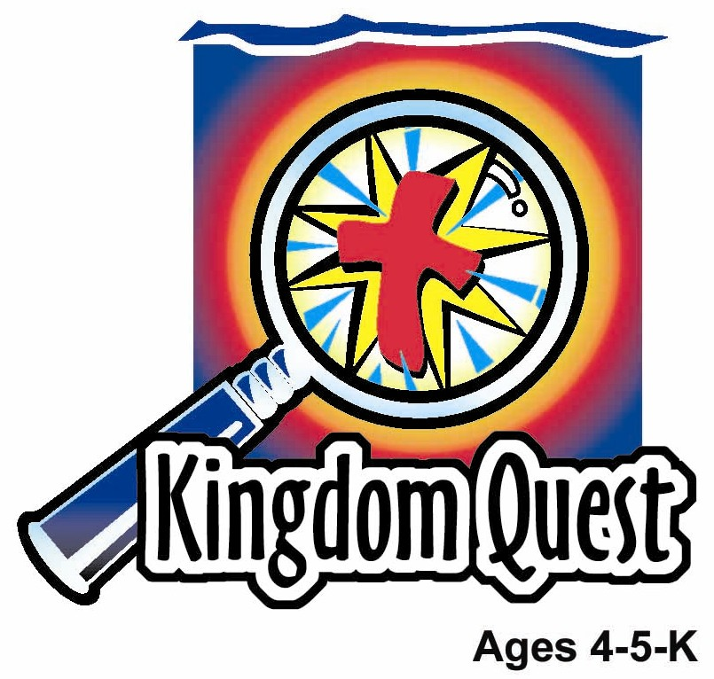
Date: ________________________
Series: Jesus Gave His Life for Me (Dec-Mar)
Year 2, Lesson 47

Jesus Dies

and is Buried

Take Home Point: *JESUS DIED FOR ME —I will live for Jesus.
*Repeat this phrase throughout the lesson. The leader will say the first part of the phrase (CAPS). The children respond with the second part of the phrase (italics).

Bible Event: Matthew 27:45-61
Jesus Link: Jesus died on the cross so we can be forgiven and live for Him.

We will help children know:
- The story of Jesus dying on the cross.
- Because Jesus died on the cross, their sins are forgiven.
- God had a plan to forgive us with an ultimate sacrifice.

We will help the children feel:
- Loved that God would sacrifice His Son Jesus on the cross.
- Forgiven because Jesus died for their sins.
- Serviceable because Jesus came to serve and teach others so we will serve and teach others.

We will help the children do:
- Review the entire Bible series event with mystery box items.
- Play a game, “Caught by the Cross.”
- Eat “putu mayam” and know Jesus covered our sins
THIS LESSON’S ROADMAP

DESTINATION | PAGE # | DISCOVERIES ON YOUR JOURNEY | SUPPLIES NEEDED
Large Group Opening  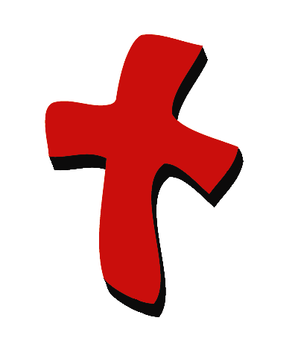 | 3  3-5 | Puppet Presentation  Bible Event | - coloring page of Jesus on the cross  - Ting Ting puppet  - Bible  - palm branch  - perfume  - sandal or towel and soap  - branch/stick from tree or bush or jar of olives  - hand cuffs  - nails or crown of thorns or cross  - box of crayons  - Mystery Box
Small Group Application   | 5  5  6  6 | Activity 1: “Palm Cross Necklace” Craft  Activity 2: “ “Sprinkled with Forgiveness” Snack  Activity 3: ”Caught by the Cross” Game  Activity 4: “Arrange the Lifesavers”  Prayer Time | Activity 1:  - palm leaves  - stapler  - string or yarn  Activity 2:  - putu mayam  - gula melaka or brown sugar  - grated coconut  - plastic plates  - serviettes  - cups  - water or juice  Activity 3:  - tape to make three lines  Activity 4:  - eight lifesaver from previous  lesson
Large Group Wrap-up   | 6  6 | Singing (Optional)  Lesson Review with Puppet Skit | - optional music for the lesson  - Xiao Er puppet

Pre-Session Singing: (10 minutes)
Purpose: When all children are in one group singing, it is easy for new children to join the group and immediately get involved. When the music can be correlated, it introduces the theme for the day. Choose two to three songs and list them here.

Large Group Opening: (15 minutes)
Purpose: The puppet demonstrates the need that will be met in today’s lesson. The scripts are not written verbatim, but give a story line in which the group leader can interact with the puppet. The children are introduced to the take home point and then interact with God’s Word as they experience the Bible event.

Supplies needed: coloring page of Jesus on the cross; Ting Ting puppet; Bible; palm branch; perfume; sandal or towel and soap; branch/stick from tree or bush or jar of olives; hand cuffs; nails or crown of thorns or cross; box of crayons; Mystery Box

Puppet Presentation:
Ting Ting has colored a picture for the large group presenter. Ting Ting is very excited and is waving around the picture she colored. She can’t wait to give it to the presenter. The presenter is impressed and thankful. Since she did that for him, he has something special he wants to give Ting Ting. He gives her a new box of crayons. She really likes that. The picture that Ting Ting colored depicts Jesus on the cross. She asks why Jesus had to die on the cross. He explains that Jesus had to die so that God could take away all the punishment of all our sin. That way we could be forgiven and live with Him forever. Ting Ting exclaims that that is a wonderful thing that Jesus did. Since Jesus died for me, I want to live for Him and do what He wants. That reminds me of the take home point.

The presenter teaches Ting Ting today’s take home point. *JESUS DIED FOR ME! – I will live for Jesus! The presenter says the first line; Ting Ting replies with the second line. After practicing it with Ting Ting several times, the presenter teaches it to the children.

Bible Event: Mystery Box

The Mystery Box contains objects that will help the presenter tell the Bible event in creative fashion. They can be lifted out and shown as the story is told. Another option is to have a hole cut in the top of the box so that a child could put a hand in and guess what the object is before it is shown.

Before class: Put Bible, palm branch, perfume, sandal or towel and soap, hand cuffs, branch/stick from tree or bush or jar of olives, nail or crown of thorns or cross in the Mystery Box.

Bring out the Mystery Box and say,

Boys and girls, our Mystery Box is filled with items that will help tell the story of Jesus dying on the cross. Before that, we will retell the highlights of the last few weeks lessons leading up to the cross.

(Take out palm branch.) Remember the day everyone had welcomed Jesus and called Him the King? They were shouting, “Hosanna! Hosanna in the highest.” Jesus had a purpose and has a kingdom for us. Jesus died for me and I will live for Jesus.

(Take out a jar of perfume.) While Jesus was visiting a home, a woman poured perfume on Jesus’ feet. She did that to show her love for Him. Jesus knew why she had done it, but His disciples were puzzled. She had prepared Him for burial. Jesus died for me, and I will live for Jesus.

(Take out a sandal or soap and towel.) Jesus wanted to show us an example of His love for His disciples and us. He washed their feet after being outside in the dirt and dust. He said, “I came to show you how to serve and love others. I have served you so that you will serve others.” Jesus died for me, and I will live for Jesus.

(Take out a branch or small stick.) Jesus knew the time was coming to be punished and take all our sins on Him. He went to the olive garden to pray to His Heavenly Father. Jesus asked if there was another way the sins of the world could be taken away. When Jesus knew there was no other way, Jesus agreed to His Father’s way and was strengthened and comforted. Jesus died for me, and I will live for Jesus.

(Take out handcuffs.) Jesus is arrested and taken to the religious leaders. They did not like His teachings. This arrest had to take place for Jesus to obey His Heavenly Father and fulfill scripture. The scripture says that Jesus will die for me. I will live for Jesus.

After the arrest, Jesus was left alone by all His friends. Peter left Him alone, and His other disciples left. People said mean things to Him. (Take out nail, crown of thorns, or cross.) When Jesus was on the cross, all the sin of the whole world was put on Him and He felt all alone. Jesus felt the punishment of all our sin. Why did Jesus do that? Because He loved us and wanted us to have a home in heaven. Boys and girls, when Jesus was dying on the cross, did His friends stay with Him the whole time? (No.) Did all the religious leaders help Him? (No.) Did the Roman soldiers help Him? (No.) How do you think He felt? (All alone). Why? Because He was taking the sin of the whole world on Himself and taking God’s punishment. He even felt alone because it felt like God turned His back on Him. But when Jesus died, it was all over. Jesus said “It is finished,” and, “Father, I give my Spirit to You.” Now, anyone who trusts in Jesus can be friends with God. Since Jesus died for me, I want to live for Him. I want to do just what He said. There was darkness and an earthquake while Jesus was on the cross. They took Jesus down from the cross and buried Him. Do you know what happens next? Yes, Jesus comes alive. We will learn about that next time.

Practice the take home point. *JESUS DIED FOR ME! – I will live for Jesus!

End with a brief prayer with children repeating after each line.

Dear God, (repeat)
Thank You for sending Jesus. (repeat)
I know He died for me. (repeat)
I accept Your gift of Jesus, (repeat)
And I know that I am forgiven. (repeat)
Help me to live for You. (repeat)
Thank You! Thank You! Thank You! (repeat)
Amen. (repeat)

Small Group Application: (30 minutes)
Purpose: Smaller groups enable children to develop closer relationships with adults and peers in the church. As you reinforce the take home point with a fun hands-on activity, discuss the Bible event. Be sure to repeat the take home point several times. Say the first part and have the children respond with the second phrase. Application questions help kids apply the take home point to their daily lives. Close this session by gathering your small group for prayer. Let the kids pray!

Who did Jesus obey to save us from our sins? (His Father, God.)

How did Jesus save us from our sins? (He died on the cross.)

Why did Jesus die for our sins? (He loves us so much and wants us to live for Him and with Him forever.)

Activity 1: “Palm Cross Necklace” Craft
Supplies needed: palm leaves; stapler; string or yarn

To Make:
- Take a palm leaf strip and cut it in half. Then fold one of the pieces in half and staple and the ends.
- Take the second strip and fold it in half. Before stapling, put this leaf through the first stapled leaf so it represents a cross. Then staple.
- Tie a string through the top of the cross to wear as a necklace or to hang on a wall, etc.

Practice the take home point. *JESUS DIED FOR ME! – I will live for Jesus!

Activity 2: “Sprinkled with Forgiveness” Snack
Supplies needed: putu mayam; gula melaka or brown sugar; grated coconut; plastic plates; serviettes; cups; water or juice

Using gula melaka, apply the shape of the cross to the putu mayam. This represents the darkness of our sin that was placed upon Jesus.

Say:
Our sins are like these brown crosses. Sprinkle the coconut on top of the putu mayam until covered. Now, our sins are covered. We can trust Jesus to forgive us.

Practice the take home point. *JESUS DIED FOR ME! – I will live for Jesus!

Activity 3: “Caught by the Cross” Game
Supplies needed: tape to make three lines

Make three parallel lines on the floor. Place two children on the middle line. They will stretch arms out like a cross. The children in the middle can move back and forth on their line but they can’t get any closer to the outside lines. The rest of the children will start on the outside line and try to get across to the other line. If they are “caught” by a child on the middle line, they become a “cross” too. They play until everyone is “caught.”

Because Jesus catches us, we get to live for Him and catch someone else to live for Him.

Practice the take home point. *JESUS DIED FOR ME! – I will live for Jesus!

Activity 4: “Arrange the Lifesavers”
Supplies needed: eight lifesaver from previous lesson

Memory Verse: Matthew 20:28b ~ “...The Son of Man came to give His life to save many people.”

MV Presentation:
Unlike the previous lesson, there are no strings attach to the lifesavers. Randomly layout the lifesavers before the children. Then ask if any of the children can arrange the lifesavers into sequence of Matthew 20:28b. Give a loud cheer to the volunteer who complete arranging the verse. Then have all the children recite the verse. Ask for another volunteer until all (if not most) of the children have shown that he/she can arrange the verse.

Prayer Time:
Have the children ask God for help to live for Jesus.

Large Group Wrap-Up: (10 minutes)
Purpose: The crazy bird puppet, Xiao Er, struggles with learning the take home point. The leader shows an example of each small group application activity from this lesson and says the first phrase of the take home point. The kids respond with their phrase. They try to teach the puppet the take home point, but each time he confuses words or concepts. After three attempts, he finally gets it right and sings the correct take home point in a silly opera-like voice.

Singing: (Optional)

Lesson Review with Puppet Skit:
Xiao Er’s crazy responses.

No “funny stuff” with this lesson. Talk serious with the large group presenter about what Jesus’ dying on the cross means to you. Be honest with the kids.

Welcome guests and thank them for attending.

Lesson 47

Large Group Opening
- coloring page of Jesus on the cross
- Ting Ting puppet
- Bible
- palm branch
- perfume
- sandal or towel and soap
- branch/stick from tree or bush or jar of olives
- hand cuffs
- nails or crown of thorns or cross
- box of crayons
- Mystery Box

Small Group Application
Activity 1:
- palm leaves
- stapler
- string or yarn
Activity 2:
- putu mayam
- gula melaka or brown sugar
- grated coconut
- plastic plates
- serviettes
- cups
- water or juice
Activity 3:
  - tape to make three lines
Activity 4:
- eight lifesaver from previous lesson (with no strings attached)

Large Group Wrap-up
- optional music for the lesson
- Xiao Er puppet

