
Date: ________________________
Series: Jesus Takes Care of Me (Dec-Mar)
Year 2, Lesson 39

Jesus Walks

on Water

Take Home Point: *WHEN I AM SCARED—I tell Jesus.
*Repeat this phrase throughout the lesson. The leader will say the first part of the phrase (CAPS). The children respond with the second part of the phrase (italics).

Bible Event: Matthew 14:22-33
Jesus Link: I will tell Jesus my problems because He knows and loves me.

We will help children know:
- The story of Jesus walking on water.
- When we are scared, we have a friend who loves us very much to whom we can tell our fears. That friend is Jesus.
- Jesus understands our fears and because He loves us, He wants to help us with our fears.

We will help the children feel:
- Compelled to tell their fears to Jesus.
- Comforted by knowing that Jesus listens, understands, and cares.
- Strengthened to face their fears.

We will help the children do:
- Assist the storyteller in relating the Bible event of Jesus walking on water.
- Make a “Walking on Water Cookie” for snack and review the Bible event while eating it.
- Play a “Cotton Ball Relay” to teach the idea that Jesus helps us through all of our fears.

THIS LESSON’S ROADMAP

DESTINATION | PAGE # | DISCOVERIES ON YOUR JOURNEY | SUPPLIES NEEDED
Large Group Opening   | 3  4-5 | Puppet Presentation  Bible Event | - Ting Ting puppet  - puppet-sized blanket  - Bible  - stepstool or chair for storyteller  - microphone
Small Group Application   | 6  6-7  7  7  8 | Activity 1: “Water Painting” Craft  Activity 2: “Walking on Water Cookie” Snack  Activity 3: ”Cotton Ball Relay” Game  Activity 4: “Wet Verse”  Prayer Time | Activity 1:  - reproducible – copy coloring sheet on manila card  - crayons  - paint brushes  - watered-down blue, liquid watercolor paints  - newspapers to cover table  Activity 2:  - half a bun  - blue frosting  - Teddy biscuits  - plastic knives  - serviettes  - cups  - water or juice  Activity 3:  - cotton balls  - masking tape  - straws (optional)  Activity 4:  - white candle  - 7 pieces of ½ A4 paper  - liquid watercolor paints  - newspapers to cover table
Large Group Wrap-up   | 8  8 | Singing (Optional)  Lesson Review with Puppet Skit | - optional music for the lesson  - Xiao Er puppet

Pre-Session Singing: (10 minutes)
Purpose: When all children are in one group singing, it is easy for new children to join the group and immediately get involved. When the music can be correlated, it introduces the theme for the day. Choose two to three songs and list them here.

Large Group Opening: (15 minutes)
Purpose: The puppet demonstrates the need that will be met in today’s lesson. The scripts are not written verbatim, but give a story line in which the group leader can interact with the puppet. The children are introduced to the take home point and then interact with God’s Word, as they experience the Bible event.

Supplies needed: Ting Ting puppet; puppet-sized blanket; Bible; stepstool or chair for storyteller; microphone

Puppet Presentation:
Ting Ting comes out carrying a worn-looking blanket. The presenter asks her about her blanket and she explains that it is her special blanket. It makes her feel safe when she is afraid.

The presenter asks Ting Ting what makes her scared. Ting Ting says that she is afraid of storms, the dark, and when her brother Xiao Hung makes scary noises like monster noises.

The presenter tells Ting Ting that it does feel good to cuddle a special blanket when you’re feeling scared, but the very best thing to do is to tell Jesus your fears. Jesus was once a child and He lived on the earth. He knows what it feels like to be scared. In fact, He felt scared when He knew He was going to die on the cross for us. Ting Ting says that she never knew that Jesus was scared.

The presenter says that because Jesus was scared, He understands our fears. He cares about our fears and wants to help us with our fears. In fact, it is because He cares so much and wants to help us that He died on the cross. He died on the cross to take away our greatest fear—the fear of facing punishment for all of our sins. When He died on the cross He brought us forgiveness. Jesus can help us with our fears, and we know that someday when we go to heaven, all of our fears will be gone forever.

Ting Ting says that she is happy that someday all her fears will be gone forever.

The presenter tells Ting Ting that in today’s Bible event, the children are going to learn that Peter, one of Jesus’ disciples, was afraid. Jesus told Peter to walk on water, and he did. Then he looked down and got scared. “When he started to sink, he yelled out, “Lord, save me!” and Jesus reached out and helped Peter.

Jesus wants to reach out and help Ting Ting, too. So the next time she is scared, while she cuddles her special blanket, she can call out to Jesus and tell Him her fears, and Jesus will reach out to help her.

The presenter teaches Ting Ting the take home point. *WHEN I AM SCARED—I tell Jesus. The presenter says the first part; Ting Ting responds with the second part. After practicing it with Ting Ting several times, the presenter teaches it to the children.

Bible Event: Simple Storytelling
Reading a Bible story, or telling the Bible event, can be done effectively by using expressive voice characterizations and dramatic gestures.

The storyteller comes onto stage and sits on the stool. He picks up the Bible and, speaking into the microphone, begins:

Boys and girls, last week in our Bible event we learned about the day when Jesus did a miracle and healed a paralyzed man. A miracle is something that can only be done by God. It tells all about it in my Bible. (Hold up Bible.)

Today we are going to learn about another miracle Jesus did. I need you to help me do some actions. You need to do whatever I do.

It was evening. The sun was going down. The sky was getting darker and darker. Close your eyes and pretend it is dark out. (Pause for a couple seconds.) You can open your eyes.

Jesus was praying up on a mountain. (Fold hands.)

His disciples were out on a boat. Let’s pretend to row. (Start rowing.) The wind started to get wild. Help me make the noise of the wind. (Still rowing, blow into microphone.) The boat went up and down. (Bob up and down while blowing and rowing.) By now it was the middle of the night.

Suddenly, the disciples saw something or someone walking out on the water. Nobody can walk on water! They were scared. (Shiver with fear and scream out next sentence.) “It’s a ghost,” they screamed!

Then they heard the voice of Jesus. “Don’t be afraid! It’s Me,” he said.

Peter called back, “Jesus, if it is You, order me to come out onto the water.”

“Come!” Jesus said.

(Get off stool.) So Peter carefully stepped out of the boat and began to walk towards Jesus on the water. (Walk a few steps with exaggerated movements.)

Then Peter noticed how strong the wind was! (Blow into microphone.) He became afraid and started to sink. (Wave arms in air.) “Lord, save me!” he yelled.

Immediately, Jesus reached out and caught hold of Peter. (Pretend to reach out and pull someone toward you.) “Peter, you have so little faith. Why don’t you trust Me?”

(Sit back on step stool.) When they got in the boat, the wind stopped blowing. (Blow into microphone and stop abruptly.)

The disciples bowed down to Jesus. (Bow.) “You truly are the Son of God!” they said.

Jesus is not only the Son of God, but He is God! When Peter was afraid, he called to Jesus and Jesus reached out and helped him. Pause and go to the cross. When we are afraid, we, too, can call out to Jesus in prayer and He will reach out and help us. Sometimes He will help us by taking away the thing that scares us. Other times He helps us by giving us the strength to get through our fear.

Practice the take home point. You say the first part; the children respond with the second part. *WHEN I AM SCARED—I tell Jesus.

End with the following prayer:

Dear God,
Thank You for the best gifts.
Thank You for sending Jesus.
He’s our Savior and Your Son.
Thank You that we can tell Jesus our fears.
Thank You! Thank You! Thank You!
Amen.

Small Group Application: (30 minutes)
Purpose: Smaller groups enable children to develop closer relationships with adults and peers in the church. As you reinforce the take home point with a fun hands-on activity, discuss the Bible event. Be sure to repeat the take home point several times. Say the first part and have the children respond with the second phrase. Application questions help kids apply the take home point to their daily lives. Close this session by gathering your small group for prayer. Let the kids pray!

During the small group application time, discuss the following questions and points:

When Peter was afraid of sinking into the water, what did he do? (He called out to Jesus.)

What did Jesus do when He heard Peter call out? (Jesus reached out and helped Peter.)

What scares you? (Answers will vary but may include storms, darkness, loud noises, monsters or large animals.)

What can you do when you are afraid? (Tell Jesus my fears and ask Him to help.)

When you tell Jesus your fears, what will Jesus do? (He will reach out and help… sometimes by taking away the fear, other times by giving strength to get through the fear.)

How do you know Jesus will help you? (The Bible tells me that Jesus loves me. In fact, He loves me enough to have died on the cross to take away my sins.)

Activity 1: “Water Painting” Craft
Supplies needed: reproducible – copy coloring sheet on manila card; crayons; paint brushes; watered-down blue, liquid watercolor paints; newspapers to cover table

To make:
- Color Peter and Jesus.
- Paint the rest of the sheet blue for water.

To discuss:
Review the Bible event. Say: What makes you afraid? What do you usually do when you are afraid? Remember, Jesus loves you. He wants you to pray to Him, tell Him your fears, and ask Him to help. He wants to reach out and help you like He reached out and helped Peter.

Practice the take home point. You say the first part; the children respond with the second part. *WHEN I AM SCARED—I tell Jesus.

Activity 2: “Walking on Water Cookie” Snack
Supplies needed: half a bun; blue frosting; Teddy biscuits; plastic knives; serviettes; cups; water or juice

To make:
- Spread frosting on the bun.
- Stick two Teddy Grahams upright into the frosting to represent Jesus and Peter.
- Eat!

To discuss:
Why was Peter afraid? How did Jesus help him? Remember, when you are afraid you can tell Jesus your fears.

Practice the take home point. You say the first part; the children respond with the second part. *WHEN I AM SCARED—I tell Jesus.

Activity 3: “Cotton Ball Relay” Game
Supplies needed: cotton balls; masking tape; straws (optional)

To set up:
- Make a 15-foot line of masking tape on the floor for each team.
- At one end of the masking tape, make an “x” out of masking tape.
- At the other end of the line, make a masking tape box to represent a boat.

To play:
- Have the team stand in a line behind the “x.”
- Place a cotton ball on the “x.”
- Say “Ready, set…blow!”
- On the word “blow,” the first child in the line gets down on her hands and knees and blows the cotton ball along the masking tape line and into the “boat.” (Optional: Blow through a straw.)
- The child runs back to the line and places a cotton ball on the masking tape “x” before returning to the end of the line.
- The second child gets down on his hands and knees and blows that cotton ball to the boat.
- The play repeats until every child has blown a cotton ball into the boat or until all the cotton balls are gone.
- The first team to finish wins.

To discuss:
When Peter looked at the wind and the waves and not at Jesus, he got scared and started to sink. But when he called out to Jesus, Jesus helped him. When we are afraid, instead of looking at our fears and thinking about them, we can call out to Jesus by praying and asking Him to help us.

Practice the take home point. You say the first part; the children respond with the second part. *WHEN I AM SCARED—I tell Jesus.

Activity 4: “Wet Verse”
Supplies needed: white candle; 7 pieces of ½ A4 paper; liquid watercolor paints; newspapers to cover table

Memory Verse: 1 Peter 5:7 ~ “Give all your worries to Him because He cares for you.”

MV Presentation:
Before class, break down the memory verse into 7 parts and write each part on the paper with the white candle and number them. During this activity, ask if anyone can quote 1 Peter 5:7. After the person quote the verse, he/she can have the privilege to paint on the first paper with the watery paint. Continue with other volunteers till all the words have been revealed. Shepherd arrange the papers and have all the children recite the verse at least twice.

If at the beginning of the activity, no one is confident to quote, you can give out the paper to seven children. Have the person with the first paper paint to reveal the words and have everyone say out the words. Then when the second person has reveal the words by painting, everyone must say the first word and then the second group of words. This will continue until the whole verse is revealed and said. Before prayer, everyone is to quote the verse several times.

Prayer Time:
Tell Jesus something that scares you and ask Him to help take away your fear.

Large Group Wrap-Up: (10 minutes)
Purpose: The crazy bird puppet, Xiao Er, struggles with learning the take home point. The leader shows an example of each small group application activity from this lesson and says the first phrase of the take home point. The kids respond with their phrase. They try to teach the puppet the take home point, but each time he confuses words or concepts. After three attempts, he finally gets it right and sings the correct take home point in a silly opera-like voice.

Singing: (Optional)

Lesson Review with Puppet Skit:
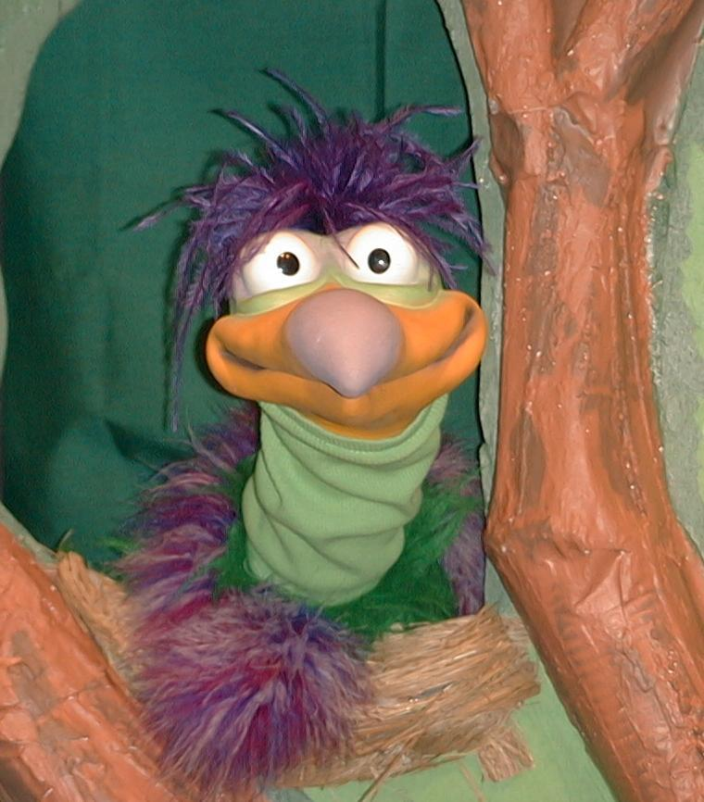
Presenter shows Xiao Er a craft made in Activity 1. Then the kids attempt to teach Xiao Er the take home point.

Presenter says to kids: “When I am scared…”
Kids say: “…I tell Jesus.”
Presenter says to Xiao Er: “When I am scared…”
Xiao Er says: “…I hide under my bed.”

Presenter shows an example of the next activity done in small group and repeats first phrase to kids. The kids say the correct response trying to teach Xiao Er the take home point. Continue in this manner with Presenter showing example of each activity. Here are Xiao Er’s responses:

Xiao Er’s response to Activity 2 sample: “…I run to my mommy.”
Xiao Er’s response to Activity 3 sample: “…I eat cookies… gimmie a cookie.”

Presenter says: “Xiao Er, listen one last time.
When I am scared…”
Kids response: “…I tell Jesus.”
Presenter says to Xiao Er: “When I am scared…”
Xiao Er’s response: (Warms up his singing voice with “Mee, mee, mee,
mee, mee…” and sings in a silly dramatic opera-like
voice) “When I am scared – I tell Jesus.”

Welcome guests and thank them for attending.

Lesson 39

Large Group Opening:
- Ting Ting puppet
- puppet-sized blanket
- Bible
- stepstool or chair for storyteller
- microphone

Small Group Application:
Activity 1:
- reproducible – copy coloring sheet on manila card
- crayons
- paint brushes
- watered-down blue, liquid watercolor paints
- newspapers to cover table
Activity 2:
- half a bun
- blue frosting
- Teddy biscuits
- plastic knives
- serviettes
- cups
- water or juice
Activity 3:
  - cotton balls
  - masking tape
  - straws (optional)
Activity 4:
  - white candle
  - 7 pieces of ½ A4 paper
  - liquid watercolor paints
  - newspapers to cover table

Large Group Wrap-up:
- optional music for the lesson
- Xiao Er puppet

