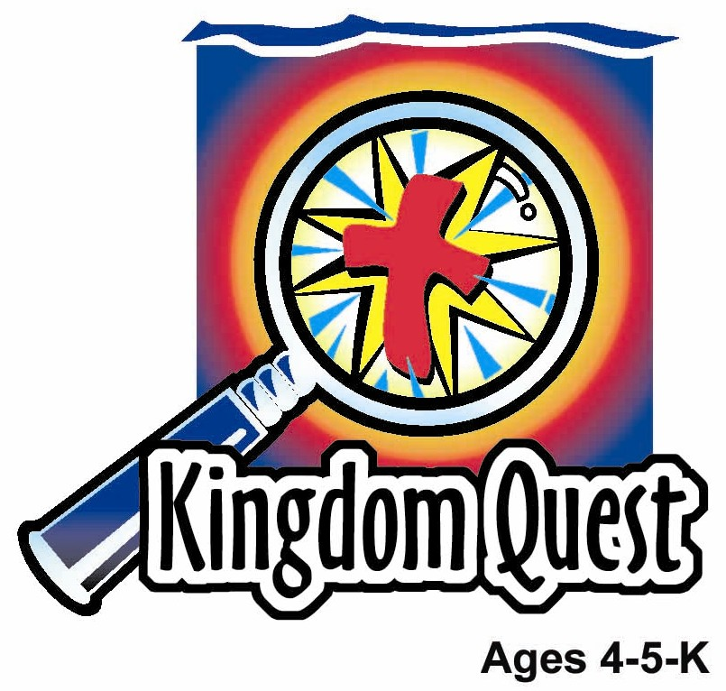
Date: ________________________
Series: Jesus is God’s Son (Dec-Feb)
Year 2, Lesson 34

Jesus is

Baptized

Take Home Point: *JESUS IS GOD’S SON—I love Jesus.
*Repeat this phrase throughout the lesson. The leader will say the first part of the phrase (CAPS). The children respond with the second part of the phrase (italics).

Bible Event: Matthew 3:13-17

Key Verse: James 1:17. “… every perfect gift is from God.” (NCV)

Jesus Link: I love Jesus because He first loved me.

We will help children know:
- The story of Jesus’ baptism.
- At Jesus’ baptism God the Father was saying, “I love you,” to His Son, Jesus.
- Because Jesus is God’s Son, who came to earth to save us, we, too, are filled with love for Jesus.

We will help the children feel:
- Love for Jesus.
- Loved by God.
- Joy at being a part of God’s family.

We will help the children do:
- Watch a video of Jesus’ baptism and learn what a “holy hug” is.
- Use a snack of apples to learn about the Trinity—“three in one”
- Play a “Water Relay” and learn that in baptism, God says, “I love you; you belong to Me.”

THIS LESSON’S ROADMAP

DESTINATION | PAGE # | DISCOVERIES ON YOUR JOURNEY | SUPPLIES NEEDED
Large Group Opening   | 3  3-4 | Puppet Presentation  Bible Event | - Ting Ting puppet  - video: “John the Baptist” from Animated Stories from the New Testament by Nest Entertainment  - T.V. and VCR
Small Group Application   | 5  6  6 | Activity 1: “Baptism Mobile” Craft  Activity 2: “Apple Slices” Snack  Activity 3: ”Water Relay” Game  Activity 4: “Action!” | Activity 1:  - copies of both reproducibles Hint: Copy the large water drop onto blue paper  - scissors  - paper punch  - one foot length of yarn per child  - glue  - crayons  Hint: Precut for 4’s, let 5 & 6’s cut the project themselves  Activity 2:  - water  - apples  - apple corer/slicer  - knife  - serviettes  - cups  Activity 3:  - five-gallon buckets—two per team  - water  - one paper cup per child  - towels, sheets, plastic sheet to protect the floor  - timer  - permanent black marker  Activity 4:  - 7 carpet squares or blank A4 paper  - masking tape
Large Group Wrap-up   | 7  7 | Singing (Optional)  Lesson Review with Puppet Skit | - optional music for the lesson  - Xiao Er puppet

Pre-Session Singing: (10 minutes)
Purpose: When all children are in one group singing, it is easy for new children to join the group and immediately get involved. When the music can be correlated, it introduces the theme for the day. Choose two to three songs and list them here.

Large Group Opening: (15 minutes)
Purpose: The puppet demonstrates the need that will be met in today’s lesson. The scripts are not written verbatim, but give a story line in which the group leader can interact with the puppet. The children are introduced to the take home point and then interact with God’s Word as they experience the Bible event.

Supplies needed: Ting Ting puppet; video: “John the Baptist” from Animated Stories from the New Testament by Nest Entertainment; T.V. and VCR

Puppet Presentation:
Ting Ting comes out giggling hysterically. The presenter asks her why she is laughing so hard. Ting Ting has a hard time calming down, but finally settles down enough to explain (with a few giggles interspersed) that she was playing “Snuggle Octopus” with her daddy. The presenter asks what Snuggle Octopus is.

Ting Ting explains that it is a game. Her daddy is the Snuggle Octopus and she has to try to keep away from him. She runs across the room trying to get past her daddy without getting caught. He makes his arms go all over the place like an octopus and tries to catch her. If he catches her, then her daddy gives her a big hug. Ting Ting loves to play Snuggle Octopus because when her daddy catches her and hugs her, it makes her feel special and loved. And besides that, it’s a lot of fun.

The presenter tells Ting Ting that Snuggle Octopus sounds like a lot of fun. It sounds like a game he would have liked to play when he was Ting Ting’s age.

Then the presenter asks Ting Ting, “Do you think Jesus ever felt that way?” Ting Ting doesn’t know. The presenter tells her that Jesus probably felt that way when He was baptized. God’s voice came from heaven and said, “This is My Son whom I love. He makes Me happy.” It was like God the Father was giving His Son Jesus a holy hug and saying, “I love You.” In today’s Bible event, the children will be learning about that special day when Jesus was baptized.

The presenter teaches Ting Ting the take home point. *JESUS IS GOD’S SON—I love Jesus. The presenter says the first part; Ting Ting responds with the second part. After practicing it with Ting Ting several times, the presenter teaches it to the children.

Bible Event: Video
Start the video “John the Baptist” at the point when John says, “Behold, the Lamb of God” (21:50) and end after Jesus says, “You are a good and faithful servant” and they walk onto the land. (Length: Couple minutes.) Before the video tell the children that they will be correcting a “Silly Story” after the video, so they need to watch closely so they get the answers correct.

After the video, tell the following story to the children. Have them correct the underlined silly words to the correct words:

Boys and girls, let me read you this story again, but if I get confused, maybe you can help me. If I say something wrong, you say, “No, that’s not it,” and help me find the right word.

There was a man in the wilderness. He was baptizing people. His name was John the Giggler (Baptist). John the Baptist was baptizing people in the Jordan Ocean (River). When John saw Jesus, he knew He was God’s Son. He said, “Behold, the cow of God.” No, that’s not it, what animal name did he use for Jesus? (Lamb)

Jesus saw John baptizing all the people. He came to John and said, “John, will you please play checkers (Baptize) with Me, too?” John said, “No, I should be baptized by You.” Jesus answered John, “This is what God says must be done.” So John was ready to baptize Jesus. He took Him into the bathtub (River) and baptized Jesus.

After Jesus was baptized, He came up from the Cordial. (Water) John looked up to the heaven and it opened up and God’s Spirit came down like an eagle (dove). A voice from heaven said, “This is My baby (Son) whom I love—I am pleased with Him,” It was the voice of God the Father.

Bring a child on stage and give him/her a hug. Then say:

When Jesus was baptized and God’s voice from heaven spoke, He was saying, “You are My Son; I love You.” It felt just like this hug. When we are baptized, God is saying, “You are My special child. I love You.” Because we are a part of God’s family, we want to say to Jesus, “You are God’s Son. I know that You love me. You showed Your love for me when You died on the cross so I can be in God’s family. I love You, too.”

Practice the take home point. You say the first part; the children respond with the second part. *JESUS IS GOD’S SON—I love Jesus.

End with the following prayer:
Dear God,
Thank You for loving Jesus.
Thank You for sending Jesus.
Jesus is Your Son.
We love Jesus.
Thank You! Thank You! Thank You!
Amen.
Small Group Application: (30 minutes)
Purpose: Smaller groups enable children to develop closer relationships with adults and peers in the church. As you reinforce the take home point with a fun hands-on activity, discuss the Bible event. Be sure to repeat the take home point several times. Say the first part and have the children respond with the second phrase. Application questions help kids apply the take home point to their daily lives. Close this session by gathering your small group for prayer. Let the kids pray!

During small group application time, discuss the following questions and points:

What special thing happened to Jesus in today’s Bible event? (He was baptized and God the Father told Him, “You are My Son and I love You.”)

What happens to us when we are baptized? (God makes us a part of His family, and tells us we are His children and tells us that He loves us.)

Why do we love Jesus? (Answers will vary but should include that Jesus is God’s Son and our Savior. It is because Jesus died on the cross that we can become a part of God’s family.)

How can we show Jesus that we love Him? (Answers will vary but may include by praying to Him, singing praises to Him, attending church and Sunday school, showing love to others, etc.)

Activity 1: “Baptism Mobile” Craft
Supplies needed: copies of both reproducibles Hint: Copy the large water drop onto blue paper; scissors; paper punch; one foot length of yarn per child; glue ; crayons
Hint: Precut for 4’s, let 5& 6’s cut the project themselves

To make:
- Color the water drop segments.
- Cut out the large water drop and the four small water drop segments.

Hint: precut for the 4’s and have the 5’s do their own cutting.

- Punch a hole into the pointed end of the large water drop.
- Glue the four segments onto the large water drop, leaving ½ inch between each of them. (A cross should appear between the segments.)
- String the yarn through the hole and tie in a loop.

To discuss:
Each of the four segments has a picture on it. These pictures remind us of what happened at Jesus’ baptism. One picture shows the sky opening up. It reminds us that when the sky opened, Jesus heard God the Father’s voice telling Him that Jesus was His Son, He loved Jesus, and He was happy with Him. The dove reminds us that at His baptism, Jesus received the Spirit of God. The picture of Jesus reminds us that Jesus is God’s Son. The heart reminds us that Jesus’ baptism was like a holy hug in which God the Father told Jesus that He loved Him. God also gives us a holy hug in baptism and tells us He loves us. As you glue the pictures on the water drop, you will see a surprise picture appear. How did Jesus show us He loves us? How can we show Jesus we love Him?

Practice the take home point. You say the first part; the children respond with the second part. *JESUS IS GOD’S SON—I love Jesus.

Activity 2: “Apple Slices” Snack
Supplies needed: water; apples; apple corer/slicer; knife; serviettes; cups

Slice an apple in half and show it to the children. Point out the three parts of the apple—the skin, the white meat and the seeds. Explain that the apple has three parts but is one apple. In the same way God is three persons—God the Father, God the Son Jesus, and God the Holy Spirit—but one God. All three persons of God were at Jesus’ baptism.

Core and slice the remaining apples. Have a snack of apple slices and water (to represent the waters of baptism) for snack.

HEALTHY SNACK OPTION: Use water and show again that water can be ice, steam and liquid. Three in one just like God the Father, God the Son, and God the Holy Spirit.

Practice the take home point. You say the first part; the children respond with the second part. *JESUS IS GOD’S SON—I love Jesus.

Activity 3: “Water Relay” Game
Supplies needed: five-gallon buckets—two per team; water; one paper cup per child; towels, sheets, plastic sheet to protect the floor; timer; permanent black marker

To set up:
- Lay out a large cloth or tarp on the floor.
- At one end of the tarp, put a 5-gallon bucket of water.
- Put an empty bucket at the other end of the tarp.
- Give all the children a cup and line them up, sitting cross legged on the floor, from one bucket to the other bucket.

To play:
- Set the timer for two minutes.
- Have the first child dip his/her cup into the bucket of water, fill it up and then pour it into the second child’s cup.
- The second child pours the water into the third child’s cup and so forth down the line.
- The last child in the line pours the water into the bucket.
- As soon as the first child pours the water into the second child’s cup he/she fills up the cup again and starts another line of water passing.
- Play continues in this manner until the time beeps.
- After the timer beeps, use the permanent marker to mark how high the water is in the bucket at the end of the line and then dump the water back into the first bucket.
- Set the timer for two minutes and repeat the game, trying to get more water into the end bucket.
- Option: Play against another team and see which team gets the most water into the bucket at the end of the line.

To discuss:

When Jesus was dipped into the water at baptism, God said to Him, “You are My Son. You belong to Me and I love You.” When we are baptized, God says to us, “You are My child. You belong to Me. I love you.” We can become children of God because of Jesus. Jesus died on the cross so our sins could be forgiven and we could become a part of God’s family. Now we are filled with God’s love and we can love Jesus like God loves us. How can we show Jesus that we love Him?

Practice the take home point. You say the first part; the children respond with the second part. *JESUS IS GOD’S SON—I love Jesus.

Activity 4: “Action!”
Supplies needed: seven carpet squares or A4 paper, masking tape.

Memory Verse: Luke 3:22 ~ “You are my Son, whom I love; with You I am well pleased.”

Memory Verse Learning:
Place carpet squares or A4 paper in a line to form a continuous path. (Note: If A4 paper is used, tape it securely to the floor with masking tape). Children stand in a line. The shepherd will say, “Action!” and the first child jump from one square or paper to the next using both feet. As they jump, they repeat the memory verse, word by word until the whole verse is completed. Repeat the activity, suggesting other motions (walking, hopping, walking backward or sideways etc).

Prayer Time:
Thank Jesus for helping you become one of God’s children. Tell Him you love Him and ask Him to help you show Him that love.

Large Group Wrap-Up: (10 minutes)
Purpose: The crazy bird puppet, Xiao Er, struggles with learning the take home point. The leader shows an example of each small group application activity from this lesson and says the first phrase of the take home point. The kids respond with their phrase. They try to teach the puppet the take home point, but each time he confuses words or concepts. After three attempts, he finally gets it right and sings the correct take home point in a silly opera-like voice.

Singing: (Optional)

Lesson Review with Puppet Skit:
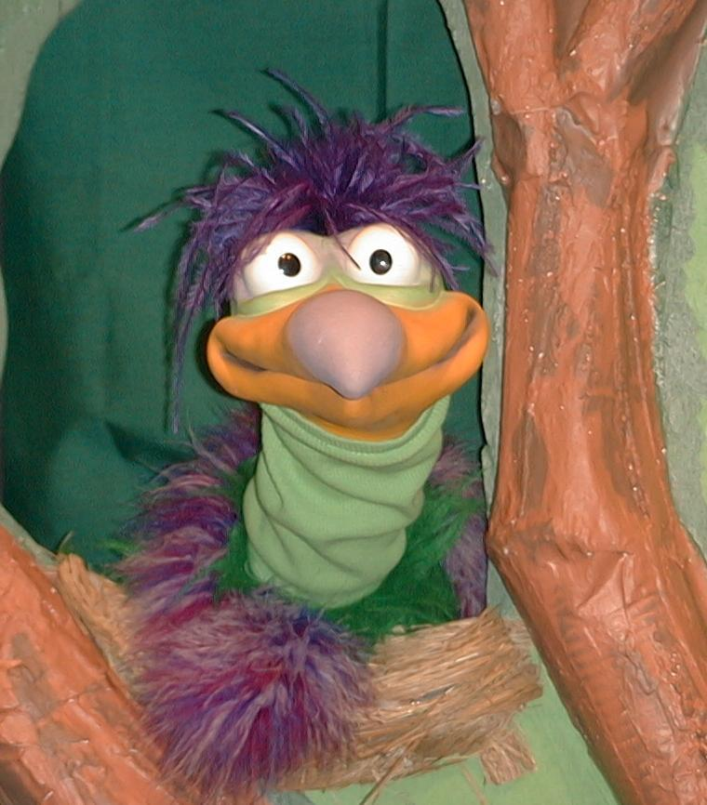
Presenter shows Xiao Er a craft made in Activity 1. Then the kids attempt to teach Xiao Er the take home point.

Presenter says to kids: “Jesus Is God’s Son…”
Kids say: “…I love Jesus”
Presenter says to Xiao Er: “Jesus Is God’s Son…”
Xiao Er says: “…I love cheese.”

Presenter shows an example of the next activity done in small group and repeats first phrase to kids. The kids say the correct response trying to teach Xiao Er the take home point. Continue in this manner with Presenter showing example of each activity. Here are Xiao Er’s responses:

Xiao Er’s response to Activity 2 sample: “…I love to wear my underwear on my head.”
Xiao Er’s response to Activity 3 sample: “…I love to say, ‘icky, picky, pookie, ookie, mookie.’”

Presenter says: “Xiao Er, listen one last time.
Jesus Is God’s Son…”
Kids response: “…I love Jesus”
Presenter says to Xiao Er: “Jesus Is God’s Son…”
Xiao Er’s response: (Warms up his singing voice with “Mee, mee, mee,
mee, mee…” and sings in a silly dramatic opera-like
voice) “Jesus Is God’s Son – I love Jesus”

Welcome guests and thank them for attending.

LESSON 34

Large Group Opening
- Ting Ting puppet
- video: “John the Baptist” from Animated Stories from the New Testament by Nest Entertainment
- T.V. and VCR

Small Group Application
Activity 1:
- copies of both reproducibles Hint: Copy the large water drop onto blue paper
- scissors
- paper punch
- one foot length of yarn per child
- glue
- crayons
Hint: Precut for 4’s, let 5 & 6’s cut the project themselves

Activity 2:
- water
- apples
- apple corer/slicer
- knife
- serviettes
- paper cups

Activity 3:
  - five-gallon buckets—two per team
  - water
  - one paper cup per child
  - towels, sheets, plastic sheet \to protect the floor
  - timer
- permanent black marker

Activity 4:
  - 7 carpet squares or blank A4 paper
  - masking tape

Large Group Wrap-Up
- optional music for the lesson
- Xiao Er puppet
Lesson 34 – Activity One (2 pages)
